# CNN

1. Convolution
2. Normalization
3. Pooling

## Hyperparameters

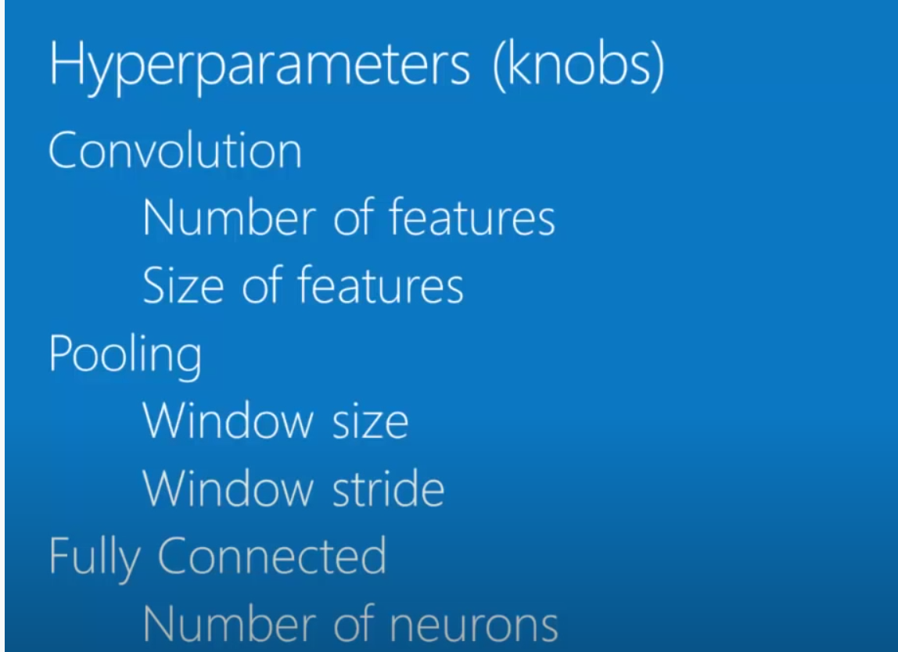

## How to define architeture:

1. tentative to mimic human brain (biology)

## Limitations:

1. Only capture local “spatial”patterns in data, if the data cant be made to look like and image CNN are less useful

## Advantages:

1. CNNS are great at finding patterns and using them to classify images (or things that can be like image… sound, text, etc..)

