Value Sensitive Design:

Case study in AH 

*Hans Alberto Franke,* [*h.a.franke@students.uu.nl*](mailto:h.a.franke@students.uu.nl)

Personalization for Public Media

Applied Data Science - Utrecht University - 2021

***Main Objective***

A study on how to apply Value Sensitive Design in an recommender system for Albert Heijn

# Introduction

A novel approach Value sensitive design (VSD) represents a pioneering endeavor to proactively consider human values throughout the process of technology design[5]. This belief is supported once products that we engage will strongly influence our lived experience and, in turn, our abilities to meet our aspirations.

In todays diverse world, values have a different importance for each user/stakeholder. Adding, the expanding spectrum of product choices and their production complexity challenge consumers to make informed and value-sensitive decisions. Recent approaches based on (personalized) psychological manipulation are often intransparent, potentially privacy-invasive and inconsistent with (informational) self-determination[1]. By contrast, responsible consumption based on informed choices currently requires reasoning to an extent that tends to overwhelm human cognitive capacity.

Many different stakeholders can use or affect a recommender system. These stakeholder have different values and desired outcomes. Which leads to the question of: How this can be connected and addressed in a single recommender system? In the next chapters this work will use a Value Sensitive Design approach to identify stakeholder values for a recommender system created for Albert Heijn.

# Theorical Framework

People are different, which means that a one-fits-all-approach doesn’t work for a recommender system made for individuals (or in our example here a stakeholder) as every person has different values and motivations. One example is presented in [1], where mainstream decisions support is compared to value-sensitive design (VSD). The example in figure1 is VSD based on sustainability and customer values as main values.

One of the biggest issues with mainstream recommender methods (p.e price-driven approach) is limited **transparency** and **accountability**. So, the person receiving the suggestion, in this case the customer, doesn`t know why he is receiving this suggestion or even who is sending it.

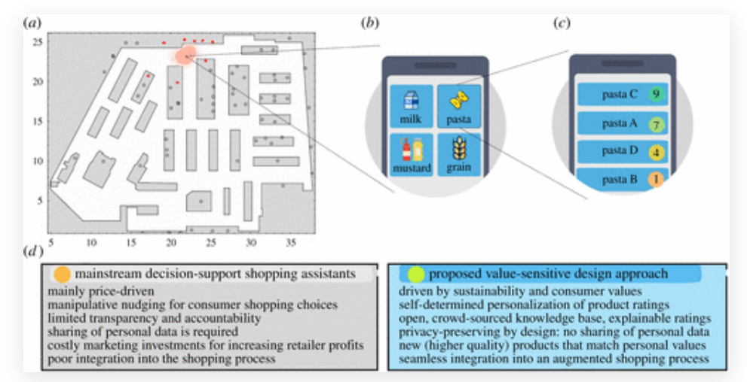

**Figure1**. Comparison between maistrem decision-support x value-sensitive design, adapted from [1]

Another important discussion, was proposed by Friedman and Nissenbau (1996), after they had already pioneered an analysis of **bias** in computer systems, and argued that such systems are biased if they "*systematically and unfairly discriminate against certain individuals or groups of individuals in favor of others [by denying] an opportunity for a good or [assigning] an undesirable outcome to an individual or groups of individuals on grounds that are unreasonable or inappropriate*" [3].

A good understanding of **biases** would allow us to identify potential harms in a system and either avoid them in the process of design or correct them if the system is already in use. To this end, Friedman and Nissenbau provided a taxonomy of biases that remains highly relevant and useful for today's debate on algorithmic bias and discrimination (see, e.g., Dobbe et al., 2019; Cramer et al., 2018). Based on the respective origin of bias, they specified three different types of biases, namely *preexisting bias*, *technical* *bias*, and *emergent* *bias*.

**Preexisting bias** has its roots in social institutions, practices, and attitudes and usually exists prior to the creation of the system[3]. It can either originate from individuals who have significant input into the design of the system (**individual preexisting bias**) or from prejudices that exist in society or culture at large (societal preexisting bias). **Technical bias** [3], in turn, arises from technical constraints or considerations. Sources of technical bias may include limitations of computer tools (e.g., in terms of hardware, software, or peripherals), the use of algorithms that have been developed for a different context, and the unwarranted formalisation of human constructs, that is, the attempt to quantify the qualitative and discretise the continuous. **Emergent bias is bias** [3] that arises in a context of use, typically some time after a design is completed, as a result of (a) new societal knowledge or changing cultural values that are not or cannot be incorporated into the system design or (b) a mismatch between the users—their expertise and values—assumed in the system design and the actual population using the system.

# Methods

As defined in [3] Value Sensitive Design as a theoretically grounded methodology emerged against the backdrop of the 1990s rapid computerisation and as a response to a perceived need for a design approach that would account for human values and social context throughout the design process. Indeed, Friedman's (1997) seminal edited book Human Values and the Design of Computer Technology already provided an impressive demonstration on how to conceptualise and address issues around agency, privacy, and bias in computer systems, emphasising the need to "embrace value-sensitive design as part of the culture of computer science".

At its core, the VSD approach offers a concrete methodology for how to intentionally embed desired values into new technologies. It consists of three iterative phases, namely conceptual-philosophical, empirical, and technical investigations, sometimes called **TRIPART** methodology:

* **Conceptual investigations** aim at (theoretical) conceptualizing the various values and value tensions
* **Empirical investigations** aim at understanding the users’ attitudes, desires, opinions, and values.
* **Technical investigations** concern identifying value issues based on existing technical designs and translating these values into technical features.

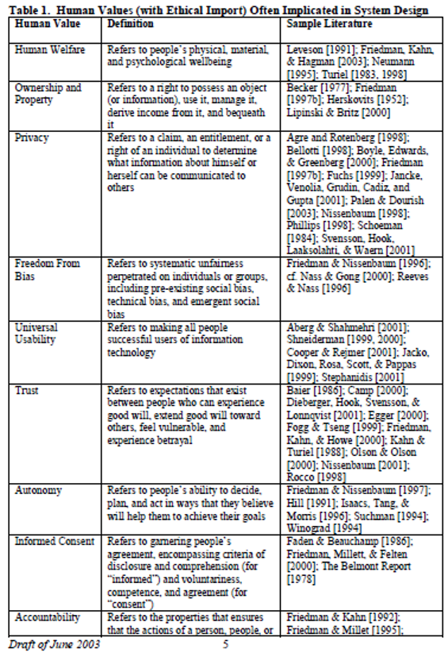Friedman defined a list of values as she called “Ignition list” see table 1. Kheirandish**,** see figure 2,continued these definitions in a framework that makes it easy for a team to discuss about many different stakeholders, values and tensions by using cards that are put on “plot” to have a full picture of the product and the values discussed. The **heterogeneity** of the team is a important part of the project to avoid mentioned bias. People with many different backgrounds have better variety of insights and discussion on how to make the system taken into account as many different human values as possible.

Stakeholders are an important aspect of the VSD as they can be **direct** (p.e customers) or **indirect** (p.e society), **human** or **non-human** (p.e technology / computer / app). The steps to define stakeholders are: 1) visualize all stakeholders, 2) categorize into group/clusters (if needed) and 3) list key characteristics.

In this work the **conceptual investigation** of values will be used as defined in HuLu [2] (see figure2), **empirical investigation** were defined by the author and other students during a group discussion. It simulate users as *personas* to exemplify the **conceptual** values. These 2 aspects will be incorporated in a recommender system developed within an APP to illustrate the **technical** **investigation.**

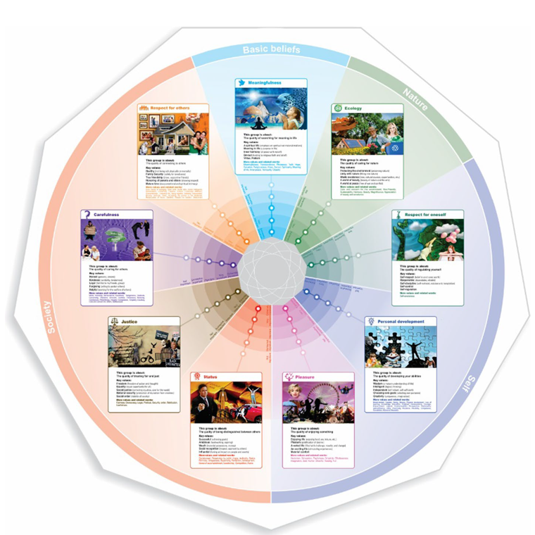

**Figure2**. Hu Value Tool, adapted from Kheirandish

The domain that these investigations were studied in is an Albert Hein (AH) APP recommender system. The app, users, AH’s employees and Dutch community are appropriate to show all the methods described above. This takes into account different stakeholders, values and tensions of this complex environment for example users preferences for prices or sustainability (p.e bioproducts), AH`s profits in opposition to product diversity (p.e + margin and - stock vs - margin and + stock). The APP is a way to address this complex environment, so its inputs should be defined by each stakeholder to produce different recommendation based on each value, and by definition not just maximize the profit of AH but the user experience and values as well, leading to a positive cycle of feedback between users and recommender system.

# Results

The first step on the development of a recommender system for AH, was mapping all possible stakeholders to later select some key stakeholders. In [4] there is list of many different stakeholders by domain, so in this case a retailer domain was chosen. The full list of stakeholders can be found on the website.

The next step was to group stakeholders and mapping key characteristics of these stakeholders. For simplicity, the stakeholders were grouped in **Internal** (stores, workers and marketing) and **external** ( Customer, food industry, suppliers, competitors, society, investors, government). As one can see on figure3, the direct and indirect impact is divided by the vertical axis (p.e society is indirect and customer is directed impacted). This representation on a plot with arrows showing interaction between nodes (stakeholders) and from/to (direction of the arrow) can illustrate the initial insights of tension or conflict between different stakeholders of the recommender system.

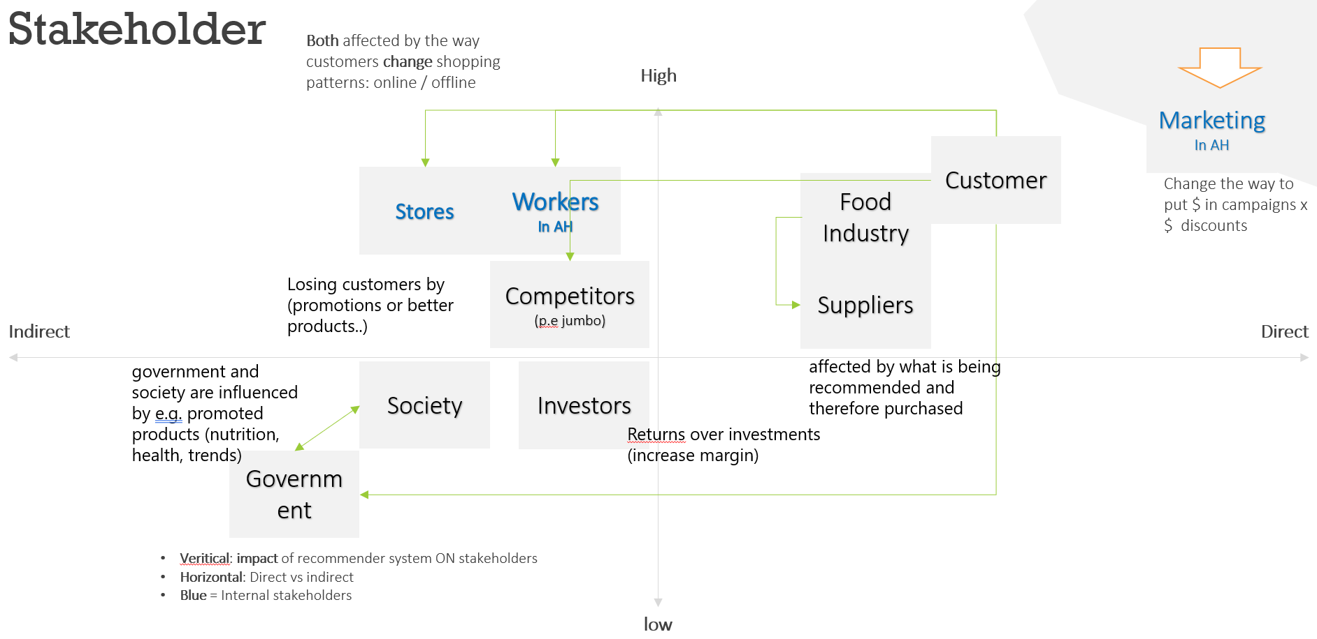

**Figure3**. Summary of stakeholder used on the analysis and initial interaction between then.

It became clear that one single recommender system without taking different stakeholders into account will lead to a bad system, with poor suggestions, bias and a loss in accuracy. As an example an algorithm that focuses only on selling more will solely show promotions to all customers, but may not consider that a supplier can`t produces that quantity or even worse, try to sell things to a customer who doesn’t ***want to*** buy that item, and maybe lose a customer. The last part of this statement brings the work to next step: define human values inside the recommender system.

The HuValue [2] framework defines a list of human values to address this part. The list of values used in this work is described in table 2. In this work, for simplicity the graduated of impact were 3 important levels only: very important, medium important and not very important. The color red doesn’t mean it is bad (p.e a customer with “red” on justice), but only that value is not very important for this stakeholder.

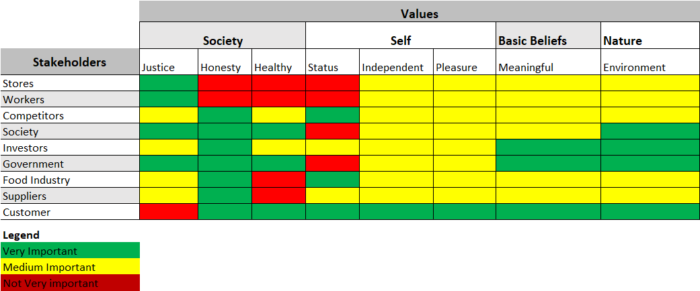

**Table2**. Relation between values and stakeholders

Customer is a very vague definition, if one taking in account all customers the same way (P.e averaging customers), we will have the same problem as before, so a one-fits-all solution is not a good idea in a recommender system. This necessity leads to another part of this work namely clustering customers as personas to model different interpretation of values. To illustrate three personals were created with very different values and personalities, see table3:

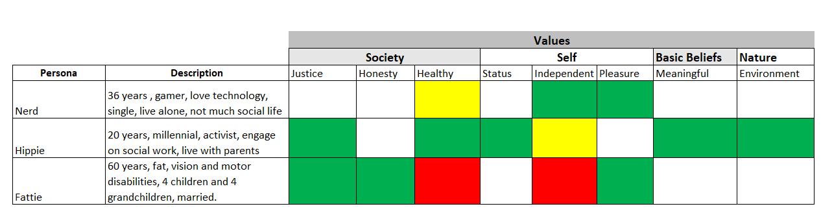

**Table3**. Relation between values and personas (sub group of customers)

These definitions were created in a group work, so different opinions were taken in account, for instance, different people backgrounds, lifestyle and interests. In a different scenario (no covid for example) the ideal procedure would be interviews with each of these stakeholders to proper define individual values. A way to minimize the bias was by using different peoples opinion through group heterogeneity as described to simulate that personas.

The last stage is to pop this personas as a cards, and plot on HuValue framework to a full view to see balance and tensions of the desired recommender system, see figure 3. Each card is a composition of **persona** AND **value.** For instance Nerd&independent, plotted in *Self*, as *independent* is a value that belongs to this “main group” of values. The colors in postcards is intended to easily differentiate the personas visually.

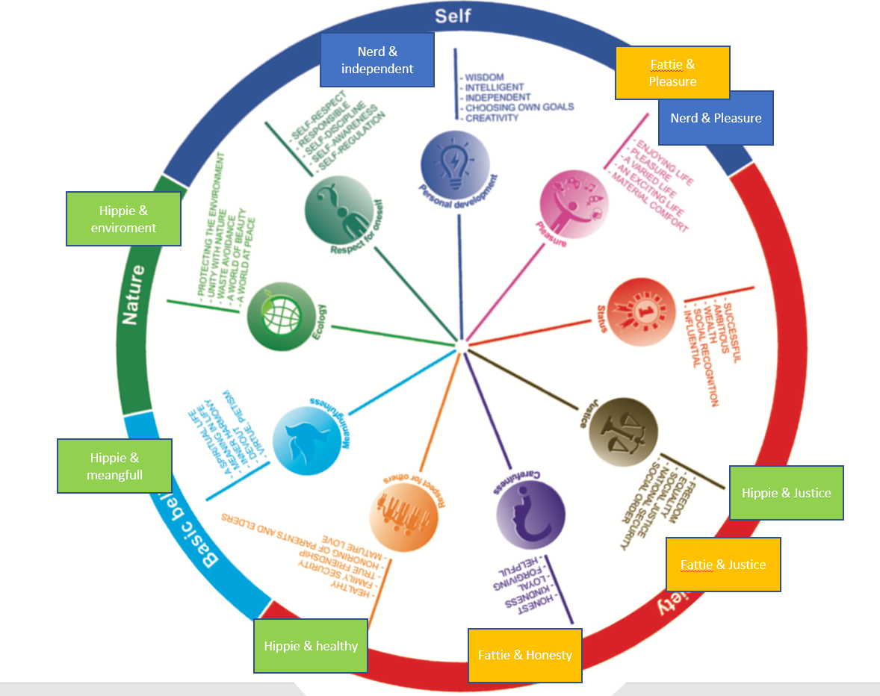

**Figure3**. HuValeu framework with personas and key values by persona.

After the “*value wheel*” has been filled it became more clear that the system has tensions and needs balance on the value-forces. As an example in one side Hippe and his lifestyle of environment activity and healthy diet, demands a range of products with engagement, like bioproducts or from local community. On the other side of the food chain we see Nerd and Fattie with a demand for pleasure, in that case junk food and cheap food (for Fattie, large family), so que question arise: How to balance the recommend and address both groups properly? The answer is: with a recommender system based on these values. Therefore, Nerd will receive a range of products, but Fattie and Gamer a very different recommendation. The stakeholders like investors that were interested in profit but in image as well have their needs fulfilled, as probably the AH will increase their selling numbers through more accurate suggestion, and both groups will increase reputation of AH by positive reviews of their own needs fulfilled.

The system need the users inputs continuously (p.e buying trends), to measure accuracy of the recommendation. All customers personas have their values satisfied and will continue improving the recommender system, so is a cycle where users provide feedback to recommender and it provides better suggestion to users. The APP should address through technology some possible limitations, for example Fattie has low vision. The app would have sound reading or large letters, for example, turning in a more inclusive device. Not only the values should be addressed but physical disabilities too.

# Conclusion

As discussed in this work, value sensitive design is a novel approach that aims to address tension from different values and stakeholders in a system. The main advantage is to balance this tension forces in a way to handle multiple perspective as an individual (p.e individual values) but aiming at a global level (p.e increase profit of AH and user satisfaction at same time). The system need to balance and change parameters as relation with customers are being built, this feedback loop contributes to maximize users engagement and more and more personas being proper addressed, almost in a individual way.

Proper utilization of VSD could support such efforts as the method not only requires diligent investigations of the values at stake (see, in par­ticular, the empirical and technical investigations in the VSD method), but also calls for the involvement of interdisciplinary research teams that include, for ex­ample, philosophers, social scientists, or legal scholars. Of course, such interdisci­plinary approach can be challenging and resource intensive, but ethical design ultimately demands more than mechanical, recipe-based treatments of FAT (Fairness, Accountability, and Transparency in socio-technical systems) re­quirements [3]. Striving for truly value-sensitive designs im­plies being sensitive to the manifold meanings of values in different societal and cultural contexts and requires recognizing, relating, and applying different discipli­nary competences[3].

# References

[1] [Thomas Asikis](https://royalsocietypublishing.org/doi/10.1098/rsos.201418), [Johannes Klinglmayr](https://royalsocietypublishing.org/doi/10.1098/rsos.201418), [Dirk Helbing](https://royalsocietypublishing.org/doi/10.1098/rsos.201418)  and [Evangelos Pournaras](https://royalsocietypublishing.org/doi/10.1098/rsos.201418) (2021). *How value-sensitive design can empower sustainable consumption*. [**https://doi.org/10.1098/rsos.201418**](https://doi.org/10.1098/rsos.201418)

[2] Shadi Kheirandish, Mathias Funk, Stephan Wensveen, Maarten Verkerk,Matthias Rauterberg1 (2019). *HuValue: a tool to support design students in considering human values in their design.* International Journal of Technology and Design Education (2020) 30:1015–1041 <https://doi.org/10.1007/s10798-019-09527-3>

[3] Simon Judith,Wong Pak-Hang, Rieder Gernot(2019). *Algorithmic bias and the Value Sensitive Design approach*  DOI: https://doi.org/10.14763/2020.4.1534

[4] Stakeholder map: <https://www.stakeholdermap.com/retail-stakeholders.html>

[5] Janet Davis, Lisa P. Nathan (2014). *Value Sensitive Design: Applications, Adaptations, and Critiques*

*[6]* Cramer, H., Garcia-Gathright, J., Springer, A., & Reddy, S. (2018). *Assessing and Addressing Algorithmic Bias in Practice*. Interactions, *25*(6), 58–63. <https://doi.org/10.1145/3278156>

[7] Dobbe, R., Dean, S., Gilbert, T., & Kohli, N. (2018). *A Broader View on Bias in Automated Decision-Making: Reflecting on Epistemology and Dynamics*. 2018 Workshop on Fairness, Accountability and Transparency in Machine Learning. <http://arxiv.org/abs/1807.00553>