Admin Pages Overview

Dashboard
The dashboard serves as the central hub for the admin. It provides quick statistics such as total active movies, total active shows, today's earnings, today's bookings, total registered users, and total unread messages. It displays visual charts like earnings overview and lists recent bookings and pending messages, allowing the admin to quickly grasp the current state of the application.
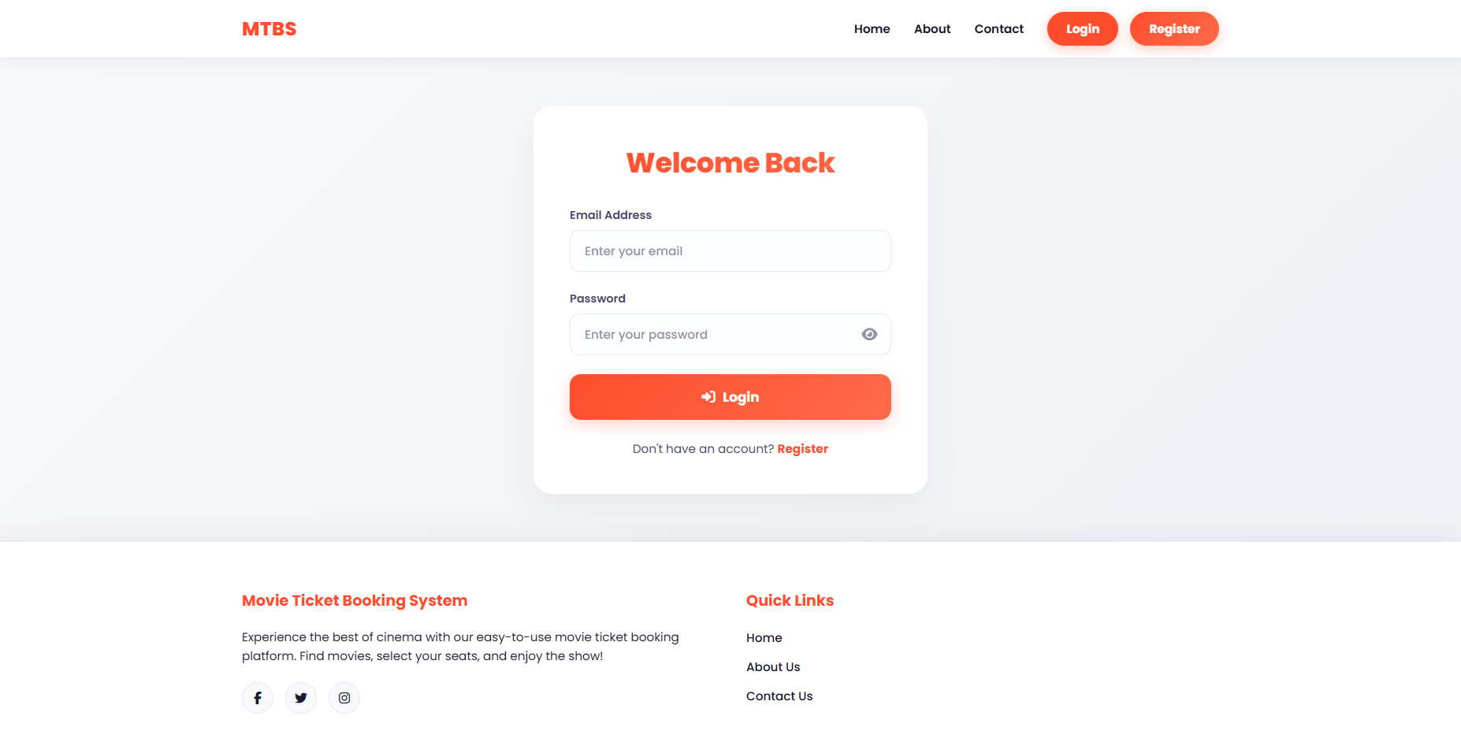

Add Movie
This page is used to add a new movie into the system. The admin can provide details such as the movie's title, description, duration, language, release date, format (2D/3D), and upload image posters and banners.
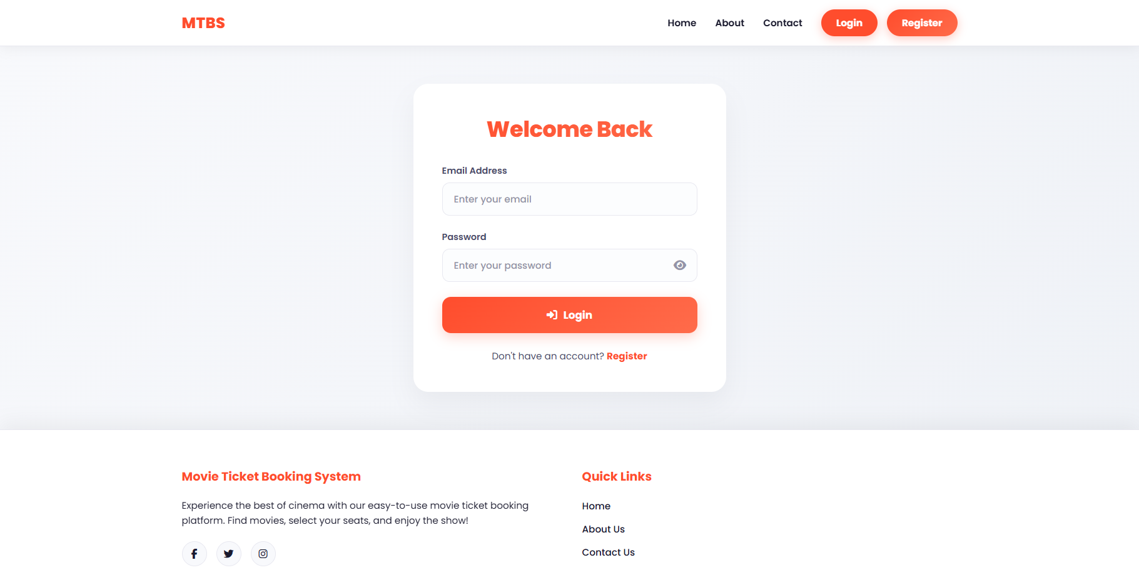

Add Show
Here, the admin can schedule a show for a specific movie. It requires selecting a movie, a screen, and specifying the show date, start time, and end time. Furthermore, it defines the pricing for that specific show.
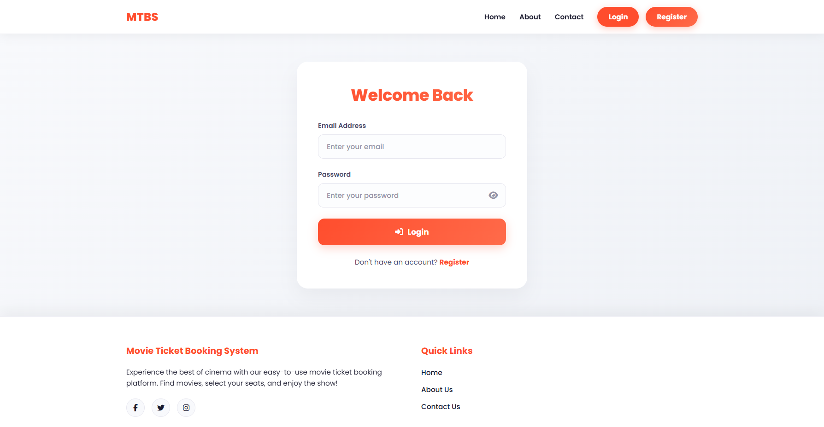

Booking Monitoring
This page allows the admin to monitor and manage all bookings. It lists the bookings with details like customer name, movie, show timing, seats booked, amount, and payment status.
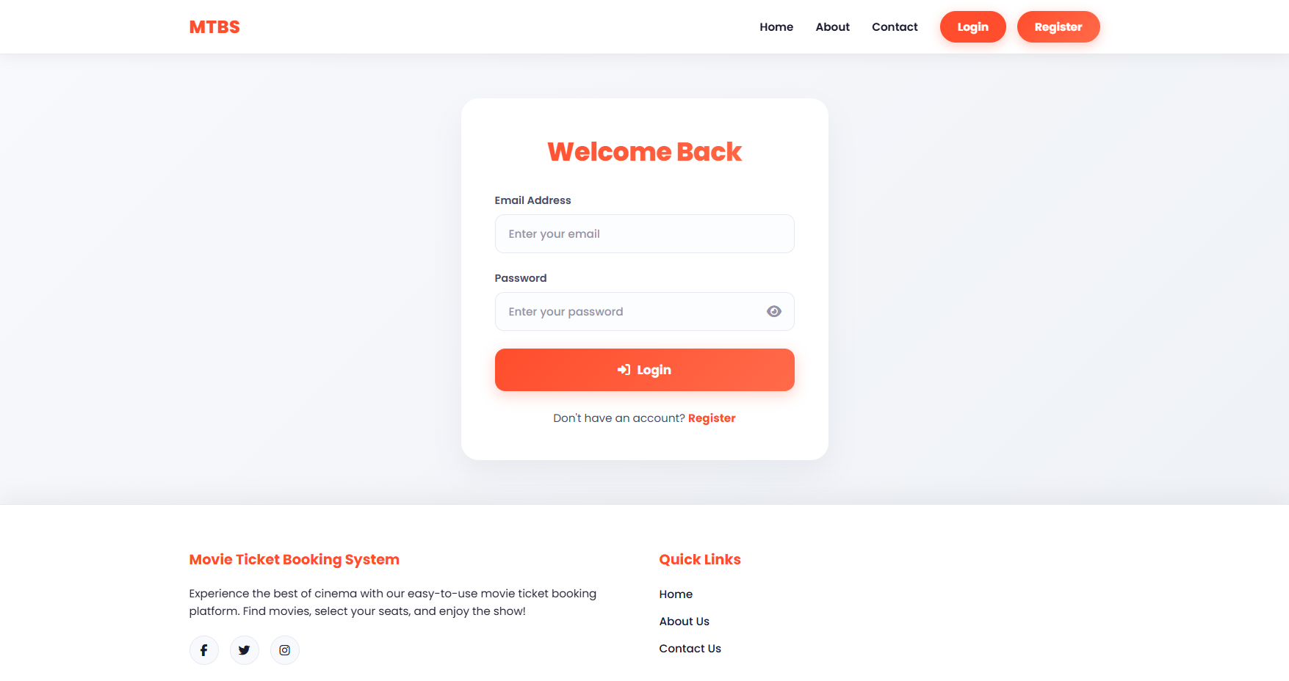

Contact Messages
A management interface for user inquiries submitted via the contact form. The admin can view messages, prioritize them, reply to them, and change their status (e.g., NEW, REPLIED, CLOSED).
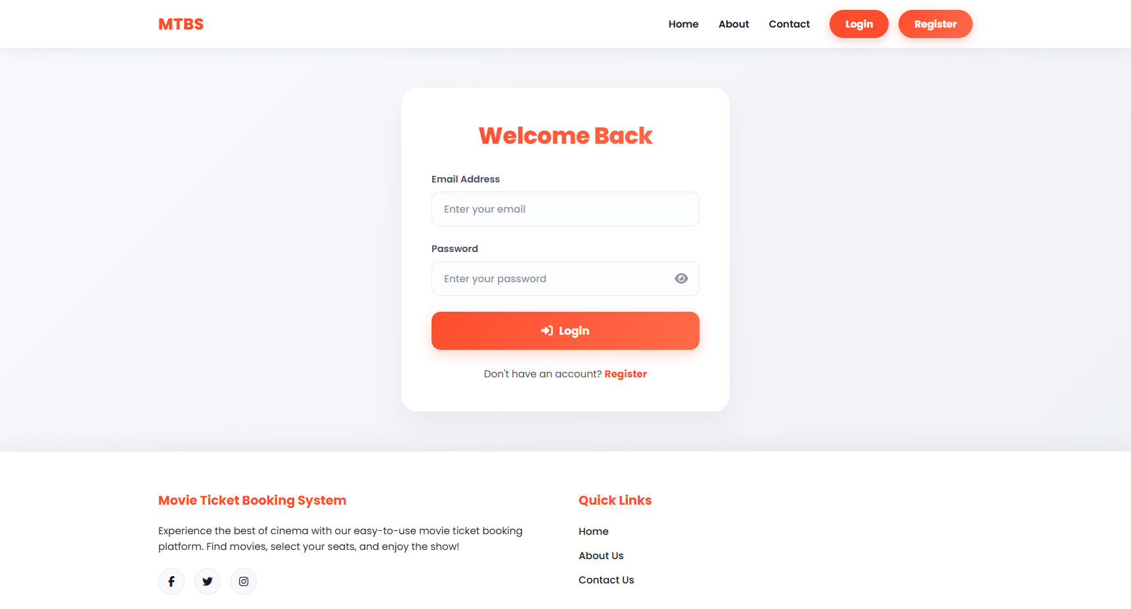

Manage Genres
A simple interface to perform CRUD operations on movie genres. The admin can add new genres (like Action, Comedy, Sci-Fi) that can later be associated with movies to categorize them appropriately.
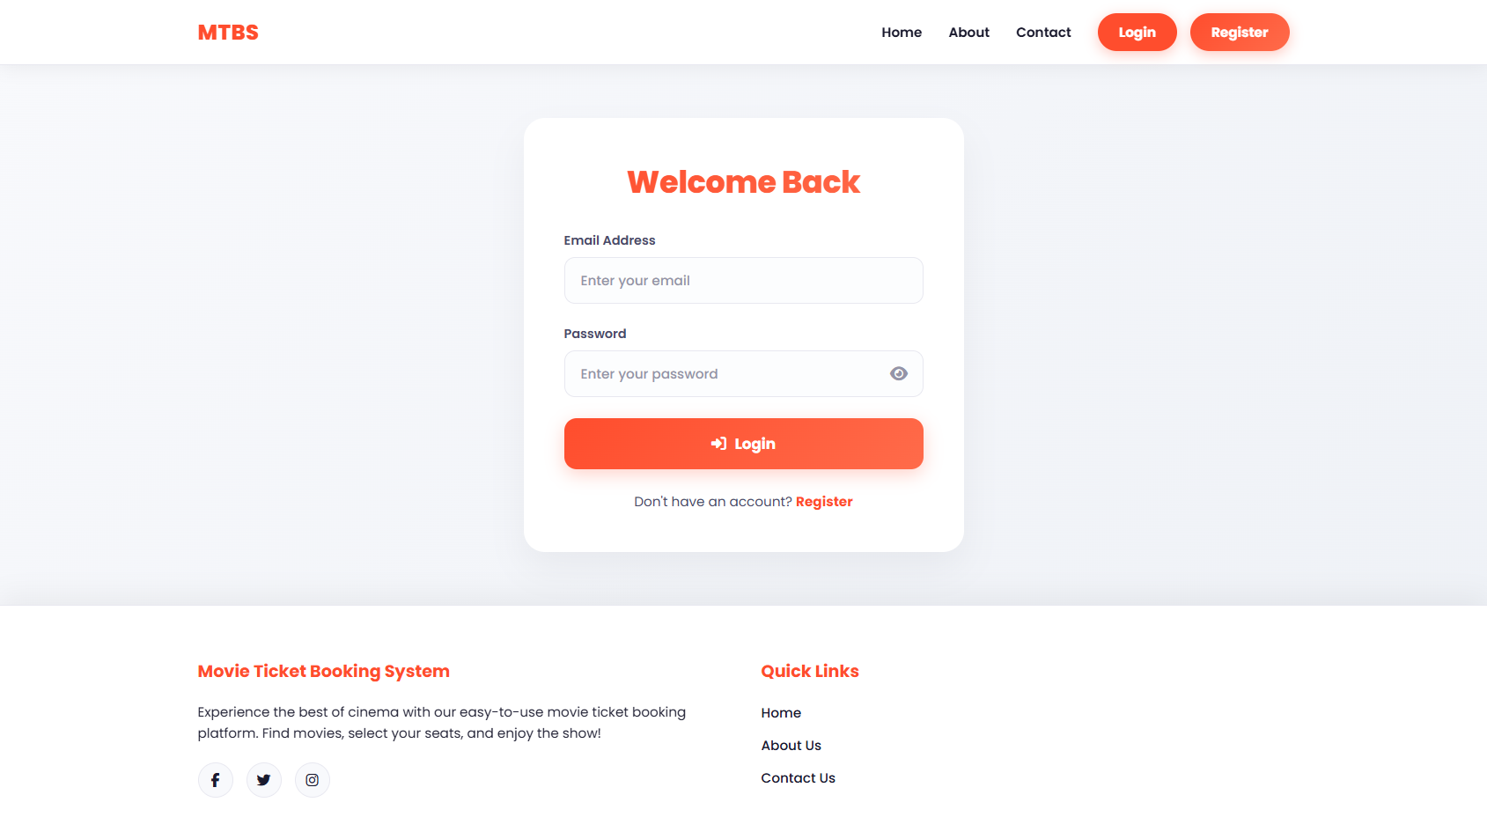

Manage Screens
Allows the administrator to configure the physical screens available in the theater. Each screen has a name, total seat capacity, and a status (Active, Inactive, Maintenance).
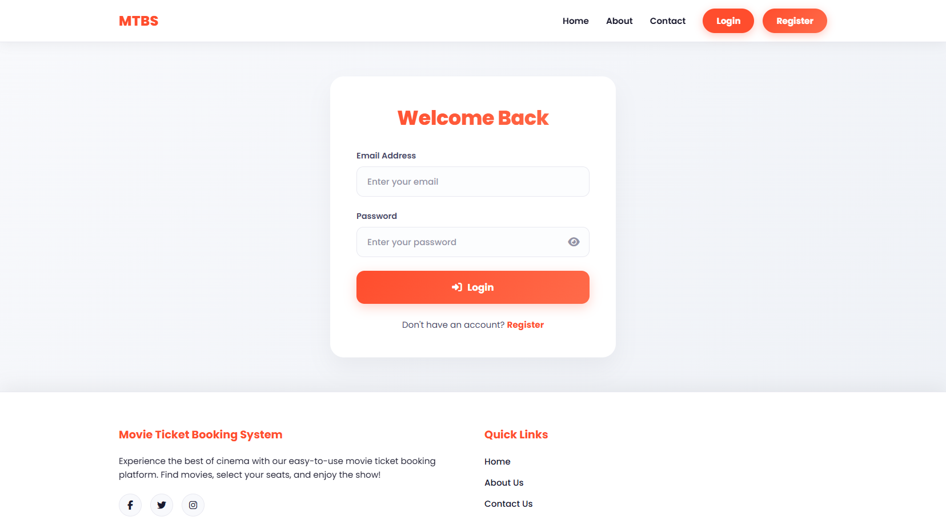

Manage Seats
Once a screen is created, this page allows the admin to define the exact layout and physical arrangement of seats for that screen. The admin can organize seats by rows, number them, and assign categories like Standard or Premium.
