|  |
| --- |
| 1. Language Enhancements |

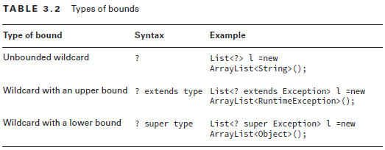

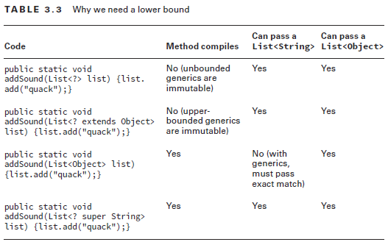

|  |
| --- |
| 5. Lambda |

**5.1 Define and write functional interfaces and describe the interfaces of the java.util.function package** 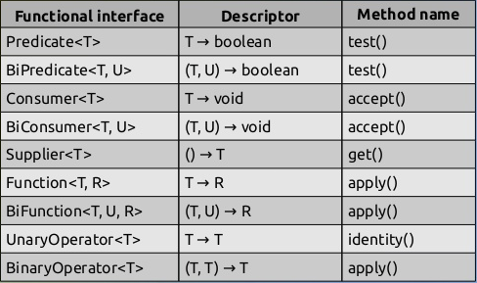

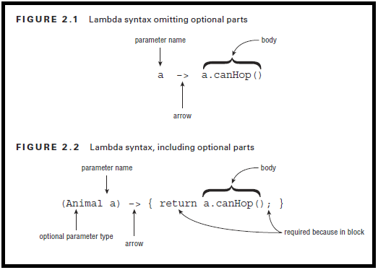

|  |  |
| --- | --- |
| **5.4** | **DDevelop code that uses a method reference, including refactoring a lambda expression to a method reference** |

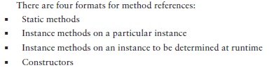

|  |
| --- |
| 6. Collections |

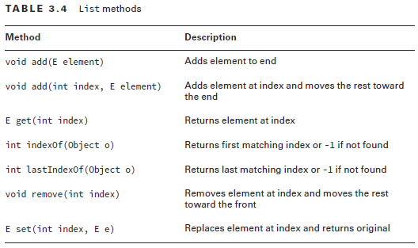  
★ LinkedList implements both the List and Queue.

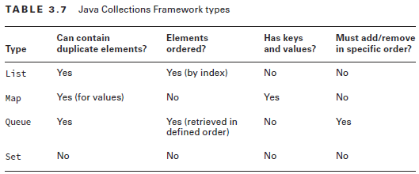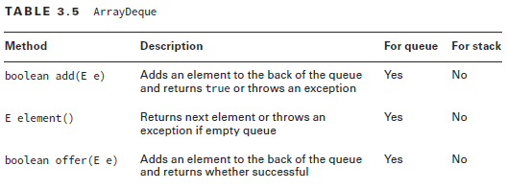

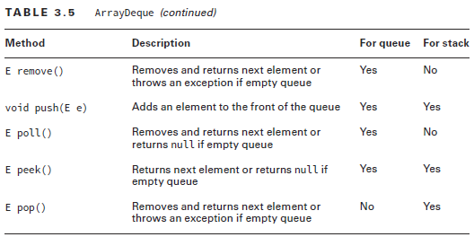

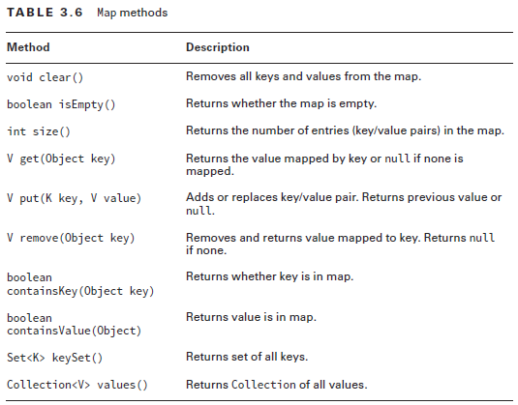

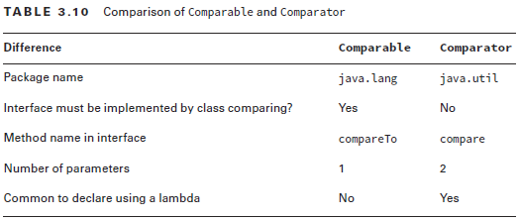

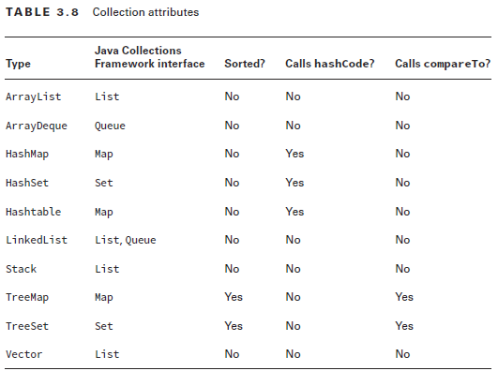

★ All data structures allow null expect Treemap (no null keys) and Hashtable (no null keys o values).

**6.1 Develop code that uses diamond with generic declarations**

**6.2 Develop code that iterates a collection, filters a collection, and sorts a collection by using lambda expressions**

