Usage
Execute
Execute “drive_checker.exe”.
It may ask you for Administrator permission because this program may write test files to a disk partition which only administrators have permission to access.
This program requires JRE. In the folder of the executable, you may see a directory “jre”. It contains a portable version of JRE. This program will first try to use the JRE or JDK installed in your system. If not available, it will try to use the bundled JRE.
If you have JRE or JDK already installed on your computer, you may remove the “jre” folder to free up your disk space.
If you want to install JRE in your system directly, follow the steps below.

Install JRE
Go to http://www.oracle.com/technetwork/java/javase
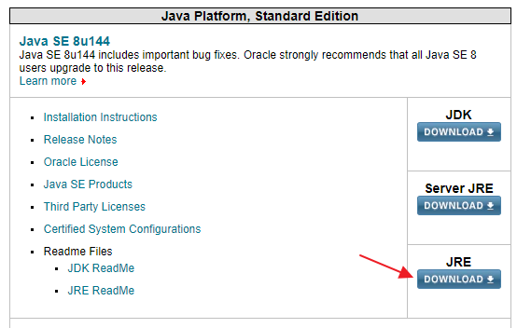
Click "JRE".
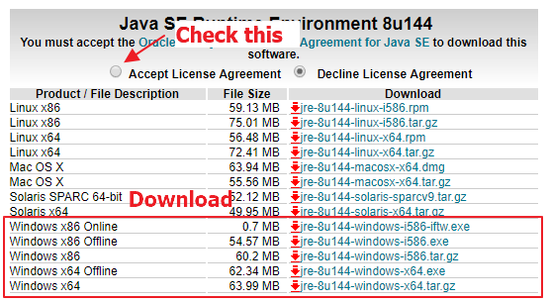
Accept license agreement, and download the JRE that fit your environment. If you are not sure, download the "jre-*-windows-i586.exe".
Install the download JRE.

