Predicting Chronic Kidney Disease

Introduction:
The goal of this project is to analyze medical diagnostic data and predict whether a patient has Chronic Kidney Disease (CKD) using Apache Spark (PySpark).
The project focuses on identifying key clinical factors associated with CKD and building a Decision Tree Classification Model to classify patients into either CKD or Not CKD categories.
A Decision Tree model is trained on features such as blood pressure, specific gravity, albumin level, red blood cell count, blood glucose level, and other biomarkers.
The model helps medical practitioners quickly identify high-risk patients and make early interventions.

Dataset Details:
The dataset for this project is sourced from Kaggle’s Chronic Kidney Disease (CKD) database and contains 400 patient records with 25 clinical features. These features represent common diagnostic indicators used in evaluating kidney health, covering patient demographics, laboratory test results, and medical history information. The target attribute classifies each case as either CKD or Not CKD.
Since the dataset includes several missing values, preprocessing was performed to ensure data quality. Missing entries in numerical attributes were imputed using the median, while missing values in categorical attributes were filled using the mode. This step prepared the dataset for accurate and reliable model training.

Source Code
# Loading data
data = spark.read.csv("C:/Users/Dell/Downloads/kidney_disease_final_clean.csv",
header=True, inferSchema=True)
# Cleaning data
data = data.drop("id")
data = data.withColumn("pcv", regexp_replace(col("pcv"), "[^0-9]", ""))
data = data.withColumn("wc", regexp_replace(col("wc"), "[^0-9]", ""))
data = data.withColumn("rc", regexp_replace(col("rc"), "[^0-9.]", ""))
data = data.withColumn("pcv", when(length(col("pcv")) == 0, None).otherwise(col("pcv")))
data = data.withColumn("wc", when(length(col("wc")) == 0, None).otherwise(col("wc")))
data = data.withColumn("rc", when(length(col("rc")) == 0, None).otherwise(col("rc")))
data = data.na.drop(subset=["pcv", "wc", "rc"])
data = data.withColumn("pcv", col("pcv").cast("int"))
data = data.withColumn("wc", col("wc").cast("int"))
data = data.withColumn("rc", col("rc").cast("float"))

categorical_cols = ["rbc", "pc", "pcc", "ba", "htn", "dm", "cad", "appet", "pe", "ane"]
label_col = "classification"
numeric_cols = [c for c in data.columns if c not in categorical_cols + [label_col]]
indexers = [StringIndexer(inputCol=c, outputCol=c + "_idx", handleInvalid="keep")
for c in categorical_cols]
label_indexer = StringIndexer(inputCol=label_col, outputCol="label", handleInvalid="keep")
assembler_inputs = [c + "_idx" for c in categorical_cols] + numeric_cols
assembler = VectorAssembler(inputCols=assembler_inputs, outputCol="features")

#Training and Testing Dataframe
dt = DecisionTreeClassifier(featuresCol="features", labelCol="label")
pipeline = Pipeline(stages=indexers + [label_indexer, assembler, dt])
train_data, test_data = data.randomSplit([0.7, 0.3], seed=42)
model = pipeline.fit(train_data)
predictions = model.transform(test_data)

#Accuracyand F1 Score
accuracy_eval=MulticlassClassificationEvaluator(labelCol="label",predictionCol="prediction",metricName="accuracy")

f1_eval=MulticlassClassificationEvaluator(labelCol="label",predictionCol="prediction",metricName="f1")

accuracy = accuracy_eval.evaluate(predictions)
f1_score = f1_eval.evaluate(predictions)

print(f"Accuracy: {accuracy:.4f}")
print(f"F1 Score: {f1_score:.4f}")
#1 Creating Spark Session and Loading, Cleaning Data
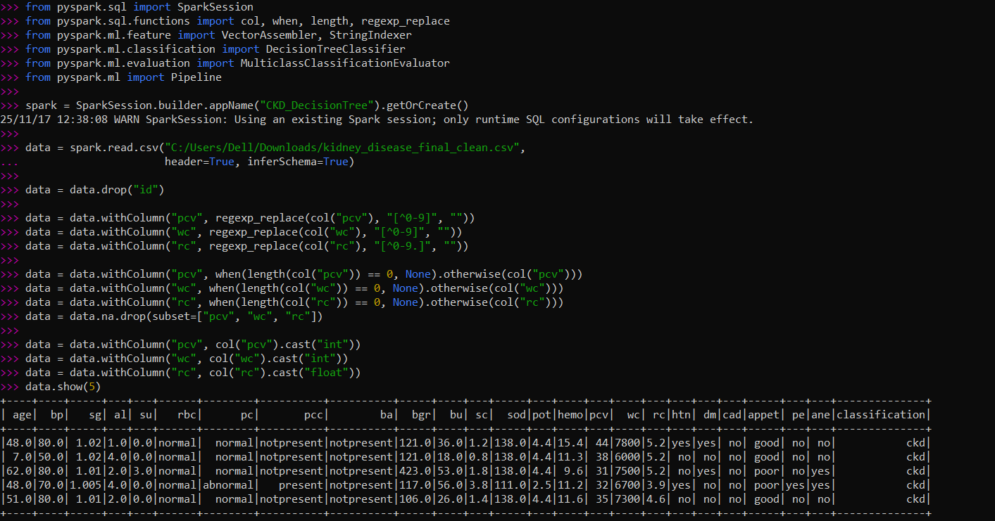
#2 Schema
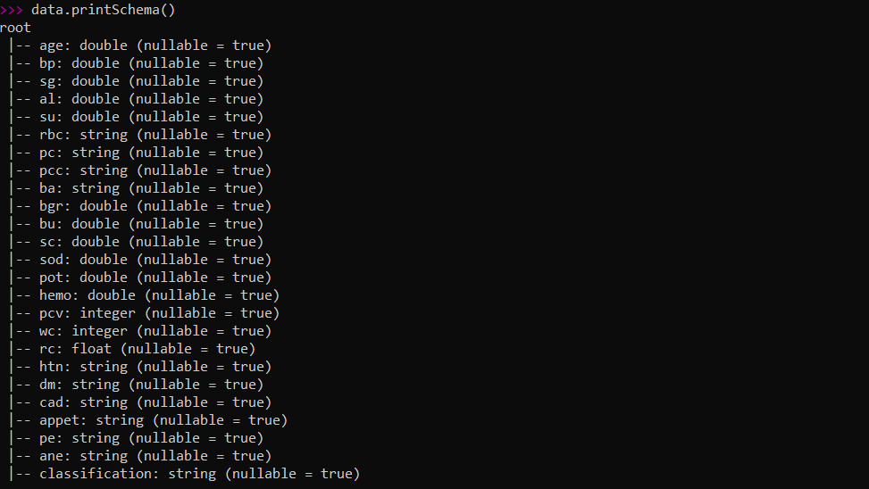
#3 Training Data Sample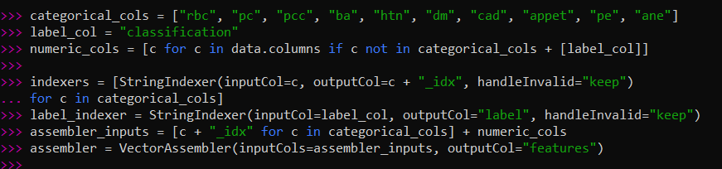
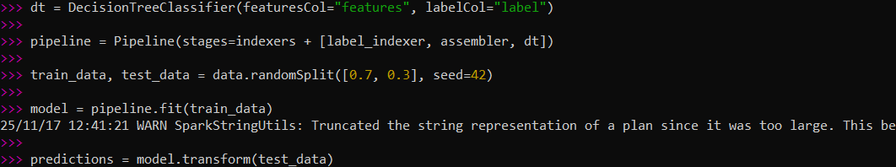

#4 Predictions(Accuracy and F1 score)
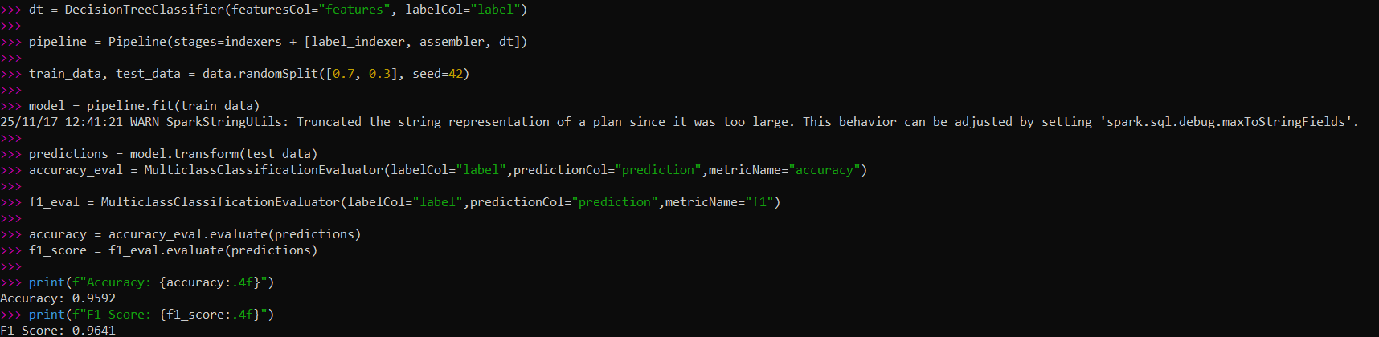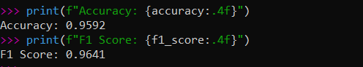

#5 Visualization
