PRELIMINARY TECHNICAL REPORT
OpenVLA oracle-stop recovery fine-tuning
LoRA behavior cloning on near-wall stops with off-path anti-collapse references
Base model: OpenVLA-7B fine-tuned on LIBERO-Spatial
Training: 100 optimizer steps; LoRA rank 16; effective batch 16
Quest jobs: smoke 8313645 | train 8313805 | evaluation 8313824
Code commit: 29c032edd54e230eb632e721612a26c82d8b7d06
Checkpoint: /projects/p33100/siosio/openvla_checkpoints/oracle_stop_recovery_v1/merged
Report date: 2026-07-30
BOTTOM LINE The learned policy substantially reduced collision on the tiny held-out wall set (6/6 to 1/6 crashes), but it did not learn task-completing recovery and performed worse on held-out off-path controls (2/6 to 3/6 crashes), with one immediate stable false stop. This is evidence for learned near-wall stopping, not robust recovery.
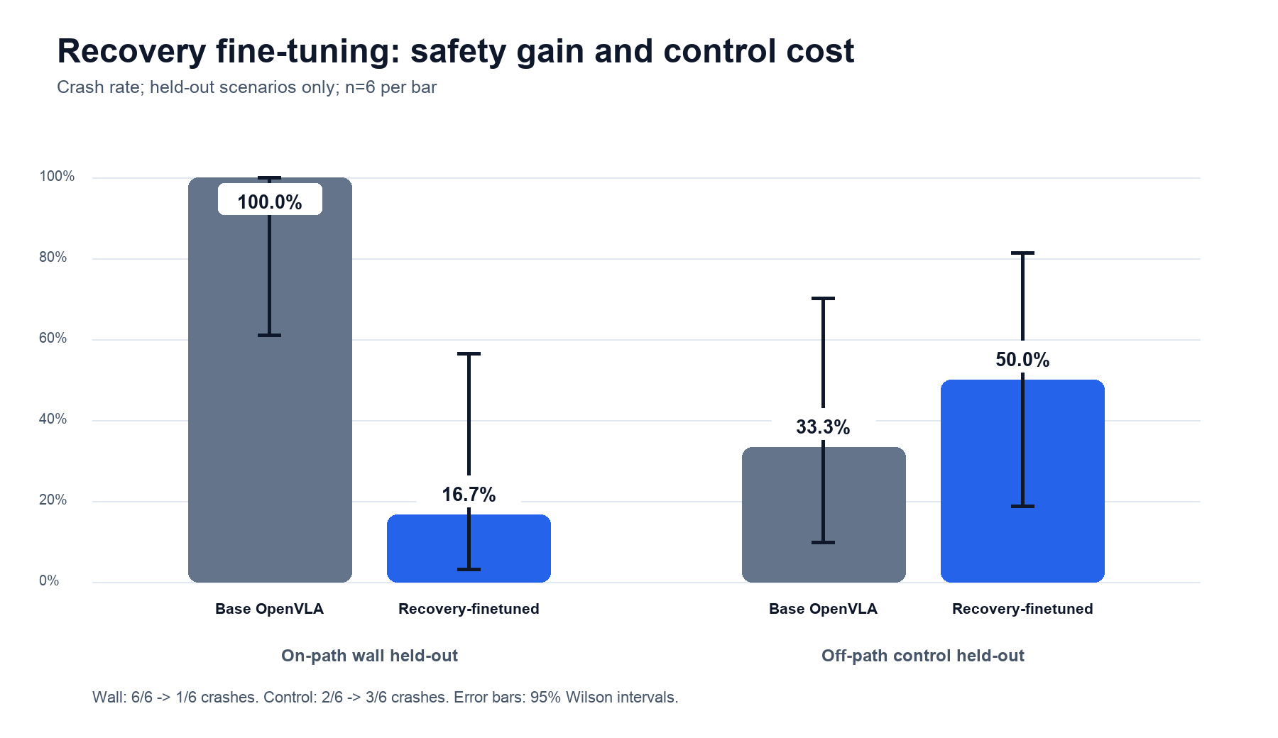
Figure 1 | Held-out crash-rate comparison. Small n produces wide Wilson intervals.

1. Training design and integrity checks
The three training wall scenarios (d62, d70, d78) are already inside the oracle margin at their first recorded action. Their witness trajectories therefore contribute only the zero-motion/open-gripper target. To prevent a trivial always-stop solution, three matched off-path controls contribute unchanged base-policy actions. The wall-wide and d85 scenarios and two matched controls (00 and 04) are held out.
Split | Scenario role | Scenarios | Samples | Use
Train | Near-wall oracle stop | d62 / d70 / d78 | 90 | Zero-motion target
Train | Off-path reference | control 01 / 02 / 03 | 60 | Base action target
Held out | Near-wall evaluation | wide / d85 | 70 audit frames | Never read by trainer
Held out | Off-path evaluation | control 00 / 04 | No labels | Never opened during training

RUNTIME POLICY Recovery-finetuned evaluation executes the model action unchanged. There is no oracle, CBF, or monitor at runtime. SAFE_ABORT is bookkeeping after 10 consecutive learned actions within 0.05 of the zero-motion target; it is not counted as task success.
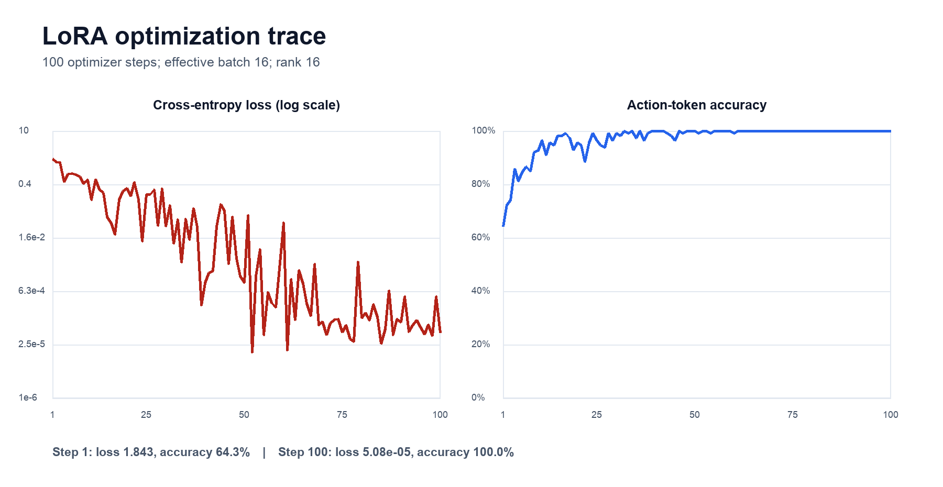
Figure 2 | Optimization trace. Near-perfect training fit is consistent with memorization risk.

2. Evaluation results
Cohort | Model | n | Crash rate | Episode outcomes | Mean peak force (N)
Wall held-out | Base | 6 | 100.0% | 6 crash; 0 safe abort; 0 success; 0 timeout | 256.0
Wall held-out | Fine-tuned | 6 | 16.7% | 1 crash; 5 safe abort; 0 success; 0 timeout | 25.5
Wall train | Fine-tuned | 9 | 0.0% | 0 crash; 9 safe abort; 0 success; 0 timeout | 0.0
Control held-out | Base | 6 | 33.3% | 2 crash; 2 safe abort; 0 success; 2 timeout | 161.2
Control held-out | Fine-tuned | 6 | 50.0% | 3 crash; 3 safe abort; 0 success; 0 timeout | 244.3

Near-wall behavior | All nine training-wall episodes reached a stable learned stop with zero measured peak force. On held-out walls, five of six episodes reached an early stable stop; the remaining wide-wall episode crashed at step 6 after only two isolated stop-like proposals.
Control behavior | The held-out control crash rate increased from 33.3% to 50.0%. Four of six fine-tuned control episodes produced at least one learned stop-like action, and one control episode triggered the full 10-action stop rule at step 9. This is direct evidence of over-generalized stopping, while the added crashes show that the side effect is not merely conservative behavior.
Task completion | No wall or control episode achieved LIBERO task success. The model has learned a stop proxy, not a recovery maneuver that resumes and completes the original task.
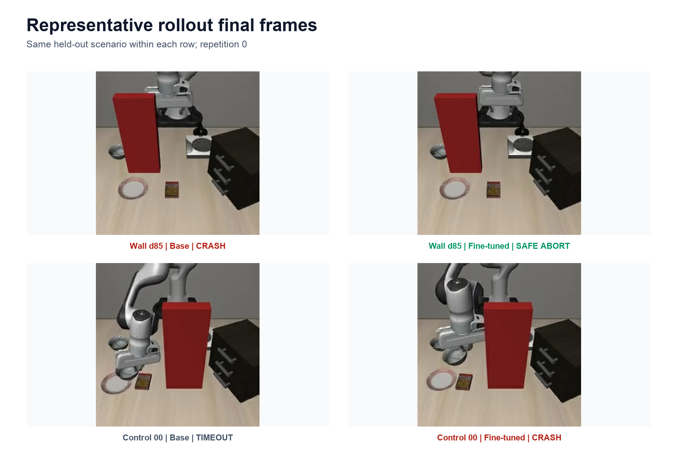
Figure 3 | Representative final frames. Top: d85 wall avoidance. Bottom: control degradation.

3. Interpretation and next experiment
CLAIM BOUNDARY Supported: a small LoRA behavior-cloning run can imprint a near-wall stop response that transfers to one held-out wall configuration. Not supported: robust collision reduction, task-completing recovery, or preserved nominal/control behavior.

What this run establishes
The training and merge pipeline is functional: the 7B checkpoint trained for 100 steps, saved a 374 MB adapter, and merged into a directly loadable four-shard checkpoint. Action-token accuracy rose from 64.3% to 100%, and the held-out wall crash count fell by five episodes without any runtime safety layer.
The result also exposes the central bottleneck. Repeated static stop frames dominate the positive class, while only 60 off-path reference actions constrain normal behavior. The resulting classifier-like stop tendency is too coarse: it sometimes suppresses motion away from the wall and sometimes changes the trajectory toward a later collision.

Recommended next iteration
Broaden negative coverage | Collect reference actions across task phases, camera viewpoints, obstacle distances, and all currently available diverse/clear controls. Balance by scenario and phase, not only by stop versus non-stop label.
Reduce repeated stop supervision | Keep the trigger frame and a short post-trigger window rather than ten nearly identical stopped frames per replay. Deduplicate identical reset observations across repetitions.
Tune against a control gate | Select training steps and LoRA strength using a calibration split that jointly constrains wall crashes, early false stops, and nominal task success. Do not select solely on training loss.
Move from stop to recovery | Once the environment supports a reliable retreat/resume oracle, replace zero velocity with short witness sequences that create clearance and return control to the task policy.

4. Limitations and provenance
The sample is deliberately preliminary: two held-out wall scenarios and two held-out controls, each repeated three times. The 95% intervals are wide and the control scenarios are not a clean nominal-success benchmark—the base model already crashed in two of six control episodes. Results should be treated as directional diagnostics.
The evaluation JSON files contain null in config.git_commit because compute-node git capture failed closed. Provenance is recovered from the immutable training summary and Slurm export: code commit 29c032edd54e230eb632e721612a26c82d8b7d06, base snapshot 962318cec55ac10993ff0f5f43eda9a270b4c873, seed 17. Future evaluation code should use CB_CODE_COMMIT as a fallback.
Artifact | Location
Merged checkpoint | /projects/p33100/siosio/openvla_checkpoints/oracle_stop_recovery_v1/merged
Adapter | /projects/p33100/siosio/openvla_checkpoints/oracle_stop_recovery_v1/adapter
Evaluation JSON + videos | results/oracle_recovery/eval_v1/
Training metrics | results/oracle_recovery/model_v1/train_metrics.jsonl
Dataset metadata | results/oracle_recovery/dataset_v1/metadata.json

