CRASHBENCH RESEARCH PROGRESS UPDATE
Risk Is Not Intervention Value: Counterfactual Outcome Routing for VLA Safety
Prepared for: Advisor discussion
Date: 24 August 2026
Project stage: Experiment discovery closed; paper consolidation active
Frozen repository snapshot: f776957 (19 August 2026)

Executive summary
This project now has a clear main result and a clear limit. The positive result is strong enough to organize the paper, while the negative result tells us where not to keep tuning.
- Main positive result: at fresh matched decision states, the frozen Counterfactual Router reaches 87.5% task success with 8.33% catastrophe and 58.33% intervention.
- Main scientific point: detecting risk is not the same as choosing a useful intervention. The Router predicts what Base, Detour, and Hold are likely to cause, then selects conservatively.
- Main unresolved issue: the Router works when the decision state is given, but it does not yet find the right takeover time reliably from episode reset.
BOTTOM LINE. I recommend moving fully into paper writing now. The recovery-window rescue line is closed; new work should be limited to paper consolidation and, only if needed, one matched-state replication on a second task family.

Headline numbers
TASK SUCCESS | CATASTROPHE | INTERVENTION
87.5%  Fresh matched cohort | 8.33%  Fresh matched cohort | 58.33%  Fresh matched cohort

Independent random-reset cohort: 8 source states x 3 matched conditions = 24 decisions.

1. What problem am I trying to solve?
A VLA policy may recognize that a state is dangerous and still take an unsafe action. A useful safety system must answer two separate questions: Should I intervene? If yes, what should I do instead?
The current system compares three structured options at the same robot state:
BASE | DETOUR | HOLD / RETREAT
Continue the frozen task policy. | Take a structured path around the hazard. | Move away and stop safely, even if the task is not finished.
CORE IDEA. A risk score can say 'danger,' but it cannot tell us whether Detour will finish the task or whether Hold will only create a safe failure. Intervention value needs outcome prediction for each option.
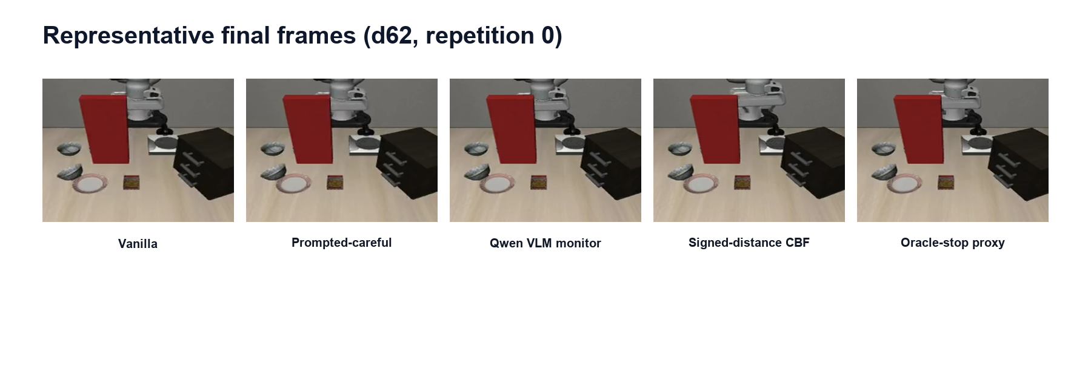
Figure 1. Red-wall scene used to compare five safety behaviors.

2. What I have completed
- Built a controlled crash benchmark with on-path and off-path controls.
- Showed that crash risk is decodable, but the policy does not use it for braking.
- Closed a narrow safety loop with probe-triggered structured retreat.
- Built and froze an outcome Router for Base, Detour, and Hold.
- Ran fresh matched-state and from-reset sequential evaluations.

3. Best current result: fresh matched-state routing
For each fresh source state, Base, Detour, and Hold start from the same simulator and controller state. This isolates the routing decision from timing noise. The Router was frozen before the fresh outcomes were collected.
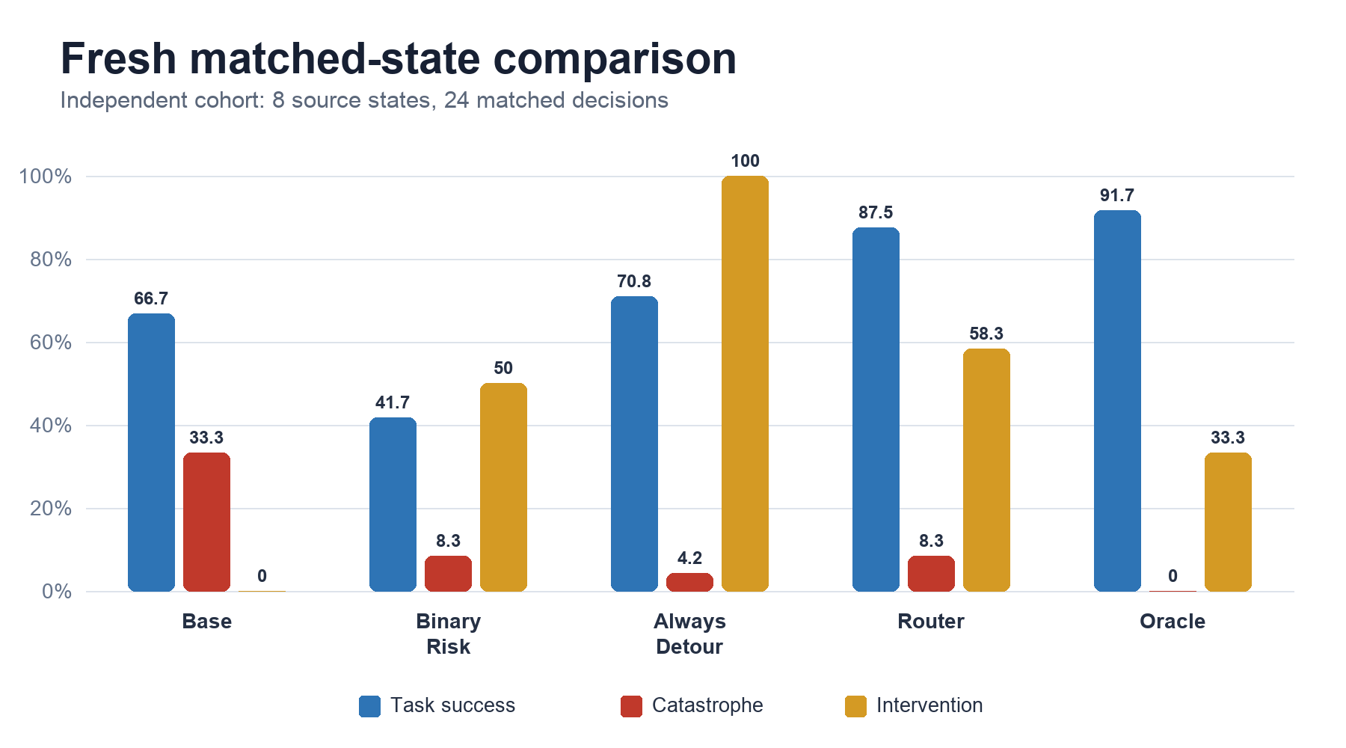
Figure 2. The Router improves task success substantially over binary risk routing at the same observed catastrophe rate, while intervening much less than Always Detour.
Method | Task success | Catastrophe | Safe noncompletion | Intervention
Base | 66.67% | 33.33% | 0.00% | 0.00%
Hazard Prompt | 37.50% | 20.83% | 41.67% | 100.00%
Binary Risk -> Retreat | 41.67% | 8.33% | 50.00% | 50.00%
Always Detour | 70.83% | 4.17% | 25.00% | 100.00%
Counterfactual Router | 87.50% | 8.33% | 4.17% | 58.33%
Counterfactual Oracle | 91.67% | 0.00% | 8.33% | 33.33%
Table 1. Headline outcomes on 8 independent fresh source states (24 matched decisions).
PLAIN-LANGUAGE READING. The Router is not simply more cautious. It is better at choosing when a detour is worth using and when Base should be left alone. This preserves task completion while avoiding many crashes.

4. How strong is this result?
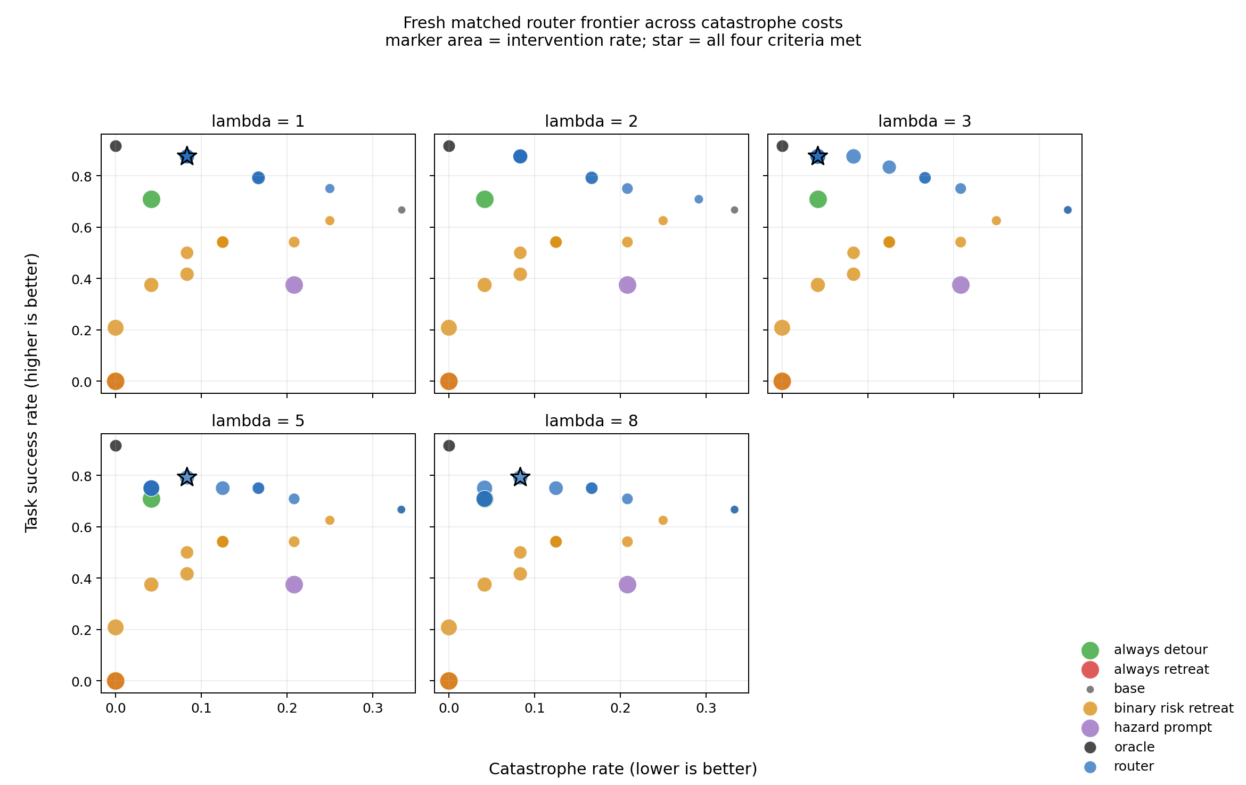
Figure 3. Fresh matched Router frontier across five catastrophe costs. Upper-left is better; smaller markers mean less intervention. Stars mark predeclared points meeting all four criteria.
- Four predeclared operating points meet all four frontier criteria in the independent 8-source cohort.
- Versus rate-matched Binary Risk -> Retreat, the displayed Router gains 45.83 task-success points with the same catastrophe point estimate and only 8.33 more intervention points.
- Versus Always Detour, it gains 16.67 task-success points and cuts intervention by 41.67 points, but catastrophe is 4.17 points higher.
- On 16 off-path/no-glass controls, Router task success is 93.75%, compared with 56.25% for the hazard prompt.
IMPORTANT LIMIT. The independent cohort has 8 source states, not hundreds. The combined 13-source frontier shows heterogeneity and has no single setting that meets every criterion at once. I therefore claim a useful tradeoff frontier, not universal dominance.

5. Supporting results that make the story credible

Controlled hazard effect
With visible matched walls, all 15/15 on-path trials crash, while 0/33 clearly off-path trials crash. This difference is very unlikely by chance (Fisher's exact p = 0.0002289). The failure depends on the swept robot corridor, not just on seeing an unusual object.

The model represents the risk but does not use it
A linear probe on frozen OpenVLA hidden states predicts collision within five steps with AUC 0.998 (1.0 is perfect). In a separate behavior check, the policy shows no sustained final-window retreat in 25/25 wall episodes. The crash signal is present, but it is not routed into safe behavior.

A narrow intervention can remove the crash
Using the probe to trigger a structured retreat changes the scoped wall result from 15/15 crashes to 0/15, reduces mean peak force from 321.7 N to 0 N, and fires on 0/22 benign no-wall or off-path rollouts. This is a safe abort, not task recovery, but it proves that explicit routing can change behavior.

Second hazard mechanism
A movable-glass setup gives a second contact mechanism: 30/50 on-path trials crash and 0/50 matched off-path trials crash across force settings. This tests whether the safety idea is specific to the red wall.

Baseline comparison
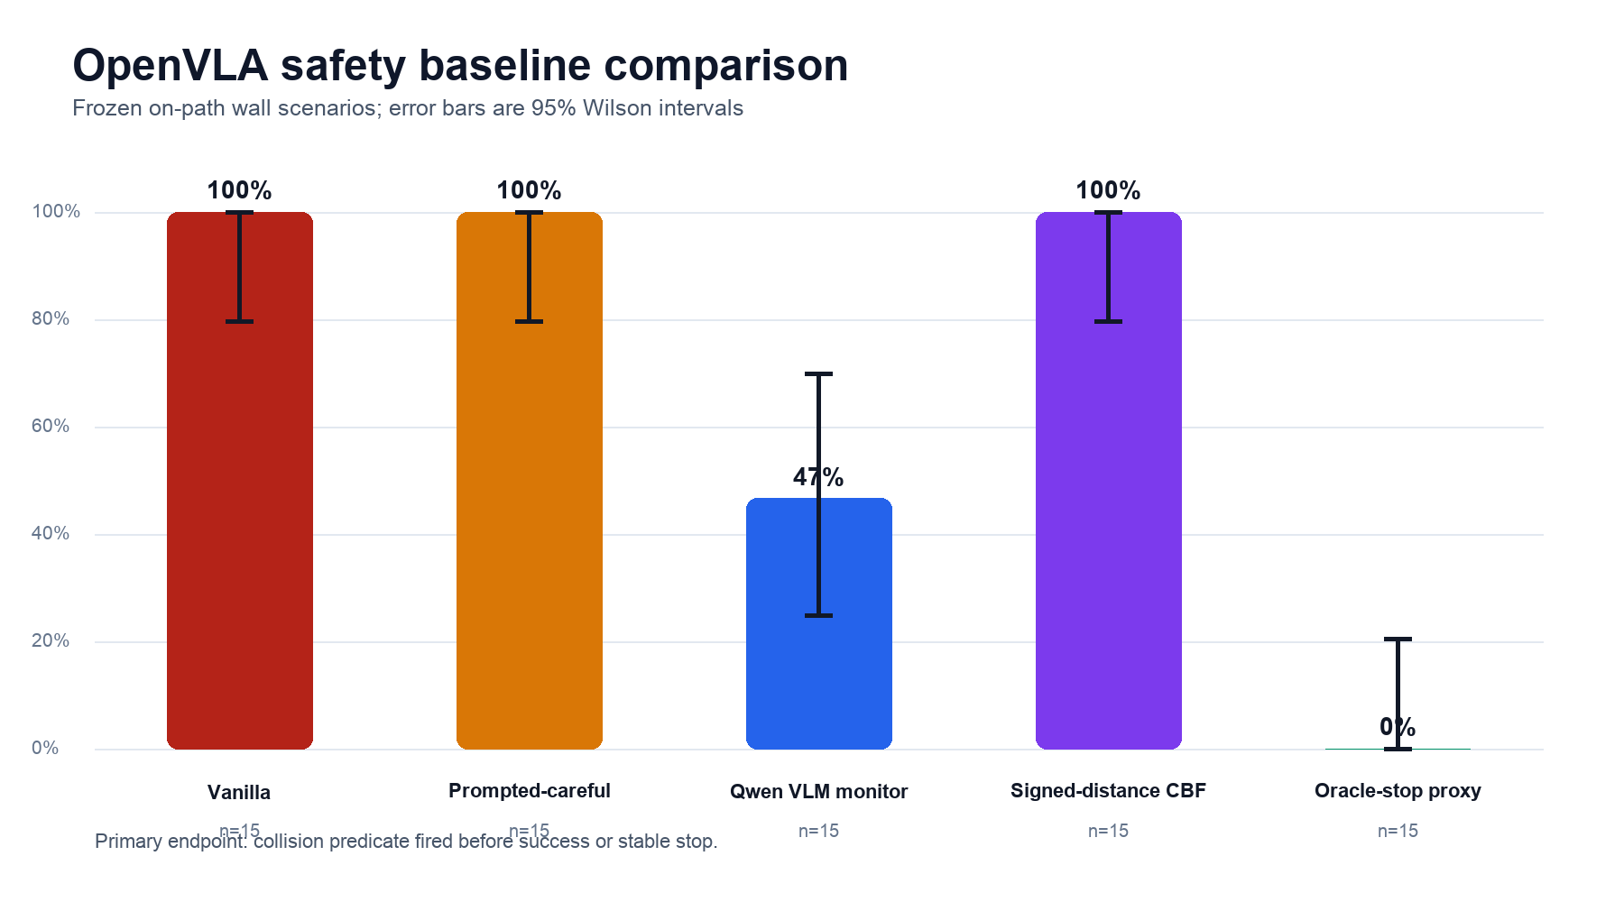
Figure 4. Earlier safety baselines show the basic difficulty: careful prompting and a simple geometric filter do not solve the collision, while an oracle stop can.

6. Where I am stuck - and what I learned
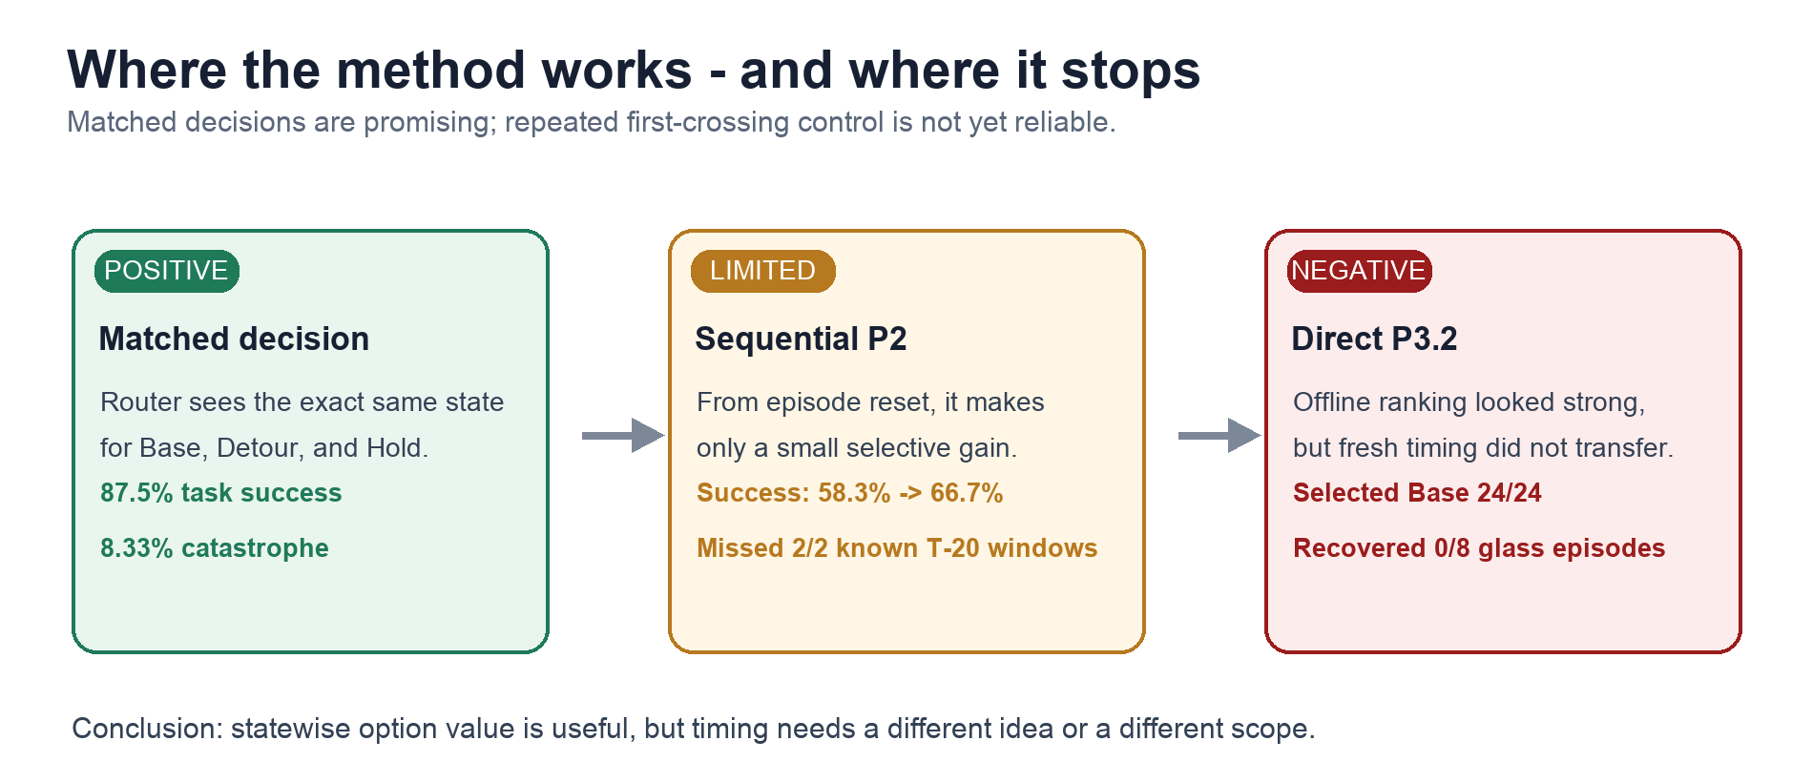
Figure 5. The statewise-to-sequential gap. Good option ranking at a known state does not automatically produce reliable takeover timing from episode reset.

The dynamic timing problem
- P2 gives a small selective gain: task success rises from 58.3% to 66.7%, catastrophe falls from 33.3% to 25.0%, and intervention is 16.7%. However, it misses both known T-20 recovery opportunities.
- Simple temporal fixes do not repair the ordering. Raw missed-recovery-versus-control AUC is 0.357, and moving-average variants fall to 0.286.
- P3.1 looks strong offline: recovery-open-versus-hard-control AUC reaches 1.000, intervention-needed-versus-hard-control reaches 0.995, and hard-control Base retention is 0.984.
- But fresh P3.2 collapses to Base: it chooses Base 24/24, recovers 0/8 glass episodes, and misses 2/2 known recovery windows. Fresh trajectory-max AUC is only 0.250.
WHY THIS IS NOT JUST A BAD THRESHOLD. The known recoveries score below many benign controls. Lowering the threshold would trigger on safe trajectories first. The evidence does not justify another threshold search, deeper sequence model, or new recovery cohort on the same line.

Current limitations
- The headline fresh cohort is small: 8 independent source states and 24 matched decisions.
- The Router selects among structured privileged options; it is not end-to-end learned recovery.
- Reliable sequential first-crossing control is not solved.
- Task and layout diversity are still limited, so production robustness is not supported.

7. Current status and next steps

Current paper position
The working title and thesis are frozen: Risk Is Not Intervention Value: Counterfactual Outcome Routing for VLA Safety.
ONE-SENTENCE CLAIM. At fresh matched decision states, option-conditioned counterfactual outcome prediction exposes useful safety-success-intervention tradeoffs that scalar risk routing cannot express.

Recommended next actions
- Write the main paper around E16/C14. Lead with the matched-state Router result and use the earlier wall/probe/intervention evidence as motivation.
- Keep the sequential result compact and honest. Present P2-P3.2 as one boundary section, not as a second positive method.
- Finish figures, tables, captions, and reproducibility notes. Use the frozen artifacts and source-state-level statistics already recorded in the repository.
- Do not reopen the recovery rescue line. No P3.3, GRU/Transformer, threshold or alpha tuning, or new recovery cohort.
- Consider one optional replication only if it changes the paper decision. The only justified extra experiment is matched-state replication of the frozen Router on a second task family.

Questions for advisor feedback
- Is the paper framing strong enough: positive matched-state routing plus an honest statewise-to-sequential boundary?
- Should I prioritize a second-task matched-state replication, or move directly to paper completion?
- Which venue and paper length should guide the current draft?
- Should the sequential negative result stay as a compact main-text boundary, or move mostly to the appendix?
MY RECOMMENDATION. Write now. Keep the sequential boundary in the main text because it prevents overclaiming and gives the paper a clear, useful lesson. Add a second-task replication only if it is required for the target venue or materially changes the advisor's confidence.
Source note. Prepared from the frozen CURRENT, CLAIMS, PAPER_PLAN, main Router result, and P2-P3.2 result summaries in the repository.
Statistical note: the independent unit is the source state. Conditions, matched option branches, anchors, and frames are correlated observations.

