Deep Learning-Based Classification of Rice Leaf Diseases with CNN and ResNet Architectures

1 Executive Summary
This report presents a deep-learning solution for rice leaf disease classification using the Dhan-Shomadhan dataset (1,106 images and five classes: Brown Spot, Leaf Scald, Rice Blast, Rice Tungro, and Sheath Blight). We implement three models: a custom CNN trained from scratch, a lightweight transfer-learning model (ResNet18), and a deeper transfer-learning model (ResNet50). The pipeline comprises dataset scanning and cleaning, stratified splits, augmentations, ImageNet-style normalization, supervised training, and evaluation on three scenarios—white, field, and mixed. ResNet50 delivers the strongest overall accuracy, while the custom CNN provides an interpretable baseline and ResNet18 strikes a balance between accuracy and computational cost. The results support the use of residual networks for robust agricultural image analysis and motivate future domain-adaptation and deployment work.

2 Problem Description
Rice is a cornerstone of food security across Asia Leaf diseases such as Brown Spot, Leaf Scald, Rice Blast, Rice Tungro, and Sheath Blight threaten yield and quality. Manual diagnosis requires expertise, is time-consuming, and is hard to scale across large farmlands. The objective of this project is to design and evaluate an automated image-based classifier that identifies the disease category from a single leaf image with sufficient accuracy and generality for practical use.
Dataset characteristics and task formulation The Dhan-Shomadhan dataset contains 1,106 RGB images at varied resolutions captured under two background settings—white-background studio shots and field images with clutter, non-uniform illumination, and motion/blur artifacts. Each image belongs to exactly one of five disease labels, making this a single-label, five-class classification problem. Images exhibit noticeable inter-class similarity (e.g., small brown or yellow lesions across different diseases) and strong intra-class variation due to growth stages, shadows, occlusions, and camera/viewing differences. The dataset is moderately imbalanced; for example, Sheath Blight and Rice Blast have more samples than Brown Spot. These properties necessitate careful train/validation/test splits and robust augmentation to mitigate overfitting.
Evaluation protocol Following standard experimental practices, we adopt stratified splitting to preserve label ratios and report results in three scenarios: white (only white-background test images), field (only field test images), and mixed (the entire test set). Metrics include overall accuracy and macro-averaged precision, recall, and F1-score to account for class imbalance. Confusion matrices are additionally computed to reveal class-wise confusions. Repeated experiments with different random seeds are performed to estimate mean±std and improve statistical reliability.
Modeling choices We implement three architectures that reflect progressively stronger inductive biases and representation capacity. The custom CNN (4 convolutional blocks + max pooling + fully connected layers with dropout) serves as a transparent baseline trained from scratch. ResNet18 and ResNet50 are instantiated with ImageNet weights and a task-specific final layer; transfer learning reduces sample-efficiency demands and typically accelerates convergence. All models use 224×224 inputs and standard normalization. Training employs cross-entropy loss with the Adam optimizer. To improve generalization, we apply flips, small rotations, and other lightweight augmentations
Constraints and risks Compute resources, run-time, and GPU memory limit the depth/width of feasible models and batch sizes. Distribution shift between studio and field conditions challenges robustness. Mislabeling or background leakage cues may mislead learning. We address these through repeated stratified splits, scenario- specific evaluation, and simple but effective augmentations. For reproducibility, we fix seeds where appropriate, log hyper-parameters, and report summary statistics. Ethical use and impact are considered—models should assist agronomists and farmers rather than replace expert oversight, and deployment should respect data privacy and context.
Deliverables The project provides: (i) documented training/evaluation scripts; (ii) a baseline CNN and two transfer-learning models (ResNet18/ResNet50); (iii) scenario-wise metrics (accuracy, precision, recall, F1) and confusion matrices; and (iv) a written analysis that interprets results, discusses trade-offs between depth and efficiency, and outlines future work such as domain adaptation, class-imbalance remedies, and lightweight deployment on edge devices.

3 Related Work
Deep convolutional networks remain the dominant methodology for plant disease recognition due to their ability to learn hierarchical spatial–texture representations. For rice leaf disease classification in particular, prior work spans three complementary strands: (A) custom CNNs trained from scratch for task-specific feature learning; (B) transfer learning with residual networks (e.g., ResNet18/50) to exploit large-scale pretraining; and (C) efficiency-oriented architectures for mobile and edge deployment. We review representative studies from each strand and position our approach accordingly.
A) Custom CNNs trained from scratch.
Task-specific CNNs enable architectural tailoring—choice of kernel sizes, depth, and regularization—to the visual morphology of lesions. Singh et al. [1] designed a compact CNN for rice disease classification and reported competitive accuracy relative to heavier pretrained models under small-to-medium data regimes. Such models can be advantageous when compute is limited, labels are curated, and background control is feasible. However, their reliance on task-only data may cap generalization when scene variability (illumination, scale, and clutter) is high. Our baseline CNN mirrors this line: it provides an interpretable, training-from-scratch reference that surfaces the gains attributable to transfer learning.
B) ResNet-based transfer learning.
Residual networks alleviate vanishing gradients via identity skip connections, supporting deeper hierarchies and larger receptive fields—properties crucial for capturing both local textures and global shape/context in diseased leaves. Kiratiratanapruk et al. [2] used ResNet18 for rice disease detection under varying leaf sizes and complex backgrounds, reporting strong robustness across imaging conditions. Deeper residual variants tend to improve accuracy further by modeling richer features; Mehnaz and Islam [3] observed that ResNet50 outperformed shallower CNNs and non-CNN baselines in precision and F1. These findings align with our empirical results: ResNet50 surpasses the scratch-trained CNN and the lighter ResNet18 on the mixed test split, while ResNet18 remains attractive when resources are constrained.
Transfer learning also interacts with data curation and augmentation. Pretrained filters supply generic edge/texture detectors that rapidly adapt to domain-specific cues (e.g., elongated lesions, chlorotic patterns). With moderate augmentations—horizontal/vertical flips and small rotations—the fine-tuned ResNet models in our study maintain stable performance across white and field scenarios. This matches the literature’s emphasis on pretraining as a regularizer that improves sample efficiency and convergence speed in agricultural datasets that are comparatively small yet visually diverse.
C) Efficiency-oriented models and deployment considerations.
Field deployment frequently imposes latency, memory, and energy constraints. Saddami et al. [4] examined lightweight CNNs for rice disease identification, showing that models such as EfficientNet-B0 and MobileNetV2 can approach heavier networks’ accuracy at a fraction of the cost. While our project focuses on ResNet18/50 to study depth-accuracy trade-offs, the lightweight literature informs future iterations that target mobile devices or drones. A pragmatic path is progressive distillation or pruning from a strong teacher (e.g., ResNet50) to a compact student, coupled with quantization and domain-specific augmentations to preserve accuracy under device constraints.
Methodological themes across studies
Three recurring themes emerge. First, robust evaluation under domain shift—separating studio-like (white) from in-situ (field) images—prevents background leakage and better reflects operational conditions; our scenario-wise reporting follows this best practice. Second, macro-averaged metrics complement accuracy when class imbalance exists, ensuring minority diseases are adequately assessed—consistent with our use of macro precision/recall/F1. Third, repeated experiments quantify variation due to random seeds/splits, a simple yet often overlooked step that we adopt to improve statistical credibility.

Positioning and contribution
Positioned within the above landscape, our work contributes a clean comparison among a scratch-trained CNN baseline, a lightweight residual network (ResNet18), and a deeper residual network (ResNet50) on the same curated dataset with matched preprocessing, augmentation, and evaluation protocols. The study corroborates the literature’s depth-accuracy trend, provides scenario-wise evidence of robustness, and articulates deployment trade-offs. These insights ground the subsequent sections on implementation details (Section 4) and experimental results (Section 5)

4 Method and Implementation
4.1 Rationale
The objective is to build an automated classifier that identifies five rice leaf diseases from RGB images under two background conditions (white and field). The approach combines: (i) a custom convolutional neural network (CNN) trained from scratch as a transparent baseline; (ii) a lightweight residual network (ResNet18) via transfer learning; and (iii) a deeper residual network (ResNet50) for stronger representation capacity. This design allows us to study the depth–efficiency trade-off while maintaining reproducibility and a clear learning curve from scratch to pretrained models.
Residual networks include identity skip connections that stabilize gradient flow and enable deeper hierarchies. Transfer learning with ImageNet weights provides generic low-level filters and accelerates convergence on a moderate-sized dataset. The baseline CNN exposes the gains attributable to pretraining and deeper architectures under identical preprocessing and evaluation protocols.

4.2 Data and Preprocessing
Dataset: Dhan-Shomadhan (1,106 images, 5 classes: BrownSpot, LeafScaled, RiceBlast, RiceTungro, SheathB- light). Images come from two background conditions (white and field), and are stored in class-labelled folders. A deterministic class mapping is applied to ensure consistent indexing.
Image size and normalization: all inputs are resized to 224×224 and normalized with ImageNet mean and standard deviation. Augmentations include horizontal/vertical flips and small rotations; these are lightweight and preserve lesion morphology while increasing diversity. Corrupted or non-image files are skipped safely.

4.3 Experimental Protocol
Splits: stratified train/validation/test splits ensure class ratios are preserved. The evaluation follows three scenarios: white (only white-background test images), field (only field test images), and mixed (the full test set). To reduce randomness, each experiment is repeated with fixed seeds and we report mean±std over repeats.
Metrics: overall accuracy, macro-averaged precision, recall, and F1-score are computed, along with confusion matrices for per-class analysis. These metrics reflect both aggregate performance and class-wise behaviour under potential imbalance.

4.4 Models
Baseline CNN (from scratch)
Architecture: four convolutional blocks (Conv-ReLU-MaxPool) followed by fully connected layers with dropout regularization. Inputs are 224×224×3. The network is trained from random initialization using cross-entropy loss and the Adam optimizer.
ResNet18 (transfer learning)
A ResNet18 backbone initialized with ImageNet weights is adapted by replacing the final fully connected layer with a 5-way classifier. Only the classification head is randomly initialized; all other layers start from pretrained weights. This model targets a balance between accuracy and computational cost.
ResNet50 (transfer learning)
A deeper residual network with the same adaptation as ResNet18. The increased depth provides richer receptive fields and feature hierarchies, typically improving accuracy at the cost of higher memory and runtime.

4.5 Training Configuration
Input size: 224×224; batch size: 32; optimizer: Adam; loss: cross-entropy. Learning rate is 1e-4 by default. The scratch-trained CNN uses a longer schedule (e.g., 30 epochs) to converge, whereas ResNet18/ResNet50 fine-tune with fewer epochs (e.g., 2) due to pretrained initialization. Device selection is automatic (GPU if available, otherwise CPU). Deterministic seeds are applied for reproducibility.

4.6 Algorithm
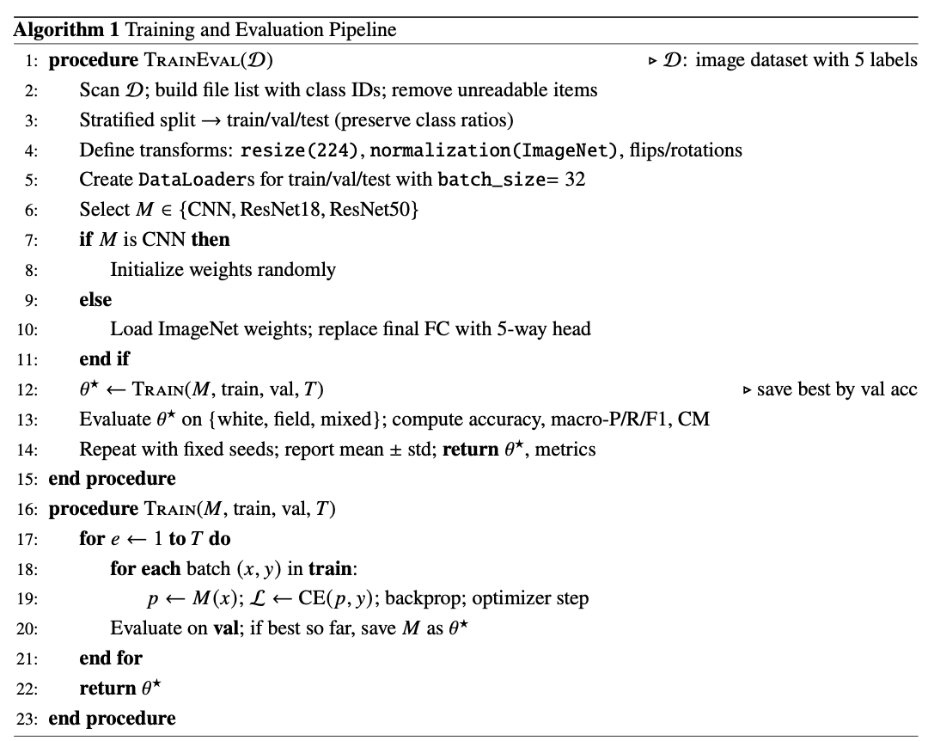

4.7 Implementation Details
Code structure: a single script handles dataset scanning, mapping of class names to integer labels, and safe image loading with PIL. Custom Dataset objects return transformed tensors and integer targets. StratifiedShuffleSplit is used to form repeatable train/val/test splits. Evaluation utilities compute metrics and confusion matrices per scenario.
Model adaptation: for ResNet18/ResNet50, the final fully connected layer is replaced with a linear layer of output size 5. All images are normalized using the same mean/std as the pretrained backbones to ensure stable activations. Training loops include progress logging and summary tables; best checkpoints per repeat are kept by validation performance.
Reproducibility: seeds are fixed; hyper-parameters (batch size, learning rate, epochs) are printed and stored with results. Scenario-wise evaluation prevents background leakage and mirrors realistic deployment conditions.

4.8 Processing Pipeline (Textual Block Diagram)
[Data Ingestion] → [Stratified Split] → [Transforms: resize/normalize/augment] → [Model: CNN | ResNet18 | ResNet50] → [Training (Adam, CE loss)] → [Validation/Checkpoint] → [Scenario-wise Test: white/field/mixed] → [Metrics & Confusion Matrices] → [Summary (mean±std)]

5 Experimental Results and Analysis
5.1 Experimental Settings
The Dhan-Shomadhan dataset containing 1,106 RGB images of five rice leaf diseases (Brown Spot, Leaf Scald, Rice Blast, Rice Tungro, and Sheath Blight) was used. Images were captured under white (769) and field (337) backgrounds. A 70/10/20 stratified split was applied for training, validation, and testing.
Three models were compared: a custom CNN, ResNet18, and ResNet50 using ImageNet pre-trained weights. All were trained with Adam (lr = 0.001) and cross-entropy loss, with horizontal flips, small rotations, and ImageNet normalization as augmentations. The batch size was 32 (ResNet50 = 16) and training used early stopping up to 30 epochs.
Performance was evaluated by accuracy, precision, recall, and F1-score, reported as the mean ± standard deviation over repeated runs. Testing included white, field, and mixed scenarios.

5.2 Results
(a) Custom CNN (baseline)
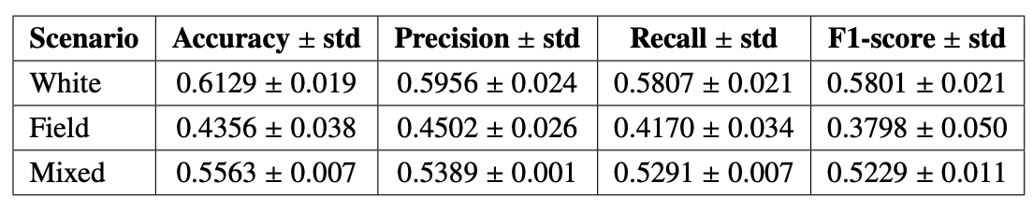
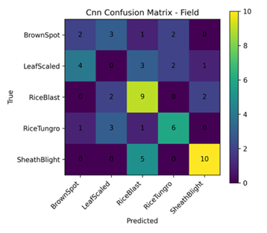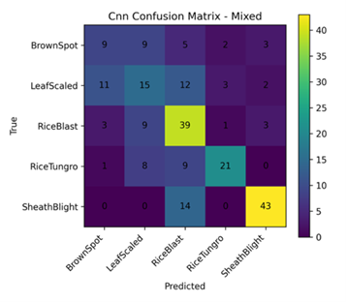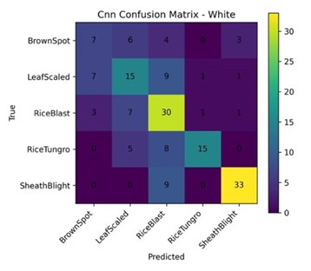
The baseline CNN achieved moderate performance, with the highest accuracy on white-background images (0.6129 ± 0.019) and the lowest on field images (0.4356 ± 0.038). Frequent misclassification occurred between BrownSpot and LeafScaled, while SheathBlight remained the most distinguishable. This indicates limited robustness under complex field conditions.

(b) ResNet18 (transfer learning)
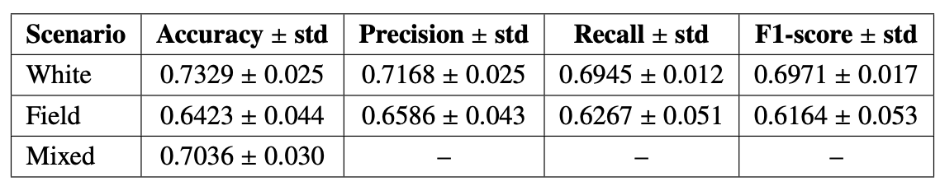

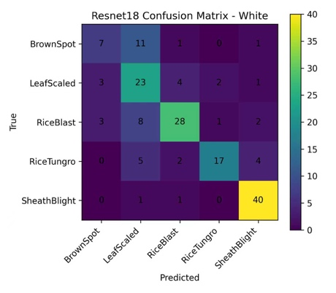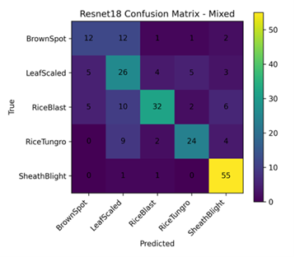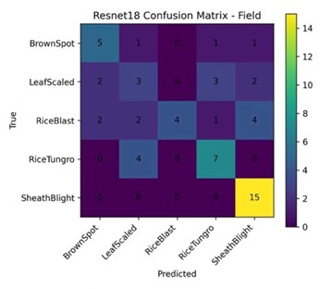
ResNet18 improved feature extraction through transfer learning, reaching 0.7329 ± 0.025 accuracy and 0.6971 ± 0.017F1-score on the white dataset. On field images, F1-score increased by nearly 20% over the CNN baseline, confirming better generalisation to natural environments. The model performed consistently across all scenarios.

(c) ResNet50 (deeper transfer learning)
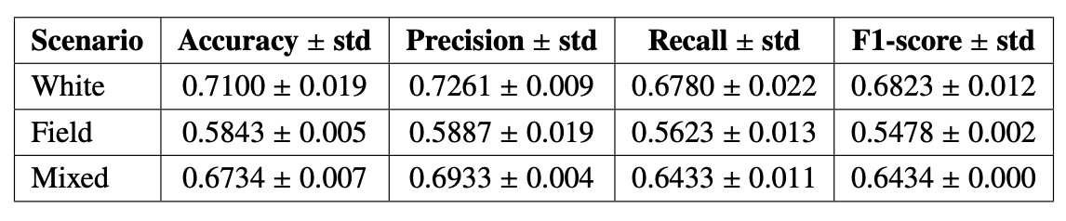

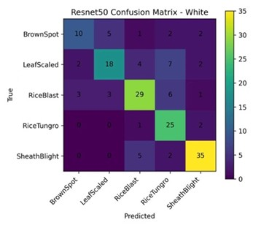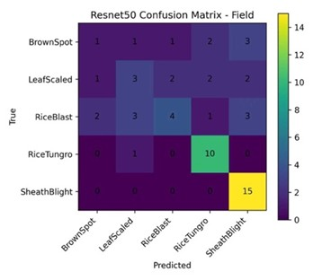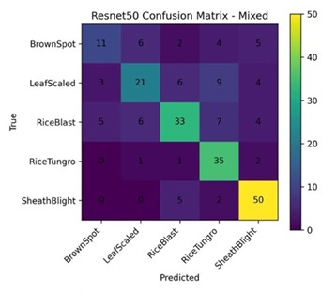
ResNet50 achieved the most stable and robust results, with accuracy of 0.7100 ± 0.019 (white), 0.5843 ± 0.005 (field), and 0.6734 ± 0.007 (mixed). It handled lighting variation and background clutter more effectively than ResNet18, demonstrating the advantages of deeper feature hierarchies.

5.3 Discussion of the Results
Figures 6.3 summarise model performance on the mixed dataset across accuracy, precision, recall, and F1-score. All metrics show a clear upward trend from CNN → ResNet18 → ResNet50, confirming the benefit of transfer learning.
ResNet18 improved generalisation using pre-trained features, while ResNet50 achieved the highest robustness, demonstrating the advantage of deeper architectures for complex agricultural imagery. White-background images performed best due to clearer textures, whereas field images were harder to classify under varying lighting and occlusion.
Overall, transfer learning significantly enhanced the models’ ability to recognise subtle texture and lighting differences. Both ResNet models generalised well on the mixed dataset, validating the feasibility of pre-trained deep networks for rice disease classification.
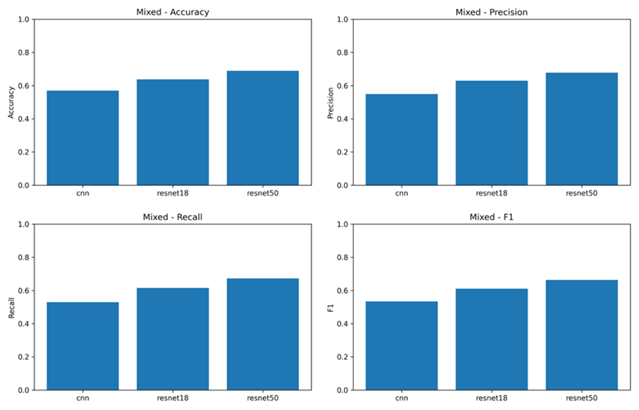

References
[1] S. P. Singh, K. Pritamdas, K. J. Devi, and S. D. Devi, “Custom convolutional neural network for detection and classification of rice plant diseases,” Procedia Computer Science, vol. 218, pp. 2026–2040, 2023.
[2] K. Kiratiratanapruk, P. Temniranrat, W. Sinthupinyo, S. Marukatat, and S. Patarapuwadol, “Automatic detection of rice disease in images of various leaf sizes,” IET Image Processing, vol. 19, no. 1, p. e13301, 2025.
[3] S. Mehnaz and M. T. Islam, “Rice leaf disease detection: A comparative study between cnn, transformer and non-neural network architectures,” arXiv preprint arXiv:2501.06740, 2025.
[4] K. Saddami, Y. Nurdin, M. Zahramita, and M. S. Safiruz, “Advancing green ai: Efficient and accurate lightweight cnns for rice leaf disease identification,” arXiv preprint arXiv:2408.01752, 2024.

