GLOBAL WATER CONSUMPTION

A Project Report

Submitted in the partial fulfillment of the
requirements for the award of the degree of

BACHELOR OF TECHNOLOGY
In

DEPARTMENT OF COMPUTER SCIENCE AND ENGINEERING

By

HANSI CHALLAGULLA - 2320030331
NALLAPARAJU NIKHIL VARMA - 2320030184
RAMAYANAM NAGA ABHIJITH - 2320030006
BANDARUPALLI BHAVIKA SREE - 2320030029

Under the Esteemed Guidance of

PRATHUSHA BONAGANI
________________________
Project Guide




K L (Deemed to be) University
DEPARTMENT OF COMPUTER SCIENCE AND ENGINEERING
Academic Year 2025-2026



Declaration

We hereby declare that the project report entitled "Global Water Consumption" is an original work carried out by the undersigned students in partial fulfillment of the requirements for the award of the Bachelor of Technology degree in Computer Science and Engineering at K L University. The work presented in this report is based on our own analysis, design, implementation, and documentation, and has not been submitted previously to any other university or institution for the award of any degree or diploma.

All references to other works are duly acknowledged in the References section, and the results embodied in this project have not been copied from any other department, university, or institution.

Hansi Challagulla - 2320030331
Nallaparaju Nikhil Varma - 2320030184
Ramayanam Naga Abhijith - 2320030006
Bandarupalli Bhavika Sree - 2320030029



K L (Deemed to be) University
DEPARTMENT OF COMPUTER SCIENCE AND ENGINEERING

Certificate

This is to certify that the project report entitled "Global Water Consumption" is a Bonafide work carried out and submitted by Hansi Challagulla -- 2320030331, Nallaparaju Nikhil Varma -- 2320030184, Ramayanam Naga Abhijith -- 2320030006, and Bandarupalli Bhavika Sree -- 2320030029, in partial fulfilment of the requirements for the award of the degree of Bachelor of Technology in Computer Science and Engineering, at K L (Deemed to be University), during the academic year 2025--2026.

Signature of the Supervisor

Signature of the HOD Signature of the External Examiner

ACKNOWLEDGEMENT

The success in this project would not have been possible but for the timely help and guidance rendered by many people. We wish to express our sincere thanks to all those who have assisted us in one way or the other for the completion of this project.

We express our sincere gratitude to our faculty guide from the Department of Computer Science and Engineering, whose tremendous support, encouragement, and guidance cannot be expressed in words.

We express our gratitude to the Head of the Department for Computer Science Engineering for providing us with adequate facilities, ways, and means by which we could complete this project.

We thank all the members of teaching and non-teaching staff who have assisted us directly or indirectly for the successful completion of this project. Finally, we sincerely thank our parents, friends, and classmates for their kind help and cooperation during our work.

Hansi Challagulla - 2320030331
Nallaparaju Nikhil Varma - 2320030184
Ramayanam Naga Abhijith - 2320030006
Bandarupalli Bhavika Sree - 2320030029

TABLE OF CONTENTS
S.No | Contents | Page no
1 | Abstract | 6
2 | Introduction | 7
3 | Existing Solutions and Problems | 9
4 | Proposed Solution | 11
5 | Methodology | 12
6 | Hardware and Software Requirements | 13
7 | Implementation | 15
8 | Experimentation and SQL Queries | 17
9 | Results and Dashboard Output | 20
10 | Conclusion | 22
11 | References | 23

ABSTRACT
Water resources are essential for economic activity, agriculture, domestic life, and environmental sustainability. However, rising demand, climate variability, and unequal regional availability have made water management a major global concern. This project presents a data-driven analysis of global water consumption using a centralized dataset and interactive business intelligence dashboards. The system is designed to compare water usage across countries, identify sector-wise patterns, and highlight water scarcity conditions using structured query processing and visual analytics.

The project uses SQL queries to aggregate and analyse water consumption indicators such as total consumption, per-capita usage, sector-wise usage, groundwater depletion, rainfall impact, and scarcity level distribution. The processed data is then visualized in an interactive dashboard that supports country-based filtering and year-wise trend exploration. By converting raw data into meaningful graphs and comparative views, the project helps users understand differences in agricultural, industrial, and household water use across countries.

Overall, the project demonstrates how database querying and dashboard-based analytics can support awareness, academic analysis, and decision-making in sustainability-oriented problems.

INTRODUCTION
Global water consumption has increased significantly due to population growth, industrial expansion, urbanization, and agricultural demand. Analysing this data manually is difficult because water-related indicators vary across years, countries, and sectors. A structured analytical approach is therefore required to compare usage patterns and interpret them effectively.

This project focuses on building a comparative analysis system for global water consumption data. The core objectives are to store water-related attributes in a database, extract insights using SQL queries, and present the findings through an interactive dashboard. The analysis emphasizes total water consumption by country, per-capita water use, sector-wise water distribution, groundwater depletion, rainfall influence, and water scarcity levels.

The project serves as an educational and analytical model that shows how databases and visualization tools can be used together to address sustainability challenges.

Problem Description and Objectives
Traditional approaches to water usage analysis rely on spreadsheets or static reports. These methods are often difficult to scale, do not provide dynamic filtering, and make comparative analysis across multiple countries time-consuming. Static charts also limit the ability to explore trends over time or evaluate relationships among multiple water indicators at once.

The main objectives of this project are:
- Store large water consumption datasets using SQL-based relational databases
- Perform data analysis using structured SQL queries to extract meaningful insights
- Identify water consumption patterns such as sector-wise and country-wise trends
- Detect high water stress regions and scarcity patterns
- Visualize results using interactive dashboards with charts and slicers
- Support decision-making through clear and interpretable data presentation

EXISTING SOLUTIONS AND PROBLEMS
Most traditional approaches to water usage analysis rely on spreadsheets or static reports. These methods are often difficult to scale, do not provide dynamic filtering, and make comparative analysis across multiple countries time-consuming. Static charts also limit the ability to explore trends over time or evaluate relationships among multiple water indicators at once.

Another common issue is that sector-wise and country-wise comparisons are often presented separately, which makes interpretation harder. Many basic systems also fail to integrate database querying with dashboard visualization, resulting in poor interactivity and limited support for exploratory analysis.

Key Limitations of Existing Approaches
- Limited scalability for large, multi-country datasets
- No dynamic filtering or real-time exploration
- Sector-wise and country-wise data presented in isolation
- Lack of integration between database querying and visual reporting
- Static charts with poor interactivity
- Time-consuming manual analysis across multiple indicators

PROPOSED SOLUTION
The proposed solution stores the water consumption dataset in a structured database and uses SQL to retrieve analytical views required for reporting. A dashboard is then used to visualize the outputs with slicers, trend charts, and comparison charts. This approach enables users to filter by country, compare annual consumption, observe sector-wise distribution, and understand scarcity patterns in a single interface.

The solution improves usability, supports better comparison, and turns raw numerical values into an interpretable decision-support view.

Key Features
- Centralized SQL database for water consumption records
- Analytical queries for aggregating country-wise and sector-wise data
- Interactive Power BI dashboard with country filter slicers
- Visual trend analysis using line charts, bar charts, and pie charts
- Scarcity level distribution and groundwater depletion views
- Year-wise consumption trend exploration

METHODOLOGY
The methodology followed in this project consists of five stages. First, the water consumption dataset is collected and stored in a relational table. Second, the dataset is inspected using sample queries to validate records and understand schema quality. Third, analytical SQL queries are written to compute totals, averages, and grouped summaries. Fourth, the query results are connected to a dashboard environment to build visual reports. Finally, the dashboard is validated by using filters and checking whether the visual outputs accurately reflect the SQL-based aggregations.

This workflow ensures that both the backend analysis and the frontend visualization remain consistent and reliable.

Stage-wise Breakdown
- Dataset collection and storage in relational database table WaterConsumption
- Schema validation using sample queries and record count checks
- Analytical SQL query development for totals, averages, and grouped summaries
- Dashboard construction with visual elements connected to query results
- Validation of visual outputs by applying filters and cross-checking against SQL results

HARDWARE AND SOFTWARE REQUIREMENTS

Hardware Specifications
A standard laptop or desktop is sufficient for implementing this project. The following specifications are recommended for smooth operation:

Processor
An Intel Core i3 processor or equivalent is the minimum requirement. An Intel Core i5 or higher is recommended for better performance and smooth multitasking, especially when running dashboard tools and SQL environments simultaneously.

RAM
A minimum of 4 GB RAM is required to run the browser, SQL server, and dashboard tools. However, 8 GB RAM or above is recommended to ensure better performance when handling large datasets.

Storage
At least 500 MB of free disk space is required for the dataset, database files, and application dependencies. For larger datasets, additional storage may be needed.

Graphics
No dedicated graphics card is required. Integrated graphics available in modern processors are sufficient for rendering dashboard visualizations.

Operating System
The project is compatible with Windows, Linux, and macOS, as the tools used are cross-platform.

Software Requirements
The project uses open-source and widely available tools for database management and visualization:

Database Environment
- Microsoft SQL Server or a compatible relational database system
- SQL Server Management Studio (SSMS) for query execution and database management

Dashboard Tool
- Microsoft Power BI Desktop -- for creating interactive visualizations, slicers, and dashboards

Development and Documentation
- Microsoft Word -- for report writing and documentation
- Web browser (Google Chrome / Microsoft Edge) -- for accessing online references

Dataset Attributes Used
Key columns in the WaterConsumption dataset include: Country, Year, Total_Water_Consumption_Billion_Cubic_Meters, Per_Capita_Water_Use_Liters_per_Day, Agricultural_Water_Use, Industrial_Water_Use, Household_Water_Use, Groundwater_Depletion_Rate, Rainfall_Impact_Annual_Precipitation_in_mm, and Water_Scarcity_Level.

IMPLEMENTATION
The implementation begins with loading the water consumption dataset into the database table WaterConsumption. Initial inspection queries such as record count and sample row retrieval are used to verify the table contents. After validation, aggregation queries are written to calculate country-wise totals, average per-capita use, average sector-wise usage, depletion rates, scarcity distribution, and rainfall-consumption relationships.

These SQL outputs are connected to an interactive dashboard. In the dashboard, bar charts are used for total and sector-wise comparison, a line chart is used for trend analysis over time, and a pie chart is used to represent scarcity-level distribution. A country slicer is added to allow dynamic filtering so that users can focus on a selected country and observe how all visual elements change together.

1. Data Representation and Dataset Description
The dataset used in this project consists of water consumption records representing real-world data from multiple countries across different years. Each record contains the following key attributes:
- Country -- Name of the country
- Year -- Year of the record
- Total_Water_Consumption_Billion_Cubic_Meters -- Total water used in BCM
- Per_Capita_Water_Use_Liters_per_Day -- Per person daily water usage
- Agricultural_Water_Use -- Percentage of water used in agriculture
- Industrial_Water_Use -- Percentage used in industry
- Household_Water_Use -- Percentage used in households
- Groundwater_Depletion_Rate -- Rate of groundwater depletion
- Rainfall_Impact_Annual_Precipitation_in_mm -- Annual rainfall in mm
- Water_Scarcity_Level -- Categorical scarcity classification (Low/Medium/High/Extreme)

2. Database Environment Setup
The relational database is created in Microsoft SQL Server. The WaterConsumption table is set up with appropriate column data types to store all dataset attributes. The dataset is imported as structured records and validated using initial inspection queries.

3. SQL Query Development and Preprocessing
Preprocessing and analysis operations are performed entirely in SQL. The following operations are carried out:
- Counting total records for data validation
- Sampling rows to inspect schema quality
- Computing country-wise total and average consumption
- Aggregating per-capita water use by country
- Calculating average sector-wise usage for agriculture, industry, and households
- Identifying groundwater depletion trends
- Grouping scarcity level distribution by country
- Correlating rainfall with total water consumption

4. Dashboard Development
The SQL query results are connected to Microsoft Power BI to build the interactive dashboard. The dashboard includes the following visual components:
- Bar charts showing total and sector-wise water consumption by country
- Line chart for year-wise trend analysis of water consumption
- Pie chart representing water scarcity level distribution
- Country filter slicer for dynamic exploration
These visual representations help in better understanding of data trends and support decision-making for water resource management.

EXPERIMENTATION AND SQL QUERIES
The project was experimentally validated by executing a series of SQL queries on the WaterConsumption table and then mapping the results into dashboard visuals. The following queries were used as the analytical core of the project.

Code Structure
The project analysis was implemented using SQL in Microsoft SQL Server. The query structure consists of the following main parts:
- Data Inspection: Record count and sample retrieval queries
- Aggregation Queries: Country-wise and sector-wise summaries
- Scarcity Analysis: Scarcity level distribution grouped by country
- Rainfall Correlation: Linking rainfall data with total consumption
- Dashboard Binding: Query outputs connected to Power BI visuals

SQL Queries Used

-- Record count
SELECT COUNT(*) FROM WaterConsumption;
SELECT TOP 10 * FROM WaterConsumption;
SELECT TOP 1 * FROM WaterConsumption;

-- Country-wise total consumption
SELECT Country,
SUM(Total_Water_Consumption_Billion_Cubic_Meters) AS TotalConsumption
FROM WaterConsumption
GROUP BY Country
ORDER BY TotalConsumption DESC;

-- Per-capita usage by country
SELECT Country,
AVG(Per_Capita_Water_Use_Liters_per_Day) AS AvgPerCapitaUse
FROM WaterConsumption
GROUP BY Country
ORDER BY AvgPerCapitaUse DESC;

-- Sector-wise usage
SELECT Country,
AVG(Agricultural_Water_Use) AS AvgAgri,
AVG(Industrial_Water_Use) AS AvgIndustrial,
AVG(Household_Water_Use) AS AvgHousehold
FROM WaterConsumption
GROUP BY Country;

-- Groundwater depletion
SELECT Country,
AVG(Groundwater_Depletion_Rate) AS AvgDepletion
FROM WaterConsumption
GROUP BY Country
ORDER BY AvgDepletion DESC;

-- Scarcity level distribution
SELECT Country, Water_Scarcity_Level, COUNT(*) AS Records
FROM WaterConsumption
GROUP BY Country, Water_Scarcity_Level
ORDER BY Country;

-- Rainfall vs consumption correlation
SELECT Country,
AVG(Rainfall_Impact_Annual_Precipitation_in_mm) AS AvgRainfall,
AVG(Total_Water_Consumption_Billion_Cubic_Meters) AS AvgConsumption
FROM WaterConsumption
GROUP BY Country;

Steps Performed
- Loaded global water consumption dataset into the WaterConsumption table in SQL Server
- Performed data inspection and validation using record count and sample queries
- Analysed water consumption patterns including total, per-capita, and sector-wise usage
- Identified high groundwater depletion and water scarcity regions
- Correlated rainfall data with water consumption for environmental insights
- Visualized all results using interactive Power BI dashboards

Performance Analysis
- Processing Speed: Efficient SQL-based aggregation for quick result generation
- Scalability: Relational database structure supports growing datasets
- Accuracy: SQL grouping and aggregation functions provide precise results
- Interactivity: Power BI slicers enable real-time filtering without re-running queries

Conclusion of Experimentation
The experimentation proved that SQL-based analytics integrated with Power BI dashboards is efficient and reliable for global water consumption analysis. The system successfully identified consumption patterns, scarcity distributions, and sector-wise trends. The results demonstrate that structured query processing combined with interactive visualization provides better scalability, performance, and flexibility compared to traditional spreadsheet-based approaches.

RESULTS AND DASHBOARD OUTPUT
The implementation of the Global Water Consumption analysis system produced meaningful results that demonstrate the effectiveness of SQL-based analytics and dashboard visualization in handling large water consumption datasets. The project successfully analysed consumption data across multiple countries and years, enabling efficient pattern detection, sector-wise comparison, and scarcity identification.

1. Water Consumption Pattern Analysis
The system analysed water consumption data to understand country-wise behaviour and trends. The following observations were obtained:
- Countries with high agricultural activity show significantly higher total water consumption compared to industrialized nations with efficient water management.
- Per-capita water usage varies greatly across countries, reflecting differences in lifestyle, infrastructure, and water availability.
- Agricultural water use dominates in most developing regions, while household and industrial usage is proportionally higher in developed countries.

2. Groundwater Depletion and Scarcity Detection
One of the major objectives was to identify water stress regions. This was achieved by analysing:
- Groundwater depletion rates by country
- Annual rainfall impact on total consumption
- Water scarcity level distribution across countries
Countries with low rainfall and high agricultural usage consistently showed higher depletion rates and extreme scarcity levels. This analysis helps in identifying regions requiring urgent water resource management.

3. Performance Evaluation

Query Efficiency
SQL-based aggregation enabled fast retrieval of summarized results across thousands of records. The structured relational table allowed complex group-by queries to execute efficiently.

Scalability
The relational database structure supports scaling to larger datasets without performance degradation. Additional years or countries can be appended to the existing table without changing the query structure.

4. Dashboard Output
The visualization component played a key role in interpreting the results. The following dashboard elements were generated using Power BI:
- Bar charts showing total water consumption by country
- Line charts representing year-wise consumption trends
- Stacked bar charts comparing sector-wise water usage (agricultural, industrial, household)
- Pie charts representing water scarcity level distribution
- Country slicer for dynamic filtering and focused analysis

The dashboard output below shows the system with Australia selected as the active country filter. The line chart shows fluctuations in total water consumption over the years, and the stacked bar chart compares sector-wise usage effectively.

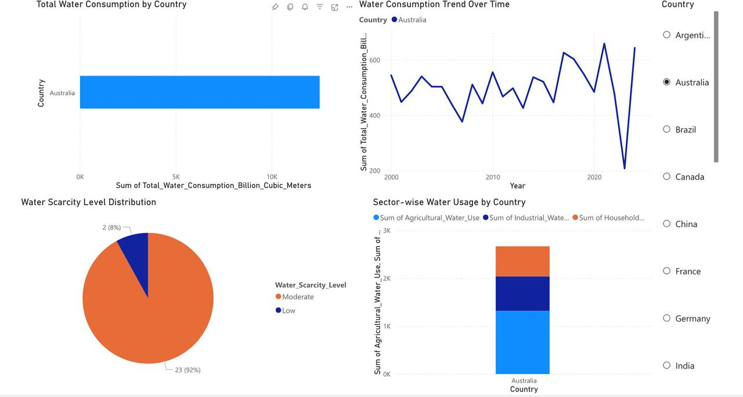
Figure 1. Dashboard output of the Global Water Consumption project.

5. Learning Outcomes
- Understanding of relational database design for environmental datasets
- Practical exposure to SQL aggregation and grouping techniques
- Knowledge of water consumption patterns and scarcity indicators
- Hands-on experience with Power BI dashboard development
- Understanding of how analytical tools support sustainability research
- Awareness of the importance of data visualization in decision support

6. ER / Architecture Diagram
The following diagram represents the structure of the water consumption database and its relationships:

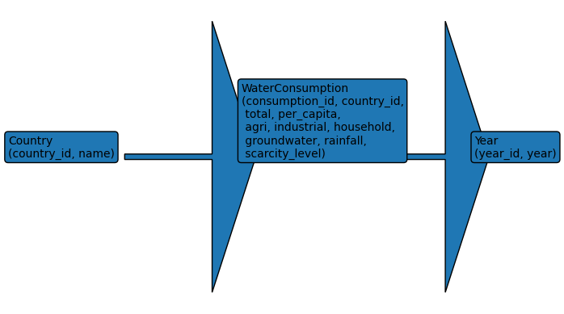
Figure 2. ER Diagram of the WaterConsumption database.

CONCLUSION
The Global Water Consumption project successfully demonstrated how database querying and dashboard visualization can be integrated to analyse sustainability-related datasets. By using SQL for structured computation and Power BI for interactive presentation, the project provides a clear and scalable way to study country-wise and sector-wise water usage patterns.

The project achieves its objective of converting raw water consumption data into meaningful insights that can support academic understanding and comparative analysis. Through the implementation of SQL analytical techniques, the project highlighted how water consumption can be categorized based on region, sector, time, and scarcity level.

The identification of high-depletion regions and extreme scarcity areas demonstrated the importance of analytics in water resource management and policy planning. The use of visualization techniques further enhanced understanding of complex data by presenting it in an intuitive and interpretable manner.

Overall, the project successfully met its objectives and demonstrated the practical application of data analytics in environmental research. It provided valuable insights into how modern analytical tools can leverage structured data for scalable processing, improved decision-making, and enhanced sustainability awareness.

This work serves as a strong foundation for future enhancements such as real-time water monitoring, predictive depletion modelling, anomaly detection for extreme consumption events, and integration with live environmental datasets, thereby making it highly relevant for real-world water resource management applications.

REFERENCES

1. Water Consumption Dataset
Water consumption dataset used for academic analysis of global water usage patterns.

2. Microsoft SQL Documentation
Microsoft SQL Server. SQL Documentation for aggregation and grouping queries.
Available at: https://learn.microsoft.com/en-us/sql/

3. Power BI Documentation
Microsoft Power BI. Documentation for dashboards, slicers, line charts, bar charts, and pie charts.
Available at: https://learn.microsoft.com/en-us/power-bi/

4. UN Water Reports on Global Water Scarcity
United Nations Water. World Water Development Reports on global scarcity and resource management.
Available at: https://www.unwater.org/

5. FAO AQUASTAT Database
Food and Agriculture Organization. AQUASTAT -- FAO's global water information system.
Available at: https://www.fao.org/aquastat/

6. Sustainability and Water Resource Management
General sustainability and water resource management references used for conceptual understanding of water usage, scarcity indicators, and conservation strategies.

Online References
- https://learn.microsoft.com/en-us/sql/
- https://learn.microsoft.com/en-us/power-bi/
- https://www.unwater.org/
- https://www.fao.org/aquastat/
- https://www.worldbank.org/en/topic/water
- https://www.kaggle.com (for water consumption datasets)

