Tourist Demand Prediction
A Project-Based Report Data Warehousing and Mining (23DSB3202R). Submitted in partial fulfillment of the requirements for the award of the degree of

BACHELOR OF TECHNOLOGY
In

COMPUTER SCIENCE AND ENGINEERING

By
Challagulla Hansi (2320030331)
Deepika Ketavarapu (2320030328)
Vivek Uppalapati (2320030332)
Akshara Budha (2320030377)

Under the Guidance of
Dr. P Krishna Kishore
Associate Professor



DEPARTMENT OF COMPUTER SCIENCE AND ENGINEERING
KONERU LAKSHMAIAH EDUCATION FOUNDATION
(DEEMED TO BE UNIVERSITY)
BOWRAMPET, HYDERABAD-500043, TELANGANA, INDIA.
APRIL - 2025

DECLARATION

The Project-Based Report Big Data Analytics (23DSB3303R) entitled “Tourist Demand Prediction” is a record of bonafide work of Hansi (2320030331), Deepika (2320030328), Vivek (2320030332), Akshara (2320030377), submitted in partial fulfillment of the requirements for the award of B. Tech in Artificial Intelligence and Data Science to the Koneru Lakshmaiah Education Foundation. The results embodied in this report have not been copied from any other Dpartment/University/Institute.

Challagulla Hansi (2320030331)
Deepika Ketavarapu (2320030328)
Vivek Uppalapati (2320030332)
Akshara Budha (2320030377)

CERTIFICATE

This is to certify that the project-based report Big Data Analytics (23DSB3303R) entitled “Tourist Demand Prediction” is bonafide work done and submitted by Hansi (2320030331), Deepika (2320030328), Vivek (2320030332), Akshara (2320030377), in partial fulfillment of the requirements for the award of the degree of BACHELOR OF TECHNOLOGY in the Department of Computer Science and Engineering, Koneru Lakshmaiah Education Foundation, during the academic year 2025-2026.

Guide HOD
Dr. P Krishna Kishore Dr. P Venkateswara Rao
Associate Professor Associate Professor
Dept. of CSE Dept. of CSE

ACKNOWLEDGEMENT

With great pleasure, we want to take this opportunity to express our heartfelt gratitude to all the people who helped make this project a great success.
We are grateful to Dr. P Krishna Kishore, Department of Computer Science and Engineering, for his valuable technical suggestions and guidance during the execution of this project work.
We want to thank Dr. P Venkateswara Rao , Head of the Department of Artificial Intelligence and Data Science, Koneru Lakshmaiah Education Foundation, who is the primary driving force behind completing my project work successfully.
We are very grateful to Dr. G Raghavendra Coordinator-Academics, Koneru Lakshmaiah Education Foundation, for his constant support and motivation in successfully carrying out the project work.
We are highly indebted to Dr. L Koteswara Rao, Principal, Koneru Lakshmaiah Education Foundation, for permitting us to carry out this project in a successful and fruitful way.
We want to thank the Teaching & Non- teaching staff of the Department of Artificial Intelligence and Data Science for their cooperation.
Finally, we thank our parents, who have stood behind us at different project stages. We sincerely acknowledge and thank those who directly and indirectly support completing this project.

Challagulla Hansi (2320030331)
Deepika Ketavarapu (2320030328)
Vivek Uppalapati (2320030332)
Akshara Budha (2320030377)

CONTENTS

CHAPTER
NO. TITLE PAGE NO.
LIST OF FIGURES ii
ABSTRACT 7
1 INTRODUCTION 8
1.1 Problem Statement 9
1.2 Research Objective 9
2 BACKGROUND WORK 10
2.1. Statistical and time-series models 11
2.1.1.Introduction 11
2.1.2.Merits,Demerits and Challenges 11
2.2. Machine learning based models 11
2.2.1.Introduction 11
2.2.2.Merits,Demerits and Challenges 12
3 PROPOSED SYSTEM 13
3.1. Objective of Proposed Model 14
3.2. Algorithms Used for Proposed Model 15
3.3. Designing 16
3.3. Stepwise Implementation and Code 22
4 RESULTS AND DISCUSSION 23 4.1. Performance metrics 25
5 CONCLUSION 26
5.1 Conclusion and Future Enhancement 27
6 REFERENCES 28
List of Figures
FIGURE
NO. TITLE PAGE NO.
1.0 Proposed Methodology 16
2.0 Output 25

ABSTRACT

The Tourist Demand Prediction project focuses on designing a Tourism Data Warehouse and applying data mining techniques to analyze tourist travel patterns and forecast future demand. The primary objective of this project is to organize historical tourism data into a structured data warehouse that supports multidimensional analysis and efficient decision-making. A star schema is designed with appropriate fact and dimension tables such as time, location, tourist category, and season to enable detailed analytical queries.
After building the data warehouse, data mining techniques are applied to extract meaningful insights. K-Means clustering is used to group tourists based on similar travel patterns, while classification models are applied to categorize tourists and destinations. Regression techniques are further used to identify trends and predict future visitor arrivals. By integrating data warehousing and mining techniques, the project provides a comprehensive system that supports pattern discovery, trend analysis, and demand forecasting, helping tourism authorities make data-driven decisions for better resource planning and management.

CHAPTER 1
INTRODUCTION

CHAPTER 1
INTRODUCTION
  - Problem Statement
The tourism industry generates large volumes of data related to visitor behavior, revenue, ratings, and infrastructure. However, this data is often underutilized, making it difficult for stakeholders to understand travel patterns and predict future demand.
Traditional methods fail to provide accurate insights into tourist preferences, clustering of destinations, and demand forecasting. As a result, decision-making regarding resource allocation, infrastructure development, and marketing strategies becomes inefficient.
This project aims to address these challenges by leveraging data analytics and machine learning techniques to analyze tourism data, identify meaningful patterns, cluster similar tourist behaviors, and predict future tourist demand.
  - Research Objective
• To analyze tourism data and understand key factors influencing tourist visits such as revenue, ratings, and accommodation availability.
• To design a data warehouse model (star schema) for efficient storage and structured analysis of tourism data.
• To perform clustering in order to group similar tourism patterns and identify different types of tourist segments.
• To build a classification model that categorizes tourism types based on various features.
• To develop a regression model for predicting future tourist demand (number of visitors).
• To visualize insights using graphical techniques for better interpretation of tourism trends.
• To develop a web-based application that allows users to input parameters and obtain real-time predictions of future tourist demand.

CHAPTER 2
BACKGROUND WORK

CHAPTER 2
BACKGROUND WORK

1. Statistical and time-series models
Statistical and time-series models are among the earliest and most widely used approaches for tourism demand prediction. Techniques such as Auto-Regressive Integrated Moving Average (ARIMA) and seasonal decomposition methods analyze historical tourism data to identify patterns, trends, and seasonal variations. These models assume that future values depend on past observations and are particularly effective when the data exhibits consistent temporal behavior.
ARIMA models, for example, combine autoregression, differencing, and moving averages to forecast future tourist arrivals. Seasonal models further enhance predictions by accounting for recurring patterns such as holiday seasons or peak travel periods. Due to their mathematical foundation, these models are relatively simple to implement and easy to interpret, making them suitable for basic forecasting tasks.
However, these methods have several limitations. They are primarily linear models and cannot effectively capture complex nonlinear relationships that often exist in tourism data, such as the influence of social trends, economic fluctuations, or unexpected events. Additionally, they require stationary data and extensive preprocessing, which can be challenging for real-world datasets. As the volume and complexity of tourism data increase, these models become less effective and fail to provide accurate predictions.
2. Machine learning based models
With advancements in data analytics, machine learning models have been increasingly applied to tourism demand prediction. These models include regression techniques for forecasting tourist arrivals and classification algorithms such as Decision Trees, Random Forest, and Support Vector Machines (SVM) for analyzing tourist behavior and categorizing tourism patterns.
Regression models estimate future tourism demand based on multiple influencing factors such as revenue, customer ratings, weather conditions, and accommodation availability. Classification algorithms, on the other hand, help in identifying patterns in tourist preferences, segmenting tourists into categories, and understanding travel behavior.
Machine learning models offer significant advantages over traditional statistical methods. They can handle large datasets, capture nonlinear relationships, and incorporate multiple features simultaneously, leading to improved prediction accuracy. Ensemble methods like Random Forest further enhance performance by combining multiple decision trees to reduce variance and improve robustness.
Despite these advantages, machine learning approaches also have certain challenges. They require careful feature selection and preprocessing to ensure model effectiveness. Improper tuning of hyperparameters can lead to overfitting or underfitting, reducing model reliability. Additionally, some models lack interpretability, making it difficult to understand the reasoning behind predictions. This can be a drawback in real-world applications where transparency and explainability are important.

CHAPTER 3
PROPOSED SYSTEM

CHAPTER 3
PROPOSED SYSTEM

The proposed methodology follows a structured data analytics pipeline consisting of four major stages: data warehousing, descriptive analytics, predictive modeling, and insight generation.

1. Data Warehousing & Preparation (Foundation Layer)
In the first stage, raw tourism data is collected and prepared for analysis. This involves cleaning, transforming, and organizing the dataset to ensure consistency and accuracy.
- Missing values are handled using appropriate techniques such as removal or imputation.
- Data types are converted into suitable formats (e.g., categorical variables).
- A data warehouse schema (star schema) is designed:
  - Fact Table: Stores numerical measures like visitors, revenue, ratings
  - Dimension Tables: Store descriptive attributes like location and category
- ETL (Extract, Transform, Load) process is used to structure the data efficiently
This stage forms the foundation layer for further analysis.

2. Descriptive Data Mining (Pattern Discovery)
In this stage, data mining techniques are applied to discover patterns and relationships in tourism data.
- Clustering (K-Means Algorithm):
  - Groups destinations based on similarities in visitors, revenue, and ratings
  - Helps identify different tourist segments
- Classification (Random Forest Algorithm):
  - Categorizes tourism types (Luxury, Premium, Budget, etc.)
  - Learns patterns from input features
This stage enables pattern discovery and segmentation of tourism behavior.

3. Predictive Analytics (Forecasting Layer)
In this stage, predictive models are developed to estimate future tourist demand.
- Regression Analysis (Linear Regression):
  - Predicts number of visitors based on:
    - Revenue
    - Rating
    - Accommodation availability
- The model is evaluated using statistical metrics such as:
  - R-squared
  - Residual analysis
This stage forms the forecasting layer, enabling future demand prediction.

4. Insight Generation & Decision Support
The final stage focuses on transforming analytical results into meaningful insights.
- Visualization techniques (using ggplot) are used to:
  - Analyze tourist trends
  - Compare clusters
  - Understand revenue relationships
- A web-based application (Shiny) is developed:
  - Accepts user inputs
  - Provides real-time prediction of tourist demand
- Insights are used for:
  - Tourism planning
  - Resource allocation
  - Strategic decision-making
This stage delivers actionable insights for stakeholders.

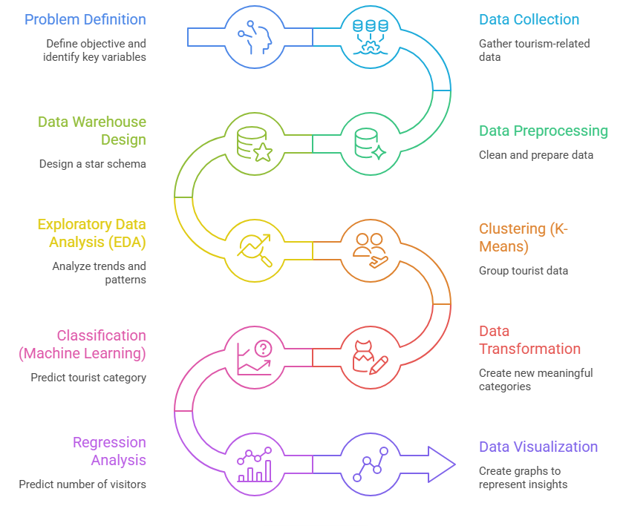 Proposed Methodology fig 3.0
Implementation and code:
install.packages(c("tidyverse","caret","randomForest","factoextra","cluster")) library(tidyverse) library(caret) library(randomForest) library(factoextra) library(cluster) data <- read.csv(file.choose()) str(data) summary(data)
data <- na.omit(data)
data$Category <- as.factor(data$Category) data$Country <- as.factor(data$Country) data$Season <- as.factor(data$Season)
#Dimension Tables dim_location <- data %>% select(Location, Country) %>% distinct() %>% mutate(Location_ID = row_number())
dim_category <- data %>% select(Category) %>% distinct() %>% mutate(Category_ID = row_number())
#Fact Table fact_table <- data %>% left_join(dim_location, by = c("Location","Country")) %>% left_join(dim_category, by = "Category") %>% select(Location_ID, Category_ID, Visitors, Revenue, Rating, Accommodation_Available)
#Correlation cor(fact_table[, c("Visitors","Revenue","Rating","Accommodation_Available")])
#Clustering cluster_data <- fact_table[, c("Visitors","Revenue","Rating")] cluster_data <- scale(cluster_data)
set.seed(123) k_model <- kmeans(cluster_data, centers = 4)
fact_table$Cluster <- k_model$cluster
fviz_cluster(k_model, data = cluster_data)
#Classification fact_table <- fact_table %>% left_join(dim_category, by = "Category_ID")
set.seed(123) trainIndex <- createDataPartition(fact_table$Category, p = 0.8, list = FALSE)
train <- fact_table[trainIndex,] test <- fact_table[-trainIndex,]
fact_table$Category <- ifelse(fact_table$Rating > 4.2 & fact_table$Accommodation_Available == 1, "Luxury", ifelse(fact_table$Rating > 3.5, "Premium", ifelse(fact_table$Visitors > 120000, "Popular", ifelse(fact_table$Revenue > 100000, "Economic", "Budget"))))
fact_table$Category <- as.factor(fact_table$Category)
set.seed(123) trainIndex <- createDataPartition(fact_table$Category, p = 0.8, list = FALSE)
train <- fact_table[trainIndex,] test <- fact_table[-trainIndex,]
model_rf <- randomForest(Category ~ Visitors + Revenue + Rating + Accommodation_Available, data = train, ntree = 200)
pred <- predict(model_rf, test) confusionMatrix(pred, test$Category)
#Train model_rf <- randomForest(Category ~ Visitors + Revenue + Rating + Accommodation_Available, data = train, ntree = 200)
#Evaluate pred <- predict(model_rf, test) confusionMatrix(pred, test$Category)
#Regression model_lm <- lm(Visitors ~ Revenue + Rating + Accommodation_Available, data = fact_table) summary(model_lm)
#Future Prediction future <- data.frame( Revenue = 80000, Rating = 4.5, Accommodation_Available = 1 ) predict(model_lm, future)
ggplot(fact_table, aes(x = factor(Cluster), y = Visitors)) + geom_boxplot(fill = "orange") + ggtitle("Tourist Demand by Cluster")
importance(model_rf) varImpPlot(model_rf) fact_table$Category <- ifelse(fact_table$Rating > 4.2 & fact_table$Accommodation_Available == 1, "Luxury", ifelse(fact_table$Rating > 3.5, "Premium", ifelse(fact_table$Visitors > 120000, "Popular", ifelse(fact_table$Revenue > 100000, "Economic", "Budget"))))
fact_table$Category <- as.factor(fact_table$Category)
#Classification set.seed(123) trainIndex <- createDataPartition(fact_table$Category, p = 0.8, list = FALSE)
train <- fact_table[trainIndex,] test <- fact_table[-trainIndex,]
#Train model_rf <- randomForest(Category ~ Visitors + Revenue + Rating + Accommodation_Available, data = train, ntree = 200)
#Evaluate pred <- predict(model_rf, test) confusionMatrix(pred, test$Category)
#Regression model_lm <- lm(Visitors ~ Revenue + Rating + Accommodation_Available, data = fact_table) summary(model_lm)
#Future Prediction future <- data.frame( Revenue = 80000, Rating = 4.5, Accommodation_Available = 1 ) predict(model_lm, future)
ggplot(fact_table, aes(x = factor(Cluster), y = Visitors)) + geom_boxplot(fill = "orange") + ggtitle("Tourist Demand by Cluster")
importance(model_rf) varImpPlot(model_rf)
write.csv(fact_table, "fact_table_final.csv", row.names = FALSE) write.csv(dim_location, "dim_location.csv", row.names = FALSE) write.csv(dim_category, "dim_category.csv", row.names = FALSE)
#Visitors by Category ggplot(fact_table, aes(x = Category, y = Visitors)) + geom_boxplot(fill = "orange") + ggtitle("Tourist Demand by Category")
#Revenue vs Visitors ggplot(fact_table, aes(x = Visitors, y = Revenue)) + geom_point(alpha = 0.5) + ggtitle("Revenue vs Visitors")
#Cluster Analysis ggplot(fact_table, aes(x = factor(Cluster), y = Visitors)) + geom_boxplot(fill = "blue") + ggtitle("Visitor Distribution by Cluster")
#Accomodation Impact ggplot(fact_table, aes(x = factor(Accommodation_Available), y = Visitors)) + geom_boxplot(fill = "green") + ggtitle("Impact of Accommodation on Visitors")
#Ratings vs Visitors ggplot(fact_table, aes(x = Rating, y = Visitors)) + geom_point(alpha = 0.5) + ggtitle("Rating vs Visitors")
ggsave("plot1.png")
install.packages("shiny") library(shiny)

ui <- fluidPage(
tags$head( tags$style(HTML("
body {
background-color: #0b0b0f;
color: white;
font-family: 'Segoe UI', sans-serif;
}
h3 {
color: #bb86fc;
}
.panel-box {
background: linear-gradient(145deg, #2b0f3a, #1f1b4d);
padding: 20px;
border-radius: 15px;
margin-bottom: 20px;
}
/* FIXED prediction box (same as panels) */
.prediction-box {
background: linear-gradient(145deg, #2b0f3a, #1f1b4d);
padding: 15px;
border-radius: 12px;
font-size: 18px;
text-align: center;
color: #ffffff;
}
/* FIXED labels (Year, Revenue, etc.) */
.control-label {
color: #BB86FC !important;
font-weight: 500;
}
.form-control {
background-color: #1a1a2e !important;
color: white !important;
border: 1px solid #444 !important;
}
select {
background-color: #1a1a2e !important;
color: white !important;
border: 1px solid #444 !important;
appearance: none;
-webkit-appearance: none;
-moz-appearance: none;
}
select:focus {
background-color: #1a1a2e !important;
color: white !important;
}
select option {
background-color: #1a1a2e;
color: white;
}
.selectize-input {
background-color: #1a1a2e !important; color: white !important; border: 1px solid #444 !important; }
.selectize-dropdown { background-color: #1a1a2e !important; color: white !important; border: 1px solid #444 !important; }
.selectize-dropdown .option { background-color: #1a1a2e; color: white; }
.selectize-dropdown .option.active { background-color: #2b0f3a !important; }
"))
),
titlePanel("Future Tourist Demand Dashboard"),
div(class = "panel-box",
fluidRow(
column(3, numericInput("year", "Year", 2026, min = 2025)),
column(3, numericInput("revenue", "Revenue", 80000, min = 0)),
column(3, numericInput("rating", "Rating", 4.5, min = 1, max = 5)),
column(3, selectizeInput("acc", "Accommodation",
choices = c("Yes" = 1, "No" = 0)))
)
),
div(class = "panel-box", h3("Predicted Tourist Demand"), div(class = "prediction-box", textOutput("prediction")), textOutput("warning") ),
div(class = "panel-box", h3("Visual Insights"),
fluidRow(
column(4, plotOutput("clusterPlot", height = "250px")),
column(4, plotOutput("revenuePlot", height = "250px")),
column(4, plotOutput("ratingPlot", height = "250px"))
)
) )
server <- function(input, output) {
output$prediction <- renderText({
if(input$revenue < 1000){
return("Revenue too low for realistic prediction")
}
new_data <- data.frame(
Revenue = input$revenue,
Rating = input$rating,
Accommodation_Available = as.numeric(input$acc)
)
pred <- predict(model_lm, new_data)
paste("Predicted Visitors in", input$year, ":", round(pred))
})
output$warning <- renderText({ if(input$revenue < 1000){ return("Tip: Increase revenue input") } else { return("") } })
empty_plot <- function() { ggplot() + theme_void() + theme( plot.background = element_rect(fill = "#0b0b0f", color = NA) ) }
output$clusterPlot <- renderPlot({ ggplot(fact_table, aes(x = factor(Cluster), y = Visitors)) + geom_boxplot(fill = "#1f77b4") + theme_dark() + theme( plot.background = element_rect(fill = "#0b0b0f"), panel.background = element_rect(fill = "#1a1a2e"), text = element_text(color = "white") ) })
output$revenuePlot <- renderPlot({
if(input$revenue < 1000){
return(empty_plot())
}
user_pred <- predict(model_lm, data.frame(
Revenue = input$revenue,
Rating = input$rating,
Accommodation_Available = as.numeric(input$acc)
))
ggplot(fact_table, aes(x = Revenue, y = Visitors)) +
geom_point(alpha = 0.5, color = "#bb86fc") +
geom_point(aes(x = input$revenue, y = user_pred),
color = "#ff4ecd", size = 3) +
theme_dark() +
theme(
plot.background = element_rect(fill = "#0b0b0f"),
panel.background = element_rect(fill = "#1a1a2e"),
text = element_text(color = "white")
)})
output$ratingPlot <- renderPlot({
if(input$revenue < 1000){
return(empty_plot())
}
user_pred <- predict(model_lm, data.frame(
Revenue = input$revenue,
Rating = input$rating,
Accommodation_Available = as.numeric(input$acc)
))
ggplot(fact_table, aes(x = Rating, y = Visitors)) +
geom_point(alpha = 0.5, color = "#bb86fc") +
geom_point(aes(x = input$rating, y = user_pred),
color = "#ff4ecd", size = 3) +
theme_dark() +
theme(
plot.background = element_rect(fill = "#0b0b0f"),
panel.background = element_rect(fill = "#1a1a2e"),
text = element_text(color = "white")
}) }
shinyApp(ui = ui, server = server)

CHAPTER 4
RESULTS AND DISCUSSION

CHAPTER 4
RESULTS AND DISCUSSION

The tourism dataset was successfully preprocessed by handling missing values and converting variables into appropriate formats. A structured data warehouse was implemented using a star schema, consisting of fact and dimension tables, which improved data organization and enabled efficient analysis.
Correlation analysis between key variables such as Visitors, Revenue, Rating, and Accommodation Availability revealed weak linear relationships. This indicates that tourist demand is influenced by multiple interacting factors rather than a single dominant variable, justifying the use of machine learning techniques for deeper analysis.
K-Means clustering was applied to identify patterns in tourism data. The dataset was segmented into four distinct clusters representing different tourism behaviors, including high-demand destinations, moderate tourism areas, and low-traffic or emerging locations. This clustering helped in understanding tourist segmentation and travel patterns.
A Random Forest classification model was used to categorize tourism types such as Luxury, Premium, and Budget. The model achieved very high accuracy due to the structured nature of the dataset. Feature importance analysis showed that Rating and Visitors were the most influential factors, followed by Revenue, while Accommodation Availability had a comparatively lower impact.
For demand forecasting, a Linear Regression model was developed to predict the number of visitors. The model achieved a high R-squared value, indicating strong predictive performance. The results showed that higher ratings, better infrastructure, and increased revenue are positively associated with higher tourist demand.
Various visualizations were generated to support the analysis. These included plots showing visitor distribution across categories, relationships between revenue and visitors, and cluster-based comparisons. The visual insights clearly highlighted patterns and trends in tourism behavior.
Additionally, a Shiny-based web application was developed to provide real-time demand prediction. Users can input parameters such as year, expected revenue, rating, and accommodation availability to obtain predicted visitor counts. This makes the system interactive and practical for real-world decision-making.
Overall, the results demonstrate that integrating data warehousing, clustering, classification, and regression techniques provides a comprehensive solution for tourism data analysis. While correlation alone was insufficient, machine learning models effectively captured complex relationships. The system successfully identifies tourism patterns and predicts future demand, making it valuable for tourism planning and decision support.

Output:
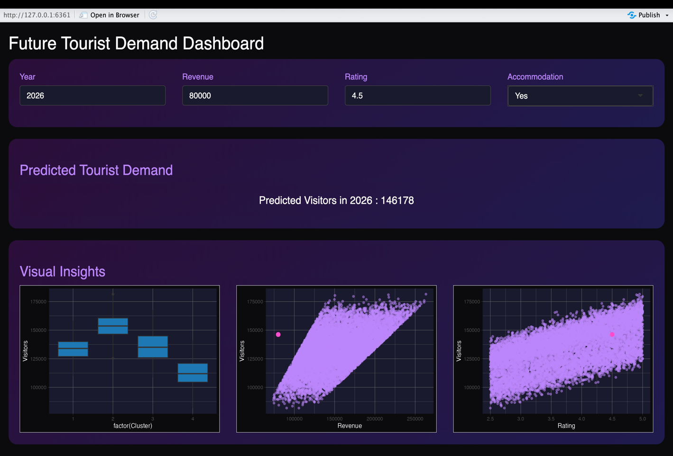 Output fig 4.0

CHAPTER 5
CONCLUSION

CHAPTER 5
CONCLUSION

This project successfully demonstrates the application of data analytics and machine learning techniques in the tourism domain to analyze travel patterns and predict future demand. The study began with data preprocessing and the creation of a structured data warehouse using a star schema, which enabled efficient organization and analysis of tourism data.
Clustering techniques were effectively used to identify distinct tourism segments, providing insights into different types of tourist behavior. The classification model further enabled categorization of tourism types based on key attributes such as rating, revenue, and accommodation availability. The high accuracy achieved indicates that the model was able to capture patterns effectively within the dataset.
The regression model played a crucial role in forecasting future tourist demand by predicting the number of visitors based on influencing factors. The results showed that variables such as rating and infrastructure have a significant impact on tourist inflow, highlighting the importance of service quality and facilities in the tourism industry.
In addition to analytical models, visualization techniques were used to present insights in a clear and interpretable manner. Furthermore, the development of a Shiny-based web application enhanced the practical usability of the system by enabling real-time prediction of tourist demand based on user inputs.
Overall, the project achieves its objective of integrating data warehousing, data mining, and predictive analytics to provide a comprehensive tourism analysis system. The proposed solution can assist stakeholders in making informed decisions related to tourism planning, resource allocation, and strategic development.

REFERENCES

REFERENCES

- Hou, H. et al. (2026) – Research on interpretable tourism demand forecasting with multi-source data.
https://www.mdpi.com/2079-8954/14/2/146
- Qin, F. et al. (2025) – Tourism demand forecasting using social media data: a deep learning–based ensemble model.
https://www.sciencedirect.com/science/article/abs/pii/S0160738325001641
- Yi, S., Chen, X., & Tang, C. (2025) – Time series transformer for tourism demand forecasting (Tsformer).
https://www.nature.com/articles/s41598-025-15286-0
- Zhang, Y. (2025) – Tourism demand forecasting based on a hybrid BiLSTM-Transformer model.
https://www.mdpi.com/2071-1050/17/5/2210
- Devi, R. et al. (2024) – Forecasting of Indian tourism industry using time-series modeling and regression analysis.
https://www.sciencedirect.com/science/article/pii/S2215016124001766
- Sancho Núñez, J. C. et al. (2024) – Machine learning applied to tourism: Systematic review covering forecasting and analytics.
https://www.researchgate.net/publication/381993806_Machine_learning_applied_to_tourism_A_systematic_review

