|  |  |  |  |  |
| --- | --- | --- | --- | --- |
|  | | | | |
| **Automated Template System**  **User Manual** | | | | |
|  | **Revision** | **:** | **8** |  |
| **Issue Date** | **:** | **2018/05/04** |

|  |
| --- |
| This document is the property of J A Odendaal (the *Licensor*).  The content thereof may not be reproduced, disclosed or used without the *Licensor’s* prior written approval. |

Contents

Abbreviations 6

1. INTRODUCTION 7

2. High-Level DEscription 8

2.1. Overview 8

2.1.1. Microsoft Word Templates 8

2.1.2. Template Database 8

2.1.3. Business Contacts Database 8

2.1.4. User Abbreviations Database 8

2.1.5. Resources and Competencies Database 9

2.1.6. Clauses Database 9

2.1.7. Product Data Management System Interface 9

2.1.8. Competency Database 9

2.2. Installed Components 9

2.2.1. Base Template Folder 9

2.2.2. Company-specific Folder 10

2.2.2.1. Company-specific Template Folder 10

2.2.2.2. Company-specific Layouts Folder 10

2.3. Dependencies 11

2.3.1. System Context 11

2.3.2. Third-party Applications 12

3. Installation 13

3.1. Compatibility 13

3.2. Templates Installation 13

3.3. Prerequisites Installation 13

3.3.1. BullZipPDFPrinter 13

3.3.2. Image Magick 14

3.4. Signature Installation 14

4. Microsoft Word Templates 16

4.1. StartING a New Document 16

4.1.1. Microsoft Word 2007 and 2010 16

4.1.2. Microsoft Word 2013 and 2016 16

4.2. Tabs and Ribbons 16

4.2.1. Styles Group – Home Ribbon 16

4.2.2. Automated Template System Ribbon 16

4.3. Company Ribbon Explained 17

4.3.1. DocControl Group 17

4.3.1.1. Update Document ActiveDocument.InlineShape -  25 of  116 17

4.3.1.1.1. Main template 17

4.3.1.1.1.1. General tab sheet 17

4.3.1.1.1.2. Approval tab sheet 20

4.3.1.1.1.3. Setup tab sheet 21

4.3.1.1.1.4. Custom Properties tab sheet 23

4.3.1.1.2. Form template 24

4.3.1.1.2.1. General tab sheet 24

4.3.1.1.2.2. Approval tab sheet 25

4.3.1.1.2.3. Setup tab sheet 26

4.3.1.1.2.4. Custom Properties tab sheet 29

4.3.1.1.3. Letter template 29

4.3.1.1.3.1. General tab sheet 29

4.3.1.1.3.2. Setup tab sheet 33

4.3.1.1.3.3. Custom Properties tab sheet 34

4.3.1.2. Export Properties ActiveDocument.InlineShape -  45 of  116 35

4.3.1.3. Import Properties ActiveDocument.InlineShape -  46 of  116 35

4.3.1.4. Export Config ActiveDocument.InlineShape -  47 of  116 35

4.3.1.5. Import Config ActiveDocument.InlineShape -  48 of  116 36

4.3.2. Page Setup Group 36

4.3.2.1. Insert Landscape ActiveDocument.InlineShape -  49 of  116 36

4.3.2.2. Insert Portrait ActiveDocument.InlineShape -  52 of  116 36

4.3.2.3. Setup Landscape ActiveDocument.InlineShape -  55 of  116 37

4.3.2.4. Setup Portrait ActiveDocument.InlineShape -  56 of  116 37

4.3.2.5. Page Defaults ActiveDocument.InlineShape -  57 of  116 37

4.3.3. Table Group 38

4.3.3.1. Format Table ActiveDocument.InlineShape -  59 of  116 38

4.3.3.2. Table Header ActiveDocument.InlineShape -  60 of  116 38

4.3.3.3. Abbreviations ActiveDocument.InlineShape -  61 of  116 38

4.3.4. Styles Group 38

4.3.4.1. Outline Numbering ActiveDocument.InlineShape -  62 of  116 38

4.3.4.1.1. Usage examples 40

4.3.4.1.2. Sequence-specific field switches 41

4.3.4.2. Delete Styles ActiveDocument.InlineShape -  64 of  116 42

4.3.4.3. Update Case ActiveDocument.InlineShape -  67 of  116 43

4.3.5. Utils Group 43

4.3.5.1. Insert Symbol ActiveDocument.InlineShape -  68 of  116 43

4.3.5.2. Insert Equation ActiveDocument.InlineShape -  69 of  116 43

4.3.5.3. Sign Document ActiveDocument.InlineShape -  71 of  116 44

4.3.5.4. Caption Table ActiveDocument.InlineShape -  73 of  116 45

4.3.5.5. Caption Figure ActiveDocument.InlineShape -  74 of  116 45

4.3.5.6. Requirements ActiveDocument.InlineShape -  75 of  116 45

4.3.5.6.1. Requirements numbered with list level numbering 45

4.3.5.6.2. Requirements numbered with outline numbering 46

4.3.5.7. Clauses  47

4.4. Embedded Fields 48

4.5. Custom Document Properties 49

4.5.1. Showing Default Values 49

4.5.2. Manipulating Table of Contents (TOC) 49

4.5.3. Manipulating Default Tab Stop 51

4.5.4. Manipulating First Page Header/Footer in a Section 52

4.5.5. Manipulating Default Document Language 53

4.5.6. User-definable Custom Document Properties 54

4.6. Creating Forms with Restricted Editing that Users can Complete 55

4.6.1. Developer Tab and Ribbon 55

4.6.2. Basic Empty Form and Signatory Blocks 56

4.6.2.1. Reapplying formatting to signatory blocks – default formatting 56

4.6.2.2. Reapplying formatting to signatory blocks – custom formatting 57

4.6.2.2.1. Creating the macro 57

4.6.2.2.2. Using the macro 59

4.6.3. Form Fields/Content Controls 59

4.6.4. Protecting the Form 59

4.7. Tips and Tricks 60

4.7.1. How to Copy Old Document Content into a New Document 60

4.7.2. Last Page Orientation Format 61

4.7.3. Formatting 61

4.7.4. Graphics in Documents 62

5. Linked Databases 63

5.1. Template Database 63

5.2. Business Contacts Database 65

5.2.1. Contents 65

5.2.2. Using the Embedded Macro 66

5.3. User Abbreviations Database 66

5.4. Resources and Competencies Database 67

5.5. Clauses Database 69

5.5.1. Contents 69

5.5.2. Using the Embedded Macro 70

5.6. Product Data Management System Interface 70

5.6.1. Contents 70

5.6.2. Using Embedded Macros 71

6. Competency Database 72

7. Appendices 80

7.1. Appendix A: Copyright and Licence 80

7.2. Appendix B: Default Form Content with Selected Signatories 82

7.3. Appendix C: Resource Competency Data Relations 83

Figures

Figure 1: System Context Diagram 11

Figure 2: Default and Revised Microsoft Word Styles Group 16

Figure 3: Automated Template System Tab and Ribbon 17

Figure 4: Document Configuration Control Details – Main Template General Tab Sheet 17

Figure 5: Document Configuration Control Details – Main Template General Tab Sheet (Locked) 18

Figure 6: Document Configuration Control Details – Main Template Approval Tab Sheet 20

Figure 7: Document Configuration Control Details – Main Template Approval Tab Sheet (Locked) 20

Figure 8: Document Configuration Control Details – Main Template Setup Tab Sheet 21

Figure 9: Document Configuration Control Details – Main Template Setup Tab Sheet (Locked) 22

Figure 10: Document Configuration Control Details – Main Template Custom Properties Tab Sheet 23

Figure 11: Document Configuration Control Details – Form Template General Tab Sheet 24

Figure 12: Document Configuration Control Details – Form Template General Tab Sheet (Locked) 24

Figure 13: Document Configuration Control Details – Form Template Approval Tab Sheet 25

Figure 14: Document Configuration Control Details – Form Template Approval Tab Sheet (Locked) 25

Figure 15: Document Configuration Control Details – Form Template Setup Tab Sheet 26

Figure 16: Document Configuration Control Details – Form Template Setup Tab Sheet Option 1 27

Figure 17: Document Configuration Control Details – Form Template Setup Tab Sheet Option 2 27

Figure 18: Document Configuration Control Details – Form Template Setup Tab Sheet Option 1 (Locked) 28

Figure 19: Document Configuration Control Details – Form Template Setup Tab Sheet Option 2 (Locked) 28

Figure 20: Document Configuration Control Details – Form Template Custom Properties Tab Sheet 29

Figure 21: Document Configuration Control Details – Letter Template General Tab Sheet 30

Figure 22: Document Configuration Control Details – Letter Template General Tab Sheet (Locked, with Validation) 31

Figure 23: Document Configuration Control Details – Letter Template Setup Tab Sheet 33

Figure 24: Document Configuration Control Details – Letter Template Setup Tab Sheet (Locked) 34

Figure 25: Document Configuration Control Details – Letter Template Custom Properties Tab Sheet 35

Figure 26: Insert Landscape Form 36

Figure 27: Insert Portrait Form 37

Figure 28: Page Defaults Form 37

Figure 29: Outline Numbering – Number Position Options 39

Figure 30: Quick Parts Field Form, Numbering, Sequence 41

Figure 31: Sequence-specific Field Switches 42

Figure 32: Delete Styles – First Prompt 42

Figure 33: Delete Styles – Second Prompt 42

Figure 34: Insert Symbol 43

Figure 35: Equation Example 44

Figure 36: Signature Utility Form – Stand-alone 44

Figure 37: Requirements Form 45

Figure 38: Clauses Utility Form 47

Figure 39: Launching Custom Document Properties via Company Ribbon 49

Figure 40: Custom Document Properties Dialogue Box (1) 49

Figure 41: Custom Document Properties Dialogue Box (2) 50

Figure 42: Default Tab Stop Custom Document Property 51

Figure 43: DocNoForceSectionSetup, Doc2ndSectionContinuous Custom Document Properties 52

Figure 44: Default Document Language Custom Document Property 53

Figure 45: User-definable Custom Document Properties 54

Figure 46: Insert Managed Custom Document Properties into Document Text 55

Figure 47: Controls Group on Developer Ribbon 55

Figure 48: Formatting Signatory Block – Select Two Rows and Three Columns 56

Figure 49: Formatting Signatory Block – Default Macro Selection 57

Figure 50: Formatting Signatory Block – Result 57

Figure 51: Custom Signatory Block Formatting – Reference to BaseTemplate 58

Figure 52: Custom Signatory Block Formatting – Macro Example 58

Figure 53: Custom Signatory Block Formatting – Custom Macro Selection 59

Figure 54: Default Form Content 82

Tables

Table 1: Impact of Automated Template System Changes on Working Documents 7

Table 2: Requirements Utility Usage Example, Type 1 46

Table 3: Requirements Cross Reference 46

Table 4: Requirements Utility Usage Example, Type 2 46

Table 5: Requirements Cross Reference 46

Abbreviations

This list contains the abbreviations used in this document.

| Abbreviation or Acronym | Definition |
| --- | --- |
| IEEE | Institute of Electrical and Electronics Engineers |
| JPG | Joint Photographic Experts Group |
| n/a | not applicable |
| PDF | Portable Document Format |
| PDMS | Product Data Management System |
| TOC | Table of Contents |
| VBA | Visual Basic for Applications |

# INTRODUCTION

This document describes the organization and usage of the Automated Template System. Its intended audience is anyone who wants to know more about or wants to use the Automated Template System to capture information in documents authorized by the Licensee, where such documents are based on or make use of this Automated Template System.

The Automated Template System enables the managing and maintaining of documentation standards within a company, providing enough flexibility and ease of use to enhance the overall productivity and efficiency of Microsoft Word users in a company. It provides a way to use Microsoft Word consistently when generating different document types and speeds up the process of producing documents that have a consistent and professional appearance. All formatting is built into the predefined styles according to the company documentation standard.

Should the Automated Template System have been changed since the last time a specific document has been worked upon, a warning message will be displayed, advising the user of the impact of the changes to the template. Table 1 gives the nature of change, the impact of the change and the user action required:

Table 1: Impact of Automated Template System Changes on Working Documents

| No. | Nature of Change | Impact | User Action |
| --- | --- | --- | --- |
|  | Document structure and/or layout change | Working document structure will no longer be according to the official company standard | Working document needs to be recompiled based on the template |
|  | Styles change | Working document styles will no longer be according to the official company standard | Updated styles from the template will only be applied to the working document upon user request |
|  | Efficiency macros change  or bug fixes | No visible effect | No user action required |

# High-Level DEscription

## Overview

### Microsoft Word Templates

In the context of this document, Microsoft Word templates are referred to as those files having a ‘dotx’ or ‘dotm’ extension. The Automated Template System reduces virtually all major types of documents in a company to a set of three default Microsoft Word templates: Main, Letter and Form. These default Microsoft Word templates embody the company look and feel (face value) and implement the company documentation standard.

The automation part of the Automated Template System is consolidated into a base template that is totally generic and does not offer any face value to any of the Microsoft Word templates. It contains the efficiency and integration macros that have been specifically developed to enhance the overall productivity and efficiency of Microsoft Word users in a company. Microsoft Word documents cannot be based on the base template. The three default Microsoft Word templates reference the base template to gain access to the automation functionality.

The three default Microsoft Word templates are customized for each company, and can be used as is to create the default version of the indicated type of document. They can also be used to create standardized Microsoft Word document layouts, each based on one of these Microsoft Word templates, to form a system of registered document layouts. These layouts in turn can then cover the total documentation requirements of a company.

Use of the default Microsoft Word templates is discussed further in Chapter 4.

### Template Database

The template database (paragraph 5.1) contains standardized abbreviations; words that should always be in lower case in captions or headings that have title case formatting; heading case definitions; style names; document type definitions; security classifications, etc. This database is the master template database and used in conjunction with all default Microsoft Word templates. It has a ‘_Template_db’ suffix in the filename with an ‘xlsm’ extension.

### Business Contacts Database

The business contacts database (paragraph 0) contains a list of business contacts, their designations and business addresses. Each company has the opportunity to maintain this database itself. This database is used exclusively in conjunction with the default Letter Microsoft Word template. It has a ‘_BusinessContacts_db’ suffix in the filename with an ‘xlsm’ extension.

### User Abbreviations Database

The user abbreviations database (paragraph 0) offers each user the opportunity to add additional user-defined abbreviation definitions that will not be overwritten with consecutive Automated Template System installations. This database is used in conjunction with all default Microsoft Word templates. It has a ‘_UserAbbreviations_db’ suffix in the filename with an ‘xlsm’ extension.

### Resources and Competencies Database

The resources and competency database (paragraph 0) provides a list of approved resources, their competency levels and competency functions for specific project phases within specific competency areas. This database is used in conjunction with all default Microsoft Word templates. It has a ‘_ResourcesAndCompetencies_db’ suffix in the filename with an ‘xlsm’ extension.

### Clauses Database

The clauses database (paragraph 0) provides a list of predefined text clauses that can be included as the content of template managed Rich Text Content Controls embedded in a document. It acts as the data source for all these content controls and provides a simple interface to manage company specific clauses that must be used in documents. This database is used in conjunction with all default Microsoft Word templates. It has a ‘_Clauses_db’ suffix in the filename with an ‘xlsm’ extension.

### Product Data Management System Interface

The product data management system interface (paragraph b) provides interfacing code to exchange and control documents’ metadata or configuration data between a product data management system and the document itself. It provides for a loose coupling that is used in an offline mode of operation. The example interfacing code resides in an Excel spreadsheet, ‘PDMS_Interface.xlsm’, which can easily be used as the official document index or integrated with the company’s product data management system. This database can be used in conjunction with all default Microsoft Word templates.

### Competency Database

The competency database (Chapter 6) provides a comprehensive tool to manage resource competencies within a company. Such a tool is required in more formal industry sectors. This ultimately influences who may prepare, review and approve such formal documents. It does not interface directly with the Microsoft Word templates, but it creates the simplified resources and competency database as discussed in paragraph 2.1.5. The competency database has a ‘_Competency_db’ suffix in the filename with an ‘xlsm’ extension.

## Installed Components

### Base Template Folder

The base template folder houses all non‑company-specific Automated Template System components and is located in:

C:\Program Files\Microsoft Office\Templates\Base

The contents of the base template folder are:

* .\BaseTemplate.dotm
* .\AutomatedTemplateSystemPresentation.pdf
* .\UserManual_A4.pdf, .\UserManual_Letter.pdf
* .\CopyrightNotice.txt, .\LicenceConditions.txt
* .\Signature\InstallSignature.txt .\Signature\Signature.PNG

### Company-specific Folder

#### Company-specific Template Folder

The company-specific template folder houses all Automated Template System components related to a specific company. For a company called MyCompany, it would be located in:

C:\Program Files\Microsoft Office\Templates\MyCompany

The contents of the company-specific template folder are:

* .\MyCompany_Main.dotm, .\MyCompany_Letter.dotm*,* .\MyCompany_Form.dotm
* .\MyCompany_Competency_db.xlsm, .\MyCompany_ResourcesAndCompetencies_db.xlsm, .\MyCompany_Template_db.xlsm, .\MyCompany_BusinessContacts_db.xlsm, .\MyCompany_Clauses_db.xlsm, .\MyCompany_UserAbbreviations_db.xlsm, .\PDMS_Interface.xlsm
* .\Layouts\BlankMyCompanyDoc.docx
* .\CopyrightNotice.txt, .\Licence.txt
* .\BaseTemplate.dotm
* .\AutomatedTemplateSystemPresentation.pdf
* .\UserManual_A4.pdf, .\UserManual_Letter.pdf

#### Company-specific Layouts Folder

The company-specific layouts folder houses all registered document layouts related to a specific company. For a company called MyCompany, it would be located in:

C:\Program Files\Microsoft Office\Templates\MyCompany\Layouts

The contents of the company-specific layouts folder as shipped with the Automated Template System are:

* .\BlankMyCompanyDoc.docx

**Note:** This is where registered document layouts as prepared for any specific company can be located.

## Dependencies

### System Context

Figure 1 shows the system context diagram for the Automated Template System.

MyCompany denotes the company name; solid connectors depict persistent interfaces; and dashed connectors indicate a loose coupling. The various MyCompany_ Microsoft Word templates are the basis for the user documents’ layout, styles and formats, and in turn rely on the base template to provide all the functionality.

MyCompany_  
Competency_db  
.xlsm

MyCompany_  
ResourcesAnd  
Competencies_db  
.xlsm

MyCompany_  
Template_db  
.xlsm

MyCompany_  
User  
Abbreviations_db  
.xlsm

PDMS_Interface  
.xlsm

MyCompany_Main.dotm  
  
etc.

BaseTemplate.dotm

UserDoc  
.docx.Config.txt  
  
etc.

transfer_  
MyCompany_  
Main.txt

UserDoc.docx  
  
etc.

MySignature  
.PNG

Bullzip PDF Printer

&

Image Magick

MyCompany_  
Business  
Contacts_db  
.xlsm

MyCompany_  
Clauses_db  
.xlsm

Figure 1: System Context Diagram

### Third-party Applications

Bullzip PDF Printer (<http://www.bullzip.com>) is free for up to 10 users in a company and is an optional installation. This application was chosen because it is one of a few Portable Document Format (PDF) printers that provide the ability to apply copy protection to PDF files, which enhances the security of PDF files created by the signature utility. If this application is not installed, all Automated Template System functionality will still be available, except for automatic creation of signed, copy-protected PDF documents.

Image Magick (<http://www.imagemagick.org>) is an open source application, free for use and distributed under the Apache 2.0 licence.

# Installation

## Compatibility

The Automated Template System is compatible with Microsoft Word 2007, Microsoft Word 2010 (32 bit and 64 bit), Microsoft Word 2013 (32 bit and 64 bit) and Microsoft Word 2016 (32 bit and 64 bit) running on any one of Windows XP, Windows 7, Windows8/8.1 or Windows10.

## Templates Installation

The demonstration version can be downloaded or the licensed company version can be obtained. These should both be in the form of a zip archive. Installation is performed as follows:

1. Physically extract the installation archive (zip file) to a local or network folder.
2. From the extracted installation archive, as the normal logged-in user, double-click on ‘Install.bat’ to execute or right-click on ‘Install.bat’ and select ‘Open’ to perform the first step of the installation process. Accept all security prompts.
3. Right-click on ‘Install.bat’ and select ‘Run as administrator’ to complete the installation process. Accept all security prompts.
4. With Microsoft Word 2016, if Microsoft Word crashes when trying to execute the procedure described in paragraph 4.3.1.1 the first time, close all open Microsoft Word documents, run ‘Fix2016UpdateError.bat’ from the installation folder and then follow the prompts.

The demonstration version can be obtained from:  
<https://drive.google.com/folderview?id=0B8X2rWHZkb1kdmZQcmhFZkxhUlU&usp=sharing#list>

**Note:** Customized versions of the ResourcesAndCompetencies_db, UserAbbreviations_db and Template_db databases may be included in the installation package retaining original filenames.

## Prerequisites Installation

### BullZipPDFPrinter

Installation of BullZipPDFPrinter is optional if ‘create pdf from Word’ functionality is required when signing; licence conditions apply. It is only done once, even though there might be consecutive Automated Template System updates. Installation is performed as follows:

1. Download the installation archive, extract it to a new or temporary folder and execute ‘BullzipPDFPrinter_X_X_X_XXXX.exe’.
2. Read and accept the licence conditions.
3. Skip installation of the AVG Toolbar and search options if prompted.
4. Dependencies can be installed manually if they are not installed automatically; the latter being dependent on the version.
5. After installation is completed, open Microsoft Word, open or create a test document and print it to the ‘Bullzip PDF Printer’ to initialize its usage in Microsoft Word.

Version 7, 10 and 11 variants for Windows XP, Windows 7, Windows 8/8.1 and Windows 10 that have been verified to work properly together with the Automated Template System can be obtained from:

<https://drive.google.com/folderview?usp=sharing&id=0B8X2rWHZkb1kY2QxcWRlWElZekE#list>

**Note:** This procedure does not need to be repeated for consecutive Automated Template System updates.

### Image Magick

Installation of Image Magick is required for signing. Installation is performed as follows:

1. Download the appropriate 32-bit (x86) or 64-bit (x64) executable installation file, depending on your version of Windows. This may be any dynamic 6.8.X‑X, 6.9.X‑X or 7.0.X‑X Q16 (16 bits‑per‑pixel) version ending with ’‑dll.exe’ in the filename.
2. Run the executable to install and accept all the default prompts.

Image Magick download binaries can be obtained from:

<http://www.imagemagick.org/download/binaries/>

or:

<https://drive.google.com/folderview?id=0B8X2rWHZkb1kLU9iS1VSYUNoT1k&usp=sharing#list>

**Note:** This procedure does not need to be repeated for consecutive Automated Template System updates.

## Signature Installation

The following signature installation procedure will enable a user to electronically sign Microsoft Word documents:

1. Copy ‘Signature.PNG’ in ‘C:\Program Files\Microsoft Office\Templates\Base\Signature’ to a personal folder on your computer.
2. Create and save your personal signature image
   1. Scan your signature into a Joint Photographic Experts Group (JPG) file.
   2. Using Paint (available from the Accessories sub-menu under the Start Menu)
      1. Open ‘Signature.PNG’.
      2. Edit → Select All, Delete.
      3. Open your JPG signature file.
      4. Make sure your signature can fit inside 440 × 220 pixels.
      5. Select your signature and copy it (selected region must be ≤ 440 × 220 pixels).
      6. Paste your signature into ‘Signature.PNG’ and position it in the middle.
      7. Save ‘Signature.PNG’.
3. Perform the automated signature procedure once to complete the installation
   1. Create a new document that is based on one of the company templates provided and make sure it is saved.
   2. Position the cursor where you want to sign.
   3. Select ‘Sign Document’ from the company ribbon under the Utils group.
   4. With the Signature Utility form
      1. Browse to and select ‘Signature.PNG’ (using the ‘Browse’ button).
      2. Type author name and surname.
      3. Select ‘Update Fields’.
      4. Select ‘Sign’ (suggest use all default options if the BullZipPDFPrinter is also installed).

This concludes the signature installation.

**Note:** This procedure does not need to be repeated for consecutive Automated Template System updates.

# Microsoft Word Templates

## StartING a New Document

### Microsoft Word 2007 and 2010

On the File tab, choose New → My templates. Then select the appropriate template from the New form under the ‘Personal Templates’ tab sheet. The ‘Layouts’ tab sheet contains all company‑specific registered document layouts.

### Microsoft Word 2013 and 2016

On the File tab, choose New → SHARED. Then select the appropriate template from those presented. The ‘Layouts’ folder contains all company‑specific registered document layouts.

## Tabs and Ribbons

In Microsoft Word, ribbons are displayed when any particular tab is selected from the menu. Ribbons can be minimized by right-clicking on any empty space inside a ribbon. This will leave only the menu visible. In this instance, the ribbon and associated controls are displayed when a corresponding tab is selected. In the context of this document, when referring to any particular ribbon, it implies that the appropriate tab has been selected from the menu.

### Styles Group – Home Ribbon

The default Styles group on the Home ribbon has been revised as shown in Figure 2. The revised Home group shows the Style drop‑down and List Level items. The Style drop‑down item always shows the name of the paragraph selection and can be used to easily apply styles to the document. The List Level item is enabled whenever the selection consists of a heading or list type style. It shows the available list level options within the selected list.

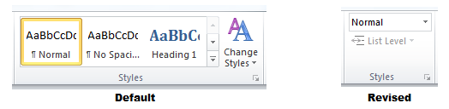

Figure 2: Default and Revised Microsoft Word Styles Group

### Automated Template System Ribbon

The Automated Template System comes with a purpose-built, company-specific tab and ribbon as shown in Figure 3. A licensed company version will have a unique name; the tab and ribbon on the demonstration version are called MyC. The Automated Template System ribbon is generic and the same for each Microsoft Word template type.

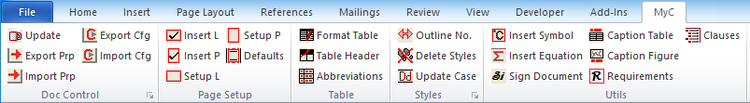

Figure 3: Automated Template System Tab and Ribbon

## Company Ribbon Explained

### DocControl Group

#### Update Document ActiveDocument.InlineShape - 25 of 116

The most important ribbon item is the Update Document item. It brings up the Document Configuration Control Details form, which consists of one or more than one tab sheet, depending on the specific template in use. It is used to change all document configuration control information embedded as fields in the document, and to consistently update the table of contents; list of figures and tables; headers and footers; and all cross-references in the document. Not all document configuration control information as shown needs to be present in the document; this is a user choice. The following paragraphs explain the various template Update Document items.

##### Main template

###### General tab sheet

The Main Template’s General tab sheet (Figure 4) contains four panes, as explained in this paragraph.

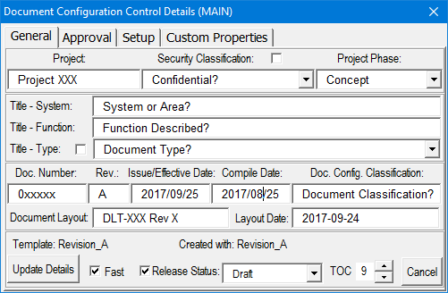

Figure 4: Document Configuration Control Details –  
Main Template General Tab Sheet

Certain controls on the General tab sheet can be disabled to prevent changes (Figure 5), and to protect the headers and footers. This is further explained in paragraph 4.3.1.1.1.3.

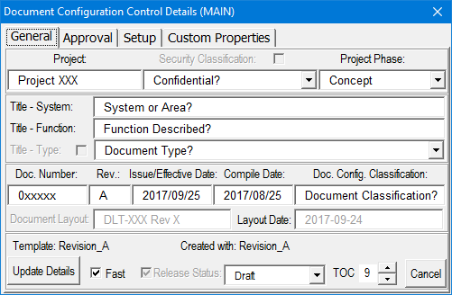

Figure 5: Document Configuration Control Details –  
Main Template General Tab Sheet (Locked)

1. Pane 1
   1. **Project:** Edit box   
      Insert text.
   2. **Security Classification:** Checkbox and drop‑down list   
      Insert text if the checkbox is not selected; otherwise, select an item from the predefined drop‑down list.
   3. **Project Phase:** Drop‑down list   
      Select an item from the predefined drop‑down list.
2. Pane 2

**Note:** The document title is made up concatenating the following three fields:

* 1. **Title – System:** Edit box   
     Insert text.
  2. **Title – Function:** Edit box   
     Insert text.
  3. **Title – Type:** Checkbox and drop‑down list   
     Insert text if the checkbox is not selected; otherwise, select an item from the predefined drop‑down list.

1. Pane 3
   1. **Doc. Number:** Edit box   
      Insert text.
   2. **Rev.:** Edit box   
      Insert text.
   3. **Issue/Effective Date:** Edit box   
      Insert text.
   4. **Compile Date:** Edit box   
      Insert text. Some quality control systems require more than one date on a document, therefore the option to use these two dates.
   5. **Doc. Config. Classification:** Edit box   
      Insert text. Some quality control systems require documents to show information about a structure to which it belongs.
   6. **Document Layout:** Edit box   
      Insert text. This field is used to control a company’s formally registered document layouts.
   7. **Document Layout Date:** Edit box   
      Insert text. This field is used to control a company’s formally registered document layouts.
2. Pane 4
   1. **Template:** and **Created with:** Labels   
      Not editable. These labels display information about the current template revision and the template revision used to create the document. If the official document structure has changed compared to the revision used to create the document, the latter field will be displayed in red with a warning.
   2. **Update Details:** Button   
      The Update Details button applies all metadata changes and updates the document throughout.
   3. **Fast:** Checkbox   
      This checkbox is selected by default and will suppress screen refresh while updating to speed up the process.
   4. **Release Status:** Checkbox and drop‑down list   
      Insert text if the checkbox is not selected; otherwise, select an item from the predefined drop‑down list.
   5. **TOC:** Spin control   
      Controls the heading level that needs to be included in the Table of Contents (TOC). For example, setting this control at 3 will include all headings in the TOC up to level 3.
   6. **Cancel:** Button   
      Cancels the update, closes the form and returns focus to the document.

###### Approval tab sheet

This paragraph explains the Main Template’s Approval tab sheet (Figure 6).

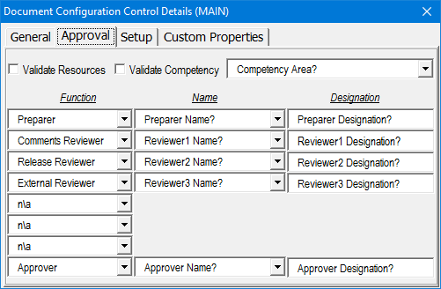

Figure 6: Document Configuration Control Details –  
Main Template Approval Tab Sheet

Certain controls on the Approval tab sheet can be disabled to prevent changes (Figure 7). This is further explained in paragraph 4.3.1.1.1.3.

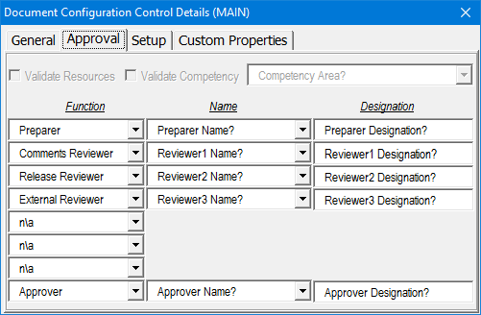

Figure 7: Document Configuration Control Details –  
Main Template Approval Tab Sheet (Locked)

1. **Validate Resources:** Checkbox   
   When selected, official resource names will be available in the Name drop‑down list.
2. **Validate Competency:** Checkbox and drop‑down list   
   When selected, the Competency Area drop‑down list will be populated with official competency areas. The resources available under the Name drop‑down list will then be filtered against the Function selected for the specific competency area.
3. **Function:** Drop‑down list   
   Select an item from the predefined drop‑down list. The first row can only be that of the competency function marked by ‘Begin’ and the last row only that of the competency function marked by ‘End’ or not applicable (n/a). All other rows can have values of the other competency functions or n/a. Refer to paragraph 0c.
4. **Name:** Edit box or drop‑down list   
   Insert text if the Validate Resources checkbox is not selected; otherwise, select an item from the predefined drop‑down list.
5. **Designation:** Edit box   
   Insert text.

###### Setup tab sheet

This paragraph explains the Setup tab sheet (Figure 8 and Figure 9).

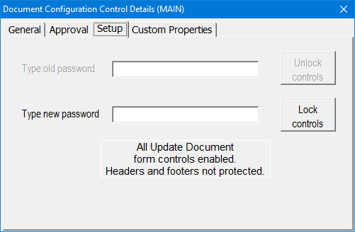

Figure 8: Document Configuration Control Details –  
Main Template Setup Tab Sheet

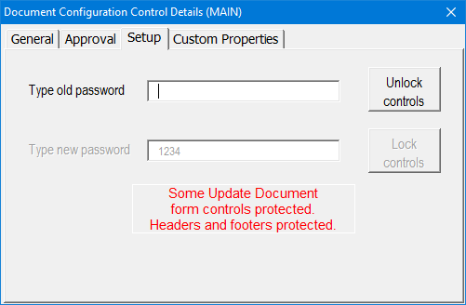

Figure 9: Document Configuration Control Details –  
Main Template Setup Tab Sheet (Locked)

1. **Type new password, Lock controls:** Edit box and Button   
   Insert text. This will disable certain controls on the General and Approval tab sheets. All controls on these tab sheets that are not disabled can still be edited or changed, and the Update Details button on the General tab sheet will still work. Editing in headers and footers is also prohibited in this mode. The most recent password typed will be visible on the Setup tab sheet until the form is closed; this must be remembered for future use. The form will not be closed by this action.
2. **Type old password, Unlock controls:** Edit box and Button   
   Insert text. This will enable all controls on the General and Approval tab sheets. The form will not be closed by this action.
3. **Enabled/Protected:** Label   
   Not editable. This label displays the enabled/protected status of certain controls on the General and Approval tab sheets.

###### Custom Properties tab sheet

This paragraph explains the Custom Properties tab sheet (Figure 10).

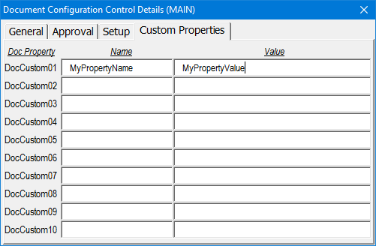

Figure 10: Document Configuration Control Details –  
Main Template Custom Properties Tab Sheet

1. **Name:** Edit boxes (column)   
   Insert text. This will be the display text of the custom document property indicated by the Doc Property name tag on the left, appended with Name; e.g. the first entry’s custom document property name will be DocCustom01Name. Refer to paragraph 4.5.6 for further explanation.
2. **Value:** Edit boxes (column)   
   Insert text. This will be the display text of the custom document property indicated by the Doc Property name tag on the left, appended with Value; e.g. the first entry’s custom document property name will be DocCustom01Value. Refer to paragraph 4.5.6 for further explanation.

##### Form template

###### General tab sheet

Figure 11 shows the Form template’s General tab sheet. All functionality is exactly as explained in paragraph 4.3.1.1.1.1.

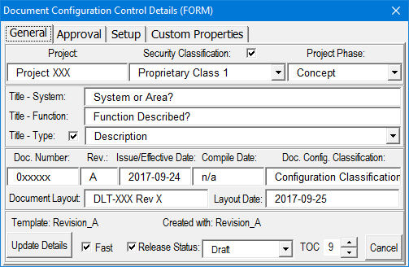

Figure 11: Document Configuration Control Details –  
Form Template General Tab Sheet

When the document is locked for filling in form fields, certain controls on the General tab sheet are disabled to prevent changes (Figure 12) and to protect the headers and footers. This is further explained in paragraph 4.3.1.1.2.3.

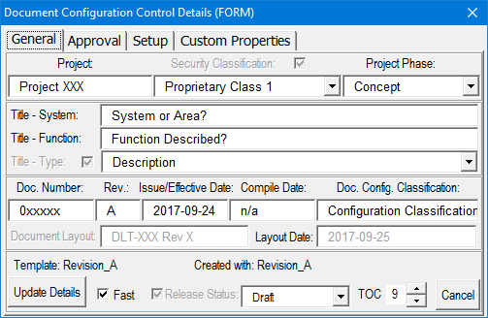

Figure 12: Document Configuration Control Details –  
Form Template General Tab Sheet (Locked)

###### Approval tab sheet

Figure 13 shows the Form template’s Approval tab sheet. All functionality is exactly as explained in paragraph 4.3.1.1.1.2.

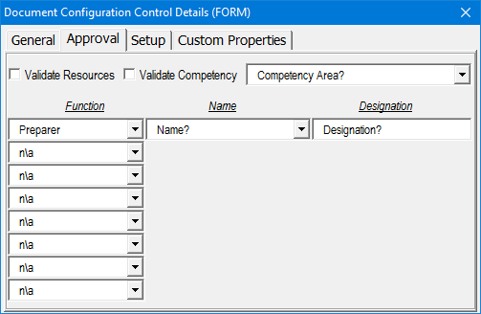

Figure 13: Document Configuration Control Details – Form Template Approval Tab Sheet

When the document is locked for filling in form fields, certain controls on the Approval tab sheet are disabled to prevent changes (Figure 14). This is further explained in paragraph 4.3.1.1.2.3.

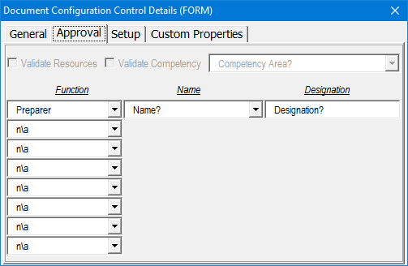

Figure 14: Document Configuration Control Details –  
Form Template Approval Tab Sheet (Locked)

###### Setup tab sheet

This paragraph explains the Setup tab sheet (Figure 15 to Figure 17).

1. **Enable form fields locking:** Checkbox   
   This checkbox is selected by default and offers the option to only disable certain controls on the General and Approval tab sheets, or to lock the document as well, by restricting editing to the filling in of form fields/content controls only (Figure 15).

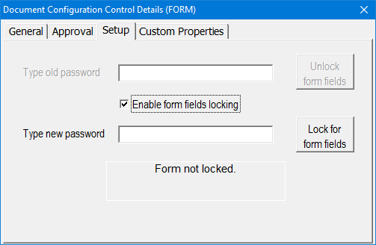

Figure 15: Document Configuration Control Details –  
Form Template Setup Tab Sheet

1. **Type new password, Lock for form fields:** Edit box and Button   
   Insert text. Depending on the form fields locking option selected, this will either disable certain controls on the General and Approval tab sheets, or lock the document as well. The latter will restrict editing to the filling in of form fields/content controls only. All controls on these tab sheets that are not disabled can still be edited or changed, and the Update Details button on the General tab sheet will still work. Editing in headers and footers is also prohibited in this mode for both options. The most recent password typed will be visible on the Setup tab sheet until the form is closed. This must be remembered for future use. The form will not be closed by this action (Figure 16 and Figure 17).

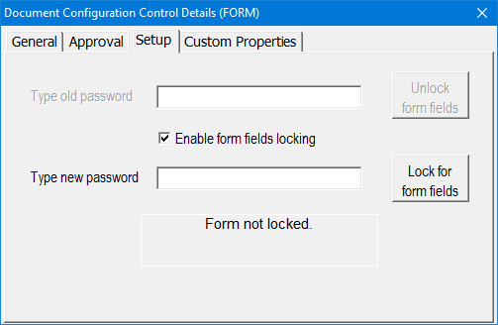

Figure 16: Document Configuration Control Details –  
Form Template Setup Tab Sheet Option 1

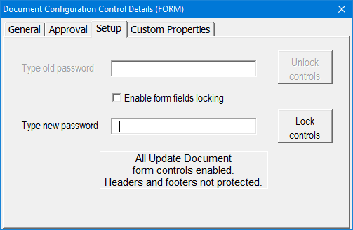

Figure 17: Document Configuration Control Details –  
Form Template Setup Tab Sheet Option 2

1. **Type old password, Unlock form fields:** Edit box and Button   
   Insert text. Depending on the form fields locking option selected, this will either enable all controls on the General and Approval tab sheets, or unlock the document as well, removing the restriction to only fill in form fields/content controls. The form will not be closed by this action (Figure 18 and Figure 19).

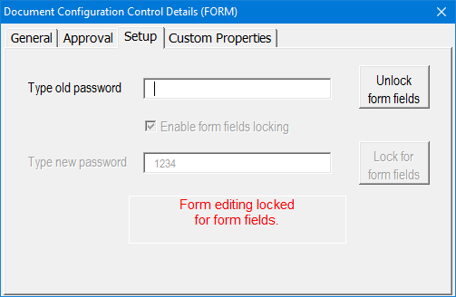

Figure 18: Document Configuration Control Details –  
Form Template Setup Tab Sheet Option 1 (Locked)

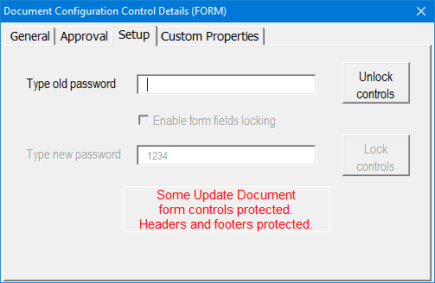

Figure 19: Document Configuration Control Details –  
Form Template Setup Tab Sheet Option 2 (Locked)

1. **Locked/Not locked:** Label   
   Not editable. This label displays the locked/unlocked status of the document and visual controls.

**Note:** For further information regarding usage of the Form template, refer to paragraph 4.6.

###### Custom Properties tab sheet

Figure 20 shows the Form template’s Custom Properties tab sheet. All functionality is exactly as explained in paragraph 4.3.1.1.1.4.

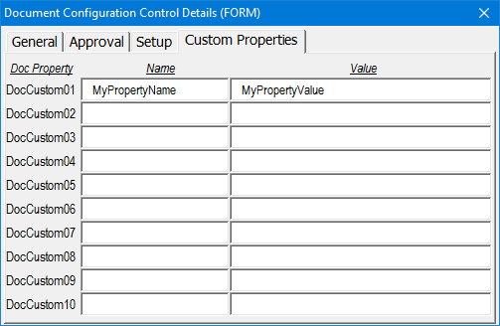

Figure 20: Document Configuration Control Details –  
Form Template Custom Properties Tab Sheet

##### Letter template

This paragraph explains the Letter template’s Update Document item.

###### General tab sheet

The Letter Template’s General tab sheet (Figure 21) contains five panes, as explained in this paragraph.

1. Pane 1

**Title:** Edit box   
Insert text. This is a multi‑line edit box; a new line is started by pressing Shift-Enter.

1. Pane 2
   1. **Number:** Edit box   
      Insert text.
   2. **Revision:** Edit box   
      Insert text.
   3. **Date:** Edit box   
      Insert text.
   4. **My reference:** Edit box   
      Insert text.
   5. **Your reference:** Edit box   
      Insert text.
   6. **Layout:** Edit box   
      Insert text. This field is used to control a company’s formally registered document layouts.

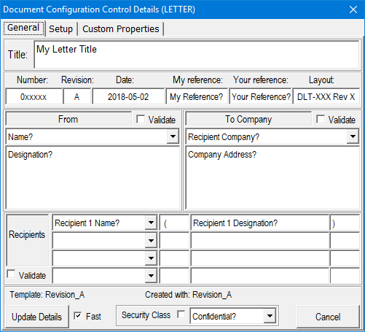

Figure 21: Document Configuration Control Details –  
Letter Template General Tab Sheet

1. Pane 3
   1. **Validate:** Checkbox   
      When selected, official resource names will be available on the Name drop‑down list.
   2. **Name:** Edit box or drop‑down list   
      Insert text if the Validate checkbox is not selected; otherwise, select an item from the predefined drop‑down list.
   3. **Designation:** Edit box   
      Insert text.

Certain controls on the General tab sheet can be disabled to prevent changes (Figure 22). This is further explained in paragraph 4.3.1.1.3.2.

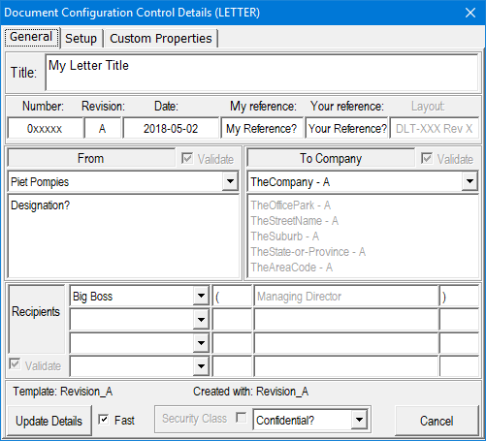

Figure 22: Document Configuration Control Details –  
Letter Template General Tab Sheet (Locked, with Validation)

1. Pane 4
   1. **Validate:** Checkbox   
      When selected, official recipient company names will be available on the Recipient Company drop‑down list.
   2. **Recipient Company:** Edit box or drop‑down list   
      Insert text if the Validate checkbox is not selected; otherwise, select an item from the predefined drop‑down list.
   3. **Recipient Address:** Edit box   
      Insert text if the Validate checkbox is not selected. This is a multi‑line edit box; a new line is started by pressing Shift-Enter.
2. Pane 5
   1. **Validate:** Checkbox   
      When selected, official recipient names will be available on the series of Recipient Name drop‑down lists.
   2. **Recipient Name:** Edit box or drop‑down list (series of 4)   
      Insert text if the Validate checkbox is not selected; otherwise, select an item from the predefined drop‑down list.
   3. **Recipient Designation (Prefix):** Edit box (series of 4)   
      Insert text.
   4. **Recipient Designation:** Edit box (series of 4)   
      Insert text if the Validate checkbox is not selected.
   5. **Recipient Designation (Postfix):** Edit box (series of 4)   
      Insert text.
3. Pane 6
   1. **Template:** and **Created with:** Labels   
      Not editable. These labels display information about the current template revision and the template revision that was used to create the document. If the official document structure has changed from the revision used to create the document, the latter field will be displayed in red with a warning.
   2. **Update Details:** Button   
      The Update Details button applies all metadata changes and updates the document throughout.
   3. **Cancel:** Button   
      Cancels the update, closes the form and returns focus to the document.
   4. **Security Classification:** Checkbox and drop‑down list   
      Insert text if the checkbox is not selected; otherwise, select an item from the predefined drop‑down list.

###### Setup tab sheet

Figure 23 and Figure 24 show the Letter Template’s Setup tab sheet. All functionality is exactly as explained in paragraph 4.3.1.1.1.3.

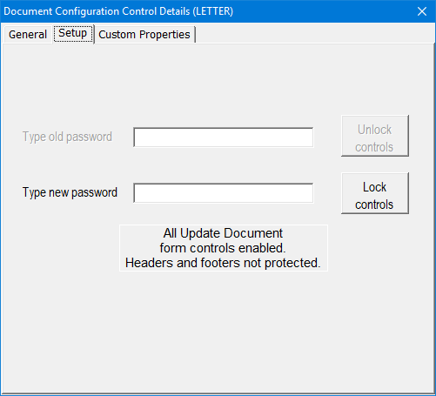

Figure 23: Document Configuration Control Details –  
Letter Template Setup Tab Sheet

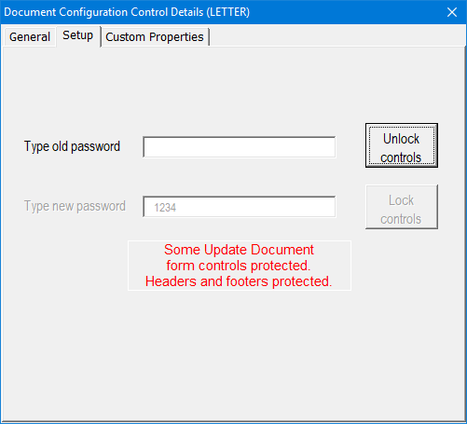

Figure 24: Document Configuration Control Details –  
Letter Template Setup Tab Sheet (Locked)

###### Custom Properties tab sheet

Figure 25 shows the Letter template’s Custom Properties tab sheet. All functionality is exactly as explained in paragraph 4.3.1.1.1.4.

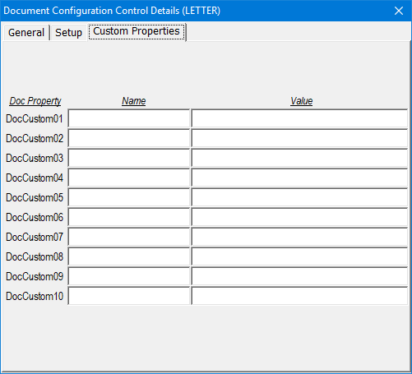

Figure 25: Document Configuration Control Details –  
Letter Template Custom Properties Tab Sheet

#### Export Properties ActiveDocument.InlineShape - 45 of 116

This utility will export all custom document properties used in any particular document to a text file for importing these properties into another document based on the same template. It is very handy when copying old document content based on a previous version of the template to a new document based on a new version of the template.

#### Import Properties ActiveDocument.InlineShape - 46 of 116

This utility will import all document properties that have been exported with the ‘Export Document Properties’ utility from another document into the current document.

#### Export Config ActiveDocument.InlineShape - 47 of 116

This utility will export all custom document properties used in any particular document to a text file for import into the Product Data Management System (PDMS) workbook (PDMS_Interface.xlsm) or company PDMS if the interface code supplied has been implemented. The exported data will be written to a text file in the same folder as the current document with the filename being the same as that of the current document, but concatenated with ‘.Config.txt’. Refer to paragraph b.

#### Import Config ActiveDocument.InlineShape - 48 of 116

This utility will import all custom document properties from a text file as exported by the PDMS workbook (PDMS_Interface.xlsm) or company PDMS if the interface code supplied has been implemented. Run the Update Document utility after import to apply the changed metadata information throughout the document. Refer to paragraph b.

### Page Setup Group

When using these utilities no manual applying of properties and/or settings are necessary to correctly format and/or insert landscape and portrait sections. This is contrary to the default Microsoft Word behaviour, which is to rotate the source section’s margin settings rather than to retain it independently if the final orientation differs. The source section’s attributes, where the cursor is before applying these utilities, will be inherited but applied consistently and correctly. All headers and footers will also be unique and not linked to previous sections.

#### Insert Landscape ActiveDocument.InlineShape - 49 of 116

This utility (Figure 26) will insert a landscape section inheriting the current cursor position’s section attributes, but applying all the correct margins, formats, headers, footers and page numbering (also see paragraph 4.3.2.5). Options are:

* at the cursor position;
* using the selected text (only if you have text selected); and
* at the end of the document.

Furthermore, the new landscape section can be inserted with a clean header, clean footer, or both.

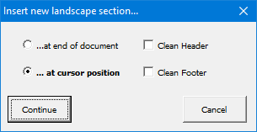 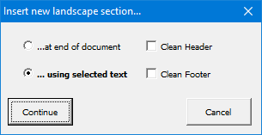

Figure 26: Insert Landscape Form

#### Insert Portrait ActiveDocument.InlineShape - 52 of 116

This utility (Figure 27) will insert a portrait section inheriting the current cursor position’s section attributes, but applying all the correct margins, formats, headers, footers and page numbering (also see paragraph 4.3.2.5). Options are:

* at the cursor position;
* using the selected text (only if you have text selected); and
* at the end of the document.

Furthermore, the new portrait section can be inserted with a clean header, clean footer, or both.

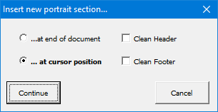 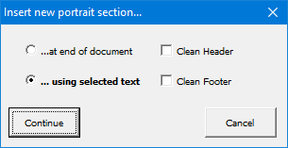

Figure 27: Insert Portrait Form

#### Setup Landscape ActiveDocument.InlineShape - 55 of 116

This utility will format a current section to the correct landscape formatting. The cursor has to be on the landscape section in question. Also see paragraph 4.3.2.5.

#### Setup Portrait ActiveDocument.InlineShape - 56 of 116

This utility will format a current section to the correct portrait formatting. The cursor has to be on the portrait section in question. Also see paragraph 4.3.2.5.

#### Page Defaults ActiveDocument.InlineShape - 57 of 116

This utility (Figure 28) is used to set default page layout parameters that work in conjunction with the Insert Landscape/Portrait and Setup Landscape/Portrait utilities. Whenever one of these utilities is used, the default page layout parameters will be applied consistently.

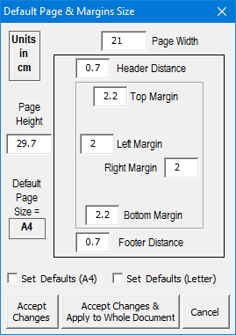

Figure 28: Page Defaults Form

Two predefined page size options exist: A4 and Letter. Applying these checkboxes will populate all the edit boxes with the predefined values, which can be changed afterwards. Other default page sizes are also possible; the user only has to enter the correct page height and width values.

Two options for applying the changes exist: the first will only change the default values without applying them to the document; and the second will change the default values and consistently apply them to all the sections in the document.

### Table Group

#### Format Table ActiveDocument.InlineShape - 59 of 116

This utility will format a new or existing table (to a consistent table standard). It will also format the top row as a table header row. The cursor has to be on the table that is to be formatted.

#### Table Header ActiveDocument.InlineShape - 60 of 116

This utility will only format selected text as table header (to a consistent table standard). The cursor has to be on the table that is to be formatted.

#### Abbreviations ActiveDocument.InlineShape - 61 of 116

This utility will delete the current abbreviations table and compile a new one based on the abbreviations used in the document. The cursor has to be positioned on the abbreviations table. Note that the compiled table will only include abbreviations that are listed in the template database and user abbreviations database. Any other abbreviations used in the document must be added manually to the list. It is a good idea to update the user abbreviations database regularly. This can then be used as input to update the official abbreviations table in the template database.

### Styles Group

#### Outline Numbering ActiveDocument.InlineShape - 62 of 116

This utility (Figure 29) adds outline‑sequence number combination field(s) to paragraphs that need to be numbered according to the outline of a document. Outline number fields can only be inserted after a numbered heading. The default options provide for basic, easy-to-use outline numbering, but the sequence number is fully customizable for advanced users. Automatic outline numbering according to the preceding heading’s outline number is applied, followed by a sequence number with user-customizable field switches. All settings will be remembered for any particular document or company-specific layout document.

|  |  |  |  |
| --- | --- | --- | --- |
|  |  |  |  |
| **(a)** Tab & hanging indent, number position at start of paragraph | **(b)** Number position at start of paragraph | **(c)** Number position at cursor position | **(d)** Number position at end of paragraph |

Figure 29: Outline Numbering – Number Position Options

1. Controlling where and how the outline‑sequence number combination is placed
   1. **Tab & Hanging Indent:** Checkbox   
      When checked, the outline number will be inserted at the start of the paragraph, followed by a tab. The paragraph will be formatted with a hanging indent. When not checked, the number position is user-selectable with the three‑way toggle button, as explained below.
   2. **Number position:** Three‑way toggle button   
      This toggle button only becomes active when the ‘Tab & Hanging Indent?’ checkbox is not checked. The number position can be at the start of the paragraph, at the cursor position or at the end of the paragraph.
   3. **Prefix:** Edit box   
      Insert text. This text will be inserted directly before the outline‑sequence number combination.
   4. **Suffix:** Edit box   
      Insert text. This text will be inserted directly after the outline‑sequence number combination.
   5. **Link to style:** Edit box   
      Insert text. If a valid style name is entered, that style will be applied to the paragraph after the outline‑sequence number combination is inserted.
2. Controlling the sequence number
   1. **Restart sequence:** Checkbox   
      The sequence numbering will be restarted together with a new heading when checked. The field-specific switch that is added automatically in this case will be \s 2 if used after a second-level heading, etc. If left unchecked, the \s n switch will be omitted.
   2. **Sequence-specific switches:** Edit box   
      Insert text. Any valid sequence-specific field switches are allowed (refer to paragraph 4.3.4.1.2). The default is **\# "0"**, which means the sequence numbering will be Arabic and start with a single digit. If, for example, **\# "000"** is used, the sequence numbers will still be Arabic and padded with zeros to make up three digits.
3. General controls
   1. **OK:** Button   
      The OK button inserts the outline‑sequence number combination in the document according to the specified options.
   2. **Cancel:** Button   
      Cancels the action, closes the form and returns focus to the document.

##### Usage examples

Some usage examples are shown here:

(4.3.4.1.1.1) Outline numbered paragraph with all the default options as per Figure 29a. This paragraph has a tab after the outline number and is formatted using a hanging indent.

Outline number inserted inside paragraph (4.3.4.1.1.002) as per Figure 29c with additional opening and closing bracket prefix and suffix as well as changed sequence-specific switch value of **\# "000"**. This paragraph has no tab after the outline number and it is not formatted using a hanging indent.

##### Sequence-specific field switches

For a list of available customizable field switches, open the Field form (Figure 30) and apply sequence-specific field options (Figure 31):

1. With the menu, select Insert → Quick Parts → Field…
2. Sequence field options:
   1. Under Categories:, select Numbering;
   2. Under Field names:, select Seq;
   3. Click on the Options… button.

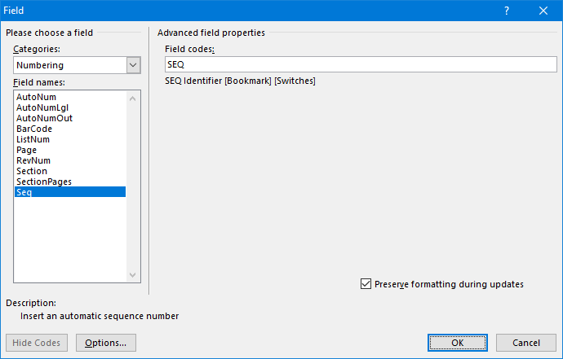

Figure 30: Quick Parts Field Form, Numbering, Sequence

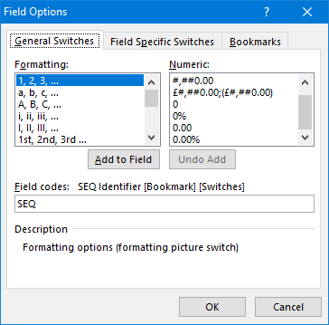

Figure 31: Sequence-specific Field Switches

#### Delete Styles ActiveDocument.InlineShape - 64 of 116

This utility will delete all foreign styles in the active document and replace them with styles from the template. The user is prompted firstly, whether or not to continue deleting all foreign styles (Figure 32); and secondly, whether or not to update the styles from the template (Figure 33).

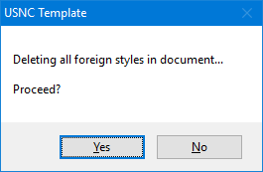

Figure 32: Delete Styles –  
First Prompt

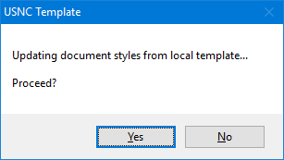

Figure 33: Delete Styles –  
Second Prompt

#### Update Case ActiveDocument.InlineShape - 67 of 116

This utility will apply the correct case formatting to all headings and captions, maintaining upper case for abbreviation and lower case for link words as specified in the template database. Examples of these are:

* Heading 1 **UPPER CASE** FORMATTING IN BOLD 12
* Heading 2 **UPPER CASE** FORMATTING IN BOLD 11
* Heading 3 **Title Case** Formatting in Bold 11
* Heading 4 to 9 **Sentence case** formatting in bold 11
* Caption Figure **Title Case** Formatting in Bold 11
* Caption Table **Title Case** Formatting in Bold 11

### Utils Group

#### Insert Symbol ActiveDocument.InlineShape - 68 of 116

Provision is made for 25 predefined complex symbols (Figure 34) that will be typed at the cursor position. These symbols are fully customizable via the template database (refer to paragraph 5.1j). A prefix and suffix can be combined with a normal symbol to form a complex string combination, e.g. °C. The purpose of this utility is to promote consistency and enhance efficiency when inserting symbols that have not been created with the equation editor, into normal text.

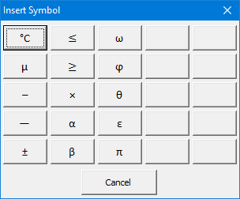

Figure 34: Insert Symbol

#### Insert Equation ActiveDocument.InlineShape - 69 of 116

This utility will insert a numbered equation inside a table in the document using standard Microsoft Word numbering fields for easy cross‑referencing (Figure 35). The default Microsoft Word equation editor is used. This prevents document corruption caused by many third-party utilities with extensive use of equations.

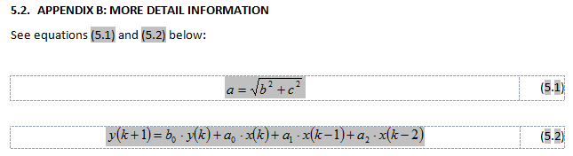

Figure 35: Equation Example

#### Sign Document ActiveDocument.InlineShape - 71 of 116

This utility (Figure 36) will insert an electronic signature at the current cursor location, create a signed, copy-protected PDF document and then delete the signature from the Microsoft Word document if the default options are used. The Browse button is used to select the user’s signature image file as per the signature installation instructions (paragraph 3.4). The Update Fields button will save the editable user settings for future use. The Sign button will proceed with signing the document (without locking it).

Electronic signatures are created by superimposing a green validation tick over the clean user signature and adding an author‑date‑time stamp at the bottom. The result is a single bitmap image where the original signature image cannot be separated easily from the composite signature if scanned or screen captured afterwards. User options are to create a signed copy-protected PDF document, to delete the signature from the Microsoft Word document after signing and lastly to open the signed PDF document afterwards.

**Notes:**

Never save the signature in a Microsoft Word document, as it is not secure, not even if the document is password-protected to restrict editing.

The copy-protected PDF document creation is dependent on BullZip; verify if it is marked secure. If not, redo the procedure. Be aware that copy-protected PDF document passwords can also easily be removed.

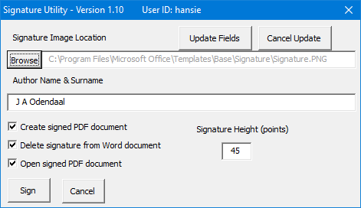

Figure 36: Signature Utility Form – Stand-alone

#### Caption Table ActiveDocument.InlineShape - 73 of 116

This utility will insert a table caption at the beginning of the paragraph and change the style accordingly. Position the cursor directly above the table before applying. A non‑breaking space will also be added between the word Table and the table number that makes up the caption label. This will keep the caption label together on the same line.

#### Caption Figure ActiveDocument.InlineShape - 74 of 116

This utility will insert a figure caption at the beginning of the paragraph and change the style accordingly. Position the cursor directly below the figure in the very next paragraph before applying. A non‑breaking space will also be added between the word Figure and the figure number that makes up the caption label; this will keep the caption label together on the same line.

#### Requirements ActiveDocument.InlineShape - 75 of 116

This utility (Figure 37) will compile a requirements cross‑reference table at the cursor position, based on use of certain list level type styles throughout the document and insert a cross‑reference to the heading number for each requirement. Any list level style’s name starting with ‘Requirement’ will be added to the requirements cross‑reference table. Different options are available to insert requirements; two variations will be explained here.

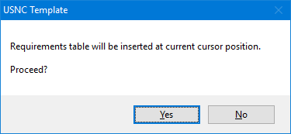

Figure 37: Requirements Form

##### Requirements numbered with list level numbering

The first variation is when a requirement list level type style is defined with the number to be visible. The list level numbers are then used as the requirement numbers and also used in cross‑referencing in the document. Table 2 shows an example.

Table 2: Requirements Utility Usage Example, Type 1

|  |  |  |  |  |  |  |  |  |  |
| --- | --- | --- | --- | --- | --- | --- | --- | --- | --- |
| 1. This is my first Requirement Name, Type 1   This is my requirement description for type 1 requirements. Requirement description is provided below the requirement number, which is visible, and name. These requirement headings will automatically be added to the requirements cross‑reference table.   1. This is my second Requirement Name, Type 1   This is my requirement description for type 1 requirements. Requirement description is provided below the requirement number, which is visible, and name. These requirement headings will automatically be added to the requirements cross‑reference table.  Table 3: Requirements Cross Reference   | No. | Description | Par. | | --- | --- | --- | | Req#001 | This is my first Requirement Name | 4.3.5.6.1 | | Req#002 | This is my second Requirement Name | 4.3.5.6.1 | |

##### Requirements numbered with outline numbering

The second variation is when a requirement list level type style is defined with the number to be hidden. In the example shown in Table 4, outline numbering must be applied to the requirement or requirement name. The outline numbers are then used as the requirement numbers and also used in cross‑referencing in the document.

Table 4: Requirements Utility Usage Example, Type 2

|  |  |  |  |  |  |  |  |  |  |
| --- | --- | --- | --- | --- | --- | --- | --- | --- | --- |
| This is my requirement description for type 2 requirements. Requirement description is provided above the requirement number, which is visible in the Microsoft Word document but hidden in printed form, and name. These requirement headings will automatically be added to the requirements cross‑reference table. The requirement names are also outline numbered.   1. This is my first Requirement Name, Type 2 (4.3.5.6.2.001)   This is my requirement description for type 2 requirements. Requirement description is provided above the requirement number, which is visible in the Microsoft Word document but hidden in printed form, and name. These requirement headings will automatically be added to the requirements cross‑reference table. The requirement names are also outline numbered.   1. This is my second Requirement Name, Type 2 (4.3.5.6.2.002)   Table 5: Requirements Cross Reference   |  |  |  | | --- | --- | --- | | No. | Description | Par. | | R#001 | This is my first Requirement Name, Type 2 (4.3.5.6.2.001) | 4.3.5.6.2. | | R#002 | This is my second Requirement Name, Type 2 (4.3.5.6.2.002) | 4.3.5.6.2. | |

#### Clauses

This utility (Figure 38) is used to embed and remove template managed Rich Text Content Controls and to assign one or more pre‑defined text clauses from the clauses database (paragraph 5.5) to its content. The content controls can be embedded in any type of paragraph or inside tables. Optimal use will be derived if these content controls are embedded in empty paragraphs or table cells due to a length restriction when updating the content programmatically.

The paragraph style of each selected clause can be applied as specified in the clauses database (paragraph 5.5) or by selecting a single style for all selected clauses. The content of the content controls can only be changed manually if a special procedure is followed.

|  |  |
| --- | --- |
|  |  |
| **(a)** Default | **(b)** Inserted Content Controls |

Figure 38: Clauses Utility Form

1. Pane 1: New Content Control
   1. **Insert:** Button   
      A Rich Text Content Control will be inserted in the document at the current cursor position with the name provided in the Control Name edit box. It will be locked for user editing and deletion. The form must be closed and the cursor repositioned to insert multiple content controls in the document.
   2. **New Control Name:** Edit box   
      Insert text.
2. Pane 2: Managing Controls & Text
   1. **Content Control:** Drop‑down list   
      The Select drop‑down list will be populated with all template managed content controls in the document. Select the content control to manage.
   2. **Remove Control:** Button   
      The content control selected in the Content Control drop‑down list will be deleted.
   3. **Remove All Controls:** Button   
      All template managed content controls will be deleted.
   4. **Insert Text:** Button   
      The associated text of the selected/highlighted clauses for the given information category will be used to update the content of the embedded content control selected with the Content Control drop‑down list.
   5. **Clear Text:** Button   
      The content of the embedded content control selected with the Content Control drop‑down list will be cleared.
   6. **Default Styles:** Check box   
      When checked, the paragraph style of each selected clause will be determined by its pre‑defined style in the clauses database (paragraph 5.5). When not checked, a single style according to the Style drop‑down list will be applied to all selected clauses.
   7. **Style:** Drop‑down list   
      When the Default Styles check box is checked, the Style drop‑down list is enabled and a style can be selected. The selected style will be applied to all selected clauses.
3. Pane 3: Category & Clause Name
   1. **Category:** Drop‑down list   
      The Category drop‑down list will be populated with all information categories present in the clauses database (paragraph 5.5). Select the information category to choose clauses from.
   2. **Clause Names:** List box   
      The Clause Names list box will be populated with all clause names for the selected information category present in the clauses database (paragraph 5.5). Multiple clause selections are possible. All associated text corresponding to the selected clause names will be assigned to the selected content control as its content.
4. General controls
   1. **Verify All Text Clauses:** Button   
      This action will compare the text of all template managed content controls to the clauses information in the clauses database (paragraph 5.5). The user will have a choice to update each content control with text differences.
   2. **Force Update:** Check box   
      When checked, the Verify All Text Clauses behaviour will offer updating of each template managed content control, not only those with text differences when compared to the clauses database (paragraph 5.5).
   3. **Close:** Button   
      Closes the form and returns focus to the document.

## Embedded Fields

Embedded fields are visually shown in the document on purpose by programmatically setting the Microsoft Word option ‘Field shading: [Always]’. These fields include the TOC; numbering counters in figure and table captions; all cross‑references; and all embedded custom document property fields. The shading will not be visible when printing the document or when creating a PDF.

Headers and footers contain important custom document property fields and, based on the Microsoft Word template type, usually the front page or title page as well. These embedded fields should not be deleted or typed over, because then they will not be updated automatically when applying the Update Document utility from the company ribbon.

## Custom Document Properties

### Showing Default Values

Custom document properties are used to control all metadata used in the document.

Some of these are used as embedded fields to visually show selected information as explained in paragraph 0. To see a list of all custom document properties, select the Advanced Document Properties dialogue box launcher as shown in Figure 39 and then select the Custom tab sheet as shown in Figure 40. If need be, these custom document properties can then be edited manually. However, caution is advised, as this may break the coherency in a document.

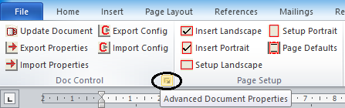

Figure 39: Launching Custom Document Properties  
via Company Ribbon

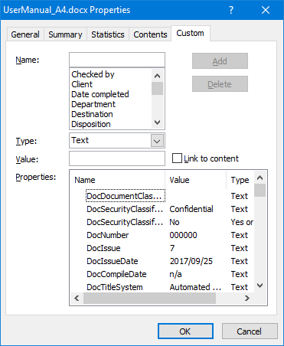

Figure 40: Custom Document Properties  
Dialogue Box (1)

### Manipulating Table of Contents (TOC)

Different regional settings between users’ computers can change the behaviour of the TOC. Styles marked to be included in the TOC may work on one computer but not on the next, due to different list separators defined in users’ regional settings. To circumvent this problem, styles marked to be included in the TOC can be selected by the user and then be programmatically entered into the TOC embedded field while applying the correct list separator for that user’s computer.

Styles that are recognized by default to be included in the TOC together with the selected heading level (refer to paragraph 4.3.1.1.1.1dv on page 19) are HEADER ABBREVIATIONS, ARTICLE and APPENDIX. Five styles, excluding headings, may be defined to be included in the TOC. These styles are configured by manually editing the custom document properties called DocTOCStyles1 to DocTOCStyles5 (Figure 41).

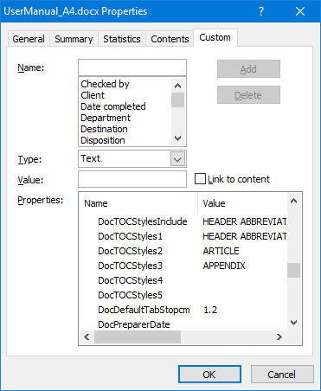

Figure 41: Custom Document Properties  
Dialogue Box (2)

### Manipulating Default Tab Stop

The default tab stop is preset at 1.2 cm. This setting may be changed by manually editing the custom document property called DocDefaultTabStopcm (Figure 42).

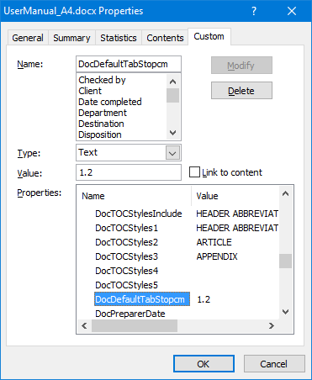

Figure 42: Default Tab Stop Custom  
Document Property

### Manipulating First Page Header/Footer in a Section

By default, all headers and footers are forced to be similar; no different first page or different odd and even header/footer combinations. All sections start on a next page and page numbers continue from the previous page. This behaviour is enforced every time the document details are updated with the Update Details Button according to paragraph 4.3.1.1. If this behaviour is not required and should not be enforced, the custom document property called ‘DocNoForceSectionSetup’ must be changed to ‘Yes’ (Figure 43). Custom document property ‘Doc2ndSectionContinuous’ only applies to the very first section of the document and if changed to ‘Yes’ (Figure 43) will only allow the second section to start continuous. This is very handy for single page documents like letter heads where consecutive section headers and footers can be ‘hidden’ on the first page. These two custom document properties are also evaluated every time the page setup methods are applied (paragraph 4.3.2).

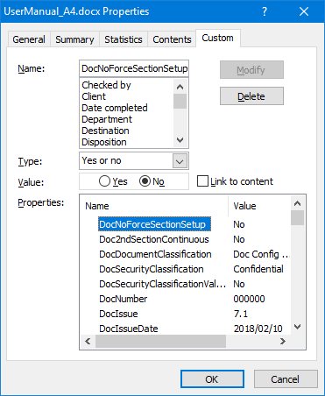 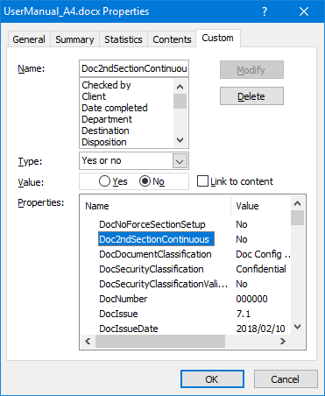

Figure 43: DocNoForceSectionSetup, Doc2ndSectionContinuous   
Custom Document Properties

**Note:** The document details update procedure paragraph 4.3.1.1.1.1dii on page 19) ensures that no header or footer is linked to the previous header or footer; this is required for the Page Setup Group (paragraph 4.3.2) automation to work properly.

### Manipulating Default Document Language

Preset default document language can be set to ‘English (U.K.)’, ‘English (U.S.)’, ‘English (South Africa)’ with the custom document property called DocLanguage. This ensures that mixed languages are not present in the document text and that language proofing is always enabled. All text will also be changed to the preset default language. This behaviour is enforced every time the document details are updated according to paragraph 4.3.1.1.1.1dii on page 19. If this behaviour is not required and should not be enforced, the DocLanguage custom document property must be changed to ‘n/a’ (Figure 44).

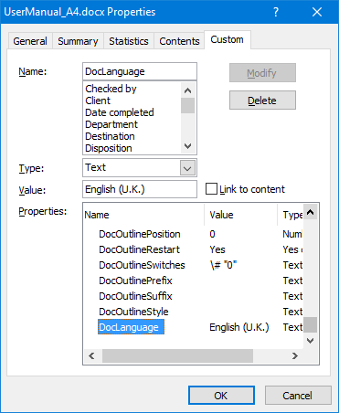

Figure 44: Default Document Language  
Custom Document Property

### User-definable Custom Document Properties

User-definable custom document properties can be inserted anywhere in the text as a field, as long as they are not inserted inside any other field. Provision is made for 20 user-definable custom document properties that are managed via the respective templates’ Custom Properties Tab Sheet of the Document Configuration Control Details form (refer to paragraphs 4.3.1.1.1.4, 4.3.1.1.2.4 and 4.3.1.1.3.3). These custom document properties are named DocCustom01Name to DocCustom10Name and DocCustom01Value to DocCustom10Value (Figure 45).

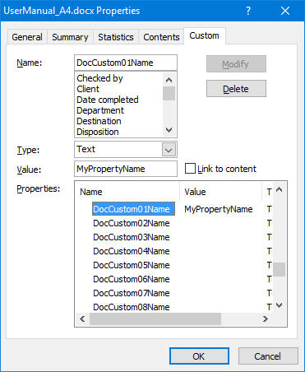 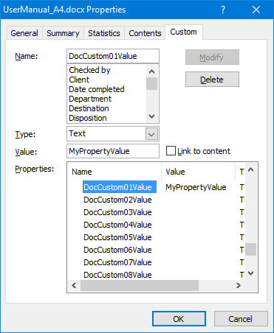

Figure 45: User-definable Custom Document Properties

The procedure to insert these managed custom document properties into the document text is as follows:

1. Position the cursor at the required location and ensure it is not inside any other field (*all fields are automatically highlighted for easy identification*).
2. Insert the field (Figure 46):
   1. With the menu select Insert → Quick Parts → Field…
   2. Under Categories:, select Document Information.
   3. Under Field names:, select DocProperty.
   4. Under Property:, select the required managed custom document property.
   5. Click on the OK button to insert the field into the document text.
3. Repeat the procedure for each required managed custom document property to be inserted into the document text.

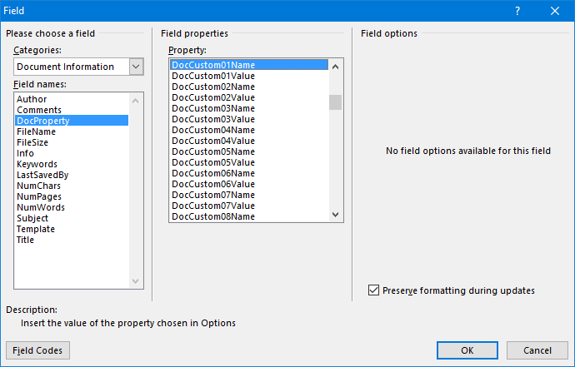

Figure 46: Insert Managed Custom Document Properties into Document Text

## Creating Forms with Restricted Editing that Users can Complete

This functionality is best used in conjunction with the Form template.

### Developer Tab and Ribbon

If it is not already enabled, the first step is to enable the Developer tab, which has the required edit controls on the ribbon (Figure 47):

* Microsoft Word 2007: From the menu, select ‘Office Button’ → ‘Word Options’ → ‘Popular’, then enable ‘Show Developer tab in the Ribbon’.
* Microsoft Word 2010, 2013 and 2016: From the menu, select ‘File’ → ‘Options’ → ‘Customize Ribbon’. Under ‘Customize the Ribbon’ on the right, ensure ‘Main Tabs’ is selected in the drop‑down list, then enable ‘Developer’.

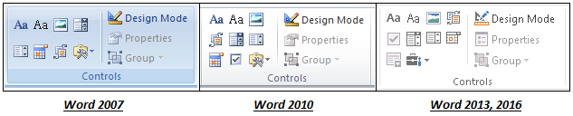

Figure 47: Controls Group on Developer Ribbon

### Basic Empty Form and Signatory Blocks

The second step is to start a new document based on the Form template (refer to paragraph 4.1) and to select all signatories that need to be included on the form on the Approval tab sheet (Figure 13). This will create an empty single section form with standard headers and footers, as well as place holders for all signatories and corresponding signing dates (Appendix B).

Tables are suggested for signatory blocks, due to the fact that sizing can be controlled and they can easily be combined. The first signatory block corresponds to the first signatory on the Approval tab sheet (Figure 13), the second signatory block to the second signatory on the Approval tab sheet, etc. All signatory blocks in the form that are not needed can then be deleted.

#### Reapplying formatting to signatory blocks – default formatting

The signatory blocks can be formatted or reformatted at any time, using the macro that has been made available. The form creator has a choice to apply the default formatting or to apply custom sizes. This formatting does not apply any inside or outside borders to the signatory block table; this is left up to the form creator. To apply the default formatting, select two rows and three columns of the table in question (Figure 48) and then simultaneously press ALT-F8.

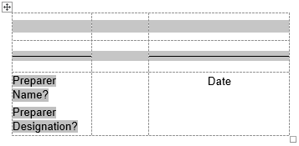

Figure 48: Formatting Signatory Block –  
Select Two Rows and Three Columns

The dialogue box in Figure 49 will appear. Use the drop‑down box arrow next to ‘Macros in:’ to select ‘BaseTemplate.dotm (global template)’. Then select the macro called ‘FormatFormSignatoryBlock’ and click on ‘Run’.

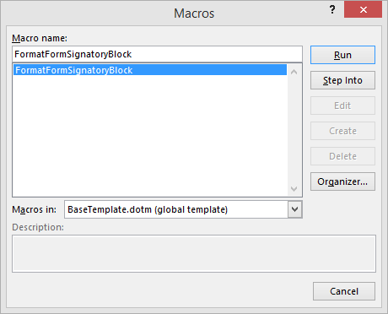

Figure 49: Formatting Signatory Block –  
Default Macro Selection

The formatting macro will execute. Figure 50 shows the result:

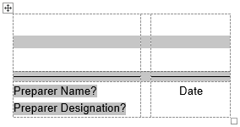

Figure 50: Formatting Signatory Block –  
Result

#### Reapplying formatting to signatory blocks – custom formatting

The first half of this application is intended for advanced Microsoft Word users that have been exposed to creating macros using the Visual Basic for Applications (VBA) editor. After the custom formatting macro has been created, it can be applied by any user.

##### Creating the macro

To apply customized formatting to the signatory blocks, create a macro in the Normal Project (Microsoft Word’s normal template) that calls the FormatFormSignatoryBlockCustom subroutine in BaseTemplate.dotm. The subroutine is called with the custom row and/or column sizes as parameters, thereby overriding the default sizes.

Such a macro is created using the VBA editor, which is accessible by pressing ALT‑F11 simultaneously when Microsoft Word is open. Insert a new module by right-clicking on Normal in the Project Explorer view; then select Insert → Module. Also include a reference to BaseTemplate.dotm (paragraph 2.2.1) as part of the Normal Project in the VBA editor. This is done with menu option ‘Tools → References’, browsing to the template, opening it and confirming the selection (Figure 51).

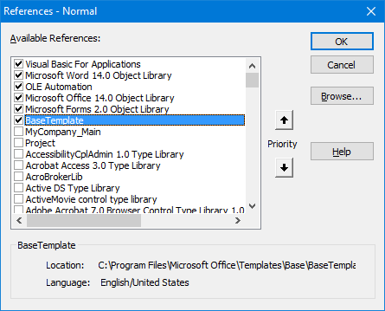

Figure 51: Custom Signatory Block Formatting –  
Reference to BaseTemplate

The example macro code in Figure 52 illustrates how to do this, and also gives the default row and column sizes. In this example, the height of the first row will 2.1 cm instead of the default 1.8 cm and the width of the second column will be 0.5 cm instead of 0.3 cm.

|  |
| --- |
| Public Sub MyCustomMacroThatFormatFormSignatoryBlock()  ‘Public Sub FormatFormSignatoryBlockCustom(  ‘ Optional heightRow1 As Double = 1.8,  ‘ Optional heightRow2 As Double = 0.3,  ‘ Optional widthColumn1 As Double = 4.0,  ‘ Optional widthColumn2 As Double = 0.3,  ‘ Optional widthColumn3 As Double = 2.5  ‘)    FormatFormSignatoryBlockCustom _  heightRow1:=2.1, _  widthColumn2:=0.5  End Sub |

Figure 52: Custom Signatory Block Formatting – Macro Example

##### Using the macro

After this macro has been created, follow the same procedure as described in paragraph 4.6.2.1, except select ‘Normal.dotm (global template)’ in the drop‑down box and then select your custom macro and click on ‘Run’ (Figure 53).

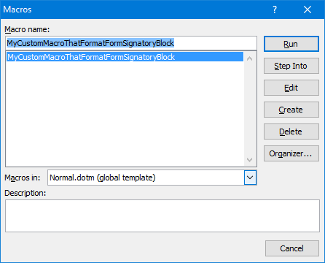

Figure 53: Custom Signatory Block Formatting –  
Custom Macro Selection

### Form Fields/Content Controls

Form fields/content controls (checkboxes, text boxes, date pickers, drop‑down lists, etc.) are added to the document from the Controls group on the Developer ribbon (Figure 47), wherever users are allowed to insert information.

Each content control has properties that can be set or changed. For example, the date picker control offers options for the date format. Instructional text can enhance the usability of the form. The default instructional text in content controls can be changed.

In a rich text content control, users can format text as bold or italics, and they can type multiple paragraphs. Plain text content controls limit what users can add. A picture control is placed where users may insert a picture in a form.

Building block controls are used when users need to choose a specific block of text, e.g. different boilerplate text in a contract template, depending on the contract’s specific requirements.

In a combo box, users can select from a list of predefined choices or can type in their own information. In a drop‑down list, users can only select from the list of predefined choices.

### Protecting the Form

After the form has been created, it can be protected to only allow editing to the form fields/content controls placed in the form. This is done using the procedure explained in paragraph 4.3.1.1.2.3.

## Tips and Tricks

### How to Copy Old Document Content into a New Document

To apply the latest release of the template to a document based on a prior version of the template:

1. Update the template according to the procedure outlined in paragraphs 4.3.1.1.1 to 4.3.1.1.2.4.
2. Open your ‘old’ document.
3. Create a new document according to the procedure outlined in paragraph 4.1 and using the correct template.
4. Accept all the prompts and save the new document with a new name. You will now have two documents open.
5. Select your ‘old’ document. Using the company ribbon, select Export Properties.
6. Select your ‘new’ document. Using the company ribbon, select Import Properties. This will copy all user input data on the Document Configuration Control Details form from the ‘old’ document to the ‘new’ document. (Select the ‘coffee cup’ in the new document from the company ribbon to verify this.)
7. With your old document, from the company ribbon, select Delete Styles to remove any unwanted styles.
8. Now you can copy the contents of your ‘old’ document into your ‘new’ document:
   1. Copy and paste the contents of ‘ABSTRACT’.
   2. Copy and paste the contents of the ‘Document History’ table – select the respective cells only, do not include the table header in your selection.
   3. Copy and paste the contents of the ‘ABBREVIATIONS’ table.
   4. Copy and paste the contents of the table under ‘REFERENCES’ into the new table – select the respective cells only; do not include the table header in your selection.
9. The main body of the document can now be copied. These are general guidelines:
   1. Make sure the ‘reveal codes’ or ‘formatting marks’ are visible – this can be switched on from the Home ribbon by selecting the paragraph mark.¶
   2. Do not select section breaks, as this will erroneously copy the old headers and footers into the ‘new’ document.
   3. If you need multiple sections in your ‘new’ document, use the company ribbon options Insert Landscape and/or Insert Portrait to create these sections, and then only copy the contents of the corresponding section from your ‘old’ document.
   4. Never select and copy the very last paragraph mark from your ‘old’ document, as this could copy hidden information, which you do not want.
10. Using the company ribbon, select Update Document and then the Update Details button to effect the changes.
11. Save your ‘new’ document.

### Last Page Orientation Format

Last page orientation format (landscape vs portrait):

1. If the orientation of the last page of your document is different from the one before it, and if it is a blank page that you want to delete; or
2. If the orientation of the last page of your document is different from the one before it, and if you want to change it so that it is consistent, do the following:
   1. Position your cursor anywhere on the last page.
   2. From the company ribbon, select the Setup Landscape utility if the page has a portrait orientation or Setup Portrait if the page has a landscape orientation.
   3. Ensure that you can see all the reveal codes; this can be switched on from the Home ribbon by selecting the paragraph mark.¶
   4. Position the cursor after the paragraph mark and directly in front of the section break.
   5. Press ‘Delete’.
   6. If there is an additional paragraph mark that you want to remove, position your cursor in front of it, and press ‘Delete’.

### Formatting

1. Always work with formatting marks turned on; this can be switched on from the Home ribbon by selecting the paragraph mark. The most beneficial of these formatting marks are tab characters, spaces and paragraph marks. They will show you exactly what is going on ‘behind the scenes’ in your document.
2. Do not manually type in paragraph or list numbers. Use the paragraph or list numbering styles available for numbering, also to be found on the style drop‑down list.
3. Use the Format Table button from the company ribbon to format tables.
4. Use only the existing template styles and do not attempt to change them:
   1. Company documents should have a consistent appearance. Therefore only use the styles as defined by the template. Do not attempt to change the existing template styles in any way. For example, if bullets are required, select the style drop‑down list from the formatting toolbar and apply the correct style from there.
   2. Do not introduce any new styles into the style sheet. To prevent the introduction of new styles into the style sheet, do not copy any formatted text into the template‑based document. Rather copy foreign text and paste it into the template as unformatted text. The text can then be formatted using the template styles.
   3. If unique styling is required (e.g. italics inside a paragraph that is not a predefined style), select the text to be formatted and apply the required formatting from the Home ribbon.
   4. Do not insert hard returns (by using the Enter key) to separate paragraphs. It is not necessary to insert hard returns, as paragraph spacing is built into the styles.
5. Use the company ribbon to format figure and table captions:
   1. Do not try to manually change figure and table numbers.
   2. There are buttons on the company ribbon for applying figure and table numbers and styles to captions.
   3. With your cursor positioned on the caption, click on ‘Caption Figure’ and ‘Caption Table’, as required.
   4. After inserting a figure into a document, insert only one hard return after a figure, before the caption.
   5. No return should be inserted before or after a table caption.
   6. Please note that a figure caption appears below a figure, and a table caption appears above a table.
   7. Captions are typed in upper and lower case.

### Graphics in Documents

Do not add labels to a figure in Microsoft Word. Rather copy the figure to a drawing package such as Visio or PowerPoint, add the labels to the figure in the drawing package, save it as a Windows Metafile type picture, and insert it as a picture using the Picture option from the Illustrations group on the Insert ribbon. Remember to format the picture as ‘In line with text’.

# Linked Databases

## Template Database

The template database (paragraph 2.1.2) contains general information regarding the Automated Template System. These tables may be edited by any user, but all changes will be overwritten when the Automated Template System is updated. It is thus important to centrally manage and change this database and distribute it via the Automated Template System release package.

Tables included in the database are:

1. Abbreviations

This table defines abbreviations that can be automatically recognized when using the Abbreviations utility (paragraph 4.3.3.3) to compile an abbreviations table in the document.

|  |  |
| --- | --- |
| **Abbreviation** | **Description** |
| 2D | two-dimensional |
| 3D | three-dimensional |
| AA | Application Activity |
| AACE | Association of American Cost Engineers |
| AADQ | Annual Authorized Discharge Quantities |

1. AbbreviationsSpecial

This table defines abbreviations that consist of two or more groups of characters such that it is not recognizable as a single word in a find all words operation. Special find methods are used to recognize these abbreviations when using the Abbreviations utility (paragraph 4.3.3.3) to compile an abbreviations table in the document.

|  |  |
| --- | --- |
| **Abbreviation** | **Description** |
| ach/h | air changes per hour |
| BE&UA | Best Estimate and Uncertainty Analysis |
| C&B | Civil and Building |
| C&I | Control and Instrumentation |
| C&MF | Calculation and Monitoring Functions |

1. CaseWords

This table defines words that should always be lower case when applying title case formatting to a text selection, e.g. ‘This **is** **a** Table **of** Contents’. It is used in conjunction with the Update Case utility (paragraph 4.3.4.3).

|  |
| --- |
| **CaseWord** |
| a |
| about |
| above |
| after |
| against |

1. Exclusions

This table defines abbreviations that are also commonly used as normal words, such as sea/SEA, case/CASE and rod/ROD. These words are ignored if they are part of a heading or caption when using the Abbreviations utility (paragraph 4.3.3.3) or Update Case utility (paragraph 4.3.4.3).

|  |
| --- |
| **Abbreviation** |
| SEA |
| ROD |
| CASE |

1. StyleCases

This table defines the case formatting to be applied to headings and captions when using the Update Case utility (paragraph 4.3.4.3).

|  |  |  |  |
| --- | --- | --- | --- |
| **Style** | **_Main** | **_Letter** | **_Form** |
| **Heading 1** | Upper | Title | Upper |
| **Heading 2** | Upper | Title | Title |
| **Heading 3** | Title | Title | Title |
| **Heading 4** | Sentence | Sentence | Sentence |
| **Heading 5** | Sentence | Sentence | Sentence |

1. Styles

This table defines allowed style names for each document template type. It is used in conjunction with the Delete Styles utility (paragraph 4.3.4.1.2).

|  |  |  |
| --- | --- | --- |
| **_Main** | **_Letter** | **_Form** |
| Appendix | Appendix | Appendix |
| Article | Article | Article |
| Caption | Caption | Caption |
| Caption Table | Caption Table | Caption Table |
| Document Map | Document Map | Document Map |

1. DocumentTypes

This table defines the contents of the Title – Type drop‑down list when using the Update Document utility (paragraphs 4.3.1.1.1.1 and 4.3.1.1.2.1).

|  |  |
| --- | --- |
| **TitleType** | **Description** |
| Description | Describe a planned or actual function, design, performance, or process |
| Manual | Define guidelines in order to give assistance to people using a particular system |
| Procedure | Define in detail when and how to perform certain jobs, including needed tools |
| Report | Describe the results of activities such as investigations, assessments, and tests |
| Request | Record information needed to solicit a response |

1. SecurityClassification

This table defines the contents of the Security Classification drop‑down list when using the Update Document utility (paragraphs 4.3.1.1.1.1, 4.3.1.1.2.1 and 4.3.1.1.3.1).

|  |
| --- |
| **SecurityClassification** |
| Proprietary Class 1 |
| Proprietary Class 2 |
| Proprietary Class 3 |

1. ReleaseStatus

This table defines the contents of the Release Status drop‑down list when using the Update Document utility (paragraphs 4.3.1.1.1.1 and 4.3.1.1.2.1).

|  |
| --- |
| **ReleaseStatus** |
| Draft |
| Approved |

1. Symbols

This table defines the contents of the Insert Symbol form when using the Insert Symbol utility (paragraph 4.3.5.1). The symbols must be defined by their Unicode (hexadecimal) values. Display Name is shown on the form and Prefix Symbol Suffix is typed in the document appended to each other without spaces.

|  |  |  |  |  |  |  |
| --- | --- | --- | --- | --- | --- | --- |
| **Position** | **Name** | **Display Name** | **Font** | **Prefix** | **Unicode (hex)** | **Suffix** |
| Row 1 Column 1 | Degree Sign & C | °C | Arial |  | 00B0 | C |
| Row 2 Column 1 | Micro Sign | μ | Arial |  | 03BC |  |
| Row 3 Column 1 | En Dash | – | Arial |  | 2013 |  |
| Row 4 Column 1 | Em Dash | — | Arial |  | 2014 |  |
| Row 5 Column 1 | Plus-Minus Sign | ± | Arial |  | 00B1 |  |

## Business Contacts Database

### Contents

The business contacts database (paragraph 2.1.3) is used to populate business contact details in documents based on the default Letter Microsoft Word template. It may be edited by any user, but all changes will be overwritten when the Automated Template System is updated. It is thus important to centrally manage and change this database and distribute it via the Automated Template System release package. This database defines the contents of the recipient’s company, company address, name and designation when using the Letter template’s Update Document utility (paragraph 4.3.1.1.3.1).

The following tables, with pre‑populated example data, are included in the database:

1. BusinessContacts

All entries in the Company column are selected with a drop‑down list of values defined in the Companies table.

| **#** | **Contact Name** | **Contact Designation** | **Company** |
| --- | --- | --- | --- |
| 1 | Big Boss | Managing Director | TheCompany - A |
| 2 | Secret Fairy | Executive Secretary | TheCompany - A |
| 3 | Eat Rite | Dietitian | TheCompany - A |
| 4 | Money Spender | Procurement Officer | TheCompany - A |
| 5 | Money Guru | Financial Director | TheCompany - B |
| 6 | Clean Alldays | Janitor | TheCompany - B |
| 7 | Nosey Nellie | Receptionist | TheCompany - B |

1. Companies

Each address line in the Company Address column must be separated with ALT‑Enter for the address information to appear like that in a letter document.

| **#** | **Company** | **Company Address** |
| --- | --- | --- |
| 1 | TheCompany - A | TheOfficePark - A TheStreetName - A TheSuburb - A TheState-or-Province - A TheAreaCode - A |
| 2 | TheCompany - B | TheOfficePark - B TheStreetName - B TheSuburb - B TheState-or-Province - B TheAreaCode - B |

### Using the Embedded Macro

If any basic data is added or changed, the built‑in macro ‘ResetDataValidationRanges’ must be used to reset data validation ranges. This will then encircle all invalid entries throughout the database, upon which the user then has the chance to correct it by choosing a valid data entry from the corresponding drop‑down list. This macro is launched with ALT-F8.

## User Abbreviations Database

The user abbreviations database (paragraph 2.1.4) contains additional abbreviations that can be added by the owning user. This database is not overwritten when the Automated Template System is updated.

Tables included in the database, with pre‑populated example data, are:

1. Abbreviations

This table defines abbreviations that can be automatically recognized when using the Abbreviations utility (paragraph 4.3.3.3) to compile an abbreviations table in the document.

|  |  |
| --- | --- |
| **Abbreviation** | **Description** |
| ABCDWXYZ | My Normal Abbreviation Description |

1. AbbreviationsSpecial

This table defines abbreviations that consist of two or more groups of characters such that it is not recognizable as a single word in a find all words operation. Special find methods are used to recognize these abbreviations when using the Abbreviations utility (paragraph 4.3.3.3) to compile an abbreviations table in the document.

|  |  |
| --- | --- |
| **Abbreviation** | **Description** |
| ABCD/WXYZ | My Special Abbreviation Description |
| ABCD&WXYZ | My Special Abbreviation Description |
| ABCD-WXYZ | My Special Abbreviation Description |
| ABCD.WXYZ. | My Special Abbreviation Description |

## Resources and Competencies Database

The resources and competencies database (paragraph 2.1.5) contains resource information with its competency graded according to specific competency areas, competency functions and a particular project phase. These tables may be edited by any user, but all changes will be overwritten when the Automated Template System is updated. It is thus important to centrally manage and change this database and distribute it via the Automated Template System release package.

Tables included in the database, with pre‑populated example data, are:

1. Competencies

This table defines which resources can perform selected competency functions based on competency area and project phase if competency validation is enabled. It is used to populate the resource drop‑down list when using with the Update Document utility (paragraphs 4.3.1.1.1.2 and 4.3.1.1.2.2).

|  |  |  |  |
| --- | --- | --- | --- |
| **Person & ID_Number** | **CompetencyFunction** | **CompetencyArea** | **ProjectPhase** |
| John Doe - 6402224444669 | External Reviewer | Basic Reactor Systems | 5 - Concept, Basic, Detail |
| John Doe - 6402224444669 | Preparer | Reactor - Neutronic | 5 - Concept, Basic, Detail |
| John Doe - 6402224444669 | Release Reviewer | Reactor - Neutronic | 5 - Concept, Basic, Detail |
| Piet Pompies - 6705033333558 | Comments Reviewer | Reactor - Neutronic | 5 - Concept, Basic, Detail |
| Piet Pompies - 6705033333558 | Comments Reviewer | Building & Civils | 5 - Concept, Basic, Detail |
| Piet Pompies - 6705033333558 | Approver | Basic Reactor Systems | 5 - Concept, Basic, Detail |
| Another Brother - 9404301234670 | Comments Reviewer | Reactor - Neutronic | 1 - Concept |
| Another Brother - 9404301234670 | Comments Reviewer | Building & Civils | 1 - Concept |
| Koos Koekemoer - 8702013473555 | Comments Reviewer | Basic Reactor Systems | 6 - n/a |

1. CompetencyAreas

This table defines the available competency areas. It is used to populate the competency areas drop‑down list when using the Update Document utility (paragraphs 4.3.1.1.1.2 and 4.3.1.1.2.2).

|  |
| --- |
| **CompetencyArea** |
| All Reactor Systems |
| Reactor - Neutronic |
| Building & Civils |

1. CompetencyFunctions

This table defines the available competency functions. It is used to populate the competency functions’ drop‑down lists when using the Update Document utility (paragraphs 4.3.1.1.1.2 and 4.3.1.1.2.2). The second column indicates which competency function appears first on the Approval tab sheet (marked by ‘Begin’) and which one last (marked by ‘End’). All other competency functions (marked by ‘n/a’) are available for selection in all other drop‑down lists.

|  |  |
| --- | --- |
| **CompetencyFunction** | **Workflow (Begin, n/a, End)** |
| Preparer | Begin |
| Comments Reviewer | n/a |
| Release Reviewer | n/a |
| Quality Reviewer | n/a |
| External Reviewer | n/a |
| Approver | End |

1. ProjectPhases

This table defines the available project phases. It is used to populate the project phases drop‑down list when using the when using the Update Document utility (paragraphs 4.3.1.1.1.1 and 4.3.1.1.2.1).

|  |
| --- |
| **ProjectPhase** |
| 1 - Concept |
| 2 - Concept, Basic |
| 3 - Basic, Detail |
| 4 - Detail |
| 5 - Concept, Basic, Detail |
| 6 - n/a |

1. Resources

This table defines all the available resources if competency validation is not enabled. It is used to populate the resource drop‑down list when using the Update Document utility (paragraphs 4.3.1.1.1.2, 4.3.1.1.2.2 and 4.3.1.1.3.1).

|  |  |  |
| --- | --- | --- |
| **ID_Number** | **Person** | **Person & ID_Number** |
| 6705033333558 | Piet Pompies | Piet Pompies - 6705033333558 |
| 6402224444669 | John Doe | John Doe - 6402224444669 |
| 9404301234670 | Another Brother | Another Brother - 9404301234670 |
| 8702013473555 | Koos Koekemoer | Koos Koekemoer - 8702013473555 |

## Clauses Database

### Contents

The clauses database (paragraph 2.1.6) contains formal company specific clauses for any given category of information. It may be edited by any user, but all changes will be overwritten when the Automated Template System is updated. It is thus important to centrally manage and change this database and distribute it via the Automated Template System release package.

This database only consists of one table, shown with pre‑populated example data:

1. Clauses

This table defines the contents of the Category & Clause Name panel when using the Clauses utility (paragraph 4.3.5.7). The associated text in the Text column is then inserted as the contents of user embedded Rich Text Content Controls in documents based on any of the default Main, Form or Letter Microsoft Word templates.

| **Line** | **Category** | **Name** | **Text** | **BaseStyle** |
| --- | --- | --- | --- | --- |
| 1 | Brake System | Brake System | Brake System | Heading 2 |
| 2 | Brake System | Clause A 01 | Clause A 01 text clause A 01 text clause A 01 text clause A 01 text clause A 01 text | Requirement 1 |
| 3 | Brake System | Clause A 02 | Clause A 02 text clause A 02 text clause A 02 text clause A 02 text clause A 02 text clause A 02 text clause A 02 text clause A 02 text | Requirement 1 |
| 4 | Bleed System | Bleed System | Bleed System | Heading 2 |
| 5 | Bleed System | Clause B 01 | Clause B 01 text clause B 01 text clause B 01 text clause B 01 text clause B 01 text | List Style Numbered |
| 6 | Bleed System | Clause B 02 | Clause B 02 text clause B 02 text clause B 02 text clause B 02 text clause B 02 text clause B 02 text clause B 02 text clause B 02 text | List Style Numbered |

1. Styles

This table defines the basic source data for the list of styles available for the BaseStyle column in the Clauses table.

| **Styles** |
| --- |
| Article |
| Heading 1 |
| Heading 2 |
| Heading 3 |
| List Style Bullet |
| List Style Numbered |
| Normal |
| Normal Indent |
| Normal Indent 2 |
| Normal Indent 3 |
| RefNumPar |
| RefNumTable |
| Requirement 1 |
| Requirement 2 |
| List Style Bullet |
| List Style Numbered |
| Table Text |

### Using the Embedded Macro

If any basic data is added or changed, the built‑in macro ‘ResetDataValidationRanges’ must be used to reset data validation ranges. This will then encircle all invalid entries throughout the database, upon which the user then has the chance to correct it by choosing a valid data entry from the corresponding drop‑down list. This macro is launched with ALT-F8.

## Product Data Management System Interface

### Contents

The PDMS interface workbook (paragraph 2.1.7) enables metadata information exchange and is intended to be copied to a different location to be edited. It contains three sheets ‑ DocumentList, PropertiesMap and NamingExamples ‑ as well as embedded macros that will import/export custom document properties (paragraph 4.5) between documents based on the Automated Template System and the PDMS interface workbook.

1. DocumentList

The DocumentList sheet contains an example of metadata information that can be used to perform configuration control of documents in a company. Companies that use a PDMS will usually have this information captured within their PDMS.

1. PropertiesMap

The PropertiesMap sheet contains the mapping table between headers in DocumentList and the custom document properties. It is password-protected to eliminate finger trouble, but can easily be changed; the password is identical to the sheet name (password = PropertiesMap) and protected/unprotected using the Unprotect Sheet/Protect Sheet options on the Review ribbon.

Additional custom document properties can be appended to or inserted in the Document Properties column. Cross‑referenced DocumentList headers in the PDMS Properties column can be moved to different rows (*NB! not copied*) or additional DocumentList headers can be referenced here. This is done by pressing the equals (=) key, selecting the appropriate header cell in the DocumentList sheet and pressing the Enter key. After changing the cross‑reference mapping table, the DocumentList sheet should be password-protected again.

1. NamingExamples

The NamingExamples sheet contains examples of how document names can be constructed based on the system‑function‑type paradigm, as well as definitions of document types according to the Institute of Electrical and Electronics Engineers (IEEE) standards.

### Using Embedded Macros

The embedded macros are contained within a VBA project module, called ConfigModule, in the PDMS interface workbook, and are accessible via the VBA editor when pressing ALT‑F11. They consist of private and public macros. Only public macros are accessible or available for use and these are called ExportConfigData, ImportConfigDataEmptyRow and ImportConfigDataOverwriteCurrent. The coding contained here can be adapted, reused or used as a basis to provide similar functionality directly with a company’s PDMS.

1. ExportConfigData

The ExportConfigData macro is used to export metadata information to a text file to be imported again into the Microsoft Word document using the Import Config utility (paragraph 4.3.1.5). Select any cell in the row that needs to be exported in the DocumentList sheet; press ALT‑F8; and select and run ExportConfigData. The exported data will be written to a text file in the same folder as the PDMS interface workbook, with the filename being a concatenation of the document number and revision fields and post‑fixed with ‘.Config.txt’. The DocForceFileName and DocFileName fields can be used to automatically change the active document’s filename to a prescribed filename.

1. ImportConfigDataEmptyRow

The ImportConfigDataEmptyRow macro is used to import metadata information from a text file created by the Export Config utility (paragraph 4.3.1.4) into an empty row in the DocumentList sheet. Select any cell in an empty row that needs to be populated in the DocumentList sheet; press ALT‑F8; and select and run ImportConfigDataEmptyRow.

1. ImportConfigDataOverwriteCurrent

The ImportConfigDataOverwriteCurrent macro is used to import metadata information from a text file created by the Export Config utility (paragraph 4.3.1.4) into a row in the DocumentList sheet already populated with information. This is useful to synchronize between the document and DocumentList sheet when metadata information is updated. Select any cell in a row that needs to be updated in the DocumentList sheet; press ALT‑F8; and select and run ImportConfigDataOverwriteCurrent.

# Competency Database

The competency database, in the form of an Excel workbook, is intended as a tool that a company can use to formally manage its resource’s competencies. It should be copied to a different location to be edited and made not read only. Many factors determine a resource’s competency; these are presented in a graphical database relationship view (Appendix C). The Excel workbook is set-up to exploit these data relations, where basic data entered by the user is presented in the form of drop‑down lists to choose from in the dependent tables[1]. A resource’s competency is not automatically determined; it is governed by a company’s internal company business rules.

When using this tool, the objective is to compile the competencies table for all resources. This is done by comparing a resource’s abilities and attributes to corresponding prerequisites. These comparison areas are tool proficiency, related experience, qualifications, membership of professional bodies and quality training received. Internal company business rules then determine if a resource is competent to perform a specific competency function within a specific competency area for a specific project phase. Basic data needed to compile the abilities, attributes and corresponding prerequisites varies per industry and consists of tools, proficiency data, experience indexes, qualifications data, field of study data, institutions data, professional bodies’ data, affiliations data and quality artefacts.

The competency database creates the resources and competencies database when applying the built‑in macro ‘ExportDataForWordTemplatesOpenExisting’. If basic data is added or changed, the built‑in macro ‘ResetDataValidationRanges’ must be used to reset data validation ranges. This will then encircle all invalid entries throughout the database, upon which the user then has the chance to correct it by choosing a valid data entry from the corresponding drop‑down list. These macros are launched with ALT-F8. It is thus important to centrally manage and change this database, and distribute the resulting resources and competencies database via the Automated Template System release package.

The following tables, with pre‑populated example data, are included in the database:

1. AffiliationsData

This table defines basic data needed to compile the abilities, attributes and corresponding prerequisites.

|  |
| --- |
| **AffiliationsData** |
| **Affilitation** |
| Engineer in Training |
| Professional Engineer |
| Practitionar In Training |
| Professional Practitionar |

1. Competencies

This table defines which resources can perform selected competency functions based on competency area and project phase, *and is exported to the resources and competencies database (paragraph 0) when applying the built‑in macro*.

|  |  |  |  |
| --- | --- | --- | --- |
| **Competencies** | | | |
| **Person & ID_Number** | **CompetencyFunction** | **CompetencyArea** | **ProjectPhase** |
| John Doe - 6402224444669 | Preparer | Reactor - Neutronic | 5 - Concept, Basic, Detail |
| Piet Pompies - 6705033333558 | Comments Reviewer | Reactor - Neutronic | 5 - Concept, Basic, Detail |
| Another Brother - 9404301234670 | Comments Reviewer | Building & Civils | 1 - Concept |
| Koos Koekemoer - 8702013473555 | Comments Reviewer | Building & Civils | 6 - n/a |

1. CompetencyAreas

This table defines basic data needed to compile the abilities, attributes and corresponding prerequisites, *and is exported to the resources and competencies database (paragraph 0) when applying the built‑in macro*.

|  |
| --- |
| **CompetencyAreas** |
| **CompetencyArea** |
| All Reactor Systems |
| Reactor - Neutronic |
| Building & Civils |
| CompetencyAreas |

1. CompetencyFunctions

This table defines basic data needed to compile the abilities, attributes and corresponding prerequisites, *and is exported to the resources and competencies database (paragraph 0) when applying the built‑in macro*. The second column is for purposes of the competency functions’ drop‑down lists when using the Update Document utility (paragraphs 4.3.1.1.1.2 and 4.3.1.1.2.2).

|  |  |
| --- | --- |
| **CompetencyFunctions** | |
| **CompetencyFunction** | **Workflow (Begin, n/a, End)** |
| Preparer | Begin |
| Comments Reviewer | n/a |
| Release Reviewer | n/a |
| Quality Reviewer | n/a |
| External Reviewer | n/a |
| Approver | End |

1. ExperienceIndexes

This table defines basic data needed to compile the abilities, attributes and corresponding prerequisites.

|  |
| --- |
| **ExperienceIndexes** |
| **ExperienceIndex** |
| 1 - Junior (0 - 2y) |
| 2 - Practitioner (2 - 5y) |
| 3 - Senior (5 - 10y) |
| 4 - Chief (10 - 15y) |
| 5 - Specialist (15 - 20y) |
| 6 - Consultant (20y+) |

1. ExperiencePrerequisites

This table defines specific competency prerequisites for a specific competency area.

|  |  |  |
| --- | --- | --- |
| **ExperiencePrerequisites** | | |
| CompetencyArea | ExperienceIndex | ProjectPhase |
| All Reactor Systems | 2 - Practitioner (2 - 5y) | 2 - Concept, Basic |
| All Reactor Systems | 3 - Senior (5 - 10y) | 4 - Detail |
| Reactor - Neutronic | 2 - Practitioner (2 - 5y) | 2 - Concept, Basic |
| Reactor - Neutronic | 3 - Senior (5 - 10y) | 4 - Detail |
| CompetencyArea | ExperienceIndex | ProjectPhase |
| All Reactor Systems | 2 - Practitioner (2 - 5y) | 2 - Concept, Basic |

1. FieldOfStudyData

This table defines basic data needed to compile the abilities, attributes and corresponding prerequisites.

|  |
| --- |
| **FieldOfStudyData** |
| **FieldOfStudy** |
| Accounting |
| Electrical |
| Electronic |
| Human Resources |
| Industrial |
| Mechanical |
| Metalurgical |
| Nuclear, Radiation Science |
| Process/Chemical |
| Software, Information Technology |

1. InstitutionsData

This table defines basic data needed to compile the abilities, attributes and corresponding prerequisites.

|  |
| --- |
| **InstitutionsData** |
| **Institution** |
| Aachen University |
| Northwest Uiversity |
| Potchefstroom University for Christian Higher Education |
| University of Pretoria |
| University of the Witwatersrand |

1. ProfessionalBodies

This table lists a resource’s specific abilities and attributes.

|  |  |  |  |
| --- | --- | --- | --- |
| **ProfessionalBodies** | | | |
| **Person & ID_Number** | **ProffesionalBody** | **Affiliation** | **DateAffiliated** |
| Piet Pompies - 6705033333558 | South African Council for Natural Scientific Professions (SACNSP) | Professional Practitionar | 1997-06-13 |
| John Doe - 6402224444669 | Engineering Council of South Africa (ECSA) | Professional Engineer | 2005-02-15 |

1. ProfessionalBodiesData

This table defines basic data needed to compile the abilities, attributes and corresponding prerequisites.

|  |
| --- |
| **ProfessionalBodiesData** |
| **ProfessionalBody** |
| Engineering Council of South Africa (ECSA) |
| South African Council for Natural Scientific Professions (SACNSP) |
| South African Council for Geosciences (SACG) |

1. ProfessionalBodyPrerequisites

This table defines specific competency prerequisites for a specific competency area.

|  |  |  |
| --- | --- | --- |
| ProfessionalBodyPrerequisites | | |
| **CompetencyArea** | **ProfessionalBody** | **Affiliation** |
| Building & Civils | Engineering Council of South Africa (ECSA) | Professional Engineer |

1. ProficiencyData

This table defines basic data needed to compile the abilities, attributes and corresponding prerequisites.

|  |
| --- |
| ProficiencyData |
| **Proficiency** |
| 1 - Beginner |
| 2 - Intermediate User |
| 3 - Qualified User |

1. ProjectPhases

This table defines basic data needed to compile the abilities, attributes and corresponding prerequisites, *and is exported to the resources and competencies database (paragraph 0) when applying the built‑in macro*.

|  |
| --- |
| **ProjectPhases** |
| **ProjectPhase** |
| 1 - Concept |
| 2 - Concept, Basic |
| 3 - Basic, Detail |
| 4 - Detail |
| 5 - Concept, Basic, Detail |
| 6 - n/a |

1. QualificationPrerequisites

This table defines specific competency prerequisites for a specific competency area.

|  |  |  |
| --- | --- | --- |
| QualificationPrerequisites | | |
| **CompetencyArea** | **Qualification** | **FieldOfStudy** |
| Reactor - Neutronic | 4 - Masters Degree of Engineering | Nuclear, Radiation Science |
| Reactor - Neutronic | 4 - Masters Degree of Science | Nuclear, Radiation Science |

1. Qualifications

This table lists a resource’s specific abilities and attributes.

|  |  |  |  |  |
| --- | --- | --- | --- | --- |
| Qualifications | | | | |
| **Person** | **Qualification** | **FiledOfStudy** | **Institution** | **Date** |
| Piet Pompies - 6705033333558 | 3 - Bachelors Degree of Science | Nuclear, Radiation Science | University of Pretoria | 1988-11-05 |
| Piet Pompies - 6705033333558 | 4 - Masters Degree of Science | Nuclear, Radiation Science | Potchefstroom University for Christian Higher Education | 1995-11-05 |
| John Doe - 6402224444669 | 3 - Bachelors Degree of Engineering | Mechanical | Potchefstroom University for Christian Higher Education | 1982-11-05 |
| John Doe - 6402224444669 | 4 - Masters Degree of Engineering | Mechanical | University of Pretoria | 1995-11-05 |
| John Doe - 6402224444669 | 5 - Doctors Degree of Engineering | Mechanical | University of the Witwatersrand | 2000-11-05 |

1. QualificationsData

This table defines basic data needed to compile the abilities, attributes and corresponding prerequisites.

|  |
| --- |
| **QualificationsData** |
| **Qualification** |
| 3 - Bachelors Degree of Engineering |
| 3 - Bachelors Degree of Science |
| 4 - Masters Degree of Engineering |
| 4 - Masters Degree of Science |
| 5 - Doctors Degree of Engineering |

1. QualityArtefacts

This table defines the quality artefacts in a company according to the different quality types and lists the effective date.

|  |  |  |  |
| --- | --- | --- | --- |
| QualityArtefacts | | | |
| **QualityArtefactNumber** | **Name** | **Type** | **EffectiveDate** |
| PD-0001 | Reactor Design | Process - Description | 2012-01-05 |
| PD-0002 | Radiation Analysis | Process - Description | 2013-01-20 |
| PD-0003 | Pressure Bondary Source Term Analysis | Process - Description | 2013-01-20 |
| PD-0004 | Radiation Fallout Analysis | Process - Description | 2013-01-20 |
| POL-00001 | Nuclear Compliance | Policy | 2013-01-20 |
| PRC-00001 | Nuclear Compliance | Procedure | 2013-01-20 |
| PS-0001 | Reactor Design | Process - Standard | 2013-01-20 |
| PS-0002 | Radiation Analysis | Process - Standard | 2013-01-20 |
| PS-0003 | Pressure Bondary Source Term Analysis | Process - Standard | 2013-01-20 |
| PS-0004 | Radiation Fallout Analysis | Process - Standard | 2013-01-20 |

1. QualityPrerequisites

This table defines specific competency prerequisites for a specific competency area.

|  |  |
| --- | --- |
| QualityPrerequisites | |
| **CompetencyArea** | **QualityArtefactNumber** |
| Reactor - Neutronic | PD-0001 |
| Reactor - Neutronic | PD-0002 |
| Reactor - Neutronic | POL-00001 |
| Reactor - Neutronic | PRC-00001 |
| Reactor - Neutronic | PS-0001 |
| Reactor - Neutronic | PS-0002 |

1. QualityTraining

This table lists a resource’s specific abilities and attributes.

|  |  |  |
| --- | --- | --- |
| QualityTraining | | |
| **Person** | **QualityArtefactNumber** | **TrainingDate** |
| Piet Pompies - 6705033333558 | PD-0001 | 2012-02-05 |
| Piet Pompies - 6705033333558 | POL-00001 | 2012-02-05 |

1. QualityTypes

This table defines basic data needed to compile the abilities, attributes and corresponding prerequisites.

|  |
| --- |
| **QualityTypes** |
| **Type** |
| Policy |
| Procedure |
| Process - Description |
| Process - Standard |

1. RelatedExperience

This table lists a resource’s specific abilities and attributes.

|  |  |  |
| --- | --- | --- |
| RelatedExperience | | |
| **Person** | **CompetencyArea** | **ExperienceIndex** |
| Piet Pompies - 6705033333558 | Reactor - Neutronic | 6 - Consultant (20y+) |
| Piet Pompies - 6705033333558 | Reactor - Neutronic | 5 - Specialist (15 - 20y) |
| John Doe - 6402224444669 | All Reactor Systems | 4 - Chief (10 - 15y) |

1. Resources

This table lists the company’s resources, *and is exported to the resources and competencies database (paragraph 0) when applying the built‑in macro*.

|  |  |  |
| --- | --- | --- |
| Resources | | |
| **ID_Number** | **Person** | **Person & ID_Number** |
| 6705033333558 | Piet Pompies | Piet Pompies - 6705033333558 |
| 6402224444669 | John Doe | John Doe - 6402224444669 |
| 9404301234670 | Another Brother | Another Brother - 9404301234670 |
| 8702013473555 | Koos Koekemoer | Koos Koekemoer - 8702013473555 |

1. ToolPrerequisites

This table defines specific competency prerequisites for a specific competency area.

|  |  |  |  |
| --- | --- | --- | --- |
| ToolPrerequisites | | | |
| **CompetencyArea** | **Tool** | **Proficiency** | **ProjectPhase** |
| Reactor - Neutronic | MCNP | 2 - Intermediate User | 2 - Concept, Basic |
| Reactor - Neutronic | MCNP | 3 - Qualified User | 4 - Detail |
| Reactor - Neutronic | NOBLEG, GETTER | 2 - Intermediate User | 2 - Concept, Basic |
| Reactor - Neutronic | NOBLEG, GETTER | 3 - Qualified User | 4 - Detail |
| All Reactor Systems | Star-CCM+ | 2 - Intermediate User | 2 - Concept, Basic |
| All Reactor Systems | Star-CCM+ | 3 - Qualified User | 4 - Detail |
| All Reactor Systems | Star-CD | 2 - Intermediate User | 2 - Concept, Basic |
| All Reactor Systems | Star-CD | 3 - Qualified User | 4 - Detail |
| Reactor - Neutronic | TINTE/MGT | 2 - Intermediate User | 2 - Concept, Basic |
| Reactor - Neutronic | TINTE/MGT | 3 - Qualified User | 4 - Detail |
| Reactor - Neutronic | VSOP | 2 - Intermediate User | 2 - Concept, Basic |
| Reactor - Neutronic | VSOP | 3 - Qualified User | 4 - Detail |

1. ToolProficiency

This table lists a resource’s specific abilities and attributes.

|  |  |  |
| --- | --- | --- |
| ToolProficiency | | |
| **Person** | **Tool** | **Proficiency** |
| Piet Pompies - 6705033333558 | VSOP | 3 - Qualified User |
| Piet Pompies - 6705033333558 | TINTE/MGT | 3 - Qualified User |
| Piet Pompies - 6705033333558 | MCNP | 2 - Intermediate User |
| John Doe - 6402224444669 | NOBLEG, GETTER | 1 - Beginner |

1. Tools

This table defines basic data needed to compile the abilities, attributes and corresponding prerequisites.

|  |
| --- |
| **Tools** |
| **Tool** |
| MCNP |
| NOBLEG, GETTER |
| Star-CCM+ |
| Star-CD |
| TINTE/MGT |
| VSOP |

# Appendices

## Appendix A: Copyright and Licence

The copyright notice applicable to the Automated Template System is contained in the file CopyrightNotice.txt in the base template folder as well as the company-specific template folder:

(c) Copyright 2001, 2002, 2003, 2004, 2005, 2006, 2007, 2008, 2009, 2010, 2011, 2012, 2013, 2014, 2015, 2016, 2017, 2018 Johannes (Hansie) Abraham Odendaal

Note: Copyright is limited to all Visual Basic for Applications programming and associated visual controls that define the template system.

General licence conditions applicable to the Automated Template System are contained in the file LicenceConditions.txt in the base template folder:

This template system is only licensed

to a Licensee by Johannes (Hansie) Abraham Odendaal,

hereafter called the Licensor, if

lawfully obtained and correctly installed.

This licence is a non-exclusive licence

for the exclusive use and direct or indirect

business of the Licensee by any of its direct

or indirect employees or contractors whereby

information is captured in documents authorized

by the Licensee where such documents are based on

or make use of this template system.

This licence is applicable to any version of the

template system that has specifically been released

to the Licensee by the Licensor.

This licence does not entitle the Licensee to future

upgrades or releases of the template system unless

agreed to between the Licensor and the Licensee on

a case-by-case basis.

This licence does not infringe on the copyright.

This licence is in automatic effect if the

template system is installed.

Company-specific licence conditions applicable to the Automated Template System are contained in the file Licence.txt in the company-specific template folder:

This template system is licensed to

MyCompanyFullName (registration number for MyCompany),

hereafter called the Licensee, by Johannes (Hansie)

Abraham Odendaal, hereafter called the Licensor.

This licence is a non-exclusive licence

for the exclusive use and direct or indirect

business of the Licensee by any of its direct

or indirect employees or contractors whereby

information is captured in documents authorized

by the Licensee where such documents are based on

or make use of this template system.

This licence is applicable to any version of the

template system that has specifically been released

to the Licensee by the Licensor.

This licence does not entitle the Licensee to future

upgrades or releases of the template system unless

agreed to between the Licensor and the Licensee on

a case-by-case basis.

This license does not infringe on the copyright.

This licence is in automatic effect if the

template system is installed.

## Appendix B: Default Form Content with Selected Signatories

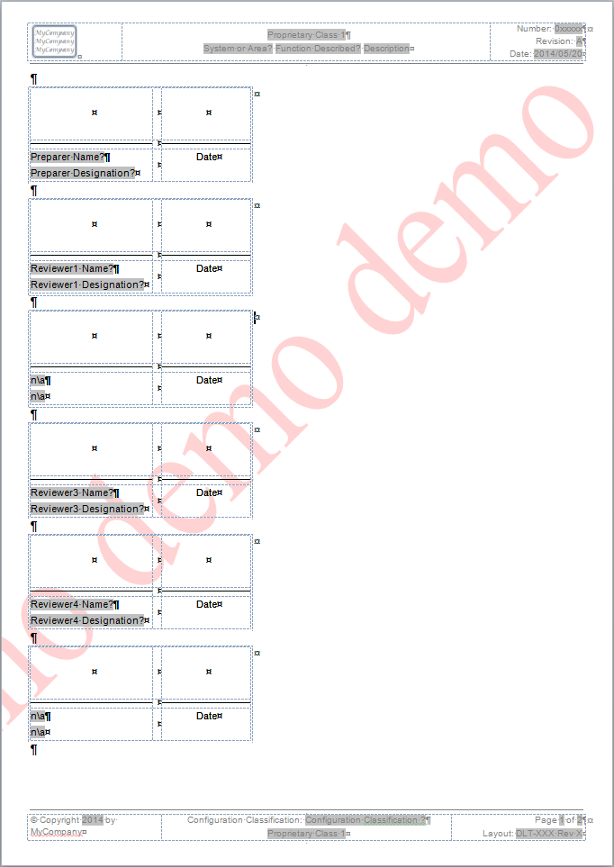

Figure 54: Default Form Content

## Appendix C: Resource Competency Data Relations

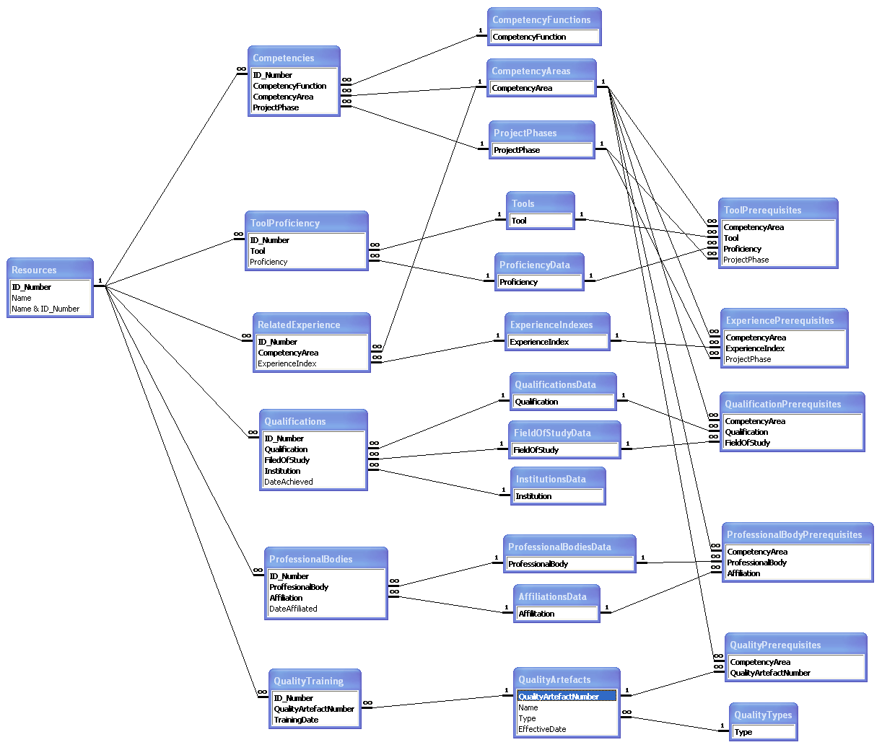

1. For Microsoft Excel 2007, the built‑in macro ‘ResetDataValidationRanges’ must be used once to reset data validation ranges before the drop‑down lists will be enabled; the macro is launched with ALT-F8.