

**SAVEETHA INSTITUTE OF MEDICAL AND TECHNICAL SCIENCES**

**ITA03 Mobile Computing**

**Lab Manual**

**1.Use Figma to create an interactive diagram illustrating the components of a basic cellular system.**

**Aim:** -

To create an interactive diagram illustrating the components of a basic cellular system

**Procedure: -**

1. open Figma

2. Create a new file

3. Select the Frames

4. Fill in the content that is required for presentation

5. Design Visual Elements

6. Make it Interactive

7. Add Annotations and Explanations

8. Incorporate Multimedia

9. Storyboard Animation

11. Review and edit the Prototype

12. Save and Share

**Design: -**

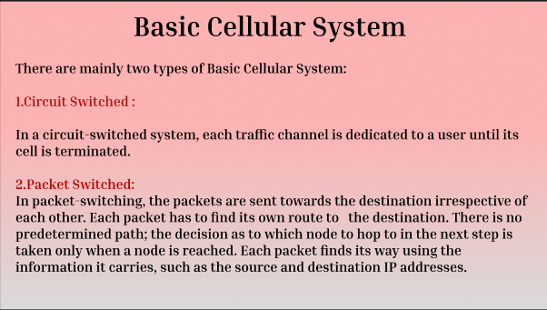

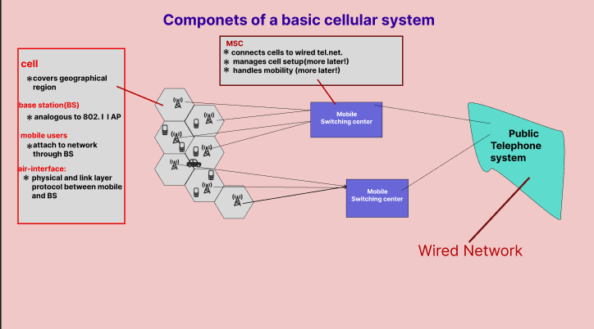

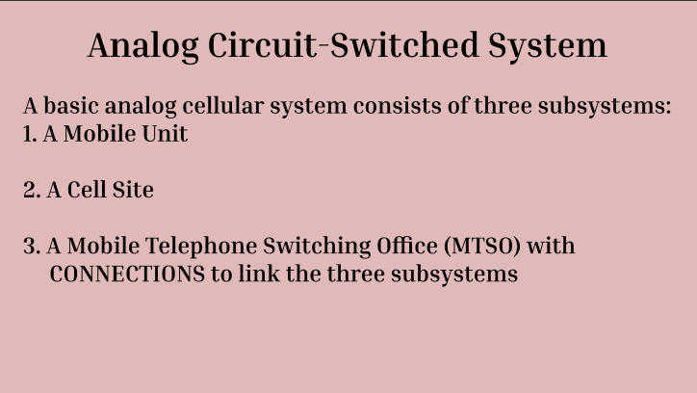

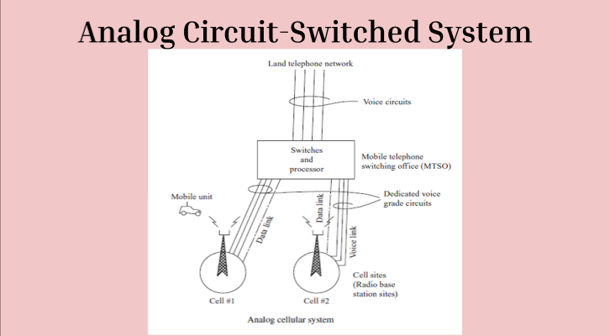



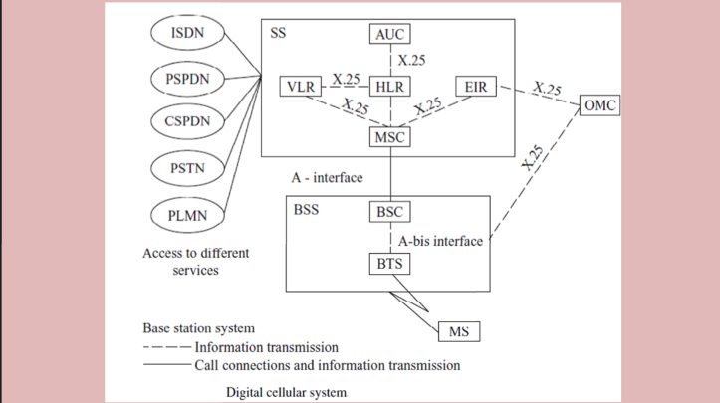



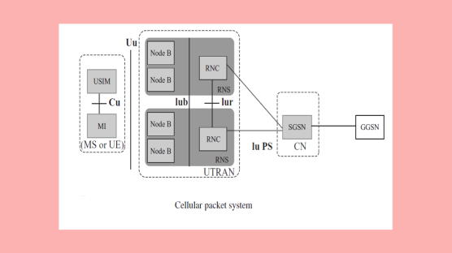

**Prototype: -**

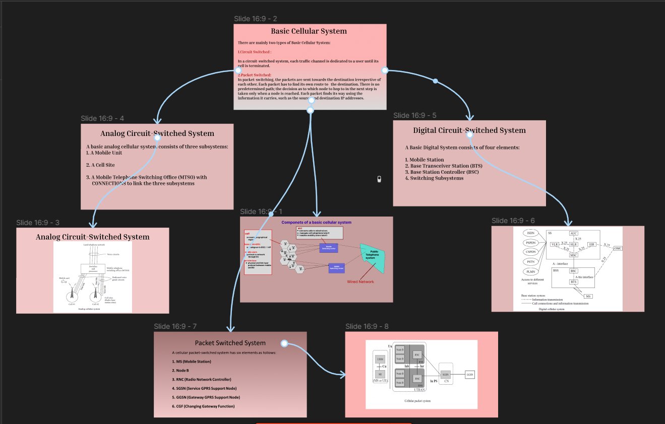

**Result: -**

Hence an interactive diagram illustrating the components of a basic cellular system using

Figma is created and executed successfully