SCHOOL OF TECHNOLOGY | 

DATABASE MANAGEMENT SYSTEMS
PROJECT-BASED LEARNING (PBL) REPORT
Small Database Application Development using Java / Python

PROJECT TITLE
DESIGN AND IMPLEMENTATION OF A DATABASE MANAGEMENT SYSTEM FOR STUDENT AND COLLEGE MANAGEMENT SYSTEM

Program | CSE-AIML
Section | Rhinos
Faculty | Prof Sahithi
Date of Submission | 15-10-2026
Academic Year | 2026 – 27

Submitted by
Roll Number | Student Name | Mobile | Email ID
25WU0102079 | Hansika Gajjala | 8790006669 | hansika.g_2029@woxsen.edu.in

ACKNOWLEDGEMENT

I express my sincere gratitude to Woxsen University, School of Technology, for providing me with the opportunity to undertake this Project-Based Learning (PBL) activity as part of the Database Management Systems (DBMS) course.
I thank my course faculty, Name of the Faculty, for the guidance, suggestions, and support throughout the design and development of this project. The guidance helped me understand the practical application of database concepts such as ER modelling, relational schema design, normalization, SQL, constraints, queries, and database application development.
This PBL activity has strengthened my understanding of DBMS concepts and provided valuable experience in applying them to a real-world problem.

UNDERTAKING

I hereby declare that the project entitled “[DESIGN AND IMPLEMENTATION OF A DATABASE MANAGEMENT SYSTEM FOR STUDENT AND COLLEGE MANAGEMENT SYSTEM]”, submitted as part of the Project-Based Learning activity for the Database Management Systems (DBMS) course, is my individual work carried out under the guidance of the course faculty.
I undertake that the project report, database design, SQL scripts, application source code, results, and supporting materials submitted by me have been prepared for academic purposes. Wherever information, ideas, tools, datasets, or other resources have been referred to, appropriate acknowledgement has been provided.
I further undertake that I am responsible for the correctness and authenticity of the work submitted and that I have followed the academic and project guidelines prescribed by the University.

 |  |  |  | Signature
Date | : | 15-10-2026 | Name: Hansika.G
Place | : |  | Roll Number:25WU0102079
 |  |  | Program:AIML

TABLE OF CONTENTS

Contents | Page No.
Abstract
LIST OF TABLES
LIST OF FIGURES
LIST OF ACRONYMS
1. PROBLEM STATEMENT, SOLUTION STRATEGY AND ER DIAGRAM | 7
1.1 Problem Statement | 7
1.2 Objectives | 7
1.3 Scope and Assumptions | 8
1.4 Proposed Solution Strategy | 10
1.5 Functional Requirements | 10
1.6 Entity-Relationship Diagram (ERD) | 11
1.7 Entity and Relationship Summary | 11
2. LOGICAL DATABASE DESIGN | 12
2.1 Relational Schema | 12
2.2 Keys and Integrity Constraints | 12
2.3 Functional Dependencies | 13
2.4 Normalization up to Third Normal Form (3NF) | 14
2.5 Data Dictionary | 15
2.6 Implementation of Logical Design: DDL and Sample Data | 15
3. APPLICATION DEVELOPMENT USING LOGICAL DATABASE DESIGN | 16
3.1 Application Overview | 17
3.2 Development Environment and Database Connectivity | 18
3.3 Application Modules and Database Mapping | 20
3.4 CRUD Operations | 22
3.5 Business Rules, Validation and Error Handling | 22
3.6 Reports and Database Operations | 23
3.7 Application Screens | 25
3.8 Testing and Results | 25
4. CONCLUSION | 262
4.1 Limitations and Future Enhancements | 27
5. REFERENCES | 28
6. APPENDICES | 29

LIST OF TABLES

Table No. | Table Title | Page No.
Table 1 | Scope and Assumptions | 8
Table 2 | Proposed Solution Strategy | 8
Table 3 | Functional Requirements | 12
Table 4 | Entity and Relationship Summary | 14
Table 5 | Relational Schema | 15
Table 6 | Keys and Integrity Constraints | 17
Table 7 | Normalization Status up to 3NF | 17
Table 8 | Data Dictionary | 18
Table 9 | Database Implementation Environment | 20
Table 10 | Application Development Environment | 20
Table 11 | Application Module-to-Database Mapping | 20
Table 12 | CRUD Operations | 24
Table 13 | Business Rules, Validation and Error Handling | 24
Table 14 | Reports and Database Operations | 25
Table 15 | Test Cases | 26

LIST OF FIGURES

Figure No. | Figure Title | Page No.
Figure 1 | Entity-Relationship Diagram of the Proposed System | 14
Figure 2 | Student data display | 16
Figure 3 | Student search output | 16
Figure 4 | Student record update | 16
Figure 5 | Student academic report | 17

ABSTRACT

Colleges manage large amounts of student information, including admissions, academic records, course registrations, attendance, examinations, grades, and fee payments. Maintaining these records in separate files or systems can lead to data duplication, inconsistency, errors, and delays in retrieving information. Therefore, a centralized database-based solution is needed for efficient college data management. The main objective of this project is to design and implement a Student and College Management System that organizes institutional records systematically while improving data accuracy and accessibility. The proposed system uses an Entity Relationship (ER) model for conceptual design, followed by logical database design and normalization to reduce redundancy and maintain data integrity. MySQL is used as the Database Management System, with a Java/Python-based application approach for user interaction. The system supports student admission, guardian management, department and course management, faculty records, course registration, attendance tracking, examination and grade processing, and fee management. SQL queries, joins, and reports enable retrieval of academic history, attendance details, examination results, and fee dues. The system demonstrates how database technology can simplify administrative operations, improve information management, and provide a structured and reliable solution for college management.
.

KEYWORDS
Keywords: [Student and College Management System, Relational Database, Entity Relationship Model, Database Normalization, MySQL, SQL]

CHAPTER 1

PROBLEM STATEMENT, SOLUTION STRATEGY AND ER DIAGRAM

.

1.1 Problem Statement
Colleges manage a large volume of information related to student admissions, guardian details, departments, programmes, courses, faculty, attendance, examinations, grades, and fee payments. In many cases, these records are maintained using separate files, spreadsheets, or disconnected systems. This approach can result in data duplication, inconsistency, errors, and difficulty in retrieving complete student information. Administrative staff may spend considerable time searching and updating records, while faculty members face challenges in maintaining attendance and examination details. Students may also experience delays in accessing their academic and fee-related information.
The existing approach lacks centralized data management, proper relationships between records, and efficient reporting facilities. Updating information in multiple places can lead to inconsistencies, while manual calculations and record maintenance increase the possibility of errors. Therefore, a centralized Student and College Management System is required to organize institutional data systematically. The proposed database application aims to integrate student, academic, attendance, examination, and fee information using a relational database, enabling efficient data storage, retrieval, updating, and reporting while improving data accuracy, consistency, and accessibility for administrators, faculty, students, and accounts staff..

1.2 Objectives

- To design a centralized relational database for managing student, academic, attendance, examination, and fee records.[6]
- To develop an ER model and convert it into a structured relational schema using appropriate primary and foreign keys.[6]
- To implement database normalization up to Third Normal Form (3NF) to reduce data redundancy and improve data consistency[7]
- To develop a Java/Python-based application for student admission, course registration, attendance, grade processing, and fee management[9]
- To generate accurate reports using SQL queries, joins, and aggregate functions for effective college record management.[9]

1.3 Scope and Assumptions
Table 1. Scope and Assumptions
Item | Description
In Scope | Student admission and profile management, guardian details, department and programmed management, course and faculty records, semester-wise registration, attendance tracking, examination and grade management, fee bills, payments, search, and report generation.[5]
Out of Scope / Exclusions | Online payment gateway integration, biometric attendance, hostel management, transport management, and full-scale university-wide deployment.[6]
Assumptions | Each student has a unique registration number. Each course has a unique course code. Users provide valid information. Students register for courses during the appropriate semester. Only authorized users can modify academic and financial records. The system uses a relational DBMS such as MySQL.[7]

1.4 Proposed Solution Strategy
Table 2. Proposed Solution Strategy
Solution Element | Project-Specific Description
Primary Users / Roles | Admin manages student, department, programmed, course, and faculty records. Faculty manages attendance and grades. Students view registration, attendance, results, and fee details. Accounts staff manages fee bills and payments.
Major Application Modules | Student Admission, Department and Programmed Management, Course Registration, Attendance Management, Examination and Grade Processing, Fee Management, and Report Generation.
Proposed Workflow | Student details are entered into the system, followed by programmed allocation and course registration. Faculty records attendance and examination marks. Fee bills and payments are maintained, and reports are generated from the database.[8]
Important Business Rules | Each student must have a unique registration number. Each course must have a unique course code. Duplicate course registration in the same semester is not allowed. Marks and attendance must be within valid ranges. Payments must not exceed the fee amount due[9]
Expected Reports / Outputs | Student profiles, course registration details, attendance reports, examination results, fee dues, payment records, and department-wise student summaries.[11]

1.5 Functional Requirements
Table 3. Functional Requirements
Req. ID | Functional Requirement | Remarks / Priority
FR-01 |  | High
  The system shall allow the admin to add, update, search, and manage student details.
FR-02 | The system shall manage departments, programmes, courses, faculty, and semester details. | High
FR-03 | The system shall allow students to register for courses in the appropriate semester while preventing duplicate registrations. | High
FR-04 | The system shall record attendance, examination marks, and grades for registered students. | High
FR-05 | The system shall manage fee bills and payments and generate academic, attendance, and fee reports. | High

1.6 Entity-Relationship Diagram (ERD)

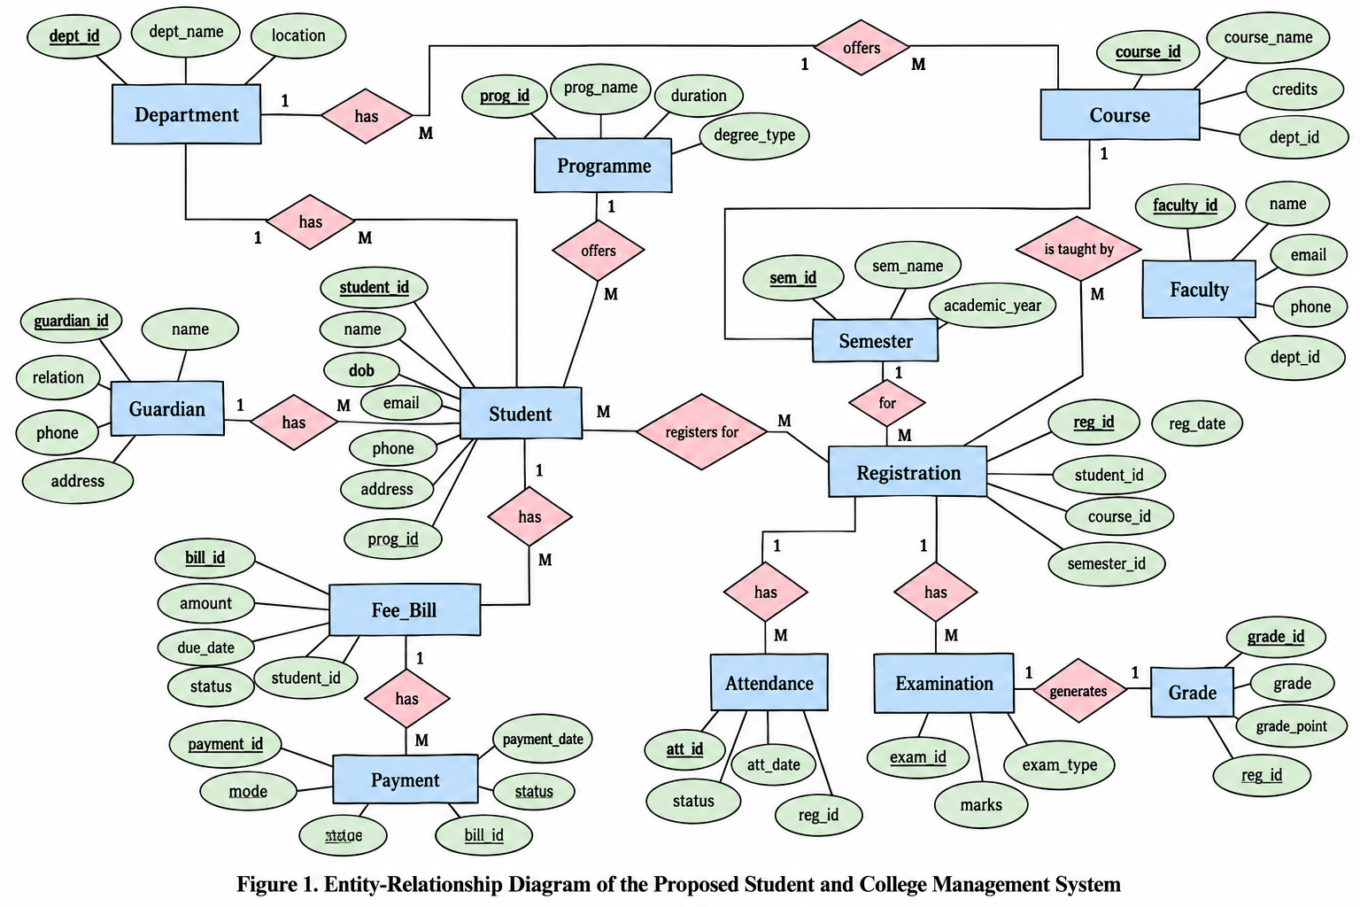

1.7 Entity and Relationship Summary
Table 4. Entity and Relationship Summary
Entity / Relationship | Major Attributes / Cardinality | Purpose / Rule
Department | Dept_ID (PK), Dept_Name, Dept_Office | Stores department details. One department can have multiple programmes, courses, and faculty members (1:M).
Programme and Student | Programme_ID (PK), Programme_Name, Student_ID (PK), Reg_No, Name, Email | A programme can have multiple students, but each student belongs to one programme (1:M).
Guardian | Guardian_ID (PK), Name, Relation, Phone, Student_ID (FK) | Stores guardian information. One student can have multiple guardian records (1:M).
Course and Faculty | Course_ID (PK), Course_Code, Course_Name, Credits, Faculty_ID (PK), Faculty_Name | Stores course and faculty details. A faculty member can teach multiple courses (1:M).
Registration and Semester | Registration_ID (PK), Student_ID (FK), Course_ID (FK), Semester_ID (FK), Registration_Date | Connects students and courses. Student–Course is M:N, resolved through Registration. Duplicate course registration in the same semester is not allowed.
Attendance, Examination and Grade | Attendance_ID (PK), Exam_ID (PK), Grade_ID (PK), Date, Marks, Grade | Maintains course-wise attendance and examination performance. Attendance and examination records are linked to Registration.

CHAPTER 2

LOGICAL DATABASE DESIGN

2.1 Relational Schema

Table 5. Relational Schema

S.No. | Table Name | Purpose
1 | Departmene | Stores department details.
2 | Programme | Stores programme details.
3 | Student | Stores student information.
4 | Guardian | Stores guardian information.
5 | Course | Stores course details
6 | Faculty | Stores faculty details
7 | Semester | Stores semester information.
8 | Registration | Records course registration
9 | Attendance | Records attendance.
10 | Examination | Stores examination details.
11 | Grade | Stores examination results
12 | Fee_Bill | Stores fee details.
13 | Payment | Records fee payments.

2.2 Keys and Integrity Constraints
Table 6. Keys and Integrity Constraints
Table Name | Key / Constraint | Attribute(s) |  |  | Business Rule Enforced
Student | PRIMARY KEY | Student_ID
  Uniquely identifies each student
Student | UNIQUE, NOT NULL | Reg_No |  |  | Registration number must be unique and provided.
Programme | FOREIGN KEY | Dept_ID |  |  | Programme must belong to an existing department.
Course | UNIQUE, NOT NULL | Course_Code |  |  | Course code must be unique and provided.
Registration | FOREIGN KEY | Student_ID, Course_ID, Semester_ID |  |  | Registration must reference valid records.
Registration | UNIQUE | Student_ID, Course_ID, Semester_ID |  |  | Prevents duplicate course registration in the same semester.
Attendance | CHECK, DEFAULT | Student_ID, Course_ID, Semester_ID |  |  | Prevents duplicate course registration in the same semester.
Examination | CHECK |  | Status | Status must be Present or Absent; default is Absent.
Examination | CHECK |  | Marks_Obtained | Marks must be between zero and maximum marks.
Fee_Bill | CHECK, DEFAULT |  | Amount, Status | Amount cannot be negative; status defaults to Pending.

2.3 Functional Dependencies

• Department: Department_ID --Department_Name, Head_of_Department

• Student: Student_ID First_--Name, Last_Name, Date_of_Birth, Email, Phone_Number, Department_ID

• Course: Course_ID Course_-Name, Credits, Department_ID

• Instructor: Instructor_ID ---First_Name, Last_Name, Email, Department_ID

• Enrollment: (Student_ID, Course_ID) -Grade, Enrollment_Date

2.4 Normalization
Table 7. Normalization Status up to 3NF
Relation Name | 1NF | 2NF | 3NF | BCNF | Remarks / Decomposition
Department | YES | YES | YES | YES | Atomic attributes; Dept_ID is the primary key.
Programme | YES | YES | YES | YES | Department details are stored separately and linked using Dept_ID.
Student | YES | YES | YES | YES | Student details are stored separately from programme information.
Course | YES | YES | YES | YES | Course details are maintained independently.
Registration | YES | YES | YES | YES | Composite uniqueness is maintained using Student_ID, Course_ID and Semester_ID.
Attendance | YES | YES | YES | YES | Attendance is linked to Registration_ID to avoid repeating student and course details.

2.5 Data Dictionary

Table 8. Data Dictionary

Table | Attribute | Data Type | Key / Constraint | Description
Department | Dept_ID | INT | PRIMARY KEY | Unique department ID
Department | Dept_Name | VARCHAR(100) | UNIQUE, NOT NULL | Department name
Department | Dept_Office | VARCHAR(100) | — | Department office location
Programme | Programme_ID | INT | PRIMARY KEY | Unique programme ID
Programme | Programme_Name | VARCHAR(100) | NOT NULL | Programme name
Programme | Duration | INT | CHECK (Duration > 0) | Duration in years
Programme | Dept_ID | INT | FOREIGN KEY | Department offering programme
Student | Student_ID | INT | PRIMARY KEY | Unique student ID
Student | Reg_No | VARCHAR(20) | UNIQUE, NOT NULL | Registration number
Student | Name | VARCHAR(100) | NOT NULL | Student name
Student | DOB | DATE | — | Date of birth
Student | Email | VARCHAR(100) | UNIQUE | Student email
Student | Phone | VARCHAR(15) | — | Contact number
Student | Programme_ID | INT | FOREIGN KEY | Student's programme
Guardian | Guardian_ID | INT | PRIMARY KEY | Unique guardian ID
Guardian | Name | VARCHAR(100) | NOT NULL | Guardian name
Guardian | Relation | VARCHAR(50) | — | Relationship with student
Guardian | Phone | VARCHAR(15) | — | Guardian phone
Guardian | Email | VARCHAR(100) | — | Guardian email
Guardian | Student_ID | INT | FOREIGN KEY | Associated student
Course | Course_ID | INT | PRIMARY KEY | Unique course ID
Course | Course_Code | VARCHAR(20) | UNIQUE, NOT NULL | Course code
Course | Course_Name | VARCHAR(100) | NOT NULL | Course name
Course | Credits | INT | CHECK (Credits > 0) | Credit value
Course | Dept_ID | INT | FOREIGN KEY | Offering department
Faculty | Faculty_ID | INT | PRIMARY KEY | Unique faculty ID
Faculty | Faculty_Name | VARCHAR(100) | NOT NULL | Faculty name
Faculty | Email | VARCHAR(100) | UNIQUE | Faculty email
Faculty | Phone | VARCHAR(15) | — | Contact number
Faculty | Dept_ID | INT | FOREIGN KEY | Faculty department
Semester | Semester_ID | INT | PRIMARY KEY | Unique semester ID
Semester | Semester_Name | VARCHAR(50) | NOT NULL | Semester name
Semester | Academic_Year | VARCHAR(20) | NOT NULL | Academic year
Semester | Start_Date | DATE | — | Start date
Semester | End_Date | DATE | — | End date
Registration | Registration_ID | INT | PRIMARY KEY | Unique registration ID
Registration | Student_ID | INT | FOREIGN KEY | Registered student
Registration | Course_ID | INT | FOREIGN KEY | Selected course
Registration | Semester_ID | INT | FOREIGN KEY | Registration semester
Registration | Registration_Date | DATE | NOT NULL | Registration date
Attendance | Attendance_ID | INT | PRIMARY KEY | Unique attendance ID
Attendance | Registration_ID | INT | FOREIGN KEY | Related registration
Attendance | Date | DATE | NOT NULL | Attendance date
Attendance | Status | VARCHAR(10) | CHECK | Present or Absent
Attendance | Classes_Held | INT | CHECK (Classes_Held >= 0) | Total classes conducted
Attendance | Classes_Attended | INT | CHECK (Classes_Attended >= 0) | Classes attended
Examination | Exam_ID | INT | PRIMARY KEY | Unique exam ID
Examination | Registration_ID | INT | FOREIGN KEY | Related registration
Examination | Exam_Type | VARCHAR(50) | NOT NULL | Exam type
Examination | Exam_Date | DATE | — | Exam date
Examination | Max_Marks | DECIMAL(5,2) | CHECK (Max_Marks > 0) | Maximum marks
Grade | Grade_ID | INT | PRIMARY KEY | Unique grade ID
Grade | Exam_ID | INT | FOREIGN KEY | Related examination
Grade | Marks_Obtained | DECIMAL(5,2) | CHECK (Marks_Obtained >= 0) | Marks scored
Grade | Grade | VARCHAR(5) | — | Letter grade
Grade | Grade_Points | DECIMAL(3,2) | — | Grade points
Fee_Bill | Bill_ID | INT | PRIMARY KEY | Unique bill ID
Fee_Bill | Student_ID | INT | FOREIGN KEY | Billed student
Fee_Bill | Semester_ID | INT | FOREIGN KEY | Related semester
Fee_Bill | Amount | DECIMAL(10,2) | CHECK (Amount >= 0) | Fee amount
Fee_Bill | Due_Date | DATE | — | Payment deadline
Fee_Bill | Status | VARCHAR(20) | DEFAULT 'Pending' | Bill status
Payment | Payment_ID | INT | PRIMARY KEY | Unique payment ID
Payment | Bill_ID | INT | FOREIGN KEY | Related fee bill
Payment | Amount_Paid | DECIMAL(10,2) | CHECK (Amount_Paid > 0) | Amount paid
Payment | Payment_Date | DATE | NOT NULL | Payment date
Payment | Payment_Mode | VARCHAR(30) | DEFAULT 'Online' | Payment method
Payment | Transaction_Ref | VARCHAR(50) | UNIQUE | Transaction reference

2.6 Implementation of Logical Design: DDL and Sample Data
Table 9. Database Implementation Environment
Item | Details
DBMS | MySQL
DBMS Version | MySQL 8.0
Number of Tables | 13
Sample Data | Representative records inserted into the tables for testing and demonstrating database relationships.

Representative DDL Statements

CREATE TABLE Department (
Dept_ID INT PRIMARY KEY,
Dept_Name VARCHAR(100) NOT NULL UNIQUE,
Dept_Office VARCHAR(100)
);

CREATE TABLE Programme (
Programme_ID INT PRIMARY KEY,
Programme_Name VARCHAR(100) NOT NULL,
Duration INT CHECK (Duration > 0),
Dept_ID INT NOT NULL,
FOREIGN KEY (Dept_ID)
REFERENCES Department(Dept_ID)
);

CREATE TABLE Student (
Student_ID INT PRIMARY KEY,
Reg_No VARCHAR(20) NOT NULL UNIQUE,
Name VARCHAR(100) NOT NULL,
DOB DATE,
Email VARCHAR(100) UNIQUE,
Phone VARCHAR(15),
Programme_ID INT NOT NULL,
FOREIGN KEY (Programme_ID)
REFERENCES Programme(Programme_ID)
);

Sample Data
INSERT INTO Department VALUES
(1, 'Computer Science', 'Block A');

INSERT INTO Programme VALUES
(1, 'B.Tech CSE-AIML', 4, 1);

INSERT INTO Student VALUES
(1, 'Wox2026AIML001', 'Aarav Kumar',
'2007-05-12', 'aarav@example.com',
'9876543210', 1);

CHAPTER 3

APPLICATION DEVELOPMENT USING LOGICAL DATABASE DESIGN

.

3.1 Application Overview

The Student and College Management System is designed to manage student information, academic records, course registrations, attendance, examinations, grades, and fee details. The system provides different functions for administrators, faculty, students, and accounts staff. It uses a centralized MySQL database to store and retrieve information. The application allows users to add, update, search, and view records efficiently, reducing data duplication and improving data accuracy.[2]

3.2 Development Environment and Database Connectivity
Table 10. Application Development Environment
Item | Details
Programming Language | [Java
DBMS | [MySQL
IDE / Framework / GUI Toolkit | VS Code / MySQL Workbench
Database Connector / Driver | MySQL JDBC Driver
Operating Environment | Windows

3.3 Application Modules and Database Mapping
Table 11. Application Module-to-Database Mapping
Application Module | Database Tables Used | Main Function
Student Management | Student, Guardian | Add, update and view student details
Department Management | Department, Programme | Manage departments and programmes
Course Management | Course, Faculty | Maintain course and faculty information
Course Registration | Registration, Student, Course, Semester | Register students for courses
Attendance Management | Attendance, Registration | Record and view student attendance
Examination Management | Examination, Grade | Store examination marks and grades
Fee Management | Fee_Bill, Payment | Manage fee bills and payment records
Search and Reports | Multiple Tables | Generate academic, attendance and fee reports

3.4 CRUD Operations
Table 12. CRUD Operations

Operation | Application Feature / Screen | Table(s) Affected | Evidence
Create | Add new student or course | Student, Course | New record inserted successfully
Read / Search | Search student and view details | Student, Programme, Department | Matching records displayed
Update | Modify student or faculty details | Student, Faculty | Updated information displayed
Delete / Controlled Removal | Remove a record when permitted | Student, Course | Record deleted after confirmation

3.5 Business Rules, Validation and Error Handling
The application validates user inputs and uses database constraints to maintain accurate and consistent records. Required fields cannot be left empty, unique identifiers prevent duplicate records, and range checks restrict invalid marks and attendance values. Foreign keys maintain valid relationships between tables. Error messages and confirmation before deletion help prevent incorrect operations[3]
Table 13. Business Rules, Validation and Error Handling
Rule / Validation | How Implemented | Evidence / Message
Unique Registration Number | UNIQUE constraint | Duplicate registration number rejected
Mandatory Fields | NOT NULL constraint | Required fields cannot be empty
Valid Marks | CHECK constraint (0 to 100) | Invalid marks rejected
Valid Attendance | CHECK constraint (0 to 100) | Invalid attendance percentage rejected
Duplicate Course Registration | UNIQUE(Student_ID, Course_ID, Semester_ID) | Duplicate registration prevented
Foreign Key Validation | FOREIGN KEY constraints | Invalid references rejected
Error Handling | Exception handling | Displays error message instead of crashing
Delete Confirmation | Confirmation before deletion | Prevents accidental removal

3.6 Reports and Database Operations
Table 14. Reports and Database Operations
Report / Operation | SQL / Database Concept Used | Application Output
Student Details Report | ELECT, JOIN | Displays student name, registration number and programme
Course Registration Report | JOIN | Displays students registered for each course.
Attendance Repor | SELECT, Aggregate Functions | Displays attendance records and attendance percentage.
Examination Result Report | JOIN, ORDER BY | Displays marks and grades of students.
Fee Due Report | WHERE, JOIN | Displays pending fee amounts of students.
Department Summary | GROUP BY, COUNT | Displays the total number of students in each department.

3.7 Application Screens
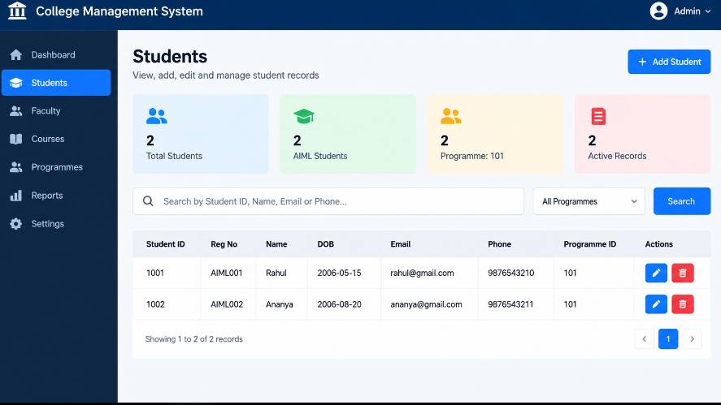
Figure 2. [Student Data Display]
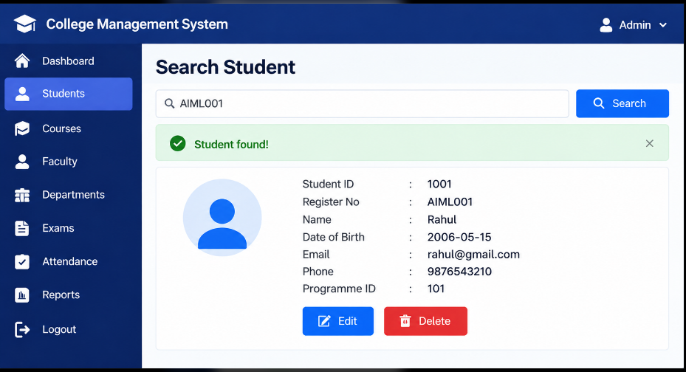
Figure 3. [Student Search Output]
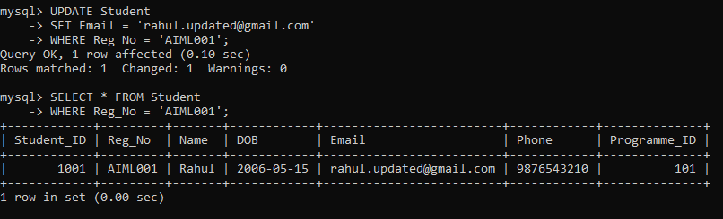
Figure 4. [Student Record Update.] 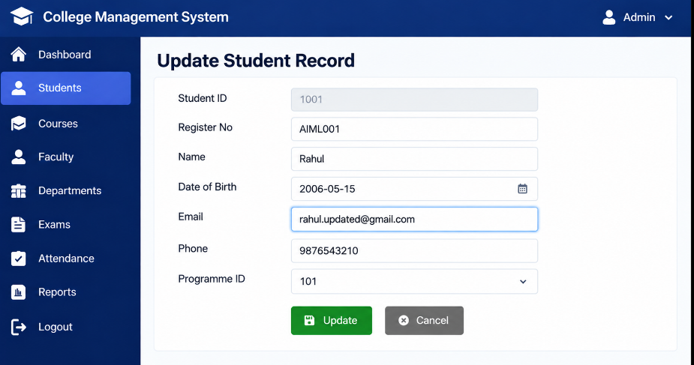
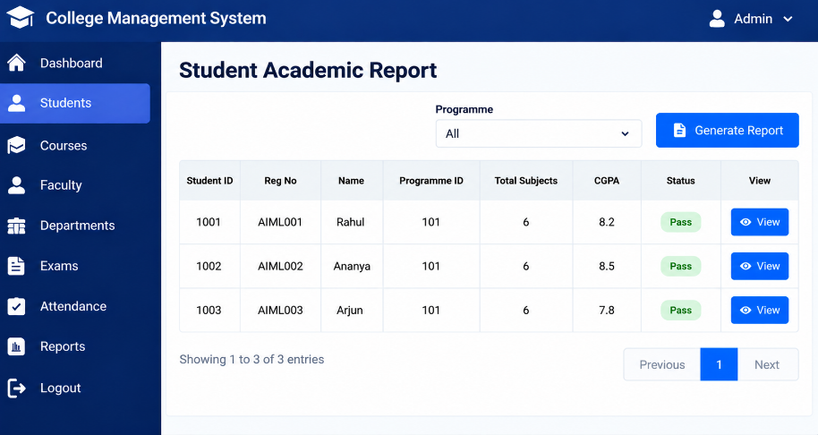
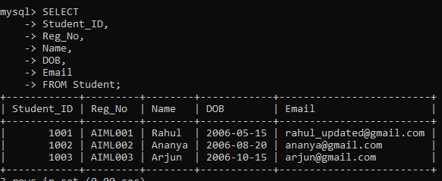
Figure 5. [Student Academic Report.]

3.8 Testing and Results
Table 15. Test Cases
Test ID | Feature | Input / Action | Expected Result | Actual Result | Status
TC-01 | Student Insertion | Enter student details | Student record should be inserted | Record inserted successfully | Pass
TC-02 | Student Search | Search using Student ID | Student details should be displayed | Details displayed successfully | Pass
TC-03 | Student Update | Modify student email | Student information should be updated | Information updated successfully | Pass
TC-04 | Course Retrieval | Display all courses | Course records should be displayed | Records displayed successfully | Pass
TC-05 | Duplicate Registration | Register same student for same course and semester | Duplicate entry should be rejected | Duplicate entry rejected | Pass
TC-06 | Foreign Key Validation | Enter invalid Student ID | Invalid entry should be rejected | Entry rejected | Pass
TC-07 | JOIN Query | Retrieve student and course details | Related records should be displayed | Joined records retrieved | Pass

The database successfully stores, retrieves, and updates student and academic information. SQL queries and joins help retrieve related records efficiently. Primary key, foreign key, and unique constraints help maintain data integrity and prevent invalid or duplicate entries.

CHAPTER 4
CONCLUSION

The Student and College Management System was designed to manage student, academic, attendance, examination, and fee records through a centralized relational database. The database design includes entities, relationships, primary keys, foreign keys, and normalized tables to reduce data redundancy and maintain data consistency.[3]

The project demonstrates database operations such as inserting, retrieving, updating, and searching records using SQL queries. It also provides a foundation for generating academic and administrative reports. Through this project, we gained practical knowledge of database design, SQL, relationships, and data management.[4]

4.1 Limitations and Future Enhancements

• Limited User Interface: The current application has basic functionality. A user-friendly graphical interface can be developed in the future.[9]

• Limited Security: Role-based login and authentication can be added to provide secure access for administrators, faculty, and students.[9]

• Advanced Features: Future enhancements can include automated attendance calculation, result generation, fee reminders, and detailed reports.[10]

REFERENCES
[1] R. Elmasri and S. B. Navathe, Fundamentals of Database Systems, 7th ed. Pearson, 2016.
[2] A. Silberschatz, H. F. Korth, and S. Sudarshan, Database System Concepts, 7th ed. McGraw-Hill, 2019.
[3] MySQL, “MySQL 8.0 Reference Manual.” [Online]. Available: https://dev.mysql.com/doc/
[4] Oracle, “Java Documentation.” [Online]. Available: https://docs.oracle.com/en/java/
[5] W3Schools, “SQL Tutorial.” [Online]. Available: https://www.w3schools.com/sql/
[6] Oracle, “JDBC Basics.” [Online]. Available:
https://docs.oracle.com/javase/tutorial/jdbc/
[7] Oracle. “MySQL Connector/Python Developer Guide.” [Online]. Available: https://dev.mysql.com/doc/connector-python/en/
[8] Oracle. “MySQL 8.0 Reference Manual: Creating and Using a Database.” [Online]. Available: https://dev.mysql.com/doc/refman/8.0/en/database-use.html
[9] W3Schools. “SQL JOIN.” [Online]. Available: https://www.w3schools.com/sql/sql_join.asp
[10] W3Schools. “SQL Constraints.” [Online]. Available: https://www.w3schools.com/sql/sql_constraints.asp
[11] W3Schools. “SQL Normalization.” [Online]. Available: https://www.w3schools.in/dbms/database-normalization

5.1 IEEE In-Text Citation Guidelines

5.2 IEEE Reference Formats and Examples

Book:

[1] A. Silberschatz, H. F. Korth, and S. Sudarshan, Database System Concepts, 7th ed. New York, NY, USA: McGraw-Hill, 2019.

[2] R. Elmasri and S. B. Navathe, Fundamentals of Database Systems, 7th ed. Pearson, 2016.

[3] C. J. Date, An Introduction to Database Systems, 8th ed. Boston, MA, USA: Addison-Wesley, 2003.

Journal Paper:

[4] E. F. Codd, “A relational model of data for large shared data banks,” Communications of the ACM, vol. 13, no. 6, pp. 377–387, Jun. 1970.

[5] D. J. Abadi et al., “The Beckman report on database research,” Communications of the ACM, vol. 59, no. 2, pp. 92–99, Feb. 2016.

Technical Documentation:

[6] MySQL, “MySQL 8.4 Reference Manual.” [Online]. Available: https://dev.mysql.com/doc/

[7] PostgreSQL Global Development Group, “PostgreSQL Documentation.” [Online]. Available: https://www.postgresql.org/docs/

[8] Oracle, “Java Documentation.” [Online]. Available: https://docs.oracle.com/en/java/

Web Page:

[9] W3Schools, “SQL Tutorial.” [Online]. Available: https://www.w3schools.com/sql/

[10] Oracle, “JDBC Basics.” [Online]. Available: https://docs.oracle.com/javase/tutorial/jdbc/

[11] Microsoft, “SQL Server Documentation.” [Online]. Available: https://learn.microsoft.com/en-us/sql/

[12] SQLite, “SQLite Documentation.” [Online]. Available: https://www.sqlite.org/docs.html

Online Learning Resources:

[13] GeeksforGeeks, “DBMS Tutorial.” [Online]. Available: https://www.geeksforgeeks.org/dbms/

[14] TutorialsPoint, “Database Management System Tutorial.” [Online]. Available: https://www.tutorialspoint.com/dbms/

[15] Oracle, “Database Concepts.” [Online]. Available: https://docs.oracle.com/en/database/

APPENDICES

APPENDIX A - COMPLETE DATABASE SCRIPT

The complete SQL database script is saved as college_management.sql. It includes database creation, 13 relational tables, primary and foreign keys, sample records, and SQL queries for retrieving student, course, attendance, examination, grade, and fee details
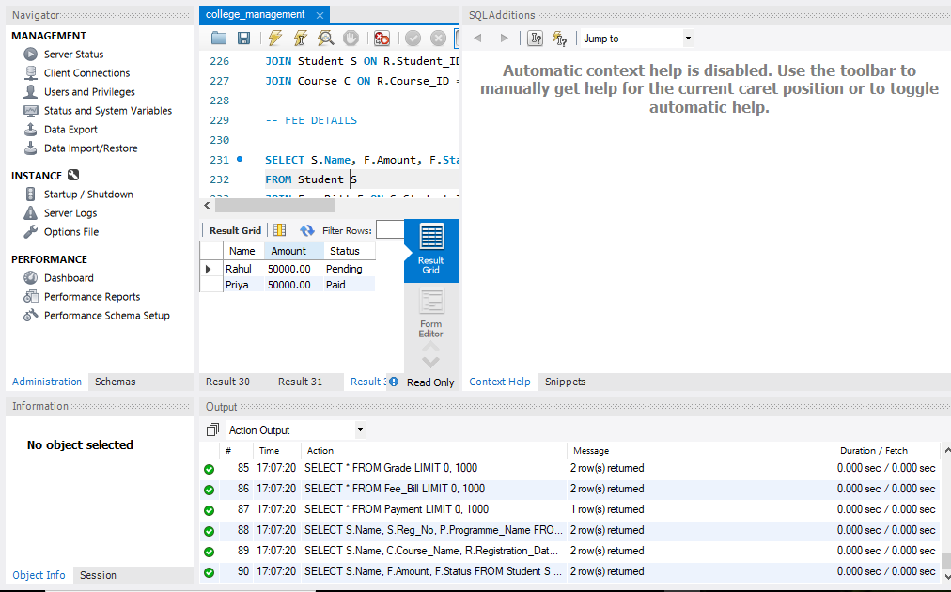

APPENDIX B - APPLICATION SOURCE CODE
The application source code for the Student and College Management System is developed using SQL and MySQL Workbench.

The source code includes:

Database creation and table definitions.

Student and department record management.

Course registration and faculty details.

Attendance and examination records.

Grade and fee management.

SQL queries for retrieving and displaying information.

Source Code File: college_management.sql

Development Tool: MySQL Workbench

The complete SQL source code is provided in Appendix A.

APPENDIX C - ADDITIONAL TEST DATA AND OUTPUT