Email Threading and Inclusive Email Detection Web Application - Project Documentation

1. Abstract
This web application allows users to upload email datasets, automatically parse and process the content, group emails into conversation threads using a hybrid fuzzy matching algorithm, and identify the inclusive email in each thread. The inclusive email is considered the most representative email, based on body richness, participant centrality, and structural cues.
The application handles both standard field-based emails and raw 'message' logs. It features a modern UI, drag-and-drop upload, progress tracking, download options, and a threaded email viewer with inclusive highlights.

2. Key Features
- CSV Upload Interface (drag & drop or browse)
- Preprocessing: Cleans empty rows/columns, removes duplicates
- Smart Parsing: Supports structured columns and raw messages
- Hybrid Threading: Fuzzy matching based on subject and participants
- Inclusive Email Detection: Scores and highlights the most representative email per thread
- Downloadable Outputs: Raw CSV, Processed CSV, and Inclusive Email CSV
- Modern UI: Gradient backgrounds, progress bars, mobile responsive

3. Tech Stack Used
Language: Python 3.10+
Web Framework: Flask
Frontend: HTML, CSS (with gradients, animations), JavaScript
Libraries:
- pandas – for data processing
- rapidfuzz – for fuzzy subject/participant matching
- dateutil – for parsing email timestamps
Frontend Description:
- HTML/CSS: Provides responsive and styled pages.
- JavaScript (upload.js): Handles file validation, AJAX upload, live progress, and response rendering.
- upload.html: Provides the interface for file upload.
- threads.html: Uses Jinja templating to list emails grouped into threads and includes search.

4. Backend Functionality
-app.py contains routes to handle file upload, threading, result display, and static file serving.
- File validation ensures only CSV files are processed (max 2MB).
- Uploaded data is parsed from either a 'message' column or structured email columns.
- Threading uses token similarity on subject and participants via RapidFuzz.
- Inclusive emails are detected using a custom scoring logic.
- Results are saved as CSV and rendered via Flask templates.

5. Email Threading Logic
• Emails are grouped by normalized subject and participant similarity.
• Subjects are normalized by removing prefixes like 'Re:' or 'Fwd:'.
• Participant signatures are constructed from From, To, CC, and BCC fields.
• RapidFuzz is used to determine similarity: Subject ≥ 90%, Participants ≥ 80%.
• Threads are dynamically formed within subject buckets.

6. Folder and File Structure
├── app.py # Main Flask backend
├── templates/
│ ├── upload.html # Upload interface
│ ├── threads.html # Threaded results display
├── static/
│ └── upload.js # JavaScript for upload and progress bar
├── uploads/ # Temporary storage for uploaded files
└── email_new.csv # Example input CSV

7. How to Run the Application
Prerequisites:
- Python 3.10+
- pip
Install Required Packages:
pip install flask pandas rapidfuzz python-dateutil
Run the Flask App:
python app.py
Access the App:
http://localhost:5000

8. Upload and Result Flow
1. Upload Page:
- Drag and drop or browse for your .csv email file.
- Live upload progress bar shown.
- Upload triggers server-side processing.
2. Processing Steps:
- Drop empty rows and columns
- Parse emails into standard format
- Remove duplicates
- Assign Hybrid_Thread_ID using fuzzy subject and participant similarity
- Score inclusive emails per thread based on:
- Latest timestamp
- Body length
- Author centrality
- Message structure (quotes, bullet points)
3. Result Page (result-display.html):
- Shows download links:
- Raw CSV
- Processed CSV
- View Threads (redirects to /result/<filename>)
4. Thread Viewer Page:
- Lists threads with toggleable view
- Inclusive email shown at the top in highlighted section
- All emails per thread shown below
- Supports search and dark mode

9. Screenshots
- Upload interface
- Result landing page
- Thread viewer with inclusive email highlight

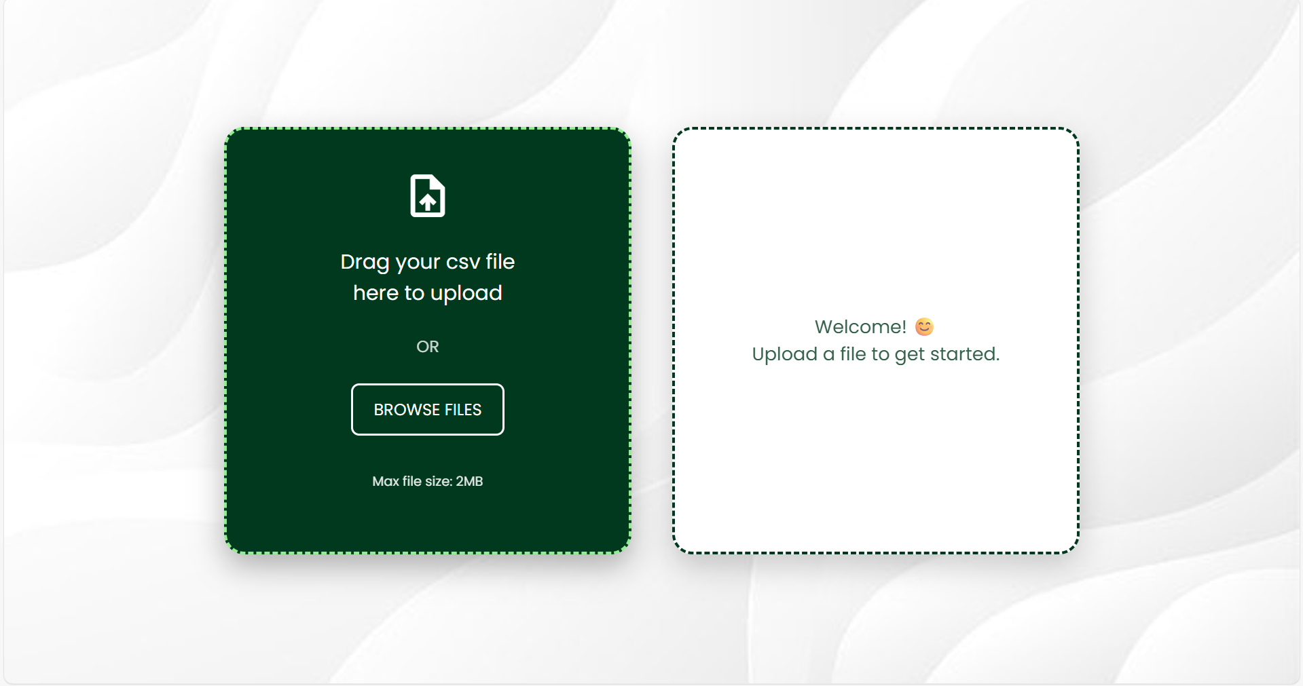

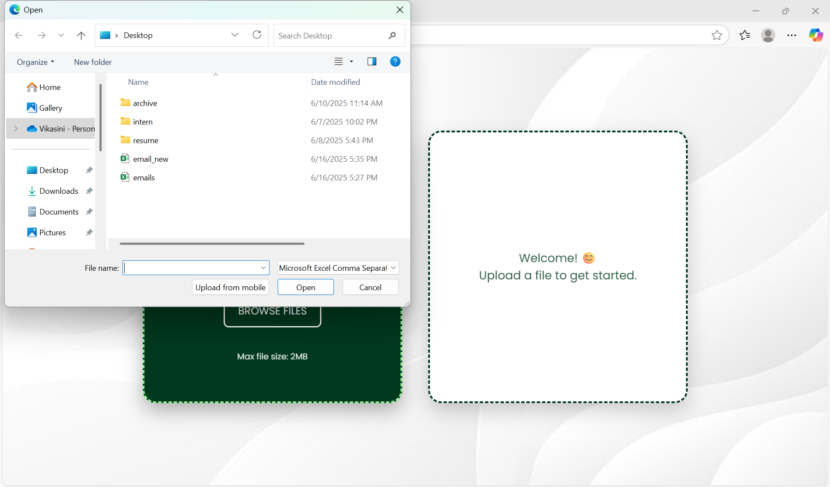

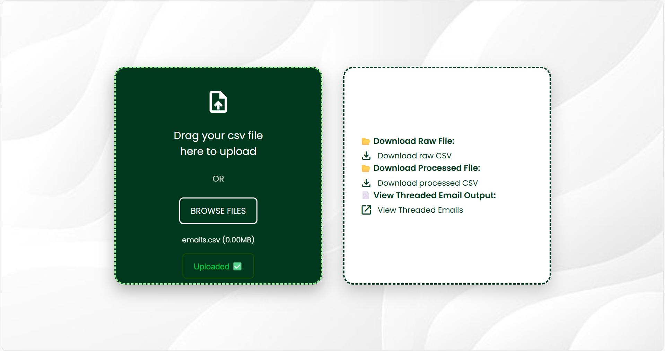

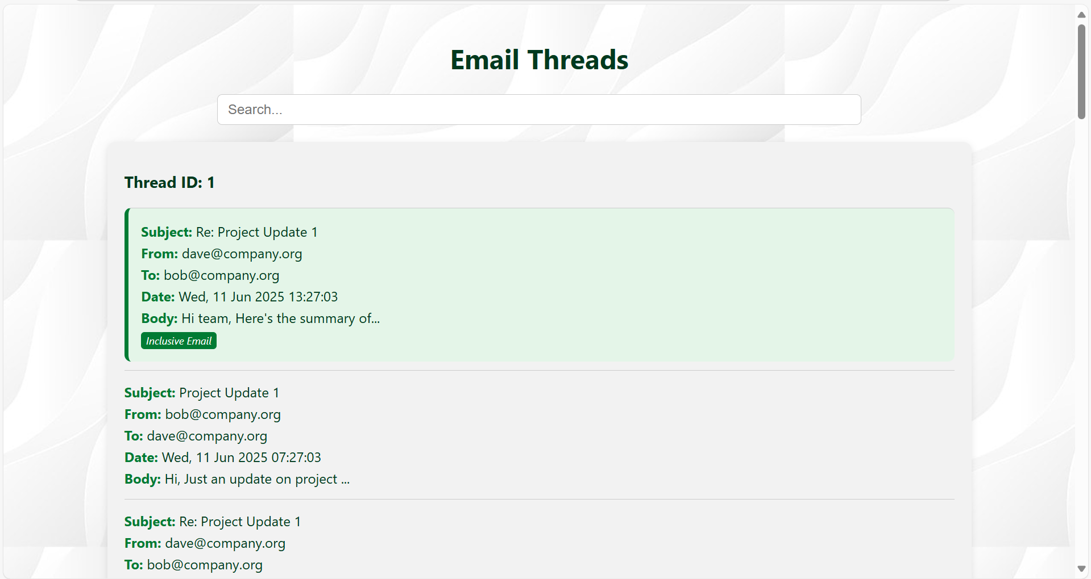

10. Contributions and Credits
Developer: Hansinee S and Vikasini G
Dataset: Enron Email Dataset (public domain)

Final Notes
- The app is designed to be scalable and user-friendly.
- Supports multiple email formats.
- All preprocessing, logic, and UI have been tested.
This project demonstrates applied NLP and software integration skills in a practical communication mining context.

