Networking Internship Task 1 Report
Date: June 5, 2026 Intern: [Hansini Kulal]

Task Objectives
- Understand the fundamental concepts and components of computer networks.
- Identify and examine the local network configuration of a system.
- Learn and define essential networking terms, devices, and protocols.
- Create a visual representation of the network connection architecture.
- Perform basic network troubleshooting using diagnostic commands and analyze the results.
- Organize project documentation systematically and publish it to a GitHub repository.

Task 1: Understand Your Network Environment

Tools and commands Used
- ipconfig / ifconfig – Network interface configuration tool
- ping – ICMP network connectivity tester
- traceroute / tracert – Packet route path diagnostic utility
- Canva / Draw.io – Network diagram architecture designer

Network Setup
Below are the network configuration details extracted from my local system:
Property | Configuration Value
Hostname (Device Name) | Windows PC
IPv4 Address | 10.144.211.176
MAC Address | 00:1A:2B:3C:4D:5E
Default Gateway | 10.144.211.120
DNS Server | Not Listed

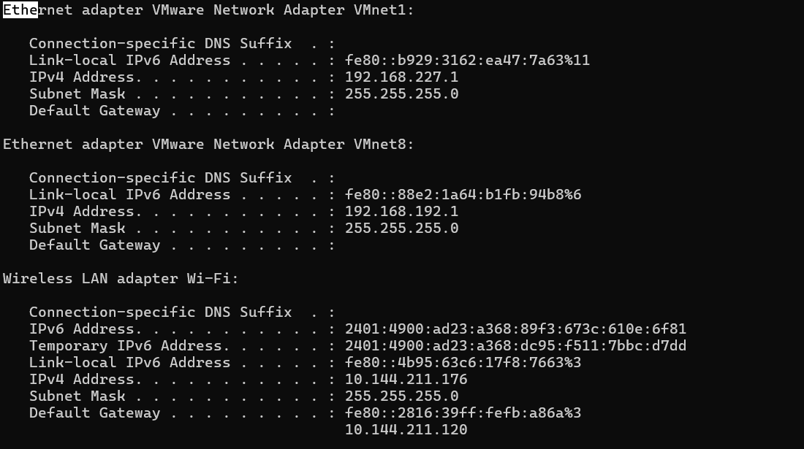

Basic Networking Concepts
- IP Address: A unique numerical identifier assigned to a device on a network, enabling communication between devices.
- MAC Address: A unique hardware address assigned to a network interface by the manufacturer for device identification.
- Default Gateway: A network device, typically a router, that directs traffic from a local network to external networks.
- DNS (Domain Name System): A service that converts domain names (e.g., google.com) into IP addresses.
- Private IP Address: An IP address used within a local network that is not directly accessible from the internet.
- Public IP Address: A globally unique IP address assigned by an ISP, used to identify a network on the internet.

Create a Basic Network Diagram
[ Local Device ] (IP: 10.144.211.xxx)
│
▼ (Wi-Fi Interface Connection)
[ Default Gateway Router ] (IP: 10.144.211.120)
│
▼ (ISP WAN Gateway)
[ INTERNET ]

Network Connectivity Test

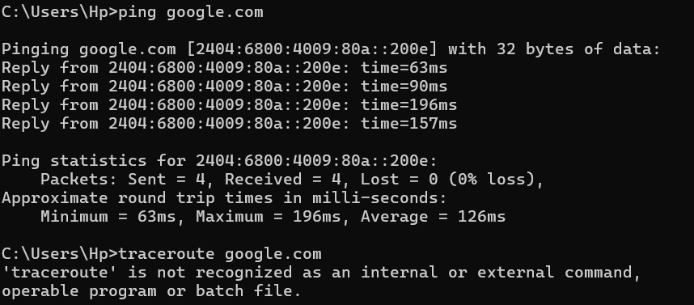

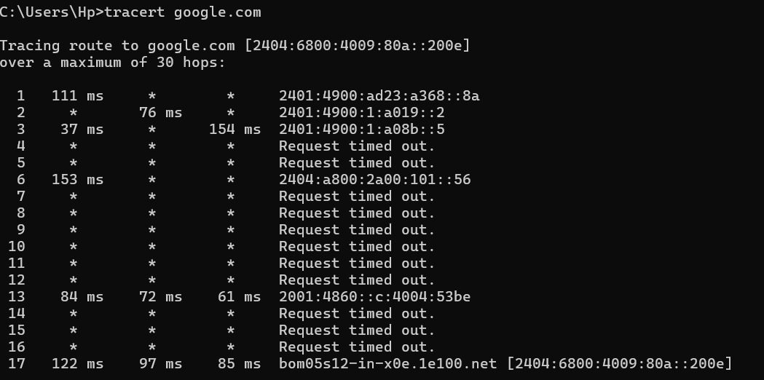

Question and answers
- Was the ping successful?
Yes, the ping was successful with 0% packet loss, which means the connection is working.
- How many hops were shown?
There were 12 hops, which means data passed through 12 steps.s
- What is the purpose of traceroute?
Traceroute is used to track how data travels from one device to another.

