WEEK-1
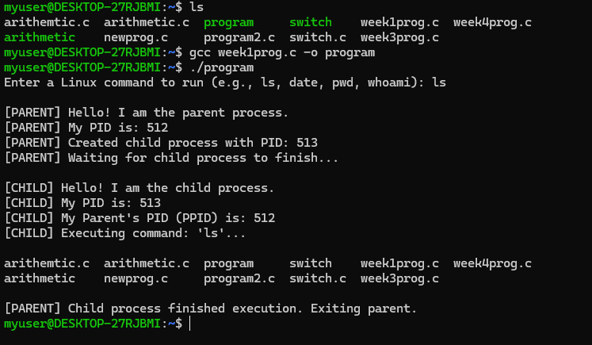

WEEK-3
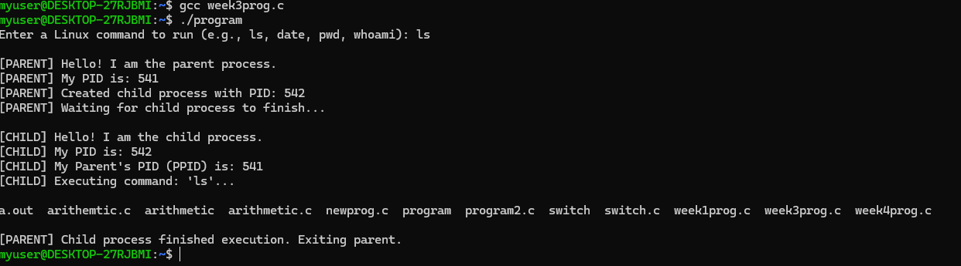

WEEK-4
