Glossary
CRC Card – A CRC card is an index card in a group setting used to represent (Beck&Cunningham, 1989):
- a class of objects
- their behavior (responsibility)
- their interactions (collaborations)
LifeCARD – A patient card for information purposes and a simple storage of readable electronic health records; 1995 planned and published as smartcard, since 2012 a QR code based plastic card with USB chipset.

User-LifeCARD-EHR-Zone-Center Structure (Rough Sketch)
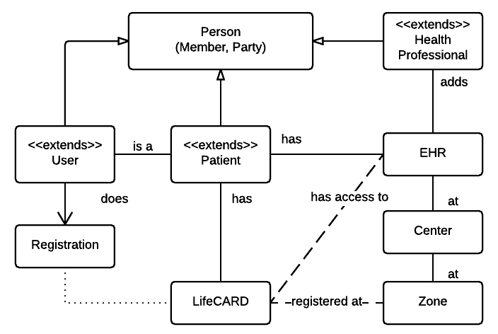
Services to store, read EHR's are not shown here, see sehr_user_group_module_orga.vsd file

CRC Cards
Patient
Name  Address  Phone No.  Mailaddress  has electronic health records  wants to store documents (Medical History)  has scheduled days  treatment takes place at different facilities  is carrier of EHR links/documents (on the LifeCARD)  has mobile; mobile has a device ID  has relationships (to exchange data like chat, notes, EHR) | Part of a User record  -“-  EHR database  EHR database  Patient Schedule  Centers, Zones  LifeCARD  LifeCARD-device assignment  Physicians, Patients (Other Users)

Physician
Name  Address  Phone No.  Mailaddress  creates, reads, updates, deletes electronic health records  enrolls patient for shared care  schedules a therapy  has mobile; mobile has a device ID (added 2013)  has relationships (to exchange data like chat, notes, EHR) | Part of a User record  -“-  EHR database  LifeCARD  Patient Schedule  t.b.d.: Acces EHR's from mobile service  other Physicians, Patients (Other Users)

Center (a health care facility)
Name  Address  Phone No.  Mailaddress  has physicians  has Patients  offers services for EHR  is part of a shared care community (zone) | EHR database

Zone (a group of centers)
Name (Title)  has responsible Person  has a headquarter address  ...Phone No.  ...Mailaddress  has centers bound  knows which services are avbl. to store/read EHR  knows the patients that are enrolled (registered)  knows which patient (who) has EHRs (relations) | LieCARD registration  EHR database

Document History
9/2015 Hans J Haase Rewritten from SEHR-SAF project specification

Previous Document: SEHR-SAF specification_crc.odt

Haase, Drescher – 1995, LifeCARD Smartcard Assisted Medical Record Support System

