Glossary
OpenEHR ...

User, Patient, Physician in relation to the openEHR context
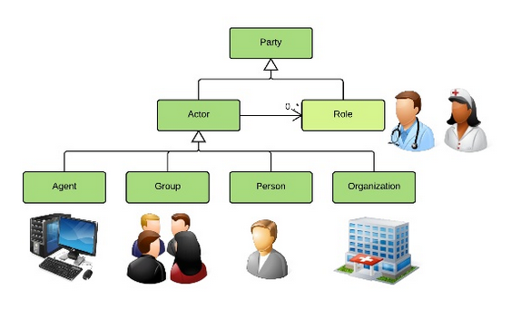
OpenEHR defines a top-level 'party' object as an entity which can partizipate in an activity.
SEHR | openEHR | Note
User (USR_MAIN) | n/a (not part of openEHR) | The openEHR does not define any implementation; so a 'user' is part of an real world application that uses openEHR
ACL role component | role | The possible roles of a user in SEHR are defined by the entity acl_roles
Resource (RES_MAIN) | agent | openEHR definition: Generic concept of any kind of agent, including devices, software systems, but not humans or organisations. In SEHR defined by resources (RES_MAIN).
zone, center and user relations | group | openEHR definition: A group is a real world group of parties which is created by another party, usually an organisation, for some specific purpose. A typical clinical example is that of the specialist care team, e.g. cardiology team . The members of the group usually work together. In SEHR a group is also a care team over the whole clinical pathway in the context of integrated /manged care.

SEHR | openEHR | Note
user | person | SEHR: A person is managed by a user record, the role of the user and the address. A user can have multiple roles like a physician that holds also a LifeCARD(R) or an administrator working also as a social worker.
center | organisation | Same meaning: Where care takes place.

The openEHR community architecture
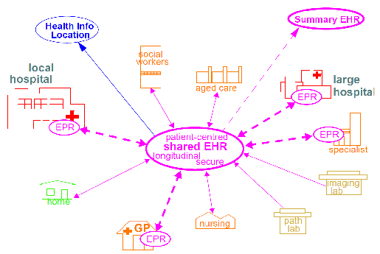
Community Shared-care Context [1]

Document History
9/2015 Hans J Haase - Rewritten from SEHR-SAF project specification

References
[1] http://www.openehr.org/releases/BASE/latest/docs/architecture_overview/architecture_overview.html

