Firmware modification requirement

固件 修改要求

Hans Kim 2024-06-04 draft

Hans Kim 2024-06-04 add event engine

1. Model name change (uboot)

ethact=sstar_emac

ethaddr=00:30:1b:ba:02:db

fileaddr=23a02750

filesize=1c2

gatewayip=192.168.101.1

ipaddr=192.168.101.220

…

…

model=SC6104QH-6211

model=SC6104QH-6212

...

修改 型号的办法 或者 工具。

1. Human detection

* enable /disable 卡开/关闭
* show object 显示 物体（人体）
* show zone 显示 区域

1. TCP server or Client(Message server or client)

* Push:

|  |  |  |
| --- | --- | --- |
| parameter | Values | Description |
| IP address | Aaa.bbb.ccc.ddd | Destination Ip address of server |
| Port | (1~65535) | Server port |
| Connection Timeout | (0~300 secs) | Connection timeout |
| Send Timeout | (0~300secs) | Send timeout |
| Alive Type | Once/Unlimited/Timeout | Once: send one time and ignore ACK  Unlimited: send repeatlt while no ACK, if receiveing ACK stop sending message  Timeout: send repeatly which no ACK, when timeout, stop sending messages |
| Alive timeout | (1~86400 secs) | When Alive type == timeout, set timeout |

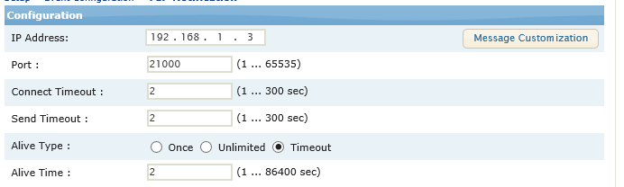

* Server

|  |  |  |
| --- | --- | --- |
| Parameter | values | Description |
| Port | (1~65535) | Port of device message server |

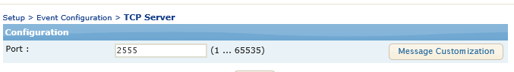

1. Message server & event source 联动

Multiple select event source

* Human detect
* Motion detect
* DI (digital iput)
* Tamper detection
* Other detections

Format:

{  
category: “human detection”,  
frame_no:12345678,  
timestamp: 123456789,  
objects : [  
 { class: “human”, score: 0.65, coords:[1054, 30, 1090, 654] },  
 { class: “human”, score: 0.70, coords:[254,630, 482, 800] },  
 …..  
]

}

|  |  |  |
| --- | --- | --- |
|  |  |  |
| Cateory | VCA, DO, DI, MD, Tamper, etc |  |
| Frame_no | Frame number of stream |  |
| timestamp | Timestamp of event triggered |  |
| Object | Description of event source, |  |

Ex)

{

category: “human detection”,

frame_no:12345678,

timestamp: 123456789,

objects : [

{ class: “human”, score: 0.65, coords:[1054, 30, 1090, 654] },

{ class: “human”, score: 0.70, coords:[254,630, 482, 800] },

……  
]

}

{

category: “motion detection”,

frame_no:12345678,

timestamp: 123456789,

zones: [

{ coords:[1054, 30, 1090, 654] },

{ coords:[254,630, 482, 800] },

……  
]

}

{

category: “tamper detetction”,

frame_no:12345678,

timestamp: 123456789,

zones: [

{ coords:[1054, 30, 1090, 654] },

{ coords:[254,630, 482, 800] },

……  
]

}

1. DI/DO API (cgi)

DO on/off 的 api, 强 do 拉高 拉低的命令（不是 联动）

DI 随时 可以 都 DI 的 状态

|  |  |  |  |
| --- | --- | --- | --- |
| action | Cgi command | method | Response |
| Get  do status | /api/v1/peripherial/query?channel=do | get | {  ‘code’ 20000,  ‘status’: ‘on/off’  } |
| Put  do command | /api/v1/peripherial/update?data=do&action=on  /api/v1/peripherial/update?data=do&action=off  /api/v1/peripherial/update?data=do&trigger=1 | get | {‘code’:20000} |
| Get DI  status | /api/v1/peripherial/query?channel=di | get | {‘code’:20000, ‘status’: 1/0} |

1. AI ISP enable/disable and calibrate parameter

Cgi command : /api/v1/isp/~~~~

* enable AI ISP (打开 AI ISP)
* disable AI ISP （关闭 AI ISP）
* Modify parameters（可调整参数）：
* AI ISP的 强度。
* AI ISP 启动的条件（CMOS 的 光亮 threshhold）

1. Init.d (Server side SDK)

支持 运行 定做的程序

/etc/init.d/rcS

#!/bin/sh

mount -a

mkdir -p /dev/shm

mkdir -p /dev/pts

mount devpts

/sbin/mdev -s

/sbin/sysctl -p

mount -t tmpfs mdev /dev

mount -t sysfs sysfs /sys

mkdir -p /dev/pts

mkdir -p /var/lock

mount -t devpts devpts /dev/pts

mount -t debugfs none /sys/kernel/debug/

echo /sbin/mdev > /proc/sys/kernel/hotplug

mdev -s

busybox telnetd &

LD_LIBRARY_PATH="/lib:/usr/local/lib:/usr/lib:/opt/app/lib:/opt/app/usr/lib"

export LD_LIBRARY_PATH

echo "

            _ _ _ _ _ _ _ _ _ _ _ _

            \  _  _   _  _ _ ___

            / /__/ \ |_/

           / __   /  -  _ ___

          / /  / /  / /

  _ _ _ _/ /  /  \_/  \_ ______

___________\___\__________________

"

for initscript in /etc/init.d/S[0-9][0-9]*

do

    if [ -x $initscript ] ;

    then

        echo "[RCS]: $initscript"

        $initscript

    fi

done

echo 768 > /proc/sys/vm/min_free_kbytes

echo 1 > /proc/sys/vm/overcommit_memory

echo 1 > /proc/sys/vm/panic_on_oom

echo 3 > /proc/sys/kernel/panic

echo 4096 > /proc/sys/kernel/msgmax

echo 32768 > /proc/sys/kernel/msgmnb

echo 64 > /proc/sys/kernel/msgmni

echo 614400 > /proc/sys/net/core/wmem_max

### mount squashfs opt/app mtd

if [ -e /dev/mtdblock4 ]; then

    /bin/mount -t squashfs /dev/mtdblock4 /opt/app

fi;

### mount squashfs opt/web mtd

if [ -e /dev/mtdblock5 ]; then

    /bin/mount -t squashfs /dev/mtdblock5 /opt/web

fi;

### mount jffs2 opt/jffs2 mtd

if [ -e /dev/mtdblock6 ]; then

    /bin/mount -t jffs2 /dev/mtdblock6 /opt/jffs2

fi;

### mount squashfs opt/data mtd

if [ -e /dev/mtdblock7 ]; then

    /bin/mount -t jffs2 /dev/mtdblock7 /opt/data

fi;

hostname ms-ipc

ifconfig lo 127.0.0.1

ifconfig eth0 down

ifconfig eth0 mtu 1470

ifconfig eth0 192.168.1.123

route add -net 224.0.0.0 netmask 224.0.0.0 dev eth0

cd /opt/app/ko

./load_ssc377.sh

date -s "2020-07-01 00:00:00"

nk_upgarde ysser 8001 image 100 &

vsftpd /usr/share/vsftpd/vsftpd.conf &

**sh /opt/data/prescript.sh &**

/opt/app/bin/xipc &

sleep 3;echo 1 > /sys/module/mi/parameters/drv_venc_wrapper.SCDN_MODE

**sh /opt/data/postscript.sh &**

1. Set default parameters

可以 设置 “工厂回复参数”

Factory default 🡺 read some parameter json

1. ~~Enable / disable audio 打开/关闭 音频 （包括 rtsp）~~

~~/api/v1/media/update~~

~~payload = {~~

~~"type":"audio_capture",~~

~~"settings":{~~

~~“enable”: ‘y’~~

~~"collect_volume":check_int(self.parent.collect_volume.text()),~~

~~"input_method":"mic",~~

~~"play_volume":check_int(self.parent.play_volume.text()),~~

~~"sample_bit":16,~~

~~"sample_rate":8000~~

~~}~~

        }

1. RTSP 设置：

可以 设置 rtsp stream 名称， rtsp 端口。 Rtsp认证

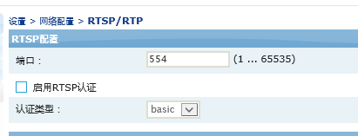

Rtsp 播放的时候 可以选 必需id:pw 或者 不用密码。

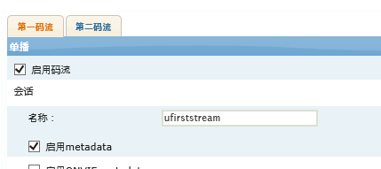

第一码流 可设 stream的名称

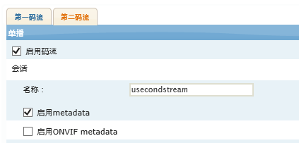

第二码流 可设 stream的名称

1. Built in Text (Korean)

OSD : 支持 韩语

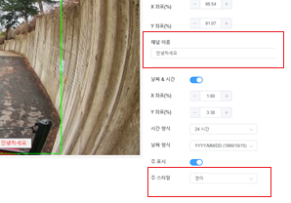

1. Webpage 端口

Api: ~~



1. Ssh 功能（if possible）
2. Design event engine(server)

Event source 🡺 event processor 🡺 event action

|  |  |  |  |
| --- | --- | --- | --- |
| Event source | Event Processor | Event Action |  |
| Digital input |  | TCP server |  |
| Motion detection | TCP push |  |
| Human detection | Digital Out |  |
| Tamper detection | Record |  |
|  | Play audio |  |