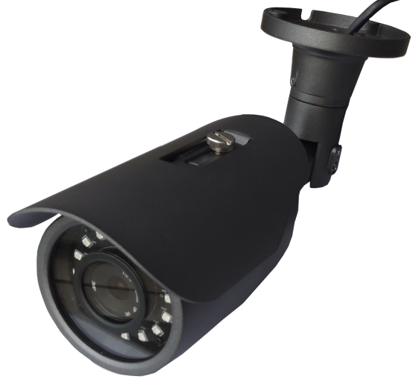**Full QHD Compact Bullet IP Camera**

FOR INTERNAL/EXTERNAL APPLICATIONS

* QHD 1440p 30fps
* H.264, H.265 and MJPEG compression
* Ultra low illuminance and WDR
* No built-in IR illuminator needed and full color at night
* Burnt-in Text, Video Motion Detection
* C:\Users\Trevor\Desktop\onvif [Converted].epsEmbedded Human detection
* Power over Ethernet (IEEE 802.3af)

|  |  |
| --- | --- |
| Camera | |
| Model | SC6104QH-6211(4mm)  SC6104QH-6212(6mm) |
| Image Sensor | Smart Sense 1/1.8" Low illuminace |
| Effective Pixels | 2994x1664 |
| Scanning System | Progressive scanning |
| AGC Control | Auto |
| Minimum Illumination | 0.0001Lux@F1.0 |
| S/N ratio | >60dB (AGC off) |
| Wide dynamic Range | Digital, >120dB |
|  |  |
| Video | |
| Compression | H.264/H.265 High/Main/Base profile  JPEG/MJPEG |
| Main Stream | 2994x1665@30fps, 2560x1440@30fps, 2304x1296@30fps, 1920x1680@30fps  1280x960@30fps, 1289x720@30fps |
| Sub Stream | 720x576@25fps, 640x480@25fps, 640x360@25fps, 352x288@25fps, 320x240@25fps |
| Image Setting | Configurable brightness, contrast, saturation, sharpness |
| Image Orientation | Flip / Mirror / Corridor Mode(-90°, +90°) |
| Built in Text | Supported |
| Privacy Mask | Supported |
|  |  |
| Audio | |
| Compression | - |
| Streaming | - |
| Audio IN /OUT | - |
| Network | |
| Protocol | TCP/IP, UDP, RTP, RTSP, HTTP, DNS, DHCP, FTP, NTP, RTMP. |
| Ethernet Standard | 10/100 Base T |
| Users | Live viewing for up to 10 clients |
|  |  |
| Integration | |
| Application Program Interface | Software Development Kit(SDK) available |
| ONVIF Compliance | Standard ONVIF2.4 |
| Events | Motopm detection, Tamper Detection; Video Content Analytics(VCA); Network Loss/Detect |
|  |  |
| General | |
| Material | Aluminum Die-Casting; Black |
| External IO | - |
| RS485 | - |
| Operating Condition | Humidity up to 85% RH (non-condensing)  [DC12V] -20°C ~ 50°C; [PoE] -20°C ~ 50°C |
| Power Consumption | DC 12V, PoE / 2W @ DC 12V |
| Language on Web | Korean, English, Chinese |
| Approval | FCC, CE, KC, IP66, UL |
| Weight | 600g |
|  |  |
|  |  |

DIMENSION

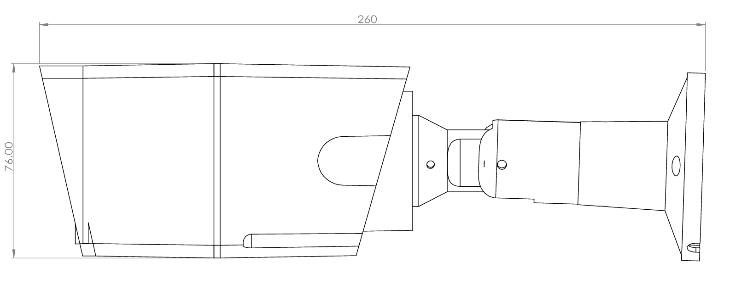

LOW ILLUMINANCE