
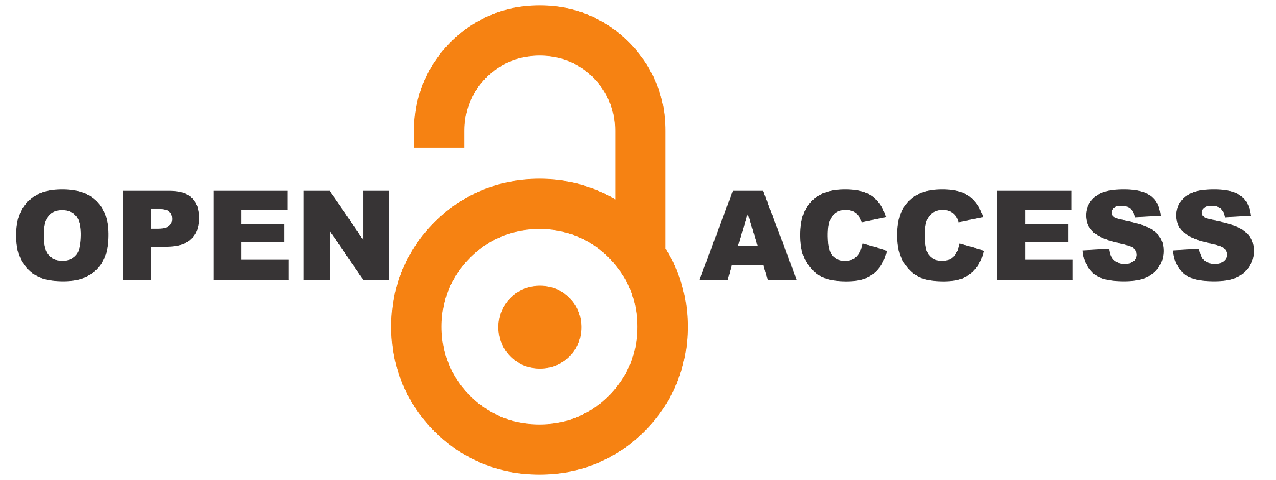

PENGARUH STATUS 'JUST FRIEND' TERHADAP STABILITAS EMOSIONAL INDIVIDU: SEBUAH STUDI FENOMENOLOGIS PADA HUBUNGAN TΑΝΡΑ KEPASTIAN"
https://ejournal.uinmadura.ac.id/index.php/ghancaran/index
https://doi.org/10.19105/xxx

RESEARCH ARTICLE

Persepsi Murid terhadap Pendekatan STEAM dalam Pembelajaran Bahasa Indonesia di Tingkat SMP
Mohammad Umar Hamdani 

¹ Universitas Gadjah Mada, Yogyakarta, Indonesia
Corresponding Author
mohammadumarhamdani@mail.ugm.ac.id

ABSTRACT
This article examines the cultural meaning and conditions of use of a Madurese self-respect principle expressed in the saying “ango’an poteya tolang ètembhâng poteya mata”, alongside related expressions concerning shame, dignity, and social propriety. It also investigates how selected news reports about carok represent or simplify the principle. The study is designed as a qualitative, document-based ethnopragmatic inquiry, combining lexical-cultural analysis, and close reading of ten to fifteen news articles published between 2021 and 2026. Cultural scripts are reconstructed through four analytic slots: the triggering situation, the person or value understood to be defended, the response expected by participants, and the limits under which the principle is or is not invoked. News excerpts are coded using a transparent codebook that distinguishes cultural generalisation, omission of use conditions, reduction to status or defeat, and cases without clear evidence of misreading. By separating the cultural principle from any single practice, the study aims to contribute an emic-sensitive account of Madurese expressions and a more accountable analysis of media representation.
Keywords: ethnopragmatics; Madurese proverbs ; self-respect; cultural script.
ARTICLE HISTORY  Received: MM DD, YYYY  Accepted: MM DD, YYYY  Published: MM DD, YYYY | LICENSErespect  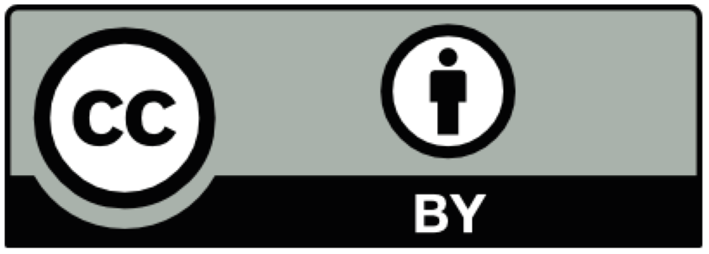  Copyright © 2026 The Author(s). This article is an open access article distributed under the terms and conditions of the Creative Commons Attribution (CC BY 4.0) License.  https://creativecommons.org/licenses/by/4.0/.

INTRODUCTION
Sebagai bangsa yang multikultural, Indonesia memiliki bervariasi budaya yang tumbuh di antara masyarakat. Hal itu memberikan kekayaan budaya yang berbeda-beda antar daerah sesuai dengan pemaknaan masyarakat suatu komunitas budaya dalam memandang realitas. Ajaran-ajaran budaya tersebut seringkali direpresentasikan dalam ungkapan-ungkapan dalam suatu budaya yang seringkali menyimpan makna tersirat dan tidak selalu dapat dipahami melalui terjemahan secara harfiah. Hal tersebut dikarenakan ungkapan tersebut berhubungan dengan situasi, konteks tertentu dan tindak tutur dalam suatu komunitas budaya. Dalam masyarakat madura terdapat tuturan yang cukup populer yakni ungkapan “ango’an poteya tolang etembhang poteya mata” yang secara lazim dimaknai sebagai “lebih baik mati daripada menanggung malu” (Wiyata, 2002). Ungkapan tersebut seringkali dihubungkan dengan pembelaan martabat, dan berlanjut menjadi kegiatan “carok”.
Ungkapan peribahasa Madura tersebut tidak sepopuler kata “carok” khususnya di luar komunitas madura, sehingga potensi terjadinya pemaknaan yang tidak utuh oleh masyarakat di luar komunitas budaya madura semakin tinggi. Penelitian ini berupaya dalam memahami prinsip harga diri yang digunakan sebagai latar belakang ungkapan yang bertujuan menjaga kehormatan muncul. Selain itu, indikator yang juga perlu dipenuhi untuk mencapai titik kematian lebih baik daripada menahan malu (Hafil & Rozi, 2022). Sehingga masyarakat di luar komunitas budaya Madura dapat memahami konteks utuh yang menyebutkan ungkapan “ango’an poteya tolang etembhang poteya mata” muncul sebagai mekanisme pertahanan harga diri pada masyarakat Madura. Hal tersebut penting untuk dipahami karena terjemahan indonesia dari malo menjadi “malu” dapat mengaburkan makna asalnya, karena tidak menjelaskan secara utuh konsep malo tersebut.
Beberapa kajian terdahulu menjelaskan beberapa

Manuscripts should contain approximately 6,000–8,000 words, including the main text, tables, figures, and appendices where applicable. The manuscript must be prepared using A4 paper size (210 mm × 297 mm) with the following page settings:

Top margin: 2.0 cm
Bottom margin: 2.0 cm
Left margin: 2.5 cm
Right margin: 2.0 cm
Line spacing: 1.5
Paragraph spacing: 0 pt before and 0 pt after

The manuscript should be formatted in a single-column layout with fully justified paragraphs. The main text should be written in Cambria, 12-point font, with a 1 cm first-line indentation for each paragraph. Alternative fonts may be used only when necessary for specialized symbols, phonetic transcription, mathematical notation, or other technical purposes.
The Introduction should establish the scholarly context of the study by clearly presenting the research problem, explaining its significance, and demonstrating its relevance within the broader field of language, literature, and education. Authors are expected to provide a critical review of recent and relevant literature, identify existing research gaps, and develop a logical argument that justifies the necessity of the present study. The theoretical framework underpinning the research should also be introduced in this section.
Furthermore, the introduction should explicitly state the research objectives, research questions or hypotheses (where applicable), the originality and novelty of the study, its relationship to previous research, and its expected theoretical and practical contributions. Rather than merely summarizing prior studies, authors should critically synthesize existing knowledge to position the current research within ongoing scholarly discussions.
As a general guideline, the Introduction should comprise approximately 15–20% of the total manuscript, including the title and abstract, while maintaining a coherent progression from the broader research context to the specific objectives of the study.
……………………………………………………………………………………………………………………………………………………………………………………………………………………………………………………………………………………………………………………………………………………………………………………………………………….
………………………………………………………………………………………………………………………………………

METHOD
Metode dalam penelitian ini menggunakan metode fenomenologi untuk menggali pengalaman murid dalam pembelajaran bahasa Indonesia dengan pendekatan STEAM. Partisipan dipilih dengan model purposive sampling yaitu memilih murid berdasarkan tujuan penelitian. Terdapat 10 murid yang akan menjadi partisipan. Murid tersebut dipilih berdasarkan tingkat prestasi akademik dalam bidang bahasa Indonesia dengan nilai 3 terbaik, 3 menengah, dan 3 cukup baik. Pertanyaan diberikan berdasarkan instrumen STEAM yang telah dilakukan pada penelitian relevan. Kemudian, hasil jawaban akan di-encoding menjadi beberapa klaster dan akan dimaknai.

Partisipan 1 | Kelas | Nama Murid
P1 | 7 | Divya (Indonesia)
P2 | 7
P3 | 7
P4 | 7 | Min Sol (Korea)
P5 | 7 | Jyn Fae (Malaysian)
P6 | 8 | Aviel (Indonesian)
P7 | 8 | Bellebitha (Indonesian)
P8 | 8 | Christian (Indo Hawai)
P9 | 8 | Nur (India)
P10 | 8 | Namira (Kazakhstan)

The Methods section should clearly describe how the study was conducted, enabling readers to understand and evaluate the research procedures. It should briefly explain the research design, participants or data sources, population and sample (where applicable), research instruments, data collection procedures, and data analysis techniques. Sufficient information should be provided to ensure the study is reproducible; however, excessively detailed descriptions of well-established methods should be avoided. When appropriate, authors should also report the validity and reliability of research instruments, ethical considerations, and statistical or qualitative analysis procedures. This section should comprise approximately 10–15% of the main manuscript.
Tables, figures, and graphs should be numbered consecutively, cited in the text, and placed as close as possible to their first citation. All visual elements must be centered and accompanied by concise, informative captions. Large tables or figures may span the full page width and should be positioned at the top or bottom of the page to maintain readability.
.…………………………………………………………………………………………………………………………………………………………………………………………………………………………………………………………………………………………………………………………...........................................................................................................................................................................

RESULTS AND DISCUSSION
The Results and Discussion should be presented as an integrated section rather than as separate sections. This section should comprise approximately 40–60% of the main manuscript. The results should be presented clearly and objectively using tables, figures, graphs, or concise narrative descriptions, or an appropriate combination of these formats. Authors should emphasize the most significant findings without presenting excessive or redundant data.
The discussion should interpret and critically analyze the findings by relating them to the research objectives, theoretical framework, and relevant previous studies. It should highlight the originality, significance, and implications of the findings, while explaining agreements, contradictions, or new insights in comparison with existing literature.
All tables, figures, and graphs must be numbered consecutively, cited in the text, and placed as close as possible to their first mention. Tables should follow a simple format without vertical lines and with horizontal lines only at the top, header, and bottom. Font sizes within tables and figures may be reduced where necessary to improve readability.

Font Size | Display (in Cambria)
Font Size | Title | Title | Title
10 | Table captions (in Small Caps),  Figure captions, reference items reference items (partial) |  | item referensi (partial)
10 | author’s email address (in Courier),  table cell | abstract content | heading abstrak
10 | heading level 1 (in Small Caps),  paragraph |  | heading level 2,  heading level-3,
Table 1. Font Sizes for Articles (Source: ….)

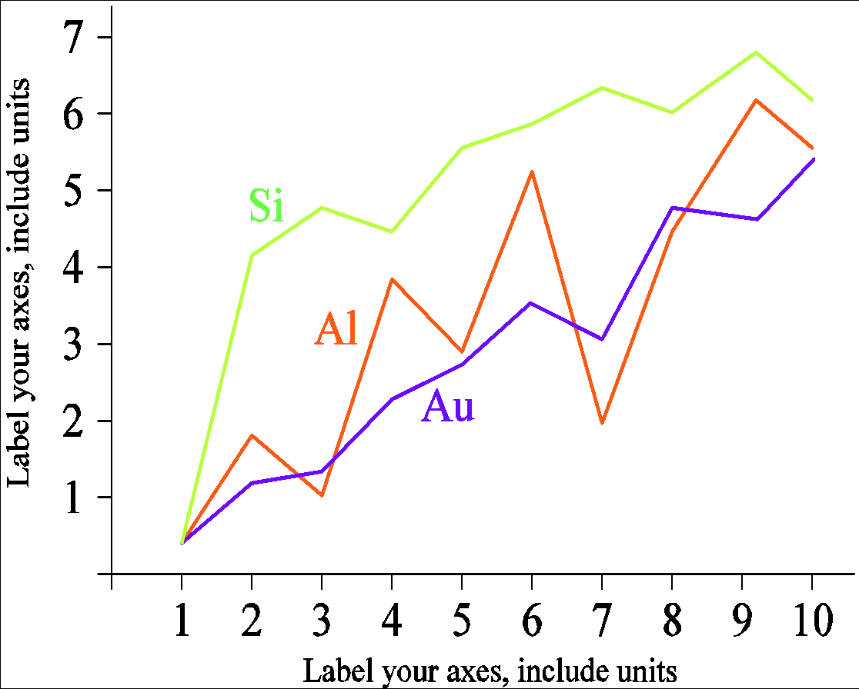

Figure 1. An example of a line graph using contrasting colours on a computer screen


Figure 2. Example image (10 pt font)

Discussions that include quotations from novels, short stories, poems, data, interview transcripts, etc. should be set in 10 pt font with single spacing. Quotations should be indented by one cm in line with the rest of the paragraph.

It sows calamity. It is the night when the Bhuta rise. That is what your mother used to say, when the full moon began to be eclipsed, whilst preparing brown sugar and coconut flesh. Meanwhile, your father would go round the village beating the kentongan with the neighbours.
At that time, you were still a child and had only just heard the term ‘gerring moon’. Nor did you initially know that terrifying creatures rose from the darkness, snatching foetuses and the peace of mind of the entire community when the full moon turned pitch-black (Masyari, 2018).

The discussion is intended to interpret and analyse the research findings in accordance with the theories employed, rather than merely explaining the findings. The discussion must be enriched by referring to the results of previous research published in scientific journals or other references. The discussion may be presented in sub-sections.
……………………………………………………………………………………………...……………………………………………………………………………………………………………………………………………………………………………………………………………………………………………………………

Note:
Article Subdivisions
It is entirely possible to add the necessary sections, and each section may consist of several subsections. You should therefore divide your article into clearly defined sections, as shown in the following format:
Subbab #`1
. . . . . . . . . . . . . . . . . . . . . . . . . . . . . . . . . . . . . . . . . . . . . . . . . . . . . . . . . . . . . . . . .
Subbab #2
. . . . . . . . . . . . . . . . . . . . . . . . . . . . . . . . . . . . . . . . . . . . . . . . . . . . . . . . . . . . . . . . .
Subbab #3
. . . . . . . . . . . . . . . . . . . . . . . . . . . . . . . . . . . . . . . . . . . . . . . . . . . . . . . . . . . . . . . . .
Subbab #4
. . . . . . . . . . . . . . . . . . . . . . . . . . . . . . . . . . . . . . . . . . . . . . . . . . . . . . . . . . . . . . . . .

CONCLUSION
The Conclusion should clearly address the research objectives and summarize the main findings without merely repeating the results. It should emphasize the significance, originality, and contribution of the study to theory, practice, or policy, where appropriate. The conclusion should be based solely on the findings presented in the manuscript and demonstrate their implications for the relevant field of study. Where applicable, authors are encouraged to acknowledge the limitations of the study and propose directions for future research. Recommendations, if included, should be concise, evidence-based, and directly derived from the research findings.
………………………………………………………………………………………………………………………………………………………………………………………………………………………………………………………………………………………………………………………………………………………………………………………………………………

ACKNOWLEDGMENTS (OPTIONAL)
The Acknowledgments section is optional and should be used to recognize financial support, institutional assistance, or contributions from individuals who have supported the research but do not meet the criteria for authorship. Authors should acknowledge the funding agency, grant number (if applicable), and any technical or academic assistance that contributed to the completion of the study. This section should be concise and should not include dedications or general expressions of gratitude.
(If the research receives funding)
The authors gratefully acknowledge the support provided by the institutions and individuals who contributed to the completion of this study. We sincerely thank [Funding Agency/Institution] for financial support under Grant No. [Grant Number], where applicable. We also appreciate the valuable assistance of [Institution/Individual] in facilitating data collection, technical support, or academic consultation. The constructive comments provided by the anonymous reviewers and editors are gratefully acknowledged and have significantly improved the quality of this manuscript.
(If the research does not receive funding)
The authors would like to thank the institutions and individuals who supported the completion of this study through academic, technical, or administrative assistance. The authors also sincerely appreciate the constructive comments and suggestions provided by the anonymous reviewers and editors, which have substantially improved the quality of this manuscript. This research received no specific grant from any funding agency in the public, commercial, or not-for-profit sectors.

DECLARATIONS
Ethical considerations
Insert text (Cambria font, size 10, and single-line spacing).
For more details on how to report this, see "Publication Ethics": https://ejournal.iainmadura.ac.id/index.php/ghancaran/Publication_Ethic
Put “Not applicable” if the study does not require an ethical statement.

Use of artificial intelligence (AI)
Authors must select one of the following statements:
“The authors declare that no generative artificial intelligence (AI) tools were used in the preparation, analysis, or writing of this manuscript.”
“The authors declare that the generative artificial intelligence (AI) tool [name of the tool] was used exclusively for language editing and/or grammatical improvement. The use of AI did not influence the scientific content, study design, data analysis, data interpretation, results, or conclusions of the manuscript. Full responsibility for the content remains with the authors.”
If the use of artificial intelligence in this manuscript does not fit either of the statements above, the authors must clearly and transparently describe, in their own words, which AI tools were used, for what specific purpose, and at which stage of the manuscript preparation.
Note: The use of AI tools does not replace the responsibility of the authors for the originality, accuracy, integrity, and validity of the manuscript. Artificial intelligence tools must not be listed as authors, as they do not meet authorship criteria and cannot take responsibility for the work.

Conflict of Interest
All authors should disclose any personal and/or financial relationships with others or organizations that may improperly influence their paper. A conflict of interest statement should be provided in the manuscript file immediately before the References section. Case there are no Conflicts of Interest, so report "The authors declare no conflicts of interest".

Funding
The names of the funding organizations should be written in full. If there was no financial aid, it should be reported that "This research did not receive any financial support".

REFERENCE
The reference list should include only works cited in the manuscript and be arranged alphabetically according to the APA (7th edition) referencing style. Authors are encouraged to cite primary sources, particularly peer-reviewed journal articles, and should avoid secondary citations whenever possible. At least 80% of the references should be published within the last 10 years to ensure the relevance and currency of the literature.
References should be formatted using single-line spacing without numbering. Every in-text citation must appear in the reference list, and every reference listed must be cited in the manuscript. Authors are strongly encouraged to use reference management software, such as Mendeley, Zotero, or EndNote, to ensure consistency and accuracy. Where available, the Digital Object Identifier (DOI) should be provided for each reference.
Examples of references are provided below.

Journal Article:
Bulté, B., Housen, A., & Pallotti, G. (2025). Complexity and difficulty in second language acquisition: A theoretical and methodological overview. Language Learning, 75(2), 533-574. https://doi.org/10.1111/lang.12669
Romadhon, S., Yulianto, B., Mulyono, M., Soepardjo, D., & Savitri, A. D. (2026). Kajian etnolinguistik pembelajaran Bahasa Indonesia bagi Penutur Asing (BIPA) lintas budaya Eropa. GHANCARAN: Jurnal Pendidikan Bahasa dan Sastra Indonesia, 7(2), 378-392. https://doi.org/10.19105/ghancaran.v7i2.20558

Books:
Ahmadi, A. (2019). Metode penelitian sastra. Penerbit Graniti.
Creswell, J. W., & Creswell, J. D. (2009). Research designs: Qualitative, quantitative, and mixed methods approaches. Sage.

Internet
United Nations. (2024). The Sustainable Development Goals Report 2024. https://unstats.un.org/sdgs/report/2024/

