Title of the manuscript max 15 words [16, Bold)

First Author^{1*}, Second Author² [← 12pt]
^{1,2}Affiliation, Institution, Country [← 11pt Font]

Article History [← 10pt, Bold]
Received : yyyy-mm-dd
Revised : yyyy-mm-dd
Accepted : yyyy-mm-dd
Published : yyyy-mm-dd

Keywords: [← 10pt, Bold]
Islamic economics, Islamic finance,
Islamic banking,
Islamic capital market [← 10pt,
separated by comma (,), max five words, ]

DOI: [← 10pt, Bold]
https://doi.org/10.19105/mabny.v5i2.xxxx [← 10pt]

Corresponding author: [← 10pt, Bold]
Author name [← 10pt]
abc1@email.com [← 10pt]

Abstract [← 12pt, Bold]
The abstract should be no more than 250 words. All submissions must include a structured abstract. These four sub-headings and their accompanying explanations must always be included:
Purpose – [← 11pt, Bold]

Methodology – [← 11pt, Bold]

Findings – [← 11pt, Bold]
Implications – [← 11pt, Bold]
Originality – [← 11pt, Bold]

Cite this article: [← 11pt, Bold ]
Author, & Author. (20xx). Title. Mabny : Journal of Sharia Management and Business , x(x), xx-xx. https://doi.org/10.19105/mabny.v5i2.xxxx
[← 10pt]

Introduction [← 14pt, Bold]
The introduction should outline the aims of your paper, as well as describe why the topic is important and what it contributes to the body of knowledge. It establishes the scope, context, and significance of the research being conducted by summarizing current understanding and background information about the topic, stating the purpose of the work in the form of the research problem supported by a hypothesis or a set of questions, explaining briefly the methodological approach used to examine the research problem, highlighting the potential outcomes your study can reveal, and outlining the remaining structure and organization of the paper. Full paper should be minimum 4000 words [← 12pt ]

Literature Review [← 14pt, Bold]
Literature review provides an analysis and generalization of relevant works (papers, monographs, reports, theses, etc.), which describe the essence of the problem and/or give an understanding on the previous efforts to solve it. The Literature Review should comply with the aim of the research (“fitness for purpose”) and represent the results of critical analysis of the analytical base for testing the research hypothesis. Literature review must not be limited only by works, which were published in the country where the author lives and works (the problem should be studied globally). Particularly it concerns the authors from non-English speaking countries (they are recommended to thoroughly analyze the works published in English).
Citations in the text should follow the referencing style used by the American Psychological Association. You are referred to the Publication Manual of the American Psychological Association, Sixth (6th) or Seventh (7th) Edition, ISBN 978-1-4338-0561-5. Please ensure that every reference cited in the text is also present in the reference list (and vice versa). Any references cited in the abstract must be given in full. Unpublished results and personal communications are not recommended in the reference list, but may be mentioned in the text. If these references are included in the reference list they should follow the standard reference style of the journal.
All citations in the text should refer to:
Single Author: the author's last name (without initials, unless there is ambiguity) and the year of publication; for example, Tumewang (2020) supports CIMAE conferences are supported by many researchers (Nurdany, 2019; Muamar, 2020).
Two Authors: list all authors' last names with "and" in the text or “&” in parentheses separating the two authors and the year of publication;
More than Three up to Five Authors: at first citation list all authors' last names with "and" in the text or “&” in parentheses separating the last two authors and the year of publication; If more than six authors, list the first six authors followed by et al. and the year of publication. In subsequent citations use the first author et al.
Groups of references should be listed first alphabetically, then chronologically. For example, Putriani and Prastowo (2019) suggest ...., or Majid and Ulina (2020) have shown that ...'
When citing a list of references in the text, put the list in alphabetical order and separate authors by semicolons; for example, several studies (Putriani & Prastowo, 2019; Majid & Ulina, 2020) support this conclusion.

Research Methods [← 14pt, Bold]
The research methods section describes the main stages and procedures of the research to investigate a research problem and the rationale for the application of specific procedures or techniques used to identify, select, process, and analyze information applied to understand the main problem of the research. In detail, research methods must be explaining the methods used, the influences that determined your approach, and why you chose samples, etc. This section must focus on answers about collected or generated data, and the process to analyze data with the relevant analytical tools. The writing should be direct and precise and always written in the past tense.
Write and save your paper keeping text and graphic files separate until after the text is formatted. Do not use hard tabs, limit use of hard returns to only one at the end of each paragraph and do not add pagination anywhere in the paper. Proceed to formatting once you are done with completing the content and organizational editing. This should include the various sections and subsections of the paper. Figures and Tables should be included as part of the manuscript and not at the end.
For example, quantile regression essentially transforms a conditional distribution function into a conditional quantile function by splitting it into segments. In OLS, modelling a conditional distribution function of a random sample (y1, …, yn) with a parametric function $m(β )$ where xi represents the independent variables, $β$ the corresponding estimates and m the conditional mean, can cause the following minimization problem:

Tables and Figures
Tables and figures should be presented as follows: 1) The name of tables and figures should follow a numbering system (Arabic numbering system). The names of the tables and figures are on the top and bottom parts of the tables, respectively. 2) The tables and figures should provide the source of information, if any, at the bottom part of both; and 3) Any table should contain only heading and contents. The table contains row lines only without column lines. Note(s) and source(s) should be included underneath the table where appropriate.
All Tables, Figures (charts, diagrams and line drawings) and Plates (photographic images) should be included as part of the manuscript. Supply clear captions for all tables, figures and plates. Tables/figures should be NO more than a single page each in portrait (Avoid vertical rules). If the data is too large for a single table, please consider another way of presenting your data. The font to be used in a Table/Figure is 12pt Garamond (minimum 10pt). There is NO bold and italic text included in the table content. Cells in tables and figures should NOT be coloured. In case you need to draw attention to a particular datum then use only a shade of grey.
Captions for tables must be placed above the table. Captions are in 12pt Garamond. The placement of the caption below the artwork removes the chance that the caption becomes separated across page boundaries (see Table 1 and 2).

Tabel 1. Descriptive Statistics
Conventional Banks Only
Variabel | Mean |  | Std.Dev |  |  | Min | Max
Bank z-score | 10.537 |  | 15.198 |  |  | -124.716 | 191.984
CFGrowth | 13.021 |  | 1.814 |  |  | 7.448 | 18.304
ROA | 1.788 |  | 1.535 |  |  | -7.470 | 8.380
BS | 81.600e+03 |  | 193.242e+06 |  |  | 394793 | 1296.898e+06
CAR | 25.065 |  | 13.966 |  |  | 10.520 | 145.810
NIM | 5.333 |  | 2.110 |  |  | 0.030 | 18.020
ETA | 0.157 |  | 0.086 |  |  | 0.001 | 0.890
BOPO | 83.718 |  | 14.959 |  |  | 30.170 | 180.620
LLP | 1.6119 |  | 1.449 |  |  | 0.000 | 9.090
Islamic Banks Only

Variabel |  | Mean |  | Std.Dev | Min |  |  | Max
Bank z-score |  | 14.271 |  | 24.971 | -2.516 |  |  | 181.297
CFGrowth |  | 12.576 |  | 1.198 | 9.194 |  |  | 15.280
ROA |  | 1.268 |  | 3.263 | -8.090 |  |  | 12.730
BS |  | 22.500e+03 |  | 25.621e+06 | 1206294 |  |  | 101.118e+06
CAR |  | 20.265 |  | 6.634 | 10.160 |  |  | 40.920
NIM |  | 7.505 |  | 8.752 | 0.860 |  |  | 37.180
ETA |  | 0.141 |  | 0.060 | 0.032 |  |  | 0.342
BOPO |  | 94.536 |  | 16.539 | 60.400 |  |  | 217.400
LLP |  | 2.672 |  | 2.446 | 0.460 |  |  | 13.990

Captions for Figures must be placed underneath the artwork. Captions are in 12pt, Centered. The placement of the caption below the art removes the chance that the figure and the caption become separated across page boundaries (see Figure 1 and 2).

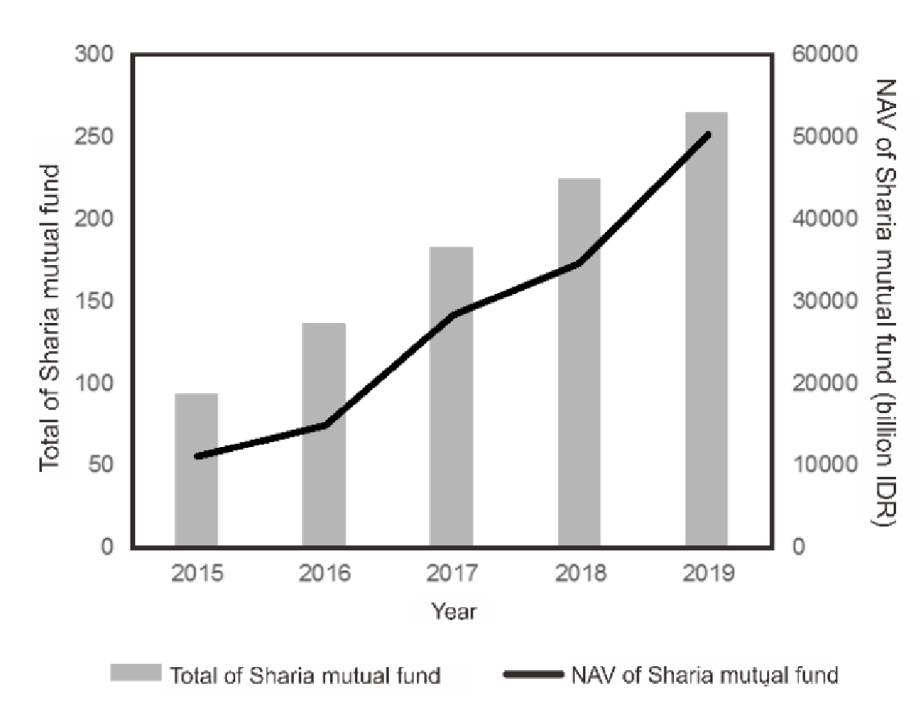
Source: (Otoritas Jasa Keuangan, 2019)

Figure 1. Growth in Sharia Mutual Funds Amount and NAV in Indonesia
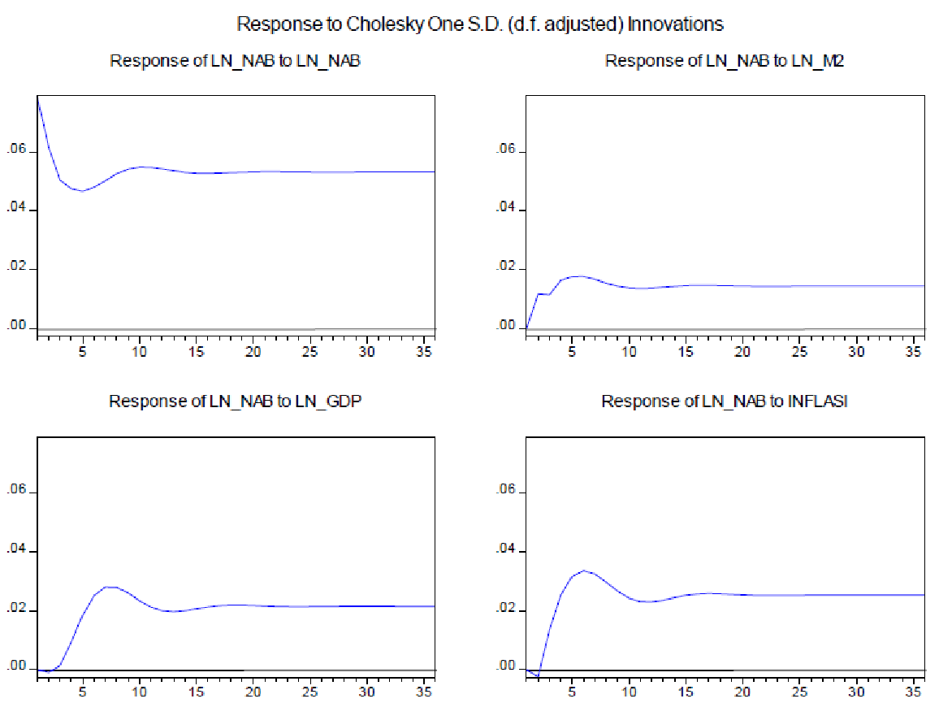
Figure 2. Result of Impulse Response Function (IRF)

Results and Discussion[← 14pt, Bold]
The result and discussion section are the main part of the author's contribution to the research by providing a report in the form of an explanation of the findings of the research based upon the methodology you applied to gather information. The results section should state the findings of the research arranged in a logical sequence without bias or interpretation. A section describing results is particularly necessary if your paper includes data generated from your own research. The purpose of the discussion is to interpret and describe the significance findings of the research considering what was already known about the research problem being investigated and to explain any new understanding or insights that emerged as a result of the research process to answer the problem. The discussion will always connect to the introduction by way of the research questions or hypotheses you posed and the literature you reviewed.

Conclusion [← 14pt, Bold]
The conclusion should summarize the main state of the findings at the point of writing and consider the next steps. This section also the synthesis key points of the result and, if applicable, recommends new areas for future research. [← 12 pt]

Acknowledgements [← 12pt, Bold]
The Acknowledgement section should specify the individuals or institutions, who have also contributed to the article but are not its authors (the relevant scientific programs, grants, scholarships, contracts are indicated, the persons or organizations, which helped an author in conducting the research, namely, access to information, organization of the survey, interview, etc.). [← 12 pt]

Author Contributions [← 12pt, Bold]
Conceptualization: [← 12pt]
Data curation: [← 12pt]
Formal analysis: [← 12pt]
Investigation: [← 12pt]
Methodology: [← 12pt]
Project administration: [← 12pt]
Supervision: [← 12pt]
Validation: [← 12pt]
Visualization: [← 12pt]
Writing – original draft: [← 12pt]
Writing – review & editing: [← 12pt]

References [← 14pt, Bold]
References List: Please ensure that every reference cited in the text is also present in the reference list (and vice versa). References should be minimum from 30 source arranged first alphabetically and then further sorted chronologically if necessary. More than one reference from the same author(s) in the same year must be identified by the letters 'a', 'b', 'c', etc., placed after the year of publication. [← 12 pt]
Web References: As a minimum, the full URL should be given and the date when the reference was last accessed. Any further information, if known (DOI, author names, dates, reference to a source publication, etc.), should also be given. For example, [← 12 pt,]

