
Karsa: Journal of Social and Islamic Culture
ISSN: 2442-3289 (p); 2442-8285 (e)
Vol. XX No.X, December 20XX, pp. XX–XX
DOI: 10.19105/karsa.vX1iX.XXXX

Prosociality of Modernist Islamic Volunteers
in Responding ........

Hazim
Graduate School of Business, Economics and Social Sciences,
Hamburg University, Hamburg, Germany
email: hazim@studium.de
Effy Maryam
Fakultas Psikologi, Universitas Muhammadiyah Sidoarjo,
Sidoarjo, Indonesia
email: effy.wardati@umsida.ac.id
Tri Ulfah
Fakultas Psikologi, Universitas Muhammadiyah Sidoarjo,
Sidoarjo, Indonesia
email: tmegaaa@gmail.com

Abstract
Historical and religious sites are developing into tourist attractions. Tourist perception is interpreted as one way to determine visitor satisfaction, can advance the improvement of tourist attractions, and is a driver for revisit intentions. This study aims to explore the views of tourists regarding the meaning of the religious and historical as a tourist attraction, the pattern of visitor density in the tourist area of the Great Mosque of Demak, and to identify the perception of tourists about facilities, and revisit the intention of the Demak Great Mosque. ....... Great Mosque of Demak is 89.42%.
[Situs bersejarah dan religious berkembang menjadi daya tarik wisata. Persepsi wisatawan diartikan sebagai salah satu cara dalam mengetahui kepuasan pengunjung serta dapat memajukan peningkatan objek wisata dan sebagai pendorong untuk intensi mengunjungi kembali. Penelitian ini bertujuan untuk mengeksplorasi pandangan wisatawan mengenai makna religi dan sejarah sebagai daya tarik wisata, serta pola kepadatan pengunjung di kawasan wisata Masjid Agung Demak, Indonesia dan mengkaji Persepsi wisatawan tentang fasilitas, dan niat berkunjung kembali ke Masjid Agung Demak. ............. Niat pengunjung untuk kembali mengunjungi Masjid Agung Demak sebesar 89,42%.]

Keywords: religious tourism; historical tourism; Islamic tourism;
Demak

Introduction
Tourism is used as an essential role in economic, social, cultural, and religious life. In addition, tourism is expected to create new jobs for the community. Sandiaga Uno, Minister of Tourism and Creative Economy Indonesia, plans to open tourism destinations, including religious tourism. Tourism has developed into an industry capable of significantly contributing to the country’s economic growth.
The existence of tourist objects is essential in tourism activities because tourists will visit tourist destinations if they have potential as tourist attractions. This tourist attraction has a variety of attractions that can be interesting for tourists.. One of the attractions of a tourist attraction is its historical value, and often, there is a historical object that includes spiritual sites and related services visited for secular and religious reasons.
Demak Regency is one of the provinces in Central Java, Indonesia, which is attractive for tourism and has a history of heritage dating back to the early development of Islam on the island of Java. One of these historical heritages is the Great Mosque of Demak, and until now, it has become the main icon of Demak, Central Java. The Great Mosque of Demak is the centre of religious and cultural activities for the supporting community. The Great Mosque of Demak is a historical tourism icon with religious elements that can be used in tourism.

Figure 1. Data on Tourist Visits to the Great Mosque of Demak Year 2019-2021

Source: Demak Regency Tourism Office, processed 2023

Methods
The research was conducted in Demak Great Mosque, Demak Regency, Central Java Province, Indonesia (figure 3).

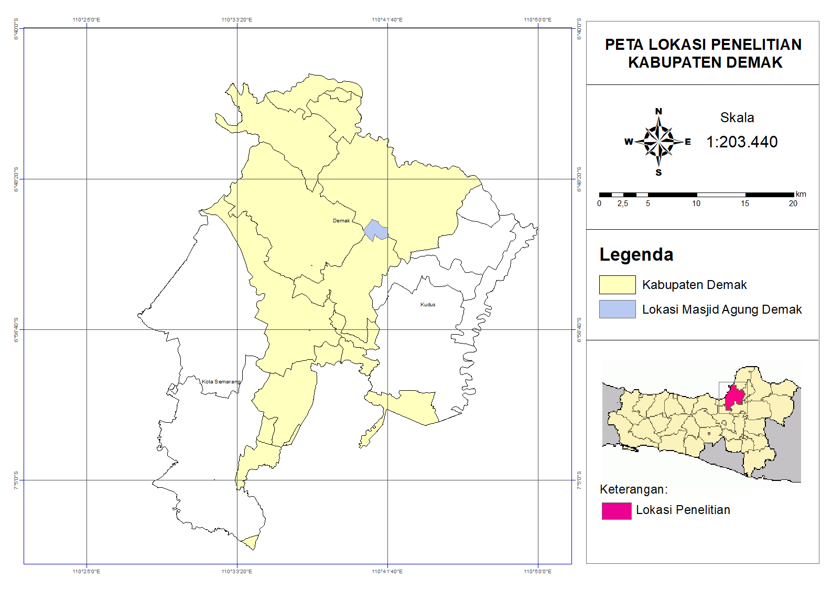

Figure 3. Research Location Map

This study combines quantitative and qualitative analysis in its research. A qualitative approach uses photovoice to answer the first research objective. The Photovoice method investigates the appeal of the Great Mosque of Demak as a tourist destination. The photovoice method is used because each visitor has their point of view about the meaning of the Great Mosque of Demak. Photovoice is a qualitative method that enables people to communicate rich stories about their lives through photographs by combining photographs and narratives that explain the participants’ perceptions and perspectives. Photovoice includes three steps: (i) recruit participants, (ii) photo assignment, and (iii) record photo narration through semi-structured interviews. This study included 12 participants from students and communities interested in and knowledgeable of the Great Mosque of Demak.

Table 2. Primary Data Collection

Objective 1 | Photovoice: 12 participants from communities and students who have an understanding and interest in the Great Mosque of Demak
Objective 2,3,4 | Survey and interview: 104 visitor respondents

Quantitative research uses descriptive statistics to answer the second, third, and fourth research studies. The second objective of this

Results
Demak Great Mosque Attractions
The Great Mosque of Demak has a meaning for visitors. This mosque is a worship site for Muslims that contains historical significance for the past development of Islam in Java. The Great Demak mosque complex is close to the Demak Sultanate Heritage Museum and the pilgrimage to the graves of Raden Patah and the Demak royal family. So, the historical and religious values ​​in the Great Mosque of Demak are very thick and inseparable. The function of the Great Demak mosque is explored by looking at the meaning of the Great Demak mosque, which is poured through photos with photovoice.
In the photovoice, .......... Research related to meaning has been carried out in the study of Ana Carolina Esteves Dias.

Discussion
Tourism combines rest with knowledge of life, history, culture, traditions, and customs of one’s own and those of other people. Historical and cultural tourism occupies one of the leading places among the main types of tourism. Demak Great Mosque is a tourism site with potential that deserves to be developed and managed optimally. Tourism in Indonesia varies, one of which is religious tourism. Walisongo Heritage is one of Indonesia’s religious tourism sites. It is a symbol of the spread of Islam in Indonesia, especially on the island of Java. One of Walisongo’s heritage is in Demak Regency.
The existence of tourist attractions is essential in tourism activities because tourists will visit tourist destinations if they have potential as tourist attractions. Although some recent studies claim that the motives are based on spirituality, religious belief, exploration and socialization. Exploring various cultures and lifestyles, finding respite from the daily pressures of life, and establishing social connections, interest in history, for cultural or recreational purposes. Religious travellers compromise specific distinctive identities and values once integral to the practice.

Conclusion
The Great Mosque of Demak has several unique tourist attractions, such as historical, religious, and educational, with the highest visitor density during the day, both during the high and low seasons, between 12.00 and 15.00. The quality of religious and non-religious facilities at the Great Mosque of Demak, as well as indicators of customer satisfaction, are driving factors for the interest and competitiveness of tourist sites. The results of acquiring a very high average quality of religious facilities and high quality of non-religious facilities at the Demak Great Mosque encourage tourists to visit.

Acknowledgment (if any)
The author would like to thank .................. tand ..... students of statistics courses who have assisted in collecting data for this study.

Reference
Abbate, Costanza Scaffidi, and Santo Di Nuovo. “Motivation and Personality Traits for Choosing Religious Tourism. A Research on the Case of Medjugorje.” Current Issues in Tourism 16, no. 5 (July 2013): 501–6. https://doi.org/10.1080/13683500.2012. 749844.
Afidah, Nur. “Perkembangan Islam Pada Masa Kerajaan Demak.” Jurnal Studi Islam Dan Kemuhammadiyahan (JASIKA) 1, no. 1 (2021): 64–76.
Aimee, Razafimanjary Maminiaina. “A Thorough Literature Review of Customer Satisfaction Definition, Factors Affecting Customer Satisfaction and Measuring Customer Satisfaction.” International Journal of Advanced Research 7, no. 9 (September 30, 2019): 828–43. https://doi.org/10.21474/IJAR01/9733.
Alifuddin, Muhammad, Alhamuddin Alhamuddin, Andri Rosadi, and Ulil Amri. “Understanding Islamic Dialectics in The Relationship with Local Culture in Buton Architecture Design.” KARSA: Journal of Social and Islamic Culture 29, no. 1 (June 30, 2021): 230–54. https://doi.org/10.19105/karsa.v29i1.3742.
Amalia, Rizki, Afrida Yahya, and . Nurhalis. “Halal Tourism: Analysis Of Religiosity, Mites and Revisit Intention.” PEOPLE: International Journal of Social Sciences 4, no. 3 (January 29, 2019): 1056–68. https://doi.org/10.20319/pijss.2019.43.1056 1068.
Andrianto, Tomy. “The Halal-Ness Hospitality on Halal Tourism, Case Study of Halal Restaurant in Bandung, Indonesia.” Journal of Indonesian Tourism, Hospitality and Recreation 2, no. 2 (2019): 210–22. https://doi.org/10.17509/jithor.v2i2.21001.

Yulie Suryani and Vina Kumala, “Magnet Wisata Religi Sebagai Perkembangan Ekonomi Masyarakat Di Kurai Taji Kabupaten Padang Pariaman,” Inovasi Penelitian 2, no. 1 (2021): 95–102.
Tomy Andrianto, “The Halal-Ness Hospitality on Halal Tourism, Case Study of Halal Restaurant in Bandung, Indonesia,” Journal of Indonesian Tourism, Hospitality and Recreation 2, no. 2 (2019): 210–22, https://doi.org/10.17509/jithor.v2i2.21001.
Helln Angga Devy and R.B Soemanto, “Pengembangan Obyek Dan Daya Tarik Wisata Alam Sebagai Daerah Tujuan Wisata Di Kabupaten Karanganyar,” Jurnal Sosiologi DILEMA 32, no. 1 (2017): 34–44.
Ni Luh Apriani, Naswan Suharsono, and Lulup Endah Tripalupi, “Persepsi Wisatawan Terhadap Objek Daya Tarik Wisata Tenganan Pegringsingan, Kabupaten Karangasem,” Jurnal Pendidikan Ekonomi Undiksha 12, no. 1 (2020): 97, https://doi.org/10.23887/jjpe.v12i1.22930.
Tahani Hassan et al., “Segmentation of Religious Tourism by Motivations: A Study of the Pilgrimage to the City of Mecca,” Sustainability (Switzerland) 14, no. 13 (2022): 1–19, https://doi.org/10.3390/su14137861.
(Dinas Pariwisa Kabupaten Demak, 2021)
Supatmo, “Ikonografi Ornamen Lawang Bledheg Masjid Agung Demak,” Imajinasi XII, no. 2 (2018): 2.
Mohammad Ardiansyah, Suharno, and Indah Susilowati, “Estimating the Conservation Value of Mangrove Forests in Marine Protected Areas: Special Reference to Karimunjawa Waters, Indonesia,” AACL Bioflux 12, no. 2 (2019): 437–47; Hapsari A. Kusumawardhani, Indah Susilowati, and Hadiyanto, “The Prospective Path of Small-Scale Fishermen: From Vulnerable to Viable Condition (A Study in Tegal Regency-Central Java Province, Indonesia),” AACL Bioflux 15, no. 2 (2022): 963–77.
Beverly Palibroda et al., A Practical Guide To Photovoice: Sharing Pictures, Telling Stories and Changing Communities, Communities, 2009; Ana Carolina Esteves Dias, “Linking Ecosystem Services and Wellbeing to Improve Coastal Conservation Initiatives under Conditions of Rapid Social-Ecological Change” (University of Waterloo, 2020); Nathan James Bennett and Philip Dearden, “A Picture of Change: Using Photovoice to Explore Social and Environmental Change in Coastal Communities on the Andaman Coast of Thailand,” Local Environment 18, no. 9 (2013), https://doi.org/10.1080/13549839.2012.748733.
Nur Afidah, “Perkembangan Islam Pada Masa Kerajaan Demak,” Jurnal Studi Islam Dan Kemuhammadiyahan (JASIKA) 1, no. 1 (2021): 64–76.
Dias, “Linking Ecosystem Services and Wellbeing to Improve Coastal Conservation Initiatives under Conditions of Rapid Social-Ecological Change.”
Devy and Soemanto, “Pengembangan Obyek dan Daya Tarik Wisata Alam Sebagai Daerah Tujuan Wisata di Kabupaten Karanganyar.”
Christine N. Buzinde et al., “Emic Understandings of Kumbh Mela Pilgrimage Experiences,” Annals of Tourism Research 49 (November 2014): 1–18, https://doi. org/10.1016/j.annals.2014.08.001; Martinette Kruger and Melville Saayman, “Understanding the Zion Christian Church (ZCC) Pilgrims,” International Journal of Tourism Research 18, no. 1 (January 26, 2016): 27–38, https://doi.org/10.1002/ jtr.2030.
Wanfei Wang, Joseph S. Chen, and Keji Huang, “Religious Tourist Motivation in Buddhist Mountain: The Case from China,” Asia Pacific Journal of Tourism Research 21, no. 1 (January 2, 2016): 57–72, https://doi.org/10.1080/10941665.2015.1016443.
Costanza Scaffidi Abbate and Santo Di Nuovo, “Motivation and Personality Traits for Choosing Religious Tourism. A Research on the Case of Medjugorje,” Current Issues in Tourism 16, no. 5 (July 2013): 501–6, https://doi.org/10.1080/13683500. 2012.749844.
Jaeyeon Choe, Michael Blazey, and Ondrej Mitas, “Motivations of Non-Buddhists Visiting Buddhist Temples,” Current Issues in Tourism 18, no. 1 (January 2, 2015): 70–82, https://doi.org/10.1080/13683500.2013.771627.
Jorge Gutic, Eliza Caie, and Andy Clegg, “In Search of Heterotopia? Motivations of Visitors to an English Cathedral,” International Journal of Tourism Research 12, no. 6 (November 11, 2010): 750–60, https://doi.org/10.1002/jtr.790.
Gyan P. Nyaupane, Dallen J. Timothy, and Surya Poudel, “Understanding Tourists in Religious Destinations: A Social Distance Perspective,” Tourism Management 48 (June 2015): 343–53, https://doi.org/10.1016/j.tourman.2014.12.009.
Iliev, “The Evolution of Religious Tourism: Concept, Segmentation and Development of New Identities.”

