Title – Font: Cambria, Font Size: 13, Sentence Case, Alignment: Center
Top Margin: 3.5 cm Bottom Margin: 2.5 cm
Left Margin: 3.5 cm Right Margin: 2.5 cm

First Author’s name^{1*}
¹First Author’s Department/Faculty, Affiliation (e.g.: Faculty of Tarbiyah, Universitas Islam Negeri Madura)
First author’s e-mail (e.g., author1@gmail.com)
(+628xxxxxxxxxx)

Second Author’s name²
² Second Author’s Department/Faculty, Affiliation (e.g.: Faculty of Tarbiyah, Universitas Islam Negeri Madura)
Second author’s e-mail (e.g.: author2@gmail.com)
*corresponding author

Abstract: The abstract should be written in one paragraph and should be between 150 - 250 words. Cambria, single space, italic, alignment: justify, left indent: 2cm, right indent: 2cm. The abstract should follow the following pattern. It starts with a general statement of the topics, the purpose of the study, the research method, the main findings, and the conclusion.

Keywords: keyword 1; keyword 2; keyword 3; keyword 4. Cambria, 11, single spacing, italic, alignment: center (no more than four keywords)

Article History:  Received : DD MM YYYY  Revised : DD MM YYYY | Accepted : DD MM YYYY  Available Online : DD MM YYYY
Suggested Citation Format:
To be added by the editorial team.

INTRODUCTION [ALL CAPITAL, type in Bold, Cambria, in 11pt font size]
The article should be between 10 - 25 pages, font style: Cambria, font size: 11pt, space: exactly 17. The paragraph should be indented first line 1 cm. In composing the introduction, you should provide an adequate background. Explain how you addressed the problem, and why it is important to answer the problem, and also clearly state the aims of the study (how you think their answer would contribute to the existing scholarship on the subject).

LITERATURE REVIEW
You should also write any related theories in depth and the relation of your research article with other research(s), especially from the most relevant and latest theories, and high reputation journals. The use of reference sources is prioritized from primary sources in the form of research articles in scientific journals, conference proceedings and / or scientific papers. The number of reference sources per article uses a minimum of 20 references to the latest books and scientific journals (60-80% of all references come from reputable scientific journals published in the last 10 years).
. . . . . . . . . . . . . . . . . . . . . . . . . . . . . . . . . . . . . . . . . . . . . . . . . . . . . . . . . . . . . . . . . . . . . . . . . . . . . . . . . . .
METHOD
Explain about the research method involving research design, population and sample, research instruments, data collection procedures, and data analysis. A very detailed description of your research method is necessary to write.

RESULTS AND DISCUSSION
Result and discussion should be written in different part. They should be presented continuously start from main result until supporting results and equipped with a discussion.
Results
. . . . . . . . . . . . . . . . . . . . . . . . . . . . . . . . . . . . . . . . . . . . . . . . . . . . . . . . . . . . . . . . . . . . . . . . . . . . . . . . . . . . . . . . . . . .

Discussion
. . . . . . . . . . . . . . . . . . . . . . . . . . . . . . . . . . . . . . . . . . . . . . . . . . . . . . . . . . . . . . . . . . . . . . . . . . . . . . . . . . . . . . . . . . . .

CONCLUSION
Conclusion should be explained clearly. Suggestion (if any) placed after conclusion containing a recommendation from the research results.
. . . . . . . . . . . . . . . . . . . . . . . . . . . . . . . . . . . . . . . . . . . . . . . . . . . . . . . . . . . . . . . . . . . . . . . . . . . . . . . . . . . . . . . . . . . .
ACKNOWLEDGMENTS (optional)
Give credit to funding bodies and departments that have been of help during the project, for instance by supporting it financially.

DECLARATION OF AI AND AI-ASSISTED TECHNOLOGIES
In developing this work, the authors utilized ChatGPT to support information retrieval, along with DeepL (V.24.4.3) to enhance linguistic accuracy and readability. The authors have carefully reviewed, revised, and refined the content as necessary and take full responsibility for the final manuscript.

REFERENCES
All quotation must be written in end-note by following American Psychological Association 6th Edition format.
References should be arranged from A to Z without numbers. We recommend the author(s) to use citation systems such as Mendeley and Zotero System. DOI number must be provided whenever a reference has “DOI” identifier.
The examples of end-note and references could be seen in the next page.

Notes:

Subdivision of the Article

It is very possible to add sections as needed, and every section may consist of several sub-sections. Therefore, you need to divide your article into clearly defined. The abstract is not included in section. Like in the following format:

MAIN POINTS
. . . . . . . . . . . . . . . . . . . . . . . . . . . . . . . . . . . . . . . . . . . . . . . . . . . . . . . . . . . . . . . . . . . . . . . . . . . . . . . . . . . . . . . . . . . .
Subheading #1
. . . . . . . . . . . . . . . . . . . . . . . . . . . . . . . . . . . . . . . . . . . . . . . . . . . . . . . . . . . . . . . . . . . . . . . . . . . . . . . . . . . . . . . . . . . .
Subheading #2
. . . . . . . . . . . . . . . . . . . . . . . . . . . . . . . . . . . . . . . . . . . . . . . . . . . . . . . . . . . . . . . . . . . . . . . . . . . . . . . . . . . . . . . . . . . .

Table and Figure

Figures and tables should be editable ones.

Table 1.
Paired sample test
Paired Differences |  |  |  |  |  |  | t | df | Sig. (2-  tailed)
 |  | Mean | Std.  Deviation | Std. Error Mean | 95% Confidence Interval of the Difference
 |  |  |  |  | Lower | Upper
Pair 1 | PRE TEST - POST TEST | -28.40000 | 16.15191 | 3.61168 | -35.95933 | -20.84067 | 7.863 | 19 | .000

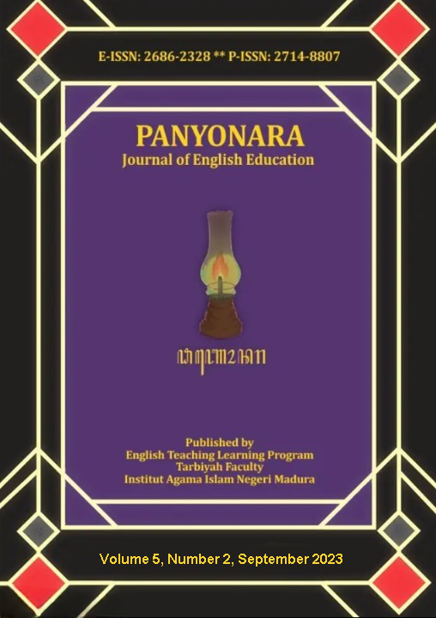
Figure 2. Panyonara: Journal of English Education (source)

How to Write References in Panyonara Journal

Reference to the book:

- One author
End-note: | (Nunan, 1989)
Reference: | Nunan, D. (1989). Designing Tasks for the Communicative Classroom. Cambridge: Cambridge University Press.
- Two authors
End-note: | (Richards & Renandya, 2002)
References | Richards, J. C., & Renandya, W. A. (2002). Methodology in Language Teaching: An Anthology of Current Practice. Cambridge: Cambridge University Press.
- Three authors
End-note: | (Radford, Atkinson, & Britain, 2009: 3)
References: | Radford, A., Atkinson, M., & Britain, D. (2009). Linguistics: An Introduction (2nd ed.). Cambridge: Cambridge University Press.
- Four or more authors
End-note: | (Ary, Jacobs, Irvine, & Walker, 2018: 16)
Reference: | Ary, D., Jacobs, L. C., Irvine, C. K. S., & Walker, D. (2018). Introduction to Research in Education (10th ed.). Boston: Cengage Learning.

Reference to the Journal Publication:
- One author
End-note: | (Uysal, 2015)
Reference: | Uysal, N. D. (2015). Teaching English to Very Young Learners. Procedia - Social and Behavioral Sciences, 197(2), 19–22. https://doi.org/10.1016/j.sbspro.2015.07.042
- Two authors
End-note: | (Poedjiastutie & Oliver, 2017)
Reference: | Poedjiastutie, D., & Oliver, R. (2017). English Learning Needs of ESP Learners: Exploring Stakeholder Perceptions at an Indonesian University. TEFLIN, 28(1), 1–21. http://dx.doi.org/10.15639/teflinjournal.v28i1/1-21

- Three authors
End-note: | (Emilia, Habibi, & Bangga, 2018)
Reference: | Emilia, E., Habibi, N., & Bangga, L. A. (2018). An Analysis of Cohesion of Exposition Texts: An Indonesian Context. Indonesian Journal of Applied Linguistics, 7(3), 515. https://doi.org/10.17509/ijal.v7i3.9791

- Four or more authors
End-note: | (Fields, Freiberg, Fickenscher, & Shelley, 2008)
Reference: | Fields, A. M., Freiberg, C. S., Fickenscher, A., & Shelley, K. H. (2008). Patients and Jargon: Are we speaking the same language? Journal of Clinical Anesthesia, 20(5), 343–346. https://doi.org/10.1016/j.jclinane.2008.02.006

Reference to a websites:
End-note: | (Abdillah, 2019)
Reference: | Abdillah, M. (2019, April 22). Menuju Demokrasi yang Religius. Retrieved February 20, 2004, from http://www.nu.or.id/page. php?lang=id&news_view_id=1253

For more info, see Author Guidelines

