Paper’s Title Should be the Fewest Possible Words that Accurately Describe the Content of the Paper (Center, Bold, 14pt)

Johan Sandahl¹, Ersis Warmansyah Abbas^{2*}, Yudi Prasetyo^{3,4} (10 pt)
¹Stockholm University, Stockholm, Sweden (8 pt)
²Universitas Lambung Mangkurat, Banjarmasin, Indonesia
³University of Northern Iowa, Iowa, United States
⁴Universitas PGRI Delta, Sidoarjo, Indonesia

Article Info |  | Abstract (10 pt)
Article History:  Received mm dd, yyyy  Revised mm dd, yyyy  Accepted mm dd, yyyy |  | An abstract is often presented separate from the article, so it must be able to stand alone. A well-prepared abstract enables the reader to identify the basic content of a document quickly and accurately, to determine its relevance to their interests, and thus to decide whether to read the document in its entirety. The abstract should be informative and completely self-explanatory, provide research problems, research objectives, method, and research result. The Abstract should be 150 to 200 words in length. References should be avoided, but if essential, then cite the author(s) and year(s). Standard nomenclature should be used, and non-standard or uncommon abbreviations should be avoided, but if essential they must be defined at their first mention in the abstract itself. No literature should be cited. The keyword list provides the opportunity to add 5 to 7 keywords, used by the indexing and abstracting services, in addition to those already present in the title (9 pt).  [Abstrak sering kali disajikan terpisah dari artikel, sehingga harus dapat berdiri sendiri. Abstrak yang disusun dengan baik memungkinkan pembaca untuk mengidentifikasi isi dasar suatu dokumen dengan cepat dan akurat, menentukan relevansinya dengan minat mereka, dan sehingga memutuskan apakah akan membaca dokumen secara keseluruhan. Abstrak harus informatif dan sepenuhnya jelas, mencakup masalah penelitian, tujuan penelitian, metode, dan hasil penelitian. Abstrak harus berpanjang 150 hingga 200 kata. Referensi sebaiknya dihindari, tetapi jika diperlukan, sebutkan nama penulis dan tahunnya. Gunakan nomenklatur standar, dan hindari singkatan non-standar atau tidak umum, tetapi jika diperlukan, singkatan tersebut harus didefinisikan pada penyebutan pertamanya dalam abstrak itu sendiri. Tidak boleh mengutip literatur. Daftar kata kunci memberikan kesempatan untuk menambahkan 5 hingga 7 kata kunci, yang digunakan oleh layanan pengindeksan dan abstraksi, selain yang sudah ada dalam judul]. © The Authors.
Keywords:
First keyword;
Second keyword;
Third keyword;
Fourth keyword;
Fifth keyword.
 |  | This is an open access article under the CC BY-NC license.
*Corresponding Author:
Ersis Warmansyah Abbas
Universitas Lambung Mangkurat
Jalan Brigjen H. Hasan Basri, Kayu Tangi, Banjarmasin Utara, Kota Banjarmasin, Kalimantan Selatan, Indonesia
Email: ersiswa@ulm.ac.id

- Introduction (10 pt)
The main text format consists of a flat left-right columns on A4 paper (quarto). The margin text from the left and top are 2.5 cm, right and bottom are 2 cm. The manuscript is written in Microsoft Word, single space, Time New Roman 10 pt, and maximum 12 pages for original research article, or maximum 16 pages for review/survey paper, which can be downloaded at the website: http://ijere.iaescore.com.
The title of an article should consist of the fewest possible words that accurately describe the content of the paper. The title should be succinct and informative and no more than about 12 words in length. Do not use acronyms or abbreviations in your title and do not mention the method you used, unless your paper reports on the development of a new method. Titles are often used in information-retrieval systems. Avoid writing long formulas with subscripts in the title. Omit all waste words such as "A study of ...", "Investigations of ...", "Implementation of ...”, "Observations on ...", "Effect of.....", “Analysis of …”, “Design of…”, etc.
A concise and factual abstract is required. The abstract should state briefly the purpose of the research, the principal results and major conclusions. An abstract is often presented separately from the article, so it must be able to stand alone. For this reason, References should be avoided, but if essential, then cite the author(s) and year(s). Also, non-standard or uncommon abbreviations should be avoided, but if essential they must be defined at their first mention in the abstract itself. Immediately after the abstract, provide a maximum of 7 keywords, using American spelling and avoiding general and plural terms and multiple concepts (avoid, for example, 'and', 'of'). Be sparing with abbreviations: only abbreviations firmly established in the field may be eligible. These keywords will be used for indexing purposes.
Indexing and abstracting services depend on the accuracy of the title, extracting from it keywords useful in cross-referencing and computer searching. An improperly titled paper may never reach the audience for which it was intended, so be specific.
The Introduction section should provide: i) a clear background, ii) a clear statement of the problem, iii) the relevant literature on the subject, iv) the proposed approach or solution, and v) the new value of research which is innovation (within 3-6 paragraphs). It should be understandable to colleagues from a broad range of scientific disciplines. Organization and citation of the bibliography are made in Institute of Electrical and Electronics Engineers (IEEE) style in sign [1], [2] and so on. The terms in foreign languages are written italic (italic). The text should be divided into sections, each with a separate heading and numbered consecutively [3]. The section or subsection headings should be typed on a separate line, e.g., 1. INTRODUCTION. A full article usually follows a standard structure: 1. Introduction, 2. The Comprehensive Theoretical Basis and/or the Proposed Method/ Algorithm (optional), 3. Method, 4. Results and Discussion, and 5. Conclusion. The structure is well-known as IMRaD style.
Literature review that has been done author used in the section "INTRODUCTION" to explain
the difference of the manuscript with other papers, that it is innovative, it are used in the section "METHOD" to describe the step of research and used in the section "RESULTS AND DISCUSSION" to support the analysis of the results [2]. If the manuscript was written really have high originality, which proposed a new method or algorithm, the additional section after the "INTRODUCTION" section and before the "METHOD" section can be added to explain briefly the theory and/or the proposed method/algorithm [3].

- Method (10 pt)
Explaining the research chronologically, including the research design, research procedures (in the form of algorithms, Pseudocode, or other), how to test, and data analysis [4], [5], [6]. For qualitative research, for example, classroom action research, ethnography, phenomenology, study case, and so on, needs to add the researcher attendance, research subject, informant that helps conducting the research, and ways in taking research data, research setting, the length of research and data validity

- Results (10 pt)
In this section, it is explained the results of research and at the same time is given
the comprehensive discussion. Results can be presented in figures, graphs, tables and others that make the reader understand easily. The description of the course of research should be supported references, so the explanation can be accepted scientifically [7], [3] Figures 1-2 and Table 1 are presented center, as shown below and cited in the manuscript [4], [8], [9], [10], [11], [12], [13]. Figure 2(a) shown math representation ability students and Figure 2(b) reasoning ability students [14], [15].

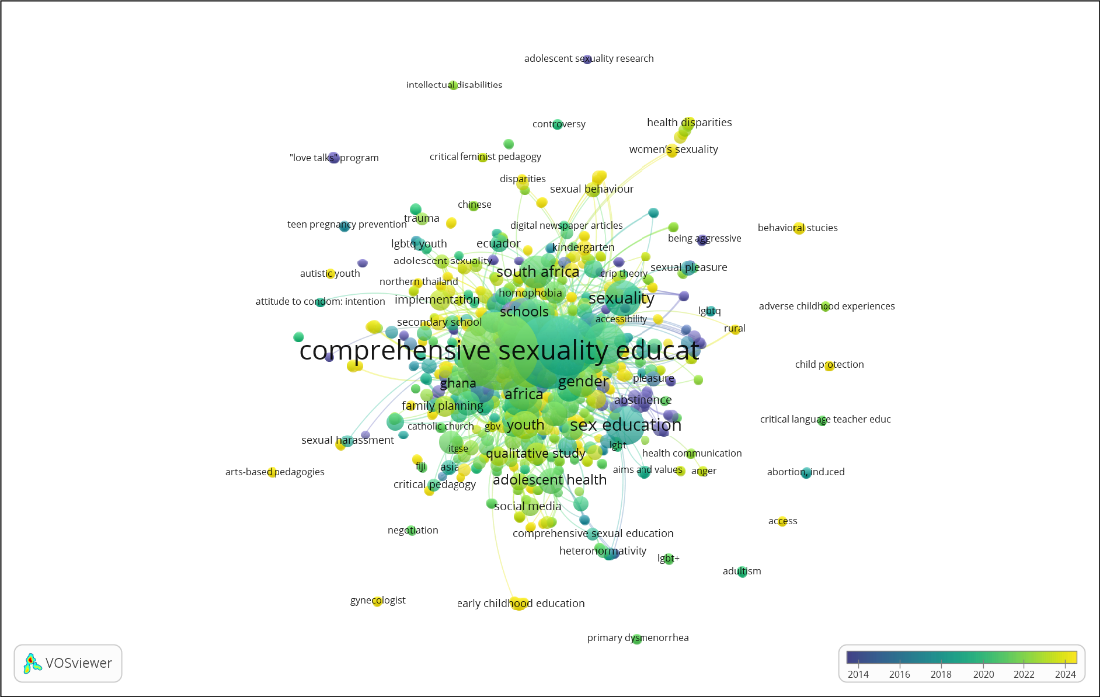
Figure 1. Overlay Visualization of Co-occurence

Table 1. Internal consistency reliability of biology test
SN | Indicator | Value
1 | Number of Item | 60
2 | Kuder Richardson (KR-20) | 0.620
3 | Cronbach's Alpha Based on Standardized Items | 0.617
4 | Mean Item Difficulty | 0.56
5 | Mean Item Difficulty | 0.4

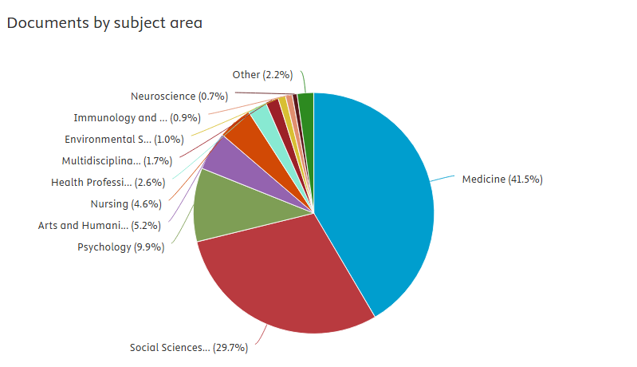
Copyright © 2025 Elsevier, its licensors, and contributors.
(a)
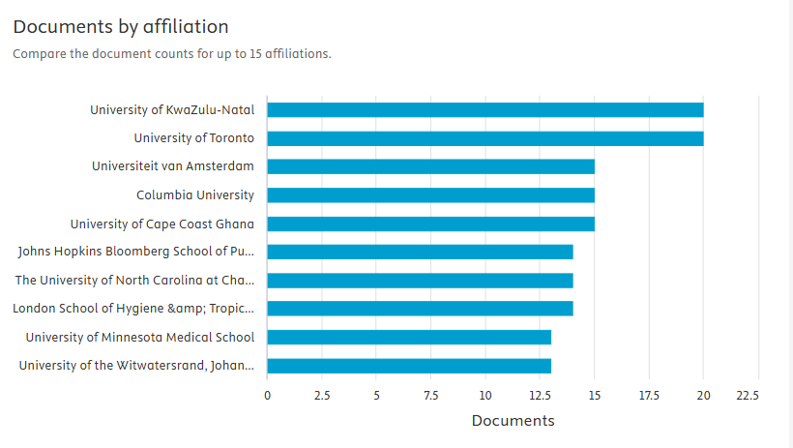
Copyright © 2025 Elsevier, its licensors, and contributors.
(b)

Figure 2. The Publication Trends (a) Documents by Subject Area and (b) Documents by Afiliation

- Discussion (10 pt)
The discussion can be made in several sub-sections.

4.1. Sub Section 1
Equations should be placed at the center of the line and provided consecutively with equation numbers in parentheses flushed to the right margin, as in (1). The use of Microsoft Equation Editor or MathType is preferred.

$E_{v}-E=\frac{h}{2.m} (k_{x}^{2}+k_{y}^{2}$) (1)

All symbols that have been used in the equations should be defined in the following text.

4.2. Sub Section 2
Proper citation of other works should be made to avoid plagiarism. When referring to a reference item, please use the reference number as in [16] or [17] for multiple references. The use of ”Ref [18]...” should be employed for any reference citation at the beginning of sentence. For any reference with more than 3 or more authors, only the first author is to be written followed by et al. (e.g. in [19]). Examples of reference items of different categories shown in the References section. Each item in the references section should be typed using 8 pt font size [20], [21], [22], [23], [24], [25].

4.2.1. Subsub Section 1
yy
4.2.2. Subsub Section 2
zz

- Conclusion (10 pt)
Provide a statement that what is expected, as stated in the "Introduction" section can ultimately result in "Results” and “Discussion" section, so there is compatibility. Moreover, the prospects for the development of research results and the application of further studies can also be added to the next (based on the results and discussion).

Acknowledgments (if applicable) (10 pt)
This section should acknowledge individuals who provided personal assistance to the work but do not meet the criteria for authorship, detailing their contributions. It is imperative to obtain consent from all individuals listed in the acknowledgments.

AI Acknowledgment (Required: Please choose from the two statements)
- If no AI technology (this includes sites like Grammarly, ChatGPT, DeepL, etc. for grammar, punctuation, fluency, translation) was applied, please use the following statement:
- The authors declare that generative AI or AI-assisted technologies were not used in any way to prepare, write, or complete this manuscript. The authors confirm that they are the sole authors of this article and take full responsibility for the content therein, as outlined in COPE recommendations.
- If AI technology was used in any way (including to improve grammar, punctuation, fluency, etc.), please use the following statement:
- The authors acknowledge the use of [insert name of AI system(s)] to [specific use of artificial intelligence]. The prompts used include [list of prompts]. The output from these prompts was used to [explain use]. While the authors acknowledge the usage of AI, they maintain that they are the sole authors of this article and take full responsibility for the content therein, as outlined in COPE recommendations.

Funding Information (mandatory) (10 pt)
This section should describe sources of funding agency that have supported the work. Authors should state how the research described in their article was funded, including grant numbers if applicable. Include the following (or similar) statement if there is no funding involved: Authors state no funding involved.

Informed Consent (if applicable) (10 pt)
The protection of privacy is a legal right that must not be breached without individual informed consent. In cases where the identification of personal information is necessary for scientific reasons, authors should obtain full documentation of informed consent, including written permission from the patient prior to inclusion in the study. Incorporate the following (or a similar) statement: We have obtained informed consent from all individuals included in this study.

Ethical Approval (if applicable) (10 pt)
When papers talk about using people or animals, authors should make it clear that the research followed all national rules and institutional policies, and it was approved by the authors' institutional review board or a similar committee. The Helsinki Declaration's tenets must guide all investigations involving human subjects. Authors must also identify the committee or review board approving the experiments and provide a statement indicating approval of the research. Incorporate the following (or a similar) statement: The research related to human use has been complied with all the relevant national regulations and institutional policies in accordance with the tenets of the Helsinki Declaration and has been approved by the authors' institutional review board or equivalent committee; or: The research related to animal use has been complied with all the relevant national regulations and institutional policies for the care and use of animals.

References (10 pt)
The main references are international journals and proceedings. All references should be to the most pertinent, up-to-date sources, and the minimum number of references should be 25 (for original research papers) and 50 (for review papers) 80% minimally are published in the last of 5 years. References are written in IEEE style. You can access a more comprehensive guide at http://ipmuonline.com/guide/refstyle.pdf. Use a tool such as EndNote, Mendeley, or Zotero for reference management and formatting; choose IEEE style. Please use a consistent format for references—see examples (8 pt):

References
[1] P. Delgadoa, C. Vargasb, R. Ackermanc, and L. Salmerón, “Don’t throw away your printed books: A meta-analysis on the effects of reading media on reading comprehension,” Educ. Res. Rev., vol. 25, pp. 23–38, 2018, doi: 10.1016/j.edurev.2018.09.003.
[2] F. Reichert, D. Lange, and L. Chow, “Educational beliefs matter for classroom instruction: A comparative analysis of teachers’ beliefs about the aims of civic education,” Teach. Teach. Educ., vol. 98, pp. 1–13, 2020, doi: 10.1016/j.tate.2020.103248.
[3] G. Ocak and A. Yamaç, “Examination of the relationships between fifth graders’ self-regulated learning strategies, motivational beliefs, attitudes, and achievement,” Educ. Sci. Theory Pract., vol. 13, no. 1, pp. 380–387, 2013.
[4] S. Li and J. Zheng, “The relationship between self-efficacy and self-regulated learning in one-to-one computing environment: The mediated role of task values,” Asia-Pacific Educ. Res., vol. 27, no. 6, pp. 455–463, 2018, doi: 10.1007/s40299-018-0405-2.
[5] B. J. Zimmerman and A. R. Moylan, “Self-regulation: where metacognition and motivation intersect,” in Handbook of Metacognition in Education, 2009, pp. 299–315.
[6] P. R. Pintrich, D. A. F. Smith, T. Duncan, and W. Mckeachie, A manual for the use of the motivated strategies for learning questionnaire (MSLQ). Ann Arbor, Michigan, 1991.
[7] J. Roick and T. Ringeisen, “Students’ math performance in higher education: examining the role of self-regulated learning and self-efficacy,” Learn. Individ. Differ., vol. 65, pp. 148–158, 2018.
[8] M. Pressley and C. B. McCormick, Advanced educational psychology for educators, researchers, and policymakers. New York, USA: HarperCollins College Publishers, 1995.
[9] A. Bandura, Prentice-Hall series in social learning theory. Social foundations of thought and action: A social cognitive theory. Prentice-Hall, Inc., 1985.
[10] A. L. Dent and A. C. Koenka, “The relation between self-regulated learning and academic achievement across childhood and adolescence: a meta-analysis,” Educ. Psychol. Rev., vol. 28, no. 3, pp. 425–474, 2015, doi: 10.1007/s10648-015-9320-8.
[11] T. J. Cleary and A. Kitsantas, “Motivation and self-regulated learning influences on middle school mathematics achievement,” School Psych. Rev., vol. 46, no. 1, pp. 88–107, 2017.
[12] P. R. Pintrich, “Chapter 14 - The Role of Goal Orientation in Self-Regulated Learning,” in Handbook of Self-Regulation, San Diego, California: Academic Press, 2000, pp. 451–502. doi: 10.1016/B978-012109890-2/50043-3.
[13] H. Vonkova and J. Hrabak, “The (in) comparability of ICT knowledge and skill self-assessments among upper secondary school students: The use of the anchoring vignette method,” Comput. Educ., vol. 85, pp. 191–202, 2015, doi: 10.1016/j.compedu.2015.03.003.
[14] F. Baier, A.-T. Decker, T. Voss, T. Kleickmann, U. Klusmann, and M. Kunter, “What makes a good teacher? The relative importance of mathematics teachers’ cognitive ability, personality, knowledge, beliefs, and motivation for instructional quality,” Br. J. Educ. Psychol., vol. 89, no. 4, pp. 767–786, 2019, doi: 10.1111/bjep.12256.
[15] A. M. Flanagan, D. C. Cormier, and O. Bulut, “Achievement may be rooted in teacher expectations: examining the differential influences of ethnicity, years of teaching, and classroom behaviour,” Soc. Psychol. Educ., vol. 23, pp. 1429–1448, 2020, doi: 10.1007/s11218-020-09590-y.
[16] F. M. van der Kleij, “Comparison of teacher and student perceptions of formative assessment feedback practices and association with individual student characteristics,” Teach. Teach. Educ., vol. 85, no. 1, pp. 175–189, 2019.
[17] R. G. Brockett and R. Hiemstra, Self-direction in adult learning: Perspectives on theory, research, and practice. London and New York: Routledge, 2020.
[18] R. Hiemstra and R. G. Brockett, “Reframing the Meaning of Self-Directed Learning: An Updated Modeltt,” in Adult Education Research Conference Proceedings, 2012, pp. 155–161.
[19] S. Geng, K. M. Y. Law, and B. Niu, “Investigating self-directed learning and technology readiness in blending learning environment,” Int. J. Educ. Technol. High. Educ., vol. 16, no. 17, pp. 1–22, 2019, doi: 10.1186/s41239-019-0147-0.
[20] J. R. Fraenkel, N. E. Wallen, and H. H. Hyun, How to design and evaluate research in education. New York, USA: McGraw-Hill, 2012.
[21] M. Honey and D. Marshall, “The impact of on-line muti-choice questions on undergraduate student nurses’ learning,” in Proceedings of the 20th Annual Conference of the Australasian Society for Computers in Learning in Tertiary Education (ASCILITE), 2003, pp. 236–243.
[22] R. A. Krueger and M. A. Casey, Focus groups: A practical guide for applied research. London: Sage Publications, Inc., 2015.
[23] J. W. Creswell and V. L. P. Clark, “Choosing a mixed methods design,” in Designing and Conducting Mixed Methods Research, California: Sage Publications, Inc., 2011, pp. 53–106.
[24] E. H. Mahvelati, “Learners’ perceptions and performance under peer versus teacher corrective feedback conditions,” Stud. Educ. Eval., vol. 70, 2021, doi: 10.1016/j.stueduc.2021.100995.
[25] K. Ismayilova and R. M.Klassen, “Research and teaching self-efficacy of university faculty: Relations with job satisfaction,” Int. J. Educ. Res., vol. 98, pp. 55–66, 2019, doi: 10.1016/j.ijer.2019.08.012.

