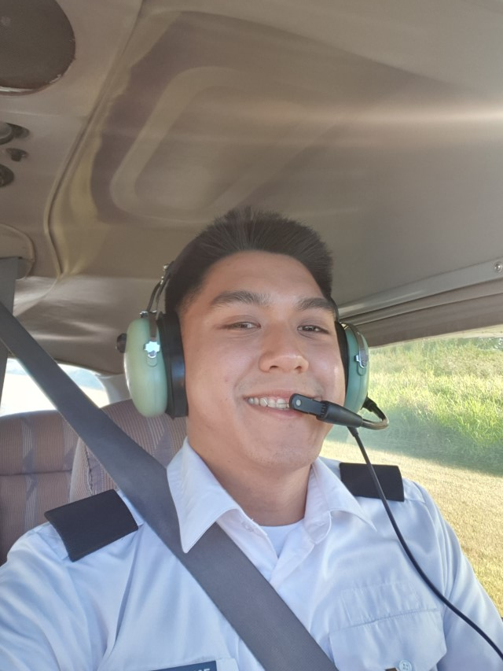

Hans Manzano | 09175894710 | hans.manzano@gmail.com

# About Me

I love flying

# Work Experience

**Kohl Analytics** *2020-2021*Good learning company

**Citibank** *2018-2019*Fun!

# Skills

* I think outside the box
* Resourceful
* Python
* Knime
* SQL
* Teamwork
* Python - Pandas