View #1 - StudentList

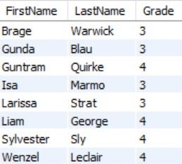

View #2 - MealStatus

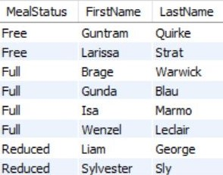

View #3 - DialyTransactions

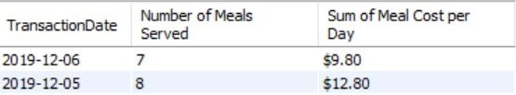

View #4 - FreeMealTotal

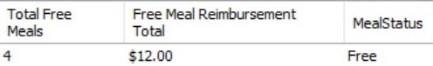

View #5 - ReducedMealTotal

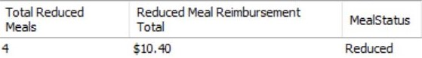

View #6 - StudentPayments

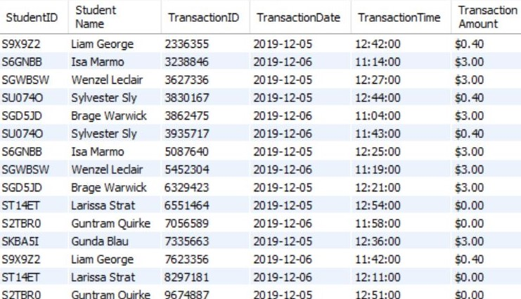

View #7 - StudentBalance

