CS 3100

Homework 4

1. Find all the customers that have orders that haven’t shipped yet (shippedDate is null). Display the customer name and the order number.

select

c.customerName,

o.orderNumber

from orders o

left join customers c

on o.customerNumber = c.customerNumber

where shippedDate is null;

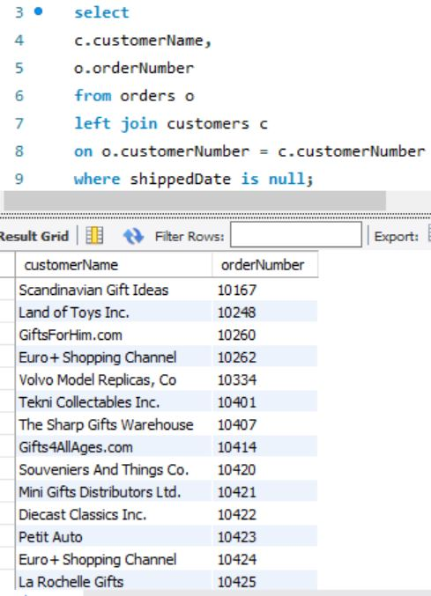

1. Find all the products that haven’t been ordered by anyone. Display the product code, name, and description.

select

p.productCode,

p.productName,

p.productDescription

from products p

left join orderdetails o

on p.productCode = o.productCode

where o.productCode is null;

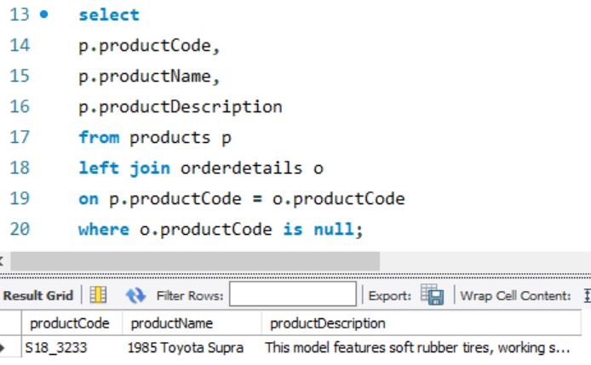

1. Find all the employees that don’t have customers assigned to them. Display the employee name.

select

concat(e.firstName,' ',e.lastName) as 'No Customer Assigned'

from employees e

left join customers c

on e.employeeNumber = c.salesRepEmployeeNumber

where c.salesRepEmployeeNumber is null;

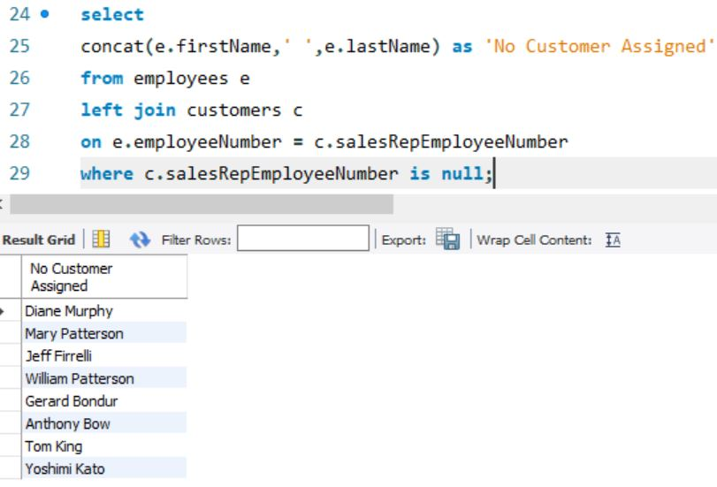

1. Find the total number of orders per customer for all customers. Display the customer name and the number of orders.

select

c.customerName,

count(o.customerNumber) as 'Number of Orders'

from customers c

left join orders o

on c.customerNumber = o.customerNumber

group by c.customerNumber;

