Homework 6

General Directions:

Please answer each question in a Word document as follows: 1) Copy your SQL query and 2) Attach a screen shot of the output. Please submit both the Word document and SQL script for grading. Each question is worth 10 points.

1. Use a join to find a list of employeeNumber, firstName, lastName, and jobTitle of employees who do not have customers assigned to them. Store the query as a view. Take a screen shot of the view and include it with your answer.

create view NoCustomerAssigned as

select

e.employeeNumber,

e.firstName,

e.lastName,

e.jobTitle

from employees e

left join customers c

on e.employeeNumber = c.salesRepEmployeeNumber

where c.salesRepEmployeeNumber is null;

select \*

from NoCustomerAssigned;

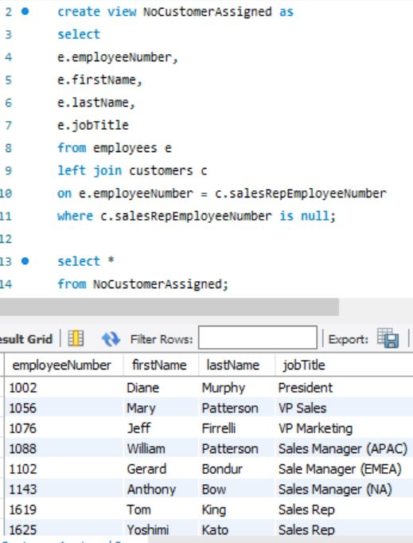

1. Use a subquery to find list of employeeNumber, firstName, lastName, and jobTitle of employees who do not have customers assigned to them. The output should look identical to the view created in the previous question. Hint: Review Question 3 in the Hackathon #6.

select

e.employeeNumber,

e.firstName,

e.lastName,

e.jobTitle

from employees e

where not exists

(select

c.salesRepEmployeeNumber

from customers c

where e.employeeNumber = c.salesRepEmployeeNumber);

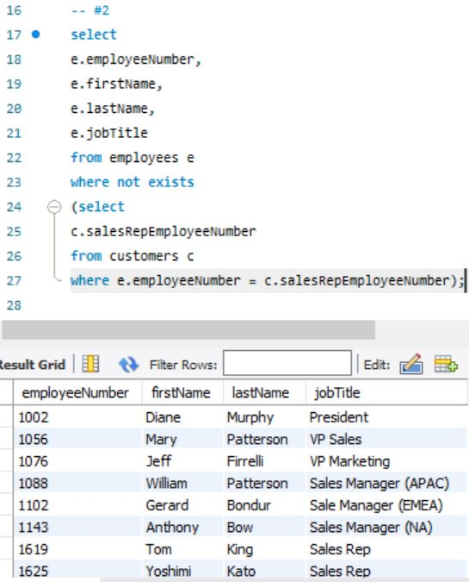

1. Use a join to write a query that returns the number of units sold per product line. Store the query as a view. Take a screen shot of the view and include it with your answer.

create view PLineQuantity as

select

p.productLine,

format(sum(o.quantityOrdered), 0) as 'QuantityOrdered'

from orderdetails o

left join products p

on o.productCode = p.productCode

group by p.productLine;

select \*

from PLineQuantity;

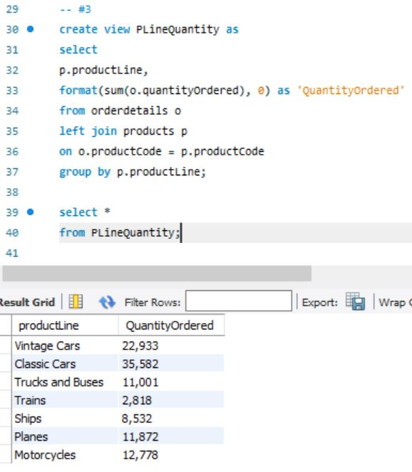

1. Use a subquery to return the number of units sold per product line. The output should look identical to the view created in the previous question. Hint: Review Subquery as a Column example discussed in class.

select

p.productLine,

sum((select

sum(o.quantityOrdered)

from orderdetails o

where o.productCode = p.productCode)) as 'QuantityOrdered'

from products p

group by p.productLine;

HW