CS 3100

Homework Assignment 8

General Directions: Please submit your answers to the following questions in a Word document. Each normalization exercise is worth 20 points. Each summary question is worth 10 points. The assignment is worth 80 points total.

1. Please put the data in 1st Normal Form (20 points)

**PET HEALTH HISTORY REPORT**

PET ID PET NAME PET TYPE PET AGE OWNER VISIT DATE PROCEDURE

246 ROVER DOG 12 SAM COOK JAN 13/2002 01 - RABIES VACCINATION

MAR 27/2002 10 - EXAMINE and TREAT WOUND

APR 02/2002 05 - HEART WORM TEST

298 SPOT DOG 2 TERRY KIM JAN 21/2002 08 - TETANUS VACCINATION

MAR 10/2002 05 - HEART WORM TEST

341 MORRIS CAT 4 SAM COOK JAN 23/2001 01 - RABIES VACCINATION

JAN 13/2002 01 - RABIES VACCINATION

519 TWEEDY BIRD 2 TERRY KIM APR 30/2002 20 - ANNUAL CHECK UP

APR 30/2002 12 - EYE WASH

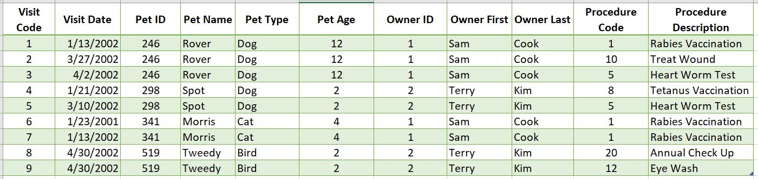

1. Please put the data in 1st Normal Form (20 points)

**Day care Roster**

|  |  |  |  |
| --- | --- | --- | --- |
| **Parent** | **Child1** | **Child2** | **Child3** |
| Jill | Matthew | Mark |  |
| Jason | Lisa | Cheryl | Brian |
| Peter | Paul |  |  |
| Harold | Betty | Julie | John |
| Reggie | Steve |  |  |
| Lisa | Marilyn | Jane |  |

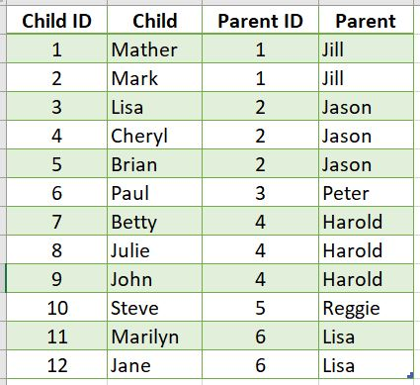

1. Please put the data in 1st Normal Form (20 points)

**Playlist**

|  |  |
| --- | --- |
| **Performer** | **SongTitles** |
| Tom Jones | It's Not Unusual She's a Lady What's New Pussycat |
| Hank Williams | I Saw the Light If You've got the Money I've got the time Love Sick Blues |
| Willie Nelson | If You've got the Money I've got the time Hello Walls Poncho and Lefty On the Road Again |
| Backstreet Boys | I Want it That Way Shape of My Heart Everybody |
| Adele | Hello When We Were Young Someone Like You Rolling in the Deep |
| Beatles | Hey Jude A Day in the Life Twist and Shout Yellow Submarine |
| Hanson | MMMBop I will Come to You If Only |
| Beethoven | Moonlight Sonata Symphony No. 5 Fur Elise |

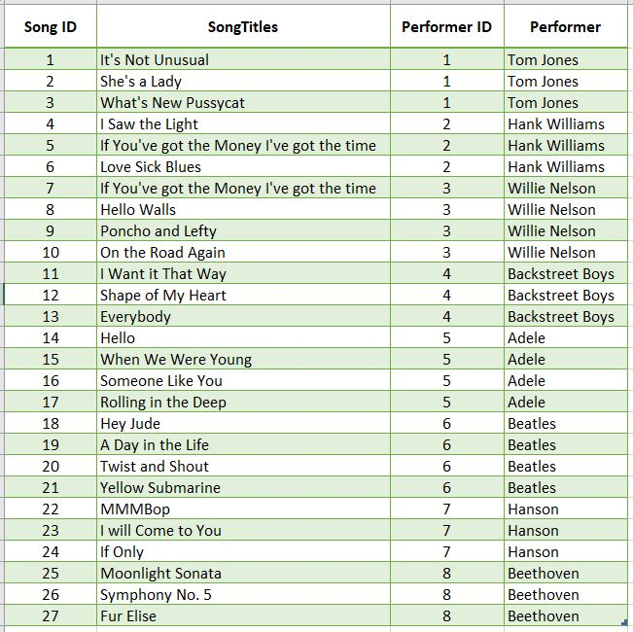

Normalization Summary Questions (10 points/each):

1. What is a basic rule of 1st normal form?
   1. The basic rule of 1st normal form is atomicity. This means that every column should have a distinct type of data with no columns repeating similar data.
2. Describe some problems that may occur if data is not normalized? Use one of the exercises above to explain your answer.
   1. Without data normalization, it is tough to access the information in columns that contain multiple entries in each row. For example, in the first table with veterinarian data, it would be tough to access the second or third procedure or even enter new procedures. If Sam Cook’s dog, Rover, were to have another procedure, the vet might click on the procedure cell next to his name and start typing out the details of the new procedure. If he/she didn’t double click to enter text after the existing entries and only clicked once, they might type the new entry over the existing ones and then Rover’s prior records would be lost.

**Normalization Exercises. Examples of how I expect you to answer them.**

|  |  |
| --- | --- |
| Student | Classes |
| Daffy Duck | AC3000 MWF 8AM-9AM, FN4000 MW 9AM-10AM, BU4500 F 9AM-10AM |
| Bugs Bunny | FN4000 MW 9AM-10AM, MG3500 W 1PM-2PM |
| Charlie Brown | AC3000 MWF 8AM-9AM, MG3500 W 1PM-2PM |
| Lucy Van Pelt | AC3000 MWF 8AM-9AM, FN4000 MW MW 9AM-10AM |

**Put this data in 1NF.**

**An example of a correct response.**

|  |  |  |  |  |  |
| --- | --- | --- | --- | --- | --- |
| **StudentID** | **StuLastName** | **StuFirstName** | **Course** | **Days** | **Time** |
| **100** | **Duck** | **Daffy** | **AC3000** | **MWF** | **8AM-9AM** |
| **100** | **Duck** | **Daffy** | **FN4000** | **MW** | **9AM-10AM** |
| **100** | **Duck** | **Daffy** | **BU4500** | **F** | **9AM-10AM** |
| **200** | **Bunny** | **Bugs** | **FN4000** | **MW** | **9AM-10AM** |
| **200** | **Bunny** | **Bugs** | **MG3500** | **W** | **1PM-2PM** |
| **300** | **Brown** | **Charlie** | **AC3000** | **MWF** | **8AM-9AM** |
| **300** | **Brown** | **Charlie** | **MG3500** | **W** | **1PM-2PM** |
| **400** | **Van Pelt** | **Lucy** | **AC3000** | **MWF** | **8AM-9AM** |
| **400** | **Van Pelt** | **Lucy** | **FN4000** | **MW** | **9AM-10AM** |