CS 3100

Hackathon 5

Directions:

Copy and paste your query and output to answer each question below. Please submit both a Word document and the SQL script (.sql file) for grading. I will grade from the Word document and refer to the SQL script in case I need to debug your codes. Each question is worth 10 points.

1. Write a query that calculates the total amount of each orderNumber.

select

orderNumber,

format(sum(quantityOrdered\*priceEach), 2) as 'Amount'

from orderdetails

group by orderNumber;

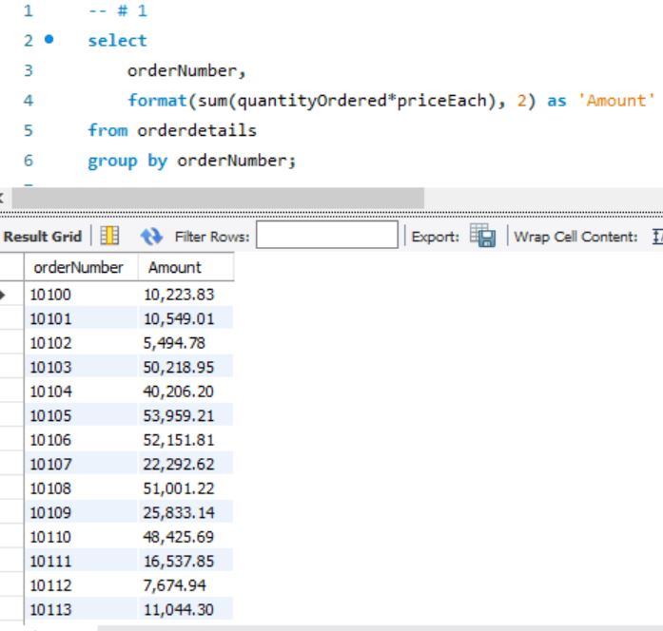

1. Create a view to store the query you created in #1.

create view OrderTotalsVIEW as

select

orderNumber,

format(sum(quantityOrdered\*priceEach), 2) as 'Amount'

from orderdetails

group by orderNumber;

select \*

from OrderTotalsVIEW;

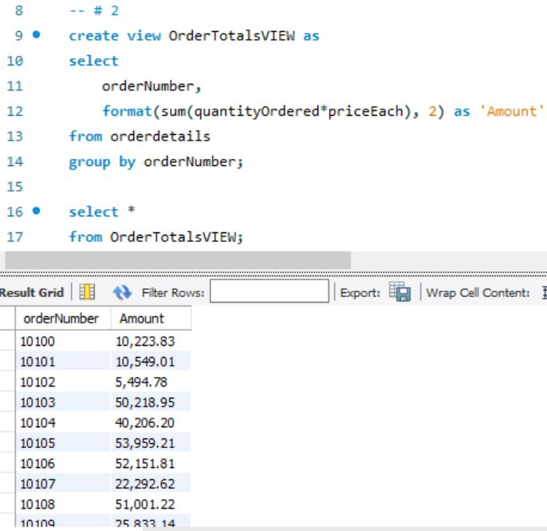

1. Write a query to retrieve the orderNumber and total amount for each order made by ‘Land of Toys Inc.’. HINTS: 1) You should think about how you can use the view created in #2 in your query; 2) Land of Toys Inc. made four orders.

select

c.customerName,

d.orderNumber,

format(sum(d.quantityOrdered\*d.priceEach), 2) as 'Amount'

from customers c

left join orders o

on c.customerNumber = o.customerNumber

left join orderdetails d

on o.orderNumber = d.orderNumber

where c.customerNumber = 131

group by d.orderNumber;

