Hackathon Assignment 7

General Directions: Please answer each question in a Word document as follows: 1) Copy your SQL query and 2) Attach a screen shot of the output. Please submit both the Word document and SQL script for grading. Each question is worth 10 points.

1. Create a procedure that will return information on all orders for a customer

delimiter $$

create procedure customerOrders (cusOrd int)

begin

select \*

from orders

where customerNumber = cusOrd;

end$$

delimiter ;

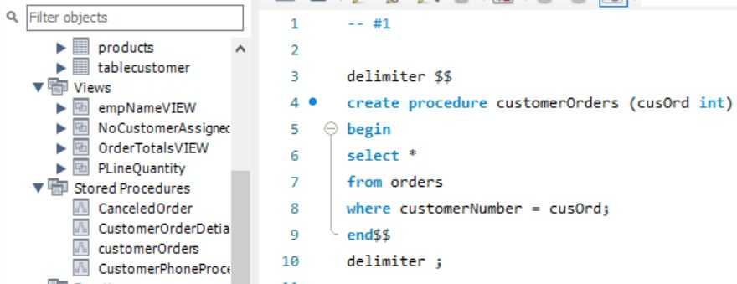

1. Invoke the procedure to get order information for customerNumber = 131. Did you notice any problem with the orders placed? Justify your answer.

call customerOrders (131);

There is one canceled order! In the Status column, it says Canceled for order number 10248

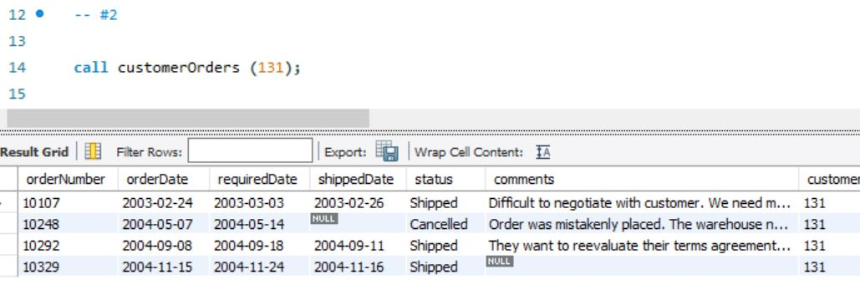

1. Create a procedure that will return the order details for the cancelled order made by customerNumber = 131. What is the total amount of this cancelled order?

delimiter $$

create procedure CanceledOrder (CancOrd int)

begin

select \*

from orderdetails od

where od.orderNumber = CancOrd;

end$$

delimiter ;

call CanceledOrder (10248);

select

orderNumber,

sum(quantityOrdered\*priceEach) as 'Amount'

from orderdetails

where orderNumber = 10248

Total amount for order 10248 is $41,445.21

