CS 3100

Hackathon 8

General Directions: Please answer each question in a Word document as follows: 1) Copy your SQL query and 2) Attach a screen shot of the output. Please submit both the Word document and SQL script for grading. Each question is worth 10 points.

1. Create a table to use for the remainder of the questions. Include the following columns: StudentID, LastName, FirstName, MiddleInitial, and DateOfBirth. Insert the following students.

|  |  |  |  |
| --- | --- | --- | --- |
| **FirstName** | **MiddleInitial** | **LastName** | **DateOfBirth** |
| Mary | L | Reed | 05/2/2000 |
| Joanne | M | Stephens | 1/17/1988 |
| Stephen | J | Dawkins | 2/25/1980 |
| Louis | B | Fitch | 3/16/2005 |
| Jason | R | Smith | 2/1/1974 |
| Leslie | Q | Downing | 12/15/1994 |
| Marie | S | Jones | 4/4/2001 |

create table people (

StudentID integer auto_increment primary key,

LastName varchar(30) not null,

FirstName varchar(30),

MiddleInitial char(1),

DateOfBirth date not null

);

insert into people

(LastName, FirstName, MiddleInitial, DateOfBirth)

Values

('Reed', 'Mary', 'L', '2000-05-02'),

('Stephens', 'Joanne', 'M', '1988-01-17'),

('Dawkins', 'Stephen', 'J', '1980-02-25'),

('Fitch', 'Louis', 'B', '2005-03-16'),

('Smith', 'Jason', 'R', '1974-02-01'),

('Downing', 'Leslie', 'Q', '1994-12-15'),

('Jones', 'Marie', 'S', '2001-04-04');

select *

from people;

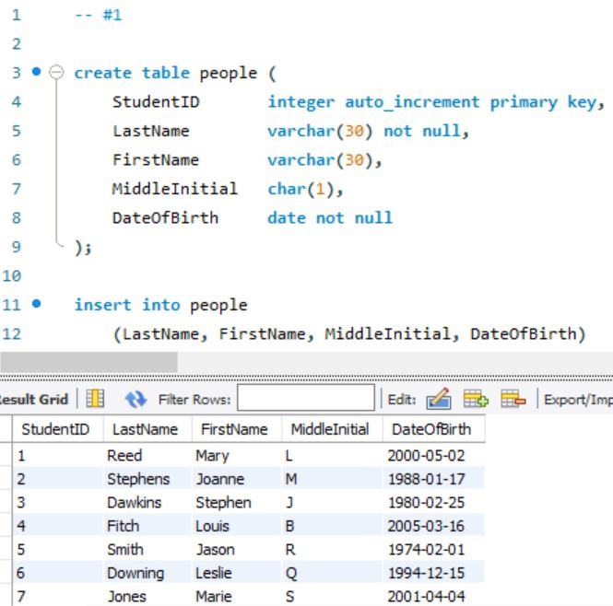

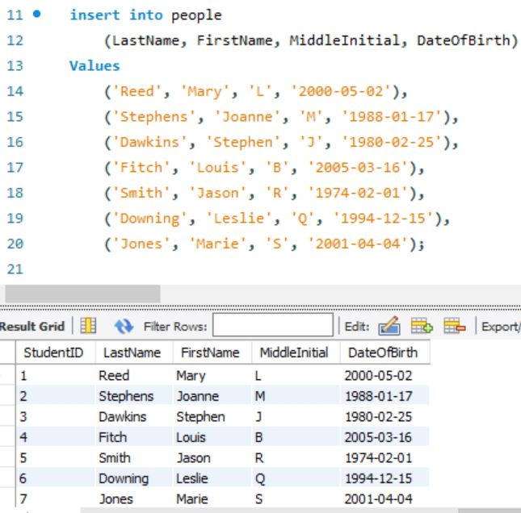

1. Joanne gets married and becomes Joanne Riley. Update the appropriate row.

update people

set LastName = 'Riley'

where StudentID = 2;

select *

from people;

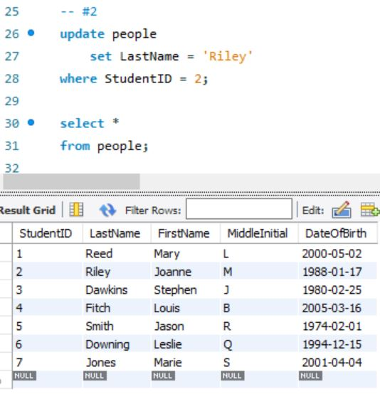

1. Stephen’s name was misspelled originally. The proper spelling is Steven. Update appropriately but don’t use an ID field in the where clause.

set sql_safe_updates = 0;

update people

set FirstName = 'Steven'

where DateOfBirth = '1980-02-25';

set sql_safe_updates = 1;

select *

from people;

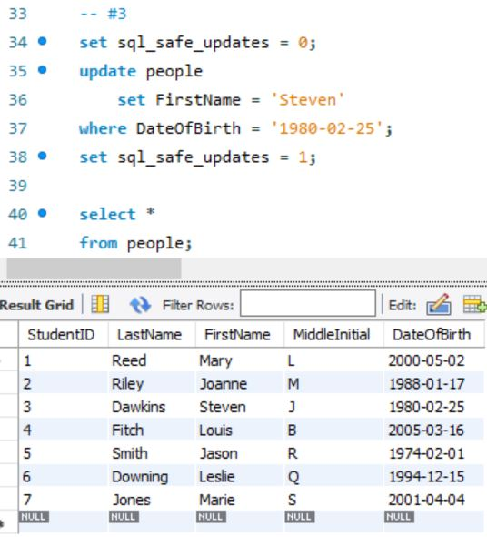

1. Jason’s middle initial and date of birth are incorrect. Middle initial should be ‘Z’ and date of birth should be 2/1/1984. Update appropriately.

update people

set MiddleInitial = 'Z',

DateOfBirth = '1984-02-01'

where StudentID = 5;

select *

from people;

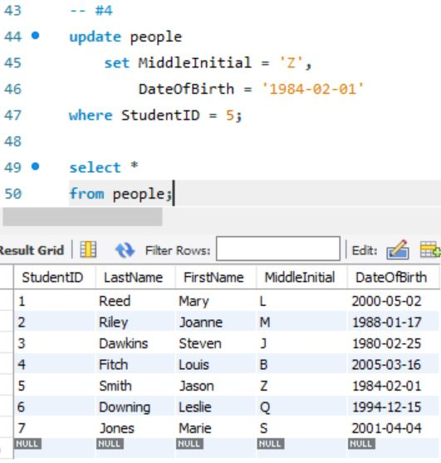

1. Leslie is no longer with the school so delete her record.

delete from people

where StudentID = 6;

select *

from people;

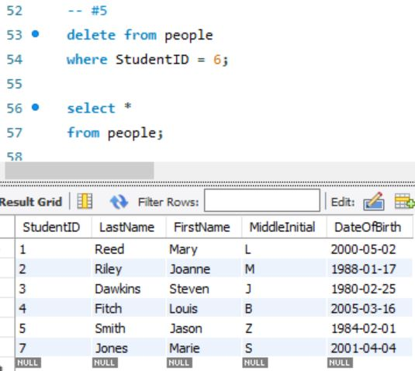

1. Delete records for all students who were born after 2000.

set sql_safe_updates = 0;

delete from people

where DateOfBirth > '2000-01-01';

set sql_sage_updates = 1;

select *

from people;

