CS 3100

Hackathon 9

General Directions: Please answer each question in a Word document as follows: 1) Copy your SQL query and 2) Attach a screen shot of the output. Please submit both the Word document and SQL script for grading. Each question is worth 10 points.

In this exercise, you will apply the concepts learned in this course so far to create your first database.

1. Create a schema (i.e. database) that will hold two tables: Persons and Orders. Make it the default schema.

create schema hackathon9db;

use hackathon9db;

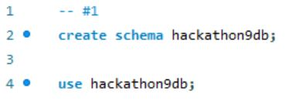

1. Create a table Persons with these columns:

PersonID is an integer

Lastname is a variable character of 2555 and is not null

FirstName is a variable character of length 255

Age is an integer

Make the primary key a composite of PersonID and LastName

Describe the table Persons and copy the output for grading.

create table Persons (

PersonID int,

LastName varchar(255) NOT NULL,

FirstName varchar(255),

Age int,

constraint PKPerson primary key (PersonID,LastName)

);

describe Persons;

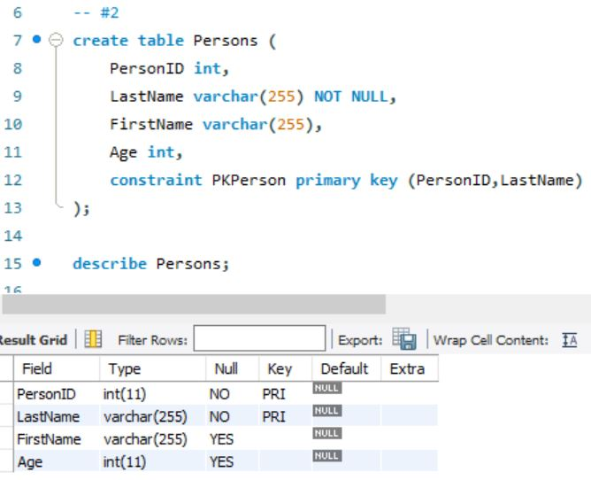

1. Fill the Persons table with this information:

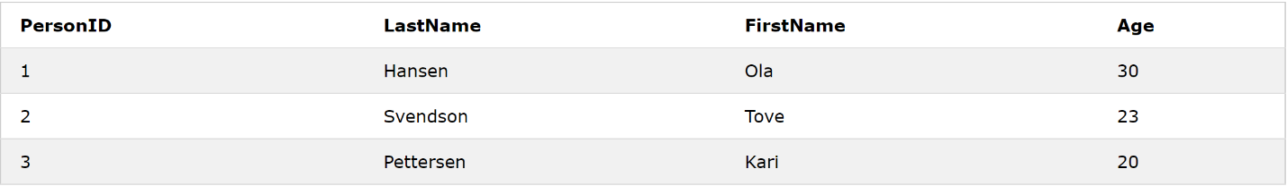

Print table and copy it for grading.

insert into Persons (PersonID, LastName, FirstName, Age)

values

(1, 'Hanson', 'Ola', 30),

(2, 'Svendson', 'Tove', 23),

(3, 'Petterson', 'Kari', 20);

select \*

from Persons;

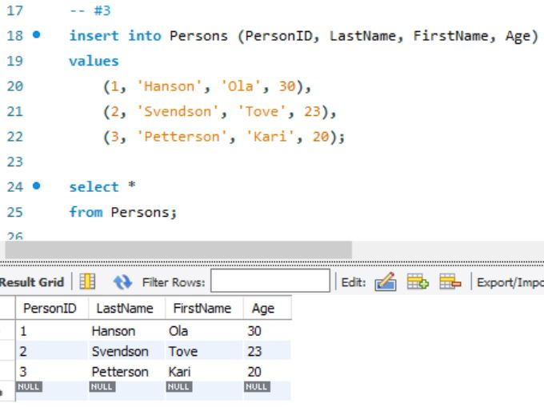

1. Create an Orders table with these columns:

OrderID int not null

OrderNumber integer and not null

PersonID integer

Make the OrderID the primary key

Make the PersonID the foreign key

Describe the table Orders and copy the output for grading.

create table Orders (

OrderID int NOT NULL,

OrderNumber int NOT NULL,

PersonID int,

primary key (OrderID),

foreign key (PersonID) references Persons(PersonID)

);

describe Orders;

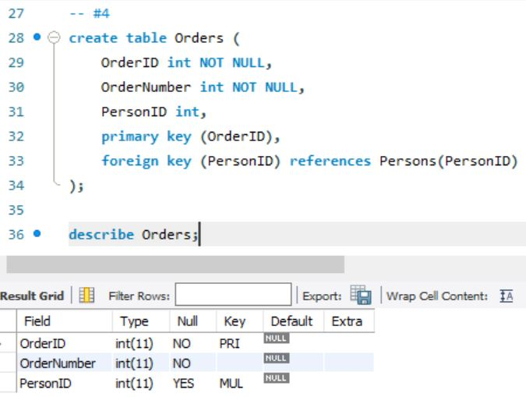

1. Fill the Orders table with this information:

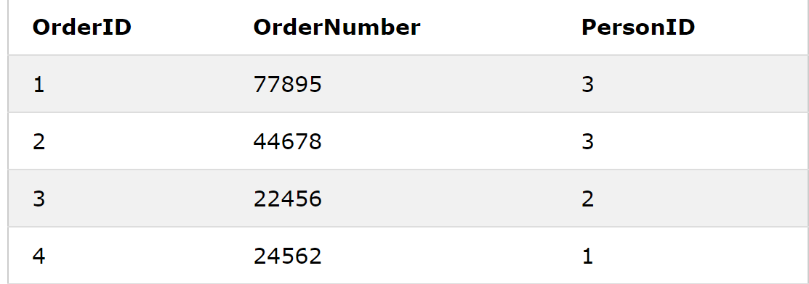

Print table and copy output for grading.

insert into Orders (OrderID, OrderNumber, PersonID)

values

(1, 77895, 3),

(2, 44678, 3),

(3, 22456, 2),

(4, 24562, 1);

select \*

from Orders;

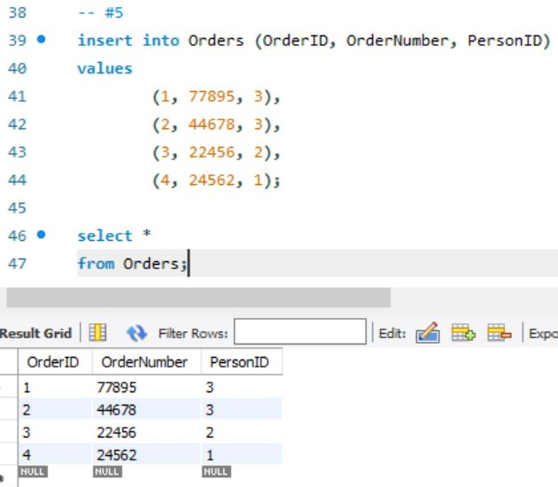

1. Join the Persons and Orders tables and print output for grading.

select \*

from Persons p

left join Orders o

on p.PersonID = o.PersonID;

