CS 3100

Homework Assignment 3

#1

select

emp_no as 'Employee Number',

format(salary, 0) as 'Highest Salary'

from salaries

where to_date = '9999-01-01'

order by salary desc

limit 1;

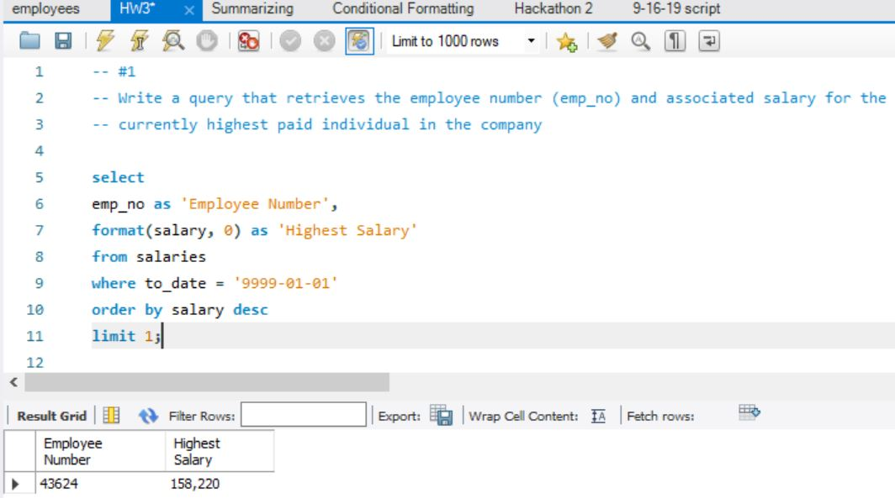

#2

select

emp_no as 'Employee Number',

format(salary, 0) as 'Lowest Salary'

from salaries

order by salary

limit 1;

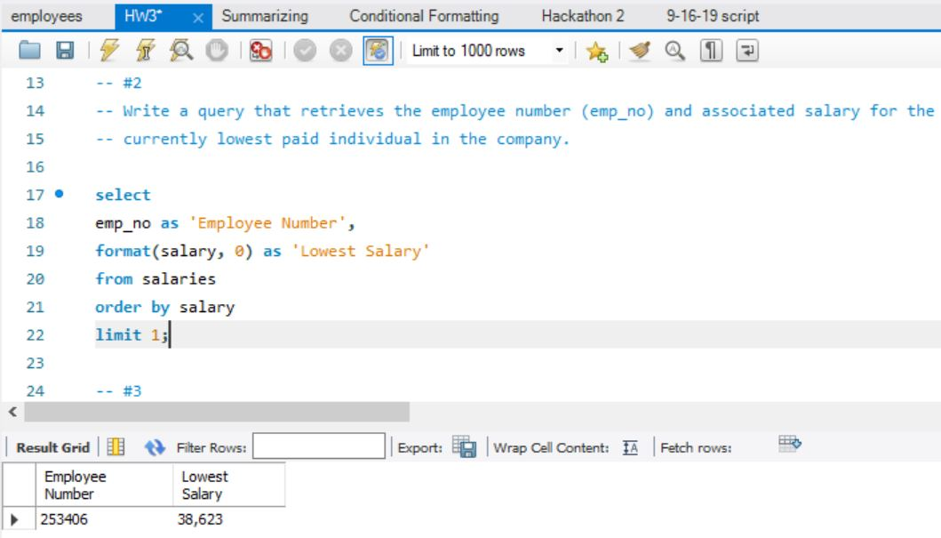

#3

select

dept_no,

count(emp_no)

from dept_emp

where to_date = '9999-01-01'

group by

dept_no;

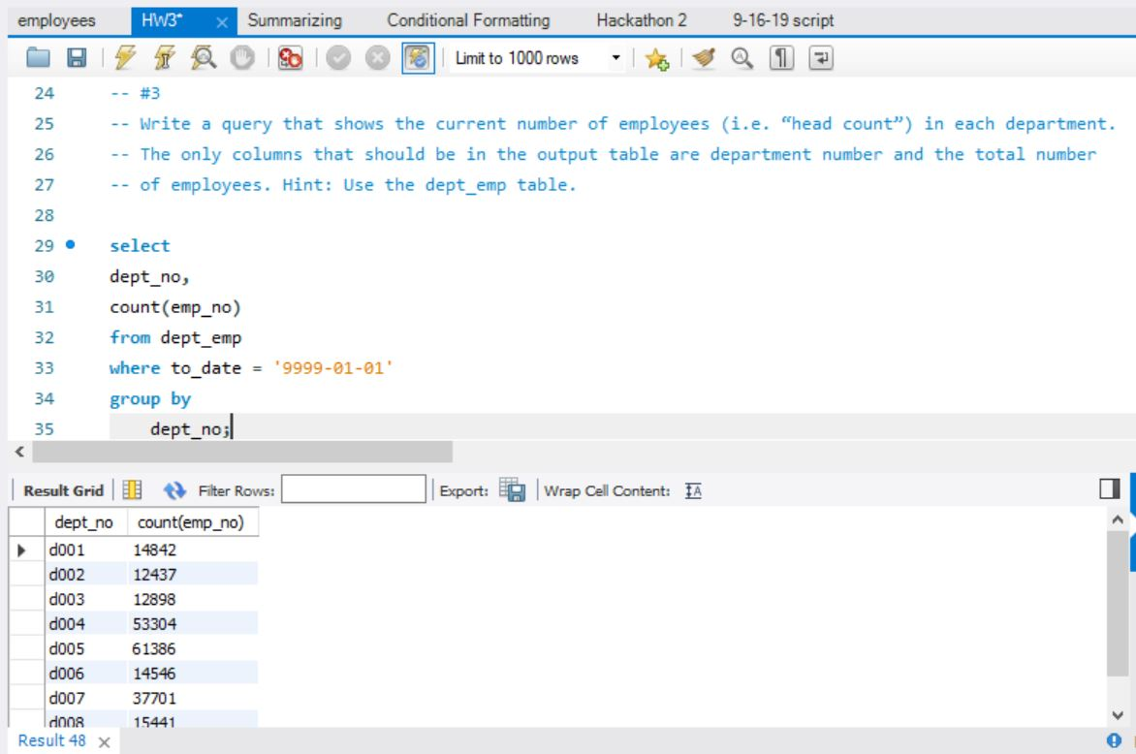

#4

select

format(count(emp_no), 0) as 'Employees over $100,000'

from salaries

where salary >= '100000'

and to_date = '9999-01-01';

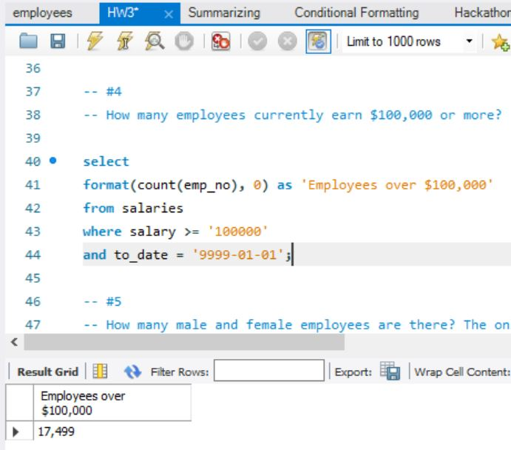

#5

select

gender,

format(count(emp_no), 0) as 'Number of employees'

from employees

group by gender;

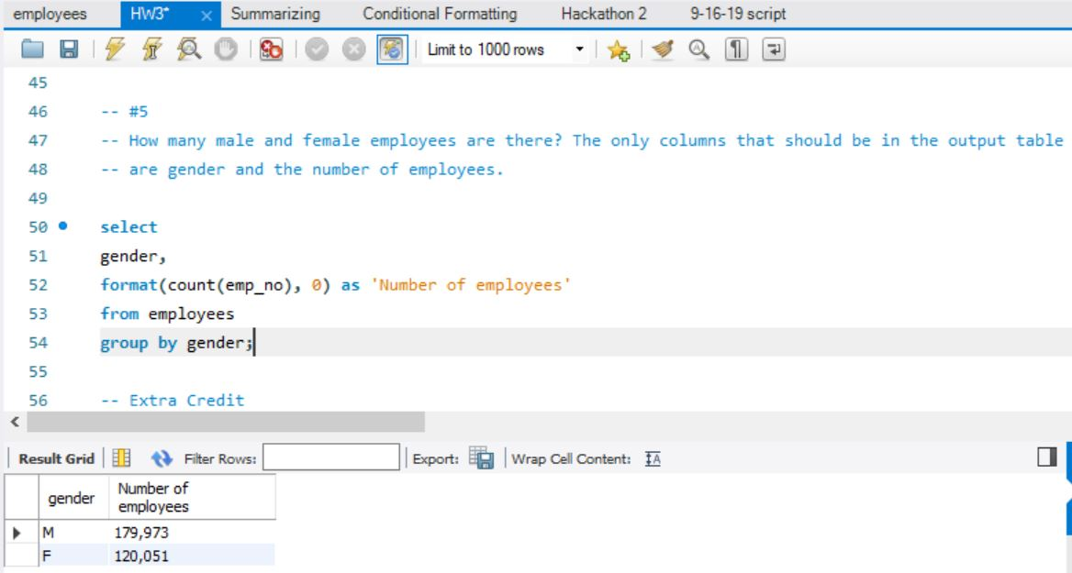

Extra Credit

select

case dept_no

when 'd009' then 'Customer Service'

when 'd004' then 'Production'

when 'd007' then 'Sales'

else 'Other'

end as 'Department',

format(count(emp_no), 0) as 'Number of Employees'

from dept_emp

group by

case dept_no

when 'd009' then 'Customer Service'

when 'd004' then 'Production'

when 'd007' then 'Sales'

else 'Other'

end;

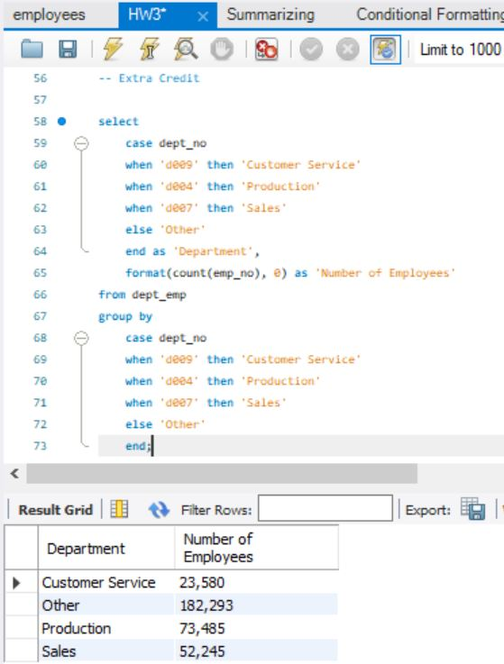

GitHub

