作业名称： | 八大行星天体运动
学 院： | 计算机学院
班 级： | DL062130
学 号： | 2021302659
姓 名： | 孙超
团队组成： | 个人

西北工业大学

请填写以下十项内容，将表格按页对齐（插入空行），勿删除任何部分。
1、问题与背景（描述程序所要解决的问题或应用背景）
过去人们只能通过望远镜来观测天体，绘制草图，从而在大脑中想象出天体的动态画面，但随着科技的发展，人们不再满足于静态以及二维空间，开始向动态，多维空间发展。
OpenGL就通过几何建模，坐标变换，颜色，光照设置功能再现出八大行星的运行状态，给人以直观映象。
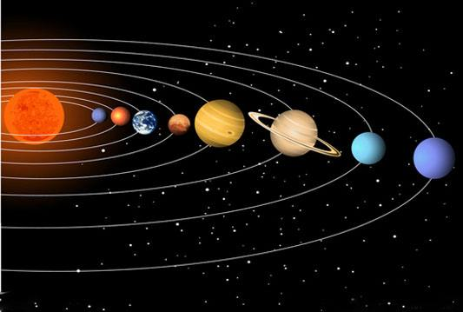
2、开发工具（列出所使用的开发工具和第3方开发库）
Code::blocks
OpenGL
3、主要功能（详细说明程序的功能）
以太阳做参考系，以动画效果粗略描绘出八大行星的运动轨迹，周期，及颜色，通过方向键的使用，可以从多个角度了解行星运动，右键为顺时针，左键为逆时针，上下键控制俯仰。
4、设计内容（详细描述解决问题的原理和方法、算法、数据结构等）
（1）编译和运行
因为是图形与图像及其运动，所以需要在codeblocks的freeglut中运行，并需要调用windows.h，gl/glut.h中的函数。
(2)主体在main函数的构建
为了能够创建窗口，就需要在主函数中引用复制glutInit，glutInitDisplayMode来确定是三维运动，glutInitWindowSize，glutCreateWindow分别来确定窗口大小和名称，glutReshapeFunc来时观察物体有透视三维效果，并来改变观察的角度。glutDisplayFunc中具体来确定所要呈现的元素，glutSpecialFunc规定某几个键来调整所要观察的方向，为全局变量，glutTimerFunc用计时器来使静态变成动态。
（3）RenderScene
用具体初始值来确定各个行星初始位置，利用for循环语句和具体的glVertex3f三维坐标体现小行星带，因为在起始时定义了PI，用改变螺旋的方式即可制作出一道小行星带，在经过glLoadIdentity()重置之后
利用gluLookAt再度确定观察方向，并把整个场景移动到视图中，来时每一次改变坐标系后恢复是下一个球体能正常运行，glColor3ub确定球体颜色，glutSolidSphere确定球体大小，改变坐标位置后需要再次返回原点，即两次调用glTranslatef
每过一周后使各小行星的的位置归零，，而小行星各个周期在初始时就确定了从而再次循环，最后glPopMatrix回复矩阵状态效率更高。
（4）SetupRC初始设定
先经过深度测试和确定背景的颜色，再通过glEnable具体确定光的类型个数，保持在整个场景中不变，而这为全局变量。
（5）TimerFunc计时器
glutTimerFunc，TimerFunc交替调用从而实现了动画效果。
（6）SpecialKeysProc改变坐标
利用switch语句来指向不同设定情况下的改变位置从而实现了方向键改变观察角度的问题。
5、程序文件与工程名称（标出程序中所有文件名、工程名称及其说明）
windows.h：图新设备接口函数
gl/glut.h：OpenGL实用库
stdio.h：标准输入输出
math.h：数学函数库
6、函数模块（程序中各个函数的原型声明及其说明）
glViewport：在窗口中设定一定视口来绘图
glMatrixMode：设置当前矩阵
glLoadIdentity：重置当前的矩阵为单位矩阵
gluPerspective：指定观察的视景体在世界坐标系中的大小
glEnable：启用各种功能
glClearColor：清空当前颜色
glLightModelfv：材质，环境光
glLightfv：光源
glClear：清除缓存
glBegin：催生计算机平台及设应用程序
glVertex3f：设置顶点坐标
glEnd：结束glBegin
gluLookAt：定义视图矩阵并与当前矩阵相乘
glPushMatrix：压入当前矩阵堆栈
glTranslatef：将当前图形平移
glColor3ub：设定颜色
glDisable：关闭各项功能
glutSolidSphere：渲染球体
glRotatef：设置图形转动
glPopMatrix：回复矩阵状态
glutSwapBuffers：交换两个缓冲区的位置
glutPostRedisplay：标识当前窗口需要重新绘制
glutTimerFunc：定时器
glutInit：初始化
glutInitDisplayMode：初始显示模式
glutInitWindowSize：指定窗口大小
glutCreateWindow：创建窗口
glutReshapeFunc：窗口改变时调用的函数
glutDisplayFunc：注册绘图函数
glutSpecialFunc：有特殊键按下时能注册函数
glutMainLoop：事件处理循环
7、使用说明（运行程序的小型说明书）
在程序运行后，会弹出窗口，看到八大行星模型，通过↑（俯）↓（仰）←（逆时针）→（顺时针）多方位控制行星视角，在变换过程中会有远近，大小不同的视觉体验，按F1恢复初始视角。
8、程序开发总结（简要叙述编写本作业的收获与思考）
好的，以上就是用OpenGL制作八大行星运行动画的过程。通过这次的作业，了解到了用编程的方法和OpenGL制作动画的魅力。但是现在对OpenGL制作动画还尚处于初步阶段，之后的学习仍需进行。
9、运行截图（附上程序运行的截图画面，至少有1幅，截图越翔实得分越高）
正式视角
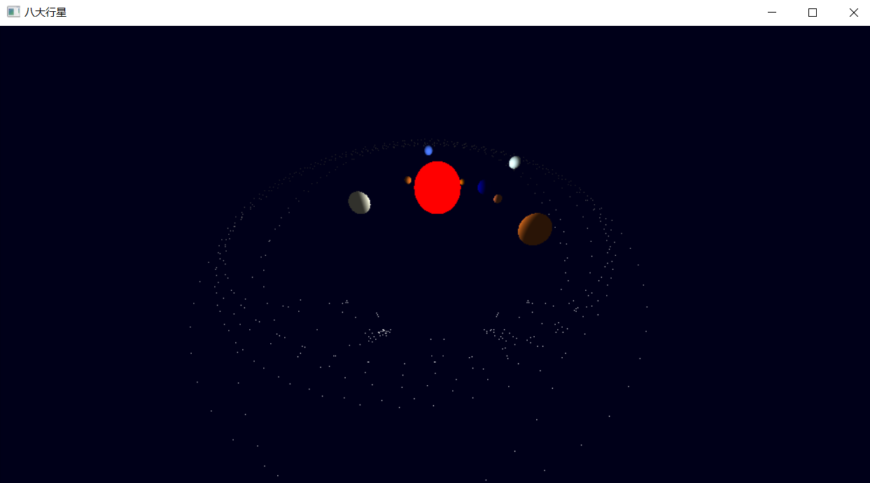
俯（仰）视视角
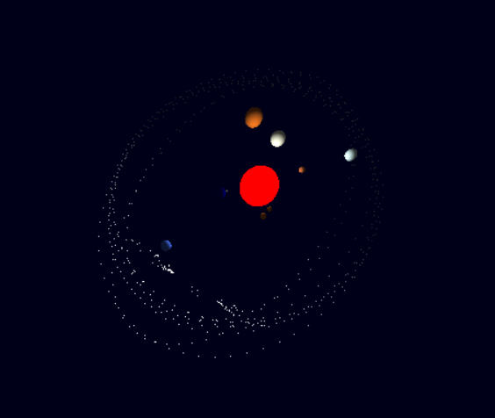
右视视角
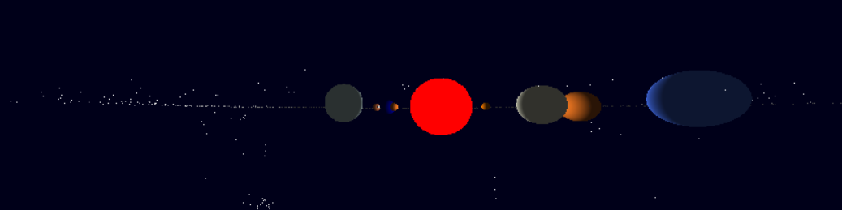

左视视角
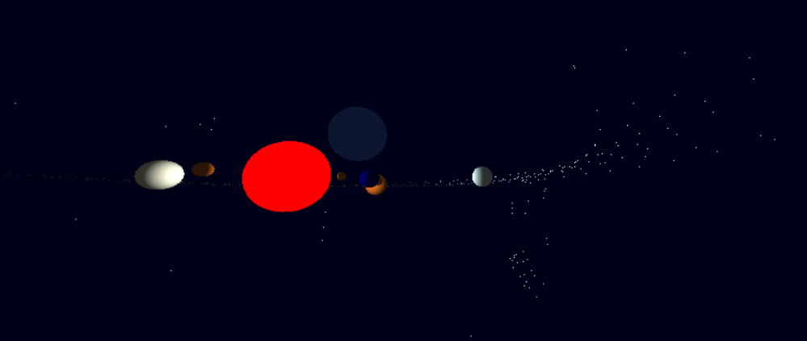

10、源程序（附上程序源代码，若是多个文件，标出文件名）
#include <windows.h>
#include <gl/glut.h>
#include<stdio.h>
#include<math.h>
#define twice(a) ((a)*(a))
#define PI 3.14159265
#define GL_PI 3.1415f

GLfloat viewx=80,viewy=30,viewz=120;
GLfloat whiteLight[] = { 0.2f, 0.2f, 0.2f, 1.0f };
GLfloat lightPos[] = { 0.0f, 0.0f, 0.0f, 1.0f };
int jud=0;
double Ang,R,addAng=0.4/PI;//透视投影
void ChangeSize(int w, int h)
{
GLfloat fAspect;// 防止被0所除导致崩溃
if(h == 0)h = 1;// 把视口设置为窗口大小
glViewport(0, 0, w, h);
fAspect = (GLfloat)w/(GLfloat)h; //实际窗口的纵横比// 重置透视坐标系统
glMatrixMode(GL_PROJECTION); //还有一个参数是L_MODELVIEW
glLoadIdentity();// 产生透视投影
gluPerspective(611.0f, fAspect, 25, 3000);//重置模型视图矩阵
glMatrixMode(GL_MODELVIEW);
glLoadIdentity();
}
void SetupRC()
{
glEnable(GL_DEPTH_TEST); // 启用深度测试
glEnable(GL_COLOR_MATERIAL); //使用不同颜色来贴物体表面
glClearColor(0.0f, 0.0f, 0.1f, 0.1f ); //类黑色背景
glEnable(GL_LIGHTING);
glLightModelfv(GL_LIGHT_MODEL_AMBIENT,whiteLight); //使用whiteLight所指定的环境光
glLightfv(GL_LIGHT0,GL_POSITION,lightPos);//0号光源的位置
glEnable(GL_LIGHT0);
}
void RenderScene(void)
{
static float fMercuryRot=1.0f;
static float fVenusRot=1.1f;
static float fEarthRot=0.5f;
static float fMoonRot=0.0f;
static float fMarsRot=0.0f;
static float fJupiterRot=0.0f;
static float fSaturnRot=0.4f;
static float fUranussRot=0.0f;
static float fNeptuneRot=0.5f;
// 清除颜色和深度缓冲区
GLfloat x,y,z,angle;
glClear(GL_COLOR_BUFFER_BIT | GL_DEPTH_BUFFER_BIT);
glBegin(GL_POINTS);
glVertex3f(80.0f,80.0f,0.0f);
glVertex3f(90.0f,90.0f,0.0f);
glVertex3f(80.0f,80.0f,0.0f);
glVertex3f(81.0f,81.0f,0.0f);
glVertex3f(82.0f,83.0f,0.0f);
glVertex3f(70.0f,80.0f,0.0f);
glVertex3f(75.0f,85.0f,0.0f);
glVertex3f(78.0f,89.0f,0.0f);
glVertex3f(82.0f,80.0f,0.0f);
glVertex3f(80.0f,89.0f,0.0f);
glVertex3f(80.0f,80.0f,0.0f);
z = -50.0f;
for(angle = 0.0f; angle <= (2.0f*GL_PI)*1.0f; angle += 0.1f)
{
x = 30+340.0f*sin(angle);
y = 0;
z = -280+370.0f*cos(angle);
glVertex3f(x, y, z);
}
z = -50.0f;
glVertex3f(85.0f,95.0f,0.0f);
glVertex3f(90.0f,90.0f,0.0f);
glVertex3f(85.0f,85.0f,0.0f);
glVertex3f(-80.0f,80.0f,0.0f);
glVertex3f(-84.0f,80.0f,0.0f);
glVertex3f(-70.0f,80.0f,0.0f);
glVertex3f(89.0f,87.0f,0.0f);
glVertex3f(90.0f,88.0f,0.0f);
glVertex3f(80.0f,99.0f,0.0f);
glVertex3f(-130.0f,128.0f,0.0f);
glVertex3f(-113.0f,115.0f,0.0f);
glVertex3f(-10.0f,180.0f,0.0f);
glVertex3f(-110.0f,10.0f,0.0f);
glVertex3f(-10.0f,111.0f,0.0f);
glVertex3f(-110.0f,13.0f,0.0f);
glVertex3f(-117.0f,14.0f,0.0f);
glVertex3f(-193.0f,19.0f,0.0f);
glVertex3f(-112.0f,12.0f,0.0f);
glVertex3f(-180.0f,31.0f,0.0f);
for(angle = 0.0f; angle <= (2.0f*GL_PI)*1.0f; angle += 0.1f)
{
x = 45+317.0f*sin(angle);
z = -300+410.0f*cos(angle);
glVertex3f(x, y, z);
}
glVertex3f(-189.0f,22.0f,0.0f);
glVertex3f(-124.0f,34.0f,0.0f);
glVertex3f(-133.0f,14.0f,0.0f);
glVertex3f(-165.0f,8.5f,0.0f);
glVertex3f(-111.0f,46.0f,0.0f);
glVertex3f(-180.0f,80.0f,0.0f);
glVertex3f(-74.0f,83.0f,0.0f);
glVertex3f(-79.0f,81.0f,0.0f);
glVertex3f(-100.0f,80.0f,0.0f);
glVertex3f(-100.0f,100.0f,0.0f);
glVertex3f(-90.0f,99.0f,0.0f);
glVertex3f(-100.0f,89.0f,0.0f);
glVertex3f(-100.0f,110.0f,0.0f);
glVertex3f(-110.0f,89.0f,0.0f);
for(angle = 0.0f; angle <= (2.0f*GL_PI)*1.0f; angle += 0.1f)
{
x = 20+330.0f*sin(angle);
z = -250+419.0f*cos(angle);
glVertex3f(x, y, z);
}
glVertex3f(-119.0f,101.0f,0.0f);
glVertex3f(-105.0f,108.0f,0.0f);
glVertex3f(-181.0f,87.0f,0.0f);
glVertex3f(-155.0f,123.0f,0.0f);
glVertex3f(-128.0f,108.0f,0.0f);
glVertex3f(-86.0f,87.0f,0.0f);
glVertex3f(-84.0f,80.0f,0.0f);
glVertex3f(-76.0f,89.0f,0.0f);
for(angle = 0.0f; angle <= (2.0f*GL_PI)*1.0f; angle += 0.1f)
{
x = 30+325.0f*sin(angle);
z = -280+395.0f*cos(angle);
glVertex3f(x, y, z);
}
glVertex3f(77.0f,84.0f,0.0f);
glVertex3f(73.0f,86.0f,0.0f);
glVertex3f(74.0f,83.0f,0.0f);
glVertex3f(79.0f,81.0f,0.0f);
glVertex3f(100.8f,80.0f,0.0f);
glVertex3f(100.0f,100.0f,0.0f);
glVertex3f(90.0f,99.0f,0.0f);
glVertex3f(100.0f,89.0f,0.0f);
glVertex3f(100.0f,110.0f,0.0f);
glVertex3f(110.0f,89.0f,0.0f);
for(angle = 0.0f; angle <= (2.0f*GL_PI)*1.0f; angle += 0.1f)
{
x = 30+340.0f*sin(angle);
z = -300+380.0f*cos(angle);
glVertex3f(x, y, z);
}
glVertex3f(-80.0f,40.0f,0.0f);
glVertex3f(-80.0f,35.0f,0.0f);
glVertex3f(-80.0f,44.0f,0.0f);
glVertex3f(109.0f,101.0f,0.0f);
glVertex3f(108.0f,108.0f,0.0f);
glVertex3f(180.0f,80.0f,0.0f);
glVertex3f(150.0f,133.0f,0.0f);
glVertex3f(108.0f,118.0f,0.0f);
glVertex3f(130.0f,128.0f,0.0f);
glVertex3f(113.0f,115.0f,0.0f);
for(angle = 0.0f; angle <= (2.0f*GL_PI)*1.0f; angle += 0.1f)
{
x = 30+330.0f*sin(angle);
z = -280+360.0f*cos(angle);
glVertex3f(x, y, z);
}
glVertex3f(10.0f,180.0f,0.0f);
glVertex3f(110.0f,10.0f,0.0f);
glVertex3f(10.0f,111.0f,0.0f);
glVertex3f(110.0f,13.0f,0.0f);
glVertex3f(117.0f,14.0f,0.0f);
glVertex3f(193.0f,19.0f,0.0f);
for(angle = 0.0f; angle <= (2.0f*GL_PI)*1.0f; angle += 0.1f)
{
x = 30+255.0f*sin(angle);
z = -280+380.0f*cos(angle);
glVertex3f(x, y, z);
}
glVertex3f(112.0f,12.0f,0.0f);
glVertex3f(180.0f,31.0f,0.0f);
glVertex3f(189.0f,22.0f,0.0f);
glVertex3f(124.0f,34.0f,0.0f);
glVertex3f(133.0f,14.0f,0.0f);
glVertex3f(165.0f,8.0f,0.0f);
for(angle = 0.0f; angle <= (2.0f*GL_PI)*1.0f; angle += 0.1f)
{
x = 35+240.0f*sin(angle);
z = -275+450.0f*cos(angle);
glVertex3f(x, y, z);
}
glVertex3f(111.0f,46.0f,0.0f);
glVertex3f(180.0f,80.0f,0.0f);
glVertex3f(80.0f,40.0f,0.0f);
glVertex3f(80.0f,35.0f,0.0f);
glVertex3f(80.0f,44.0f,0.0f);
glEnd();
glMatrixMode(GL_MODELVIEW);
glLoadIdentity();
gluLookAt(viewx,viewy,viewz,0.0,0.0,0.0,0.0,1.0,0.0);
glPushMatrix();//把整个场景移动到视图中
glTranslatef(0.0f,0.0f,-300.0f);
glColor3ub(255,0,0);//设置材料颜色，太阳为红色
glDisable(GL_LIGHTING);
glutSolidSphere(50.0f,100.0f,100.0f);
glEnable(GL_LIGHTING);
glLightfv(GL_LIGHT0,GL_POSITION,lightPos);
glColor3ub(67, 110, 238);//海王星RoyalBlue2
glRotatef(fNeptuneRot, 0.0f, 1.0f, 0.0f);
glTranslatef(290.0f,0.0f,0.0f);
fNeptuneRot+=0.3f;
if(fNeptuneRot>=365.0f)
fNeptuneRot=0.0f;
glutSolidSphere(13.0f,100.0f,100.0f);
glTranslatef(-290.0f,0.0f,0.0f);
glColor3ub(209, 238, 238);//天王星LightCyan2
glRotatef(fUranussRot, 0.0f, 1.0f, 0.0f);
glTranslatef(275.0f,0.0f,0.0f);
fUranussRot+=0.2f;
if(fUranussRot>=365.0f)
fUranussRot=0.0f;
glutSolidSphere(15.0f,100.0f,100.0f);
glTranslatef(-275.0f,0.0f,0.0f);
glColor3ub(205, 102, 29);//土星Chocolate3
glRotatef(fSaturnRot, 0.0f, 1.0f, 0.0f);
glTranslatef(225.0f,0.0f,0.0f);
fSaturnRot+=0.3f;
if(fSaturnRot>=365.0f)
fSaturnRot=0.0f;
glutSolidSphere(25.0f,100.0f,100.0f);
glTranslatef(-225.0f,0.0f,0.0f);
glColor3ub(245, 245, 220);//木星Beige
glRotatef(fJupiterRot, 0.0f, 1.0f, 0.0f);
glTranslatef(165.0f,0.0f,0.0f);
fJupiterRot+=0.4f;
if(fJupiterRot>=365.0f)
fJupiterRot=0.0f;
glutSolidSphere(20.0f,100.0f,100.0f);
glTranslatef(-165.0f,0.0f,0.0f);
glColor3ub(205, 104, 57);//火星Sienna3
glRotatef(fMarsRot, 0.0f, 1.0f, 0.0f);
glTranslatef(130.0f,0.0f,0.0f);
fMarsRot+=0.8f;
if(fMarsRot>=365.0f)
fMarsRot=0.0f;
glutSolidSphere(8.0f,100.0f,100.0f);
glTranslatef(-130.0f,0.0f,0.0f);
glColor3ub(205, 102, 29);//金星Chocolate3
glRotatef(fVenusRot, 0.0f, 1.0f, 0.0f);
glTranslatef(86.0f,0.0f,0.0f);
fVenusRot+=2.0f;
if(fVenusRot>=365.0f)
fVenusRot=0.0f;
glutSolidSphere(8.0f,100.0f,100.0f);
glTranslatef(-86.0f,0.0f,0.0f);
glColor3ub(205,102,0);//水星DarkOrange3
glRotatef(fMercuryRot, 0.0f, 1.0f, 0.0f);
glTranslatef(70.0f,0.0f,0.0f);
fMercuryRot+=3.0f;
if(fMercuryRot>=365.0f)
fMercuryRot=0.0f;
glutSolidSphere(6.0f,100.0f,100.0f);
glTranslatef(-70.0f,0.0f,0.0f);
glColor3ub(0, 0, 128);//地球NavyBlue
glRotatef(fEarthRot, 0.0f, 1.0f, 0.0f);
glTranslatef(105.0f,0.0f,0.0f);
glutSolidSphere(15.0f,100.0f,100.0f);
glColor3ub(211, 211, 211);//月球
glRotatef(fMoonRot, 0.0f, 1.0f, 0.0f);
glTranslatef(20.0f,0.0f,0.0f);
glutSolidSphere(3.0f,100.0f,100.0f);
fMoonRot+=5.1f;
if(fMoonRot>=365.0f)
fMoonRot=0.0f;
fEarthRot+=0.1f;
if(fEarthRot>=365.0f)
fEarthRot=0.0f;
glPopMatrix(); //回复矩阵状态//交换缓冲区
glutSwapBuffers();
}
void TimerFunc(int value)
{
glutPostRedisplay();
glutTimerFunc(100, TimerFunc, 1);
}
void SpecialKeysProc(int key,int x,int y)
{
R=sqrt(twice(viewz)+twice(viewx));
switch(key){
case GLUT_KEY_LEFT :Ang-=addAng,
viewz=cos(Ang)*R,
viewx=sin(Ang)*R;
break;//逆时针转 键盘左键
case GLUT_KEY_RIGHT:Ang+=addAng,
viewz=cos(Ang)*R,
viewx=sin(Ang)*R;
break;//顺时针转 键盘右键
case GLUT_KEY_F1:viewx=80,viewy=30,viewz=120,addAng=0.3/PI;
break;//返回初始视角 F1
case GLUT_KEY_UP:viewy+=5;
break;
case GLUT_KEY_DOWN:viewy-=5;
break;//控制俯仰 键盘上下键
}
}
int main(int argc, char *argv[])
{
glutInit(&argc, argv);
glutInitDisplayMode(GLUT_DOUBLE | GLUT_RGB | GLUT_DEPTH);
glutInitWindowSize(1000, 618);
glutCreateWindow("八大行星");
glutReshapeFunc(ChangeSize);
glutDisplayFunc(RenderScene);
glutSpecialFunc(SpecialKeysProc);
SetupRC();
glutTimerFunc(95, TimerFunc, 2);
glutMainLoop();
return 0;
}

