tf树分析

需要的TF变换：
<the frame attached to incoming scans> → <base_link>
usually a fixed value,broadcast periodically by a robot_state_publisher,or a tf static_transform_publisher

<base_link> → <odom>
usually provided by the odometry system

得到的TF转换：
map → odom
the current estimate of the robot's pose within the map frame

最终目的是让激光雷达坐标下的数据转换到里程计坐标系下，最终转换到世界坐标系下

为了测试这个TF树是否正确：
教程源代码放在base_tf包里
一.先建立两个节点/scan（scan.py）和/odom（odom.py）发布模拟传感器数据
编写/odom节点代码：
#!/usr/bin/env python
#-*- coding: utf-8 -*-

import sys
import time

import PyKDL as kdl

import rospy
import tf

from nav_msgs.msg import Odometry
from geometry_msgs.msg import Point, Quaternion, Twist

if __name__ == '__main__':
rospy.init_node('odomtery')
gps_ekf_odom_pub = rospy.Publisher('/odomtery', Odometry, queue_size=5)
frame_id = '/odomtery'
child_frame_id = '/base_footprint'
odom_msg = Odometry()

odom_msg.header.frame_id = frame_id
odom_msg.child_frame_id = child_frame_id

rate = rospy.Rate(10)
while not rospy.is_shutdown():
odom_msg.header.stamp = rospy.Time.now()
odom_msg.pose.pose.position = Point(1, 56, 24)
odom_msg.pose.pose.orientation = Quaternion(*(kdl.Rotation.RPY(0, 0, 0).GetQuaternion()))
gps_ekf_odom_pub.publish(odom_msg)
# print self.odom_msg.pose.pose.position
# print self.odom_msg.pose.pose.orientation
rate.sleep()

- 如代码所示，初始化节点之后发布/odomtery话题，
- 父参考设定为frame_id = '/odomtery' ；子参设定为child_frame_id = '/base_footprint' 。这样弄就保证了odom_msgs的位置角度信息是相对于 '/base_footprint'的
- 模拟/odom里程计传感器的之值 odom_msg.pose.pose.position和 odom_msg.pose.pose.orientation
- 最后发布/odom传感器信息

同理编写/scan节点代码：
#!/usr/bin/env python
#-*- coding: utf-8 -*-

import sys
import time

import PyKDL as kdl
# import scipy as np
import rospy
import tf

from nav_msgs.msg import Odometry
from geometry_msgs.msg import Point, Quaternion, Twist

if __name__ == '__main__':
rospy.init_node('scan')

gps_ekf_odom_pub = rospy.Publisher('/scan', Odometry, queue_size=5)
frame_id = '/scan'
child_frame_id = '/odomtery'
odom_msg = Odometry()

odom_msg.header.frame_id = frame_id
odom_msg.child_frame_id = child_frame_id

rate = rospy.Rate(10)
while not rospy.is_shutdown():

odom_msg.header.stamp = rospy.Time.now()
odom_msg.pose.pose.position = Point(22, 21, 43)
odom_msg.pose.pose.orientation = Quaternion(*(kdl.Rotation.RPY(0, 0, 0).GetQuaternion()))
gps_ekf_odom_pub.publish(odom_msg)
# print self.odom_msg.pose.pose.position
# print self.odom_msg.pose.pose.orientation
rate.sleep()

于/odom不同点在于坐标系和传感器数据
1. 如代码所示，初始化节点之后发布/scan话题，
2. 父参考设定为frame_id = '/scan' ；子参设定为child_frame_id = '/odomtery' 。这样弄就保证了odom_msgs的位置角度信息是相对于 '/odomtery'的
3. 模拟/scan里程计传感器的之值 odom_msg.pose.pose.position和 odom_msg.pose.pose.orientation
4. 最后发布/scan传感器信息

以上两个节点表示我们要得到的坐标转换是由/scan状态下转到/base_footprint（世界坐标系）

二.建立两个节点/odom_tf_broadcaster（tf_broadcaster.py）和/scan_tf_broadcaster（tf_broadcaster.py）将数据发布到tf树

编写代码：

#!/usr/bin/env python
#-*- coding: utf-8 -*-
import roslib
roslib.load_manifest('base_tf')
import rospy
import tf
from nav_msgs.msg import Odometry

def handle_pose(msg, framename):
br = tf.TransformBroadcaster()
##################################################
# rospy.loginfo('str')
# br.sendTransform(msg.pose.pose.position,
# msg.pose.pose.orientation,
# rospy.Time.now(),
# framename,
# msg.child_frame_id)
这段代码编译出错，原因时函数的传递参数类型不统一，换成下面的写法就好了
##################################################
br.sendTransform((msg.pose.pose.position.x,msg.pose.pose.position.y,msg.pose.pose.position.z),
(msg.pose.pose.orientation.x,msg.pose.pose.orientation.y,msg.pose.pose.orientation.z,msg.pose.pose.orientation.w),
rospy.Time.now(),
framename,
msg.child_frame_id)

if __name__ == '__main__':
rospy.init_node('tf_broadcaster')
framename = rospy.get_param('~frame')

rate = rospy.Rate(20)
rospy.Subscriber('/%s' % framename,Odometry,handle_pose,framename)
rospy.spin()

订阅传感器数据/odom和/scan，然后将数据往TF上发

三.建立监听节点/tf_listener（tf_listener .py）

#!/usr/bin/env python
#-*- coding: utf-8 -*-

import roslib
roslib.load_manifest('base_tf')
import rospy
import math
import tf
import geometry_msgs.msg

if __name__ == '__main__':
rospy.init_node('listener')

listener = tf.TransformListener()

rate = rospy.Rate(10.0)

while not rospy.is_shutdown():
try:
(trans,rot) = listener.lookupTransform('/base_footprint', '/scan', rospy.Time(0))
except (tf.LookupException, tf.ConnectivityException, tf.ExtrapolationException):
continue
print trans,rot

rate.sleep()
打印/scan参考系中传感器数据相对于/base_footprint参考系所表示的数据

四.编写launch文件运行(start_tf.launch)
<launch>
<node pkg="base_tf" type="tf_broadcaster.py" name="odom_tf_broadcaster" respawn="false" output="screen" >
<param name="frame" type="string" value="odomtery" />
</node>
<node name="scan_tf_broadcaster" pkg="base_tf" type="tf_broadcaster.py" respawn="false" output="screen" >
<param name="frame" type="string" value="scan" />
</node>
<node pkg="base_tf" type="tf_listener.py" name="listener" output="screen" />
<node pkg="base_tf" type="scan.py" name="scan" output="screen"/>
<node pkg="base_tf" type="odom.py" name="odom" output="screen"/>
</launch>
注意：
1.一定要加上output="screen"才能打印出信息
2.在运行launch文件之前必须使用 $chmod +x ×××.py
目的是让python代码可以执行，否则会出现类似这样的错误：
ERROR: cannot launch node of type [learning_tf/turtle_tf_broadcaster.py]: can't locate node [turtle_tf_broadcaster.py] in package [learning_tf]

五.其他观测方法
rqt_graph图像
$ rosrun rqt_graph rqt_graph
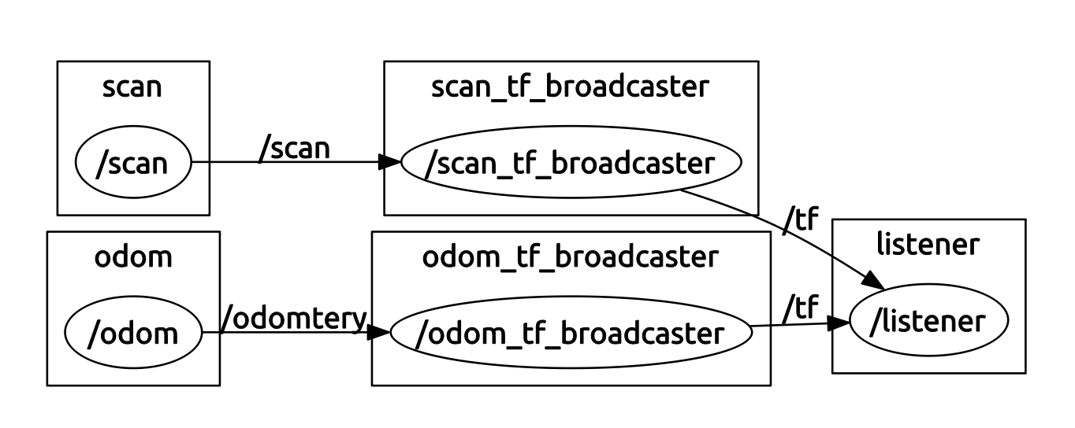
rviz图像
$ rosrun rviz rviz
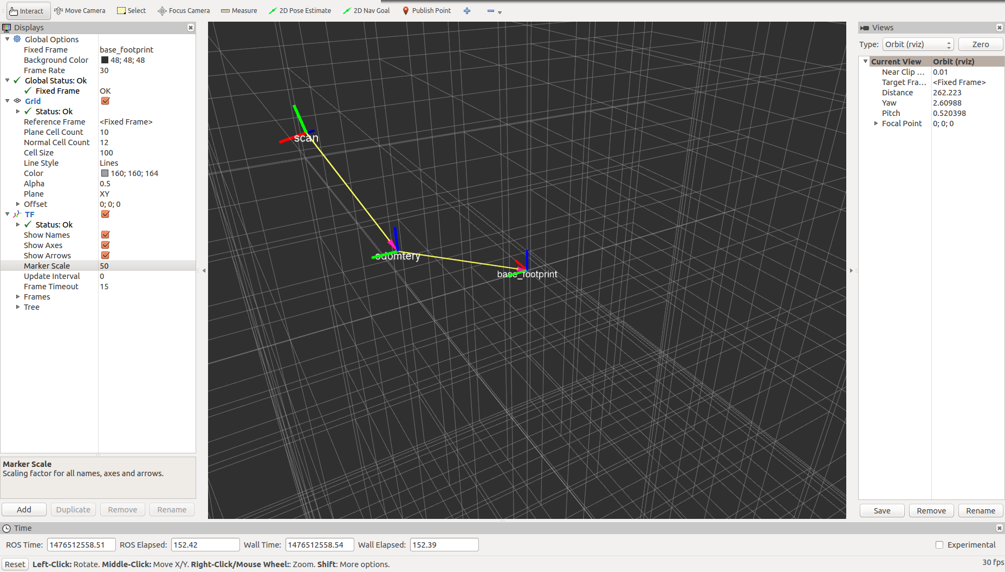
rqt_tf_tree图像
$ rosrun rqt_tf_tree rqt_tf_tree
