HO TECHNICAL UNIVERSITY


Surveillance AI:
AI-Powered Passive Personal Safety Monitoring

Hanson Johnny
Frimpong-Manso Julius

SUPERVISOR:
Mr. Prince Modey

A Thesis Submitted in Partial Fulfillment of the Requirements
for the Degree of Bachelor of Technology in Computer Science.

HTU
HO TECHNICAL UNIVERSITY
B.Tech. Computer Science Thesis
Faculty of Applied Science and Technology (FAST)
Department of Computer Science
© 2026
Hanson Johnny (0324080275)
Frimpong-Manso Julius (0324080133)

DECLARATION

We hereby declare that this dissertation is the result of our original work towards the award of Bachelor of Technology in Computer Science and that, to the best of our knowledge, no part of this work has been submitted for another certification in this university or elsewhere except for references to other people works which have been duly acknowledge.

HANSON JOHNNY ………………………… ……………………………

0324080275 Signature Date

FRIMPONG-MANSO JULIUS ………………………… …………………………

0324080133 Signature Date

CERTIFICATION

Certified by:

MR. PRINCE MODEY ……………………… ………………………
SUPERVISOR Signature Date

PROF.JOHN COKER AYIMAH ……………………… ………………………
HEAD OF DEPT. Signature Date

Table of Contents
CHAPTER ONE 3
INTRODUCTION 3
1.1 Background of the Project 3
1.2 Statement of the Problem 5
1.3 Aim and Objectives of the Project 6
1.4 Significance of the Project 7
1.5 Scope of the Project 8
1.6 Limitation of the Project 8
1.7 Organisation of the Project 9
CHAPTER TWO 10
LITERATURE REVIEW 10
2.1 Review of Related Works 10
2.2 Review of Related Systems 11
2.2.1 Features 12
2.2.2 Benefits 12
2.2.3 Drawbacks 13
2.3 Existing System 14
2.3.1 Component of Existing System 14
2.3.2 Process of the System 14
2.3.3 Problems of the Existing System 15
CHAPTER THREE 17
DESIGN AND METHODOLOGY 17
3.1 The Proposed System 17
3.2 System Specification 18
3.2.1 Functional Requirements 18
3.2.2 Non-Functional Requirements 20
3.3 Selection of Technologies and Tools 21
3.4 Architecture of the System 22
3.5 Design of the System 23
3.5.1 Use Case and Sequence Diagrams 23
3.5.2 Database Design 25
CHAPTER FOUR 28
SYSTEM DEVELOPMENT AND TESTING 28
4.1 Implementing of the Design 28
4.2 Programming and Coding 28
4.3 Main User Interfaces 39
4.4 Testing of the New System 45
4.5 Documentation 47
CHAPTER FIVE 48
CONCLUSION AND RECOMMENDATIONS 48
5.1 Conclusion 48
5.2 Recommendations 49
REFERENCES 51
APPENDIX 53
Appendix A – Project Plan 53
Appendix B – User Interfaces (more) 53
Appendix C – User Documentation (Guide) 56

CHAPTER ONE

INTRODUCTION

1.1 Background of the Project
Personal safety has emerged as one of the defining social and technological concerns of the contemporary digital era. As urbanization intensifies and lone travel, night-time mobility, and independent living become increasingly common, individuals are frequently exposed to situations in which they may become victims of assault, robbery, accidents, or medical emergencies without any immediate means of summoning assistance. In response, the mobile technology industry has produced a wide range of personal-safety applications that seek to shorten the interval between the onset of danger and the arrival of help. The global market for such applications has expanded rapidly and is projected to grow from approximately USD 1.7 billion in 2025 to USD 6.7 billion by 2034, a trajectory attributed largely to rising smartphone penetration and the maturation of artificial-intelligence-driven threat detection (Dimension Market Research, 2026).
Early personal-safety applications were built almost exclusively around a manually activated alarm. Widely adopted products such as bSafe, Noonlight, Life360, and Citizen provide an emergency Save-Our-Souls (SOS) button, real-time location sharing, safety-timer check-ins, and, in some cases, a connection to professional monitoring dispatchers (AppMaster, 2023; Grokipedia, 2026). These systems have demonstrably improved emergency response and have offered users a valuable sense of security. However, they share a common and consequential design assumption: that the user will be conscious, physically able, and sufficiently aware to trigger the alert at the critical moment. In practice, victims of a sudden assault, an incapacitating fall, or a rapidly escalating confrontation are frequently unable to reach their device, unlock it, and activate an SOS control before harm occurs. The reliance on deliberate, manual activation therefore constitutes a structural weakness in the prevailing generation of safety applications.
Parallel advances in artificial intelligence, and in particular the release of powerful multimodal large language models, have created an opportunity to address this weakness. Multimodal models such as OpenAI's GPT-4o are capable of jointly processing text, image, and audio inputs in near real time, and of producing contextual, human-interpretable assessments of a scene (Andrenacci, 2025). Research in adjacent domains has confirmed that vision-language models can perform meaningful risk perception: studies applying GPT-4V to forward-facing road imagery found that the model could judge situational risk in a manner broadly consistent with human raters (Driessen et al., 2024), while comparable pipelines built on GPT-4o and GPT-4o-mini have been shown to identify safety hazards such as missing protective equipment and dangerous conditions from construction-site images (Sahraoui, 2025). These findings establish that a contemporary multimodal model can serve as an automated situational-awareness engine rather than merely a passive record-keeper.
It is against this background that the present project, Surveillance AI, was conceived. Surveillance AI is an artificial-intelligence-powered personal-safety mobile application that inverts the conventional interaction model. Instead of waiting for the user to recognise danger and raise an alarm, the application passively and continuously monitors the user's surroundings through the phone's own sensors, namely the Global Positioning System (GPS) receiver, the camera, the microphone, and the accelerometer. On a repeating, configurable cycle, each sensor stream is analysed by an OpenAI model to produce a consolidated Low, Medium, or High risk score. Should the risk reach the High threshold, the application autonomously fires a three-channel emergency alert, dispatching a Short Message Service (SMS) text, an electronic-mail incident report, and an automated voice call to a pre-configured emergency contact. The single-sentence statement that defines the product is that Surveillance AI silently monitors the user's surroundings using the phone's sensors and immediately alerts the user's emergency contact by SMS, email, and call if danger is detected.
The application is engineered on a TypeScript-first mobile stack, comprising Expo and React Native on the client and Supabase, a managed PostgreSQL platform, on the server. All third-party artificial-intelligence and communication providers, including OpenAI, Twilio, and SendGrid, are invoked exclusively from server-side Edge Functions so that no sensitive credential is ever exposed on the device. Beyond the core individual-monitoring loop, Surveillance AI extends protection to a family group through a Guardian plan, in which a nominated guardian receives centrally routed alerts and read-only visibility of each linked member's live status, event log, and alert history. The commercial and operational parameters of the system, including pricing, artificial-intelligence usage quotas, monitoring cadence, and the underlying model, are stored in an administrator-editable configuration table and can be adjusted at runtime without releasing a new application binary. In combining passive multimodal sensing, autonomous multi-channel alerting, and a configurable family-monitoring architecture, the project seeks to advance personal-safety technology beyond the manual-alarm paradigm that has dominated the field to date.

1.2 Statement of the Problem
The central problem addressed by this project is that existing personal-safety applications depend on the timely, conscious, and physically unimpeded action of the very person who is under threat. When an individual is assaulted, rendered unconscious by a fall, drugged, or otherwise incapacitated, they are frequently unable to retrieve their phone, unlock it, navigate to a safety application, and activate an SOS control within the narrow window during which intervention would be most effective. Consequently, the protective value of manually activated systems collapses precisely in the most severe scenarios they are intended to guard against.
A second dimension of the problem concerns situational awareness. Traditional applications transmit a distress signal but convey little or no information about the nature of the emergency. An emergency contact who receives a bare location ping cannot readily distinguish a medical collapse from a violent assault, and therefore cannot prioritise an appropriate response. The absence of an automated, intelligent interpretation of the surrounding environment limits the usefulness of the alert to the responding party.
A third dimension relates to family and dependent care. Guardians of children, elderly relatives, or vulnerable individuals currently have no unified means of passively monitoring the safety status of multiple dependents, of receiving alerts on their behalf, and of reviewing their event history, without either compromising the dependent's autonomy or requiring the dependent to actively manage the safety process themselves.
Finally, safety applications operate in a volatile commercial and technological environment in which pricing, usage limits, and the most capable underlying artificial-intelligence models change frequently. Systems that hard-code these parameters into the application binary cannot adapt without a full release cycle, introducing operational rigidity and delay. Taken together, these problems establish a clear need for a personal-safety system that is passive rather than reactive, intelligent rather than merely transmissive, capable of protecting dependents as well as individuals, and configurable at runtime rather than fixed at build time.

1.3 Aim and Objectives of the Project
The aim of this project is to design and develop an artificial-intelligence-powered personal-safety mobile application that passively monitors a user's surroundings through the phone's sensors and autonomously alerts a pre-configured emergency contact through multiple channels when danger is detected.
In pursuit of this aim, the specific objectives of the project are:
- To design a passive, one-tap monitoring mechanism that continuously captures GPS location, camera snapshots, ambient audio, and accelerometer data without requiring any further manual reporting by the user.
- To integrate a multimodal artificial-intelligence pipeline that analyses the captured sensor inputs on each monitoring cycle and produces a consolidated Low, Medium, or High risk assessment.
- To implement an autonomous, three-channel emergency-alert pipeline that dispatches an SMS message, an email incident report, and an automated voice call to an emergency contact the moment the assessed risk reaches the High threshold.
- To develop a Guardian family-monitoring plan that enables a guardian to receive centrally routed alerts and read-only access to the live status, event log, and alert history of multiple linked members.
- To build an administrator panel that permits pricing, usage quotas, monitoring cadence, and the underlying artificial-intelligence model to be edited at runtime without an application-store release.
- To secure all user data and third-party service credentials through row-level security policies and server-side Edge Functions, ensuring that no sensitive key is exposed on the device.
- To test and evaluate the resulting system against its functional and non-functional requirements.

1.4 Significance of the Project
The significance of Surveillance AI lies principally in its potential to protect individuals in exactly those circumstances where existing solutions fail. By removing the dependence on conscious, manual activation, the system offers meaningful protection to victims of sudden assault, incapacitating accidents, and medical emergencies who would otherwise be unable to summon help. In doing so, the project contributes to the broader public-health and public-safety goal of reducing the time between the onset of an emergency and the arrival of assistance.
For families and carers, the Guardian plan provides a practical and non-intrusive mechanism for safeguarding children, elderly relatives, and other dependents. It thereby extends the benefit of the system beyond the technologically confident individual user to those who most require oversight yet are least able to manage a safety application themselves.
From an academic and technical perspective, the project demonstrates a concrete, deployable application of multimodal large language models to a real-world safety problem, contributing to the growing body of work on artificial-intelligence-enhanced situational awareness (Cadet et al., 2024). It also illustrates a secure, credential-protected architecture in which all artificial-intelligence and communication services are mediated by server-side functions, offering a reference design for privacy-conscious mobile applications that handle sensitive personal data.
Commercially, the runtime-configurable administrative model shows how a safety product can remain economically viable and technically current in a fast-moving market by adjusting its pricing, quotas, and model selection without repeated release cycles. The project therefore holds significance for developers, entrepreneurs, families, and the wider community concerned with personal security.

1.5 Scope of the Project
This project encompasses the design, development, and testing of the Surveillance AI mobile application as currently implemented. Its scope includes the cross-platform mobile client built with Expo and React Native; the Supabase-hosted PostgreSQL backend with row-level security, authentication, realtime updates, storage, and Edge Functions; the four-sensor passive monitoring loop covering GPS, camera, ambient audio, and accelerometer input; the multimodal artificial-intelligence risk-scoring pipeline based on the OpenAI GPT-4o family and the Whisper speech-to-text model; and the autonomous three-channel alert pipeline implemented through Twilio for SMS and voice and SendGrid for email.
The scope further includes the tiered plan model comprising Free, Pro, and Guardian tiers; the Guardian family-monitoring subsystem with pooled artificial-intelligence usage and centralised alert routing; the in-application administrator panel with database-backed, runtime-editable pricing, quotas, cadence, and model selection; and the complete event-logging and alert-history subsystem. The project covers the specification, architecture, database design, implementation, and testing of these components.

1.6 Limitation of the Project
Notwithstanding its contributions, the project is subject to several limitations. First, the accuracy of the risk assessment is bounded by the capability of the underlying multimodal model; although such models perform strongly, prior research notes that their reasoning on complex, high-risk, and out-of-distribution scenes remains imperfect and dependent on prompt design (Driessen et al., 2024). False positives and false negatives are therefore possible and cannot be entirely eliminated.
Second, the system depends on continuous access to the phone's sensors, an active internet connection, and adequate battery life; monitoring may be degraded in areas of poor network coverage or when the device is out of power. Third, passive monitoring of camera and audio raises legitimate privacy considerations, and the system's usefulness is contingent upon the user's informed consent and appropriate configuration. Fourth, at the time of writing, payment processing has not yet been made live, and the plan-tier billing is therefore evaluated at the level of configuration rather than end-to-end transaction. Finally, the project has been developed and tested primarily on Android through Expo, and comprehensive validation across the full range of iOS hardware falls outside the present scope.

1.7 Organisation of the Project
This report is organised into five chapters. Chapter One introduces the project, presenting its background, the statement of the problem, the aim and objectives, the significance, the scope, and the limitations of the work. Chapter Two reviews the related literature and existing systems, examining the features, benefits, and drawbacks of comparable personal-safety applications and analysing the shortcomings of the existing approach. Chapter Three presents the design and methodology of the proposed system, including its functional and non-functional requirements, the selection of technologies and tools, the system architecture, the design diagrams, and the database design. Chapter Four describes the development and testing of the system, covering the implementation of the design, the principal user interfaces, and the testing procedures. Chapter Five concludes the report and offers recommendations for future work. A bibliography and appendices follow the concluding chapter.

CHAPTER TWO

LITERATURE REVIEW
This chapter examines the body of scholarly and technical literature relevant to artificial-intelligence-powered personal-safety systems, and critically reviews the existing personal-safety applications against which Surveillance AI is positioned. The review first surveys related academic and industry work on personal safety, real-time threat detection, and multimodal artificial intelligence. It then analyses a representative set of existing systems in terms of their features, benefits, and drawbacks, before characterising the existing manual-alarm approach and the problems it presents.

2.1 Review of Related Works
A substantial and growing literature addresses the use of mobile technology for personal safety. Systematic reviews of applications designed to prevent violence against women and girls have documented a rapid proliferation of such tools, and have observed that emerging artificial-intelligence-powered applications now employ machine-learning algorithms to identify potential safety risks in real time, detecting unusual patterns of behaviour and hazardous conditions and issuing timely warnings to users (Banerjee et al., 2024). This work establishes both the social demand for personal-safety technology and the emerging expectation that such technology should become proactive rather than purely reactive.
The technical feasibility of real-time, artificial-intelligence-driven threat detection has been examined extensively in the surveillance domain. Cadet et al. (2024) propose a real-time data-processing framework for artificial-intelligence-powered threat detection in surveillance systems, arguing that traditional methods, which depend on human operators analysing feeds in real time or reviewing recorded footage after an incident, are increasingly inadequate to the complexity of modern security threats. Their framework, integrating real-time processing with advanced artificial-intelligence models, is presented as a means of improving both the efficiency and the accuracy of threat detection. The same body of work cautions, however, that such systems raise significant ethical and privacy challenges that must be addressed through transparency and compliance with legal standards.
The specific capability on which Surveillance AI depends, namely the ability of a multimodal model to interpret a scene and assess risk, is supported by a rapidly expanding empirical literature. Following the release of GPT-4o in May 2024, which was engineered to process and generate text, audio, and visual inputs in real time (Andrenacci, 2025), researchers began to evaluate the risk-perception abilities of vision-language models directly. Driessen et al. (2024), applying GPT-4V to forward-facing road imagery, demonstrated that the model could judge situational risk in a manner informed by, and broadly comparable to, human psychometric responses. In the occupational-safety domain, Sahraoui (2025) constructed a hybrid pipeline using GPT-4o and GPT-4o-mini to extract structured insights from a large corpus of accident reports and to guide a vision-language model in detecting and localising site hazards such as missing protective equipment, producing contextual safety assessments that mirrored real-world evaluations. Comparative studies have further shown that GPT-4o materially outperforms its predecessors on multimodal reasoning tasks (Hirano et al., 2025).
Taken together, these related works confirm three points that underpin the present project. First, there is a clear and documented need for proactive, intelligent personal-safety technology. Second, real-time artificial-intelligence threat-detection frameworks are technically viable, though they carry ethical and privacy obligations. Third, contemporary multimodal models are demonstrably capable of the scene interpretation and risk assessment required to power an autonomous safety monitor. Surveillance AI synthesises these strands by embedding a multimodal risk engine within a passive, sensor-driven mobile safety application.

2.2 Review of Related Systems
A number of commercial personal-safety applications occupy the market that Surveillance AI seeks to enter. The most prominent of these include bSafe, Noonlight, Life360, and Citizen, each of which offers a distinct combination of features. bSafe provides an SOS button, voice-activated alerting, live audio and video streaming, and location tracking; Noonlight connects users with professional dispatchers who can notify local police, fire, or emergency medical services; Life360 focuses on family location-sharing and coordination; and Citizen delivers community-sourced local safety alerts (AppMaster, 2023; Risk Track, 2026). The following subsections analyse the features, benefits, and drawbacks common to this class of system.

2.2.1 Features
The prevailing generation of personal-safety applications shares a recognisable set of features:
- A manually activated emergency SOS button that dispatches an alert to a predefined set of trusted contacts, and in some products to a professional monitoring service (Grokipedia, 2026).
- Real-time location sharing, allowing trusted contacts to follow the user's journey and, in some products, to receive automatic alerts if the user deviates from a planned route.
- Safety-timer or check-in mechanisms, in which the application alerts the user's contacts if the user fails to confirm safety before a timer expires; this is commonly used for solo travel and walks alone at night (SilentSecurity, 2026).
- Voice-activated SOS and evidence capture, including audio and video recording and live streaming to trusted contacts, as offered by bSafe (ResQ, 2025).
- Professional monitoring and direct emergency-service integration, exemplified by Noonlight's dispatcher connection and by advanced pipelines that transmit enriched incident data directly to emergency call centres (Grokipedia, 2026).
- Community incident reporting and local safety alerts, as provided by Citizen, which keeps users informed of nearby incidents in real time (Risk Track, 2026).

2.2.2 Benefits
These systems confer several well-documented benefits:
- They provide an additional layer of security and peace of mind for users in potentially dangerous or unfamiliar situations, complementing the SOS features now built into both major mobile operating systems (SilentSecurity, 2026).
- They accelerate emergency response by delivering a distress signal, and frequently the user's location, to trusted contacts or dispatchers far more quickly than a conventional telephone call could achieve.
- Products with professional monitoring, such as Noonlight, can escalate directly to emergency services, and integrations such as RapidSOS can supply responders with enriched incident details without requiring a voice call (Grokipedia, 2026).
- Family-oriented products such as Life360 support the coordination and reassurance of family groups through continuous location visibility and driving-safety alerts (ResQ, 2025).

2.2.3 Drawbacks
Despite these benefits, the existing systems exhibit significant and recurrent drawbacks:
- Dependence on manual activation. The defining limitation of the class is that protection is contingent on the user consciously and physically triggering the alert. Products that require the user to hold or press a button, or to speak a command, cannot help a user who has been rendered unconscious, incapacitated, or otherwise unable to reach the device at the decisive moment (Grokipedia, 2026).
- Absence of intelligent situational interpretation. Most systems transmit a location or a bare distress signal but do not automatically interpret the surrounding environment. The receiving contact is therefore left to infer the nature and severity of the emergency, which delays and may misdirect the response.
- Technical reliability concerns. Reviews of leading products report recurring complaints of glitches following updates, occasional GPS lag, and billing friction; such reliability problems are especially serious in a safety application, where a failure at the critical moment can have grave consequences (Localsinsider, 2026).
- Limited passive protection for dependents. Family-oriented products offer location visibility but not autonomous, intelligent monitoring of a dependent's safety status, and generally require the dependent to participate actively in the safety process.
- Operational rigidity. Where pricing, quotas, and service parameters are fixed within the application binary, providers cannot readily adapt to a fast-moving market or adopt newer, more capable artificial-intelligence models without a full release cycle.

2.3 Existing System
For the purposes of this review, the existing system denotes the prevailing paradigm of manually activated personal-safety applications, of which bSafe, Noonlight, Life360, and Citizen are representative. This paradigm is characterised by a reactive interaction model in which the human user is responsible for recognising danger and initiating the protective response. The subsections that follow describe the components of this existing system, the process by which it operates, and the problems that motivate the development of Surveillance AI.

2.3.1 Component of Existing System
The existing manual-alarm system is typically composed of the following components:
- A trigger mechanism, most commonly a physical or on-screen SOS button, and in some products a voice command or a hardware accessory such as a paired wearable or pepper-spray device (ResQ, 2025).
- A contact registry, comprising the trusted contacts or, in monitored products, the professional dispatch service to which alerts are directed.
- A location subsystem, which acquires the device's GPS coordinates and shares them with the registered contacts.
- A communication subsystem, which transmits the alert to the contacts by SMS, push notification, or automated call, and in some products supports live audio or video streaming.
- An optional monitoring service, which, in products such as Noonlight, links the alert to professional dispatchers able to notify local police, fire, or emergency medical services (AppMaster, 2023).

2.3.2 Process of the System
The operational process of the existing system proceeds in a strictly sequential and human-initiated manner:
- The user perceives a threat or emergency in their environment.
- The user retrieves the mobile device, unlocks it, and opens the safety application.
- The user activates the trigger mechanism, whether by pressing the SOS button, holding a control, or issuing a voice command.
- The application acquires the current GPS location and composes the alert payload.
- The application transmits the alert, together with the location, to the registered emergency contacts or to the professional monitoring service.
- The contacts or dispatchers receive the alert and initiate a response, frequently without detailed knowledge of the nature of the emergency.
The critical characteristic of this process is that its first three steps depend entirely upon the user being conscious, physically able, and sufficiently aware to act. If any of these conditions fails, the process cannot begin, and the protective value of the system is lost.

2.3.3 Problems of the Existing System
Analysis of the existing system reveals a set of interrelated problems that the proposed system is designed to overcome:
- The activation gap. Because the process is human-initiated, the system offers no protection in the very scenarios, such as sudden assault, unconsciousness, or incapacitation, in which the user cannot activate it. This is the most fundamental weakness of the existing paradigm (Grokipedia, 2026).
- Information poverty of alerts. The alerts generated convey little contextual information about the emergency, leaving the responding party unable to assess severity or nature and thereby impairing the effectiveness of the response.
- Reliability and continuity risks. Documented technical shortcomings, including update-related glitches and GPS lag, undermine confidence in the system at the moment it is most needed (Localsinsider, 2026).
- Inadequate passive care for dependents. The existing systems provide location visibility but not autonomous, intelligent oversight of dependents' safety, and require the dependent's active participation.
- Static configuration. Fixed pricing, quotas, and model selection prevent providers from adapting quickly to market conditions and from adopting more capable artificial-intelligence models as they emerge.
These problems, and in particular the activation gap and the absence of intelligent situational interpretation, provide the direct justification for the design of Surveillance AI. By replacing the reactive, human-initiated model with a passive, continuously sensing, artificial-intelligence-driven monitor that alerts autonomously and conveys a summarised interpretation of the scene, the proposed system addresses each of the identified problems in turn. The detailed design and methodology of that proposed system are presented in Chapter Three.

CHAPTER THREE

DESIGN AND METHODOLOGY
This chapter presents the design and methodology of Surveillance AI. It translates the problems and conclusions established in Chapters One and Two, namely the activation gap, the information poverty of conventional alerts, the lack of passive protection for dependents, and the static, build-time configuration of existing products, into a concrete system specification and architecture. The chapter first states the proposed system and its functional and non-functional requirements, then justifies the technologies selected to build it, and finally presents the architecture and design of the system, including its database, use case and sequence diagrams.

3.1 The Proposed System
Surveillance AI proposes to invert the reactive, human-initiated alarm paradigm identified in Chapter Two by making protection passive and continuous rather than dependent on a user consciously recognising danger, retrieving a locked device, and pressing a button. Once a user taps “Start Surveillance”, the application autonomously and repeatedly captures the user's location, a camera snapshot, ambient audio, and accelerometer readings, and submits the camera and audio evidence to a multimodal artificial-intelligence pipeline built on OpenAI's GPT-4o and Whisper models. This directly operationalises the real-time, artificial-intelligence-powered threat-detection framework argued for by Cadet et al. (2024), replacing the human operator or the user's own vigilance with an automated, continuously running risk engine. Each monitoring cycle produces a Low, Medium, or High risk classification; a Medium classification raises a push notification to the user alone, while a High classification autonomously and simultaneously notifies a pre-configured emergency contact by SMS, email, and an automated voice call, addressing the information-poverty problem by carrying the AI's summary and a GPS link rather than a bare distress signal.
Because Driessen et al. (2024) caution that a multimodal model's reasoning on complex or out-of-distribution scenes remains imperfect and sensitive to prompt design, every prompt sent to GPT-4o is deliberately conservative: the model is instructed to prefer a lower risk classification unless the visual or audio evidence is unambiguous, so that the system fails toward silent logging rather than toward false alarms. The proposed system further addresses the static-configuration problem identified in Chapter Two by introducing three subscription tiers, Free, Pro, and Guardian, each with its own daily artificial-intelligence usage cap, minimum monitoring interval, and audio-analysis entitlement, together with an administrator capability to reassign a user's tier at runtime without a new application release. The Guardian tier, in particular, is designed to extend the benefit of the system to dependents such as children, elderly relatives, and other family members who may be less able to manage a safety application unaided.

3.2 System Specification

3.2.1 Functional Requirements
The functional requirements below describe the observable behaviour that the implemented system provides to its users and administrator.
1. Registration and Authentication. The system shall allow a user to register and sign in with an email address and password through Supabase Authentication, and to request a password reset via a deep link that reopens the application.
2. Guided Onboarding. The system shall guide a first-time user through a fixed sequence of screens that collect the emergency contact's name, phone number, and email address, and store this information securely for use during an alert.
3. Configurable Preferences. The system shall allow the user to configure the monitoring interval (20, 30, or 60 seconds), shake sensitivity (Low, Medium, or High), stealth mode, and a wellness check-in time.
4. One-Tap Session Control. The system shall allow the user to start and stop a surveillance session with a single tap, creating and later closing a corresponding session record.
5. Parallel Sensor Capture. While a session is active, the system shall capture the device's GPS location, a silent camera snapshot, and an ambient audio clip in parallel on every monitoring cycle.
6. Continuous Shake Detection. The system shall continuously monitor accelerometer data, independently of the timed monitoring cycle, and classify a sudden qualifying impact as a High-risk event immediately.
7. Image Risk Analysis. The system shall submit each captured photograph, together with the current GPS coordinates, to the analyse-image function for GPT-4o Vision risk analysis.
8. Audio Risk Analysis. The system shall transcribe each captured audio clip using Whisper and submit the resulting transcript to the analyse-audio function for GPT-4o threat analysis, without blocking the delivery of the image-based result.
9. Consolidated Risk Scoring. The system shall combine the image-based and audio-based risk outputs of a monitoring cycle into a single consolidated risk level of Low, Medium, or High.
10. Medium-Risk Notification. On a Medium-risk classification, the system shall deliver a local push notification to the user only.
11. High-Risk Alert Pipeline. On a High-risk classification, the system shall automatically and simultaneously send an SMS and an email, and place an automated voice call, to the registered emergency contact, each carrying the GPS location, the AI-generated summary, and the photograph where available, and shall not send a duplicate alert for the same event.
12. Event Log and Alert History. The system shall record every monitoring cycle to an Event Log, showing its timestamp, risk level, AI summary, and coordinates, and shall record every High-risk alert to a separate Alerts screen showing which channels were sent and when.
13. Live Location Map. The system shall display the user's current location on an interactive map during an active session.
14. Tiered Usage Plans. The system shall enforce a per-user, per-day cap on artificial-intelligence analysis calls according to the user's subscription plan (Free, Pro, or Guardian), and shall allow an authorised administrator to list registered users and reassign a user's plan at runtime.
15. Wellness Check-In. The system shall raise a scheduled notification at the user's configured check-in time and, if the user has not confirmed safety within ten minutes, shall alert the emergency contact.

3.2.2 Non-Functional Requirements
The non-functional requirements below describe the quality attributes that constrain how the functional requirements are satisfied.
• Security. Every database table has Row Level Security enabled and scoped to auth.uid(), so a user can read and write only their own data; all OpenAI, Twilio, and SendGrid API keys are stored as Supabase secrets and are never bundled into the client, with every third-party call proxied through a Supabase Edge Function.
• Performance. GPS, camera, and audio capture run in parallel within a monitoring cycle rather than sequentially, and audio transcription and analysis run asynchronously so that a slower audio pipeline never delays the delivery of the image-based risk result.
• Reliability. The monitoring loop is registered with Expo Task Manager and Background Fetch so that cycles continue while the application is minimised or the screen is locked, and every Edge Function returns a safe low-risk fallback result rather than throwing an error if the underlying AI call fails.
• Usability. Camera, microphone, location, and notification permissions are requested one at a time during onboarding, each preceded by a plain-language explanation of why it is needed, and a denied camera or microphone permission degrades the experience with a visible banner rather than crashing the application.
• Scalability. The system is built on Supabase's managed PostgreSQL and Edge Function infrastructure, and per-tier daily usage caps bound the growth of third-party AI cost as the number of users increases.
• Maintainability. All AI prompts are centralised in a single prompts.ts file and all plan parameters (price, daily cap, minimum interval, audio entitlement) are centralised in a single plans.ts file, so behaviour can be adjusted in one place rather than across the codebase.
• Portability. The application is built with Expo and React Native so that a single TypeScript codebase targets both Android and iOS; development and testing in this project were carried out primarily on Android.
• Privacy. Camera and microphone data are used only to produce a risk assessment for the active session, and the Event Log is automatically cleared after five days by default, limiting how long sensitive personal data is retained on the device.

3.3 Selection of Technologies and Tools
The technologies selected for Surveillance AI were chosen to keep a single TypeScript codebase, to avoid exposing third-party credentials on the client, and to minimise the amount of custom backend infrastructure the project would otherwise need to build and operate.
• Expo, React Native, and TypeScript. provide a single, statically typed codebase that targets both Android and iOS and give access to native device capabilities (camera, location, sensors, background tasks) through a consistent, well-documented API.
• Expo Router. supplies file-based navigation for the application's authentication, onboarding, and tab-based screens.
• NativeWind (Tailwind CSS). allows the interface to be styled with utility classes directly in component code, keeping presentation close to markup.
• Zustand and AsyncStorage. manage in-memory application state (session, alerts, settings, onboarding) and persist it locally so the app remains responsive and usable offline between synchronisations.
• Supabase (PostgreSQL, Authentication, Row Level Security, Edge Functions). supplies a managed relational database, email/password authentication, and a serverless runtime, removing the need to design and operate a bespoke server while still allowing every third-party API key to be kept off the client.
• OpenAI GPT-4o and Whisper. provide, respectively, the multimodal vision-and-language reasoning used to interpret camera snapshots and the speech-to-text transcription used to make ambient audio analysable by GPT-4o.
• Twilio. delivers the SMS and automated voice call channels of the High-risk alert pipeline.
• SendGrid. delivers the email channel of the High-risk alert pipeline.
• Expo Camera, Expo AV, Expo Location, and Expo Sensors. provide, respectively, silent photo capture, audio recording, GPS access, and accelerometer readings for shake detection.
• Expo Task Manager and Background Fetch. register and continue the monitoring loop while the application is minimised or the screen is locked.
• Expo Secure Store, Keep Awake, Notifications, and SMS. provide, respectively, on-device storage of the emergency contact, prevention of screen sleep during stealth mode, local and push notifications, and a fallback SMS composer.
• react-native-webview and Leaflet. render the Live Map using CartoDB Dark Matter tiles inside a self-contained HTML page, avoiding a native maps SDK and its associated API key.

3.4 Architecture of the System
Surveillance AI follows a three-tier architecture comprising the mobile client, the Supabase backend, and a set of external third-party services, as shown in Figure 3.1. The mobile client owns the user interface, local state, and the monitoring orchestrator that drives each capture cycle. It communicates with Supabase for authentication and for synchronising sessions, events, alerts, contacts, and settings, all of which are protected by Row Level Security. Rather than call OpenAI, Twilio, or SendGrid directly, the client invokes a small set of Supabase Edge Functions (analyse-image, analyse-audio, send-sms, send-email, make-call, and admin-users/upgrade-plan), each of which holds the corresponding third-party credential as a server-side secret and performs the actual third-party call on the client's behalf. This arrangement means that no OpenAI, Twilio, or SendGrid key is ever present in the mobile application binary.
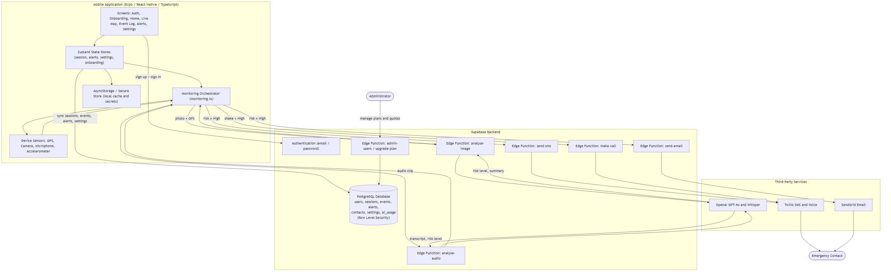
Figure 3.1: Three-tier system architecture of Surveillance AI.

3.5 Design of the System
Two complementary diagrams are presented to describe the design of the system: a use case diagram, which identifies the actors of the system and the functions each actor performs, and a sequence diagram, which traces the order of interactions that occur during a single monitoring cycle and the alert pipeline it may trigger.

3.5.1 Use Case and Sequence Diagrams
Figure 3.2 presents the use case diagram of the system. The Registered User is the principal actor and interacts with the system to register and sign in, complete onboarding and set an emergency contact, start and stop a surveillance session, view the live map and event log, configure monitoring preferences, and perform a wellness check-in. Starting a session triggers the monitoring cycle use case, which in turn may result in the user receiving a Medium-risk push notification or a High-risk alert being sent to the emergency contact. A second actor, the Administrator, interacts with the system separately to manage user plans and usage quotas.
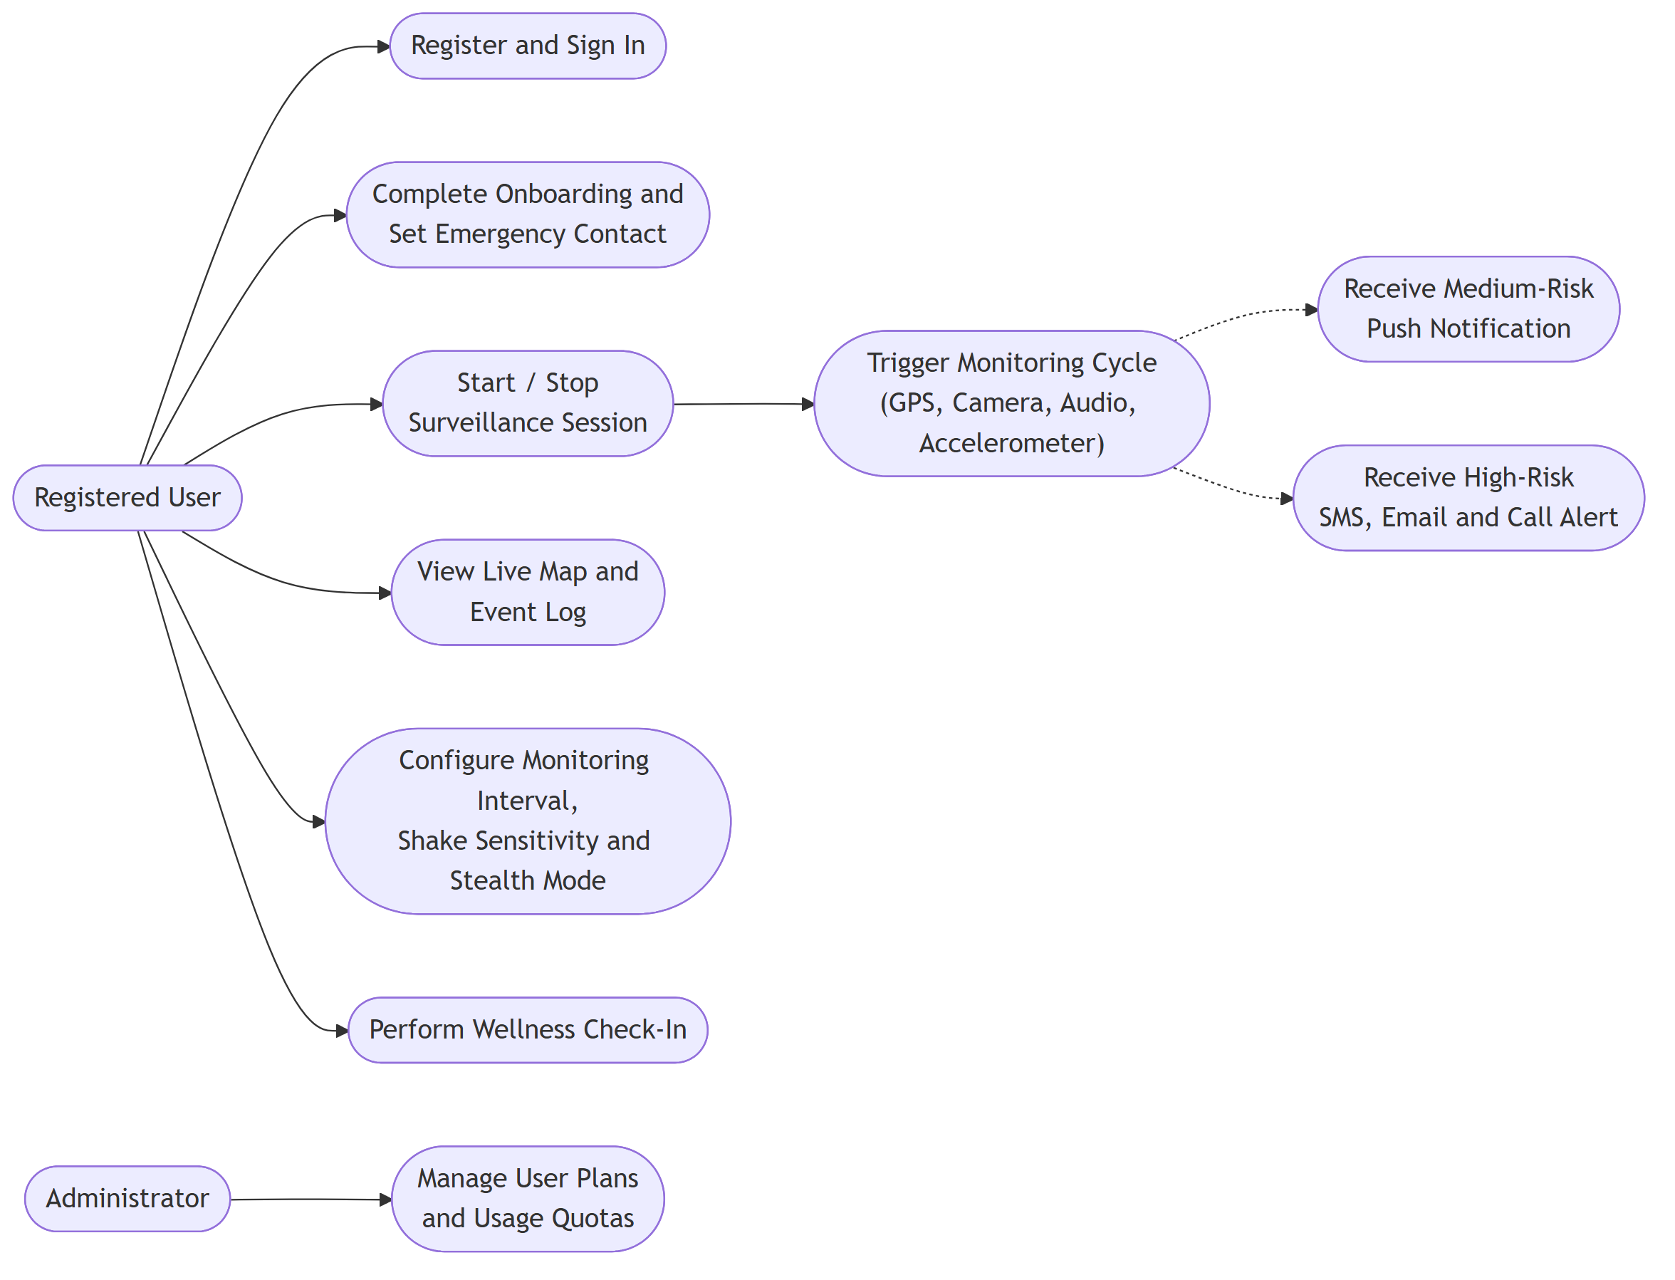
Figure 3.2: Use case diagram of Surveillance AI.
Figure 3.3 presents the sequence diagram of a single monitoring cycle. After the user starts a session, the orchestrator repeats a fixed loop roughly every twenty to thirty seconds: it captures the GPS location and a camera snapshot in parallel, submits the photograph and location to the analyse-image Edge Function for GPT-4o Vision analysis, and, without waiting for that result, records and submits an ambient audio clip to the analyse-audio Edge Function for Whisper transcription and GPT-4o threat analysis. The image-based and audio-based risk results are combined into one risk level for the cycle. A Medium result produces a local push notification to the user only, while a High result causes the orchestrator to invoke the send-sms, send-email, and make-call Edge Functions, which dispatch the alert to the emergency contact through Twilio and SendGrid.
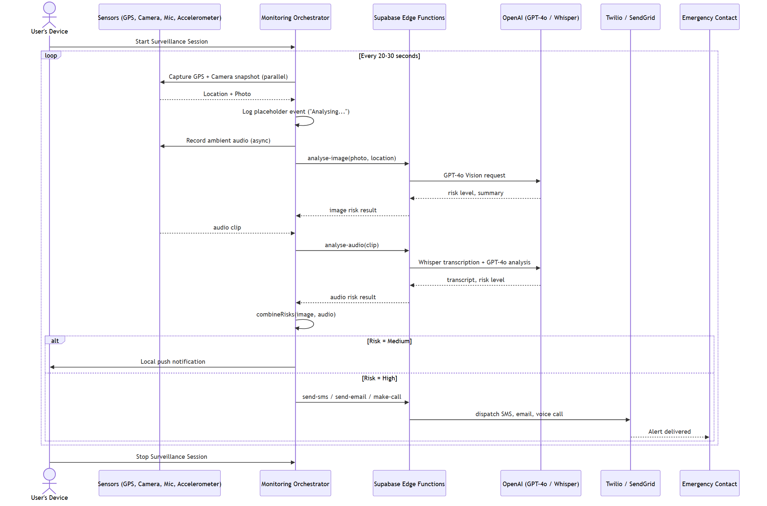
Figure 3.3: Sequence diagram of a monitoring cycle and the High-risk alert pipeline.

3.5.2 Database Design
The system's persistent data is held in a PostgreSQL database managed by Supabase and organised into seven tables, all protected by Row Level Security policies that restrict every row to the authenticated user identified by auth.uid(). The entity-relationship diagram in Figure 3.4 shows these tables and the foreign-key relationships between them.
• users. one row per authenticated user, created automatically by a database trigger on first sign-up, storing the user's subscription plan (free, pro, or guardian) and account creation timestamp.
• sessions. one row per surveillance session, recording when the session started and ended and how many monitoring cycles it completed.
• events. one row per monitoring cycle, recording its timestamp, consolidated risk level, AI-generated summary, GPS coordinates, and, where available, a photo URL and audio transcript.
• alerts. created only for High-risk events, recording which channels (SMS, email, call) were sent, to which contact, and when, and used to prevent the same event from triggering a duplicate alert.
• contacts. the emergency contact's name, phone number, and email address collected during onboarding or updated in Settings.
• settings. one row per user, storing the monitoring interval, shake sensitivity, stealth mode toggle, and wellness check-in time.
• ai_usage. one row per user per calendar date, incremented atomically by a database function to enforce each plan tier's daily artificial-intelligence usage cap.
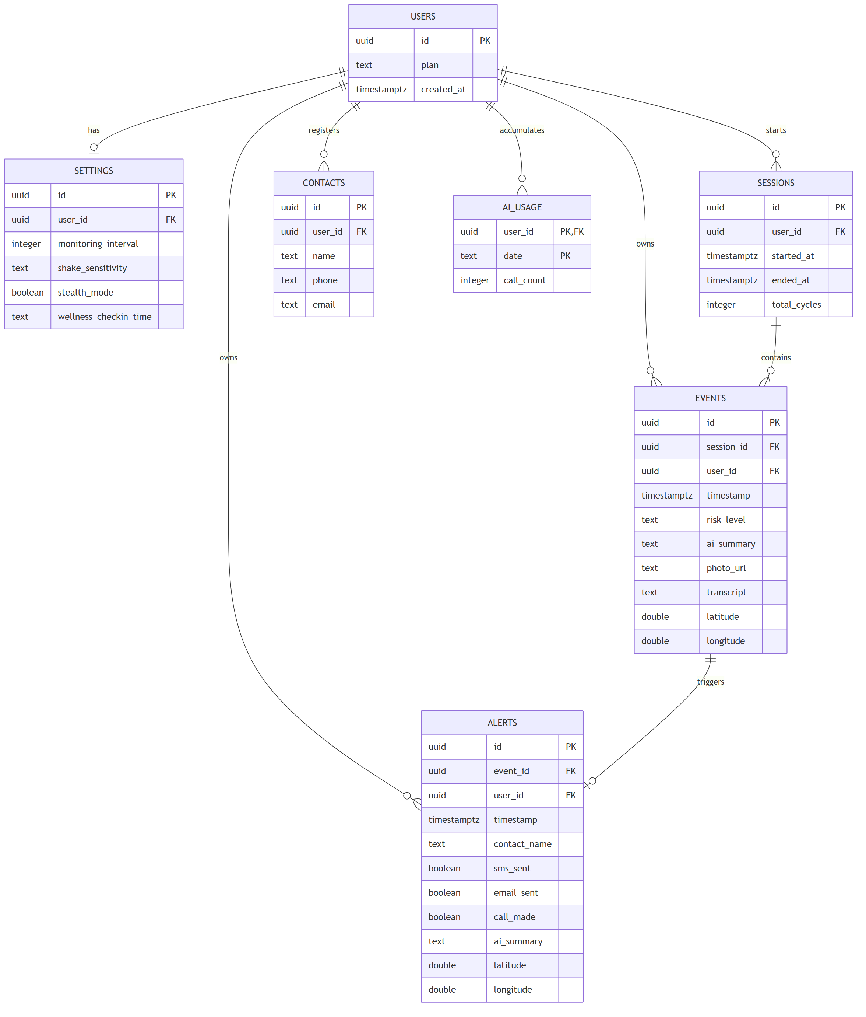
Figure 3.4: Entity-relationship diagram of the Surveillance AI database.

CHAPTER FOUR

SYSTEM DEVELOPMENT AND TESTING
This chapter describes how the design presented in Chapter Three was implemented and verified. It covers the development approach and environment used to build the system, the organisation and key mechanisms of the codebase, the application's main user interfaces, the testing carried out on the completed system, and the documentation produced alongside it.

4.1 Implementing of the Design
The system was implemented feature by feature rather than as a single monolithic build: authentication and the Supabase schema (with Row Level Security enabled on every table) were established first, followed by the core monitoring loop and its sensor integrations, then the three-channel alert pipeline, the five main application screens, the tiered subscription and administrator model, and finally the manual test pass described in Section 4.2. For each feature, the smallest working version was built first and refactored only once genuine repetition or complexity appeared, in keeping with the project's own development conventions, which explicitly favour readable, minimal implementations over premature abstraction.
Development was carried out in Visual Studio Code against an Expo SDK 56 / React Native project written entirely in TypeScript. Because the system depends on native modules (camera, microphone, background tasks, accelerometer) that are unavailable in a plain Expo Go sandbox, a custom Expo Dev Client was built and distributed through Expo Application Services (EAS) so that the application could be installed and iterated on directly on a physical Android device, which the project's own testing documentation identifies as mandatory since the simulator cannot exercise camera, microphone, accelerometer, background execution, or push notifications. On the backend, the Supabase CLI was used to author and apply PostgreSQL migrations and to deploy the seven Edge Functions, and static analysis was enforced through the project's `expo lint` script.

4.2 Programming and Coding
The codebase is organised so that each concern has a single, predictable home: screens live under /app (grouped into authentication, onboarding, and tab routes managed by Expo Router), presentational components live under /components, framework-independent business logic lives under /lib (monitoring.ts, vision.ts, audio.ts, alerts.ts, location.ts, sensors.ts, plans.ts, prompts.ts), Zustand state containers live under /store, and the seven serverless functions that hold third-party credentials live under /supabase/functions. This separation keeps the AI prompts, in prompts.ts, and the plan parameters, in plans.ts, each centralised in one file, so that adjusting a prompt or a subscription tier does not require touching the screens or state containers that use them.
The monitoring orchestrator in monitoring.ts is the most important module in the client, since it implements the passive capture cycle described in Chapter Three. Figure 4.1 reproduces its core logic: the camera snapshot and GPS fix are requested together with Promise.all so that neither sensor waits on the other, the resulting event is written to the Event Log immediately with a placeholder summary so the interface never appears to hang, and the image-based and audio-based risk levels returned by the two Edge Functions are later reconciled by combineRisks, which simply keeps whichever of the two carries the higher severity.
function combineRisks(a: RiskLevel, b: RiskLevel | null): RiskLevel {
if (!b) return a;
const order: Record<RiskLevel, number> = { low: 0, medium: 1, high: 2 };
return order[a] >= order[b] ? a : b;
}

// Snapshot and GPS captured in parallel — neither blocks the other.
const [photoUri, location] = await Promise.all([
takeSnapshot(),
getCurrentLocation(),
]);

// Event is logged immediately with a placeholder summary; the AI
// result patches it in place once analyse-image resolves.
useAlertStore.getState().addEvent(event);
Figure 4.1: Parallel sensor capture and risk-combination logic from monitoring.ts.
On the server side, the daily artificial-intelligence usage cap described in Chapter Three is enforced by a single atomic PostgreSQL function, increment_ai_usage, rather than by a separate read followed by a write from the Edge Function. Figure 4.2 shows the relevant clause: the INSERT ... ON CONFLICT DO UPDATE only increments call_count while it remains below the caller's cap, so two concurrent monitoring cycles for the same user on the same day cannot both increment past the limit.
INSERT INTO ai_usage (user_id, date, call_count)
VALUES (p_user_id, p_date, 1)
ON CONFLICT (user_id, date) DO UPDATE
SET call_count = ai_usage.call_count + 1
WHERE ai_usage.call_count < p_cap
RETURNING ai_usage.call_count INTO v_count;
Figure 4.2: Atomic, race-condition-safe usage-cap increment (increment_ai_usage RPC).
The excerpts above show the client-side capture cycle and the database's atomic usage-cap function. The remaining figures in this section illustrate four further representative parts of the implementation: continuous shake detection, the server-side call to GPT-4o Vision with its safe-fallback handling, the alert pipeline's deduplication and message composition, and the registration of the background task that drives the wellness check-in.
Shake detection runs as its own continuous accelerometer listener, entirely independent of the timed monitoring cycle, so that a violent impact is classified as High risk within about half a second rather than waiting for the next scheduled cycle. Figure 4.3 shows the magnitude threshold check and the 500-millisecond sustained-impact and 5-second cooldown logic that together prevent a single fall from firing repeated alerts as the phone continues to move after impact.
const subscription = Accelerometer.addListener(({ x, y, z }) => {
const magnitude = Math.sqrt(x * x + y * y + z * z);

if (magnitude > threshold) {
if (thresholdExceededAt === null) thresholdExceededAt = Date.now();

const sustainedFor = Date.now() - thresholdExceededAt;
const cooldownPassed = Date.now() - lastShakeAt > 5000;

if (sustainedFor >= 500 && cooldownPassed) {
lastShakeAt = Date.now();
thresholdExceededAt = null;
onShake();
}
} else {
// Reset unless the impact is sustained continuously, not cumulatively.
thresholdExceededAt = null;
}
});
Figure 4.3: Continuous, threshold-based shake detection with cooldown (sensors.ts).
The analyse-image Edge Function is the only part of the system that holds the OpenAI API key, and it calls GPT-4o Vision with the captured photograph, encoded as a base64 data URL, alongside the current GPS coordinates. Figure 4.4 shows the request together with the safe-fallback branch: if OpenAI responds with anything other than a successful status, or if the call throws, the function returns a well-formed Low-risk result instead of an error, which is why a temporary OpenAI outage produces an “Analysis failed” log entry rather than a crash.
const response = await fetch("https://api.openai.com/v1/chat/completions", {
method: "POST",
headers: { Authorization: `Bearer ${OPENAI_API_KEY}`, ... },
body: JSON.stringify({
model: "gpt-4o",
max_tokens: 256,
messages: [{
role: "user",
content: [
{ type: "image_url", image_url: { url: dataUrl, detail: "low" } },
{ type: "text", text: buildPrompt(lat, lng, situation) },
],
}],
}),
});

if (!response.ok) {
console.error("[analyse-image] OpenAI error:", response.status);
return json({ riskLevel: "low", summary: "Analysis failed.", confidence: 0 });
}
Figure 4.4: GPT-4o Vision request with safe-fallback error handling (analyse-image Edge Function).
The alert orchestrator in alerts.ts is responsible for both preventing duplicate alerts and composing the message sent to the emergency contact. Figure 4.5 shows the deduplication check, which looks up the triggering event's ID against every alert already recorded before any channel is dispatched, together with the SMS message template that carries the AI summary, a Google Maps link, and the event timestamp.
// Deduplicate — if an alert for this event was already fired, bail out.
const existingAlerts = useAlertStore.getState().alerts;
if (existingAlerts.some((a) => a.eventId === event.id)) {
console.log("[alerts] duplicate event, skipping:", event.id);
return;
}

const mapsLink = event.location
? `https://maps.google.com/?q=${event.location.lat},${event.location.lng}`
: "Location unavailable";

const smsMessage =
`SAFETY ALERT: ${contact.name} may need help.\n` +
`Map: ${mapsLink}\n` +
`AI detected: ${event.aiSummary}\n` +
`Time: ${timestamp}`;
Figure 4.5: Alert deduplication and SMS message composition (alerts.ts).
Finally, the wellness check-in feature relies on Expo Task Manager and Background Fetch to keep running even when the application itself is not open. Figure 4.6 shows the task definition, which must be registered at module load time as required by Task Manager, and the registration call, which is safe to invoke on every app launch because it checks whether the task is already registered before scheduling it again.
// Defined at module load time — required by TaskManager.
TaskManager.defineTask(WELLNESS_CHECK_TASK, async () => {
const shouldAlert = await checkWellnessWindow();
if (!shouldAlert) return BackgroundFetch.BackgroundFetchResult.NoData;

await triggerWellnessAlert(contact);
return BackgroundFetch.BackgroundFetchResult.NewData;
});

export async function registerWellnessTask(): Promise<void> {
const isRegistered = await TaskManager.isTaskRegisteredAsync(WELLNESS_CHECK_TASK);
if (isRegistered) return;

await BackgroundFetch.registerTaskAsync(WELLNESS_CHECK_TASK, {
minimumInterval: 10 * 60,
stopOnTerminate: false,
startOnBoot: true,
});
}
Figure 4.6: Background task definition and registration for the wellness check-in (wellnessTask.ts).

The remaining figures in this section extend the walkthrough to the audio-analysis path, the client and server sides of the AI integration, the GPS and camera capture utilities, push notifications, the two Zustand stores that hold session and event state, the Twilio SMS Edge Function, the hand-written Leaflet map, and the Row Level Security policies that protect every table.
Audio transcription is never awaited inside the main capture path. Figure 4.7 shows how, once the audio clip finishes recording, the transcript and its risk score are combined with the image risk already computed, and the combined result is only allowed to escalate a level that has not already triggered a notification, preventing the same cycle from firing two notifications at different points in time.
const [audioUri, imageResult] = await Promise.all([
audioPromise.catch((err) => { console.error(err); return null; }),
imagePromise.catch(() => null),
]);

const imageRisk: RiskLevel = imageResult?.riskLevel ?? "low";

if (audioUri) {
useAlertStore.getState().updateEvent(event.id, { audioUri });
transcribeAudio(audioUri).then(async (transcript) => {
if (!transcript) return;
useAlertStore.getState().updateEvent(event.id, { transcript });

const { audioSummary, audioRisk } = await analyseAudioTranscript(transcript);
const consolidatedRisk = combineRisks(imageRisk, audioRisk);

// Only escalate — never double-alert a level already fired above.
if (consolidatedRisk === "high" && imageRisk !== "high") {
sendLocalNotification("HIGH RISK DETECTED", audioSummary ?? "");
}
});
}
Figure 4.7: Non-blocking audio transcription and risk escalation logic (monitoring.ts).
On the client, every Edge Function call goes through the Supabase functions client rather than a raw fetch, so that the user's auth session is attached automatically. Figure 4.8 shows analyseImage, which additionally unwraps the FunctionsHttpError's underlying Response so that the real server-side error, such as a missing OpenAI key or a 4xx from OpenAI, is logged instead of the generic “non-2xx status code” message Supabase returns by default.
export async function analyseImage(
imageBase64: string,
location: { lat: number; lng: number } | null,
): Promise<VisionResult | null> {
const { data, error } = await supabase.functions.invoke("analyse-image", {
body: { imageBase64, lat: location?.lat ?? null, lng: location?.lng ?? null },
});

if (error) {
const ctx = (error as unknown as { context?: Response }).context;
if (ctx) {
const body = await ctx.text().catch(() => "(unreadable)");
console.error(`[vision] analyseImage error: HTTP ${ctx.status} —`, body);
} else {
console.error("[vision] analyseImage error:", error.message);
}
return null;
}

return data as VisionResult;
}
Figure 4.8: Client-side Edge Function invocation with detailed error extraction (vision.ts).
Audio must be recorded in a Whisper-compatible container, which differs by platform. Figure 4.9 shows the recording configuration used by expo-audio: an uncompressed WAV container on iOS, because AVAudioRecorder infers the container from the file extension and compressed formats were found to produce an unreadable file, and an AAC-in-MP4 container on Android, which MediaRecorder writes reliably.
const WHISPER_RECORDING_OPTIONS: RecordingOptions = {
extension: Platform.OS === "ios" ? ".wav" : ".mp4",
sampleRate: 16000,
numberOfChannels: 1,
bitRate: 128000,
isMeteringEnabled: false,
ios: {
outputFormat: IOSOutputFormat.LINEARPCM,
audioQuality: AudioQuality.HIGH,
linearPCMBitDepth: 16,
linearPCMIsBigEndian: false,
linearPCMIsFloat: false,
},
android: {
extension: ".mp4",
outputFormat: "mpeg4",
audioEncoder: "aac",
},
web: { mimeType: "audio/webm", bitsPerSecond: 64000 },
};
Figure 4.9: Platform-specific, Whisper-compatible audio recording configuration (audio.ts).
Reverse geocoding turns a raw GPS coordinate into a human-readable address for the event log and SMS alert. Figure 4.10 shows how this call is raced against a three-second timeout, because Android's native geocoder can otherwise block for the full five-second operating-system timeout and hold up the monitoring cycle.
export async function reverseGeocode(
lat: number,
lng: number,
): Promise<Address | null> {
let timer: ReturnType<typeof setTimeout> | undefined;
try {
const timeout = new Promise<never>((_, reject) => {
timer = setTimeout(() => reject(new Error("reverseGeocode timeout")), 3000);
});
const results = await Promise.race([
Location.reverseGeocodeAsync({ latitude: lat, longitude: lng }),
timeout,
]);
if (!results.length) return null;
const r = results[0];
return { name: r.name ?? null, street: r.street ?? null, city: r.city ?? null,
region: r.region ?? null, country: r.country ?? null };
} catch {
return null;
} finally {
clearTimeout(timer);
}
}
Figure 4.10: Timeout-guarded reverse geocoding (location.ts).
Because expo-camera has no headless capture API, a picture can only be taken from a mounted CameraView. Figure 4.11 shows the ref-registration pattern that lets a one-pixel, invisible CameraView rendered by SilentCamera.tsx be driven from plain functions, so the rest of the codebase can call takeSnapshot() without knowing that a camera component exists at all.
let _ref: RefObject<CameraView | null> | null = null;
let _ready = false;

export function registerCameraRef(ref: RefObject<CameraView | null>) {
_ref = ref;
_ready = false;
}

export function setCameraReady() {
_ready = true;
}

export function clearCameraRef() {
_ref = null;
_ready = false;
}

export async function takeSnapshot(): Promise<string | null> {
if (!_ref?.current || !_ready) return null;
const photo = await _ref.current.takePictureAsync({ quality: 0.5 });
return photo?.uri ?? null;
}
Figure 4.11: Headless snapshot capture via a registered CameraView ref (camera.ts).
Medium-risk events raise a local push notification rather than an alert to the emergency contact. Figure 4.12 shows the permission request together with the Android notification channel that must be created before any local alert can appear on that platform, since Android silently drops notifications sent to an unregistered channel.
export async function requestNotificationPermission(): Promise<boolean> {
const { status: existing } = await Notifications.getPermissionsAsync();
if (existing === "granted") return true;
const { status } = await Notifications.requestPermissionsAsync();
return status === "granted";
}

export async function registerForPushNotifications(): Promise<string | null> {
if (!Device.isDevice) return null;
const granted = await requestNotificationPermission();
if (!granted) return null;

if (Platform.OS === "android") {
await Notifications.setNotificationChannelAsync("safety-alert", {
name: "Safety Alerts",
importance: Notifications.AndroidImportance.MAX,
vibrationPattern: [0, 250, 250, 250],
lightColor: "#00E5FF",
});
}
return null;
}
Figure 4.12: Notification permission request and Android channel setup (notifications.ts).
Session state is held in a persisted Zustand store so that an active session survives an app restart. Figure 4.13 shows the slice that starts and stops a session: a new session ID is generated locally from the current timestamp, avoiding a network round-trip before monitoring can begin, and stopping a session resets every transient field back to its idle state.
startSession: () =>
set({
isActive: true,
sessionId: Date.now().toString(),
sessionStartTime: Date.now(),
lastRiskLevel: "low",
cycleCount: 0,
}),

stopSession: () =>
set({
isActive: false,
sessionId: null,
sessionStartTime: null,
lastRiskLevel: null,
lastAISummary: null,
cycleCount: 0,
}),
Figure 4.13: Persisted session-lifecycle slice (useSessionStore.ts).
The alert store keeps a local, optimistic copy of every fired alert and syncs it to Supabase in the background so the Alerts screen never waits on the network. Figure 4.14 shows addAlert, which deduplicates by event ID before doing anything else, updates local state immediately, and then inserts the row into Supabase without rolling back the local copy if the network write fails.
addAlert: async (alert) => {
// Deduplicate: skip if an alert for this event already exists.
if (get().alerts.some((a) => a.eventId === alert.eventId)) return;

// Optimistic local update — Alerts screen updates instantly.
set((state) => ({ alerts: [alert, ...state.alerts].slice(0, MAX_EVENTS) }));

const userId = useSessionStore.getState().userId;
if (!userId) return;

const { error } = await supabase.from("alerts").insert({
id: alert.id,
event_id: alert.eventId,
user_id: userId,
contact_name: alert.contactName,
sms_sent: alert.smsSent,
email_sent: alert.emailSent,
call_made: alert.callMade,
});

if (error) {
console.error("[useAlertStore] Failed to sync alert:", error.message);
// Alert stays in local AsyncStorage — do not roll back.
}
},
Figure 4.14: Optimistic local update with background Supabase sync (useAlertStore.ts).
The SMS channel of the alert pipeline is implemented as its own Supabase Edge Function so that the Twilio credentials never reach the client. Figure 4.15 shows the full function: it validates the request body, reads the three Twilio secrets from the Edge Function environment, and posts the message to the Twilio REST API using HTTP basic authentication built from the account SID and auth token.
Deno.serve(async (req) => {
if (req.method === "OPTIONS") return new Response("ok", { headers: CORS });

const { to, message } = await req.json();
if (!to || !message) {
return json({ success: false, error: "to and message are required" }, 400);
}

const accountSid = Deno.env.get("TWILIO_ACCOUNT_SID");
const authToken = Deno.env.get("TWILIO_AUTH_TOKEN");
const from = Deno.env.get("TWILIO_PHONE_NUMBER");
if (!accountSid || !authToken || !from) {
return json({ success: false, error: "Twilio not configured" }, 500);
}

const credentials = btoa(`${accountSid}:${authToken}`);
const url = `https://api.twilio.com/2010-04-01/Accounts/${accountSid}/Messages.json`;
const body = new URLSearchParams({ To: to, From: from, Body: message });

const response = await fetch(url, {
method: "POST",
headers: {
Authorization: `Basic ${credentials}`,
"Content-Type": "application/x-www-form-urlencoded",
},
body: body.toString(),
});

if (!response.ok) return json({ success: false, error: "Twilio request failed" }, 502);
return json({ success: true });
});
Figure 4.15: Twilio SMS dispatch Edge Function (send-sms/index.ts).
The Live map is not built with a native maps library, since the project deliberately renders CartoDB Dark Matter tiles inside a WebView using a small, self-contained Leaflet-style HTML page. Figure 4.16 shows the coordinate-to-tile conversion functions that the page uses to work out which tile images to request for the user's current latitude and longitude at a given zoom level.
var TILE = 256;
function lng2x(ln, z) {
return (ln + 180) / 360 * Math.pow(2, z) * TILE;
}
function lat2y(la, z) {
var r = la * Math.PI / 180;
return (1 - Math.log(Math.tan(r) + 1 / Math.cos(r)) / Math.PI) / 2
* Math.pow(2, z) * TILE;
}
function x2lng(x, z) {
return x / (Math.pow(2, z) * TILE) * 360 - 180;
}
function y2lat(y, z) {
return Math.atan(Math.sinh(Math.PI * (1 - 2 * y / (Math.pow(2, z) * TILE))))
* 180 / Math.PI;
}
Figure 4.16: Latitude/longitude to slippy-map tile coordinate conversion (LiveMap.tsx).
Every table in the database enforces Row Level Security so that a user can only see and modify their own rows. Figure 4.17 shows the recurring policy pattern, applied here to the sessions table: select, insert, update, and delete are each gated by a separate policy that compares the row's user_id column against auth.uid(), the ID of the currently authenticated Supabase user making the request.
create table if not exists sessions (
id uuid primary key default gen_random_uuid(),
user_id uuid not null references users (id) on delete cascade,
started_at timestamptz not null default now(),
ended_at timestamptz,
total_cycles integer not null default 0
);

alter table sessions enable row level security;

create policy "sessions: select own rows"
on sessions for select
using ((select auth.uid()) = user_id);

create policy "sessions: insert own rows"
on sessions for insert
with check ((select auth.uid()) = user_id);

create policy "sessions: update own rows"
on sessions for update
using ((select auth.uid()) = user_id);

create policy "sessions: delete own rows"
on sessions for delete
using ((select auth.uid()) = user_id);
Figure 4.17: Row Level Security policy pattern applied to the sessions table (001_initial_schema.sql).

4.3 Main User Interfaces
The application exposes five main screens behind a bottom tab navigator, reached only after a user has signed in and completed the twelve-screen onboarding sequence described in Chapter Three.
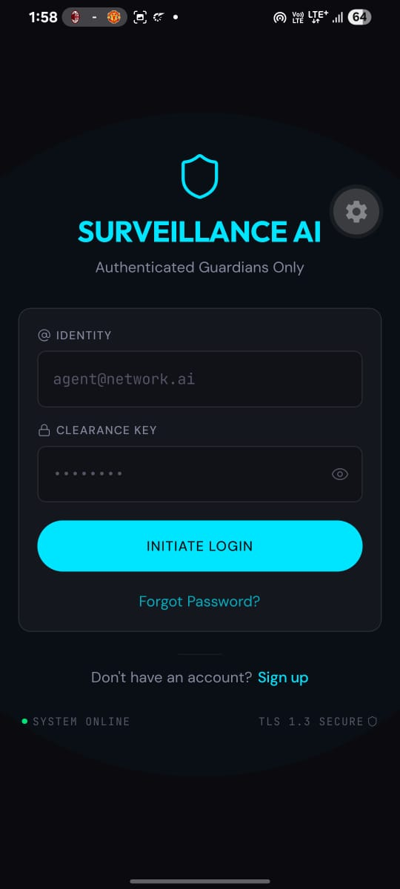

•Home (home.tsx). shows the single Start / Stop Surveillance control, an animated shield status indicator, the current risk badge, the most recent AI summary, a manual SOS button, and, where a permission has been denied, a degraded-mode banner.
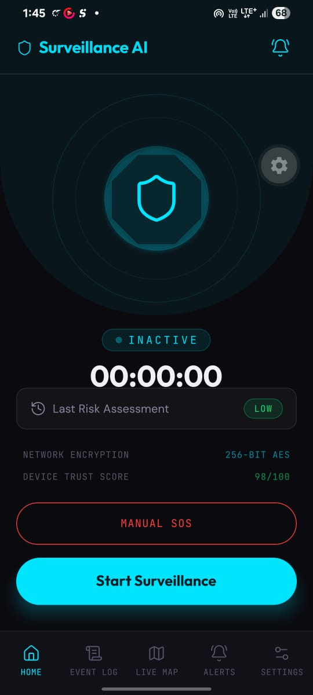
•Live (live.tsx). renders LiveMap.tsx, a WebView hosting a self-contained Leaflet page with dark CartoDB tiles, showing the user's current position, alongside the active risk badge and latest cycle summary.
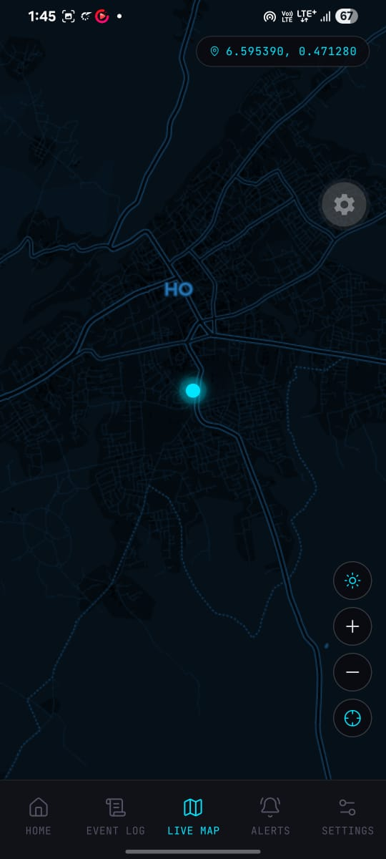
• Log (log.tsx). lists every event recorded during past and current sessions using EventCard.tsx, each showing a timestamp, risk badge, and AI summary; tapping a card opens ExpandedEventCard.tsx with the full report, photo, and transcript.
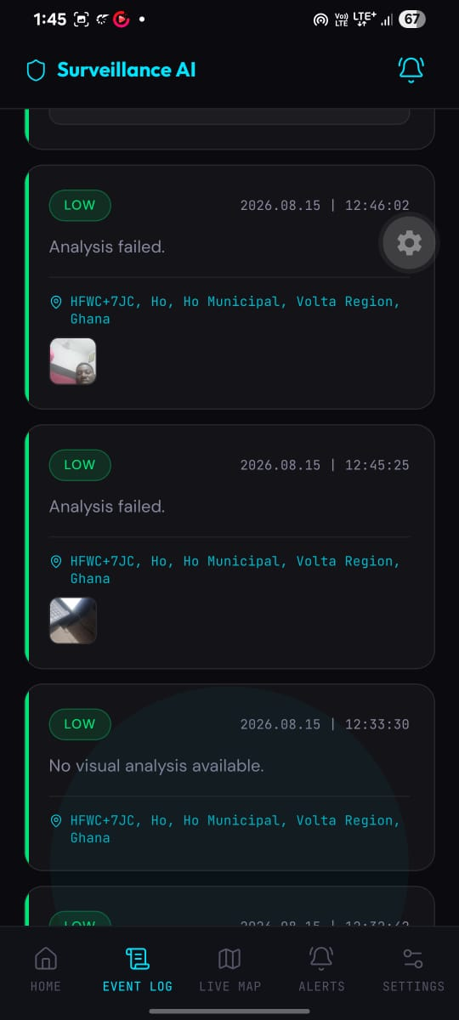
• Alerts (alerts.tsx). lists every High-risk event that triggered the alert pipeline using AlertCard.tsx, showing which channels (SMS, email, call) were sent, to whom, and what the AI detected.
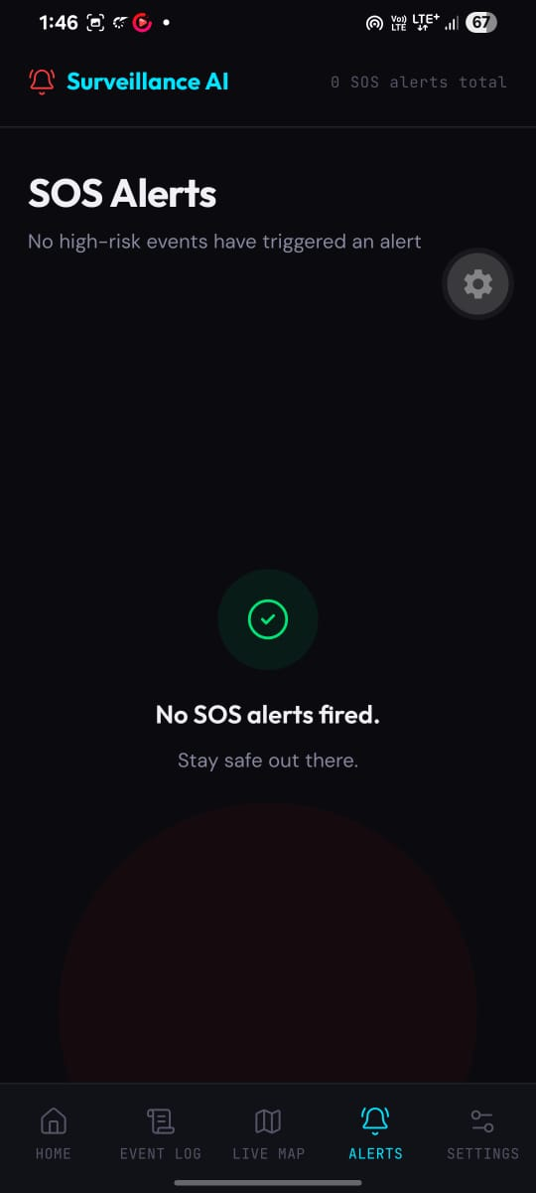
• Settings (settings.tsx). exposes the emergency contact fields, MonitoringIntervalPicker.tsx and ShakeSensitivityPicker.tsx, the stealth-mode and wellness check-in configuration, the user's current subscription plan and usage, and a sign-out control.
When stealth mode is enabled, StealthOverlay.tsx dims the screen to black immediately after a session starts, and a single tap wakes it for approximately three seconds before it fades back to black, so that the session continues to run without any UI visible to a bystander. Device screenshots of these screens are provided in Appendix B.
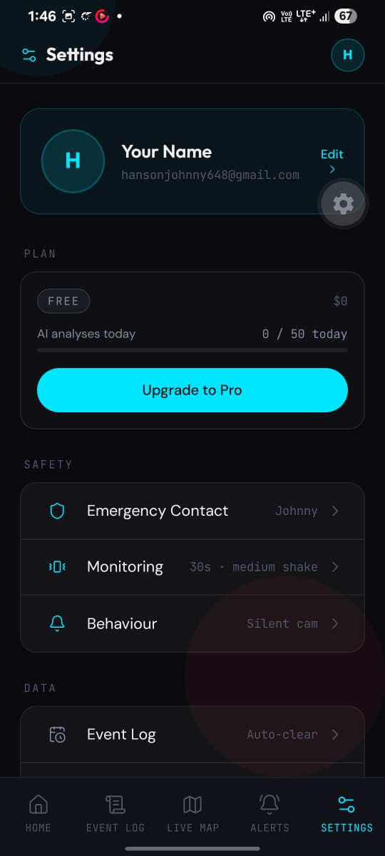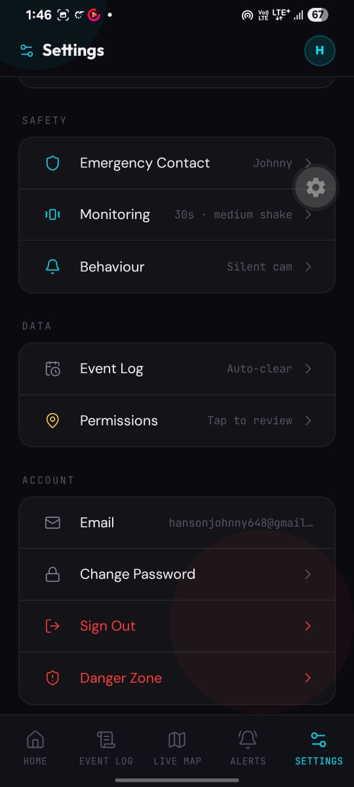

4.4 Testing of the New System
Because the system's most safety-critical behaviour, camera capture, microphone recording, accelerometer-based shake detection, background execution, and push notifications, cannot be exercised in a simulator, the system was tested manually on a physical Android device running the custom Expo Dev Client described in Section 4.1. Testing followed a black-box, scenario-based checklist covering every functional requirement in Section 3.2.1, summarised in Table 4.1.
Test Area | Test Case | Expected Result | Status
Authentication | Sign up, sign in, wrong-password handling, password reset via deep link | Account created/authenticated; invalid credentials rejected without crashing; reset link reopens app and updates password | Pass
Onboarding | Complete all 12 onboarding screens and enter emergency contact | Contact details persist and pre-fill Settings; onboarding does not replay after force-quit | Pass
Session Control | Tap Start Surveillance, then Stop Surveillance | Session record created/closed; timer runs; screen stays awake while active | Pass
Sensor Capture & AI Analysis | Run a session and observe the Event Log | Event appears immediately with placeholder summary, then updates with risk level, AI summary, and real GPS coordinates | Pass
Background Execution | Minimise the app and lock the screen during a session | Monitoring cycles continue; new events appear after reopening the app | Pass
Shake Detection | Shake the device firmly while a session is active | Immediate High-risk event logged with source "shake"; repeat shake within 5 seconds does not duplicate the alert | Pass
Medium-Risk Notification | Mock a medium-risk AI response | Local push notification delivered; no SMS or email sent | Pass
High-Risk Alert – Email | Mock a high-risk AI response with a contact configured | Full report email received via SendGrid with AI summary and GPS link | Pass
High-Risk Alert – SMS | Mock a high-risk AI response with a contact configured | SMS received via Twilio with GPS link and AI summary | Pending – Twilio credentials not yet provisioned
High-Risk Alert – Voice Call | Shake event combined with a High AI score | Automated Twilio voice call places to the emergency contact | Pending – Twilio credentials not yet provisioned
Alert Deduplication | Trigger High risk twice for the same event | Only one alert record is created; channels are not fired twice | Pass
Stealth Mode | Enable stealth mode and start a session | Screen fades to black; a single tap reveals the UI for ~3 seconds before dimming again | Pass
Wellness Check-In | Configure a check-in time and let it lapse without confirming | Emergency contact alerted after a 10-minute grace period; confirming "I'm Safe" cancels the alert | Pass
Live Map | Move the device during an active session | GPS marker on the Live screen updates to follow the device's real position | Pass
Settings Persistence | Change contact details, interval, and sensitivity, then force-quit | All changed values remain after reopening; the new interval is used on the next session | Pass
Degraded Mode | Deny camera and/or microphone permission | Amber banner shown; monitoring continues with the remaining sensors; app does not crash | Pass
Offline / Edge Cases | Start a session with no internet connection or revoked location permission | Cycles continue; events log a safe fallback summary; no alert fires; app does not crash | Pass
Usage Cap | Exceed the daily AI-analysis cap for the current plan | Further analyses are skipped once the cap is reached; usage count shown in Settings matches the enforced cap | Pass
Table 4.1: Manual functional test plan and results.
The only outstanding item at the time of writing is the Twilio-backed SMS and voice-call channels, which remain untested end-to-end because Twilio account credentials had not yet been provisioned in the deployment used for testing; the SendGrid email channel, which shares the same trigger logic and Edge Function pattern, was verified successfully, and the SMS and call channels are expected to behave identically once the corresponding secrets are configured.

4.5 Documentation
Alongside the source code, the project maintains a small set of living documents that record its conventions and behaviour rather than leaving them implicit in the code alone. AGENTS.md defines the project's technology stack, development philosophy, and feature-by-feature build rules and was consulted before implementing every feature described in this chapter. IMPLEMENTATION.md records the step-by-step build plan the system was developed against, design.md records the visual design language (colour, spacing, and typography) used across the interface, and TESTING.md is the manual test checklist summarised in Table 4.1. The codebase itself is documented at the point of use: monitoring.ts, for example, opens with a comment explaining that an event is logged immediately and patched asynchronously once analysis returns, and the SQL migrations under /supabase/migrations each carry a comment block explaining the purpose of the table or function they define. This report constitutes the final layer of documentation, describing the problem, design, and implementation of the system as a whole.

CHAPTER FIVE

CONCLUSION AND RECOMMENDATIONS

5.1 Conclusion
This project set out to address a specific gap identified in Chapters One and Two: existing personal-safety applications are reactive, requiring a user to consciously recognise danger and manually trigger an alarm, they convey little contextual information when they do fire, they offer only limited passive protection for dependents, and their pricing, quotas, and underlying models are fixed at build time. Surveillance AI was designed and implemented to close this gap by making protection passive rather than reactive. Once a session is started, the system continuously and autonomously captures GPS location, camera snapshots, ambient audio, and accelerometer data, and submits the camera and audio evidence to a multimodal artificial-intelligence pipeline built on OpenAI's GPT-4o and Whisper models, producing a Low, Medium, or High risk classification on every cycle without requiring the user to do anything after the initial tap.
The resulting system satisfies the functional and non-functional requirements set out in Chapter Three. A High-risk classification autonomously and simultaneously notifies a pre-configured emergency contact by SMS, email, and an automated voice call, each carrying the AI's summary and a GPS link rather than a bare distress signal, directly addressing the information-poverty problem identified in Chapter Two. Every user's data is protected by Row Level Security scoped to their own account, and every OpenAI, Twilio, and SendGrid credential is held only on the server, in a Supabase Edge Function, never on the client, satisfying the project's security objective. The three-tier plan model, together with an administrator capability to reassign a user's tier at runtime, demonstrates a concrete way in which a personal-safety product can remain configurable without a new application release, addressing the static-configuration problem identified in Chapter Two, although, as noted below, the full administrator control over pricing and quotas envisioned in Chapter One remains partly a matter for future work rather than a fully editable runtime configuration in the current build.
The manual functional test plan in Table 4.1 confirmed that authentication, onboarding, session control, sensor capture, AI risk analysis, background execution, shake detection, Medium-risk notifications, High-risk email alerts, alert deduplication, stealth mode, wellness check-ins, the live map, settings persistence, degraded-permission handling, and the daily usage cap all behave as designed. The one outstanding item, end-to-end verification of the Twilio-backed SMS and voice-call channels, was not yet completed because Twilio account credentials had not been provisioned in the deployment used for testing; the parallel SendGrid email channel, which shares the same trigger logic, was verified successfully, giving confidence that the SMS and call channels will behave identically once configured. The limitations noted in Chapter One remain: the accuracy of the risk assessment is bounded by the underlying multimodal model and by prompt design, as Driessen et al. (2024) caution, and the system's usefulness depends on continuous sensor access, network connectivity, battery life, and the user's informed consent to passive monitoring of their camera and microphone. Within these limitations, the project demonstrates that a real-time, multimodal artificial-intelligence pipeline can be embedded in a mobile application to convert a conventional reactive safety alarm into a passive, autonomous, and context-aware protection system.

5.2 Recommendations
The following recommendations are made for extending Surveillance AI beyond the scope of this project.
1. Complete Twilio provisioning. Provision live Twilio account credentials and repeat the High-risk SMS and voice-call test cases end to end, so that all three alert channels are verified rather than only the SendGrid email channel.
2. Build a true Guardian family-linking feature. The current Guardian tier is a higher-cap, shorter-interval subscription plan on a single account; a genuine multi-member guardian dashboard, in which one guardian account can view the status of several linked monitored users, was envisioned in Chapter One but was not implemented in this build and is recommended as the next major feature.
3. Implement geo-fencing. Add the optional geo-fence capability described in the project's early planning, so that a user leaving a defined safe area triggers a Medium-risk event independently of the AI analysis cycle.
4. Introduce automated testing. Testing in this project was entirely manual, using the checklist in Table 4.1, because the simulator cannot exercise camera, microphone, accelerometer, background execution, or push notifications; introducing unit and integration tests for the pure business logic in /lib (for example combineRisks, isCapReached, and the risk-combination pipeline) would reduce regression risk as the codebase grows.
5. Broaden administrator control. Extend the admin-users Edge Function beyond reassigning a user's existing plan tier so that an administrator can also edit each tier's price, daily cap, and minimum monitoring interval at runtime, fully realising the runtime-configurable administrative model described in Chapter One.
6. Extend iOS testing. Development and testing in this project were carried out primarily on Android; the same TypeScript codebase targets iOS through Expo, and a dedicated iOS testing pass, including Apple Sign-In, which becomes a legal requirement once any social login is offered, is recommended before any public release.
7. Add Google and Apple Sign-In. Email/password authentication was implemented for this project; social login was deferred by design and is recommended as a follow-on feature to reduce onboarding friction.

REFERENCES
Andrenacci, G. (2025). 18 artificial intelligence LLM trends in 2025. AI Bistrot (Medium). https://medium.com/data-bistrot/15-artificial-intelligence-llm-trends-in-2024-618a058c9fdf
AppMaster. (2023). How to develop a personal safety app like Noonlight or bSafe? AppMaster. https://appmaster.io/blog/developing-personal-safety-app
Banerjee, S., Maiti, P., & Biswas, S. (2024). Empowering personal safety through mobile apps. In S. Ponnusamy et al. (Eds.), AI Tools and Applications for Women’s Safety (pp. 91–120). IGI Global Scientific Publishing. https://doi.org/10.4018/979-8-3693-1435-7.ch006
Cadet, E., Osundare, O. S., Ekpobimi, H. O., Samira, Z., & Weldegeorgise, Y. W. (2024). AI-powered threat detection in surveillance systems: A real-time data processing framework. Open Access Research Journal of Engineering and Technology, 7(2), 31–45.
Dimension Market Research. (2026). Personal safety app market to surge from 1.7 billion in 2025 to 6.7 billion by 2034 as smartphone penetration and AI-powered threat detection reshape personal security. openPR. https://www.openpr.com/news/4506157
Driessen, T., Dodou, D., Bazilinskyy, P., & de Winter, J. (2024). Putting ChatGPT vision (GPT-4V) to the test: Risk perception in traffic images. Royal Society Open Science, 11(5), 231676. https://doi.org/10.1098/rsos.231676
Grokipedia. (2026). Personal safety app. Grokipedia. https://grokipedia.com/page/personal_safety_app
Hirano, Y., Miki, S., Yamagishi, Y., Hanaoka, S., Nakao, T., Kikuchi, T., Nakamura, Y., Nomura, Y., Yoshikawa, T., & Abe, O. (2025). Assessing accuracy and legitimacy of multimodal large language models on Japan Diagnostic Radiology Board Examination [Preprint]. medRxiv. https://doi.org/10.1101/2025.06.23.25329534
Localsinsider. (2026). App with personal safety features, SOS alerts, and live tracking: bSafe review and pricing. Localsinsider. https://localsinsider.com/apps/app-with-personal-safety-features-sos-alerts-and-live-tracking-bsafe-review-pricing/
ResQ. (2025). Best personal safety apps 2025. ResQ. https://resqjewelry.com/blogs/news/best-personal-safety-apps-2025
Risk Track. (2026). Top personal safety apps to stay safe anytime, anywhere. Risk Track. https://www.risktrack.co/personal-safety-apps
Sahraoui, I. (2025). Automated hazard detection in construction sites using large language and vision-language models [Preprint]. arXiv. https://arxiv.org/pdf/2511.15720
SilentSecurity. (2026). Best personal safety apps: What they do and don't do. SilentSecurity. https://www.silentsecurity.net/resources/best-personal-safety-apps/

APPENDIX

Appendix A – Project Plan
The table below presents the project plan in relative weeks rather than fixed calendar dates, reflecting the order in which the system was actually built: feature by feature, starting with the backend schema and authentication and ending with manual testing and report writing, as described in Section 4.1.
Phase | Duration | Activities | Deliverable
Phase 1 | Weeks 1–2 | Requirements gathering and literature review | Finalised problem statement, aim, and objectives (Chapter One/Two)
Phase 2 | Weeks 3–4 | System design | Functional/non-functional requirements, architecture, and database design (Chapter Three)
Phase 3 | Weeks 5–6 | Backend setup | Supabase project, PostgreSQL schema, Row Level Security policies, email/password authentication
Phase 4 | Weeks 7–8 | Core monitoring loop | GPS/camera/audio/accelerometer capture and the analyse-image / analyse-audio Edge Functions
Phase 5 | Weeks 9–10 | Alert pipeline and plan model | send-sms / send-email / make-call Edge Functions and the Free/Pro/Guardian plan and admin model
Phase 6 | Weeks 11–12 | Main interface screens | Onboarding, Home, Live, Log, Alerts, and Settings screens
Phase 7 | Week 13 | Testing and bug-fixing | Manual functional test plan and results (Table 4.1)
Phase 8 | Week 14 | Documentation and defence preparation | Final report, diagrams, and defence slides
Table A.1: Project plan by development phase.

Appendix B – User Interfaces (more)
Section 4.3 describes the five main tab screens and stealth mode. The additional screens and states listed below are recommended for inclusion here as device screenshots, captured directly from the running application on a physical phone rather than reproduced from design mockups, so that this appendix reflects the actual delivered interface:
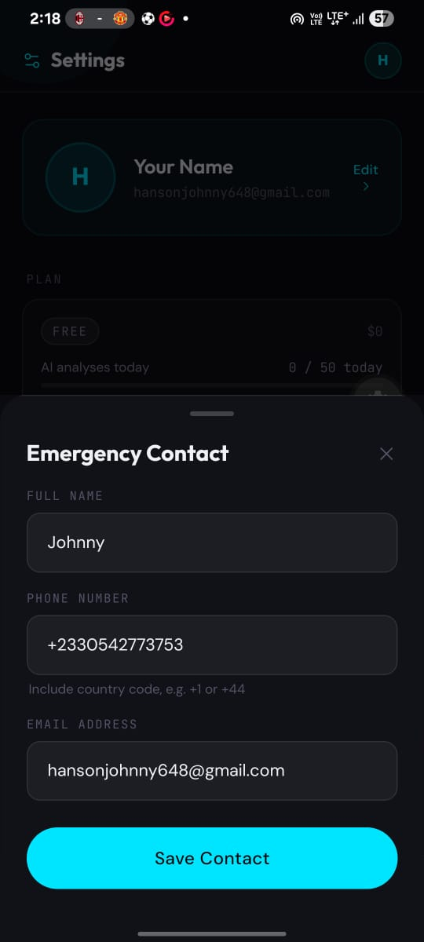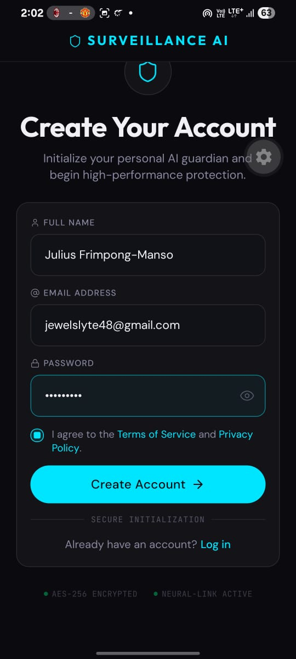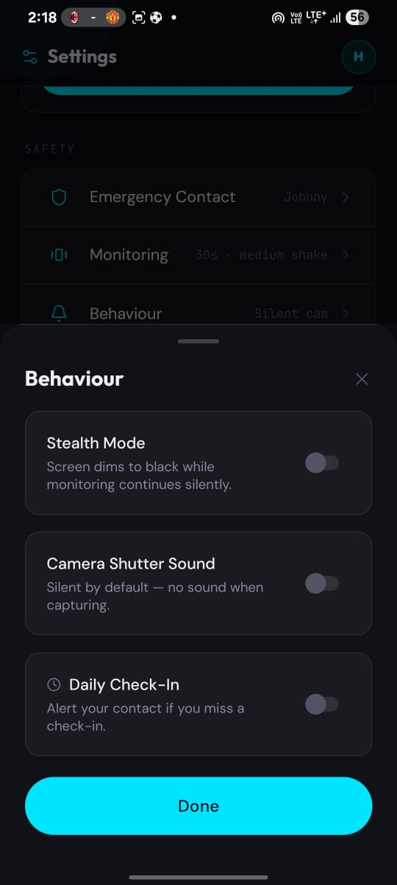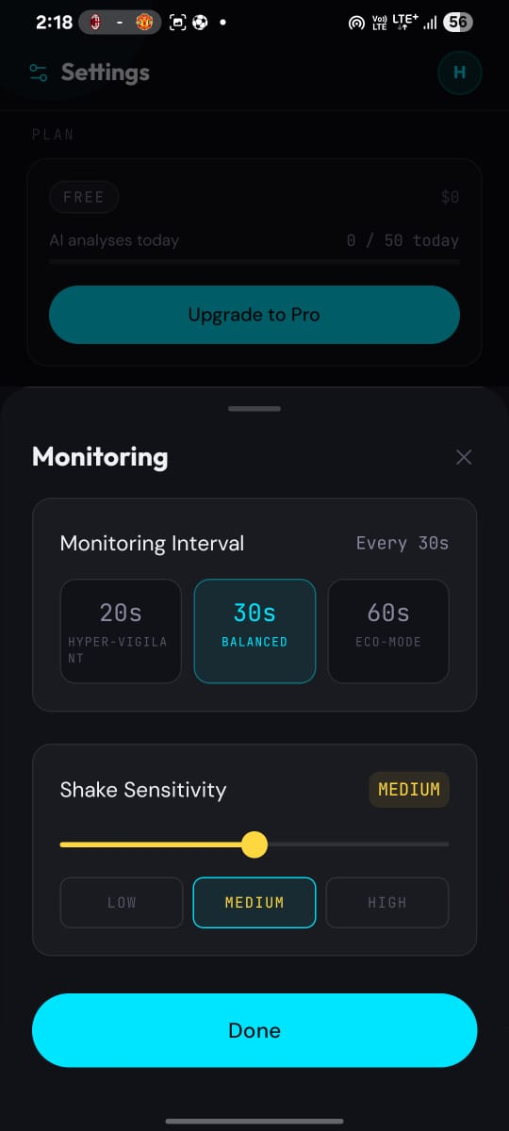

Appendix C – User Documentation (Guide)
This appendix is a short guide to using Surveillance AI, written for a first-time user of the completed application.
1. Create an account. Open the app and tap Sign Up on the landing screen, enter an email address and password, and submit the form. Existing users tap Sign In instead; a Forgot Password link is available if the password is not remembered.
2. Complete onboarding. On first sign-in, the app asks a short series of questions about when and who you want protection for, then asks for your primary safety concern before collecting your emergency contact's name, phone number, and email address. It then asks you to choose a monitoring interval, shake sensitivity, and whether to enable stealth mode.
3. Grant permissions. The app requests Camera, Microphone, Location (Always), and Notifications permission one at a time, each with a short explanation of why it is needed. All four should be allowed for full protection; declining camera or microphone still allows the app to run in a degraded mode using the remaining sensors.
4. Start a session. From the Home screen, tap Start Surveillance. The shield indicator becomes active and a timer begins counting. The app will now capture your location, take periodic photos, listen to your surroundings, and watch for sudden impacts, without any further action from you.
5. Understand the risk badge. The Home and Live screens show a risk badge: green for Low, amber for Medium, and red for High. A Medium result sends you a push notification only. A High result, or a detected impact, automatically contacts your emergency contact by SMS, email, and phone call.
6. Check the Live map. Open the Live tab to see your current position on the map, along with the risk level and summary from the most recent monitoring cycle.
7. Review the Event Log. Open the Log tab to see every past monitoring cycle. Tap any entry to see its full AI summary, photo, and audio transcript where available.
8. Review Alerts. Open the Alerts tab to see a history of every High-risk event that contacted your emergency contact, including which channels were sent and when.
9. Stop a session. Tap Stop Surveillance on the Home screen at any time to immediately end monitoring.
10. Use stealth mode. If stealth mode is enabled in Settings, the screen fades to black as soon as a session starts. Tap anywhere on the black screen to reveal the interface for a few seconds; the session keeps running in the background the entire time.
11. Respond to a wellness check-in. If a check-in time is configured in Settings, the app sends a notification at that time. Tap the notification and confirm you are safe within ten minutes, or your emergency contact will be alerted automatically.
12. Update Settings. Open the Settings tab at any time to change your emergency contact, monitoring interval, shake sensitivity, stealth mode, or wellness check-in time, and to sign out.
13. Troubleshooting. If a banner appears saying camera or microphone is disabled, open your phone's system settings and re-enable the permission for the app. If the daily analysis limit for your plan is reached, the Settings screen shows your current usage; upgrading your plan raises the limit.

