Project Plan

Moodle+

NJIT

Table of Contents
1. Introduction 3
1.1 Foreword 3
1.2 Background 3
2. Project Organization 4
2.1 Development Model 4
2.2 Project Team 4
3. Risk Analysis 5
4. Hardware and Software Requirements 6
5. Schedule and Breakdown Structure 6

1. Introduction

1.1 Foreword
The purpose of this document is to provide information about the Moodle+ project. It will include the project schedules, risks, project team, and the work break down structure. This plan will:
- Provide a general product description.
- Identify required resources.
- Identify schedules and activities to be performed.

1.2 Background
The Moodle+ app is a Learning Management System (LMS) provided to NJIT professors and students. It resembles NJIT’s current LMS but Moodle+ provides a greater interface and a responsive feel to the user.
Features involve:
- Add/Drop students in class
- Message and event notifications
- Add and view assignments, projects and grades
- Provide information about students and professors

2. Project Organization

2.1 Development Model

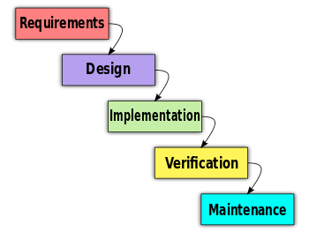

2.2 Project Team
The table below lists the members of the Moodle+ project team. The project Team consists of:
Project Team
Keith Williams (Project Instructor)
Hans Marcelino (Developer)
Maximilian C Kung (Developer)
Michael Rogowski (Developer)

3. Risk Analysis

3.1 Risk Analysis
Risk | Affects | Descriptions
Working on a new or unfamiliar language | Time | The team has to learn programming in JavaScript, JQuery, HTML5, CSS.
App may not be finished by due date | Grade | Dealing with other classes on top of the app project.
Meet professor’s expectations | Grade | The app’s ideas is based from the project instructor.
Distributing tasks evenly among team members | Individual performance | Each team member may not be comfortable programming.

3.2 Risk Analysis (i)
Risk | Probability | Effects
Working on a new or unfamiliar language | 60% | Slower development
App may not be finished by due date | 30% | Lower grade
Meet professor’s expectations | 10% | Lower grade
Distributing tasks evenly among team members | 80% | Poor team work

3.2 Risk Analysis Strategy
Risk | Solution / Mitigation
Working on a new or unfamiliar language | Learn from websites such as Lynda.com, w3schools, etc.
App may not be finished by due date | Set more due dates as a group
Meet professor’s expectations | Constant communication with professor about app’s performance
Distributing tasks evenly among team members | Keep track of who’s doing what in GitHub

4. Hardware and Software Requirements
- OS: Windows XP, Vista, 7 or Apple OS X
- Smart phone or tablet
- Script editor

5. Schedule and Work Breakdown Structure
< MS Project file and/or Gantt chart>

