ICS3 Software Design Hans Sun

Program Name:
Factorio Defense

Explain how your game will work. Do not assume that I have played your game. Be sure to describe how all input will be received and all output will be displayed.
“Factorio Defense” is intended to be an RTS-style, Tower Defense-style resource-management game, inspired by Factorio.
In this game, one balances furthering production so that they can escape the hostile planet they’re on on a spaceship with producing military buildings to keep the hostile aliens at bay.
In this game, the map is displayed as a grid; the player can see where his turrets, walls etc. are located and how they fend off the aliens. The main driving force behind the game, the allocation of production, is controlled by a slider on a sidebar on the right hand side. New buildings can be placed by dragging the corresponding icon on the sidebar onto the desired placement on the map, should the building be available.

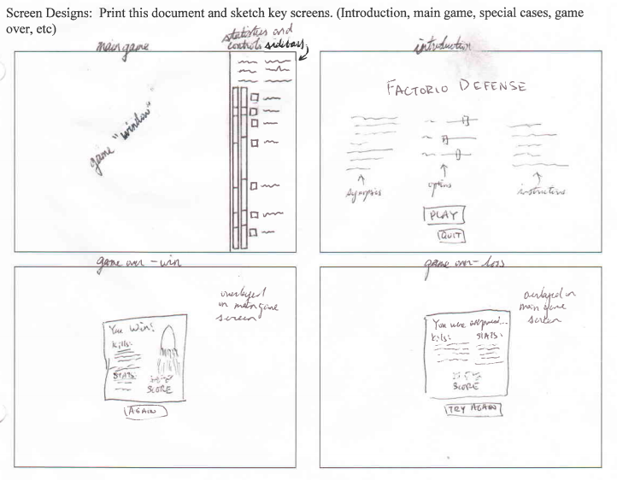
ICS3CU Software Design Hans Sun

Data Structures Used:

Arrays: map (int), metamap (int)
enemies (enemy class), projectiles (projectile class), turrets (turret class)
stats (real
various information arrays which map enemy/projectile/turret IDs to their properties
Strings: token-oriented read-from-file

Files Used:
data.txt – all the data in the game point.t – vector arithmetic
Main.t – main program projectile.t – projectile class
test.t – for testing enemy.t – enemy class
globals.t – global variables and definitions turret.t – turret class
includes.t – include order intrastructure.t – infrastructure of the game
class_vars.t – class arrays and its handling interface.t – handles the interface

Predefined OOT Units Used:

Pic

Main Program Steps:

- Load things
- Display menu screen
  - When user presses [begin], advance
- Initialize game
- Tick
  - Check for input
  - Update all turrets
  - Update all enemies
  - Update all projectiles
  - Update all stats
  - Check for win-condition or for lose-condition
    - If yes, exit
  - Loop
- Display game-over screen
- Ask for replay
  - If [yes], goto 3
  - If [no], exit

