* * * * * * * * * * * 学 号： 姓 名： * * * * * * * * * * * * * * * * * * * * * * * * * * * * * * * * * * * * * * * * * * * * 学 院： 专业年级： * * * * * * * * * * * * * * * * * * * * * * * * * * * * * * * * * * * * * * * * * * * * * * * * * * * * * * * * * *
The paper of course exam

Name： | Big Data Analysis and Applications
Content： | Course Report （Class assignments、thesis、report ）
Institution： |  | Teacher： | Li Jie
Grade and major：

Teacher’s comments | Total score | Grading teacher

…………………………………………………………………………………………………

Digital Lifestyle Analysis: High-Risk Screening, Digital Dependence Prediction, and Lifestyle Profile Clustering

1. Analysis Goals and Tasks

1.1 Background
This report analyzes digital lifestyle patterns through a complete course-level data analysis workflow.
1) The dataset records device use, notifications, social media time, study time, sleep, and physical activity.
2) These variables describe daily digital behavior and lifestyle habits.
3) The report uses statistics, visualization, and machine learning to turn these records into interpretable results.
The whole report focuses on three connected tasks.
1) High Risk screening is used as the classification task.
2) digital_dependence_score prediction is used as the main regression task.
3) Lifestyle profile clustering is used as the unsupervised profiling task.

1.2 Key Questions
This section defines the questions that the later experiments answer.
1) Can High Risk samples be screened from behavior and lifestyle features?
2) Can digital_dependence_score be predicted from digital behavior and lifestyle variables?
3) Can productivity_score be tested as a weak-prediction target?
4) Can clustering summarize samples into readable digital lifestyle profiles?

1.3 Analysis Tasks
The three tasks are connected by the same dataset and preprocessing logic.
1) Classification answers whether High Risk samples can be screened.
2) Regression answers which score can be predicted well and which score cannot.
3) Clustering answers whether behavior patterns can be summarized into lifestyle profiles.
These tasks are not separate experiments. Together, they show how one digital lifestyle dataset can support risk screening, score prediction, and exploratory profile analysis.

2. Dataset and Task Support

2.1 Dataset Source
This dataset is suitable because it supports the complete report workflow in one digital lifestyle scenario.
1) The dataset is the 2025 Digital Lifestyle Benchmark Dataset.
2) It is a public structured CSV dataset.
3) It contains 3,500 records and 24 fields.
4) It supports classification, regression, clustering, preprocessing evidence, and visualization.

This means the dataset is not only a file for model training. It can support the whole process from raw data inspection to final result interpretation.

2.2 Raw Data Preview
The raw data preview is used as evidence that the analysis starts from the original CSV structure.
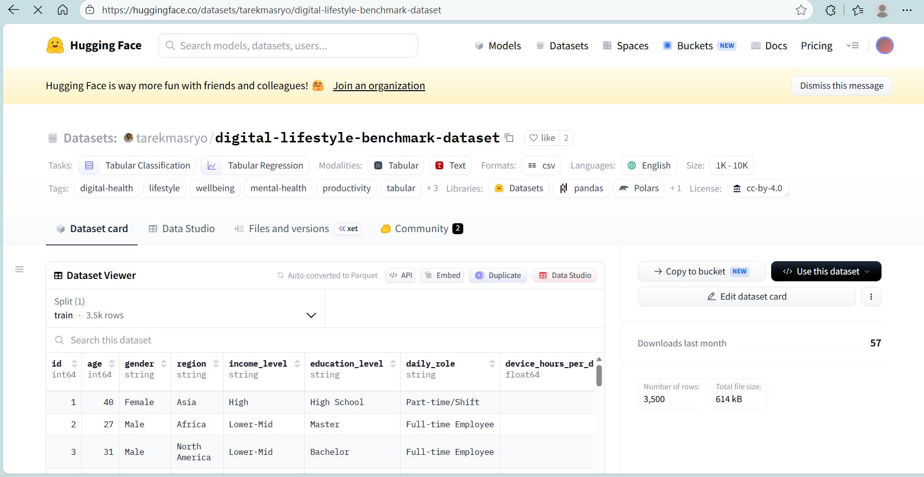
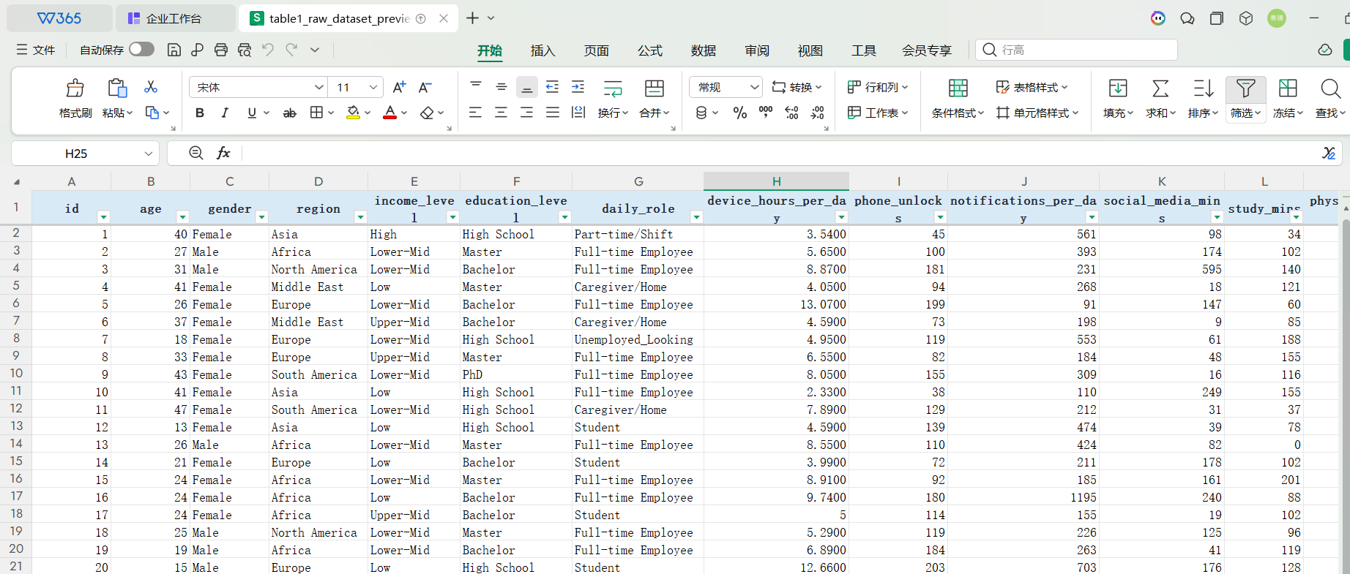
Table1 Raw Dataset Preview
Summary: This table shows what the original dataset looks like before preprocessing.
1) Purpose: It records original columns, sample rows, and example values.
2) Observation: The raw data includes behavior variables, lifestyle variables, and target variables.
3) Meaning: The original table can support later cleaning, feature engineering, visualization, classification, regression, and clustering.

2.3 Field Structure
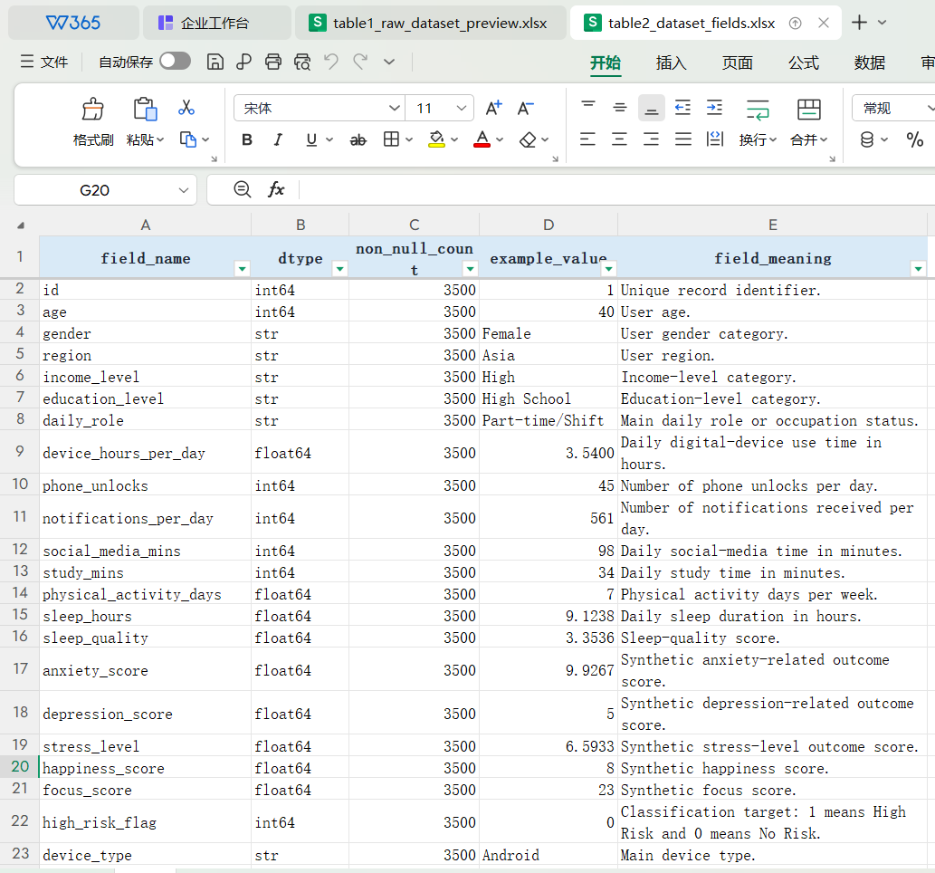
Table2 Dataset Fields
Summary: This table explains the name, type, example value, and meaning of each field.
1) Purpose: It helps identify behavior variables, lifestyle variables, background variables, and target variables.
2) Observation: Important target variables include high_risk_flag, digital_dependence_score, and productivity_score.
3) Meaning: The dataset supports several tasks, but outcome-style variables must be controlled before modeling to reduce target leakage.

2.4 Task Support
The task design is direct and matches the dataset fields.
1) high_risk_flag is used for High Risk classification.
2) digital_dependence_score is used as the main regression target.
3) productivity_score is kept as a weak-prediction target.
4) Behavior and lifestyle numerical features are used for clustering.
This dataset therefore fits the course requirement for a structured report with preprocessing, visualization, modeling, evaluation, and interpretation.

3. Data Cleaning and Feature Engineering
This section turns the raw CSV into a clean and leakage-controlled modeling table.
1) Data-quality checks confirm that all 3,500 records can be kept.
2) Feature engineering adds seven behavior-intensity features.
3) Leakage control prepares separate input feature sets for classification, regression, and clustering.

3.1 Data Loading
This step confirms that the raw dataset is loaded correctly.
1) Input: The original CSV file.
2) Check: Dataset shape, column names, data types, and preview rows.
3) Result: The dataset has 3,500 rows and 24 fields.
4) Meaning: The preprocessing starts from the original raw table.
from pathlib import Path
import pandas as pd

PROJECT_ROOT = Path.cwd() / "期末考查报告_数字生活方式分析"
raw_path = PROJECT_ROOT / "data" / "raw" / "digital_lifestyle_benchmark_2025.csv"

df = pd.read_csv(raw_path)

print("Shape:", df.shape)
print("Columns:", df.columns.tolist())
print("Data types:")
print(df.dtypes)
print(df.head())
Explanation: This code verifies the input data before any cleaning or modeling.
1) It reads the raw CSV file.
2) It checks the dataset shape and field types.
3) It prints preview rows to confirm that the file is loaded correctly.
4) This step supports the dataset description in Section 2.

3.2 Missing and Duplicate Check
This step checks whether any records should be removed before modeling.
1) Missing values = 0.
2) Duplicate rows = 0.
3) Duplicate id values = 0.
4) All 3,500 records are kept.
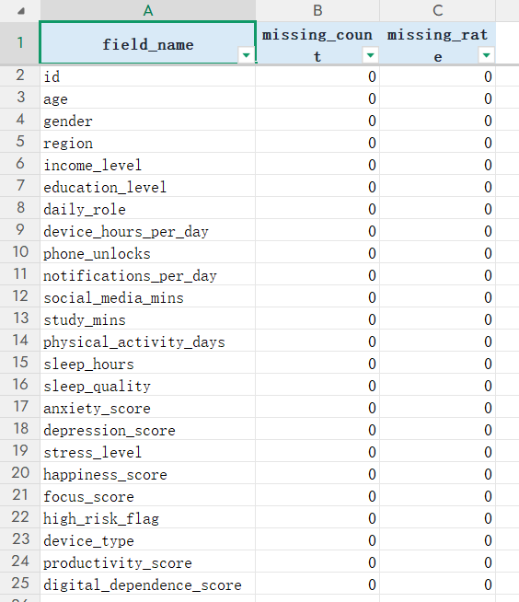
Table3 Missing Value Check
Summary: This table records missing-value evidence.
1) Purpose: Check missing counts and missing rates for all fields.
2) Observation: All fields have 0 missing values.
3) Meaning: No sample is removed because of missing data.
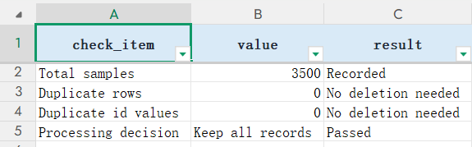
Table4 Duplicate Check
Summary: This table records duplicate-check evidence.
1) Purpose: Check repeated rows and repeated ids.
2) Observation: Duplicate rows and duplicate ids are both 0.
3) Meaning: The full dataset can be kept for later analysis.
key_numeric = [
"age", "device_hours_per_day", "phone_unlocks",
"notifications_per_day", "social_media_mins", "study_mins",
"sleep_hours", "sleep_quality", "productivity_score",
"digital_dependence_score",
]

missing_summary = df.isna().sum().reset_index()
missing_summary.columns = ["field_name", "missing_count"]

duplicate_rows = df.duplicated().sum()
duplicate_id = df["id"].duplicated().sum()
range_summary = df[key_numeric].agg(["min", "max", "mean"]).T

print(missing_summary)
print("Duplicate rows:", duplicate_rows)
print("Duplicate id:", duplicate_id)
print(range_summary)

Explanation: This code provides the basic data-quality evidence.
1) It counts missing values.
2) It counts duplicate rows and duplicate ids.
3) It summarizes key numeric ranges.
4) It supports the decision to keep all records.

3.3 Range Check
This step checks whether key numerical fields stay within reasonable ranges.
1) The checked fields include age, device_hours_per_day, phone_unlocks, notifications_per_day, social_media_mins, study_mins, sleep_hours, sleep_quality, productivity_score, and digital_dependence_score.
2) The goal is not to make the data look perfect.
3) The goal is to confirm that the main numerical values are usable.
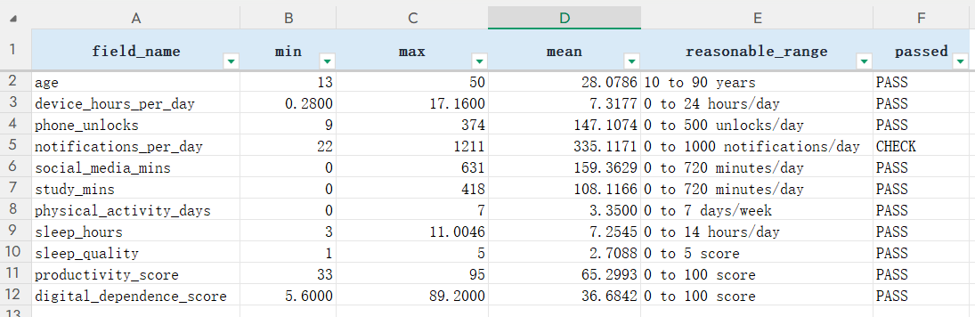
Table5 Range and Rationality Check
Summary: This table records the rationality check of key numerical fields.
1) Purpose: Show min, max, mean, reasonable range, and pass status.
2) Observation: The checked variables stay within expected ranges.
3) Meaning: No serious abnormal value requires record deletion.

3.4 Feature Engineering
This step converts raw time and count variables into behavior-intensity features.
1) social_media_hours and study_hours make time variables easier to interpret.
2) notifications_per_device_hour and unlocks_per_device_hour describe behavior intensity.
3) device_to_sleep_ratio describes the balance between device use and sleep.
4) activity_sleep_interaction combines physical activity and sleep.
5) social_to_study_ratio compares social media time with study time.
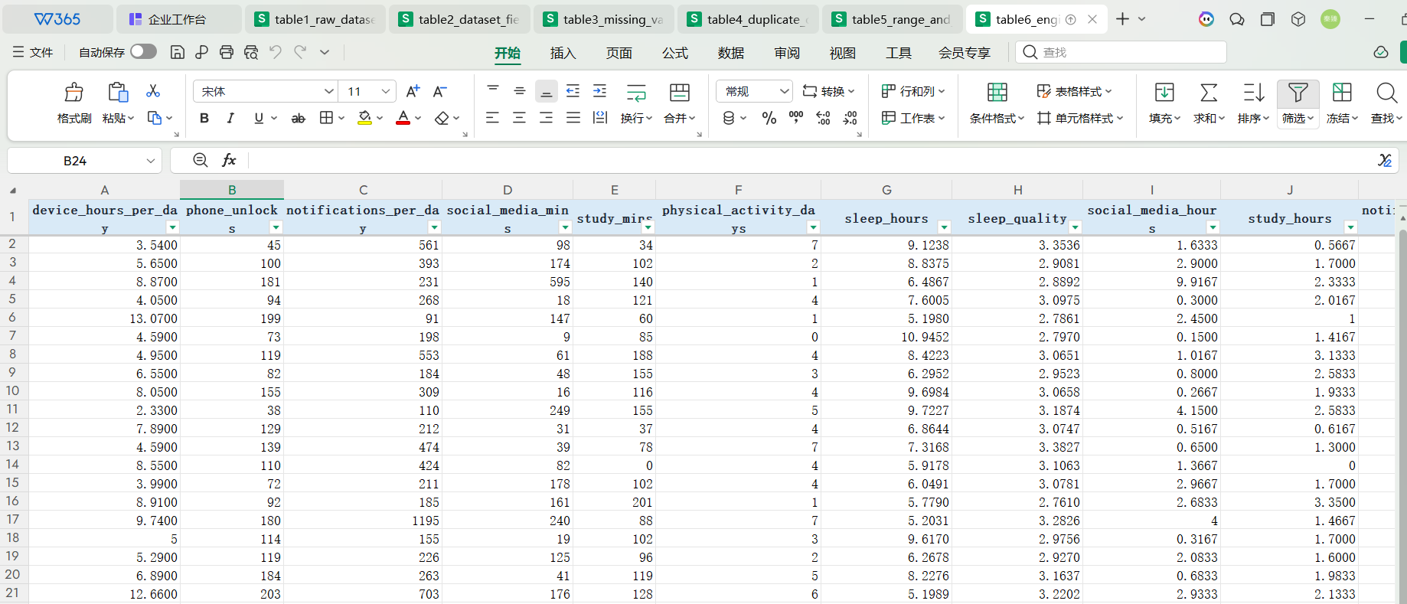
Table6 Engineered Features Preview
Summary: This table shows that the engineered features have been generated.
1) Purpose: Show new features beside key original variables.
2) Observation: Raw minutes and counts are transformed into ratios and interaction terms.
3) Meaning: Later models can use behavior intensity instead of only raw counts.
engineered = df.copy()
eps = 1e-6

engineered["social_media_hours"] = engineered["social_media_mins"] / 60.0
engineered["study_hours"] = engineered["study_mins"] / 60.0
engineered["notifications_per_device_hour"] = (
engineered["notifications_per_day"] / engineered["device_hours_per_day"].clip(lower=eps)
)
engineered["unlocks_per_device_hour"] = (
engineered["phone_unlocks"] / engineered["device_hours_per_day"].clip(lower=eps)
)
engineered["device_to_sleep_ratio"] = (
engineered["device_hours_per_day"] / engineered["sleep_hours"].clip(lower=eps)
)
engineered["activity_sleep_interaction"] = (
engineered["physical_activity_days"] * engineered["sleep_hours"]
)
engineered["social_to_study_ratio"] = engineered["social_media_mins"] / (
engineered["study_mins"] + 1.0
)
Explanation: This code creates seven engineered features from the original columns.
1) It converts minutes into hours.
2) It creates ratio features for intensity and balance.
3) It creates an interaction feature for activity and sleep.
4) These features are used later in classification, regression, and clustering.

3.5 Leakage Control
This is the most important preprocessing step before modeling.
1) For high_risk_flag classification, outcome-style variables are removed from the input.
2) Removed variables include digital_dependence_score, productivity_score, anxiety_score, depression_score, stress_level, happiness_score, focus_score, id, and high_risk_flag itself.
3) This prevents the classifier from learning target-related outcome information directly.
4) For regression, feature selection is target-specific.
5) For clustering, only behavior and lifestyle numerical features are used as inputs.
6) This keeps each modeling task connected to suitable evidence instead of leaked targets.
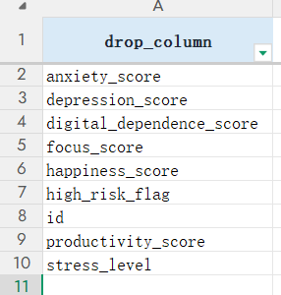
Table7 Feature Selection and Leakage Control
Summary: This table records the input-feature design for different tasks.
1) Purpose: Show dropped columns and retained features.
2) Observation: Classification, regression, and clustering use different input rules.
3) Meaning: The modeling results are more credible because each task uses suitable features.
outcome_cols = [
"anxiety_score", "depression_score", "stress_level",
"happiness_score", "focus_score", "high_risk_flag",
"productivity_score", "digital_dependence_score",
]
classification_drop = [
"id", "high_risk_flag", "anxiety_score", "depression_score",
"stress_level", "happiness_score", "focus_score",
"productivity_score", "digital_dependence_score",
]

def regression_drop_for(target):
drop_cols = {"id", target}
drop_cols.update(outcome_cols)
if target == "digital_dependence_score":
drop_cols.add("productivity_score")
if target == "productivity_score":
drop_cols.add("digital_dependence_score")
return sorted(drop_cols)

clustering_features = [
"device_hours_per_day", "phone_unlocks", "notifications_per_day",
"social_media_mins", "study_mins", "physical_activity_days",
"sleep_hours", "sleep_quality", "social_media_hours", "study_hours",
"notifications_per_device_hour", "unlocks_per_device_hour",
"device_to_sleep_ratio", "activity_sleep_interaction", "social_to_study_ratio",
]

digital_dependence_drop = regression_drop_for("digital_dependence_score")
productivity_drop = regression_drop_for("productivity_score")
Explanation: This code defines task-specific feature sets.
1) It removes leakage columns for classification.
2) It removes target-related variables for each regression target.
3) It keeps only behavior and lifestyle numerical features for clustering.
4) This supports fairer model evaluation and clearer interpretation.

3.6 PCA and GMM Extension
This step adds dimensionality-reduction and probabilistic clustering evidence.
1) PCA is used for structure understanding, not for classification or regression input.
2) The first two principal components explain about 42.41% of the total variance.
3) This means a two-dimensional view captures only part of the high-dimensional structure.
4) Because the clustering inputs are mainly continuous variables, GaussianMixture is used as a probabilistic clustering comparison instead of a separate LCA model.
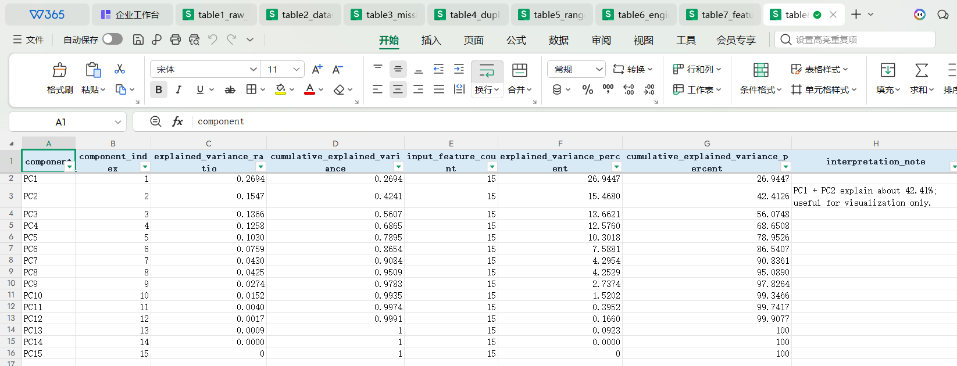
Table8 PCA Explained Variance
Summary: This table records PCA explained-variance evidence.
1) Purpose: Show explained variance and cumulative variance.
2) Observation: PC1 and PC2 explain about 42.41% of total variance.
3) Meaning: PCA is useful as auxiliary evidence, but the final models still use task-specific feature sets.
Section summary: After preprocessing, all 3,500 records are kept, seven engineered features are added, and leakage-controlled feature sets are prepared for classification, regression, and clustering.

4. Statistics and Visualization
This section explains the dataset before modeling.
1) Descriptive statistics show basic numerical characteristics.
2) Visualizations show target balance, feature distributions, correlations, and group differences.
3) These findings explain why later modeling uses Recall, PR-AUC, regression metrics, scaling, and clustering metrics.
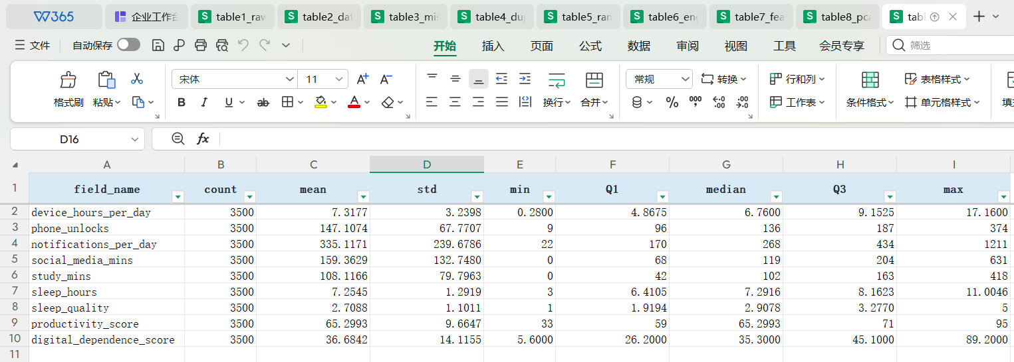
Table9 Descriptive Statistical Summary
Summary: This table gives the mathematical summary before visual analysis.
1) Purpose: Show count, mean, standard deviation, min, quartiles, and max.
2) Observation: Core variables have different ranges and scales.
3) Meaning: Scaling is needed before PCA and clustering.

4.1 Target Distribution
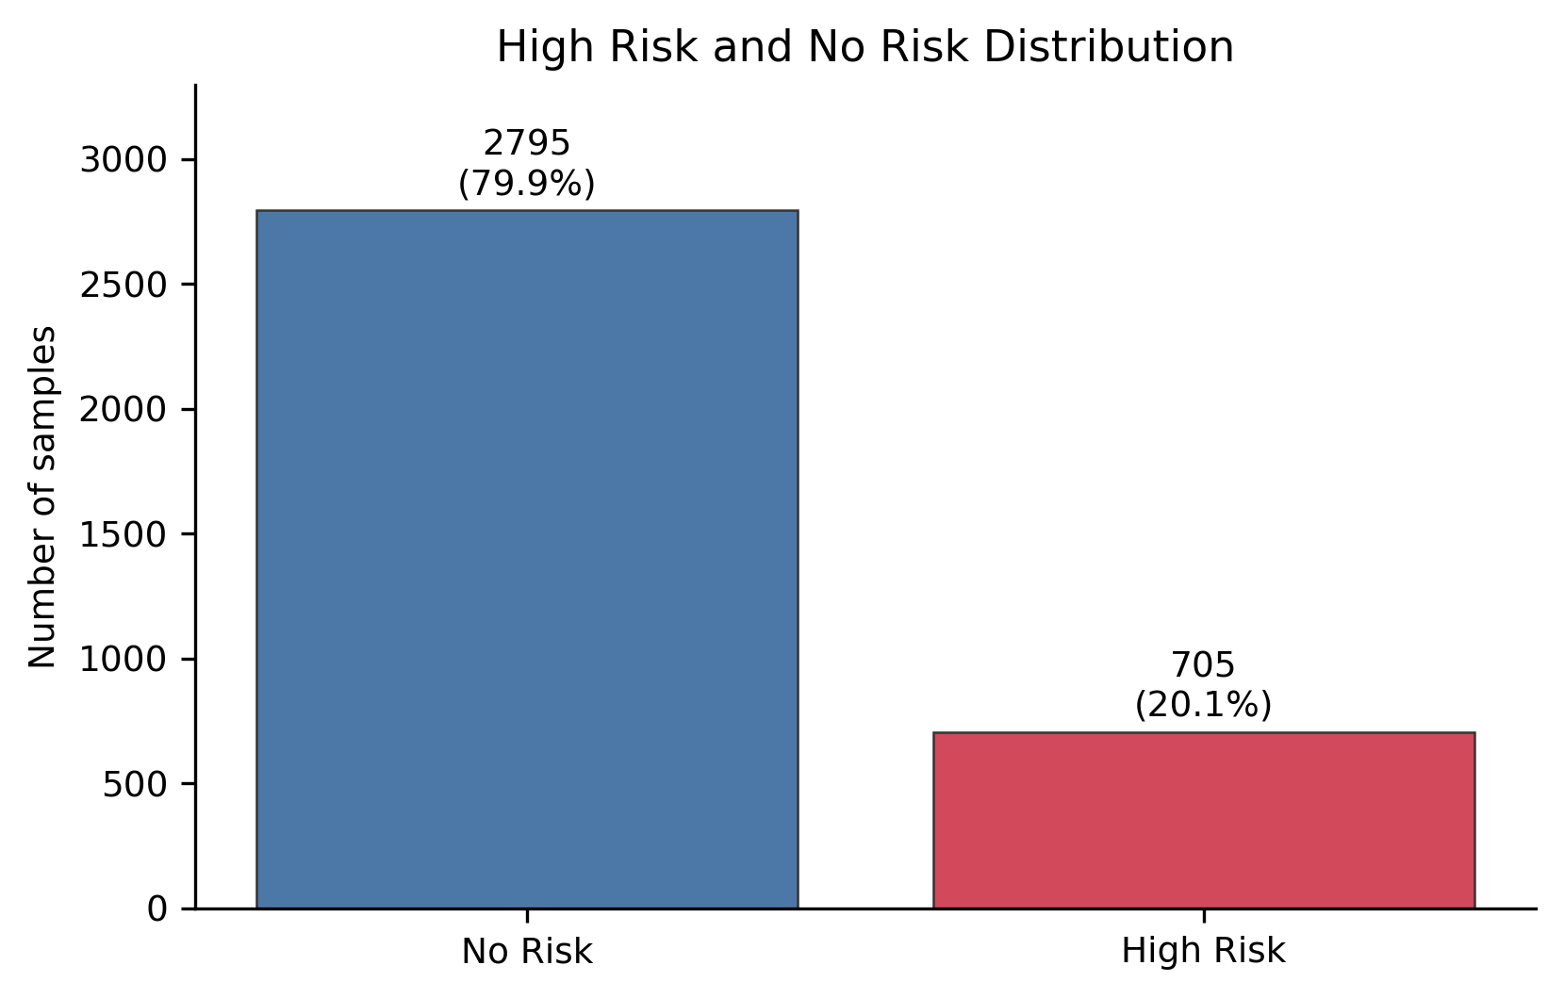
Fig1 High Risk vs No Risk Sample Structure
Summary: This figure explains the classification target distribution.
1) Purpose: Check whether High Risk and No Risk samples are balanced.
2) Observation: The No Risk group is larger than the High Risk group.
3) Meaning: Classification should focus on Recall, F1, PR-AUC, and confusion matrix instead of Accuracy alone.

4.2 Feature Distributions
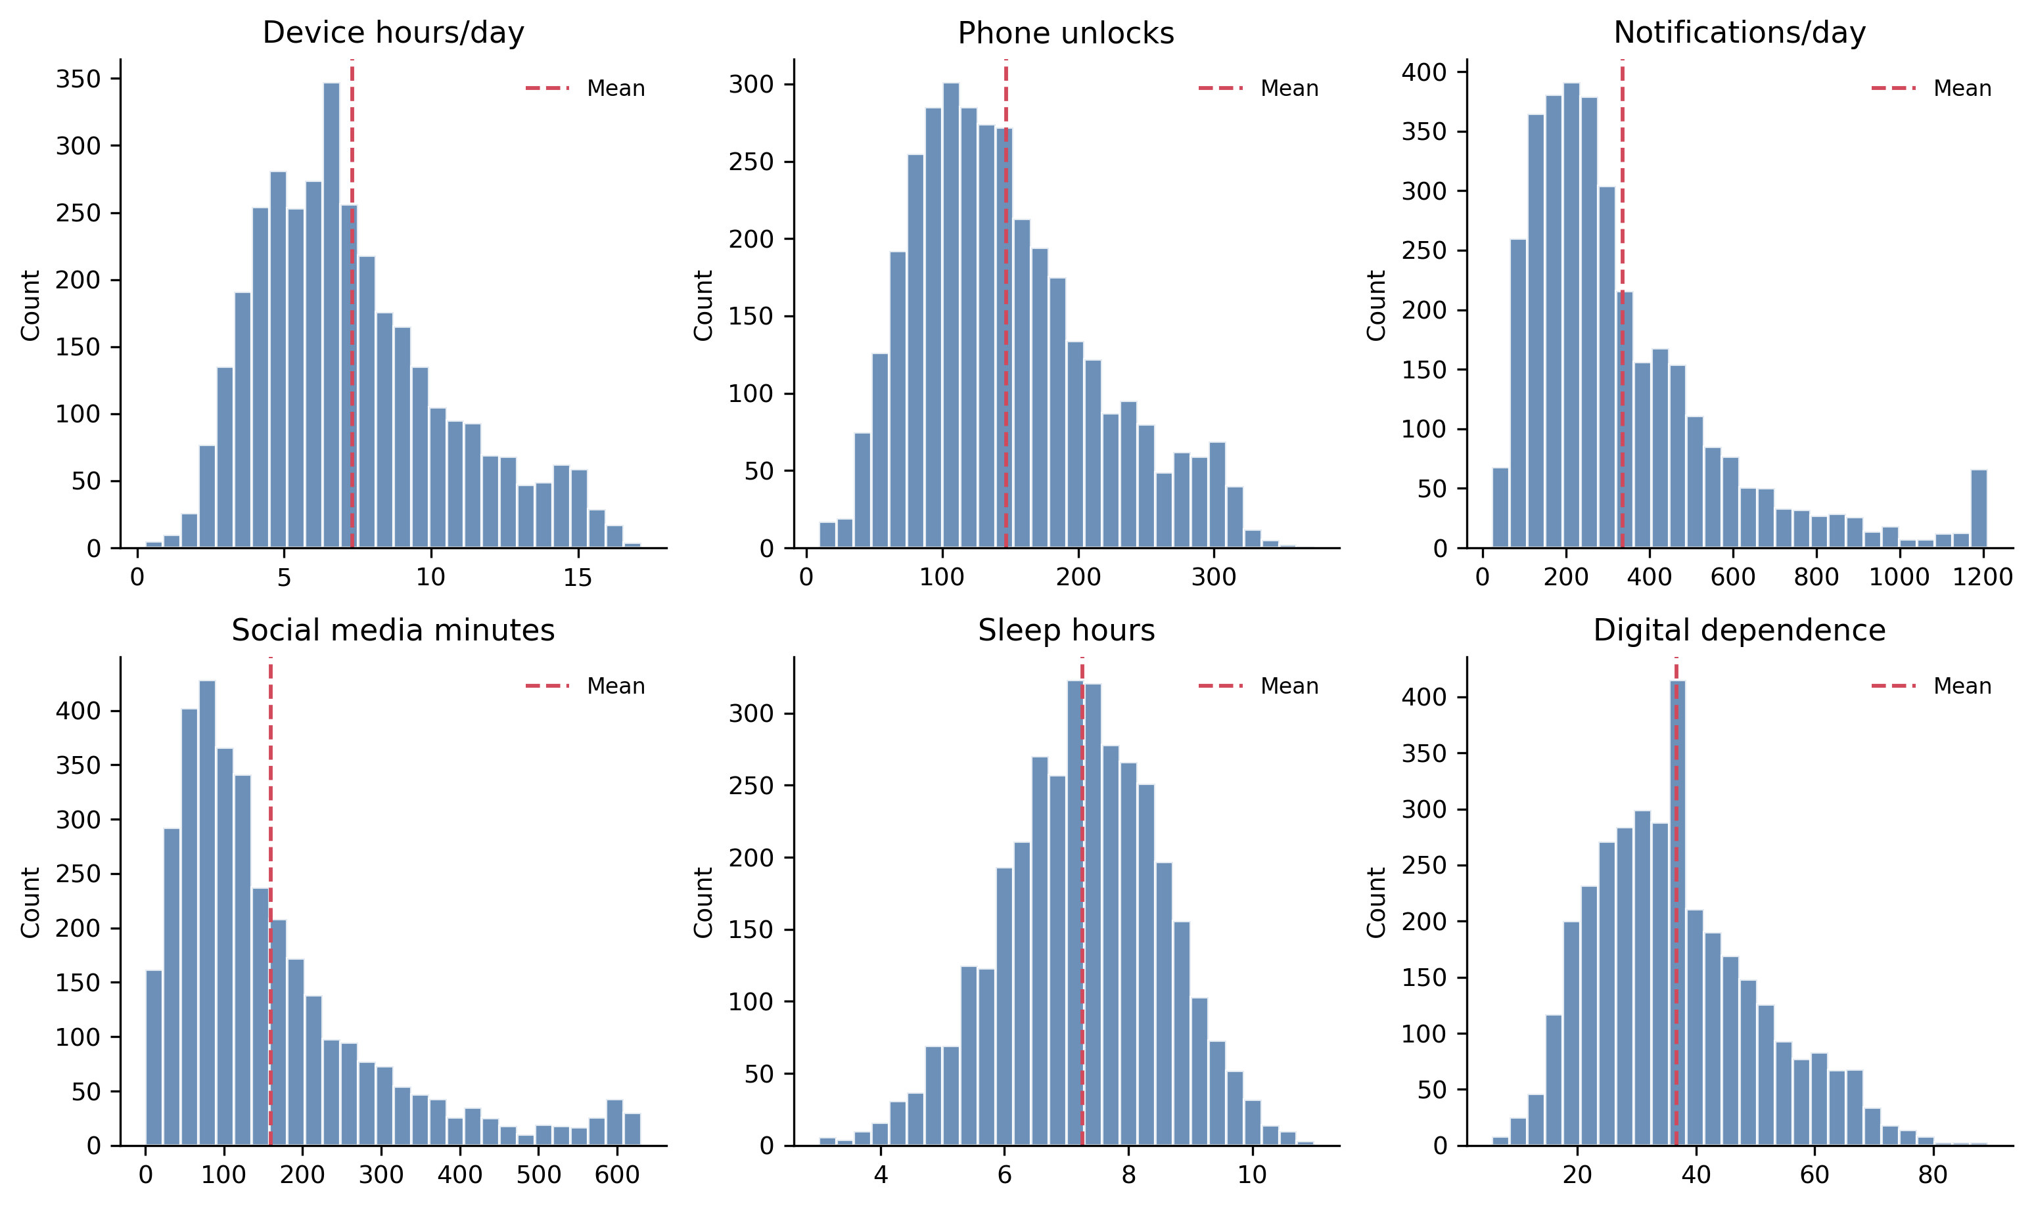
Fig2 Core Digital Lifestyle Feature Distributions
Summary: This figure shows how the main numerical variables are distributed.
1) Purpose: Check variable ranges and distribution shapes.
2) Observation: Device use, notifications, social media time, sleep, and scores have different scales.
3) Meaning: Standardization is needed before PCA and clustering.

4.3 Correlation Analysis
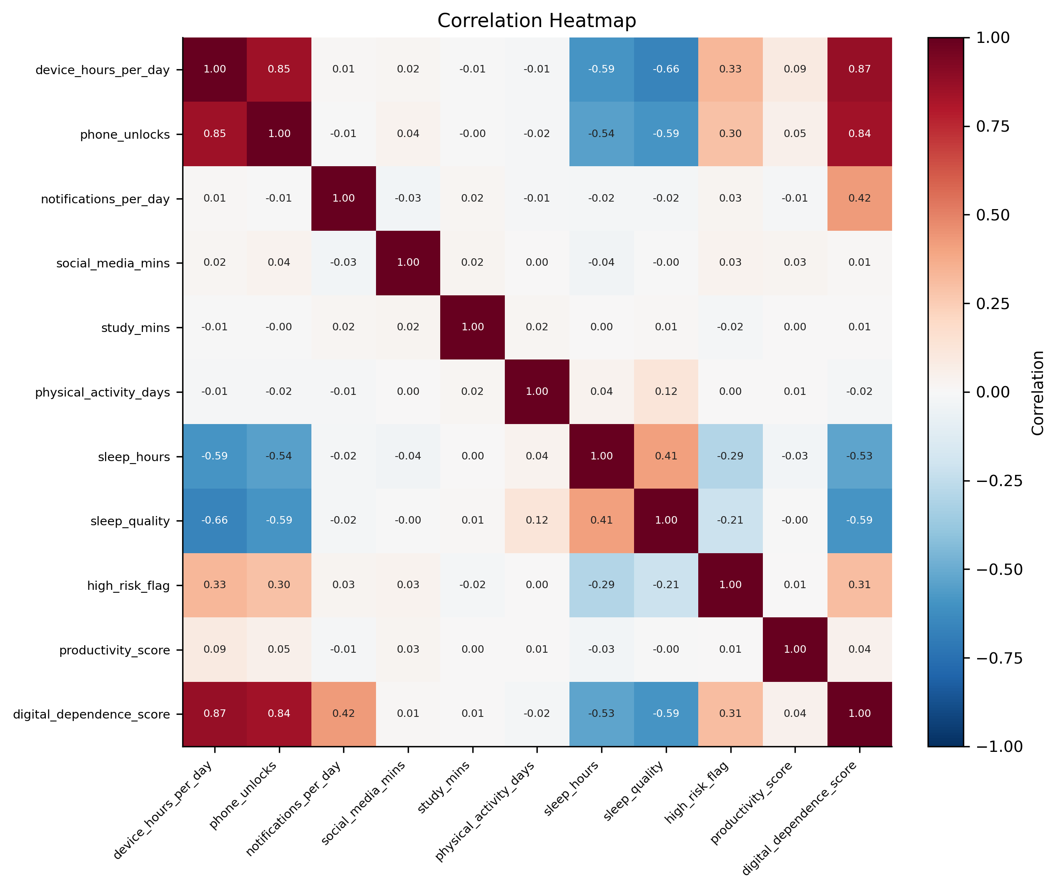
Fig3 Correlation Structure of Digital Lifestyle Variables
Summary: This figure explains relationships among numerical variables.
1) Purpose: Check feature correlation before modeling.
2) Observation: digital_dependence_score has stronger visible relationships with behavior variables than productivity_score.
3) Meaning: This helps explain why digital dependence is easier to predict than productivity, but the result is not causal.

4.4 High Risk vs No Risk Comparison
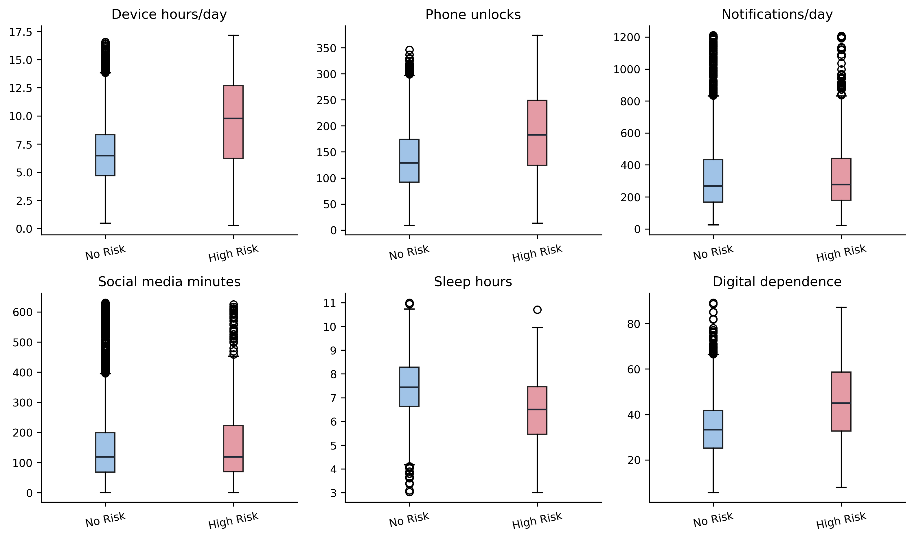
Fig4 Behavioral Difference Between High Risk and No Risk Groups
Summary: This figure compares the two classification groups.
1) Purpose: Check whether High Risk and No Risk samples differ in behavior variables.
2) Observation: The groups show some differences, but their distributions also overlap.
3) Meaning: High Risk screening is useful, but the classifier cannot be treated as a perfect separator.

4.5 EDA Summary
The EDA results give three modeling signals.
1) Target imbalance explains why classification should use Recall, F1, PR-AUC, and confusion matrix.
2) Correlation patterns explain why digital_dependence_score is more predictable than productivity_score.
3) Feature-scale differences explain why PCA and clustering require standardization.

5. Model Training and Evaluation

5.1 High Risk Classification
This section compares models, tunes parameters, evaluates results, and explains model boundaries.
1) Classification is used for High Risk screening.
2) Regression is used for digital dependence prediction and productivity weak-prediction checking.
3) Clustering is used for exploratory lifestyle profiling.
The final classification model is Gradient Boosting with threshold=0.14.
1) The target variable is high_risk_flag.
2) Outcome-style variables are removed to reduce target leakage.
3) Logistic Regression, Random Forest, and Gradient Boosting are compared.
4) Gradient Boosting is selected as the final base model because it gives the most suitable screening trade-off after model comparison and threshold tuning.
5) threshold=0.14 is selected because High Risk screening cares more about reducing missed High Risk samples than maximizing Accuracy.
6) With this threshold, Recall=0.6420, F1=0.5355, and PR-AUC=0.5084.
7) The result is a screening reference, not a final individual-level judgment.
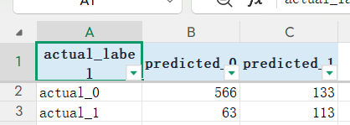
Table10 Classification Model Comparison and Threshold Results
Summary: This table records both model comparison and threshold-selection evidence.
1) Purpose: Compare candidate classifiers and threshold strategies.
2) Observation: The final Gradient Boosting threshold=0.14 gives Recall=0.6420, F1=0.5355, and PR-AUC=0.5084.
3) Meaning: The model is suitable as a recall-oriented screening reference, not as a final individual-level judgment.
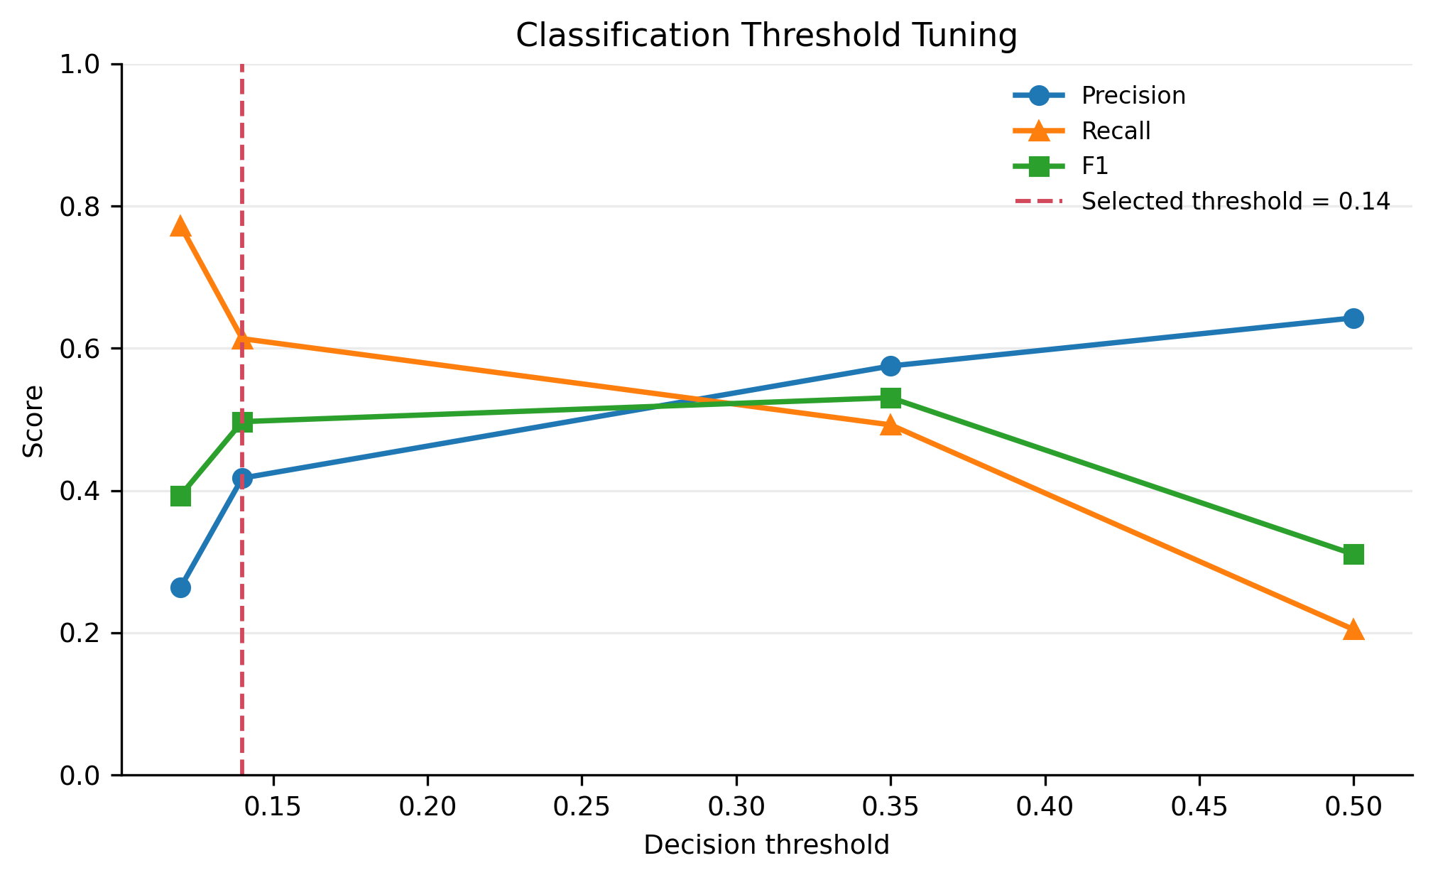
Fig5 Threshold Tuning for Recall-Oriented Screening
Summary: This figure explains why the default threshold=0.50 is not used.
1) Purpose: Compare Precision, Recall, and F1 under different thresholds.
2) Observation: Lower thresholds identify more High Risk samples but create more false positives.
3) Meaning: threshold=0.14 fits the screening purpose better than the default threshold.
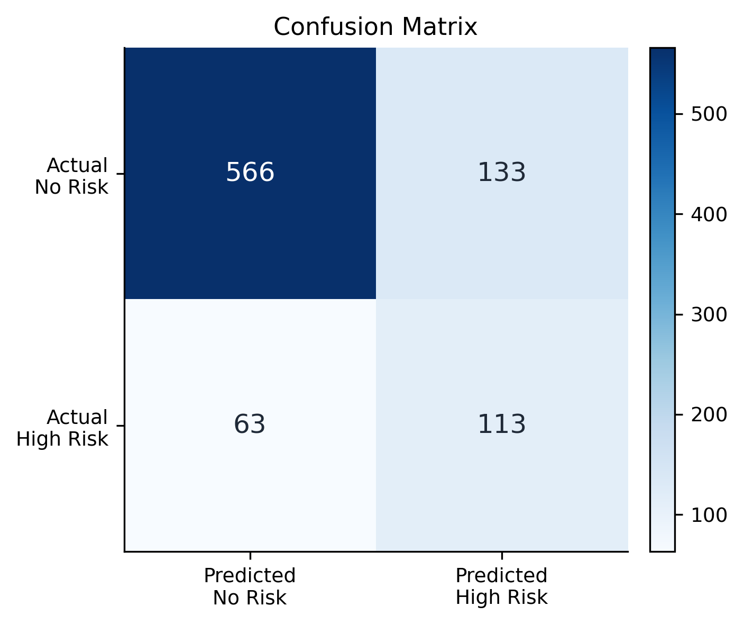
Fig6 Confusion Matrix of the Final High Risk Classifier
Summary: This figure shows the final prediction trade-off.
1) Purpose: Show true No Risk, false High Risk, missed High Risk, and true High Risk cases.
2) Observation: Recall=0.6420 means about 64.20% of true High Risk samples are identified.
3) Meaning: The model finds more High Risk samples, but the cost is more false alarms.
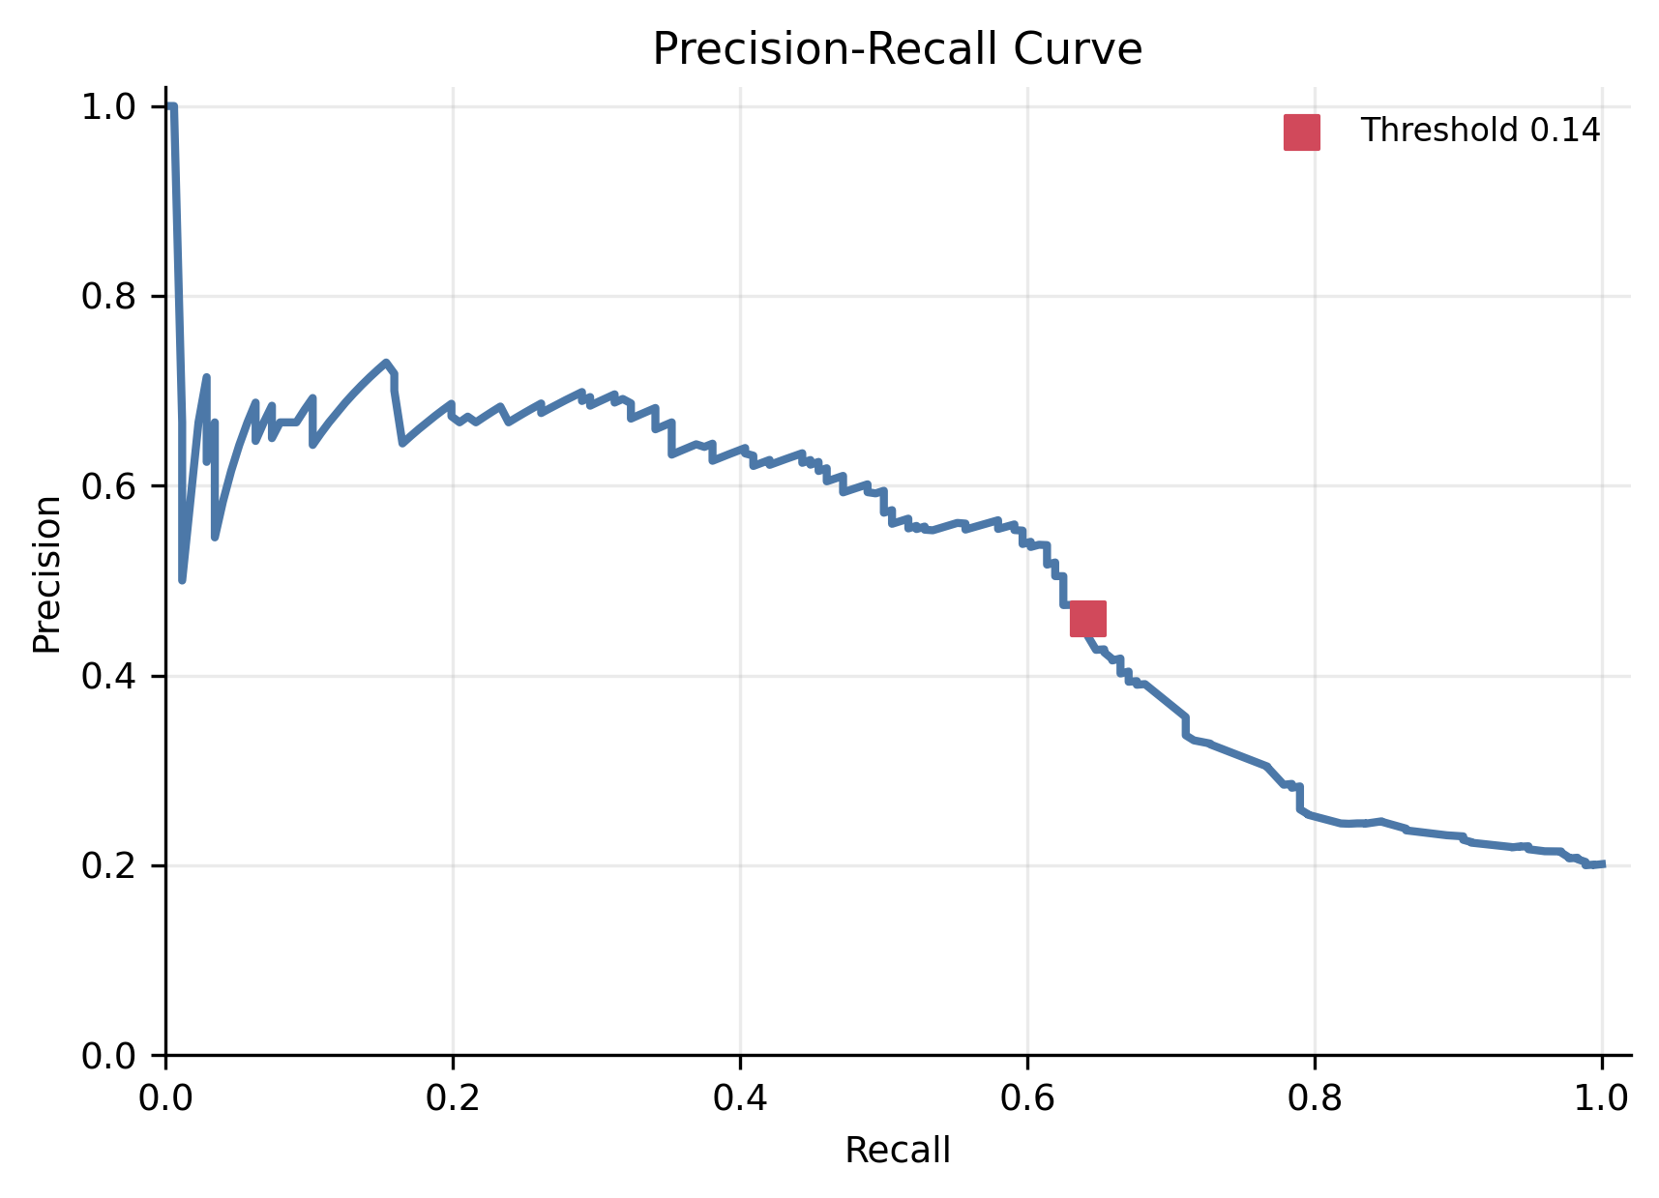
Fig7 Precision-Recall Curve under Class Imbalance
Summary: This figure evaluates the model under different thresholds.
1) Purpose: Show the Precision-Recall relationship.
2) Observation: PR-AUC=0.5084 shows some ability to rank High Risk samples above No Risk samples.
3) Meaning: PR-AUC, Recall, and F1 are more informative than Accuracy alone for this screening task.
from sklearn.model_selection import StratifiedKFold, GridSearchCV, train_test_split
from sklearn.ensemble import GradientBoostingClassifier
from sklearn.metrics import precision_recall_fscore_support
from sklearn.compose import ColumnTransformer
from sklearn.pipeline import Pipeline
from sklearn.preprocessing import OneHotEncoder, StandardScaler

X = engineered.drop(columns=classification_drop)
y = engineered["high_risk_flag"]
num_cols = X.select_dtypes(include="number").columns.tolist()
cat_cols = X.select_dtypes(exclude="number").columns.tolist()

X_train, X_test, y_train, y_test = train_test_split(
X, y, test_size=0.25, stratify=y, random_state=42
)

preprocess = ColumnTransformer([
("num", StandardScaler(), num_cols),
("cat", OneHotEncoder(handle_unknown="ignore"), cat_cols),
])
pipe = Pipeline([
("preprocess", preprocess),
("model", GradientBoostingClassifier(random_state=42)),
])
cv = StratifiedKFold(n_splits=5, shuffle=True, random_state=42)
grid = GridSearchCV(
pipe,
{"model__learning_rate": [0.03, 0.05, 0.1], "model__max_depth": [2, 3]},
scoring="average_precision",
cv=cv,
)
grid.fit(X_train, y_train)
proba = grid.predict_proba(X_test)[:, 1]
pred = (proba >= 0.14).astype(int)
print(precision_recall_fscore_support(y_test, pred, average="binary"))

Explanation: This code implements the final classification strategy.
1) It trains Gradient Boosting with cross-validation and GridSearchCV-style tuning.
2) It outputs High Risk probabilities instead of direct labels.
3) It applies threshold=0.14 to create recall-oriented predictions.
4) It supports the final High Risk screening strategy.
Classification summary: The classification result is useful as a screening reference. Lowering the threshold increases the chance of finding true High Risk samples, but it also increases false positives.

5.3 Dependence and Productivity Regression
The regression results show one strong target and one weak target.
1) digital_dependence_score is the main regression target.
2) Gradient Boosting reaches R2=0.9839, MSE=3.1471, and MAE=0.9982.
3) This means behavior and lifestyle features strongly represent digital dependence in this dataset.
4) productivity_score has R2=-0.0041.
5) This means the current features do not explain productivity better than a simple baseline.
6) The weak result is still useful because it shows that not every target can be predicted well from the same feature set.
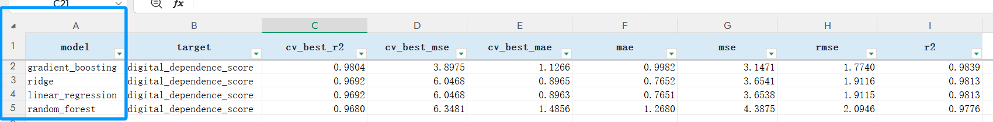
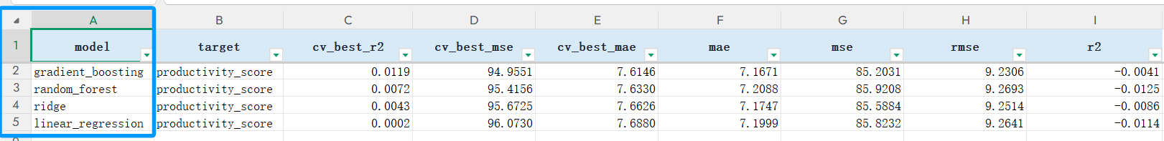
Table11 Regression Model Comparison
Summary: This table compares regression results for both targets.
1) Purpose: Compare model performance using R2, MSE, RMSE, MAE, and cross-validation scores.
2) Observation: digital_dependence_score is strongly predicted, while productivity_score remains weak.
3) Meaning: The same feature set does not explain every target equally well.
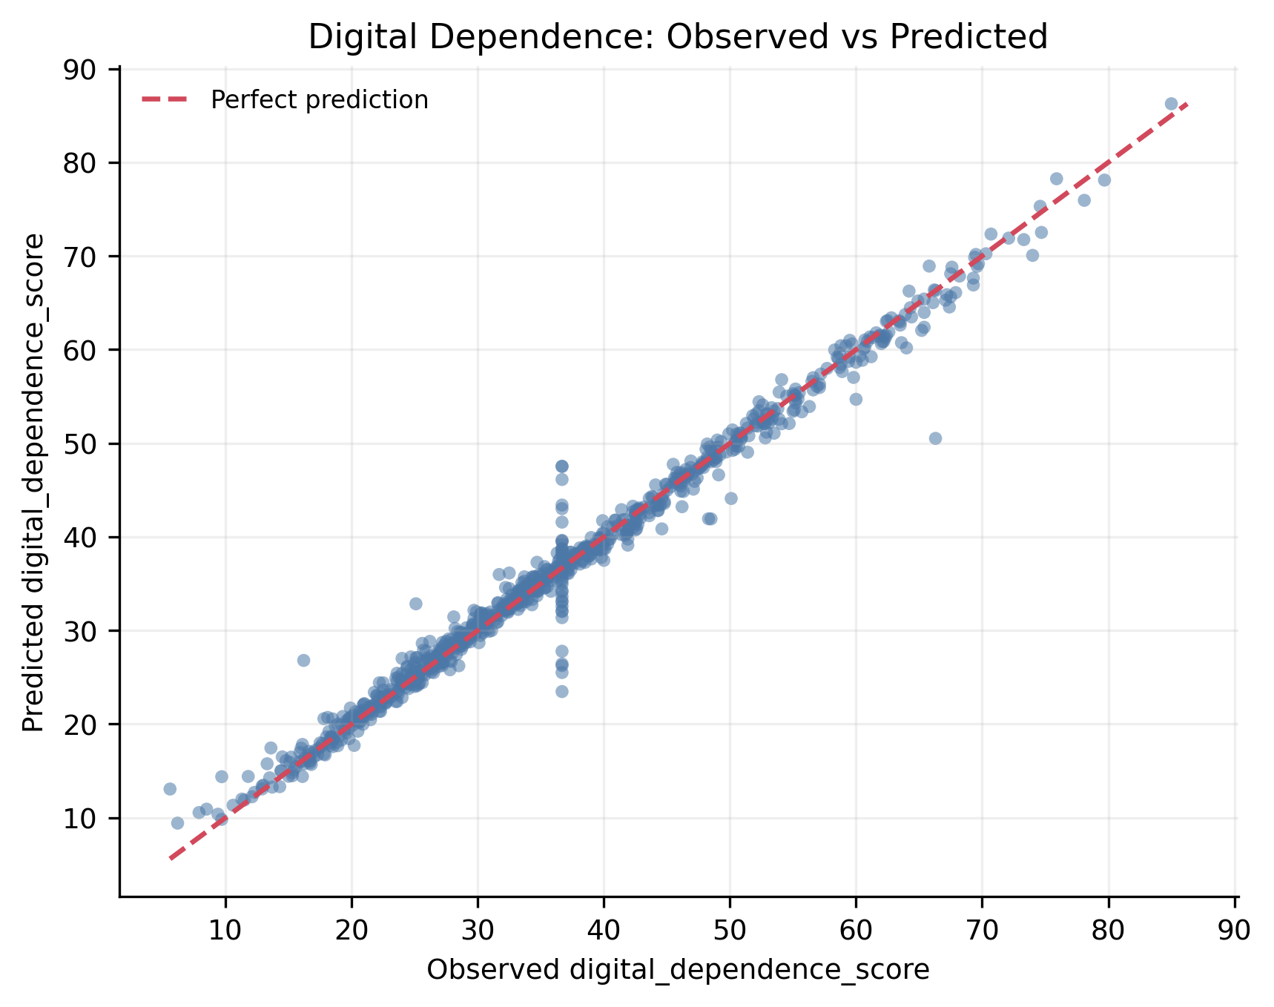
Fig8 Digital Dependence: Observed vs Predicted Scores
Summary: This figure shows that digital_dependence_score is predicted well.
1) Purpose: Compare observed and predicted digital dependence scores.
2) Observation: Most points stay close to the diagonal line.
3) Meaning: The high R2 result is visually supported, but it should be interpreted as prediction rather than causality.
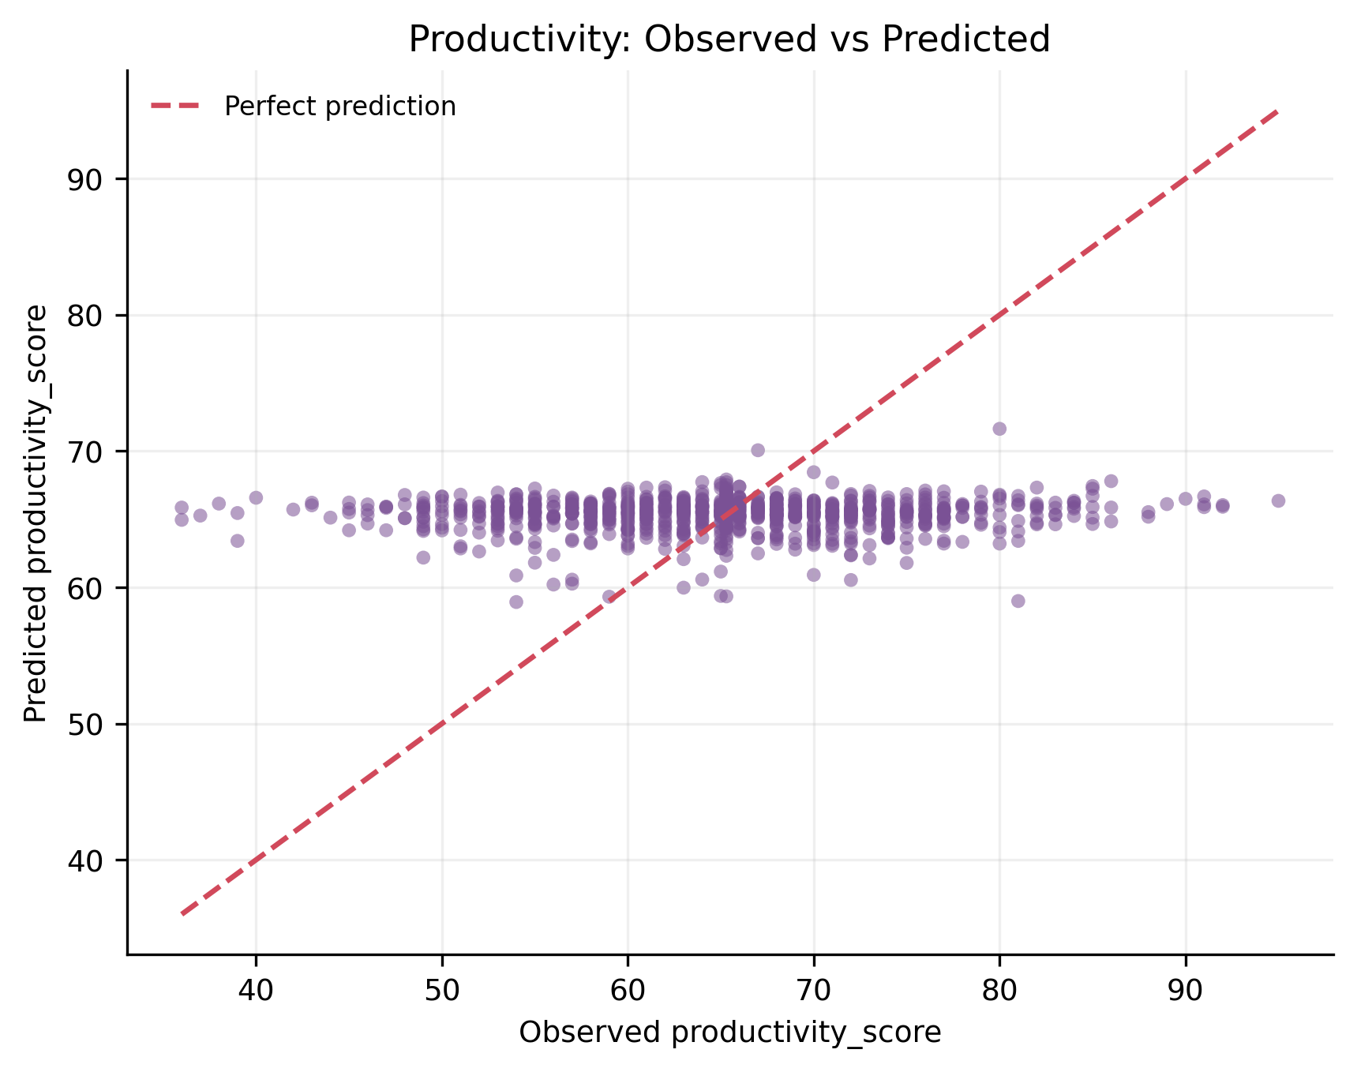
Fig9 Productivity Weak Prediction: Observed vs Predicted Scores
Summary: This figure shows why productivity_score is a weak-prediction result.
1) Purpose: Check whether productivity_score can be predicted like digital_dependence_score.
2) Observation: The points are scattered and do not follow the diagonal line closely.
3) Meaning: Productivity may depend on motivation, task difficulty, learning environment, self-control, and work context, which are not fully captured by this dataset.
import numpy as np
from sklearn.metrics import mean_absolute_error, mean_squared_error, r2_score

def regression_metrics(y_true, y_pred):
mse = mean_squared_error(y_true, y_pred)
return {
"r2": r2_score(y_true, y_pred),
"mse": mse,
"rmse": np.sqrt(mse),
"mae": mean_absolute_error(y_true, y_pred),
}

dd_pred = pd.read_csv(PROJECT_ROOT / "results" / "regression_digital_dependence_predictions.csv")
prod_pred = pd.read_csv(PROJECT_ROOT / "results" / "regression_productivity_predictions.csv")

print(regression_metrics(dd_pred["actual"], dd_pred["predicted"]))
print(regression_metrics(prod_pred["actual"], prod_pred["predicted"]))

Explanation: This code evaluates the two regression targets.
1) It reads prediction result files.
2) It calculates R2, MSE, RMSE, and MAE.
3) It compares digital dependence prediction with productivity prediction.
4) It supports the conclusion that one target is strongly predicted and the other is weakly predicted.
Regression summary: Digital dependence can be strongly predicted from the current features. Productivity cannot. This contrast makes the analysis more realistic.

5.4 Lifestyle Clustering
The final clustering result is KMeans with k=3, used only for exploratory lifestyle profiling.
1) The clustering input uses only behavior and lifestyle numerical features.
2) high_risk_flag, digital_dependence_score, and productivity_score are not used as clustering inputs.
3) KMeans, AgglomerativeClustering, and GaussianMixture are compared.
4) k values are evaluated with elbow method, Silhouette, Calinski-Harabasz, and Davies-Bouldin.
5) KMeans k=3 is selected because it gives the best tested Silhouette result and produces readable profiles.
6) Silhouette=0.1860 is low, so the clusters are exploratory summaries rather than strict natural groups.
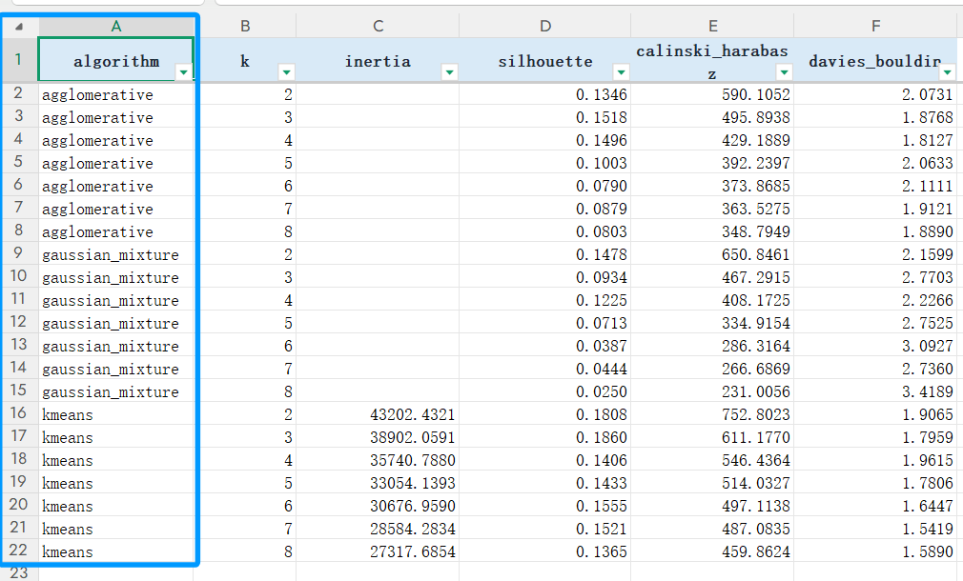
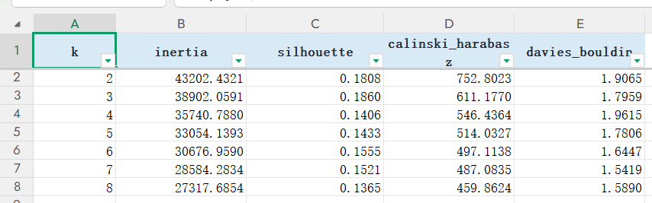
Table12 Clustering Model Comparison and Cluster Profiles
Summary: This table records clustering comparison and final profile interpretation.
1) Purpose: Compare clustering methods, k-selection metrics, and compact cluster profiles.
2) Observation: KMeans k=3 gives Silhouette=0.1860 and three readable profiles.
3) Meaning: The profiles are useful for interpretation, but the weak silhouette means the cluster boundaries are not strong.
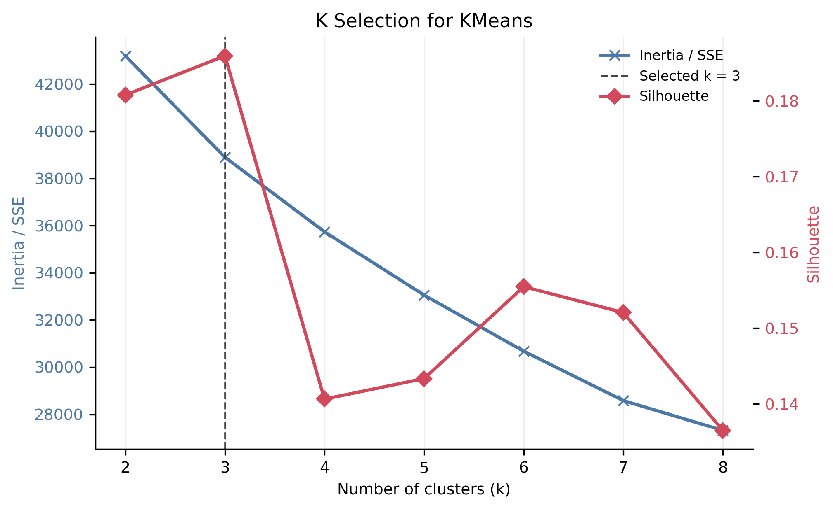
Fig10 KMeans k Selection by Elbow and Silhouette
Summary: This figure explains the choice of k=3.
1) Purpose: Compare inertia and silhouette across k values.
2) Observation: k=3 gives the best tested silhouette and a readable profile structure.
3) Meaning: k=3 is reasonable for exploration, but the low silhouette requires cautious interpretation.
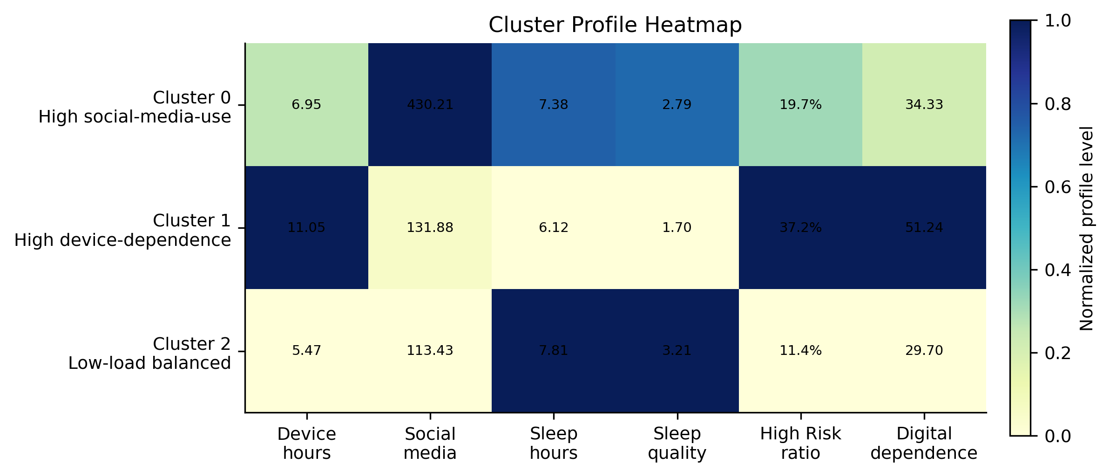
Fig11 Three Digital Lifestyle Cluster Profiles
Summary: This figure explains the meaning of the three clusters.
1) Purpose: Compare average behavior patterns across clusters.
2) Observation: Cluster 0 has high social media use; Cluster 1 has high device dependence; Cluster 2 has lower digital load and better sleep-related values.
3) Meaning: The cluster names are interpretable, but the groups are not sharply separated.
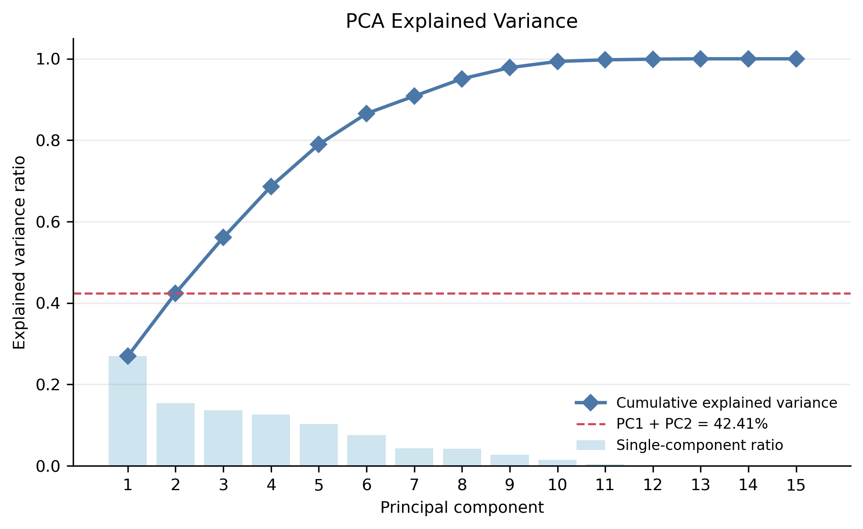
Fig12 PCA Explained Variance for Dimensionality Reduction
Summary: This figure explains how much information PCA captures.
1) Purpose: Record explained variance of leading principal components.
2) Observation: The first two components explain about 42.41% of total variance.
3) Meaning: PCA helps visualization and structure understanding, but it should not replace the original feature space.
from sklearn.cluster import KMeans
from sklearn.cluster import AgglomerativeClustering
from sklearn.mixture import GaussianMixture
from sklearn.metrics import silhouette_score
from sklearn.preprocessing import StandardScaler

X_cluster = engineered[clustering_features]
X_scaled = StandardScaler().fit_transform(X_cluster)

scores = []
for k in range(2, 9):
km = KMeans(n_clusters=k, random_state=42, n_init=10)
km_labels = km.fit_predict(X_scaled)
agg = AgglomerativeClustering(n_clusters=k)
agg_labels = agg.fit_predict(X_scaled)
gmm = GaussianMixture(n_components=k, random_state=42)
gmm_labels = gmm.fit_predict(X_scaled)
scores.extend([
{"algorithm": "KMeans", "k": k, "silhouette": silhouette_score(X_scaled, km_labels)},
{"algorithm": "Agglomerative", "k": k, "silhouette": silhouette_score(X_scaled, agg_labels)},
{"algorithm": "GaussianMixture", "k": k, "silhouette": silhouette_score(X_scaled, gmm_labels)},
])

print(pd.DataFrame(scores))

Explanation: This code implements clustering comparison.
1) It standardizes clustering features.
2) It compares KMeans, AgglomerativeClustering, and GaussianMixture.
3) It calculates silhouette scores across k values.
4) It supports selecting KMeans k=3 as an exploratory profile solution.
Clustering summary: The clustering result is useful because it summarizes behavior patterns into readable profiles. It should not be treated as a strict grouping rule because Silhouette=0.1860 is low.

5.5 Result Analysis
The three modeling tasks form one consistent conclusion.
1) Classification can screen High Risk samples as a reference, but more false positives appear when recall is improved.
2) Regression shows that digital_dependence_score is much easier to predict than productivity_score.
3) Clustering summarizes lifestyle patterns, but the cluster boundaries are weak.
4) These results connect back to preprocessing, feature engineering, and EDA.
Final meaning: The value of the modeling chapter is not perfect performance. Its value is explainable and traceable analysis.

6. Findings and Reflection

6.1 Main Findings
The final findings are consistent with the workflow.
1) High Risk can be screened from behavior and lifestyle features, but the model is only a reference.

2) digital_dependence_score can be predicted well, with R2=0.9839, MSE=3.1471, and MAE=0.9982.

3) productivity_score is weakly predicted, which shows that not every outcome can be explained by current digital behavior features.

4) Clustering forms three readable lifestyle profiles, but Silhouette=0.1860 shows weak boundaries.
The workflow is also consistent.
1) Data checks confirm that the original table is usable.
2) Feature engineering turns raw records into behavior-intensity variables.
3) EDA explains why recall, PR-AUC, regression metrics, and clustering metrics are needed.
4) The final models connect back to these earlier steps.

6.2 Value
The value of this report is the complete analysis process.
1) It starts from dataset selection.
2) It checks data quality.
3) It constructs behavior features.
4) It explores statistical and visual patterns.
5) It compares models and tunes thresholds.
6) It explains both useful results and limitations.
The value is not perfect prediction. The value is clear and traceable analysis.

6.3 Limitations
The limitations are clear and should be stated honestly.
1) The dataset is a benchmark/synthetic educational dataset.
2) The classification Recall is not 100%, so some High Risk samples are still missed.
3) productivity_score is weakly predicted.
4) The clustering silhouette score is low.
5) No external dataset is used for validation.

6.4 Reflection
The main lesson is that data analysis is more than running models.
1) Dataset selection affects whether the whole report can support classification, regression, and clustering.
2) Data cleaning and leakage control affect whether model results are meaningful.
3) Visualization should answer questions, not decorate the report.
4) Weak results can still be useful if they explain the boundary of the current feature set.
5) Reproducible code and clear evidence make the report easier to check.
I also appreciate our teacher's repeated emphasis on data cleaning, feature extraction, visualization, evaluation, and reproducible reporting.

Appendix A Environment and Complete Code

A.1 Environment and Dependencies
This appendix records the running environment and complete code source.
1) The experiment uses a CPU-based Python environment.
2) The main packages are pandas, NumPy, scikit-learn, Matplotlib, openpyxl, python-docx, and joblib.
3) The environment can be installed with:
pip install -r requirements.txt
4) The complete code can regenerate preprocessing evidence, Excel screenshot tables, final figures, model metrics, and result summaries.

A.2 Complete Runnable Code
The complete runnable code is copied from appendix_A_complete_code.py.
"""Complete runnable code source for Appendix A.

Run from the repository root:
python 期末考查报告_数字生活方式分析/appendix_A_complete_code.py

This file rebuilds the final report evidence files without changing the
validated core CSV metrics. It loads the raw dataset, checks data quality,
creates engineered features, documents leakage control, regenerates the final
figures, exports screenshot Excel tables, and summarizes the validated results.
"""

from __future__ import annotations

import runpy
from pathlib import Path

import pandas as pd

PROJECT_ROOT = Path(__file__).resolve().parent
RAW_DATA_PATH = PROJECT_ROOT / "data" / "raw" / "digital_lifestyle_benchmark_2025.csv"
PROCESSED_DATA_PATH = PROJECT_ROOT / "data" / "processed" / "digital_lifestyle_benchmark_2025_processed.csv"
RESULTS_DIR = PROJECT_ROOT / "results"
FIGURE_DIR = PROJECT_ROOT / "figures" / "final_report"
SCREENSHOT_TABLE_DIR = PROJECT_ROOT / "screenshot_tables"
RANDOM_STATE = 42

def load_raw_data() -> pd.DataFrame:
df = pd.read_csv(RAW_DATA_PATH)
print("Raw dataset shape:", df.shape)
print("Raw columns:", df.columns.tolist())
print(df.head())
return df

def check_missing_duplicates_and_ranges(df: pd.DataFrame) -> None:
key_numeric = [
"age",
"device_hours_per_day",
"phone_unlocks",
"notifications_per_day",
"social_media_mins",
"study_mins",
"sleep_hours",
"sleep_quality",
"productivity_score",
"digital_dependence_score",
]
print("\nMissing values:")
print(df.isna().sum())
print("\nDuplicate rows:", df.duplicated().sum())
print("Duplicate id:", df["id"].duplicated().sum())
print("\nRange summary:")
print(df[key_numeric].agg(["min", "max", "mean"]).T)

def add_engineered_features(df: pd.DataFrame) -> pd.DataFrame:
engineered = df.copy()
eps = 1e-6
engineered["social_media_hours"] = engineered["social_media_mins"] / 60
engineered["study_hours"] = engineered["study_mins"] / 60
engineered["notifications_per_device_hour"] = (
engineered["notifications_per_day"] / engineered["device_hours_per_day"].clip(lower=eps)
)
engineered["unlocks_per_device_hour"] = (
engineered["phone_unlocks"] / engineered["device_hours_per_day"].clip(lower=eps)
)
engineered["device_to_sleep_ratio"] = (
engineered["device_hours_per_day"] / engineered["sleep_hours"].clip(lower=eps)
)
engineered["activity_sleep_interaction"] = (
engineered["physical_activity_days"] * engineered["sleep_hours"]
)
engineered["social_to_study_ratio"] = engineered["social_media_mins"] / (
engineered["study_mins"] + 1
)
engineered.to_csv(PROCESSED_DATA_PATH, index=False)
print("\nProcessed dataset saved:", PROCESSED_DATA_PATH)
return engineered

def define_feature_sets(engineered: pd.DataFrame) -> dict[str, list[str]]:
outcome_cols = [
"anxiety_score",
"depression_score",
"stress_level",
"happiness_score",
"focus_score",
"high_risk_flag",
"productivity_score",
"digital_dependence_score",
]
classification_drop = [
"id",
"high_risk_flag",
"anxiety_score",
"depression_score",
"stress_level",
"happiness_score",
"focus_score",
"productivity_score",
"digital_dependence_score",
]

def regression_drop_for(target: str) -> list[str]:
drop_cols = {"id", target}
drop_cols.update(outcome_cols)
if target == "digital_dependence_score":
drop_cols.add("productivity_score")
if target == "productivity_score":
drop_cols.add("digital_dependence_score")
return sorted(drop_cols)

digital_dependence_drop = regression_drop_for("digital_dependence_score")
productivity_drop = regression_drop_for("productivity_score")
clustering_features = [
"device_hours_per_day",
"phone_unlocks",
"notifications_per_day",
"social_media_mins",
"study_mins",
"physical_activity_days",
"sleep_hours",
"sleep_quality",
"social_media_hours",
"study_hours",
"notifications_per_device_hour",
"unlocks_per_device_hour",
"device_to_sleep_ratio",
"activity_sleep_interaction",
"social_to_study_ratio",
]
classification_features = [c for c in engineered.columns if c not in classification_drop]
digital_dependence_features = [c for c in engineered.columns if c not in digital_dependence_drop]
productivity_features = [c for c in engineered.columns if c not in productivity_drop]
print("\nClassification drop columns:", classification_drop)
print("Classification feature count:", len(classification_features))
print("Digital dependence regression feature count:", len(digital_dependence_features))
print("Productivity regression feature count:", len(productivity_features))
print("Clustering features:", clustering_features)
return {
"classification_drop": classification_drop,
"classification_features": classification_features,
"digital_dependence_drop": digital_dependence_drop,
"digital_dependence_features": digital_dependence_features,
"productivity_drop": productivity_drop,
"productivity_features": productivity_features,
"clustering_features": clustering_features,
}

def summarize_validated_results() -> None:
classification = pd.read_csv(RESULTS_DIR / "classification_tuned_metrics.csv")
regression_dd = pd.read_csv(RESULTS_DIR / "regression_digital_dependence_metrics.csv")
regression_prod = pd.read_csv(RESULTS_DIR / "regression_productivity_metrics.csv")
clustering = pd.read_csv(RESULTS_DIR / "clustering_kmeans_scores.csv")

final_cls = classification[
(classification["dataset"] == "test")
& (classification["model"] == "gradient_boosting")
& (classification["threshold"].round(2) == 0.14)
].iloc[0]
final_dd = regression_dd[regression_dd["model"] == "gradient_boosting"].iloc[0]
final_prod = regression_prod[regression_prod["model"] == "gradient_boosting"].iloc[0]
final_cluster = clustering[clustering["k"] == 3].iloc[0]

summary = pd.DataFrame(
[
{
"task": "classification_high_risk",
"main_result": "Gradient Boosting threshold=0.14",
"metric_1": f"Recall={final_cls['recall']:.4f}",
"metric_2": f"F1={final_cls['f1']:.4f}",
"metric_3": f"PR-AUC={final_cls['pr_auc']:.4f}",
},
{
"task": "regression_digital_dependence",
"main_result": "Gradient Boosting",
"metric_1": f"R2={final_dd['r2']:.4f}",
"metric_2": f"MSE={final_dd['mse']:.4f}",
"metric_3": f"MAE={final_dd['mae']:.4f}",
},
{
"task": "regression_productivity",
"main_result": "weak prediction / negative result",
"metric_1": f"R2={final_prod['r2']:.4f}",
"metric_2": "",
"metric_3": "",
},
{
"task": "clustering_lifestyle_profiles",
"main_result": "KMeans k=3",
"metric_1": f"Silhouette={final_cluster['silhouette']:.4f}",
"metric_2": "",
"metric_3": "",
},
]
)
output = RESULTS_DIR / "final_workflow_report_summary.csv"
summary.to_csv(output, index=False)
print("\nValidated result summary saved:", output)

def regenerate_figures_and_screenshot_tables() -> None:
FIGURE_DIR.mkdir(parents=True, exist_ok=True)
SCREENSHOT_TABLE_DIR.mkdir(parents=True, exist_ok=True)
runpy.run_path(str(PROJECT_ROOT / "scripts" / "generate_final_report_figures.py"), run_name="__main__")
runpy.run_path(str(PROJECT_ROOT / "scripts" / "export_screenshot_tables.py"), run_name="__main__")

def main() -> None:
print("Random state:", RANDOM_STATE)
df = load_raw_data()
check_missing_duplicates_and_ranges(df)
engineered = add_engineered_features(df)
define_feature_sets(engineered)
summarize_validated_results()
regenerate_figures_and_screenshot_tables()
print("\nComplete workflow evidence generation finished.")

if __name__ == "__main__":
main()

