* * * * * * * * * * * 学 号： 姓 名： * * * * * * * * * * * * * * * * * * * * * * * * * * * * * * * * * * * * * * * * * * * * 学 院： 专业年级： * * * * * * * * * * * * * * * * * * * * * * * * * * * * * * * * * * * * * * * * * * * * * * * * * * * * * * * * * *
The paper of course exam

Name： | Big Data Analysis and Applications
Content： | Course Report （Class assignments、thesis、report ）
Institution： |  | Teacher： | Li Jie
Grade and major：

Teacher’s comments | Total score | Grading teacher

…………………………………………………………………………………………………

Digital Lifestyle Analysis: High-Risk Screening, Digital Dependence Prediction, and Lifestyle Profile Clustering

1. Analysis Goals and Tasks
This report follows the workflow required by the course: define the analysis goal, introduce the dataset, clean and transform the data, conduct statistical visualization, train and evaluate machine learning models, and finally interpret the results. The main purpose is not to claim that every model is perfect. The purpose is to make each step explainable and supported by data evidence.

1.1 Background
Digital lifestyle data combine device use, notifications, social media time, sleep, study, and activity records. These variables provide a practical setting for studying whether behavior patterns are associated with High Risk labels, digital dependence scores, and exploratory lifestyle profiles.

1.2 Key Questions
Can High Risk samples be screened from behavior and lifestyle variables?
Can digital_dependence_score be predicted more reliably than productivity_score?
Can continuous behavior features be summarized into readable lifestyle profiles?

1.3 Analysis Tasks
The report uses three machine learning tasks: classification for high_risk_flag, regression for digital_dependence_score and productivity_score, and clustering for lifestyle profiling. The same preprocessing pipeline is used to keep the analysis coherent across tasks.

2. Dataset and Task Support

2.1 Dataset Source
The selected dataset is the 2025 Digital Lifestyle Benchmark Dataset. It contains 3,500 rows and 24 original fields in CSV format. The dataset is a benchmark or educational dataset, so the results should be interpreted as course-level analysis rather than real individual assessment.

2.2 Raw Data Preview
Table1 is used to confirm that the report starts from the raw CSV rather than from a pre-summarized result table.
Table1 Raw Dataset Preview
id | device_hours_per_day | phone_unlocks | notifications_per_day | sleep_hours | high_risk_flag | productivity_score | digital_dependence_score
1.000 | 3.540 | 45.000 | 561.000 | 9.124 | 0.000 | 70.000 | 25.700
2.000 | 5.650 | 100.000 | 393.000 | 8.838 | 0.000 | 64.000 | 30.100
3.000 | 8.870 | 181.000 | 231.000 | 6.487 | 0.000 | 65.299 | 40.600
4.000 | 4.050 | 94.000 | 268.000 | 7.601 | 1.000 | 80.000 | 36.684
5.000 | 13.070 | 199.000 | 91.000 | 5.198 | 1.000 | 65.299 | 48.400
6.000 | 4.590 | 73.000 | 198.000 | 10.945 | 0.000 | 63.000 | 21.200
Table1 shows that the raw records include digital behavior fields, lifestyle fields, and target fields in the same row. This structure is the reason why the dataset can support classification, regression, and clustering in one workflow.

2.3 Field Structure
Table2 lists every original field with its type and role, which makes the later leakage-control decision traceable.
Table2 Dataset Fields
field | dtype | role | example
id | int64 | identifier | 1
age | int64 | background | 40
gender | str | background | Female
region | str | background | Asia
income_level | str | background | High
education_level | str | background | High School
daily_role | str | background | Part-time/Shift
device_hours_per_day | float64 | digital behavior | 3.540
phone_unlocks | int64 | digital behavior | 45
notifications_per_day | int64 | digital behavior | 561
social_media_mins | int64 | digital behavior | 98
study_mins | int64 | lifestyle | 34
physical_activity_days | float64 | lifestyle | 7.000
sleep_hours | float64 | lifestyle | 9.124
sleep_quality | float64 | lifestyle | 3.354
anxiety_score | float64 | outcome-style field | 9.927
depression_score | float64 | outcome-style field | 5.000
stress_level | float64 | outcome-style field | 6.593
happiness_score | float64 | outcome-style field | 8.000
focus_score | float64 | outcome-style field | 23.000
high_risk_flag | int64 | classification target | 0
device_type | str | device category | Android
productivity_score | float64 | auxiliary regression target | 70.000
digital_dependence_score | float64 | main regression target | 25.700
Table2 confirms that high_risk_flag, productivity_score, and digital_dependence_score are outcome-style variables. They should not be mixed blindly into every task because doing so would make the model evaluation less credible.

2.4 Task Support
The dataset naturally supports at least two machine learning task types and in this report supports three. high_risk_flag is the classification target, digital_dependence_score is the main regression target, productivity_score is used as a weak-prediction check, and behavior/lifestyle variables are used for clustering.

3. Data Cleaning and Feature Engineering

3.1 Data Loading
The loading step verifies the input file shape and column structure. The raw dataset contains exactly 3,500 records and 24 fields, matching the dataset requirement and the later task design.

3.2 Missing and Duplicate Check
Table3 checks every field before any modeling step.
Table3 Missing Value Check
field | missing_count | missing_rate
id | 0 | 0.000
age | 0 | 0.000
gender | 0 | 0.000
region | 0 | 0.000
income_level | 0 | 0.000
education_level | 0 | 0.000
daily_role | 0 | 0.000
device_hours_per_day | 0 | 0.000
phone_unlocks | 0 | 0.000
notifications_per_day | 0 | 0.000
social_media_mins | 0 | 0.000
study_mins | 0 | 0.000
physical_activity_days | 0 | 0.000
sleep_hours | 0 | 0.000
sleep_quality | 0 | 0.000
anxiety_score | 0 | 0.000
depression_score | 0 | 0.000
stress_level | 0 | 0.000
happiness_score | 0 | 0.000
focus_score | 0 | 0.000
high_risk_flag | 0 | 0.000
device_type | 0 | 0.000
productivity_score | 0 | 0.000
digital_dependence_score | 0 | 0.000
Table3 confirms that all 24 fields contain zero missing values. Together with Table4, this allows all 3,500 records to be retained and avoids introducing imputation assumptions into the later models.
Table4 tests whether repeated rows or duplicated identifiers should be removed.
Table4 Duplicate Check
check_item | value | handling
total_records | 3500 | kept
duplicate_rows | 0 | none removed
duplicate_id | 0 | none removed
Table4 reports 0 duplicate rows and 0 duplicate id values. Therefore, the data-cleaning step keeps all samples, and the later train/test split is not affected by duplicated records.

3.3 Range and Rationality Check
Table5 summarizes the minimum, maximum, and mean values of key numerical fields.
Table5 Range and Rationality Check
feature | min | max | mean | status
age | 13.000 | 50.000 | 28.079 | pass
device_hours_per_day | 0.280 | 17.160 | 7.318 | pass
phone_unlocks | 9.000 | 374.000 | 147.107 | pass
notifications_per_day | 22.000 | 1211.000 | 335.117 | pass
social_media_mins | 0.000 | 631.000 | 159.363 | pass
study_mins | 0.000 | 418.000 | 108.117 | pass
sleep_hours | 3.000 | 11.005 | 7.254 | pass
sleep_quality | 1.000 | 5.000 | 2.709 | pass
productivity_score | 33.000 | 95.000 | 65.299 | pass
digital_dependence_score | 5.600 | 89.200 | 36.684 | pass
Table5 indicates that device_hours_per_day ranges from 0.28 to 17.16, notifications_per_day ranges from 22 to 1,211, and sleep_hours ranges from 3.00 to 11.00. These values are wide but still interpretable for a benchmark dataset, so no severe abnormal record is removed.

3.4 Feature Engineering
Table6 records the engineered behavior-intensity variables.
Table6 Engineered Features Preview
device_hours_per_day | social_media_mins | study_mins | sleep_hours | social_media_hours | study_hours | notifications_per_device_hour | device_to_sleep_ratio | activity_sleep_interaction | social_to_study_ratio
3.540 | 98.000 | 34.000 | 9.124 | 1.633 | 0.567 | 158.475 | 0.388 | 63.867 | 2.800
5.650 | 174.000 | 102.000 | 8.838 | 2.900 | 1.700 | 69.558 | 0.639 | 17.675 | 1.689
8.870 | 595.000 | 140.000 | 6.487 | 9.917 | 2.333 | 26.043 | 1.367 | 6.487 | 4.220
4.050 | 18.000 | 121.000 | 7.601 | 0.300 | 2.017 | 66.173 | 0.533 | 30.402 | 0.148
13.070 | 147.000 | 60.000 | 5.198 | 2.450 | 1.000 | 6.963 | 2.514 | 5.198 | 2.410
4.590 | 9.000 | 85.000 | 10.945 | 0.150 | 1.417 | 43.137 | 0.419 | 0.000 | 0.105
Table6 confirms that raw minutes and counts are transformed into ratios such as notifications_per_device_hour, device_to_sleep_ratio, and social_to_study_ratio. The feature activity_sleep_interaction is consistently defined as physical_activity_days multiplied by sleep_hours.

3.5 Feature Selection and Leakage Control
Table7 explains which columns are excluded before modeling.
Table7 Feature Selection and Leakage Control
feature_set | rule
classification drop | id, high_risk_flag, anxiety_score, depression_score, stress_level, happiness_score, focus_score, productivity_score, digital_dependence_score
regression drop | id, high_risk_flag, other outcome-style target fields, and the current target itself
clustering input | digital behavior and lifestyle numerical features only
leakage principle | targets and outcome-style variables are used for interpretation, not as direct inputs
Table7 is important because the classification task must not use anxiety_score, depression_score, stress_level, happiness_score, focus_score, productivity_score, digital_dependence_score, id, or high_risk_flag as inputs. This keeps the classifier focused on behavior evidence instead of direct outcome fields.

3.6 PCA and GMM Extension
Table8 provides the numerical evidence for the PCA extension.
Table8 PCA Explained Variance
component | explained_variance_ratio | cumulative_explained_variance
PC1 | 0.269 | 0.269
PC2 | 0.155 | 0.424
PC3 | 0.137 | 0.561
PC4 | 0.126 | 0.687
PC5 | 0.103 | 0.790
PC6 | 0.076 | 0.865
Table8 shows that PC1 and PC2 explain 42.41% of the total variance. Since 57.59% remains outside the first two components and 6 components are needed to exceed 80%, PCA is used only for auxiliary structure understanding rather than as classification or regression input.

4. Statistics and Visualization

4.1 Descriptive Statistics
Table9 gives the mathematical summary before visual analysis.
Table9 Descriptive Statistical Summary
feature | count | mean | std | min | 25% | 50% | 75% | max
device_hours_per_day | 3500.000 | 7.318 | 3.240 | 0.280 | 4.867 | 6.760 | 9.152 | 17.160
phone_unlocks | 3500.000 | 147.107 | 67.771 | 9.000 | 96.000 | 136.000 | 187.000 | 374.000
notifications_per_day | 3500.000 | 335.117 | 239.679 | 22.000 | 170.000 | 268.000 | 434.000 | 1211.000
social_media_mins | 3500.000 | 159.363 | 132.748 | 0.000 | 68.000 | 119.000 | 204.000 | 631.000
sleep_hours | 3500.000 | 7.254 | 1.292 | 3.000 | 6.411 | 7.292 | 8.162 | 11.005
sleep_quality | 3500.000 | 2.709 | 1.101 | 1.000 | 1.919 | 2.908 | 3.277 | 5.000
productivity_score | 3500.000 | 65.299 | 9.665 | 33.000 | 59.000 | 65.299 | 71.000 | 95.000
digital_dependence_score | 3500.000 | 36.684 | 14.116 | 5.600 | 26.200 | 35.300 | 45.100 | 89.200
Table9 shows that notifications_per_day and social_media_mins have wide ranges, while sleep_quality is bounded between 1 and 5. This scale difference explains why StandardScaler is needed for PCA, KMeans, GaussianMixture, and linear models, while tree-based models are less sensitive to raw scale.

4.2 Target Distribution
Fig1 is used to check the class structure before model training.
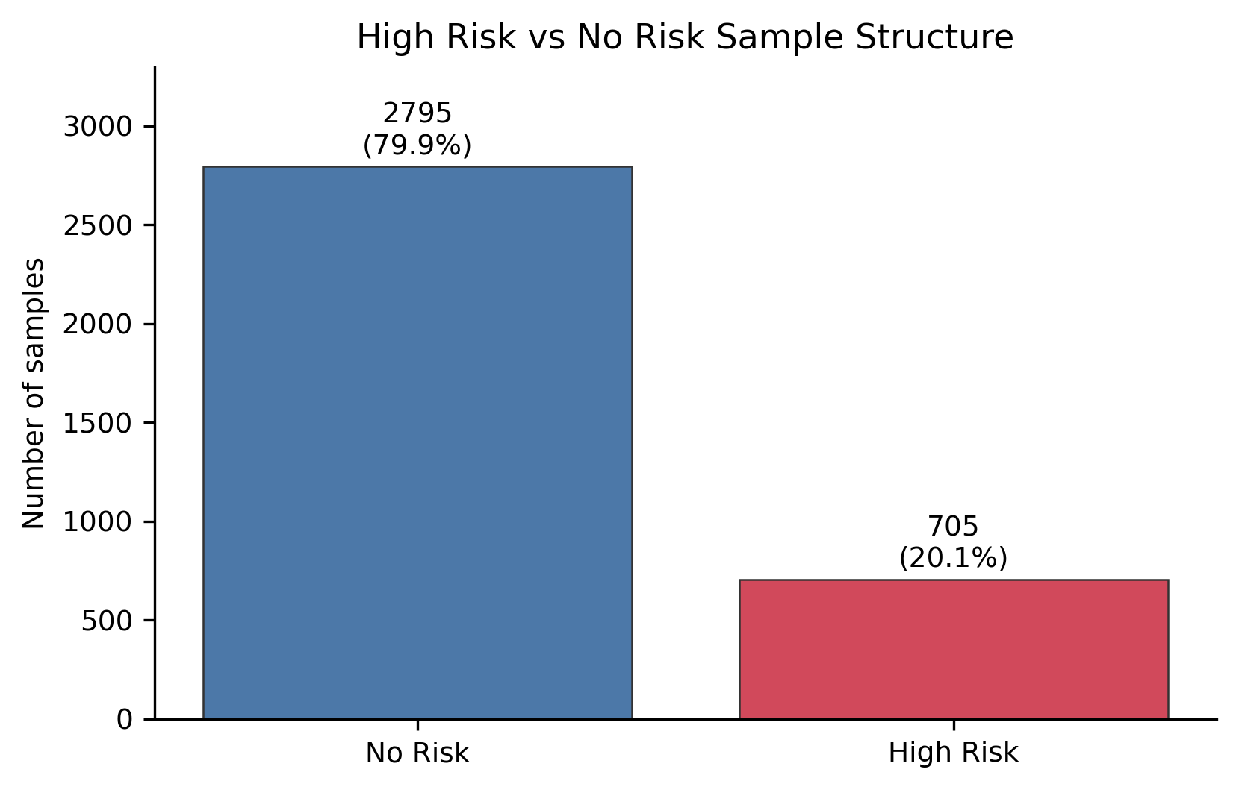
Fig1 High Risk vs No Risk Sample Structure
Fig1 reports 2795 No Risk samples (79.86%) and 705 High Risk samples (20.14%). Because the No Risk class is about four times larger, a classifier can look acceptable on Accuracy while still missing many High Risk cases. This class structure is why the later model evaluation emphasizes Recall, F1, PR-AUC, and the confusion matrix.

4.3 Numeric Feature Distribution
Fig2 summarizes the main numerical variables before modeling.
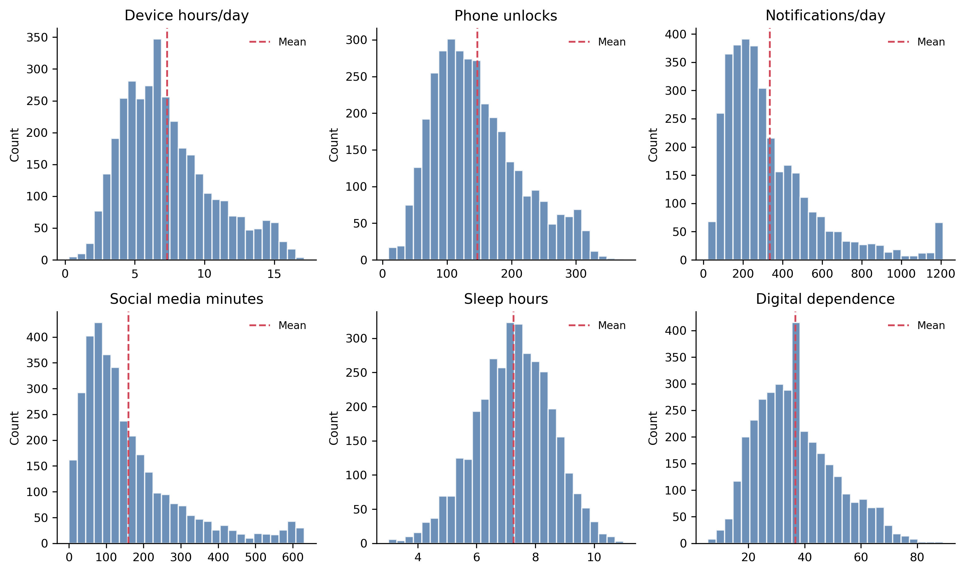
Fig2 Core Digital Lifestyle Feature Distributions
Fig2 indicates that notifications_per_day has a long right tail up to 1,211 and phone_unlocks reaches 374, while sleep_hours stays in a much narrower range from about 3 to 11 hours. This means distance-based steps such as PCA, KMeans, GaussianMixture, and linear models need scaling, whereas tree models can use raw splits more directly.

4.4 Correlation Structure
Fig3 checks the correlation structure among behavior variables, lifestyle variables, and outcomes.
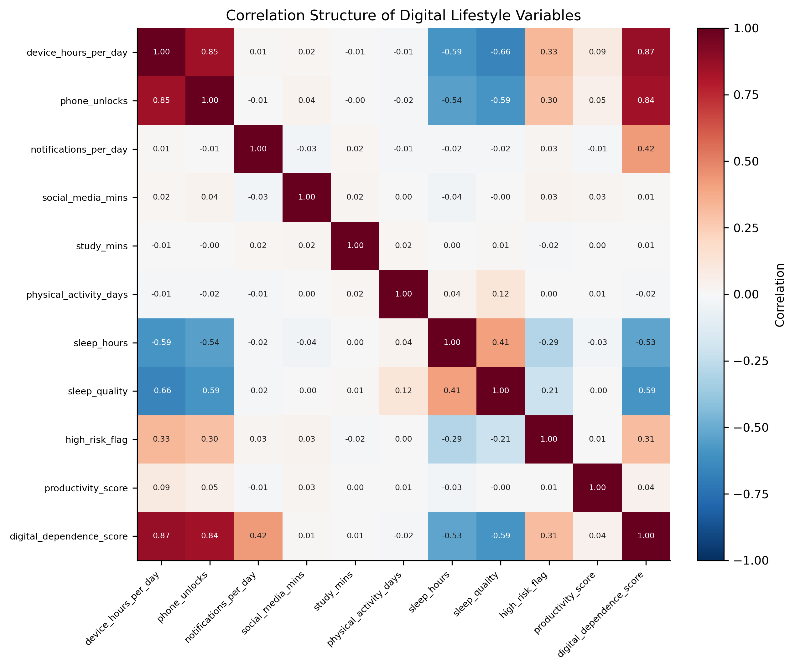
Fig3 Correlation Structure of Digital Lifestyle Variables
Fig3 shows that digital_dependence_score is positively related to device_hours_per_day (r=0.87) and negatively related to sleep_quality (r=-0.59), while productivity_score has a much weaker relationship with device_hours_per_day (r=0.09). This difference helps explain why digital_dependence_score is highly predictable but productivity_score is not. The heatmap is still only correlation evidence and is not used as a causal claim.

4.5 High Risk and No Risk Group Difference
Fig4 compares the High Risk and No Risk groups using the variables with direct behavioral meaning.
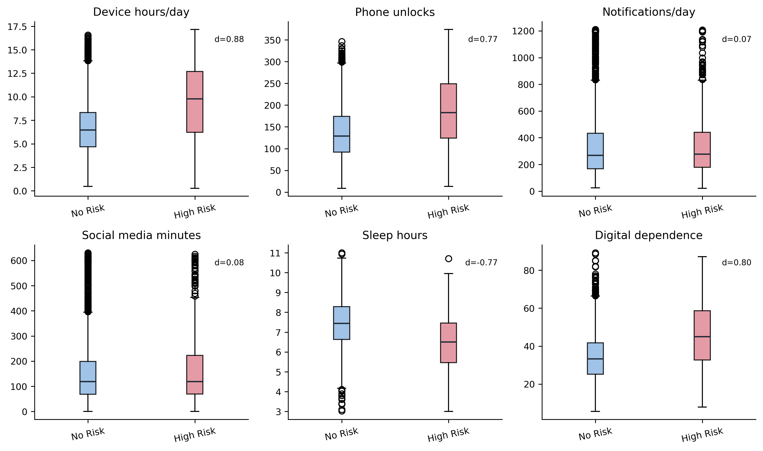
Fig4 Behavioral Difference Between High Risk and No Risk Groups
Fig4 and the statistics in results/high_risk_group_comparison.csv show that the High Risk group has a higher median device_hours_per_day (9.78 vs 6.48) and a higher median digital_dependence_score (45.00 vs 33.40). The largest standardized group difference among the displayed variables is device_hours_per_day (Cohen's d=0.88), followed by digital_dependence_score (d=0.80) and sleep_hours (d=-0.77, lower in the High Risk group). However, notifications_per_day has only a small standardized difference (d=0.07), and the box ranges still overlap across groups. Therefore, no single variable can serve as a reliable rule, which supports the later multi-feature classifier and threshold tuning.

5. Model Training and Evaluation

5.1 Experimental Setup
All supervised experiments use train/test separation, random_state=42, cross-validation or grid-search evidence, and final testing on the held-out test set. Classification focuses on Recall, F1, PR-AUC, ROC-AUC, Balanced Accuracy, and the confusion matrix. Regression focuses on R2, MSE, RMSE, and MAE. Clustering uses inertia, Silhouette, Calinski-Harabasz, Davies-Bouldin, and profile interpretability.

5.2 High Risk Classification
Fig5 replaces the previous Excel screenshot for classification model comparison.
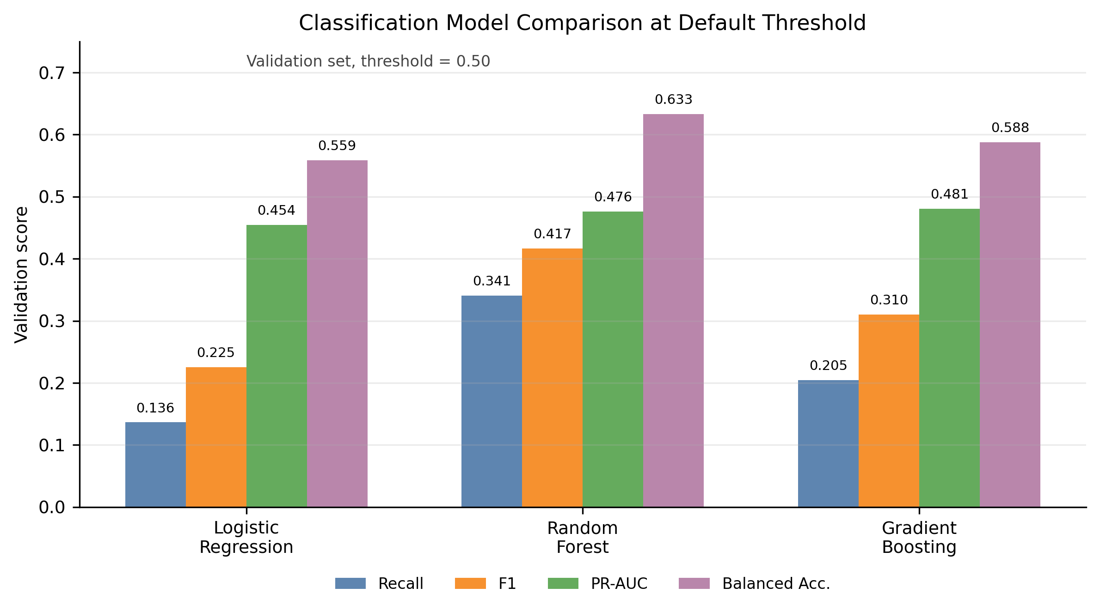
Fig5 Classification Model Comparison at the Default Threshold
At the default threshold of 0.50, Random Forest has the highest Recall (0.3409), F1 (0.4167), and Balanced Accuracy (0.6333), whereas Gradient Boosting has only a slight advantage in PR-AUC (0.4805) and ROC-AUC (0.7233). This comparison does not mean that Gradient Boosting dominates every metric. Gradient Boosting is retained as the probability-ranking model and is then adjusted through threshold tuning to match the recall-oriented screening objective.
Fig6 explains why the final classifier does not use the default threshold of 0.50.
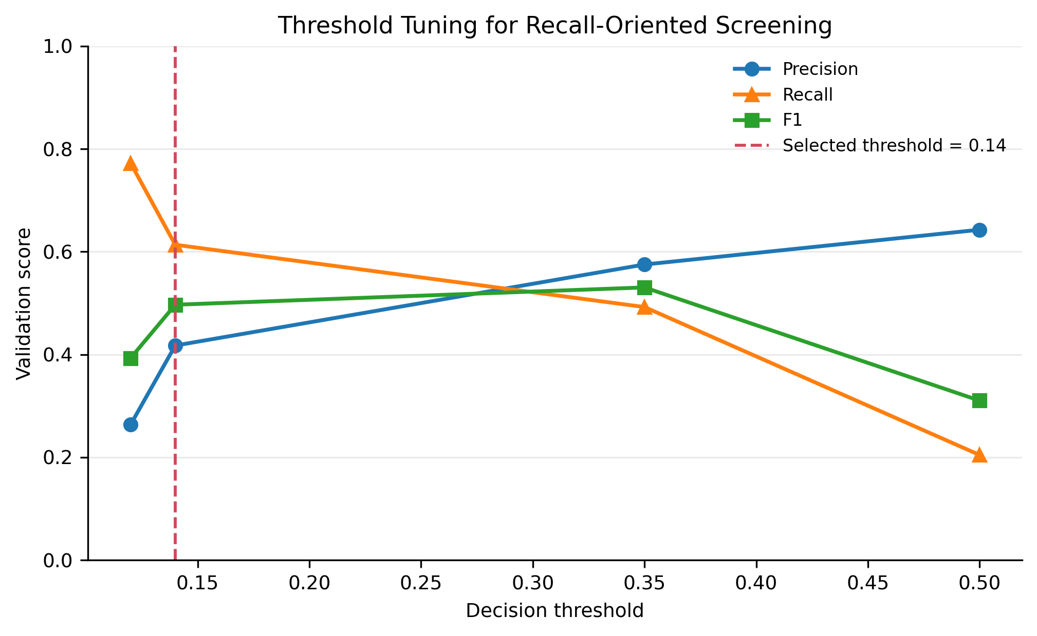
Fig6 Threshold Tuning for Recall-Oriented Screening
As Fig6 indicates, increasing the decision threshold improves precision but sharply reduces recall. The middle threshold has the highest validation F1, while the selected threshold of 0.14 preserves recall above the screening requirement. On the independent test set, this policy reaches Precision=0.4593, Recall=0.6420, F1=0.5355, PR-AUC=0.5084, ROC-AUC=0.7531, and Balanced Accuracy=0.7259. The selected point is therefore a deliberate screening trade-off rather than the threshold that maximizes overall correctness.
Fig7 provides the final test-set confusion matrix for Gradient Boosting at threshold 0.14.
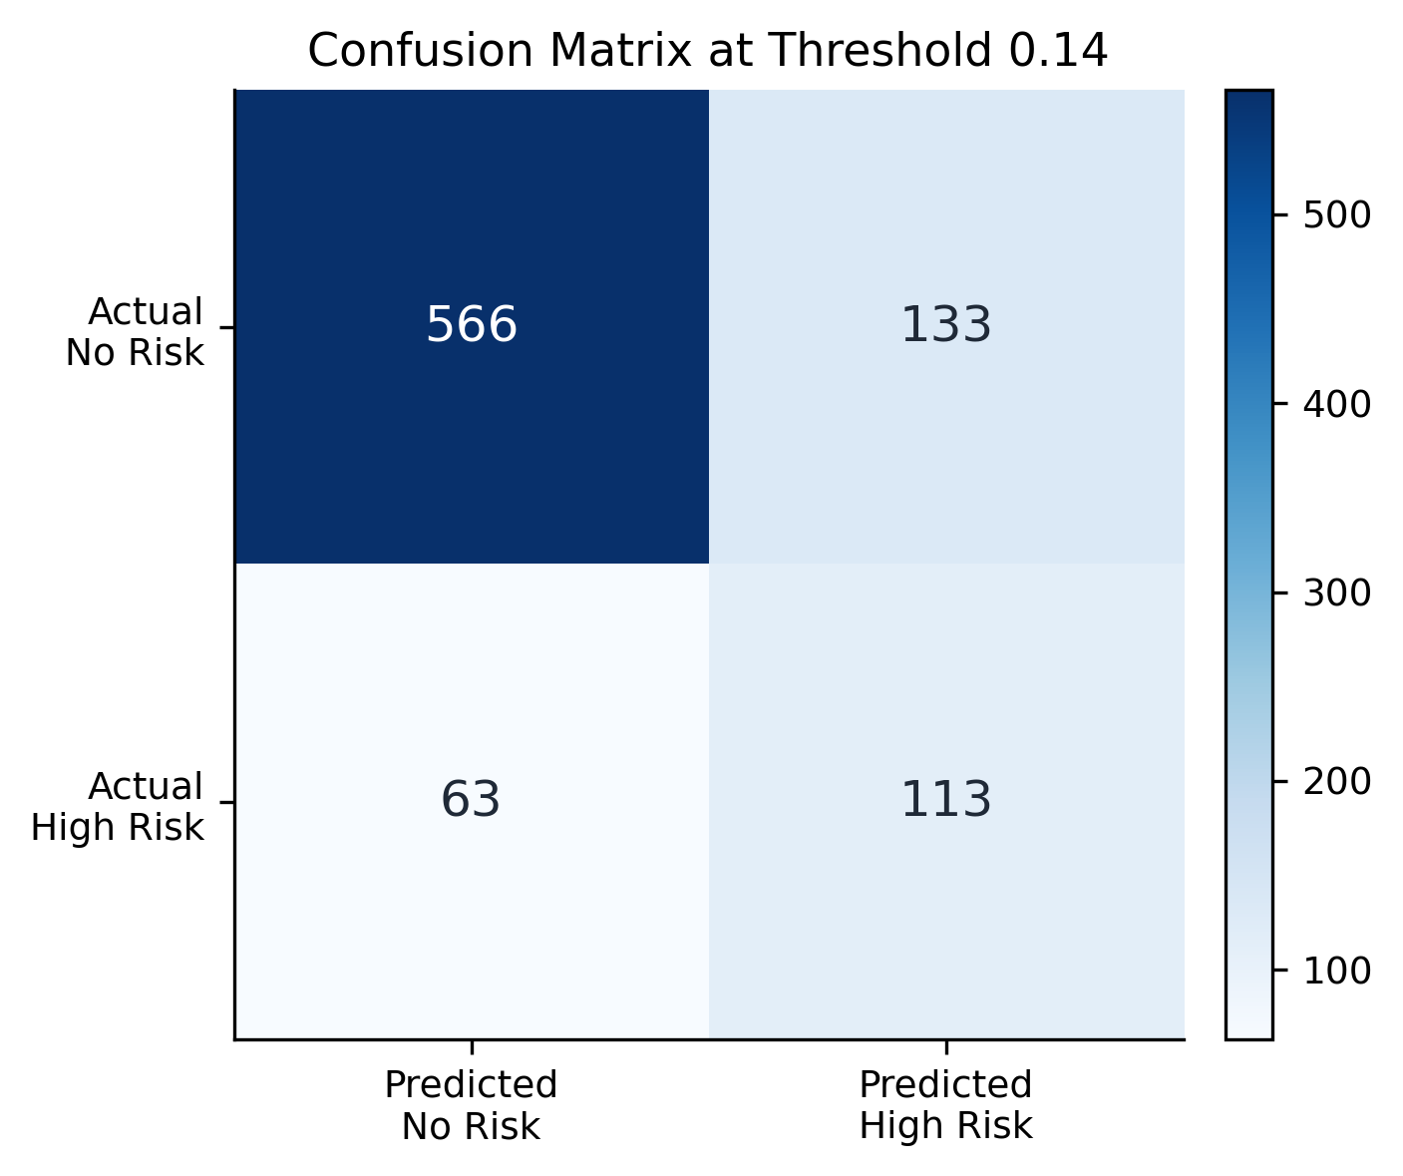
Fig7 Confusion Matrix of the Final High Risk Classifier
Fig7 shows TN=566, FP=133, FN=63, and TP=113. The model finds 113 true High Risk samples but still misses 63 High Risk samples. To reduce missed High Risk cases, it produces 133 false alarms, which is larger than the number of false negatives. This is the direct cost of the recall-oriented policy, so the model should be used as a screening reference rather than a final individual-level conclusion.
Fig8 evaluates the High Risk ranking ability across thresholds.
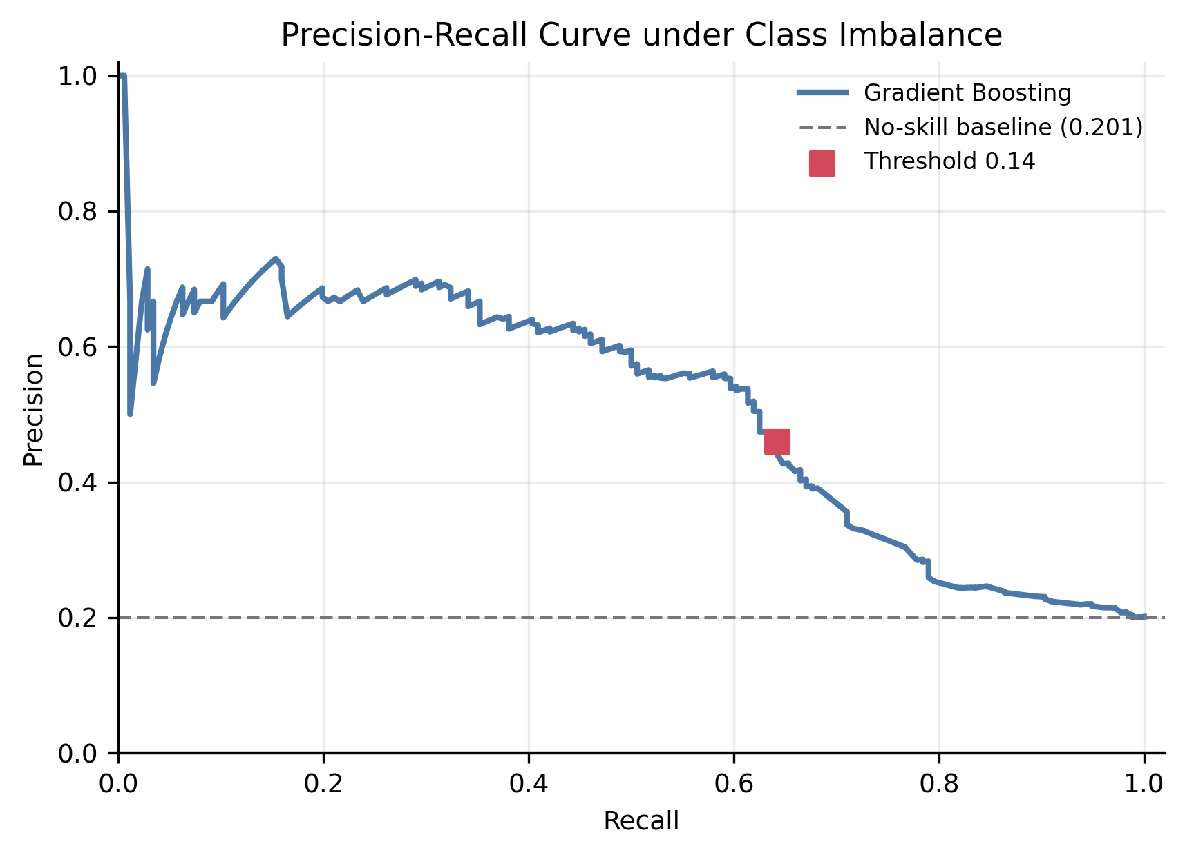
Fig8 Precision-Recall Curve under Class Imbalance
Fig8 includes the no-skill baseline computed from the test-set High Risk proportion, about 20.11%. The PR-AUC is 0.5084, which is clearly above this baseline but still far from a high-precision screening system. This supports the conclusion that the model contains useful ranking information, but the threshold must be chosen carefully and the output should not be treated as a final personal judgment.

5.3 Digital Dependence and Productivity Regression
Fig9 checks whether the final digital_dependence_score predictions align with the observed scores.
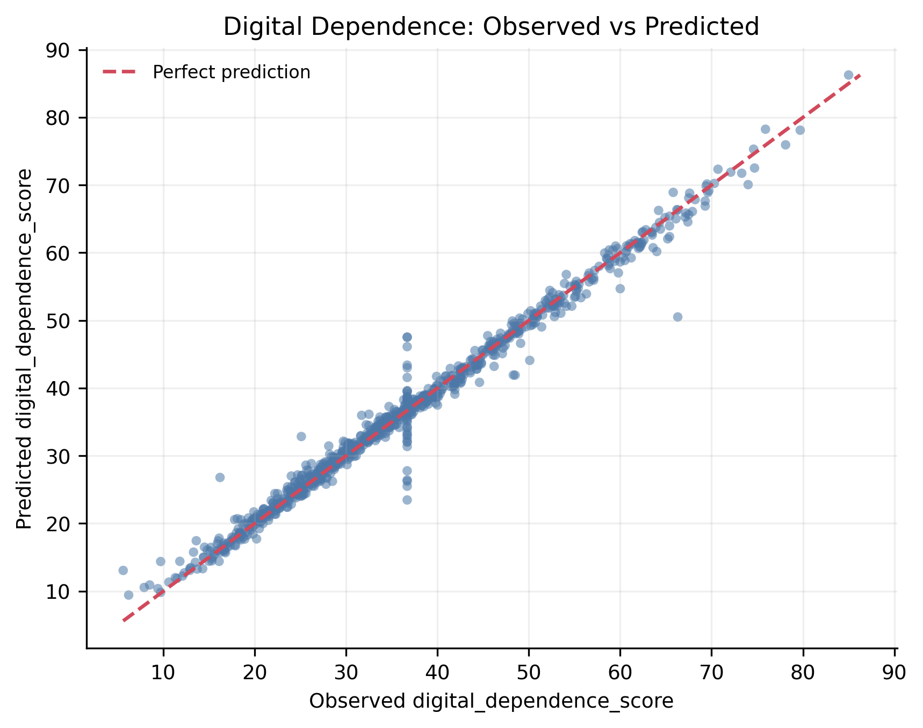
Fig9 Digital Dependence Observed vs Predicted Scores
In Fig9, most points are close to the 45-degree reference line, and the final Gradient Boosting result reaches R2=0.9839, MSE=3.1471, and MAE=0.9982. The point cloud does not show a strong systematic curve away from the diagonal, so the current behavior features provide strong predictive information for this target inside the benchmark dataset. This is still a prediction result, not a causal statement.
Fig10 keeps the productivity_score experiment as a negative-result check.
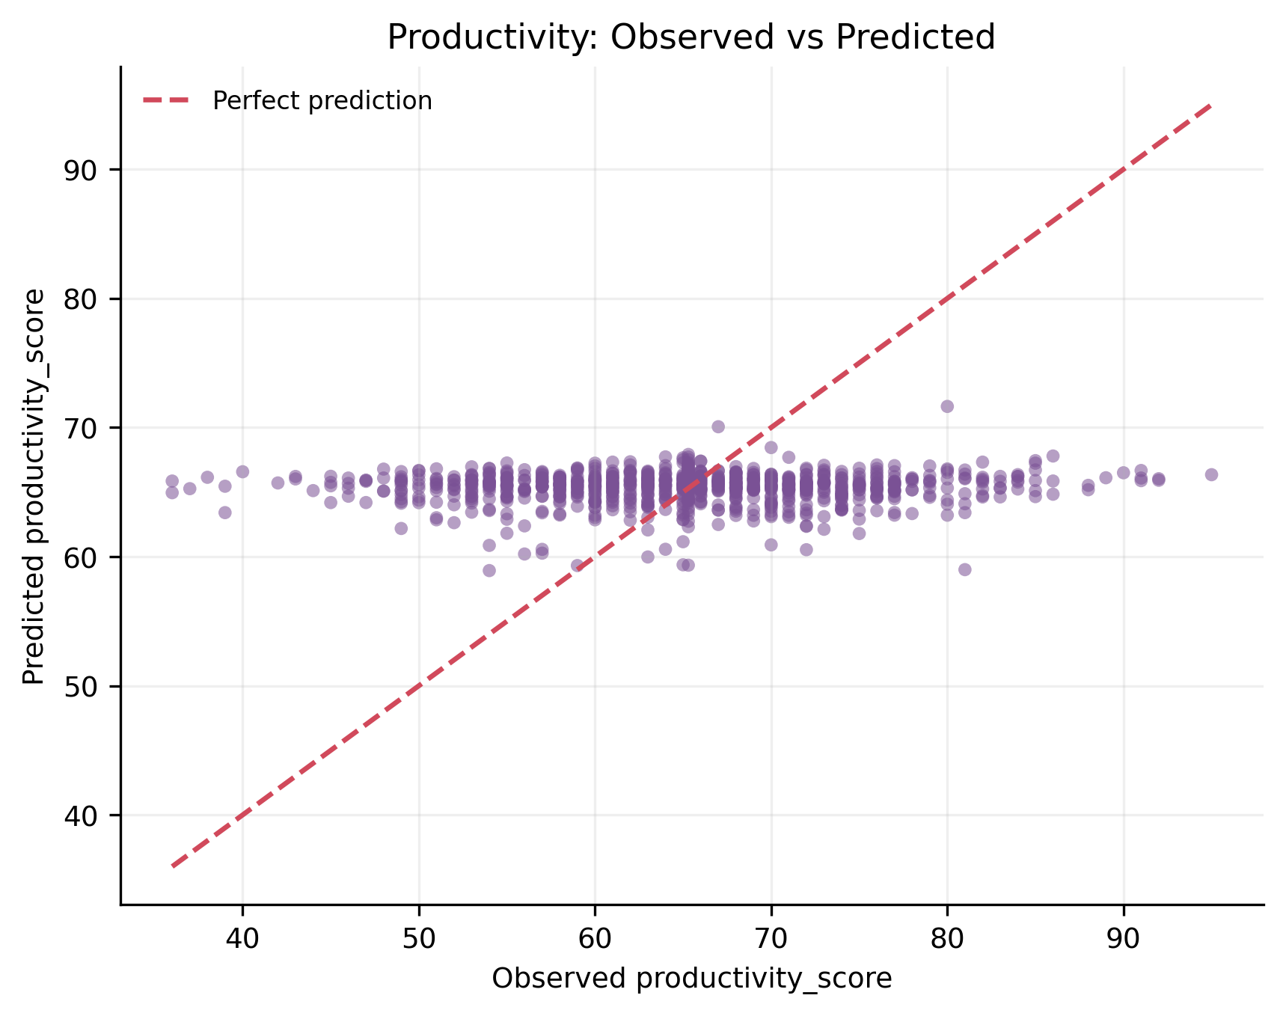
Fig10 Productivity Weak Prediction Observed vs Predicted Scores
Fig10 shows that the observed productivity_score spans about 59.0 points, but the predicted values cover only about 12.7 points and concentrate near the average. This is a regression-to-the-mean pattern. The final R2=-0.0041 means the model does not outperform a simple mean baseline, so the current behavior variables are not enough to explain individual productivity differences.
Fig11 replaces the previous Excel regression comparison screenshot with a formal R2 comparison.
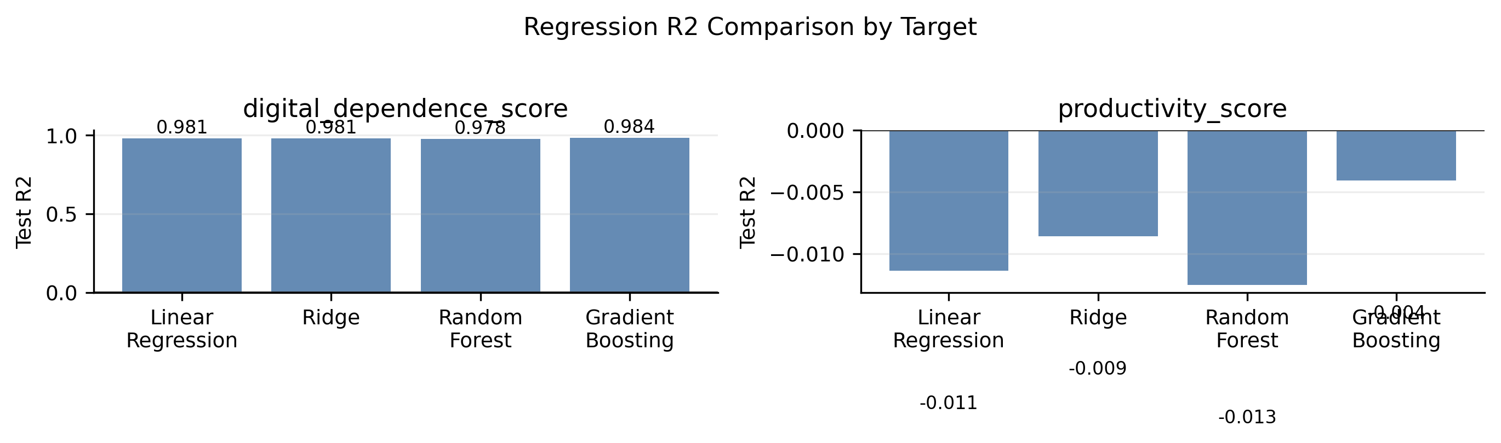
Fig11 Regression R2 Comparison by Target
Fig11 separates the two regression targets so that R2 is not mixed with MSE or MAE on one axis. All models predict digital_dependence_score very well, with Gradient Boosting reaching R2=0.9839. In contrast, all productivity_score R2 values are close to or below zero. The same feature set therefore represents digital dependence strongly but does not explain productivity_score well.

5.4 Digital Lifestyle Clustering
Fig12 replaces the previous clustering model comparison screenshot and combines the key k-selection evidence.
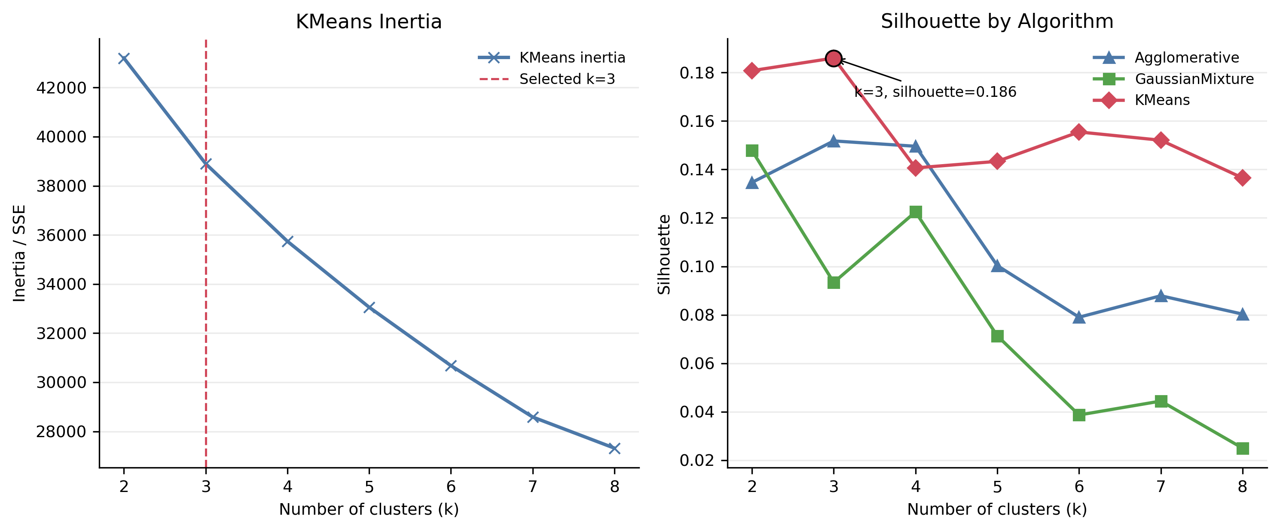
Fig12 K Selection by Inertia and Silhouette
In Fig12, the KMeans inertia curve decreases smoothly rather than forming a sharp elbow. The silhouette panel shows that KMeans reaches its highest tested silhouette at k=3 with Silhouette=0.1860, while AgglomerativeClustering and GaussianMixture do not provide a clearly stronger alternative. Because 0.1860 is low, k=3 is a reasonable and readable exploratory choice, not evidence of strict natural groups.
Fig13 summarizes the final KMeans k=3 lifestyle profiles.
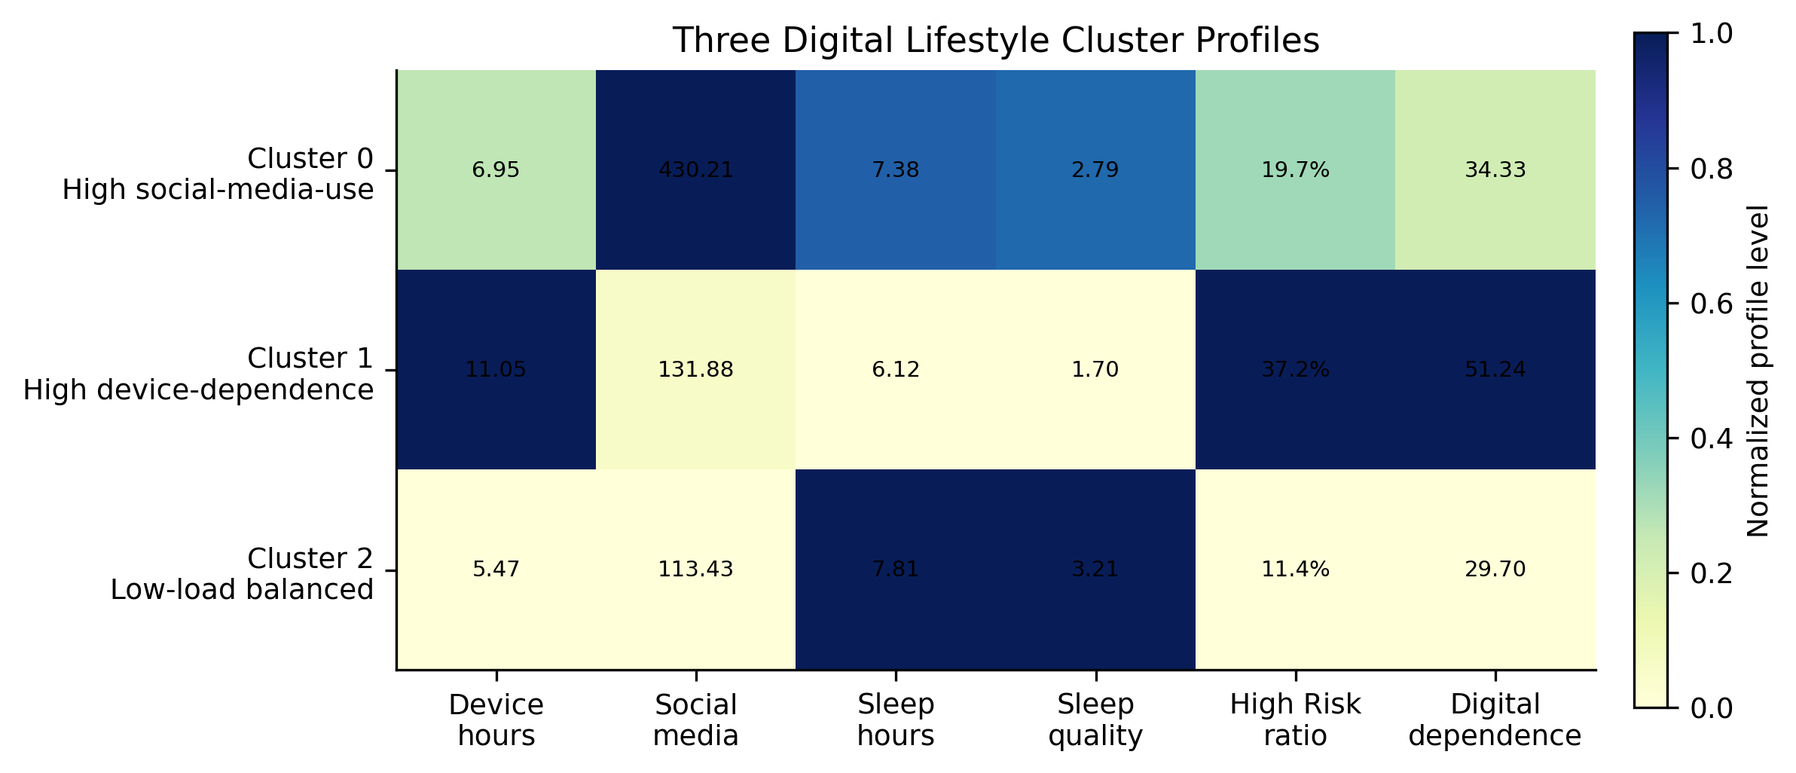
Fig13 Three Digital Lifestyle Cluster Profiles
Fig13 shows that Cluster 0 has very high social_media_mins (430.2) but moderate device_hours_per_day (6.95). Cluster 1 has the highest device_hours_per_day (11.05), the lowest sleep_quality (1.70), the highest High Risk ratio (37.2%), and the highest digital_dependence_score (51.24). Cluster 2 has the lowest device_hours_per_day (5.47) and the lowest High Risk ratio (11.4%). These patterns support the names High social-media-use, High device-dependence, and Low-load balanced, but the low silhouette score means the profiles should be treated as gradual summaries.
Fig14 provides the PCA evidence used to discuss dimensionality reduction.
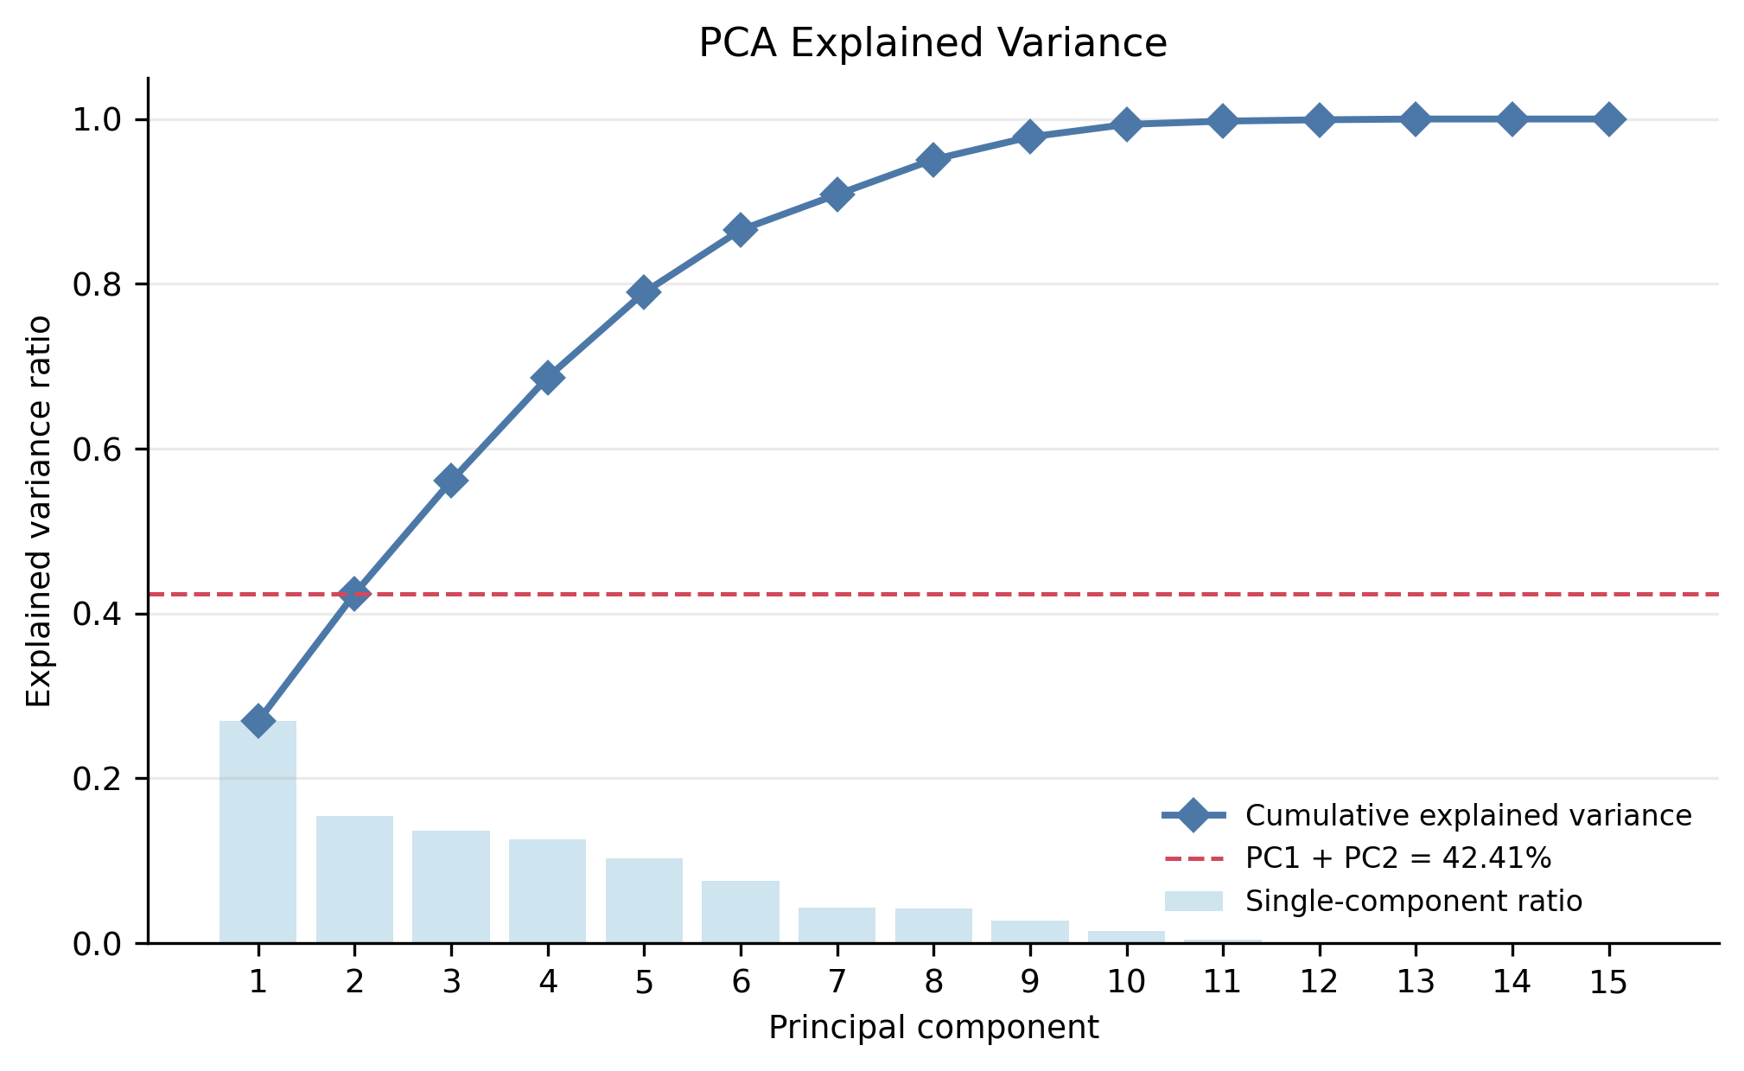
Fig14 PCA Explained Variance for Dimensionality Reduction
Fig14 shows that the first two principal components explain 42.41% of the total variance, leaving 57.59% outside the two-dimensional view. The cumulative curve reaches 80% only after 6 components. Therefore, PCA is useful for auxiliary visualization and structure understanding, but it should not replace the original feature space for classification, regression, or final clustering evaluation.

5.5 Integrated Result Analysis
The model evidence forms a consistent chain. EDA explains class imbalance and group overlap, so classification is handled as recall-oriented screening. The regression comparison explains why digital_dependence_score is the main regression target and productivity_score remains a weak result. The clustering evidence gives readable profiles, but the low silhouette value prevents the report from claiming strict population segmentation.

6. Findings and Reflection

6.1 Main Findings
High Risk can be screened from behavior variables, but the final threshold trades more false alarms for fewer missed High Risk cases.
digital_dependence_score is strongly represented by the current behavior features in this benchmark dataset, with R2=0.9839.
productivity_score remains a weak-prediction target, with R2=-0.0041, which shows that the feature set does not explain every outcome equally.
The KMeans k=3 clusters are readable lifestyle profiles, but Silhouette=0.1860 means they are exploratory summaries rather than strict groups.

6.2 Limitations
The dataset is a benchmark/synthetic educational dataset, so the high R2 for digital_dependence_score may partly reflect the data-generation structure. The classification recall is not 100%, productivity_score is not explained well, and the clustering silhouette is low. External validation with real digital lifestyle data would be needed before stronger practical claims could be made.

6.3 Personal Reflection
This revision helped me understand that figures and tables should not be decoration. Each visual item needs a question, a data-supported observation, and a conclusion that connects to the next step. The most important lesson is that a complete data-analysis report is not only a list of model scores; it is a traceable workflow from raw data to cleaning, visualization, model evaluation, and honest interpretation.

Appendix A Complete Runnable Code

A.1 Environment and Dependencies
The experiment was completed with a CPU-based Python environment. The main dependencies are pandas, NumPy, scikit-learn, Matplotlib, openpyxl, python-docx, and joblib. The environment can be installed with: pip install -r requirements.txt.

A.2 Complete Code
The complete runnable code is copied from appendix_A_complete_code.py.
﻿"""Complete runnable code source for Appendix A.

Run from the project directory:
python appendix_A_complete_code.py

Or run from the repository root:
python <project_dir>/appendix_A_complete_code.py

This file rebuilds the final report evidence files without changing the
validated core CSV metrics. It loads the raw dataset, checks data quality,
creates engineered features, documents leakage control, regenerates the final
figures, exports screenshot Excel tables, and summarizes the validated results.
"""

from __future__ import annotations

import runpy
from pathlib import Path

import pandas as pd

PROJECT_ROOT = Path(__file__).resolve().parent
RAW_DATA_PATH = PROJECT_ROOT / "data" / "raw" / "digital_lifestyle_benchmark_2025.csv"
PROCESSED_DATA_PATH = PROJECT_ROOT / "data" / "processed" / "digital_lifestyle_benchmark_2025_processed.csv"
RESULTS_DIR = PROJECT_ROOT / "results"
FIGURE_DIR = PROJECT_ROOT / "figures" / "final_report"
SCREENSHOT_TABLE_DIR = PROJECT_ROOT / "screenshot_tables"
RANDOM_STATE = 42

def load_raw_data() -> pd.DataFrame:
df = pd.read_csv(RAW_DATA_PATH)
print("Raw dataset shape:", df.shape)
print("Raw columns:", df.columns.tolist())
print(df.head())
return df

def check_missing_duplicates_and_ranges(df: pd.DataFrame) -> None:
key_numeric = [
"age",
"device_hours_per_day",
"phone_unlocks",
"notifications_per_day",
"social_media_mins",
"study_mins",
"sleep_hours",
"sleep_quality",
"productivity_score",
"digital_dependence_score",
]
print("\nMissing values:")
print(df.isna().sum())
print("\nDuplicate rows:", df.duplicated().sum())
print("Duplicate id:", df["id"].duplicated().sum())
print("\nRange summary:")
print(df[key_numeric].agg(["min", "max", "mean"]).T)

def add_engineered_features(df: pd.DataFrame) -> pd.DataFrame:
engineered = df.copy()
eps = 1e-6
engineered["social_media_hours"] = engineered["social_media_mins"] / 60
engineered["study_hours"] = engineered["study_mins"] / 60
engineered["notifications_per_device_hour"] = (
engineered["notifications_per_day"] / engineered["device_hours_per_day"].clip(lower=eps)
)
engineered["unlocks_per_device_hour"] = (
engineered["phone_unlocks"] / engineered["device_hours_per_day"].clip(lower=eps)
)
engineered["device_to_sleep_ratio"] = (
engineered["device_hours_per_day"] / engineered["sleep_hours"].clip(lower=eps)
)
engineered["activity_sleep_interaction"] = (
engineered["physical_activity_days"] * engineered["sleep_hours"]
)
engineered["social_to_study_ratio"] = engineered["social_media_mins"] / (
engineered["study_mins"] + 1
)
engineered.to_csv(PROCESSED_DATA_PATH, index=False)
print("\nProcessed dataset saved:", PROCESSED_DATA_PATH)
return engineered

def define_feature_sets(engineered: pd.DataFrame) -> dict[str, list[str]]:
outcome_cols = [
"anxiety_score",
"depression_score",
"stress_level",
"happiness_score",
"focus_score",
"high_risk_flag",
"productivity_score",
"digital_dependence_score",
]
classification_drop = [
"id",
"high_risk_flag",
"anxiety_score",
"depression_score",
"stress_level",
"happiness_score",
"focus_score",
"productivity_score",
"digital_dependence_score",
]

def regression_drop_for(target: str) -> list[str]:
drop_cols = {"id", target}
drop_cols.update(outcome_cols)
if target == "digital_dependence_score":
drop_cols.add("productivity_score")
if target == "productivity_score":
drop_cols.add("digital_dependence_score")
return sorted(drop_cols)

digital_dependence_drop = regression_drop_for("digital_dependence_score")
productivity_drop = regression_drop_for("productivity_score")
clustering_features = [
"device_hours_per_day",
"phone_unlocks",
"notifications_per_day",
"social_media_mins",
"study_mins",
"physical_activity_days",
"sleep_hours",
"sleep_quality",
"social_media_hours",
"study_hours",
"notifications_per_device_hour",
"unlocks_per_device_hour",
"device_to_sleep_ratio",
"activity_sleep_interaction",
"social_to_study_ratio",
]
classification_features = [c for c in engineered.columns if c not in classification_drop]
digital_dependence_features = [c for c in engineered.columns if c not in digital_dependence_drop]
productivity_features = [c for c in engineered.columns if c not in productivity_drop]
print("\nClassification drop columns:", classification_drop)
print("Classification feature count:", len(classification_features))
print("Digital dependence regression feature count:", len(digital_dependence_features))
print("Productivity regression feature count:", len(productivity_features))
print("Clustering features:", clustering_features)
return {
"classification_drop": classification_drop,
"classification_features": classification_features,
"digital_dependence_drop": digital_dependence_drop,
"digital_dependence_features": digital_dependence_features,
"productivity_drop": productivity_drop,
"productivity_features": productivity_features,
"clustering_features": clustering_features,
}

def summarize_validated_results() -> None:
classification = pd.read_csv(RESULTS_DIR / "classification_tuned_metrics.csv")
regression_dd = pd.read_csv(RESULTS_DIR / "regression_digital_dependence_metrics.csv")
regression_prod = pd.read_csv(RESULTS_DIR / "regression_productivity_metrics.csv")
clustering = pd.read_csv(RESULTS_DIR / "clustering_kmeans_scores.csv")

final_cls = classification[
(classification["dataset"] == "test")
& (classification["model"] == "gradient_boosting")
& (classification["threshold"].round(2) == 0.14)
].iloc[0]
final_dd = regression_dd[regression_dd["model"] == "gradient_boosting"].iloc[0]
final_prod = regression_prod[regression_prod["model"] == "gradient_boosting"].iloc[0]
final_cluster = clustering[clustering["k"] == 3].iloc[0]

summary = pd.DataFrame(
[
{
"task": "classification_high_risk",
"main_result": "Gradient Boosting threshold=0.14",
"metric_1": f"Recall={final_cls['recall']:.4f}",
"metric_2": f"F1={final_cls['f1']:.4f}",
"metric_3": f"PR-AUC={final_cls['pr_auc']:.4f}",
},
{
"task": "regression_digital_dependence",
"main_result": "Gradient Boosting",
"metric_1": f"R2={final_dd['r2']:.4f}",
"metric_2": f"MSE={final_dd['mse']:.4f}",
"metric_3": f"MAE={final_dd['mae']:.4f}",
},
{
"task": "regression_productivity",
"main_result": "weak prediction / negative result",
"metric_1": f"R2={final_prod['r2']:.4f}",
"metric_2": "",
"metric_3": "",
},
{
"task": "clustering_lifestyle_profiles",
"main_result": "KMeans k=3",
"metric_1": f"Silhouette={final_cluster['silhouette']:.4f}",
"metric_2": "",
"metric_3": "",
},
]
)
output = RESULTS_DIR / "final_workflow_report_summary.csv"
summary.to_csv(output, index=False)
print("\nValidated result summary saved:", output)

def regenerate_figures_and_screenshot_tables() -> None:
FIGURE_DIR.mkdir(parents=True, exist_ok=True)
SCREENSHOT_TABLE_DIR.mkdir(parents=True, exist_ok=True)
runpy.run_path(str(PROJECT_ROOT / "scripts" / "generate_final_report_figures.py"), run_name="__main__")
runpy.run_path(str(PROJECT_ROOT / "scripts" / "export_screenshot_tables.py"), run_name="__main__")

def main() -> None:
print("Random state:", RANDOM_STATE)
df = load_raw_data()
check_missing_duplicates_and_ranges(df)
engineered = add_engineered_features(df)
define_feature_sets(engineered)
summarize_validated_results()
regenerate_figures_and_screenshot_tables()
print("\nComplete workflow evidence generation finished.")

if __name__ == "__main__":
main()

