Hubei University

Academic Year 2025 -- 2026
Semester 2

Student Laboratory Report Book

Institute： Manchester United College
Student Name： Qin Tian
Class： 2402
Student ID： 202431123002054
Course Course： Big Data Analysis
Instructor： Li Jie

Student Laboratory Rules

1. Students must conduct experiments at the scheduled time and may not be absent or late without cause.
2. Before each experiment, students must preview the assigned experiment and prepare a preview report as required.
3. Before each experiment, students must submit the previous experiment report and the preview report for the current experiment. The experiment may begin only after the instructor has checked and approved them.
4. After reaching their assigned lab station, students must check the instruments they use against the equipment list for any missing or damaged items. Any problems must be reported to the instructor promptly. Using another group's instruments without authorization is strictly forbidden.
5. During the experiment, students must maintain a rigorous scientific attitude and strictly follow instrument operating procedures and precautions.
6. After the experiment, students must submit their data to the instructor for inspection. Once approved, they should restore and organize the instruments and equipment before leaving the lab.
7. Keep the laboratory quiet and tidy. Loud talking, littering, and eating are prohibited.
8. If an accident or damage to instruments or equipment is caused by violating operating procedures or conducting experiments without permission, it must be reported promptly. A damage list must be completed, and compensation shall be made according to the college's relevant regulations.

Big Data Analysis and Application Experiment 1

Laboratory: Innovation & Entrepreneurship 604 Date: 2026.3.20

- Problem Description
This experiment uses employee attrition data from pfm_train.csv and pfm_test.csv. The task in this part is not the final prediction model yet. What I need to do first is prepare the raw data for the later logistic regression work.

In the original files, the training set contains the target column Attrition, while the test set does not. So the main problem is not hard to see: before modeling, I need to check the dataset structure, find useless columns, handle text features that can not go into the model directly, and keep the processed train and test data in the same feature format.
2. Basic Approach
First, I read the two csv files with pandas and check their shape, column types, missing values, duplicate rows, and constant columns. This step helps me know what kind of cleaning is really needed, instead of changing the data without checking it first.

After the inspection, I remove Over18, StandardHours, and EmployeeNumber, because they do not provide useful information for prediction. Then I use pd.get_dummies() to encode the categorical columns, split the training data into X_train and y_train, and use reindex() to keep the test set aligned with the training feature columns. In the last step, I standardize the original numeric features by StandardScaler, fitting on the training set first and applying the same rule to the test set.

3. Source Code
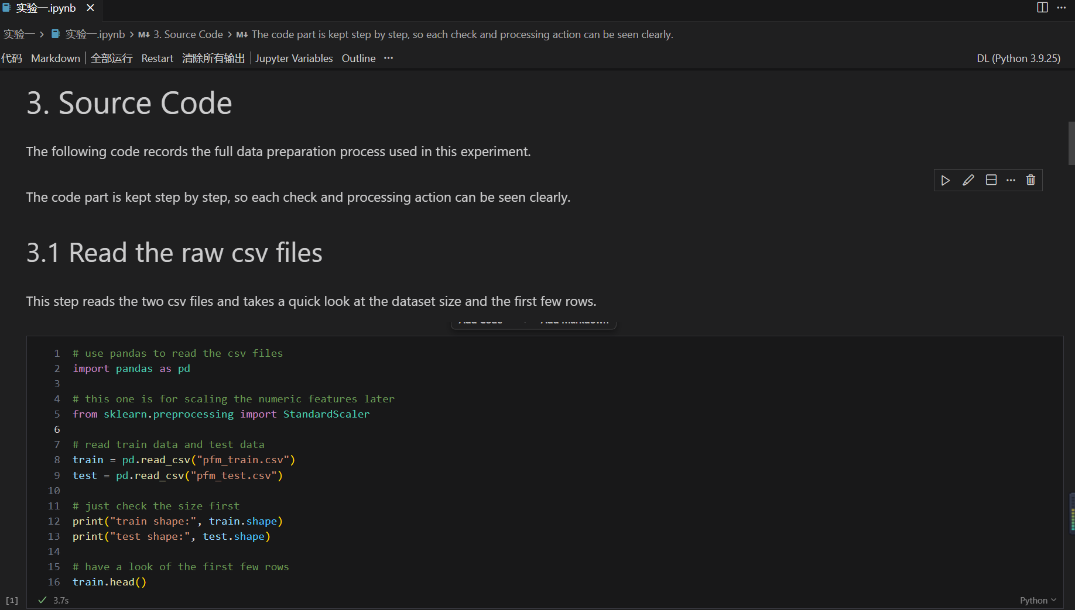
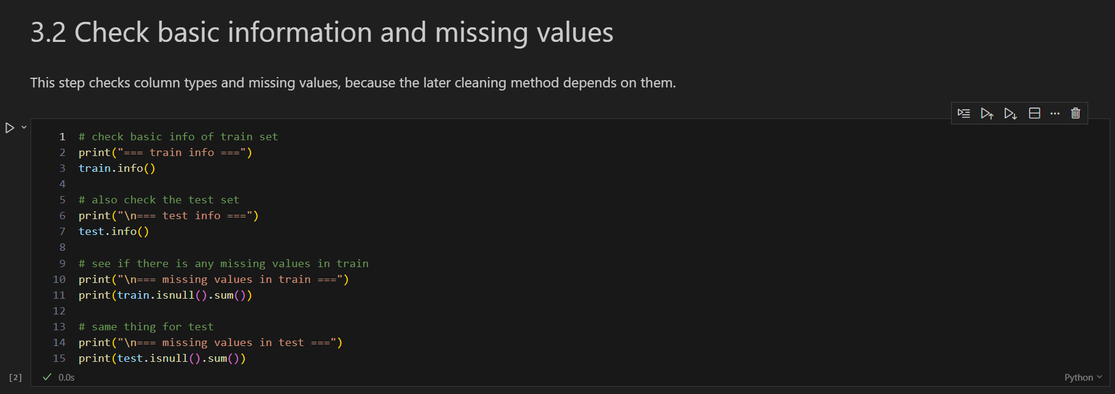
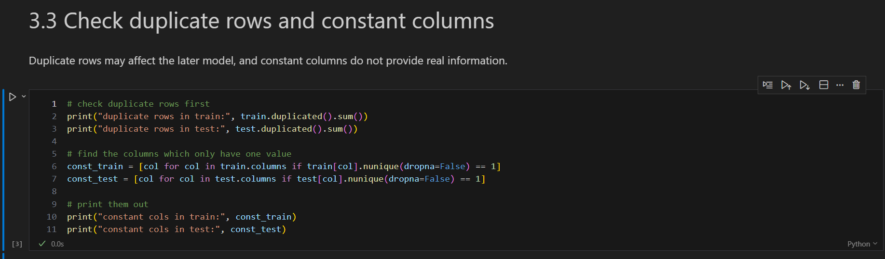
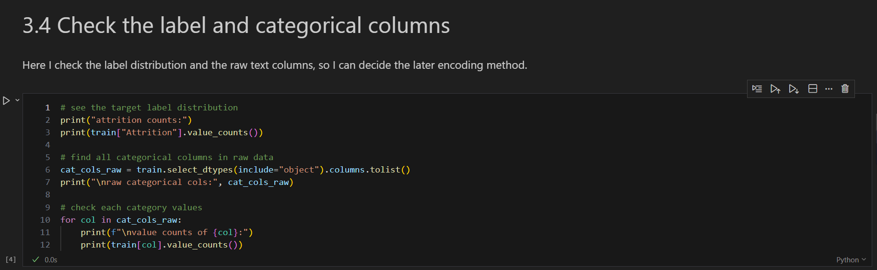
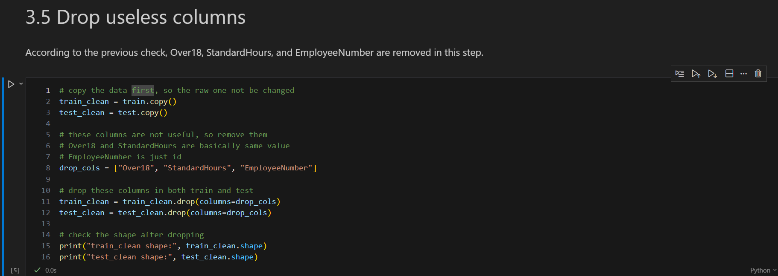
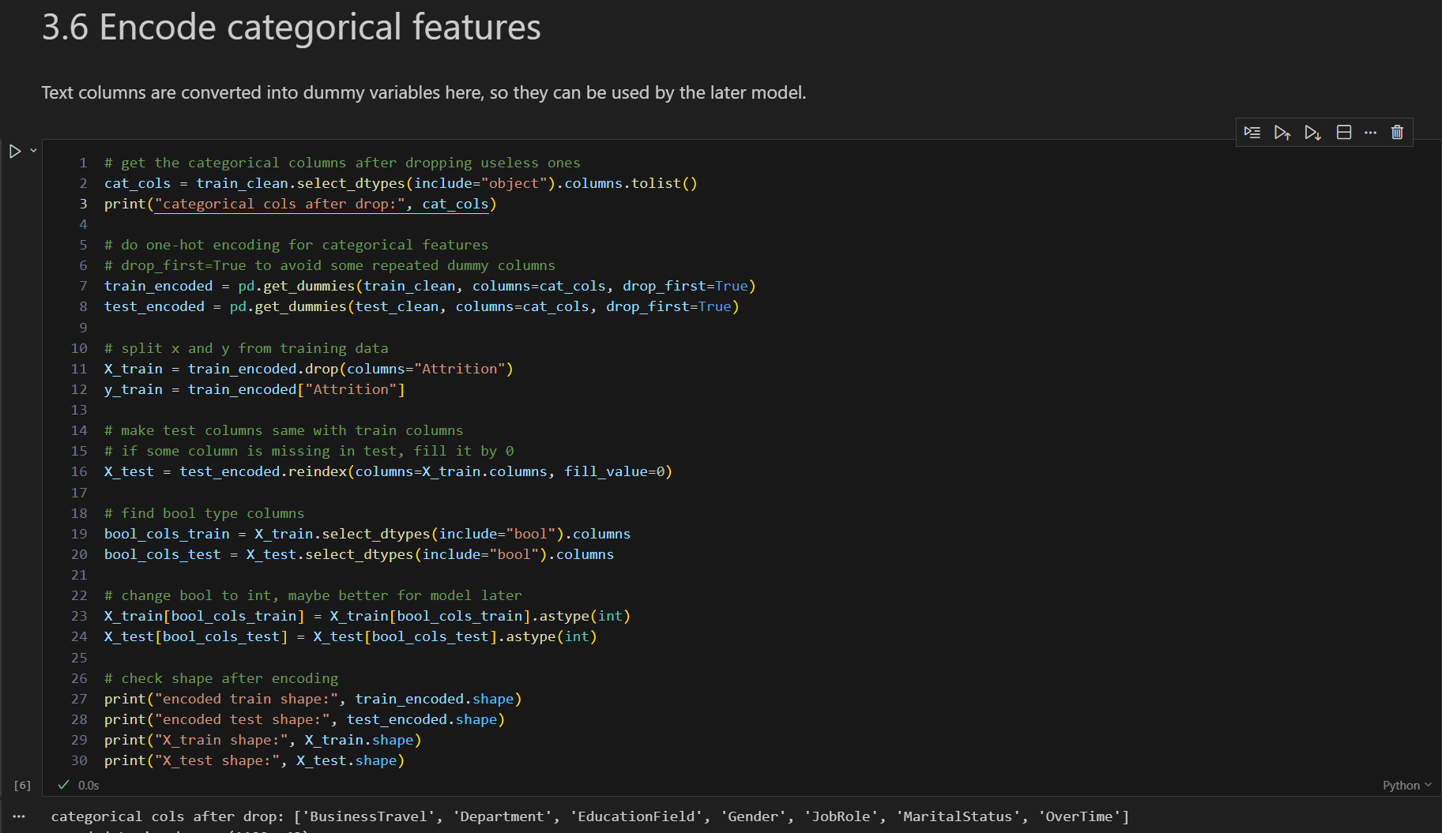

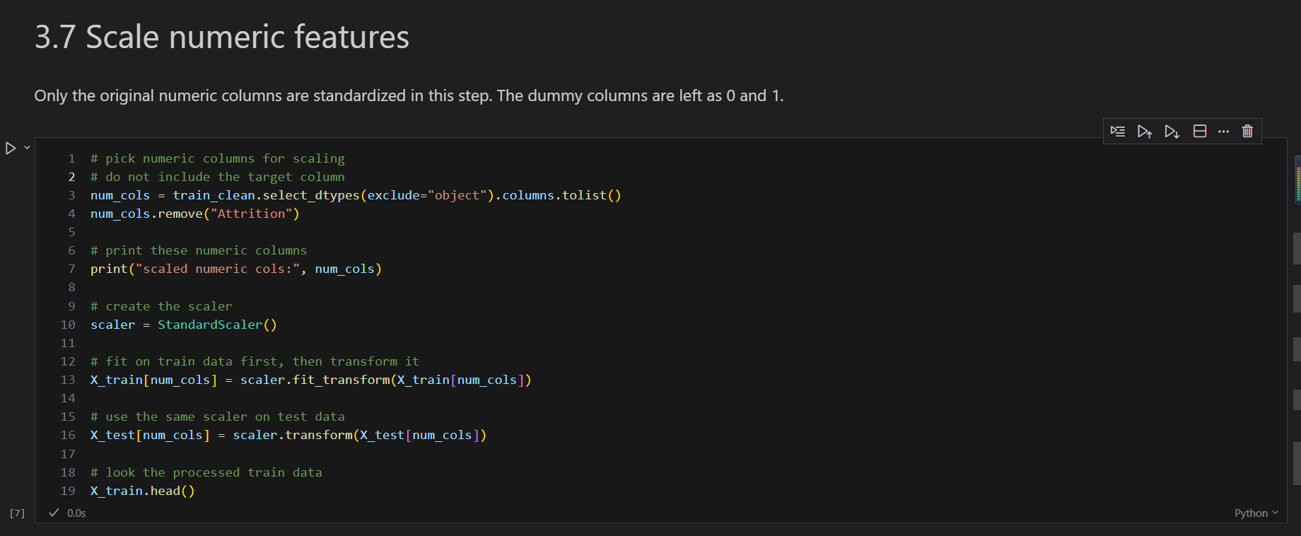
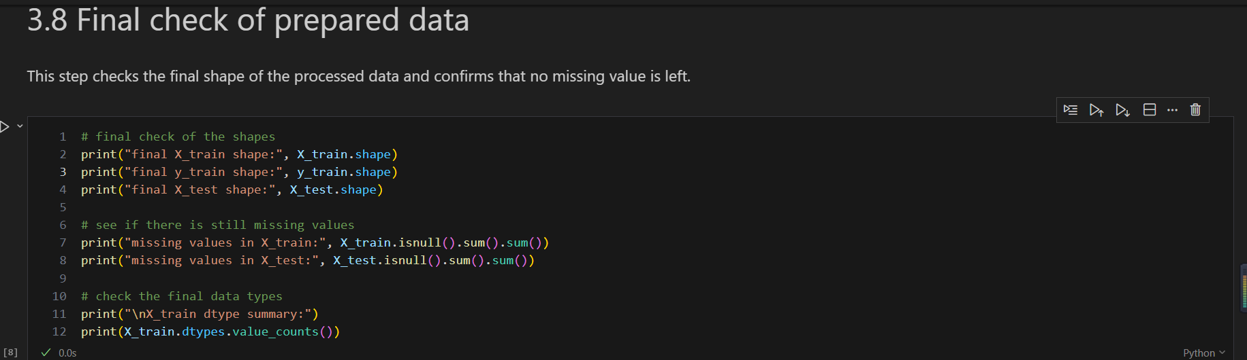
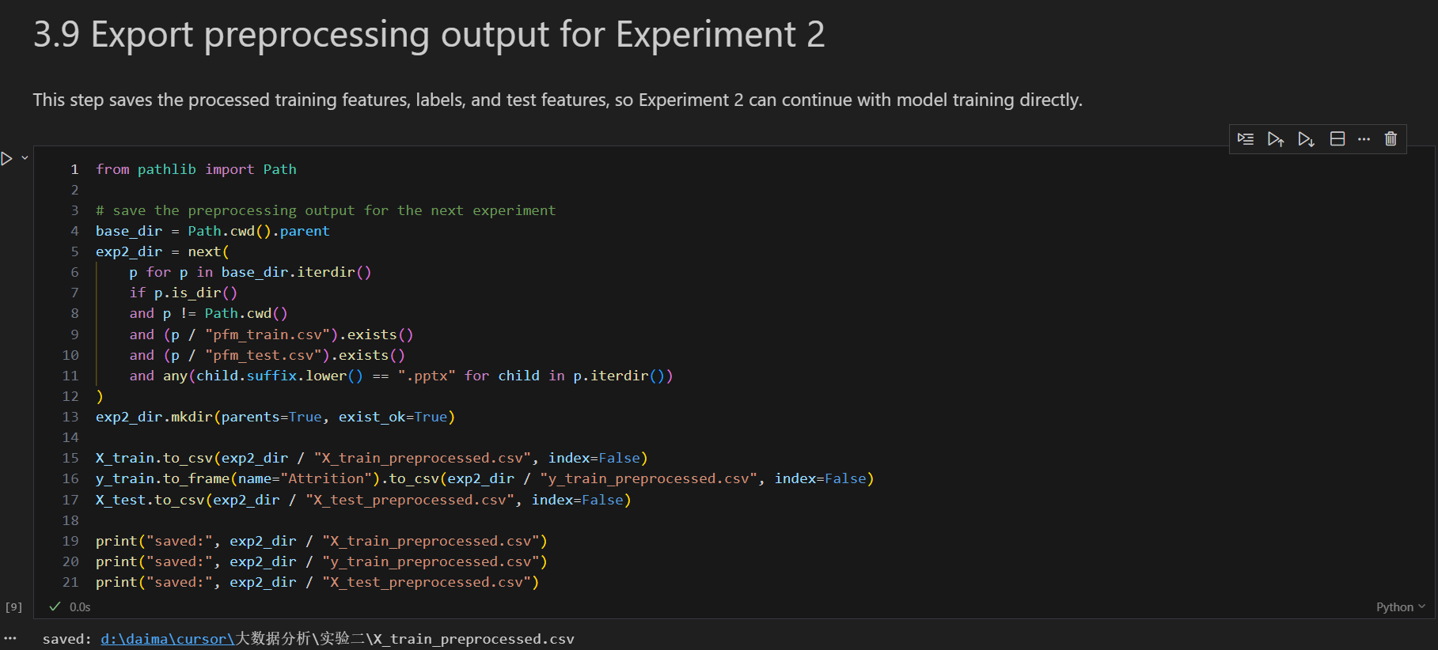

############################################################
# Part 1. Read the raw csv files
############################################################

# use pandas to read the csv files
import pandas as pd

# this one is for scaling the numeric features later
from sklearn.preprocessing import StandardScaler

# read train data and test data
train = pd.read_csv("pfm_train.csv")
test = pd.read_csv("pfm_test.csv")

# just check the size first
print("train shape:", train.shape)
print("test shape:", test.shape)

# have a look of the first few rows
train.head()

############################################################
# Part 2. Check basic information and missing values
############################################################

# check basic info of train set
print("=== train info ===")
train.info()

# also check the test set
print("\n=== test info ===")
test.info()

# see if there is any missing values in train
print("\n=== missing values in train ===")
print(train.isnull().sum())

# same thing for test
print("\n=== missing values in test ===")
print(test.isnull().sum())

############################################################
# Part 3. Check duplicate rows and constant columns
############################################################

# check duplicate rows first
print("duplicate rows in train:", train.duplicated().sum())
print("duplicate rows in test:", test.duplicated().sum())

# find the columns which only have one value
const_train = [col for col in train.columns if train[col].nunique(dropna=False) == 1]
const_test = [col for col in test.columns if test[col].nunique(dropna=False) == 1]

# print them out
print("constant cols in train:", const_train)
print("constant cols in test:", const_test)

############################################################
# Part 4. Check the label and categorical columns
############################################################

# see the target label distribution
print("attrition counts:")
print(train["Attrition"].value_counts())

# find all categorical columns in raw data
cat_cols_raw = train.select_dtypes(include="object").columns.tolist()
print("\nraw categorical cols:", cat_cols_raw)

# check each category values
for col in cat_cols_raw:
print(f"\nvalue counts of {col}:")
print(train[col].value_counts())

############################################################
# Part 5. Drop useless columns
############################################################

# copy the data first, so the raw one not be changed
train_clean = train.copy()
test_clean = test.copy()

# these columns are not useful, so remove them
# Over18 and StandardHours are basically same value
# EmployeeNumber is just id
drop_cols = ["Over18", "StandardHours", "EmployeeNumber"]

# drop these columns in both train and test
train_clean = train_clean.drop(columns=drop_cols)
test_clean = test_clean.drop(columns=drop_cols)

# check the shape after dropping
print("train_clean shape:", train_clean.shape)
print("test_clean shape:", test_clean.shape)

############################################################
# Part 6. Encode categorical features
############################################################

# get the categorical columns after dropping useless ones
cat_cols = train_clean.select_dtypes(include="object").columns.tolist()
print("categorical cols after drop:", cat_cols)

# do one-hot encoding for categorical features
# drop_first=True to avoid some repeated dummy columns
train_encoded = pd.get_dummies(train_clean, columns=cat_cols, drop_first=True)
test_encoded = pd.get_dummies(test_clean, columns=cat_cols, drop_first=True)

# split x and y from training data
X_train = train_encoded.drop(columns="Attrition")
y_train = train_encoded["Attrition"]

# make test columns same with train columns
# if some column is missing in test, fill it by 0
X_test = test_encoded.reindex(columns=X_train.columns, fill_value=0)

# find bool type columns
bool_cols_train = X_train.select_dtypes(include="bool").columns
bool_cols_test = X_test.select_dtypes(include="bool").columns

# change bool to int, maybe better for model later
X_train[bool_cols_train] = X_train[bool_cols_train].astype(int)
X_test[bool_cols_test] = X_test[bool_cols_test].astype(int)

# check shape after encoding
print("encoded train shape:", train_encoded.shape)
print("encoded test shape:", test_encoded.shape)
print("X_train shape:", X_train.shape)
print("X_test shape:", X_test.shape)

############################################################
# Part 7. Scale numeric features
############################################################

# pick numeric columns for scaling
# do not include the target column
num_cols = train_clean.select_dtypes(exclude="object").columns.tolist()
num_cols.remove("Attrition")

# print these numeric columns
print("scaled numeric cols:", num_cols)

# create the scaler
scaler = StandardScaler()

# fit on train data first, then transform it
X_train[num_cols] = scaler.fit_transform(X_train[num_cols])

# use the same scaler on test data
X_test[num_cols] = scaler.transform(X_test[num_cols])

# look the processed train data
X_train.head()

############################################################
# Part 8. Final check of prepared data
############################################################

# final check of the shapes
print("final X_train shape:", X_train.shape)
print("final y_train shape:", y_train.shape)
print("final X_test shape:", X_test.shape)

# see if there is still missing values
print("missing values in X_train:", X_train.isnull().sum().sum())
print("missing values in X_test:", X_test.isnull().sum().sum())

# check the final data types
print("\nX_train dtype summary:")
print(X_train.dtypes.value_counts())

############################################################
# Part 9. Export preprocessing output for Experiment 2
############################################################

from pathlib import Path

# save the preprocessing output for the next experiment
base_dir = Path.cwd().parent
exp2_dir = next(
p for p in base_dir.iterdir()
if p.is_dir()
and p != Path.cwd()
and (p / "pfm_train.csv").exists()
and (p / "pfm_test.csv").exists()
and any(child.suffix.lower() == ".pptx" for child in p.iterdir())
)
exp2_dir.mkdir(parents=True, exist_ok=True)

X_train.to_csv(exp2_dir / "X_train_preprocessed.csv", index=False)
y_train.to_frame(name="Attrition").to_csv(exp2_dir / "y_train_preprocessed.csv", index=False)
X_test.to_csv(exp2_dir / "X_test_preprocessed.csv", index=False)

print("saved:", exp2_dir / "X_train_preprocessed.csv")
print("saved:", exp2_dir / "y_train_preprocessed.csv")
print("saved:", exp2_dir / "X_test_preprocessed.csv")

4. Experimental Data and Results
Experimental Data:
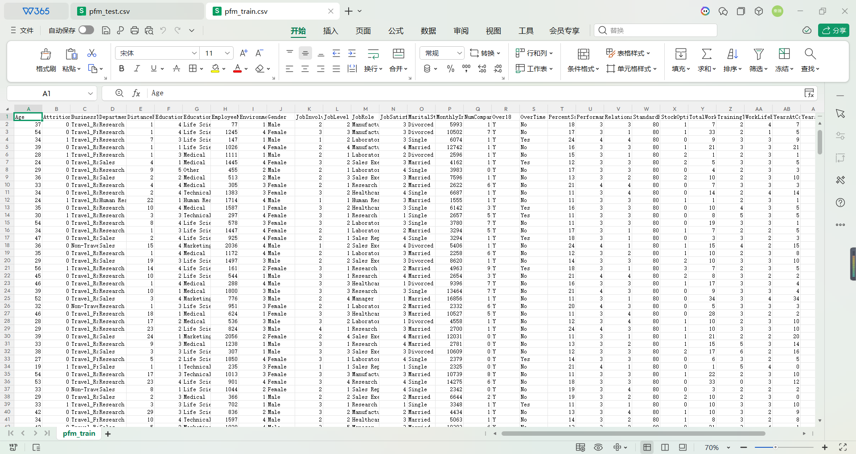
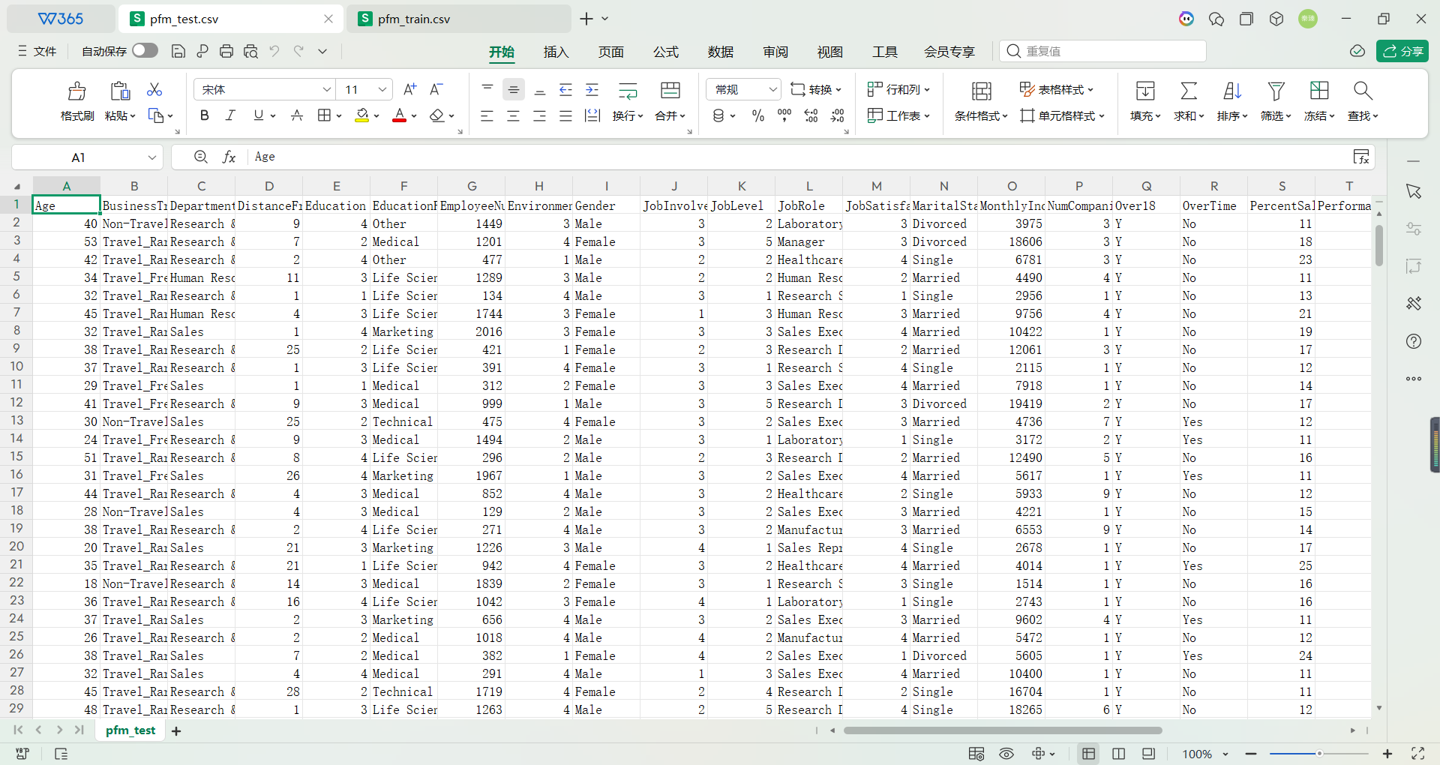
Experimental Results:
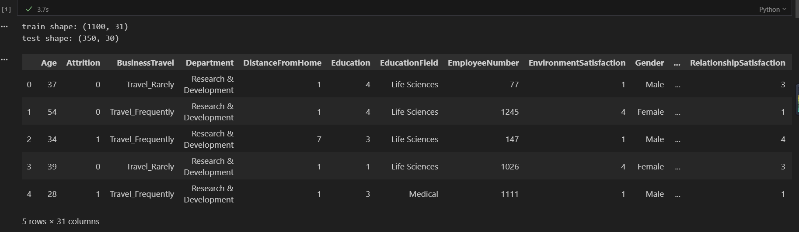
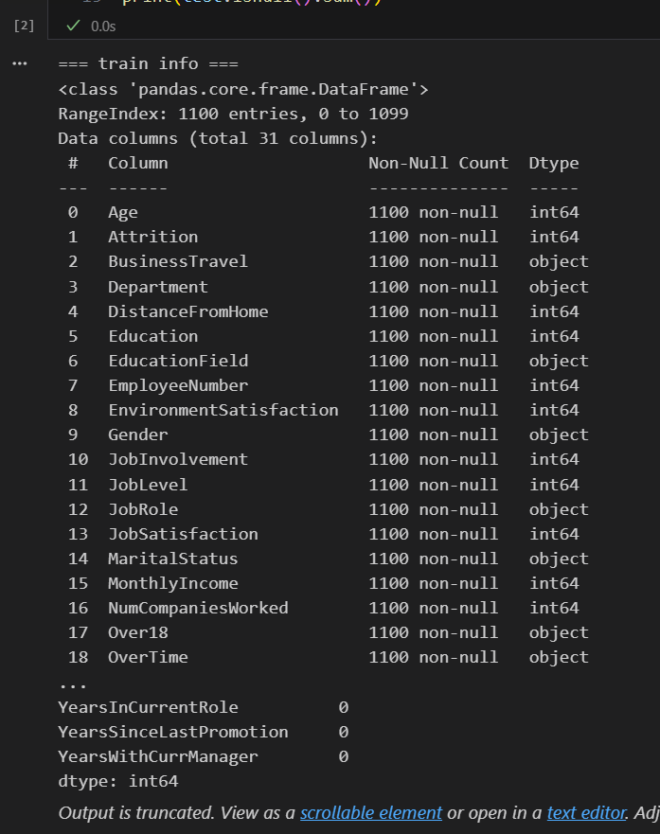

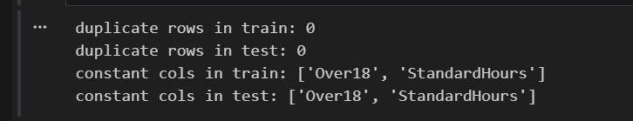

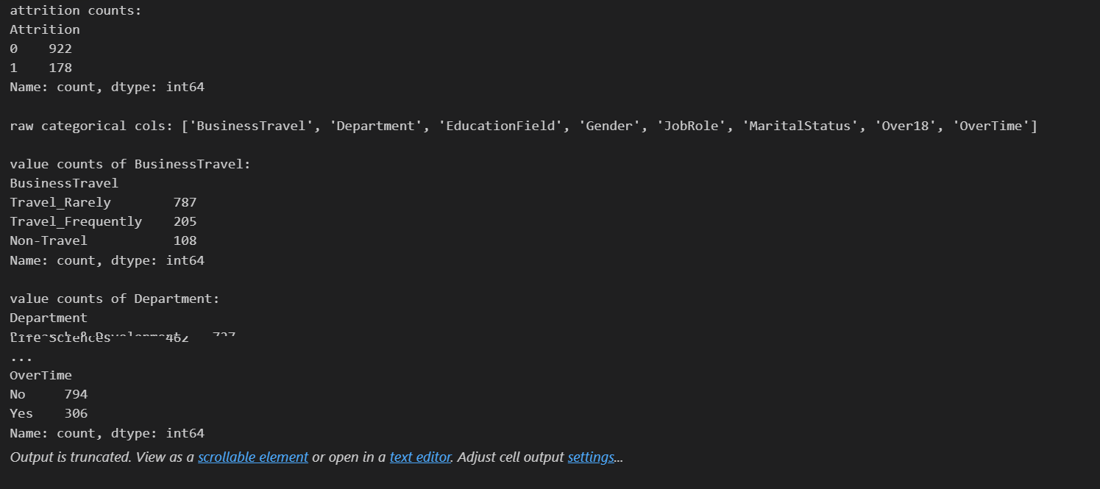
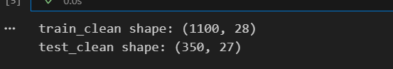
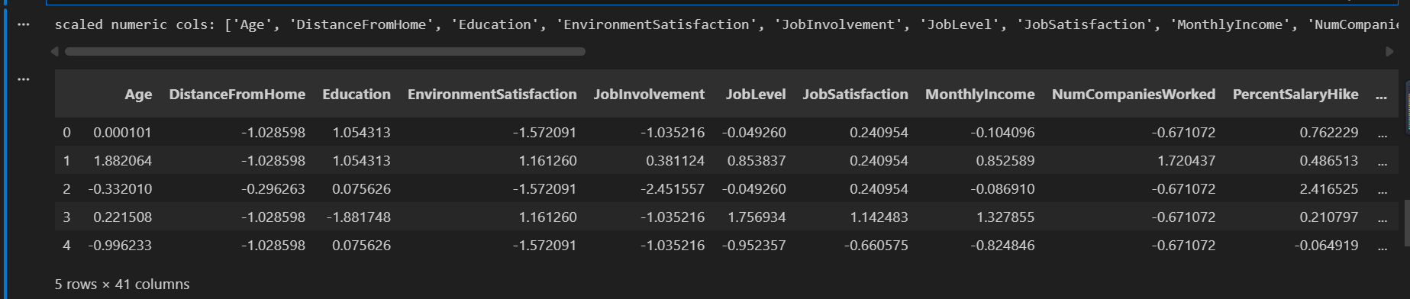
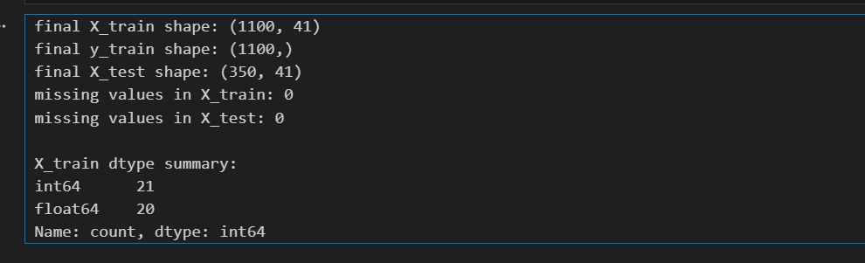
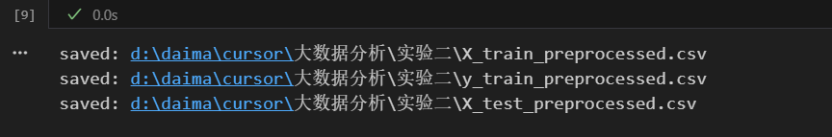
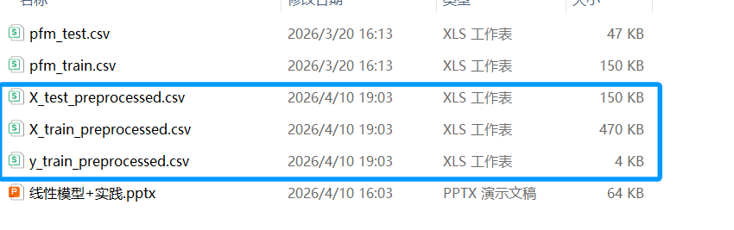
5. Reflections on the Experiment

This experiment looked simple at first, but after doing it step by step, I found that the important problems were hidden in small details. At first I thought the main work would be handling missing values. After checking info() and isnull().sum(), I found that both datasets were already complete. So the real problem was not null values, but some columns that looked normal and still should not be kept, such as Over18, StandardHours, and EmployeeNumber.

Another thing I understood more clearly is that get_dummies() is not only changing text into 0 and 1. After encoding, the structure of the table changes too. Because of that, the test set must follow the same feature columns as the training set. The step reindex(columns=X_train.columns, fill_value=0) looked small at first, but it is actually very important. If this step is missed, the later model may still run in some cases, but the feature meaning is already not the same anymore.

This experiment also helped me understand the difference between fit_transform() and transform() in a more practical way. The scaling rule should come from the training set first, and then the same rule should be used on the test set. If the test set also joins the fitting step, the whole preparation process is no longer strict. So after this experiment, I feel data preparation is not just a simple step before modeling. If this part is careless, the later result may look normal, but the process itself is already wrong.

One more thing became clearer after I linked this notebook to Experiment Two. The work in this experiment is not isolated. The processed X_train, y_train, and X_test are exactly the input needed by the later logistic regression task. That means the quality of preprocessing will directly affect model training, evaluation, and prediction in the next experiment. So this experiment is not only about cleaning data. It is also the foundation for the next step of the whole analysis process.

Grade:

Reviewed by: --------

Date: --------

