Hubei University

Academic Year 2025 -- 2026
Semester 2

Student Laboratory Report Book

Institute： Manchester United College
Student Name： Qin Tian
Class： 2402
Student ID： 202431123002054
Course Course： Big Data Analysis
Instructor： Li Jie

Student Laboratory Rules

1. Students must conduct experiments at the scheduled time and may not be absent or late without cause.
2. Before each experiment, students must preview the assigned experiment and prepare a preview report as required.
3. Before each experiment, students must submit the previous experiment report and the preview report for the current experiment. The experiment may begin only after the instructor has checked and approved them.
4. After reaching their assigned lab station, students must check the instruments they use against the equipment list for any missing or damaged items. Any problems must be reported to the instructor promptly. Using another group's instruments without authorization is strictly forbidden.
5. During the experiment, students must maintain a rigorous scientific attitude and strictly follow instrument operating procedures and precautions.
6. After the experiment, students must submit their data to the instructor for inspection. Once approved, they should restore and organize the instruments and equipment before leaving the lab.
7. Keep the laboratory quiet and tidy. Loud talking, littering, and eating are prohibited.
8. If an accident or damage to instruments or equipment is caused by violating operating procedures or conducting experiments without permission, it must be reported promptly. A damage list must be completed, and compensation shall be made according to the college's relevant regulations.

Big Data Analysis and Application Experiment 1

Laboratory: Innovation & Entrepreneurship 604 Date: 2026.3.20

1.Problem Description

This experiment uses employee attrition data from pfm_train.csv and pfm_test.csv to complete a full workflow from data preparation to linear-model prediction. The training set contains the target variable Attrition, while the test set only contains employee features, so the task is not only to clean the raw data, but also to make sure the processed training set and test set can be used in the same modeling pipeline.

At the beginning, the dataset looked simple, but after checking it carefully I found that the real difficulty was not just “running a model.” Before the linear model could be trained, I first needed to understand the structure of the data, identify columns that were useless for prediction, deal with categorical variables that could not be fed directly into a model, and keep the feature columns consistent between training and test data. After that, I also needed to use the prepared data to build and compare several models, and then observe whether the preprocessing really helped the later prediction task.

So the main problem in this experiment was how to turn raw employee data into a clean, consistent, and model-ready dataset, and then use that dataset to carry out a reasonable linear-model practice. In other words, this experiment was not only about cleaning data, but also about connecting preprocessing, visualization, feature preparation, model training, and result checking into one complete process.

2. Basic Approach
My basic idea in this experiment was to move step by step instead of jumping directly into modeling. First, I used pandas to read the two csv files and checked their shape, data types, missing values, duplicate rows, and constant columns. This helped me understand what problems really existed in the dataset, because if I skipped this step and directly trained a model, it would be easy to ignore hidden issues in the raw data.

After the inspection, I removed Over18, StandardHours, and EmployeeNumber. The first two columns had almost no useful variation, and EmployeeNumber was only an identifier, so keeping them would not help the prediction task. Then I focused on the categorical variables. Since linear models cannot use text features directly, I applied pd.get_dummies() to convert categorical columns into numerical dummy variables. At the same time, I split the training data into X_train and y_train, and used reindex() to make the test set follow exactly the same feature columns as the training set. This step was very important, because even if the encoding method is correct, the model will still fail or give unreliable results if the train and test features are not aligned.

Next, I standardized the original numeric features with StandardScaler. I fit the scaler only on the training data and then applied the same transformation to the test data, so the preprocessing process stayed consistent and avoided data leakage. After that, I carried out a small modeling stage on the processed data. I split the training data again into a fitting set and a validation set, then trained several models, including logistic regression with different regularization settings, SGDClassifier with log-loss, and a random forest baseline for comparison. Finally, I compared the models with metrics such as accuracy, precision, recall, F1-score, and ROC-AUC, and also drew several figures such as ROC curves, confusion matrices, and coefficient plots to make the results clearer.

Source Code

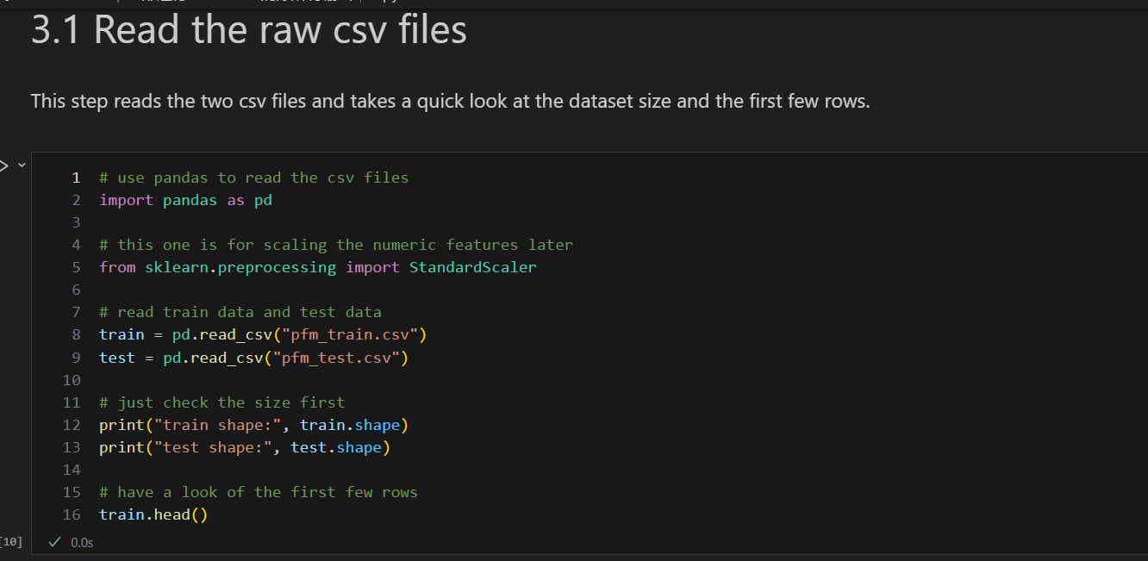

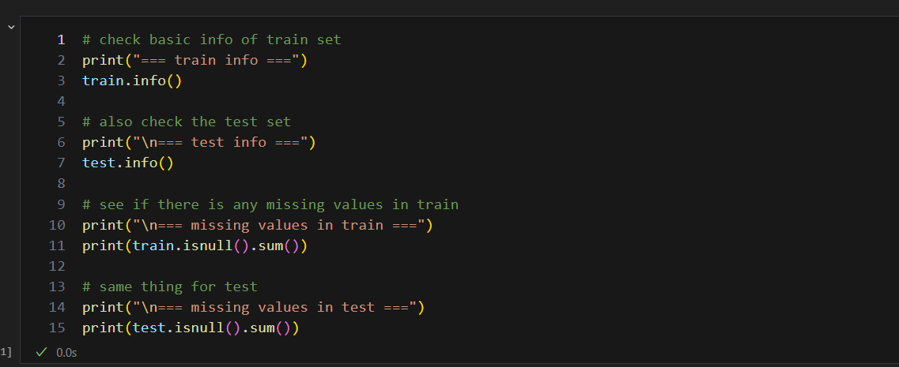

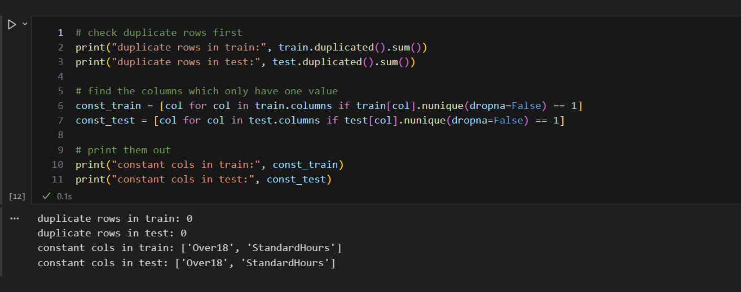

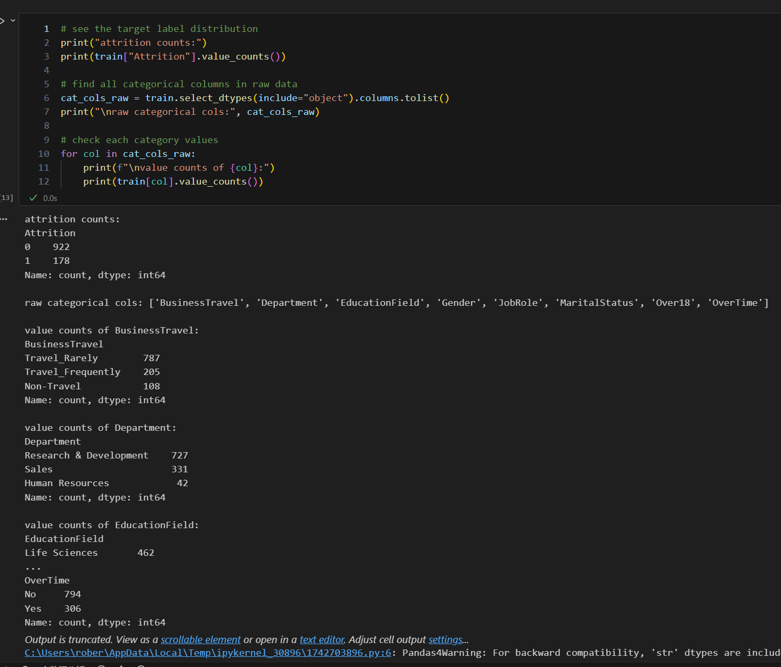

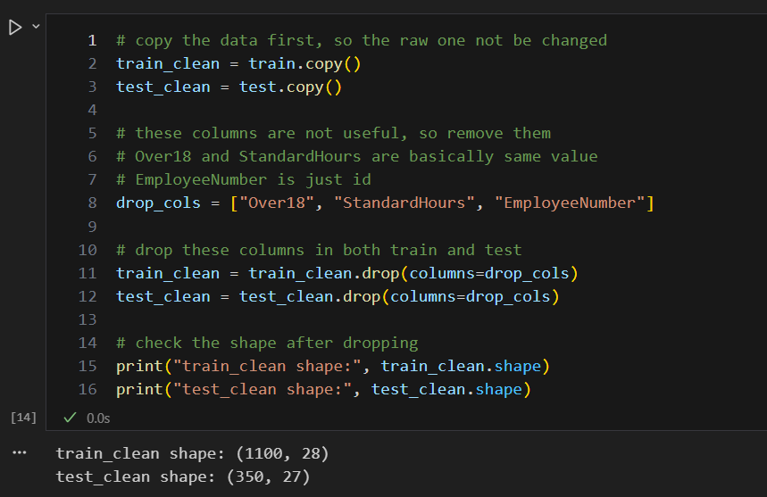

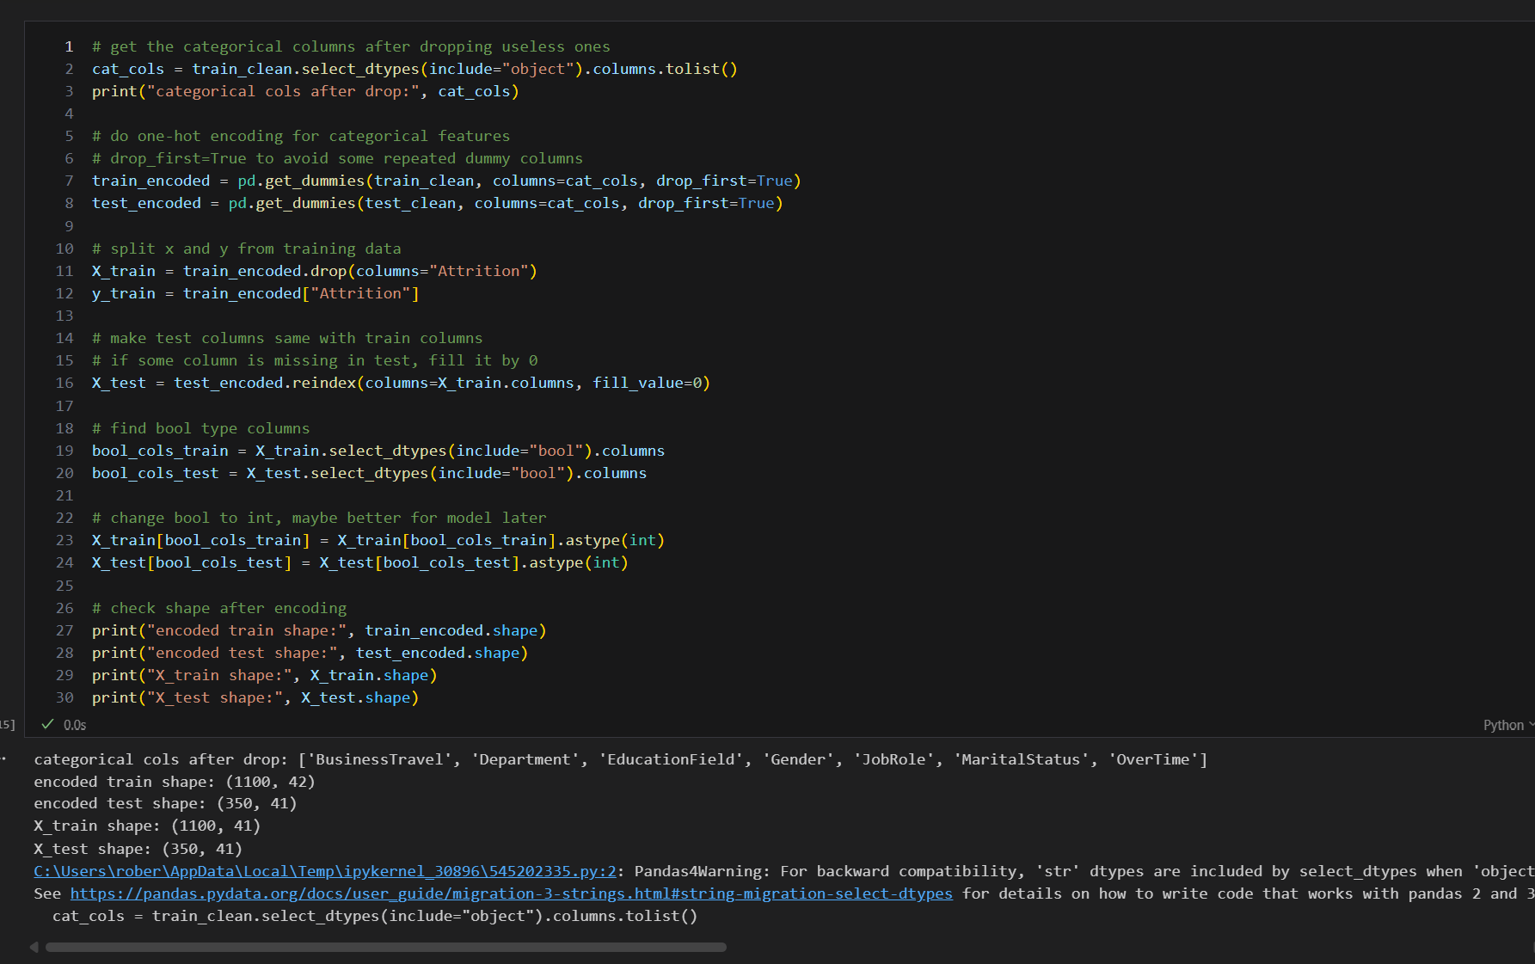

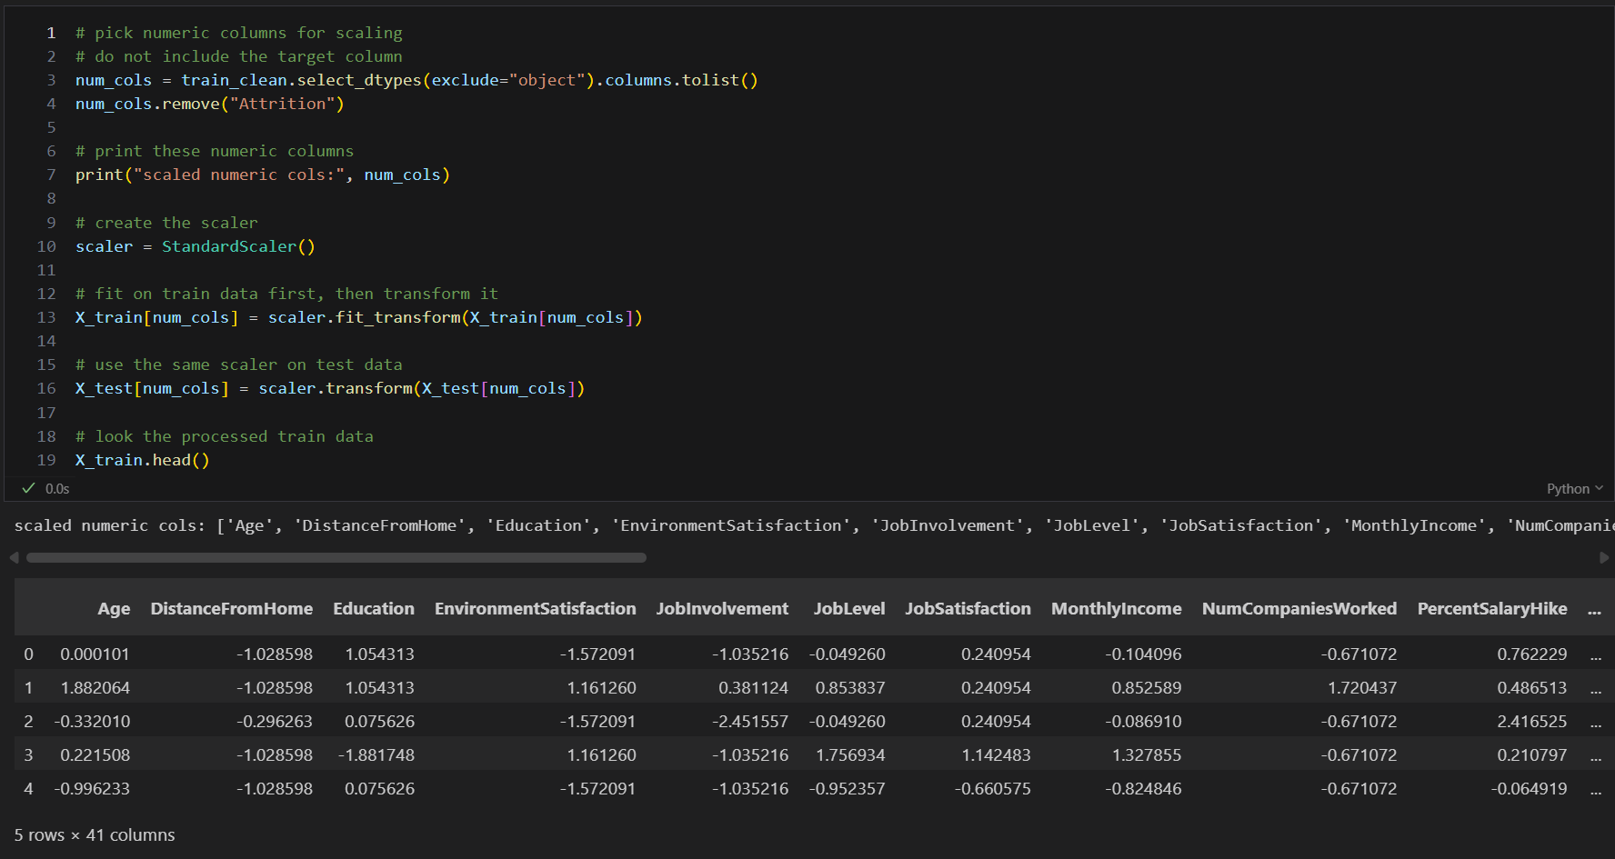

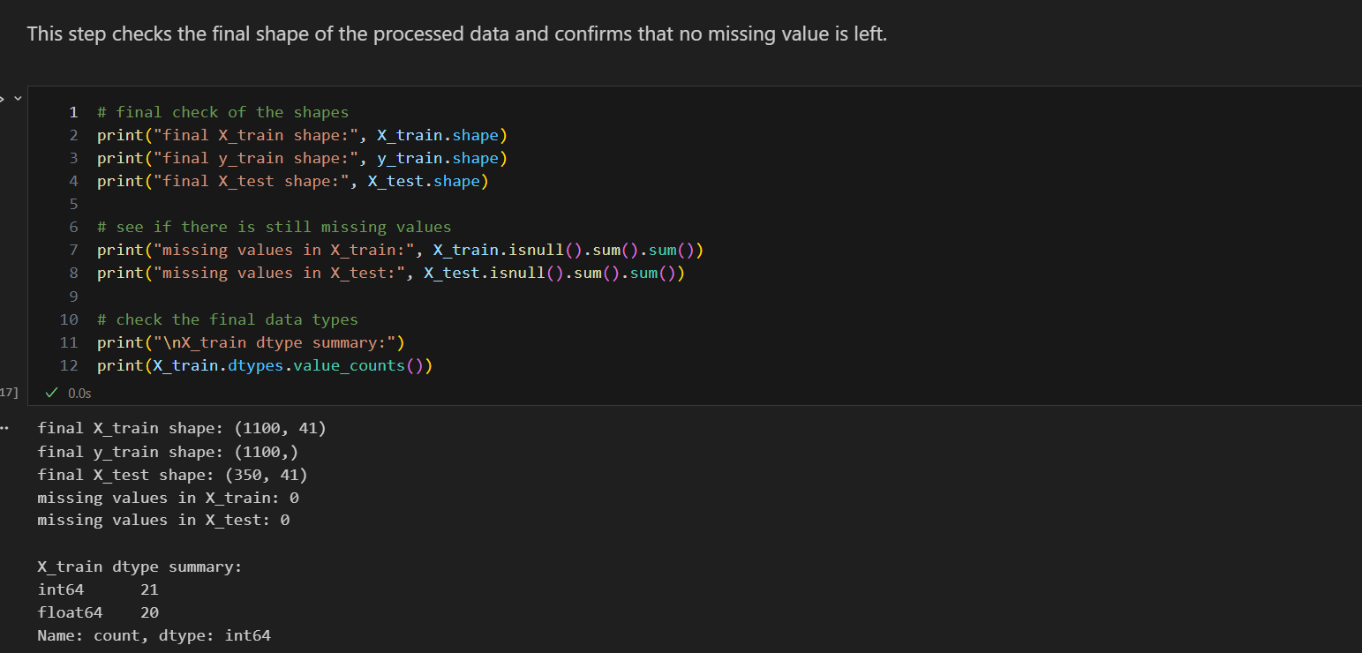

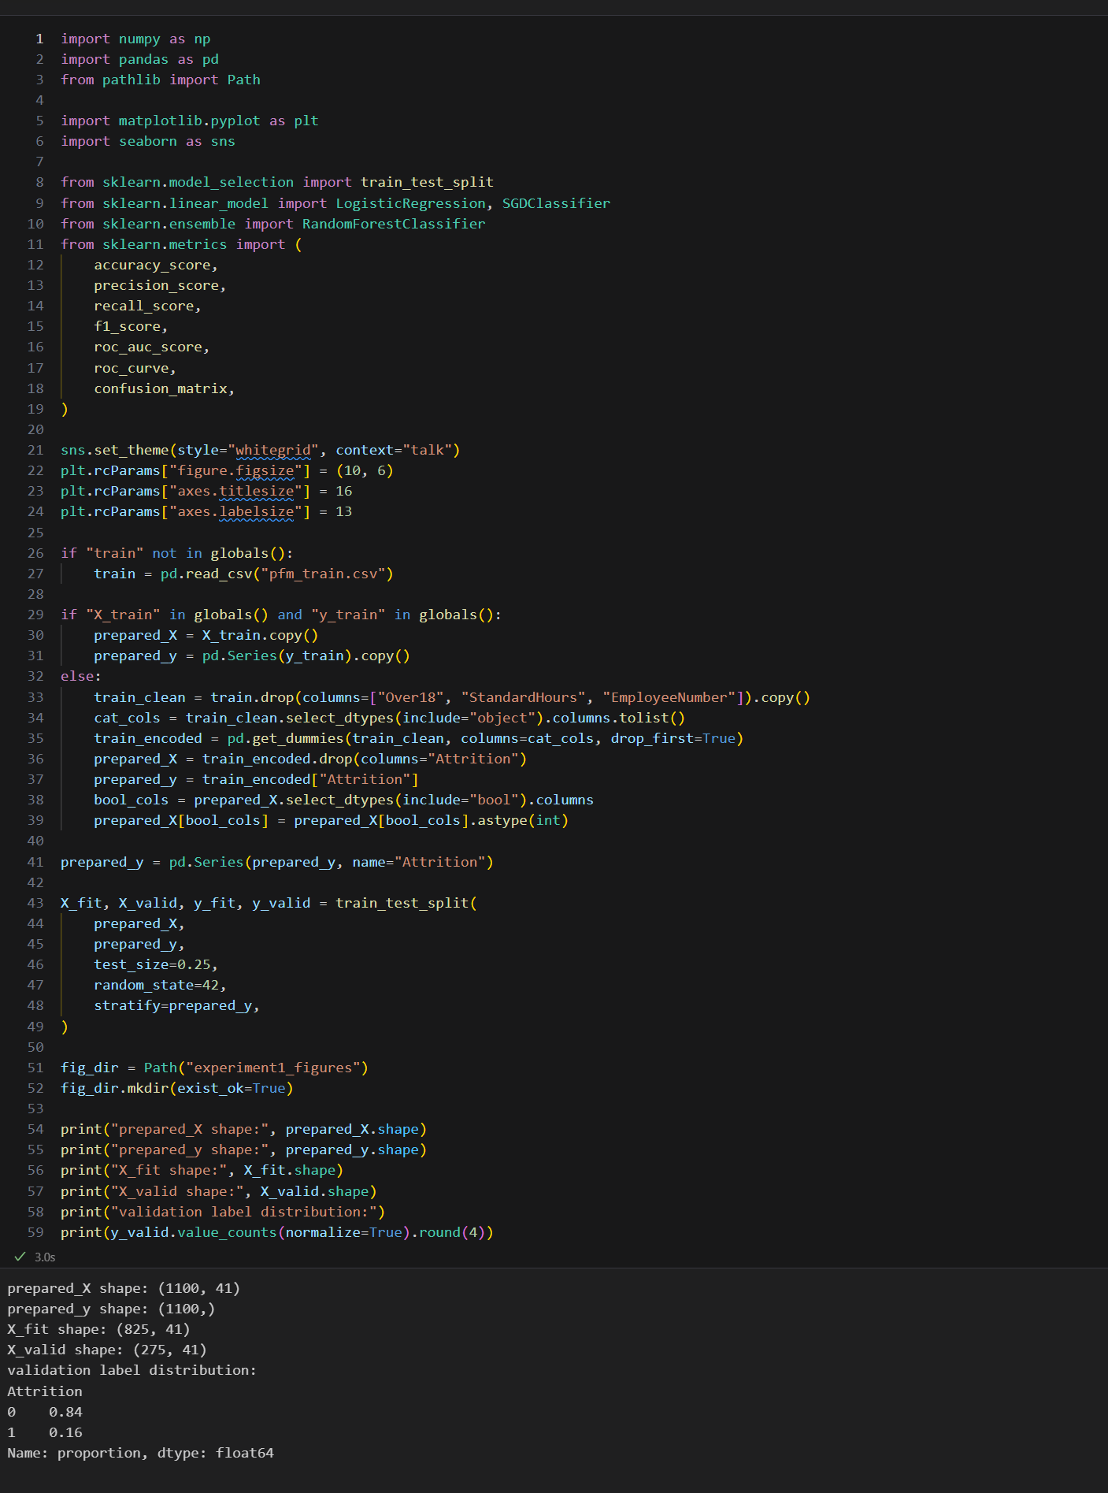

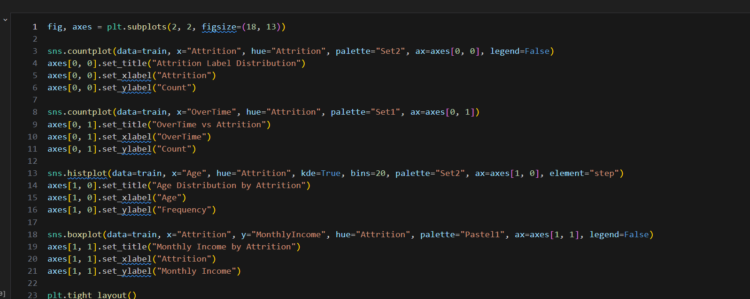

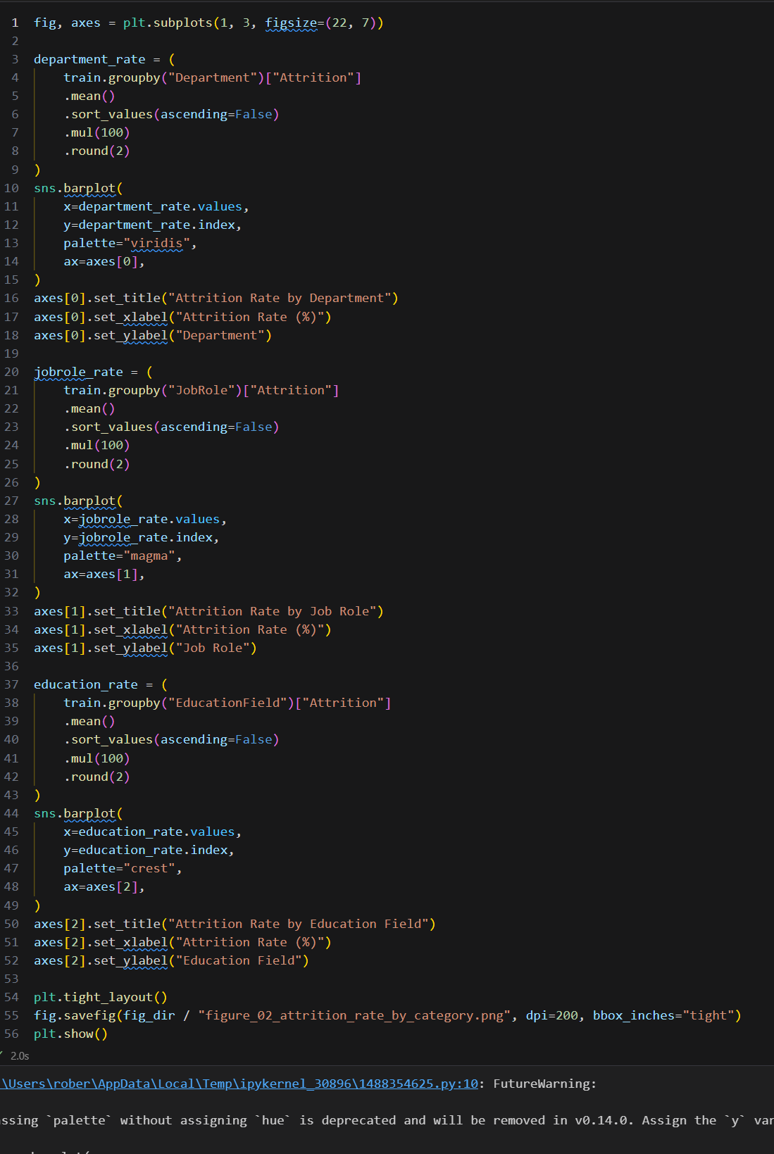

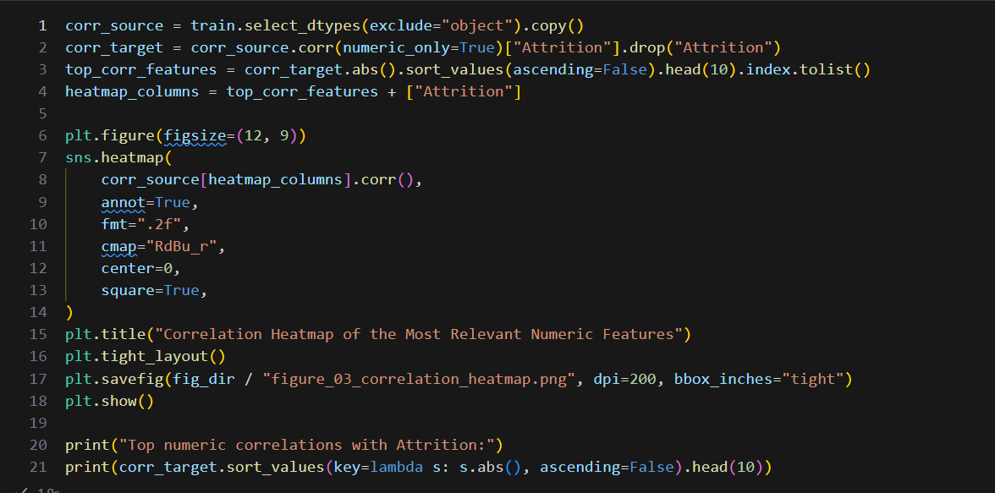

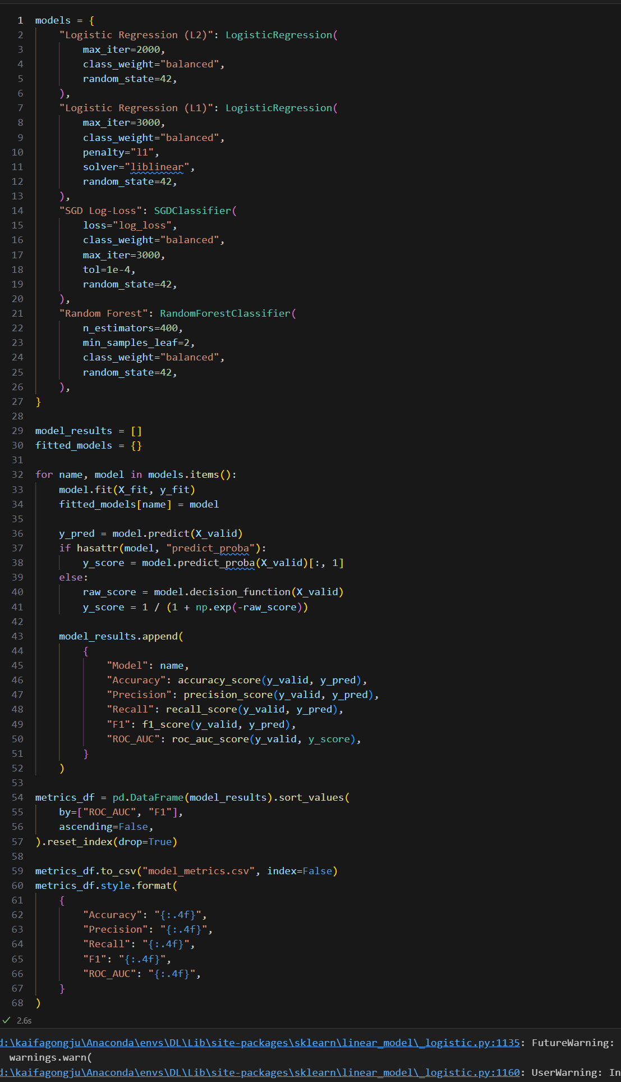
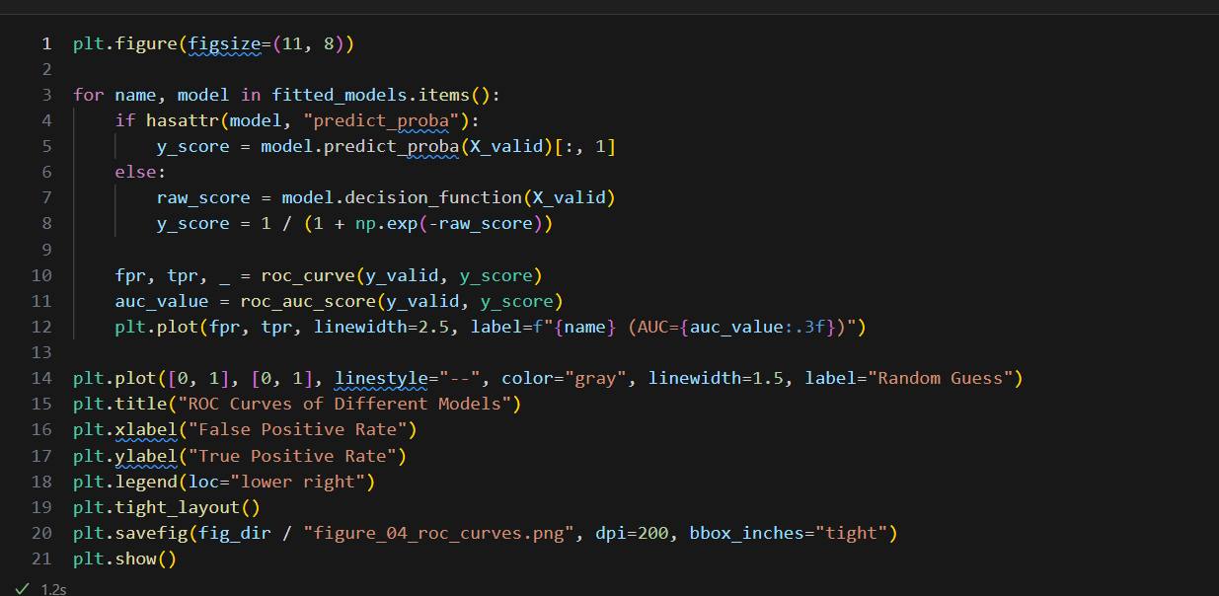

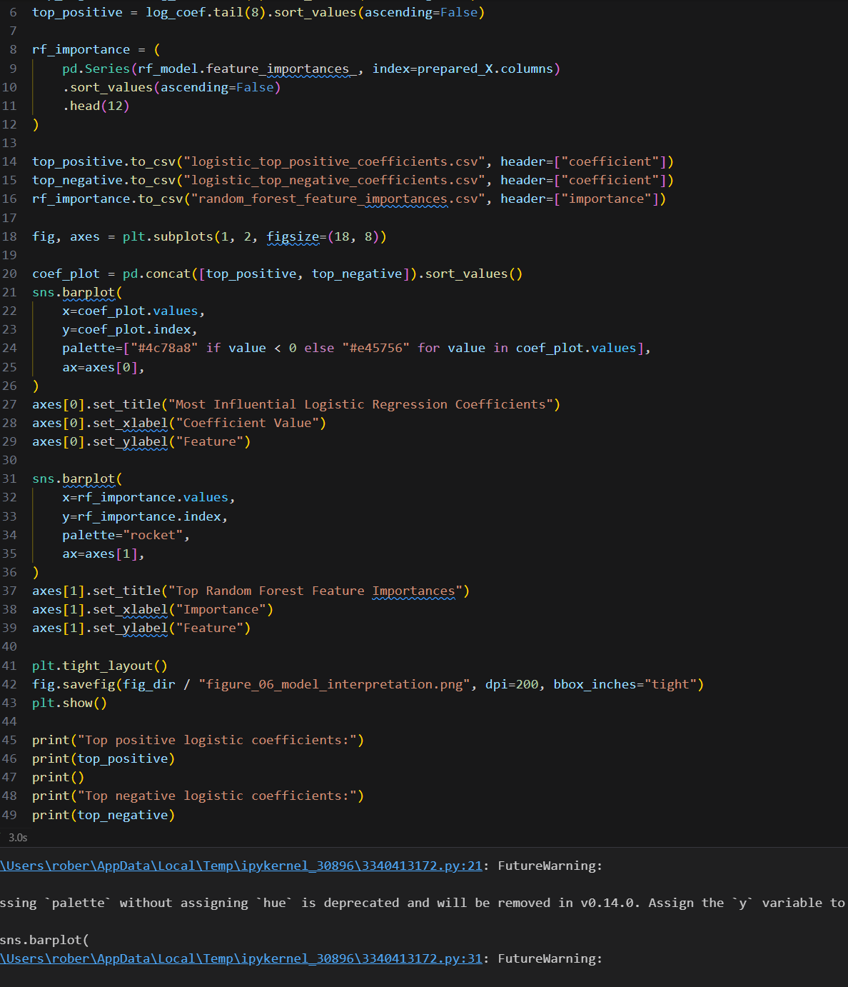

############################################################
# Part 1. Read the raw csv files
############################################################

# use pandas to read the csv files
import matplotlib
import numpy as np
import pandas as pd
import seaborn as sns
from pathlib import Path

from sklearn.ensemble import RandomForestClassifier
from sklearn.linear_model import LogisticRegression, SGDClassifier
from sklearn.metrics import (
accuracy_score,
confusion_matrix,
f1_score,
precision_score,
recall_score,
roc_auc_score,
roc_curve,
)
from sklearn.model_selection import train_test_split

# this one is for scaling the numeric features later
from sklearn.preprocessing import StandardScaler

# use a non-interactive backend so figures can be saved by script
matplotlib.use("Agg")
import matplotlib.pyplot as plt

# read train data and test data
train = pd.read_csv("pfm_train.csv")
test = pd.read_csv("pfm_test.csv")

# just check the size first
print("train shape:", train.shape)
print("test shape:", test.shape)

# have a look of the first few rows
train.head()

############################################################
# Part 2. Check basic information and missing values
############################################################

# check basic info of train set
print("=== train info ===")
train.info()

# also check the test set
print("\n=== test info ===")
test.info()

# see if there is any missing values in train
print("\n=== missing values in train ===")
print(train.isnull().sum())

# same thing for test
print("\n=== missing values in test ===")
print(test.isnull().sum())

############################################################
# Part 3. Check duplicate rows and constant columns
############################################################

# check duplicate rows first
print("duplicate rows in train:", train.duplicated().sum())
print("duplicate rows in test:", test.duplicated().sum())

# find the columns which only have one value
const_train = [col for col in train.columns if train[col].nunique(dropna=False) == 1]
const_test = [col for col in test.columns if test[col].nunique(dropna=False) == 1]

# print them out
print("constant cols in train:", const_train)
print("constant cols in test:", const_test)

############################################################
# Part 4. Check the label and categorical columns
############################################################

# see the target label distribution
print("attrition counts:")
print(train["Attrition"].value_counts())

# find all categorical columns in raw data
cat_cols_raw = train.select_dtypes(include="object").columns.tolist()
print("\nraw categorical cols:", cat_cols_raw)

# check each category values
for col in cat_cols_raw:
print(f"\nvalue counts of {col}:")
print(train[col].value_counts())

############################################################
# Part 5. Drop useless columns
############################################################

# copy the data first, so the raw one not be changed
train_clean = train.copy()
test_clean = test.copy()

# these columns are not useful, so remove them
# Over18 and StandardHours are basically same value
# EmployeeNumber is just id
drop_cols = ["Over18", "StandardHours", "EmployeeNumber"]

# drop these columns in both train and test
train_clean = train_clean.drop(columns=drop_cols)
test_clean = test_clean.drop(columns=drop_cols)

# check the shape after dropping
print("train_clean shape:", train_clean.shape)
print("test_clean shape:", test_clean.shape)

############################################################
# Part 6. Encode categorical features
############################################################

# get the categorical columns after dropping useless ones
cat_cols = train_clean.select_dtypes(include="object").columns.tolist()
print("categorical cols after drop:", cat_cols)

# do one-hot encoding for categorical features
# drop_first=True to avoid some repeated dummy columns
train_encoded = pd.get_dummies(train_clean, columns=cat_cols, drop_first=True)
test_encoded = pd.get_dummies(test_clean, columns=cat_cols, drop_first=True)

# split x and y from training data
X_train = train_encoded.drop(columns="Attrition")
y_train = train_encoded["Attrition"]

# make test columns same with train columns
# if some column is missing in test, fill it by 0
X_test = test_encoded.reindex(columns=X_train.columns, fill_value=0)

# find bool type columns
bool_cols_train = X_train.select_dtypes(include="bool").columns
bool_cols_test = X_test.select_dtypes(include="bool").columns

# change bool to int, maybe better for model later
X_train[bool_cols_train] = X_train[bool_cols_train].astype(int)
X_test[bool_cols_test] = X_test[bool_cols_test].astype(int)

# check shape after encoding
print("encoded train shape:", train_encoded.shape)
print("encoded test shape:", test_encoded.shape)
print("X_train shape:", X_train.shape)
print("X_test shape:", X_test.shape)

############################################################
# Part 7. Scale numeric features
############################################################

# pick numeric columns for scaling
# do not include the target column
num_cols = train_clean.select_dtypes(exclude="object").columns.tolist()
num_cols.remove("Attrition")

# print these numeric columns
print("scaled numeric cols:", num_cols)

# create the scaler
scaler = StandardScaler()

# fit on train data first, then transform it
X_train[num_cols] = scaler.fit_transform(X_train[num_cols])

# use the same scaler on test data
X_test[num_cols] = scaler.transform(X_test[num_cols])

# look the processed train data
X_train.head()

############################################################
# Part 8. Final check of prepared data
############################################################

# final check of the shapes
print("final X_train shape:", X_train.shape)
print("final y_train shape:", y_train.shape)
print("final X_test shape:", X_test.shape)

# see if there is still missing values
print("missing values in X_train:", X_train.isnull().sum().sum())
print("missing values in X_test:", X_test.isnull().sum().sum())

# check the final data types
print("\nX_train dtype summary:")
print(X_train.dtypes.value_counts())

############################################################
# Part 9. Prepare the final modeling matrix
############################################################

# save the preprocessing output for the later linear-model practice
# always write to the sibling experiment folder, so the files can be regenerated anytime
output_dir = Path.cwd().parent / "实验二"
output_dir.mkdir(parents=True, exist_ok=True)

X_train.to_csv(output_dir / "X_train_preprocessed.csv", index=False)
y_train.to_frame(name="Attrition").to_csv(output_dir / "y_train_preprocessed.csv", index=False)
X_test.to_csv(output_dir / "X_test_preprocessed.csv", index=False)

print("saved:", output_dir / "X_train_preprocessed.csv")
print("saved:", output_dir / "y_train_preprocessed.csv")
print("saved:", output_dir / "X_test_preprocessed.csv")

############################################################
# Part 10. Prepare validation data and figure folder
############################################################

sns.set_theme(style="whitegrid", context="talk")
plt.rcParams["figure.figsize"] = (10, 6)
plt.rcParams["axes.titlesize"] = 16
plt.rcParams["axes.labelsize"] = 13

X_fit, X_valid, y_fit, y_valid = train_test_split(
X_train,
y_train,
test_size=0.25,
random_state=42,
stratify=y_train,
)

figure_dir = Path.cwd() / "experiment1_figures"
figure_dir.mkdir(exist_ok=True)

print("X_fit shape:", X_fit.shape)
print("X_valid shape:", X_valid.shape)
print("validation label distribution:")
print(y_valid.value_counts(normalize=True).round(4))

############################################################
# Part 11. Draw and save the main figures
############################################################

fig, axes = plt.subplots(2, 2, figsize=(18, 13))

sns.countplot(data=train, x="Attrition", hue="Attrition", palette="Set2", ax=axes[0, 0], legend=False)
axes[0, 0].set_title("Attrition Label Distribution")
axes[0, 0].set_xlabel("Attrition")
axes[0, 0].set_ylabel("Count")

sns.countplot(data=train, x="OverTime", hue="Attrition", palette="Set1", ax=axes[0, 1])
axes[0, 1].set_title("OverTime vs Attrition")
axes[0, 1].set_xlabel("OverTime")
axes[0, 1].set_ylabel("Count")

sns.histplot(data=train, x="Age", hue="Attrition", kde=True, bins=20, palette="Set2", ax=axes[1, 0], element="step")
axes[1, 0].set_title("Age Distribution by Attrition")
axes[1, 0].set_xlabel("Age")
axes[1, 0].set_ylabel("Frequency")

sns.boxplot(data=train, x="Attrition", y="MonthlyIncome", hue="Attrition", palette="Pastel1", ax=axes[1, 1], legend=False)
axes[1, 1].set_title("Monthly Income by Attrition")
axes[1, 1].set_xlabel("Attrition")
axes[1, 1].set_ylabel("Monthly Income")

plt.tight_layout()
fig.savefig(figure_dir / "figure_01_label_and_basic_patterns.png", dpi=200, bbox_inches="tight")
plt.close(fig)

fig, axes = plt.subplots(1, 3, figsize=(22, 7))

department_rate = (
train.groupby("Department")["Attrition"]
.mean()
.sort_values(ascending=False)
.mul(100)
.round(2)
)
sns.barplot(
x=department_rate.values,
y=department_rate.index,
palette="viridis",
ax=axes[0],
)
axes[0].set_title("Attrition Rate by Department")
axes[0].set_xlabel("Attrition Rate (%)")
axes[0].set_ylabel("Department")

jobrole_rate = (
train.groupby("JobRole")["Attrition"]
.mean()
.sort_values(ascending=False)
.mul(100)
.round(2)
)
sns.barplot(
x=jobrole_rate.values,
y=jobrole_rate.index,
palette="magma",
ax=axes[1],
)
axes[1].set_title("Attrition Rate by Job Role")
axes[1].set_xlabel("Attrition Rate (%)")
axes[1].set_ylabel("Job Role")

education_rate = (
train.groupby("EducationField")["Attrition"]
.mean()
.sort_values(ascending=False)
.mul(100)
.round(2)
)
sns.barplot(
x=education_rate.values,
y=education_rate.index,
palette="crest",
ax=axes[2],
)
axes[2].set_title("Attrition Rate by Education Field")
axes[2].set_xlabel("Attrition Rate (%)")
axes[2].set_ylabel("Education Field")

plt.tight_layout()
fig.savefig(figure_dir / "figure_02_attrition_rate_by_category.png", dpi=200, bbox_inches="tight")
plt.close(fig)

corr_source = train.select_dtypes(exclude="object").copy()
corr_target = corr_source.corr(numeric_only=True)["Attrition"].drop("Attrition")
top_corr_features = corr_target.abs().sort_values(ascending=False).head(10).index.tolist()
heatmap_columns = top_corr_features + ["Attrition"]

fig, ax = plt.subplots(figsize=(12, 9))
sns.heatmap(
corr_source[heatmap_columns].corr(),
annot=True,
fmt=".2f",
cmap="RdBu_r",
center=0,
square=True,
ax=ax,
)
ax.set_title("Correlation Heatmap of the Most Relevant Numeric Features")
plt.tight_layout()
fig.savefig(figure_dir / "figure_03_correlation_heatmap.png", dpi=200, bbox_inches="tight")
plt.close(fig)

print("top numeric correlations with Attrition:")
print(corr_target.sort_values(key=lambda s: s.abs(), ascending=False).head(10))

############################################################
# Part 12. Train multiple models and save the metrics
############################################################

models = {
"Logistic Regression (L2)": LogisticRegression(
max_iter=2000,
class_weight="balanced",
random_state=42,
),
"Logistic Regression (L1)": LogisticRegression(
max_iter=3000,
class_weight="balanced",
penalty="l1",
solver="liblinear",
random_state=42,
),
"SGD Log-Loss": SGDClassifier(
loss="log_loss",
class_weight="balanced",
max_iter=3000,
tol=1e-4,
random_state=42,
),
"Random Forest": RandomForestClassifier(
n_estimators=400,
min_samples_leaf=2,
class_weight="balanced",
random_state=42,
),
}

model_results = []
fitted_models = {}

for name, model in models.items():
model.fit(X_fit, y_fit)
fitted_models[name] = model

y_pred = model.predict(X_valid)
if hasattr(model, "predict_proba"):
y_score = model.predict_proba(X_valid)[:, 1]
else:
raw_score = model.decision_function(X_valid)
y_score = 1 / (1 + np.exp(-raw_score))

model_results.append(
{
"Model": name,
"Accuracy": accuracy_score(y_valid, y_pred),
"Precision": precision_score(y_valid, y_pred),
"Recall": recall_score(y_valid, y_pred),
"F1": f1_score(y_valid, y_pred),
"ROC_AUC": roc_auc_score(y_valid, y_score),
}
)

metrics_df = pd.DataFrame(model_results).sort_values(
by=["ROC_AUC", "F1"],
ascending=False,
).reset_index(drop=True)
metrics_df.to_csv(Path.cwd() / "model_metrics.csv", index=False)

print("\nmodel metrics:")
print(metrics_df.round(4))

############################################################
# Part 13. Draw ROC curves and confusion matrices
############################################################

fig, ax = plt.subplots(figsize=(11, 8))

for name, model in fitted_models.items():
if hasattr(model, "predict_proba"):
y_score = model.predict_proba(X_valid)[:, 1]
else:
raw_score = model.decision_function(X_valid)
y_score = 1 / (1 + np.exp(-raw_score))

fpr, tpr, _ = roc_curve(y_valid, y_score)
auc_value = roc_auc_score(y_valid, y_score)
ax.plot(fpr, tpr, linewidth=2.5, label=f"{name} (AUC={auc_value:.3f})")

ax.plot([0, 1], [0, 1], linestyle="--", color="gray", linewidth=1.5, label="Random Guess")
ax.set_title("ROC Curves of Different Models")
ax.set_xlabel("False Positive Rate")
ax.set_ylabel("True Positive Rate")
ax.legend(loc="lower right")
plt.tight_layout()
fig.savefig(figure_dir / "figure_04_roc_curves.png", dpi=200, bbox_inches="tight")
plt.close(fig)

best_log_model = fitted_models["Logistic Regression (L2)"]
rf_model = fitted_models["Random Forest"]

cm_log = confusion_matrix(y_valid, best_log_model.predict(X_valid))
cm_rf = confusion_matrix(y_valid, rf_model.predict(X_valid))

fig, axes = plt.subplots(1, 2, figsize=(14, 6))

sns.heatmap(cm_log, annot=True, fmt="d", cmap="Blues", cbar=False, ax=axes[0])
axes[0].set_title("Confusion Matrix: Logistic Regression (L2)")
axes[0].set_xlabel("Predicted Label")
axes[0].set_ylabel("True Label")

sns.heatmap(cm_rf, annot=True, fmt="d", cmap="Greens", cbar=False, ax=axes[1])
axes[1].set_title("Confusion Matrix: Random Forest")
axes[1].set_xlabel("Predicted Label")
axes[1].set_ylabel("True Label")

plt.tight_layout()
fig.savefig(figure_dir / "figure_05_confusion_matrices.png", dpi=200, bbox_inches="tight")
plt.close(fig)

############################################################
# Part 14. Save coefficient and feature importance outputs
############################################################

log_coef = pd.Series(best_log_model.coef_[0], index=X_train.columns).sort_values()
top_negative = log_coef.head(8).sort_values(ascending=True)
top_positive = log_coef.tail(8).sort_values(ascending=False)

rf_importance = (
pd.Series(rf_model.feature_importances_, index=X_train.columns)
.sort_values(ascending=False)
.head(12)
)

top_positive.to_csv(Path.cwd() / "logistic_top_positive_coefficients.csv", header=["coefficient"])
top_negative.to_csv(Path.cwd() / "logistic_top_negative_coefficients.csv", header=["coefficient"])
rf_importance.to_csv(Path.cwd() / "random_forest_feature_importances.csv", header=["importance"])

fig, axes = plt.subplots(1, 2, figsize=(18, 8))

coef_plot = pd.concat([top_positive, top_negative]).sort_values()
sns.barplot(
x=coef_plot.values,
y=coef_plot.index,
palette=["#4c78a8" if value < 0 else "#e45756" for value in coef_plot.values],
ax=axes[0],
)
axes[0].set_title("Most Influential Logistic Regression Coefficients")
axes[0].set_xlabel("Coefficient Value")
axes[0].set_ylabel("Feature")

sns.barplot(
x=rf_importance.values,
y=rf_importance.index,
palette="rocket",
ax=axes[1],
)
axes[1].set_title("Top Random Forest Feature Importances")
axes[1].set_xlabel("Importance")
axes[1].set_ylabel("Feature")

plt.tight_layout()
fig.savefig(figure_dir / "figure_06_model_interpretation.png", dpi=200, bbox_inches="tight")
plt.close(fig)

print("\ntop positive logistic coefficients:")
print(top_positive)
print("\ntop negative logistic coefficients:")
print(top_negative)

4. Experimental Data and Results

Experimental Data:
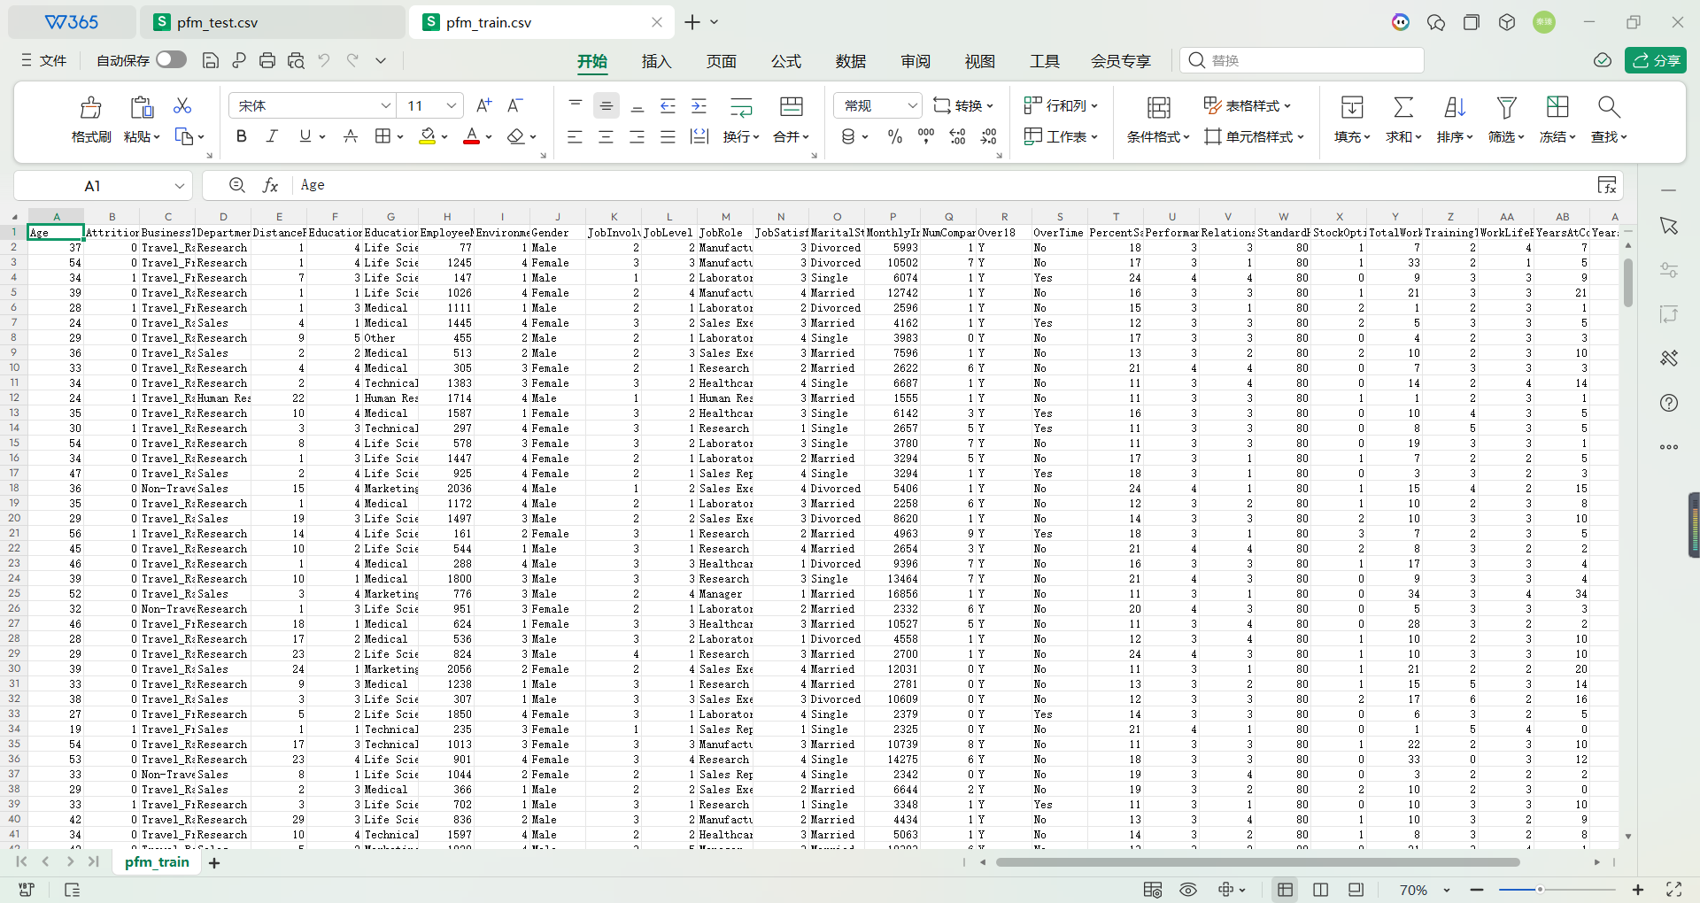
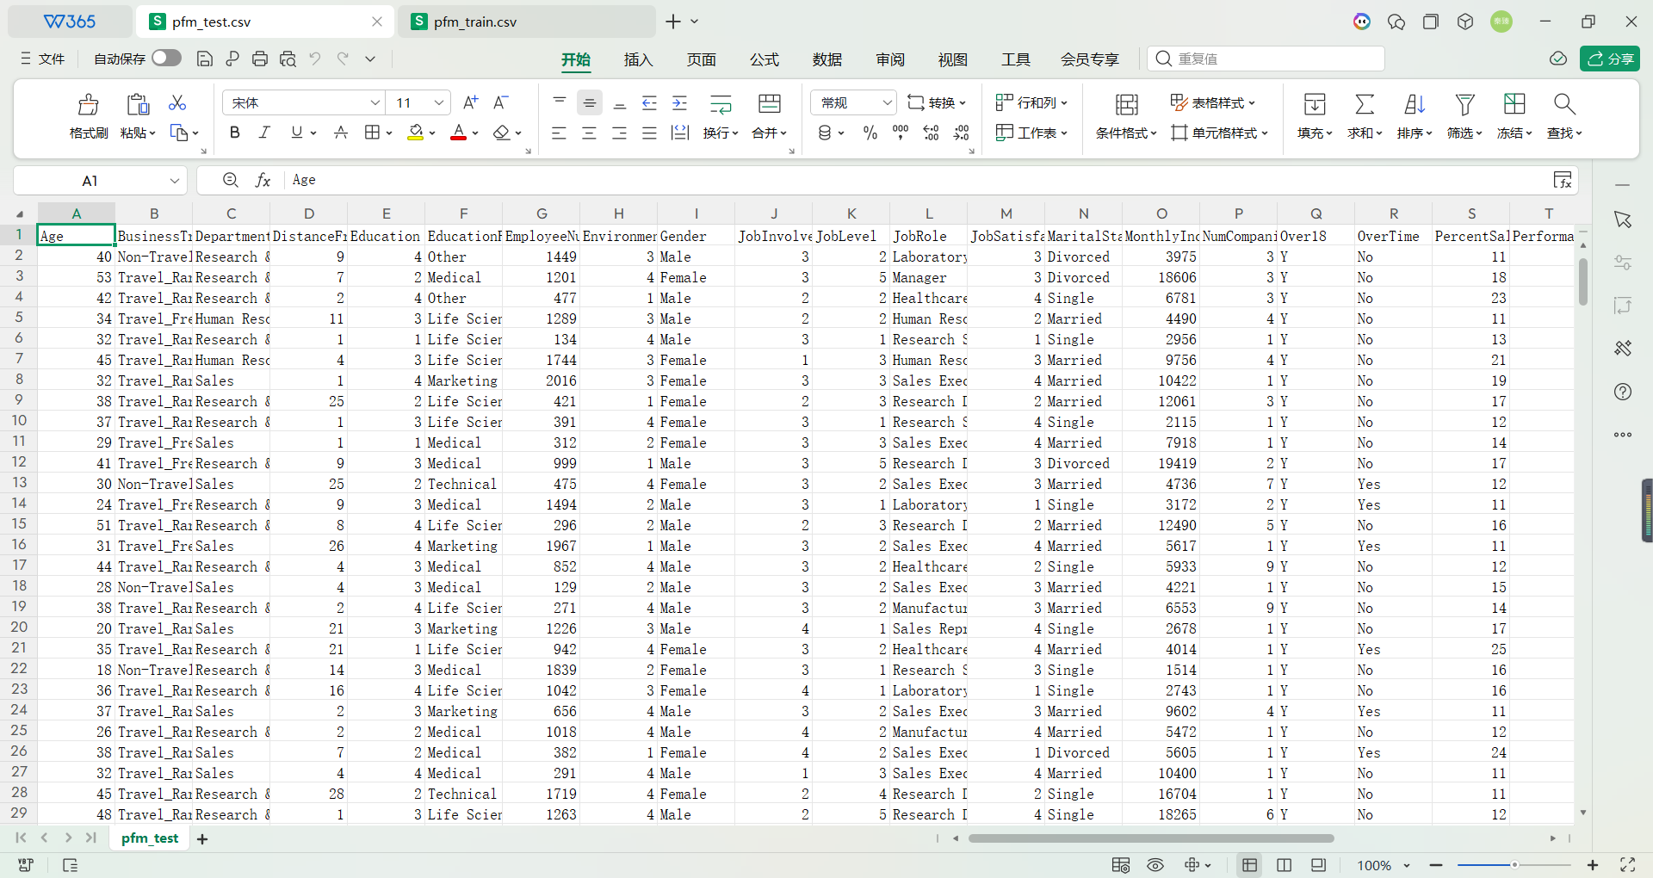

Experimental Results:
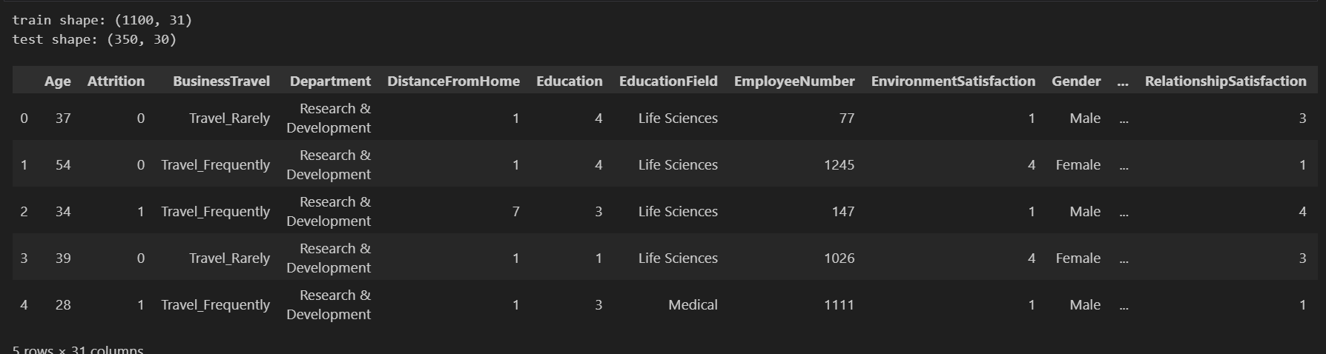

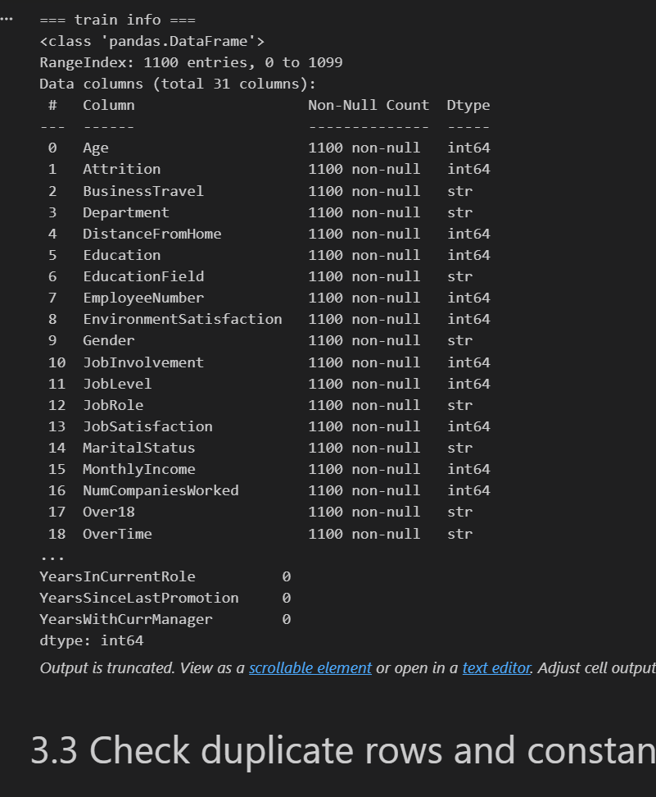








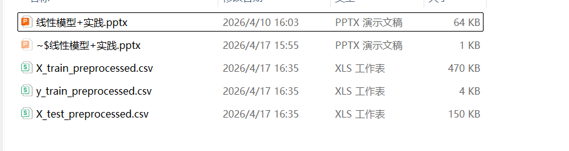



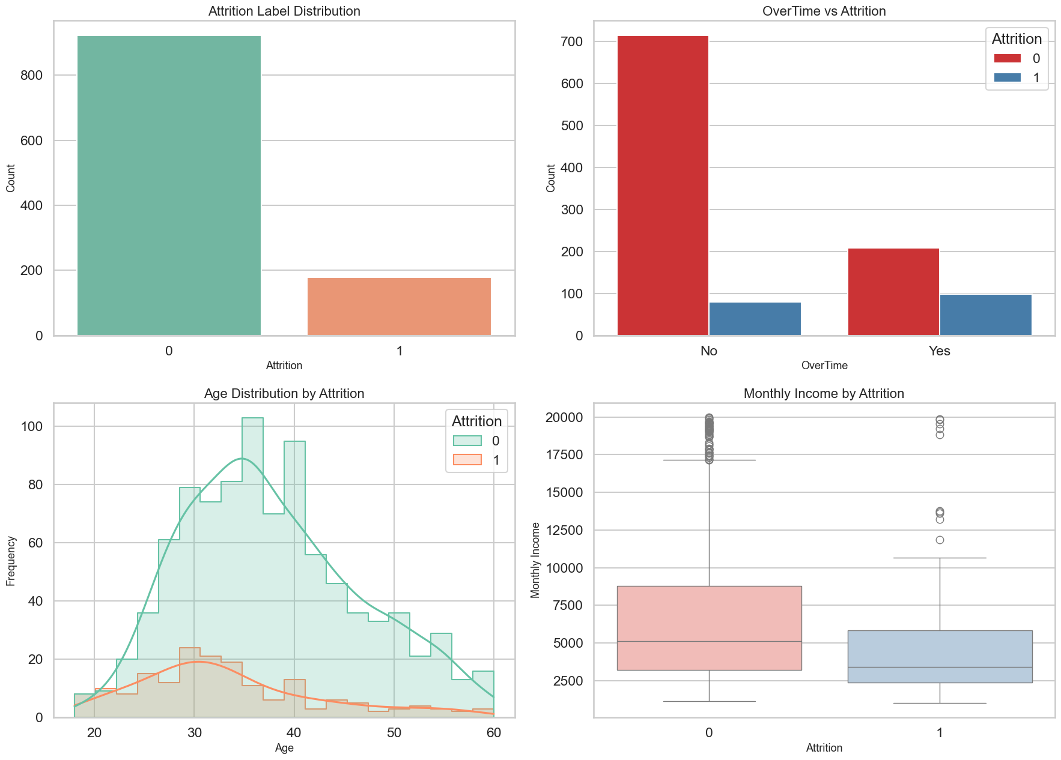

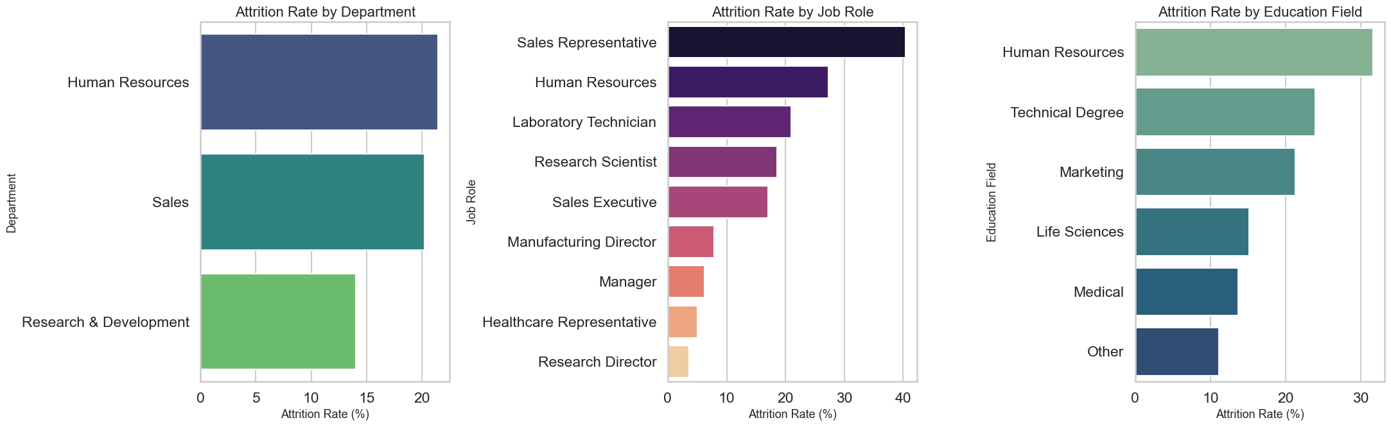

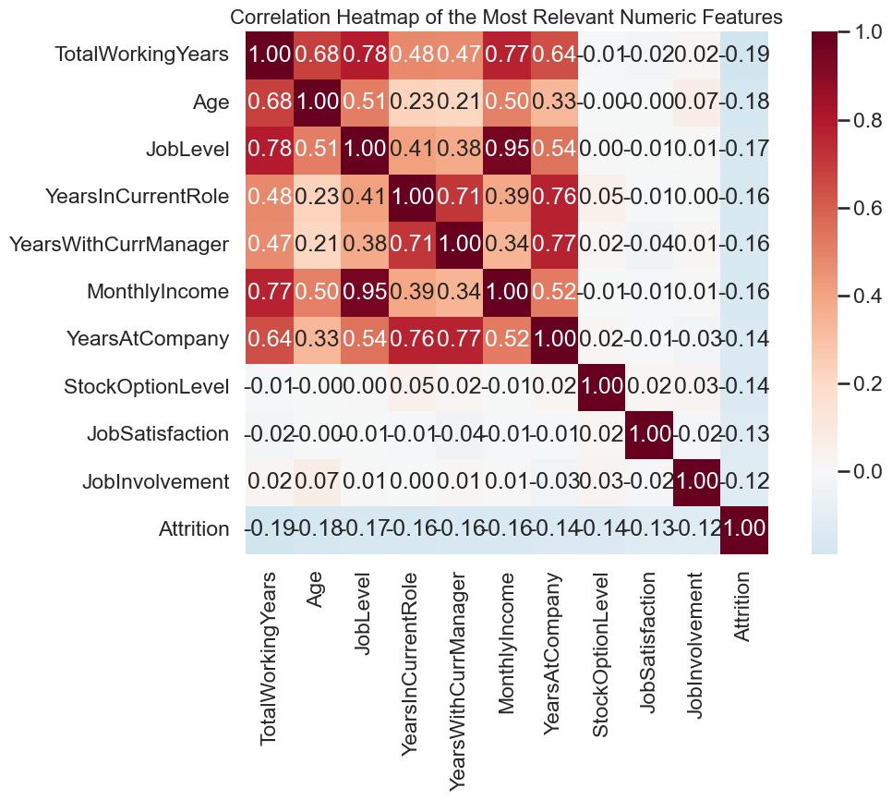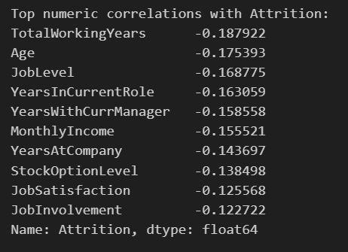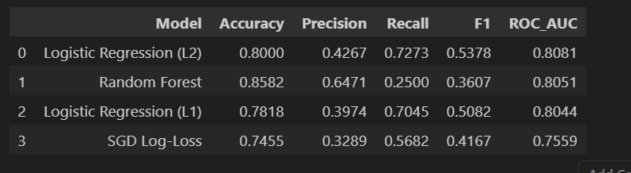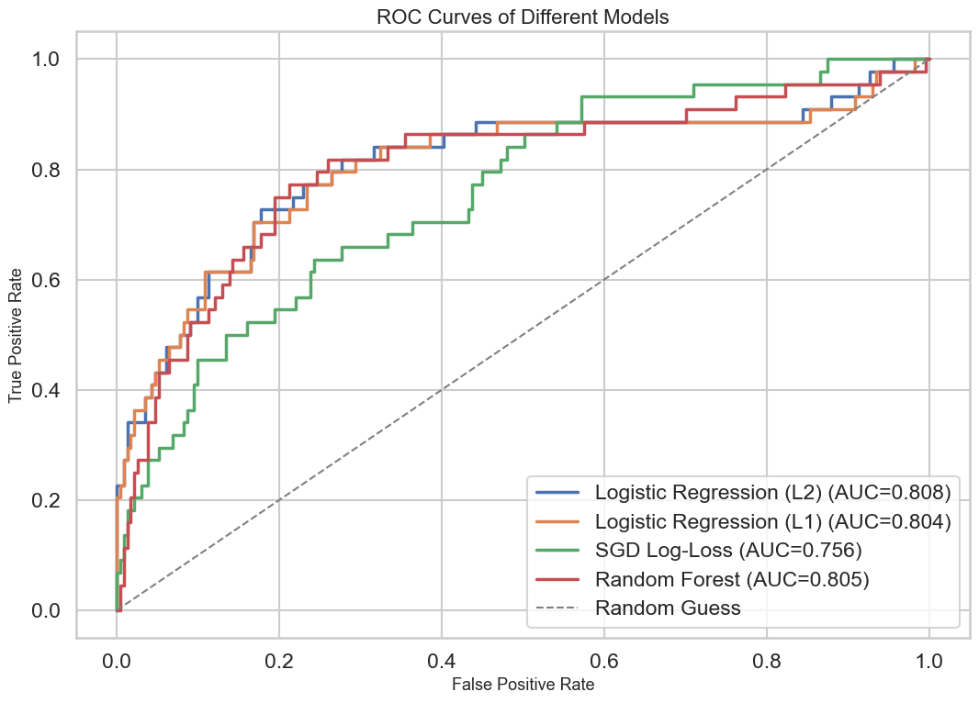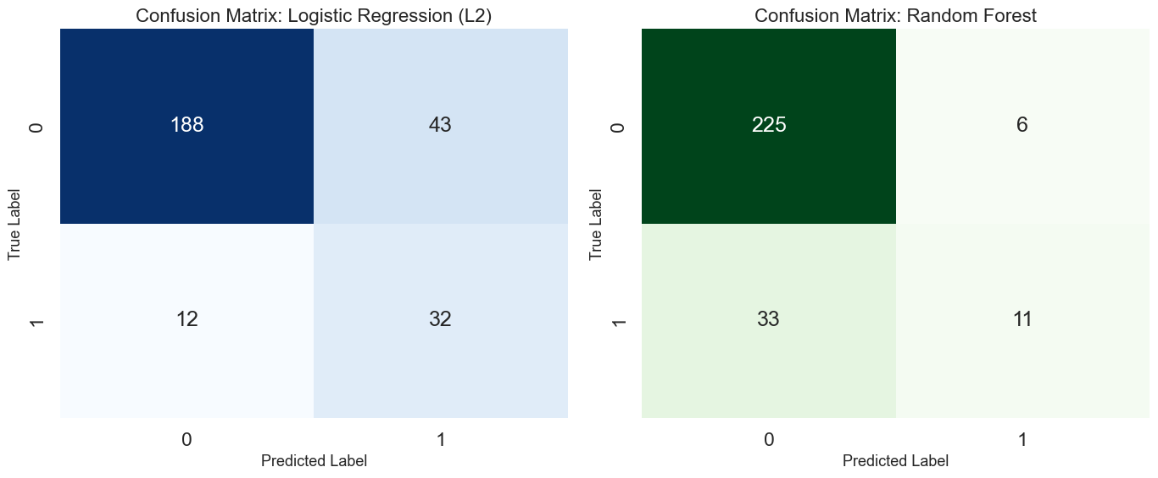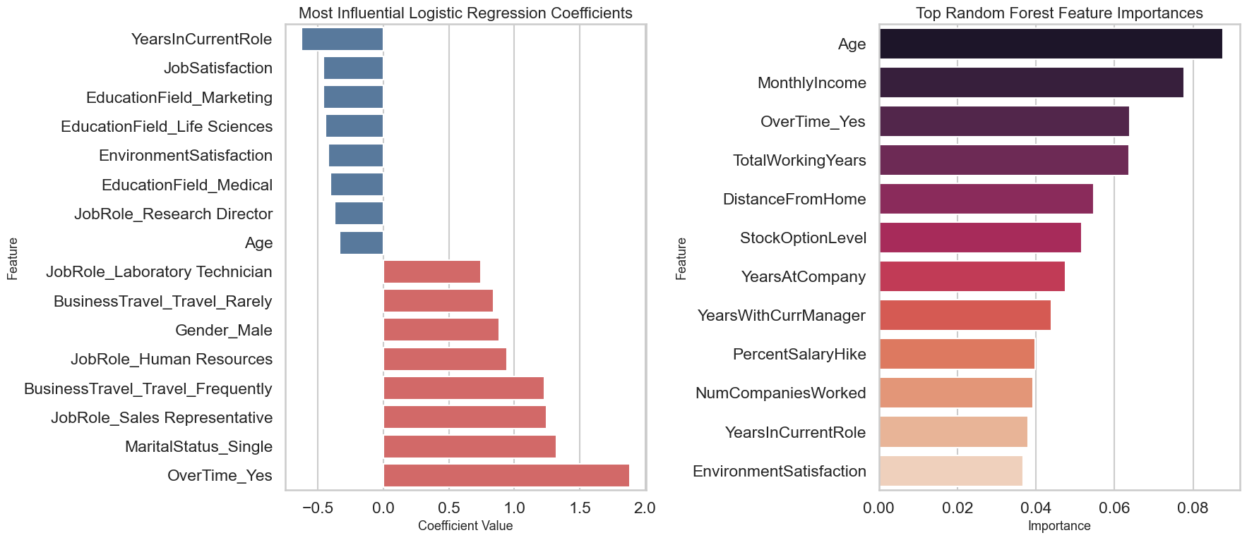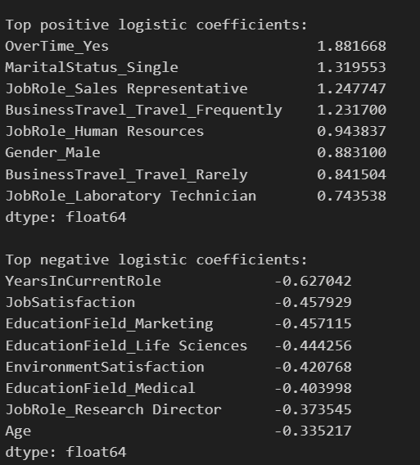
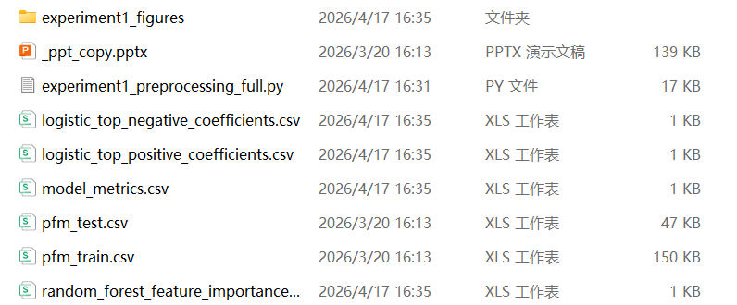

5. Reflections on the Experiment

This experiment gave me a much stronger feeling that data analysis is never just about “choosing a model and pressing run.” At the beginning, I thought the main work would probably be filling missing values, because that is usually the first problem mentioned in data cleaning. But after I checked the dataset with info() and isnull().sum(), I found that there were actually no missing values in the training and test sets. That result surprised me a little. It made me realize that real problems are not always the most obvious ones. In this dataset, the more important issues were constant columns, identifier columns, categorical encoding, and keeping the train and test feature spaces consistent.

One problem that took me some time to understand was the role of categorical features in linear models. At first, those columns just looked like ordinary text fields, but once I started thinking about model input, I realized they could not be used directly at all. My first concern was whether converting them would change the meaning of the data too much. Later, after comparing the different categories and seeing how many important employee attributes were stored as text, I understood that dropping them would actually lose too much information. That is why one-hot encoding became necessary. But after solving that problem, another one appeared immediately: the encoded training set and the encoded test set might not end up with exactly the same columns. I found that this was one of those details that looks very small in code but is actually very serious inpractice. Using reindex was the step that really fixed this issue, and after I understood it, I felt I had learned something much more practical than just a syntax trick.

Another thing I learned from this experiment was that preprocessing decisions directly affect model behavior later. For example, I standardized the numeric features because I knew that linear models are sensitive to scale. Before doing this experiment, I only understood “standardization” as a general textbook concept. But after actually writing the code, I understood why the order matters: the scaler must be fitted on the training data first, and then the same rule must be applied to validation or test data. Otherwise, the whole process becomes loose and can even introduce information leakage. This made me more careful with the distinction between fit_transform() and transform(). It is a small coding detail, but it carries an important methodological meaning.

The modeling stage also gave me a more realistic view of evaluation. At first, it was tempting to look mainly at accuracy, because accuracy is the easiest number to read. But once I checked the label distribution, I found that the attrition class was much smaller than the non-attrition class. That meant a model could still get a decent accuracy even if it missed many employees who were actually likely to leave. Because of that, I started paying much more attention to recall, F1-score, and ROC-AUC. This changed how I looked at the results. For example, a model with higher accuracy was not always the best choice if its recall was too low. That made the comparison between logistic regression and random forest much more meaningful, and it also helped me understand why a linear model can still be a strong and practical choice even if it is not the most complicated model in the experiment.

I also ran into a very concrete workflow problem during the experiment: some generated output files had been deleted, and then the old export logic failed because it was trying to infer the output directory by checking whether certain files already existed. At first this error looked confusing, because the preprocessing code itself was correct, but the export step still stopped. After tracing the problem, I realized the issue was not the data transformation logic, but the path selection logic. The fix was to stop depending on previously existing files and instead write the outputs directly to a clear target folder. This small debugging experience made the experiment feel more real to me, because it reminded me that practical data work is not only about algorithms. File organization, reproducibility, and stable code structure are also part of doing the job well.

Overall, this experiment helped me connect many things that used to feel separate in theory: raw data inspection, cleaning, feature encoding, scaling, train-test alignment, model comparison, metric selection, and result interpretation. What I gained most was not just a set of processed csv files or a finished notebook, but a clearer sense of how one step leads to the next. When a later model works well, it is often because the earlier preprocessing was done carefully. When a result looks strange, the reason may be hidden several steps earlier. That is probably the biggest lesson I learned here: a good model result usually begins with patient, detailed, and sometimes even tedious preprocessing work.

Grade:

Reviewed by: --------

Date: --------

