Hubei University

Academic Year 2025 -- 2026
Semester 2

Student Laboratory Report Book

Institute： Manchester United College
Student Name： Qin Tian
Class： 2402
Student ID： 202431123002054
Course Course： Big Data Analysis
Instructor： Li Jie

Student Laboratory Rules

1. Students must conduct experiments at the scheduled time and may not be absent or late without cause.
2. Before each experiment, students must preview the assigned experiment and prepare a preview report as required.
3. Before each experiment, students must submit the previous experiment report and the preview report for the current experiment. The experiment may begin only after the instructor has checked and approved them.
4. After reaching their assigned lab station, students must check the instruments they use against the equipment list for any missing or damaged items. Any problems must be reported to the instructor promptly. Using another group's instruments without authorization is strictly forbidden.
5. During the experiment, students must maintain a rigorous scientific attitude and strictly follow instrument operating procedures and precautions.
6. After the experiment, students must submit their data to the instructor for inspection. Once approved, they should restore and organize the instruments and equipment before leaving the lab.
7. Keep the laboratory quiet and tidy. Loud talking, littering, and eating are prohibited.
8. If an accident or damage to instruments or equipment is caused by violating operating procedures or conducting experiments without permission, it must be reported promptly. A damage list must be completed, and compensation shall be made according to the college's relevant regulations.

Experiment Title:
Lab2-Experiment 3 Classification Model Practice

Laboratory: Innovation & Entrepreneurship 7001 Date: 2026.5.15

Problem Description
This experiment is Experiment 3: Classification Model Practice in the continuous project of Big Data Analysis and Application. In the previous experiments, I had already completed the main preprocessing work for the employee attrition dataset. The raw data were cleaned, categorical features were encoded, numeric features were scaled, and the training and test feature columns were made consistent. Therefore, this experiment does not start from the original raw data again. Instead, it continues from the preprocessed data files generated in Experiment 2 and focuses on training and comparing different classification models.
The main task of this experiment is to build several supervised classification models to predict employee attrition. The target variable is Attrition, which represents whether an employee left the company or not. According to Teacher Li Jie’s PPT and class explanation, this experiment is not only about running sklearn code, but also about understanding how different classification algorithms make decisions. A Decision Tree classifies samples by splitting the data step by step. The split criterion can be based on Information Gain / Entropy or Gini Index. Naive Bayes uses probability and Bayes’ theorem to make classification decisions. Support Vector Machine tries to find a decision boundary that separates different classes as well as possible. These ideas from the class materials helped me understand why the same dataset may produce different results under different models.
In this experiment, I need to implement four required models: Information Gain Decision Tree, Gini Index Decision Tree, Naive Bayes, and Support Vector Machine. All of them are implemented with sklearn and run on CPU. This means the experiment does not use GPU, cuML, RAPIDS, or PyTorch. I think this setting is suitable for the course requirement, because the purpose here is to practise traditional machine learning classification methods and compare their performance clearly.
At first, this experiment looked like a simple model comparison task. However, after checking the data files more carefully, I found that the most important issue was how to evaluate the models correctly. The file X_test_preprocessed.csv only contains test features, but there is no y_test_preprocessed.csv. Because the real labels of the test set are not available, I cannot use the test set to calculate accuracy, precision, recall, F1-score, or any other evaluation metric. This point was also related to what Teacher Li Jie emphasized in class: a model result is only meaningful when the evaluation method is correct. This reminder helped me slow down and check the role of each dataset before calculating model performance.
Because of this, I used the preprocessed training data to create a new training set and validation set. The models were trained on the training part and evaluated on the validation part. The test set was only used to generate final predictions. This design avoids the mistake of treating an unlabeled test set as an evaluation set. It also makes the experiment more reliable and easier to explain in the report.
Another important problem is that employee attrition prediction is not a perfectly balanced classification task. The number of employees who leave is much smaller than the number of employees who stay. Because of this, accuracy alone is not enough. A model may get a high accuracy by predicting most employees as non-attrition, but it may still miss many employees who actually leave. So in this experiment, I need to compare the models with multiple metrics, including accuracy, precision, recall, F1-score, ROC-AUC, PR-AUC, confusion matrix, classification report, training score, validation score, overfitting gap, training time, and prediction time.
So the main problem in this experiment is not only how to train four classification models. More importantly, it is how to use the data from Experiment 2 correctly, how to build a fair validation process, and how to explain the strengths and weaknesses of each model. In my understanding, Experiment 3 connects the previous preprocessing work with real classification practice. It helps me see the full workflow from prepared data, to model training, to validation evaluation, to visual analysis, and finally to test prediction.

2. Basic Approach
My basic idea in this experiment was to continue the previous workflow instead of rebuilding the whole data processing process from the beginning. First, I loaded the three preprocessed files from the Experiment 2 folder: X_train_preprocessed.csv, y_train_preprocessed.csv, and X_test_preprocessed.csv. These files were already prepared in the earlier experiments, so using them made Experiment 3 consistent with the whole project. This also made me understand more clearly that the previous preprocessing results were not just temporary outputs. They became the foundation of the later classification experiment.

After loading the data, I checked the shapes of the feature matrices and the label file. I also made sure that the target variable Attrition was used as the binary classification label. Since there was no true label file for the test set, I did not use X_test_preprocessed.csv for evaluation. This was one of the most important parts of the experiment. In a normal situation, the word “test” may make people think it should be used for testing model performance. But in this project, the test set has no ground-truth labels, so it can only be used for final prediction. Teacher Li Jie’s explanation in class helped me notice this difference more carefully, and I think this was a very useful reminder for avoiding wrong evaluation.

Then I split the preprocessed training data into a new training set and validation set. I used a stratified split so that the class distribution in the training set and validation set could stay similar. This step is important because employee attrition is an imbalanced classification problem. If the split is not stratified, the validation set may contain too few positive samples, and the result may become unstable. After the split, each model was fitted on the training set and evaluated on the validation set.

Next, I defined the four required classification models according to the experiment requirement and the course materials. For the decision tree part, I built two versions. The first one used entropy as the criterion, so it represented the Information Gain Decision Tree. The second one used gini as the criterion, so it represented the Gini Index Decision Tree. Although both models belong to decision trees, their split criteria are different. This allowed me to compare how entropy / information gain and Gini index may lead to different tree structures and different validation performance.

Besides the two decision tree models, I also trained Gaussian Naive Bayes and Support Vector Machine. Naive Bayes was used as a simple probabilistic classifier. It is easy to train and can work as a useful baseline model. Support Vector Machine was used as a stronger nonlinear classifier. In my code, I used an RBF kernel and enabled probability output, so that I could calculate metrics such as ROC-AUC and PR-AUC. This part matched the idea from Teacher Li Jie’s classification model practice materials: different classifiers have different assumptions and different decision styles, so the comparison should not be limited to only one model or one metric.

For each model, I calculated a full set of evaluation metrics. The main metrics included accuracy, precision, recall, F1-score, ROC-AUC, and PR-AUC. I also generated the confusion matrix and classification report for each model. These metrics helped me understand the result from different angles. For example, accuracy shows the overall correct prediction rate, but recall shows how many true attrition cases were found. For this employee attrition task, recall and false negatives are especially important, because missing an employee who may leave can be more serious than making a false alarm.

I also recorded the training score, validation score, and overfitting gap. This helped me check whether a model fitted the training data too much. If a model performs very well on the training set but much worse on the validation set, then it may have an overfitting problem. This is especially important for decision trees, because a tree can easily become too deep and memorize training samples. In addition, I recorded training time and prediction time, because a complete model comparison should also include computational cost, not only prediction metrics.

After the evaluation, I saved the numerical results into the results folder. The main result files include model_evaluation_results.csv, classification_report_all_models.txt, validation_predictions_all_models.csv, test_predictions.csv, model_runtime_results.csv, and model_ranking_summary.csv. These files make the experiment easier to check, reproduce, and explain. They also make the report writing easier, because the model comparison table and prediction results are stored clearly.

At the same time, I generated figures in the figures folder. These figures include the target variable distribution, feature correlation heatmap, model metrics comparison, confusion matrices, ROC curves, PR curves, decision tree structures, decision tree feature importance plots, prediction probability distribution, FP/FN error analysis, and runtime comparison. I kept the titles, axes, and legends in English so that the figures can be used directly in the English experiment report.

Finally, I used the trained models to generate predictions for X_test_preprocessed.csv. Since the real test labels were not available, I only saved the predicted labels and positive-class probability or score values into test_predictions.csv. I did not calculate test accuracy or test F1-score. This is an important part of my approach, because it shows that the validation set and the test set have different roles in this experiment. The validation set is used for model evaluation, while the test set is only used for final prediction.

Overall, my approach was to keep the experiment correct, clear, and reproducible. I used the preprocessed data from Experiment 2, trained the four required sklearn classification models, evaluated them on a proper validation set, saved complete result files, and generated figures for analysis. I also tried to follow Teacher Li Jie’s class emphasis on careful experimental logic. For me, this experiment was not just about finishing four models. It was more about learning how to build a complete classification workflow and how to avoid misleading evaluation results.

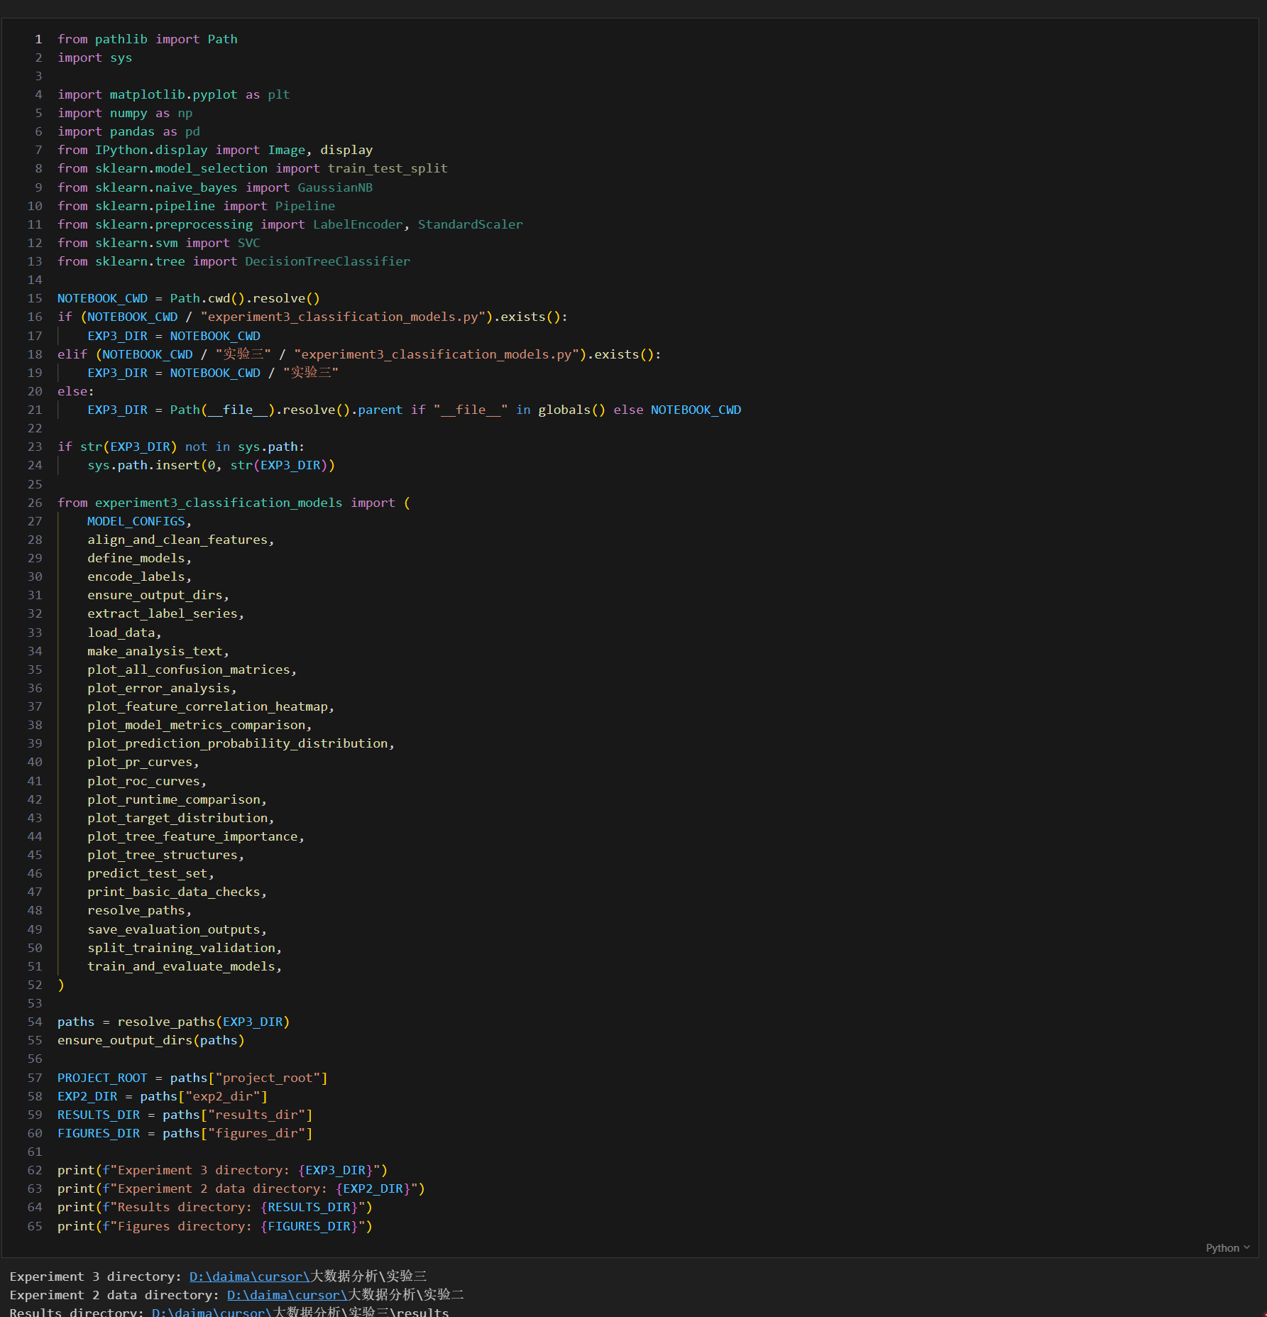3. Source Code

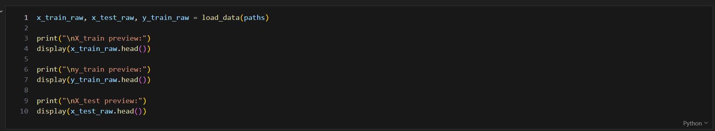

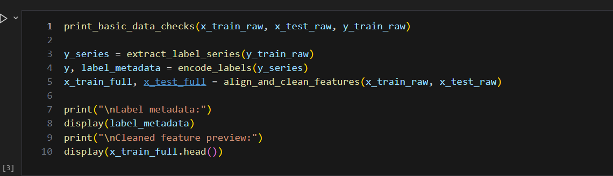

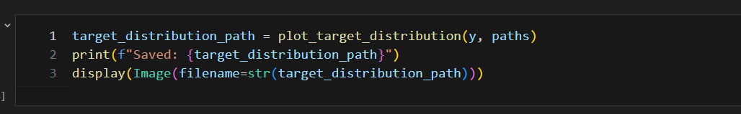

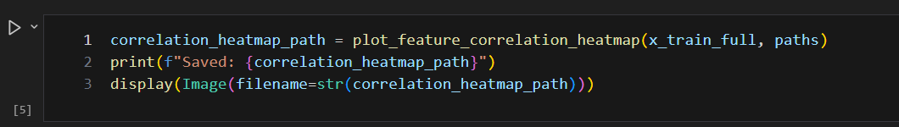

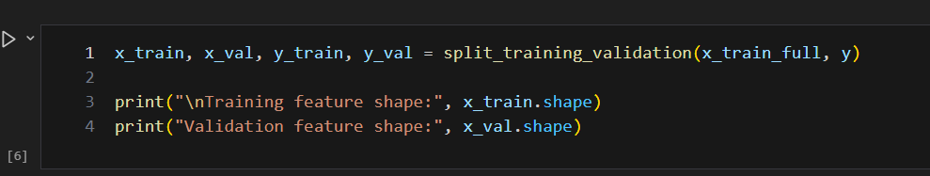

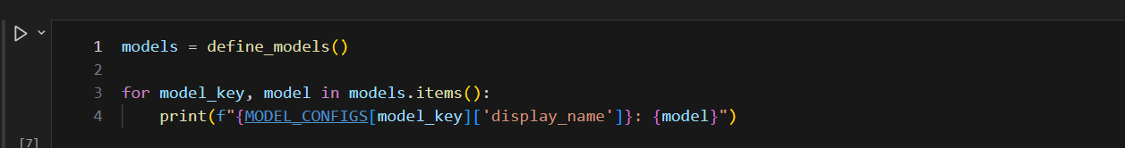

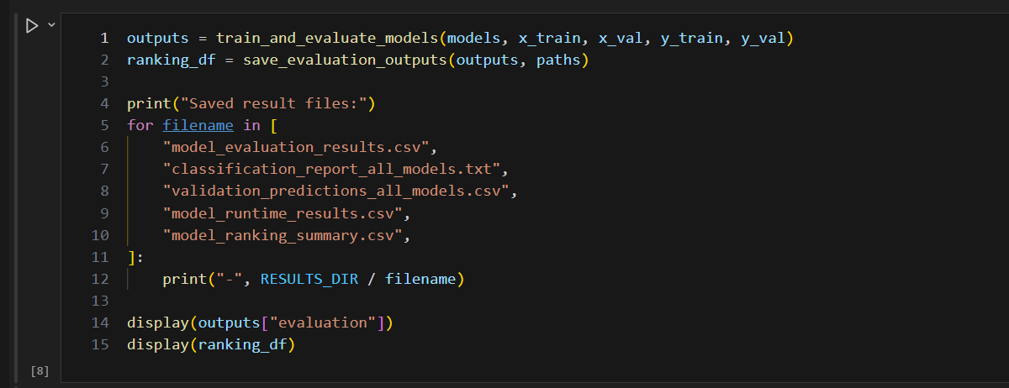

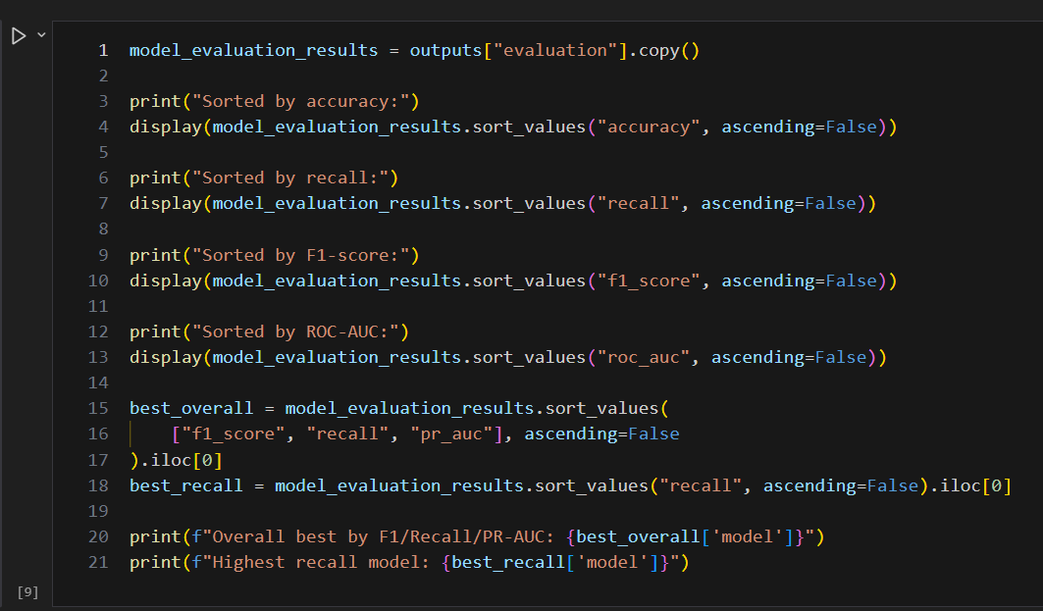

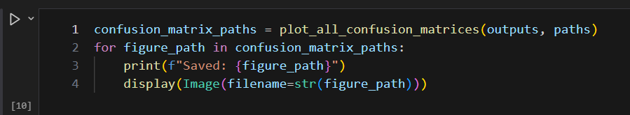

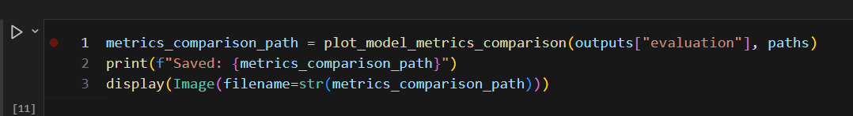

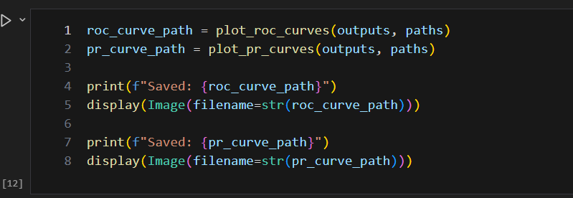

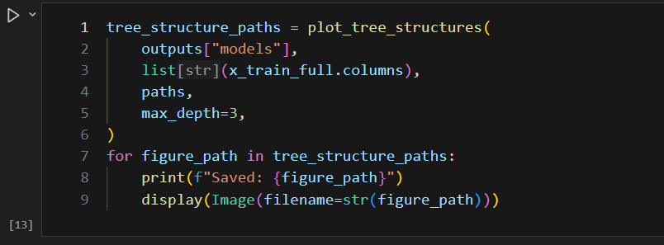

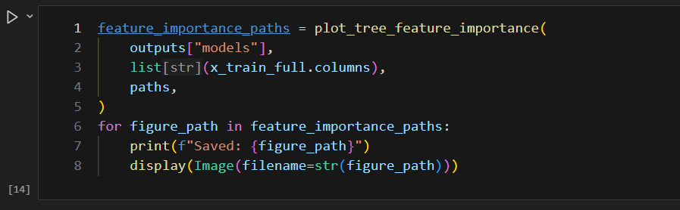

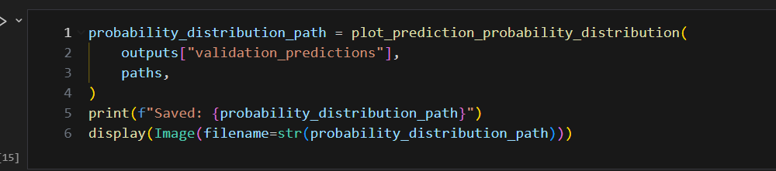

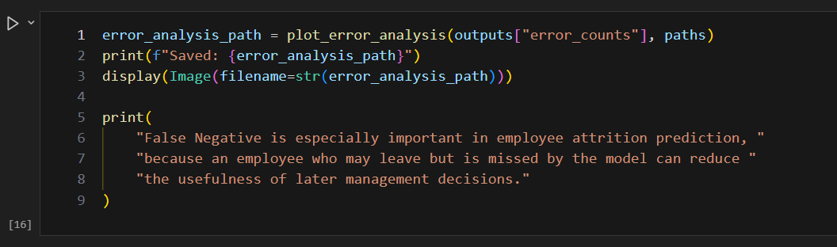

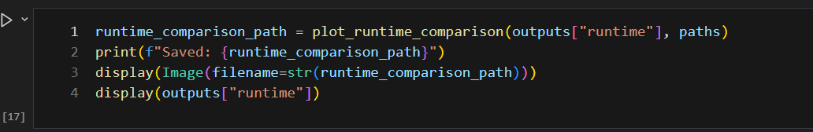

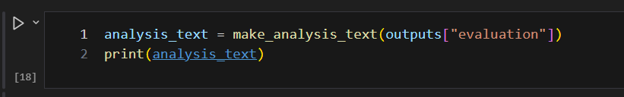

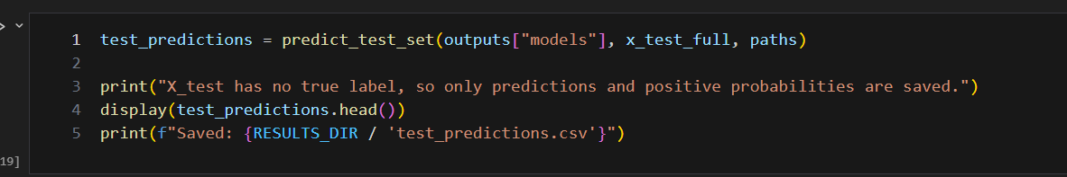

from __future__ import annotations

import time
import warnings
from pathlib import Path
from typing import Any

import matplotlib.pyplot as plt
import numpy as np
import pandas as pd
from sklearn.metrics import (
accuracy_score,
average_precision_score,
classification_report,
confusion_matrix,
f1_score,
precision_recall_curve,
precision_score,
recall_score,
roc_auc_score,
roc_curve,
)
from sklearn.model_selection import train_test_split
from sklearn.naive_bayes import GaussianNB
from sklearn.pipeline import Pipeline
from sklearn.preprocessing import LabelEncoder, StandardScaler
from sklearn.svm import SVC
from sklearn.tree import DecisionTreeClassifier, plot_tree

RANDOM_STATE = 42
VALIDATION_SIZE = 0.2
TOP_CORRELATION_FEATURES = 25
TOP_IMPORTANCE_FEATURES = 20

MODEL_CONFIGS = {
"entropy_tree": {
"display_name": "Information Gain Decision Tree",
"column_prefix": "information_gain_tree",
"confusion_figure": "04_confusion_matrix_entropy_tree.png",
},
"gini_tree": {
"display_name": "Gini Index Decision Tree",
"column_prefix": "gini_index_tree",
"confusion_figure": "05_confusion_matrix_gini_tree.png",
},
"naive_bayes": {
"display_name": "Naive Bayes",
"column_prefix": "naive_bayes",
"confusion_figure": "06_confusion_matrix_naive_bayes.png",
},
"svm": {
"display_name": "Support Vector Machine",
"column_prefix": "svm",
"confusion_figure": "07_confusion_matrix_svm.png",
},
}

POSITIVE_KEYWORDS = {
"1",
"1.0",
"yes",
"y",
"true",
"t",
"left",
"leave",
"leaver",
"attrition",
"attrited",
"resigned",
"quit",
"是",
"离职",
}

NEGATIVE_KEYWORDS = {
"0",
"0.0",
"no",
"n",
"false",
"f",
"stay",
"stayed",
"active",
"not left",
"no attrition",
"否",
"在职",
"未离职",
}

def resolve_paths(exp3_dir: str | Path | None = None) -> dict[str, Path]:
"""Resolve project paths so the script works from the repo root or Experiment 3."""
if exp3_dir is None:
exp3_dir = Path(__file__).resolve().parent
else:
exp3_dir = Path(exp3_dir).resolve()

project_root = exp3_dir.parent
exp2_dir = project_root / "实验二"
return {
"project_root": project_root,
"exp3_dir": exp3_dir,
"exp2_dir": exp2_dir,
"results_dir": exp3_dir / "results",
"figures_dir": exp3_dir / "figures",
"x_train": exp2_dir / "X_train_preprocessed.csv",
"x_test": exp2_dir / "X_test_preprocessed.csv",
"y_train": exp2_dir / "y_train_preprocessed.csv",
}

def ensure_output_dirs(paths: dict[str, Path]) -> None:
paths["results_dir"].mkdir(parents=True, exist_ok=True)
paths["figures_dir"].mkdir(parents=True, exist_ok=True)

def check_required_files(paths: dict[str, Path]) -> None:
required_files = [paths["x_train"], paths["x_test"], paths["y_train"]]
missing_files = [str(path) for path in required_files if not path.exists()]
if missing_files:
raise FileNotFoundError(
"The following required data files were not found:\n"
+ "\n".join(missing_files)
)

def load_data(paths: dict[str, Path]) -> tuple[pd.DataFrame, pd.DataFrame, pd.DataFrame]:
check_required_files(paths)
x_train_full = pd.read_csv(paths["x_train"])
x_test_full = pd.read_csv(paths["x_test"])
y_train_raw = pd.read_csv(paths["y_train"])

print("Data loaded from Experiment 2.")
print(f"X_train shape: {x_train_full.shape}")
print(f"X_test shape: {x_test_full.shape}")
print(f"y_train shape: {y_train_raw.shape}")

return x_train_full, x_test_full, y_train_raw

def count_infinite_values(frame: pd.DataFrame) -> int:
numeric_frame = frame.select_dtypes(include=[np.number])
if numeric_frame.empty:
return 0
return int(np.isinf(numeric_frame.to_numpy()).sum())

def print_basic_data_checks(
x_train_full: pd.DataFrame,
x_test_full: pd.DataFrame,
y_train_raw: pd.DataFrame,
) -> None:
print("\nBasic data checks")
print(f"X_train missing values: {int(x_train_full.isna().sum().sum())}")
print(f"X_test missing values: {int(x_test_full.isna().sum().sum())}")
print(f"y_train missing values: {int(y_train_raw.isna().sum().sum())}")
print(f"X_train infinite values: {count_infinite_values(x_train_full)}")
print(f"X_test infinite values: {count_infinite_values(x_test_full)}")

def align_and_clean_features(
x_train_full: pd.DataFrame,
x_test_full: pd.DataFrame,
) -> tuple[pd.DataFrame, pd.DataFrame]:
"""Align test columns to train columns and use simple safe cleaning for NaN/inf."""
train_columns = list(x_train_full.columns)
missing_in_test = [col for col in train_columns if col not in x_test_full.columns]
extra_in_test = [col for col in x_test_full.columns if col not in train_columns]

if missing_in_test:
print(f"Columns missing in X_test and filled with 0: {missing_in_test}")
if extra_in_test:
print(f"Extra columns in X_test dropped: {extra_in_test}")

x_train_clean = x_train_full.copy()
x_test_aligned = x_test_full.copy()
for col in missing_in_test:
x_test_aligned[col] = 0
x_test_aligned = x_test_aligned[train_columns]

non_numeric_columns = [
col
for col in train_columns
if not pd.api.types.is_numeric_dtype(x_train_clean[col])
or not pd.api.types.is_numeric_dtype(x_test_aligned[col])
]
if non_numeric_columns:
print(
"Non-numeric columns were converted with pandas.to_numeric: "
f"{non_numeric_columns}"
)

x_train_clean = x_train_clean.apply(pd.to_numeric, errors="coerce")
x_test_clean = x_test_aligned.apply(pd.to_numeric, errors="coerce")

x_train_clean = x_train_clean.replace([np.inf, -np.inf], np.nan)
x_test_clean = x_test_clean.replace([np.inf, -np.inf], np.nan)

medians = x_train_clean.median(numeric_only=True).replace(
[np.inf, -np.inf], np.nan
)
medians = medians.fillna(0)

train_missing_before = int(x_train_clean.isna().sum().sum())
test_missing_before = int(x_test_clean.isna().sum().sum())
if train_missing_before or test_missing_before:
print(
"NaN or infinite values were handled with train-set medians, "
"then 0 for any remaining empty columns."
)

x_train_clean = x_train_clean.fillna(medians).fillna(0)
x_test_clean = x_test_clean.fillna(medians).fillna(0)

print(f"Cleaned X_train shape: {x_train_clean.shape}")
print(f"Cleaned X_test shape: {x_test_clean.shape}")
return x_train_clean, x_test_clean

def extract_label_series(y_train_raw: pd.DataFrame | pd.Series) -> pd.Series:
if isinstance(y_train_raw, pd.DataFrame):
if y_train_raw.shape[1] > 1:
print("y_train has more than one column. The first column is used as label.")
y_series = y_train_raw.iloc[:, 0]
else:
y_series = pd.Series(y_train_raw)

y_series = y_series.reset_index(drop=True)
if y_series.isna().any():
label_mode = y_series.mode(dropna=True)
fill_value = label_mode.iloc[0] if not label_mode.empty else 0
print(f"Missing labels found. They were filled with the mode value: {fill_value}")
y_series = y_series.fillna(fill_value)

print("\nLabel distribution before encoding:")
print(y_series.value_counts(dropna=False))
return y_series

def _normalized_label(value: Any) -> str:
return str(value).strip().lower()

def choose_positive_label(labels: list[Any]) -> Any:
"""Try to detect the attrition/leave class. Fall back to the largest label."""
normalized_map = {label: _normalized_label(label) for label in labels}

for label, text in normalized_map.items():
if text in POSITIVE_KEYWORDS:
return label

strong_keywords = POSITIVE_KEYWORDS - {"1", "1.0", "y", "t"}
for label, text in normalized_map.items():
if text in NEGATIVE_KEYWORDS or text.startswith("no "):
continue
if any(keyword in text for keyword in strong_keywords):
return label

numeric_labels = pd.to_numeric(pd.Series(labels), errors="coerce")
if numeric_labels.notna().all():
if (numeric_labels == 1).any():
return labels[int(np.where(numeric_labels.to_numpy() == 1)[0][0])]
return labels[int(numeric_labels.to_numpy().argmax())]

return sorted(labels, key=lambda item: str(item))[-1]

def encode_labels(y_series: pd.Series) -> tuple[np.ndarray, dict[str, Any]]:
"""Convert labels to binary 0/1 labels for sklearn metrics."""
unique_labels = list(pd.unique(y_series))
if len(unique_labels) < 2:
raise ValueError("At least two label classes are required for classification.")

numeric_labels = pd.to_numeric(y_series, errors="coerce")
unique_numeric = sorted(pd.unique(numeric_labels.dropna()))
is_clean_binary_numeric = (
numeric_labels.notna().all() and set(unique_numeric).issubset({0, 1})
)

if is_clean_binary_numeric:
y = numeric_labels.astype(int).to_numpy()
positive_label = 1
encoder_classes = None
print("Numeric 0/1 labels detected. Positive class is 1.")
else:
positive_label = choose_positive_label(unique_labels)
encoder = LabelEncoder()
labels_as_text = y_series.astype(str)
encoded = encoder.fit_transform(labels_as_text)
positive_text = str(positive_label)

if positive_text in encoder.classes_:
positive_code = int(np.where(encoder.classes_ == positive_text)[0][0])
else:
positive_code = len(encoder.classes_) - 1
positive_label = encoder.classes_[positive_code]

y = np.where(encoded == positive_code, 1, 0).astype(int)
encoder_classes = list(encoder.classes_)
print("LabelEncoder was used for non-0/1 labels.")
print(f"Encoder classes: {encoder_classes}")
print(f"Positive class: {positive_label}")

print("\nEncoded label distribution:")
print(pd.Series(y).value_counts().sort_index())

metadata = {
"positive_label": positive_label,
"encoder_classes": encoder_classes,
"negative_class": 0,
"positive_class": 1,
}
return y, metadata

def plot_target_distribution(y: np.ndarray, paths: dict[str, Path]) -> Path:
counts = pd.Series(y).value_counts().sort_index()
labels = ["Negative (0)", "Positive (1)"]

fig, ax = plt.subplots(figsize=(6, 4))
ax.bar(labels, [counts.get(0, 0), counts.get(1, 0)], color=["#4C78A8", "#F58518"])
ax.set_title("Target Distribution")
ax.set_xlabel("Class")
ax.set_ylabel("Number of Employees")
for index, value in enumerate([counts.get(0, 0), counts.get(1, 0)]):
ax.text(index, value, str(value), ha="center", va="bottom")
fig.tight_layout()

output_path = paths["figures_dir"] / "01_target_distribution.png"
fig.savefig(output_path, dpi=300)
plt.close(fig)
return output_path

def plot_feature_correlation_heatmap(
x_train_full: pd.DataFrame,
paths: dict[str, Path],
top_n: int = TOP_CORRELATION_FEATURES,
) -> Path:
variances = x_train_full.var().sort_values(ascending=False)
selected_features = list(variances.head(min(top_n, len(variances))).index)
corr_matrix = x_train_full[selected_features].corr().fillna(0)

fig_width = max(10, len(selected_features) * 0.45)
fig, ax = plt.subplots(figsize=(fig_width, fig_width * 0.75))
image = ax.imshow(corr_matrix, cmap="coolwarm", vmin=-1, vmax=1)
ax.set_title(f"Feature Correlation Heatmap (Top {len(selected_features)} by Variance)")
ax.set_xticks(np.arange(len(selected_features)))
ax.set_yticks(np.arange(len(selected_features)))
ax.set_xticklabels(selected_features, rotation=60, ha="right", fontsize=7)
ax.set_yticklabels(selected_features, fontsize=7)
ax.set_xlabel("Features")
ax.set_ylabel("Features")
fig.colorbar(image, ax=ax, fraction=0.046, pad=0.04, label="Correlation")
fig.tight_layout()

output_path = paths["figures_dir"] / "02_feature_correlation_heatmap.png"
fig.savefig(output_path, dpi=300)
plt.close(fig)
return output_path

def split_training_validation(
x_train_full: pd.DataFrame,
y: np.ndarray,
) -> tuple[pd.DataFrame, pd.DataFrame, np.ndarray, np.ndarray]:
x_train, x_val, y_train, y_val = train_test_split(
x_train_full,
y,
test_size=VALIDATION_SIZE,
random_state=RANDOM_STATE,
stratify=y,
)
print("\nTraining/validation split")
print(f"Training set shape: {x_train.shape}")
print(f"Validation set shape: {x_val.shape}")
print("Training label distribution:")
print(pd.Series(y_train).value_counts().sort_index())
print("Validation label distribution:")
print(pd.Series(y_val).value_counts().sort_index())
return x_train, x_val, y_train, y_val

def define_models() -> dict[str, Any]:
return {
"entropy_tree": DecisionTreeClassifier(
criterion="entropy",
random_state=RANDOM_STATE,
),
"gini_tree": DecisionTreeClassifier(
criterion="gini",
random_state=RANDOM_STATE,
),
"naive_bayes": GaussianNB(),
"svm": Pipeline(
[
("scaler", StandardScaler()),
(
"svm",
SVC(kernel="rbf", probability=True, random_state=RANDOM_STATE),
),
]
),
}

def get_positive_scores(model: Any, x_data: pd.DataFrame) -> np.ndarray:
"""Return positive class probability when available, otherwise a decision score."""
if hasattr(model, "predict_proba"):
probabilities = model.predict_proba(x_data)
if probabilities.ndim == 2 and probabilities.shape[1] > 1:
return probabilities[:, 1]
return probabilities.ravel()

if hasattr(model, "decision_function"):
scores = model.decision_function(x_data)
return np.asarray(scores).ravel()

return model.predict(x_data)

def safe_auc(metric_name: str, y_true: np.ndarray, y_score: np.ndarray) -> float:
try:
if metric_name == "roc_auc":
return float(roc_auc_score(y_true, y_score))
if metric_name == "pr_auc":
return float(average_precision_score(y_true, y_score))
except ValueError as error:
print(f"{metric_name} could not be calculated: {error}")
return float("nan")

def train_and_evaluate_models(
models: dict[str, Any],
x_train: pd.DataFrame,
x_val: pd.DataFrame,
y_train: np.ndarray,
y_val: np.ndarray,
) -> dict[str, Any]:
evaluation_rows: list[dict[str, Any]] = []
runtime_rows: list[dict[str, Any]] = []
report_sections: list[str] = []
roc_data: dict[str, tuple[np.ndarray, np.ndarray, float]] = {}
pr_data: dict[str, tuple[np.ndarray, np.ndarray, float]] = {}
confusion_matrices: dict[str, np.ndarray] = {}
error_rows: list[dict[str, Any]] = []

validation_predictions = pd.DataFrame(
{
"validation_index": x_val.index.to_numpy(),
"true_label": y_val,
}
)

for model_key, model in models.items():
display_name = MODEL_CONFIGS[model_key]["display_name"]
column_prefix = MODEL_CONFIGS[model_key]["column_prefix"]
print(f"\nTraining {display_name}...")

training_start = time.perf_counter()
model.fit(x_train, y_train)
training_time = time.perf_counter() - training_start

prediction_start = time.perf_counter()
y_val_pred = model.predict(x_val)
y_val_score = get_positive_scores(model, x_val)
prediction_time = time.perf_counter() - prediction_start

training_score = float(model.score(x_train, y_train))
validation_score = float(accuracy_score(y_val, y_val_pred))
overfitting_gap = training_score - validation_score

accuracy = float(accuracy_score(y_val, y_val_pred))
precision = float(precision_score(y_val, y_val_pred, zero_division=0))
recall = float(recall_score(y_val, y_val_pred, zero_division=0))
f1 = float(f1_score(y_val, y_val_pred, zero_division=0))
roc_auc = safe_auc("roc_auc", y_val, y_val_score)
pr_auc = safe_auc("pr_auc", y_val, y_val_score)

cm = confusion_matrix(y_val, y_val_pred, labels=[0, 1])
tn, fp, fn, tp = cm.ravel()
confusion_matrices[model_key] = cm

if not np.isnan(roc_auc):
fpr, tpr, _ = roc_curve(y_val, y_val_score)
roc_data[model_key] = (fpr, tpr, roc_auc)
if not np.isnan(pr_auc):
precision_curve, recall_curve, _ = precision_recall_curve(y_val, y_val_score)
pr_data[model_key] = (recall_curve, precision_curve, pr_auc)

evaluation_rows.append(
{
"model": display_name,
"accuracy": accuracy,
"precision": precision,
"recall": recall,
"f1_score": f1,
"roc_auc": roc_auc,
"pr_auc": pr_auc,
"training_score": training_score,
"validation_score": validation_score,
"overfitting_gap": overfitting_gap,
"training_time_seconds": training_time,
"prediction_time_seconds": prediction_time,
"true_negative": int(tn),
"false_positive": int(fp),
"false_negative": int(fn),
"true_positive": int(tp),
}
)
runtime_rows.append(
{
"model": display_name,
"training_time_seconds": training_time,
"prediction_time_seconds": prediction_time,
}
)
error_rows.extend(
[
{
"model": display_name,
"error_type": "False Positive",
"count": int(fp),
},
{
"model": display_name,
"error_type": "False Negative",
"count": int(fn),
},
]
)

validation_predictions[f"{column_prefix}_predicted_label"] = y_val_pred
validation_predictions[f"{column_prefix}_positive_probability"] = y_val_score

report_sections.append(
"\n".join(
[
f"=== {display_name} ===",
"Confusion matrix labels: [0, 1]",
str(cm),
"",
classification_report(
y_val,
y_val_pred,
labels=[0, 1],
target_names=["Negative (0)", "Positive (1)"],
zero_division=0,
),
"",
]
)
)

print(
f"{display_name}: accuracy={accuracy:.4f}, recall={recall:.4f}, "
f"f1={f1:.4f}, roc_auc={roc_auc:.4f}, pr_auc={pr_auc:.4f}"
)

return {
"models": models,
"evaluation": pd.DataFrame(evaluation_rows),
"runtime": pd.DataFrame(runtime_rows),
"validation_predictions": validation_predictions,
"classification_report_text": "\n".join(report_sections),
"roc_data": roc_data,
"pr_data": pr_data,
"confusion_matrices": confusion_matrices,
"error_counts": pd.DataFrame(error_rows),
}

def make_model_ranking_summary(evaluation_df: pd.DataFrame) -> pd.DataFrame:
def best_model(metric: str, prefer_min: bool = False) -> tuple[str, float]:
series = evaluation_df[["model", metric]].replace([np.inf, -np.inf], np.nan)
series = series.dropna(subset=[metric])
if series.empty:
return "N/A", float("nan")
index = series[metric].idxmin() if prefer_min else series[metric].idxmax()
row = evaluation_df.loc[index]
return str(row["model"]), float(row[metric])

best_accuracy_model, best_accuracy_value = best_model("accuracy")
best_precision_model, best_precision_value = best_model("precision")
best_recall_model, best_recall_value = best_model("recall")
best_f1_model, best_f1_value = best_model("f1_score")
best_roc_auc_model, best_roc_auc_value = best_model("roc_auc")
best_pr_auc_model, best_pr_auc_value = best_model("pr_auc")
fastest_training_model, fastest_training_value = best_model(
"training_time_seconds", prefer_min=True
)
largest_gap_model, largest_gap_value = best_model("overfitting_gap")

return pd.DataFrame(
[
{
"best_accuracy_model": best_accuracy_model,
"best_accuracy_value": best_accuracy_value,
"best_precision_model": best_precision_model,
"best_precision_value": best_precision_value,
"best_recall_model": best_recall_model,
"best_recall_value": best_recall_value,
"best_f1_model": best_f1_model,
"best_f1_value": best_f1_value,
"best_roc_auc_model": best_roc_auc_model,
"best_roc_auc_value": best_roc_auc_value,
"best_pr_auc_model": best_pr_auc_model,
"best_pr_auc_value": best_pr_auc_value,
"fastest_training_model": fastest_training_model,
"fastest_training_seconds": fastest_training_value,
"largest_overfitting_gap_model": largest_gap_model,
"largest_overfitting_gap_value": largest_gap_value,
}
]
)

def save_evaluation_outputs(outputs: dict[str, Any], paths: dict[str, Path]) -> pd.DataFrame:
evaluation_df = outputs["evaluation"]
runtime_df = outputs["runtime"]
validation_predictions = outputs["validation_predictions"]
ranking_df = make_model_ranking_summary(evaluation_df)

evaluation_df.to_csv(paths["results_dir"] / "model_evaluation_results.csv", index=False)
runtime_df.to_csv(paths["results_dir"] / "model_runtime_results.csv", index=False)
validation_predictions.to_csv(
paths["results_dir"] / "validation_predictions_all_models.csv",
index=False,
)
ranking_df.to_csv(paths["results_dir"] / "model_ranking_summary.csv", index=False)

report_path = paths["results_dir"] / "classification_report_all_models.txt"
report_path.write_text(outputs["classification_report_text"], encoding="utf-8")

return ranking_df

def plot_model_metrics_comparison(
evaluation_df: pd.DataFrame,
paths: dict[str, Path],
) -> Path:
metrics = ["accuracy", "precision", "recall", "f1_score", "roc_auc", "pr_auc"]
metric_labels = ["Accuracy", "Precision", "Recall", "F1-score", "ROC-AUC", "PR-AUC"]
models = evaluation_df["model"].tolist()
x_positions = np.arange(len(metrics))
bar_width = 0.18

fig, ax = plt.subplots(figsize=(12, 6))
for index, model_name in enumerate(models):
values = evaluation_df.loc[evaluation_df["model"] == model_name, metrics]
values = values.iloc[0].replace([np.inf, -np.inf], np.nan).fillna(0).to_numpy()
ax.bar(
x_positions + (index - 1.5) * bar_width,
values,
width=bar_width,
label=model_name,
)

ax.set_title("Model Metrics Comparison")
ax.set_xlabel("Evaluation Metric")
ax.set_ylabel("Score")
ax.set_xticks(x_positions)
ax.set_xticklabels(metric_labels)
ax.set_ylim(0, 1.05)
ax.legend(loc="lower center", bbox_to_anchor=(0.5, -0.35), ncol=2)
ax.grid(axis="y", alpha=0.25)
fig.tight_layout()

output_path = paths["figures_dir"] / "03_model_metrics_comparison.png"
fig.savefig(output_path, dpi=300)
plt.close(fig)
return output_path

def plot_confusion_matrix_figure(
cm: np.ndarray,
title: str,
output_path: Path,
) -> None:
fig, ax = plt.subplots(figsize=(5.5, 4.8))
image = ax.imshow(cm, cmap="Blues")
ax.set_title(title)
ax.set_xlabel("Predicted Label")
ax.set_ylabel("True Label")
ax.set_xticks([0, 1])
ax.set_yticks([0, 1])
ax.set_xticklabels(["Negative (0)", "Positive (1)"])
ax.set_yticklabels(["Negative (0)", "Positive (1)"])

threshold = cm.max() / 2 if cm.max() else 0
for row in range(cm.shape[0]):
for col in range(cm.shape[1]):
color = "white" if cm[row, col] > threshold else "black"
ax.text(col, row, int(cm[row, col]), ha="center", va="center", color=color)

fig.colorbar(image, ax=ax, fraction=0.046, pad=0.04, label="Count")
fig.tight_layout()
fig.savefig(output_path, dpi=300)
plt.close(fig)

def plot_all_confusion_matrices(outputs: dict[str, Any], paths: dict[str, Path]) -> list[Path]:
saved_paths = []
for model_key, cm in outputs["confusion_matrices"].items():
display_name = MODEL_CONFIGS[model_key]["display_name"]
output_path = paths["figures_dir"] / MODEL_CONFIGS[model_key]["confusion_figure"]
plot_confusion_matrix_figure(cm, f"{display_name} Confusion Matrix", output_path)
saved_paths.append(output_path)
return saved_paths

def plot_roc_curves(outputs: dict[str, Any], paths: dict[str, Path]) -> Path:
fig, ax = plt.subplots(figsize=(7, 6))
if outputs["roc_data"]:
for model_key, (fpr, tpr, auc_value) in outputs["roc_data"].items():
display_name = MODEL_CONFIGS[model_key]["display_name"]
ax.plot(fpr, tpr, label=f"{display_name} (AUC = {auc_value:.3f})")
ax.plot([0, 1], [0, 1], linestyle="--", color="gray", label="Random Guess")
ax.legend(loc="lower right", fontsize=8)
else:
ax.text(0.5, 0.5, "ROC curve unavailable", ha="center", va="center")

ax.set_title("ROC Curves for All Models")
ax.set_xlabel("False Positive Rate")
ax.set_ylabel("True Positive Rate")
ax.grid(alpha=0.25)
fig.tight_layout()

output_path = paths["figures_dir"] / "08_roc_curves_all_models.png"
fig.savefig(output_path, dpi=300)
plt.close(fig)
return output_path

def plot_pr_curves(outputs: dict[str, Any], paths: dict[str, Path]) -> Path:
fig, ax = plt.subplots(figsize=(7, 6))
if outputs["pr_data"]:
for model_key, (recall_curve, precision_curve, auc_value) in outputs[
"pr_data"
].items():
display_name = MODEL_CONFIGS[model_key]["display_name"]
ax.plot(
recall_curve,
precision_curve,
label=f"{display_name} (PR-AUC = {auc_value:.3f})",
)
ax.legend(loc="lower left", fontsize=8)
else:
ax.text(0.5, 0.5, "PR curve unavailable", ha="center", va="center")

ax.set_title("Precision-Recall Curves for All Models")
ax.set_xlabel("Recall")
ax.set_ylabel("Precision")
ax.grid(alpha=0.25)
fig.tight_layout()

output_path = paths["figures_dir"] / "09_pr_curves_all_models.png"
fig.savefig(output_path, dpi=300)
plt.close(fig)
return output_path

def plot_tree_structures(
models: dict[str, Any],
feature_names: list[str],
paths: dict[str, Path],
max_depth: int = 3,
) -> list[Path]:
saved_paths = []
tree_figures = {
"entropy_tree": "10_entropy_tree_structure.png",
"gini_tree": "11_gini_tree_structure.png",
}

for model_key, filename in tree_figures.items():
display_name = MODEL_CONFIGS[model_key]["display_name"]
fig, ax = plt.subplots(figsize=(24, 12))
plot_tree(
models[model_key],
feature_names=feature_names,
class_names=["Negative (0)", "Positive (1)"],
filled=True,
rounded=True,
max_depth=max_depth,
fontsize=7,
ax=ax,
)
ax.set_title(f"{display_name} Structure (Max Depth = {max_depth})")
fig.tight_layout()

output_path = paths["figures_dir"] / filename
fig.savefig(output_path, dpi=300)
plt.close(fig)
saved_paths.append(output_path)

return saved_paths

def plot_tree_feature_importance(
models: dict[str, Any],
feature_names: list[str],
paths: dict[str, Path],
top_n: int = TOP_IMPORTANCE_FEATURES,
) -> list[Path]:
saved_paths = []
importance_figures = {
"entropy_tree": "12_entropy_tree_feature_importance.png",
"gini_tree": "13_gini_tree_feature_importance.png",
}

feature_array = np.asarray(feature_names)
for model_key, filename in importance_figures.items():
display_name = MODEL_CONFIGS[model_key]["display_name"]
importances = models[model_key].feature_importances_
top_count = min(top_n, len(importances))
top_indices = np.argsort(importances)[::-1][:top_count][::-1]

fig, ax = plt.subplots(figsize=(10, 7))
ax.barh(feature_array[top_indices], importances[top_indices], color="#4C78A8")
ax.set_title(f"{display_name} Top {top_count} Feature Importances")
ax.set_xlabel("Feature Importance")
ax.set_ylabel("Feature")
ax.grid(axis="x", alpha=0.25)
fig.tight_layout()

output_path = paths["figures_dir"] / filename
fig.savefig(output_path, dpi=300)
plt.close(fig)
saved_paths.append(output_path)

return saved_paths

def plot_prediction_probability_distribution(
validation_predictions: pd.DataFrame,
paths: dict[str, Path],
) -> Path:
fig, axes = plt.subplots(2, 2, figsize=(12, 8))
axes = axes.ravel()

for index, (model_key, config) in enumerate(MODEL_CONFIGS.items()):
column = f"{config['column_prefix']}_positive_probability"
axes[index].hist(
validation_predictions[column],
bins=20,
color="#4C78A8",
alpha=0.78,
edgecolor="white",
)
axes[index].set_title(f"{config['display_name']} Positive Probability")
axes[index].set_xlabel("Positive Class Probability / Score")
axes[index].set_ylabel("Frequency")
axes[index].grid(axis="y", alpha=0.25)

fig.suptitle("Prediction Probability Distribution on Validation Set", y=1.02)
fig.tight_layout()

output_path = paths["figures_dir"] / "14_prediction_probability_distribution.png"
fig.savefig(output_path, dpi=300, bbox_inches="tight")
plt.close(fig)
return output_path

def plot_error_analysis(error_counts: pd.DataFrame, paths: dict[str, Path]) -> Path:
models = error_counts["model"].drop_duplicates().tolist()
false_positive_counts = []
false_negative_counts = []
for model_name in models:
model_errors = error_counts[error_counts["model"] == model_name]
false_positive_counts.append(
int(
model_errors.loc[
model_errors["error_type"] == "False Positive", "count"
].iloc[0]
)
)
false_negative_counts.append(
int(
model_errors.loc[
model_errors["error_type"] == "False Negative", "count"
].iloc[0]
)
)

x_positions = np.arange(len(models))
bar_width = 0.36
fig, ax = plt.subplots(figsize=(11, 6))
ax.bar(
x_positions - bar_width / 2,
false_positive_counts,
width=bar_width,
label="False Positive",
color="#72B7B2",
)
ax.bar(
x_positions + bar_width / 2,
false_negative_counts,
width=bar_width,
label="False Negative",
color="#E45756",
)
ax.set_title("Error Analysis: False Positives and False Negatives")
ax.set_xlabel("Model")
ax.set_ylabel("Number of Validation Samples")
ax.set_xticks(x_positions)
ax.set_xticklabels(models, rotation=15, ha="right")
ax.legend()
ax.grid(axis="y", alpha=0.25)
fig.tight_layout()

output_path = paths["figures_dir"] / "15_error_analysis_fp_fn.png"
fig.savefig(output_path, dpi=300)
plt.close(fig)
return output_path

def plot_runtime_comparison(runtime_df: pd.DataFrame, paths: dict[str, Path]) -> Path:
models = runtime_df["model"].tolist()
x_positions = np.arange(len(models))
bar_width = 0.36

fig, ax = plt.subplots(figsize=(11, 6))
ax.bar(
x_positions - bar_width / 2,
runtime_df["training_time_seconds"],
width=bar_width,
label="Training Time",
color="#4C78A8",
)
ax.bar(
x_positions + bar_width / 2,
runtime_df["prediction_time_seconds"],
width=bar_width,
label="Prediction Time",
color="#F58518",
)
ax.set_title("Model Training and Prediction Time Comparison")
ax.set_xlabel("Model")
ax.set_ylabel("Time (seconds)")
ax.set_xticks(x_positions)
ax.set_xticklabels(models, rotation=15, ha="right")
ax.legend()
ax.grid(axis="y", alpha=0.25)
fig.tight_layout()

output_path = paths["figures_dir"] / "16_model_training_time_comparison.png"
fig.savefig(output_path, dpi=300)
plt.close(fig)
return output_path

def generate_all_figures(
outputs: dict[str, Any],
x_train_full: pd.DataFrame,
y: np.ndarray,
paths: dict[str, Path],
) -> list[Path]:
figure_paths = [
plot_target_distribution(y, paths),
plot_feature_correlation_heatmap(x_train_full, paths),
plot_model_metrics_comparison(outputs["evaluation"], paths),
]
figure_paths.extend(plot_all_confusion_matrices(outputs, paths))
figure_paths.append(plot_roc_curves(outputs, paths))
figure_paths.append(plot_pr_curves(outputs, paths))
figure_paths.extend(
plot_tree_structures(outputs["models"], list(x_train_full.columns), paths)
)
figure_paths.extend(
plot_tree_feature_importance(outputs["models"], list(x_train_full.columns), paths)
)
figure_paths.append(
plot_prediction_probability_distribution(outputs["validation_predictions"], paths)
)
figure_paths.append(plot_error_analysis(outputs["error_counts"], paths))
figure_paths.append(plot_runtime_comparison(outputs["runtime"], paths))
return figure_paths

def predict_test_set(
models: dict[str, Any],
x_test_full: pd.DataFrame,
paths: dict[str, Path] | None = None,
) -> pd.DataFrame:
test_predictions = pd.DataFrame({"test_index": x_test_full.index.to_numpy()})

for model_key, model in models.items():
column_prefix = MODEL_CONFIGS[model_key]["column_prefix"]
test_predictions[f"{column_prefix}_predicted_label"] = model.predict(x_test_full)
test_predictions[f"{column_prefix}_positive_probability"] = get_positive_scores(
model,
x_test_full,
)

if paths is not None:
output_path = paths["results_dir"] / "test_predictions.csv"
test_predictions.to_csv(output_path, index=False)
print(f"Test predictions saved to: {output_path}")

return test_predictions

def make_analysis_text(evaluation_df: pd.DataFrame) -> str:
def row_for(metric: str, prefer_min: bool = False) -> pd.Series:
clean_df = evaluation_df.replace([np.inf, -np.inf], np.nan).dropna(
subset=[metric]
)
index = clean_df[metric].idxmin() if prefer_min else clean_df[metric].idxmax()
return evaluation_df.loc[index]

best_accuracy = row_for("accuracy")
best_recall = row_for("recall")
best_f1 = row_for("f1_score")
largest_gap = row_for("overfitting_gap")
fastest = row_for("training_time_seconds", prefer_min=True)

recommended = best_recall
if best_f1["recall"] >= best_recall["recall"] * 0.95 and best_f1["f1_score"] > best_recall["f1_score"]:
recommended = best_f1

return "\n".join(
[
"Detailed model evaluation analysis:",
f"1. Highest accuracy: {best_accuracy['model']} ({best_accuracy['accuracy']:.4f}).",
f"2. Highest recall: {best_recall['model']} ({best_recall['recall']:.4f}).",
f"3. Highest F1-score: {best_f1['model']} ({best_f1['f1_score']:.4f}).",
f"4. Largest overfitting gap: {largest_gap['model']} ({largest_gap['overfitting_gap']:.4f}).",
f"5. Fastest training: {fastest['model']} ({fastest['training_time_seconds']:.6f} seconds).",
f"6. Suggested model for employee attrition prediction: {recommended['model']}. "
"This choice gives priority to recall while still considering F1-score.",
"7. Accuracy alone is not enough for attrition prediction because the positive class "
"is usually smaller and false negatives are costly. Recall, F1-score, PR-AUC, "
"and the false-negative count show whether the model can find employees who may leave.",
]
)

def run_experiment(exp3_dir: str | Path | None = None) -> dict[str, Any]:
warnings.filterwarnings("ignore", category=UserWarning)
plt.rcParams["font.family"] = "DejaVu Sans"
plt.rcParams["axes.unicode_minus"] = False

paths = resolve_paths(exp3_dir)
ensure_output_dirs(paths)

print("Experiment 3: Classification Models for Employee Attrition")
print(f"Experiment 3 directory: {paths['exp3_dir']}")
print(f"Experiment 2 data directory: {paths['exp2_dir']}")

x_train_raw, x_test_raw, y_train_raw = load_data(paths)
print_basic_data_checks(x_train_raw, x_test_raw, y_train_raw)

y_series = extract_label_series(y_train_raw)
y, label_metadata = encode_labels(y_series)
x_train_full, x_test_full = align_and_clean_features(x_train_raw, x_test_raw)

if len(x_train_full) != len(y):
raise ValueError(
f"X_train rows ({len(x_train_full)}) and y_train rows ({len(y)}) do not match."
)

x_train, x_val, y_train, y_val = split_training_validation(x_train_full, y)
models = define_models()
outputs = train_and_evaluate_models(models, x_train, x_val, y_train, y_val)
ranking_df = save_evaluation_outputs(outputs, paths)
figure_paths = generate_all_figures(outputs, x_train_full, y, paths)
test_predictions = predict_test_set(outputs["models"], x_test_full, paths)
analysis_text = make_analysis_text(outputs["evaluation"])

print("\nModel evaluation results:")
print(outputs["evaluation"])
print("\nModel ranking summary:")
print(ranking_df)
print("\n" + analysis_text)
print("\nGenerated figures:")
for figure_path in figure_paths:
print(f"- {figure_path.name}")

print("\nExperiment 3 completed successfully.")
print(f"Results directory: {paths['results_dir']}")
print(f"Figures directory: {paths['figures_dir']}")

outputs.update(
{
"paths": paths,
"label_metadata": label_metadata,
"x_train_full": x_train_full,
"x_test_full": x_test_full,
"y": y,
"x_train": x_train,
"x_val": x_val,
"y_train": y_train,
"y_val": y_val,
"ranking": ranking_df,
"figure_paths": figure_paths,
"test_predictions": test_predictions,
"analysis_text": analysis_text,
}
)
return outputs

def main() -> None:
run_experiment()

if __name__ == "__main__":
main()

4. Experimental Data and Results

Experimental Data:


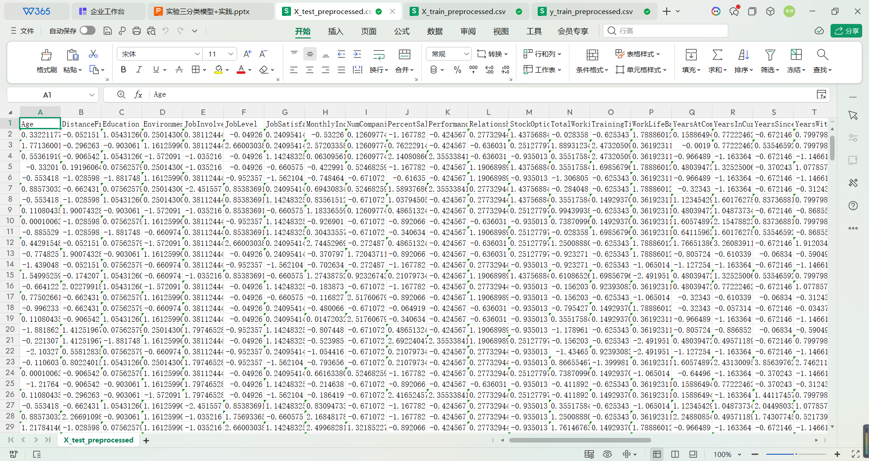

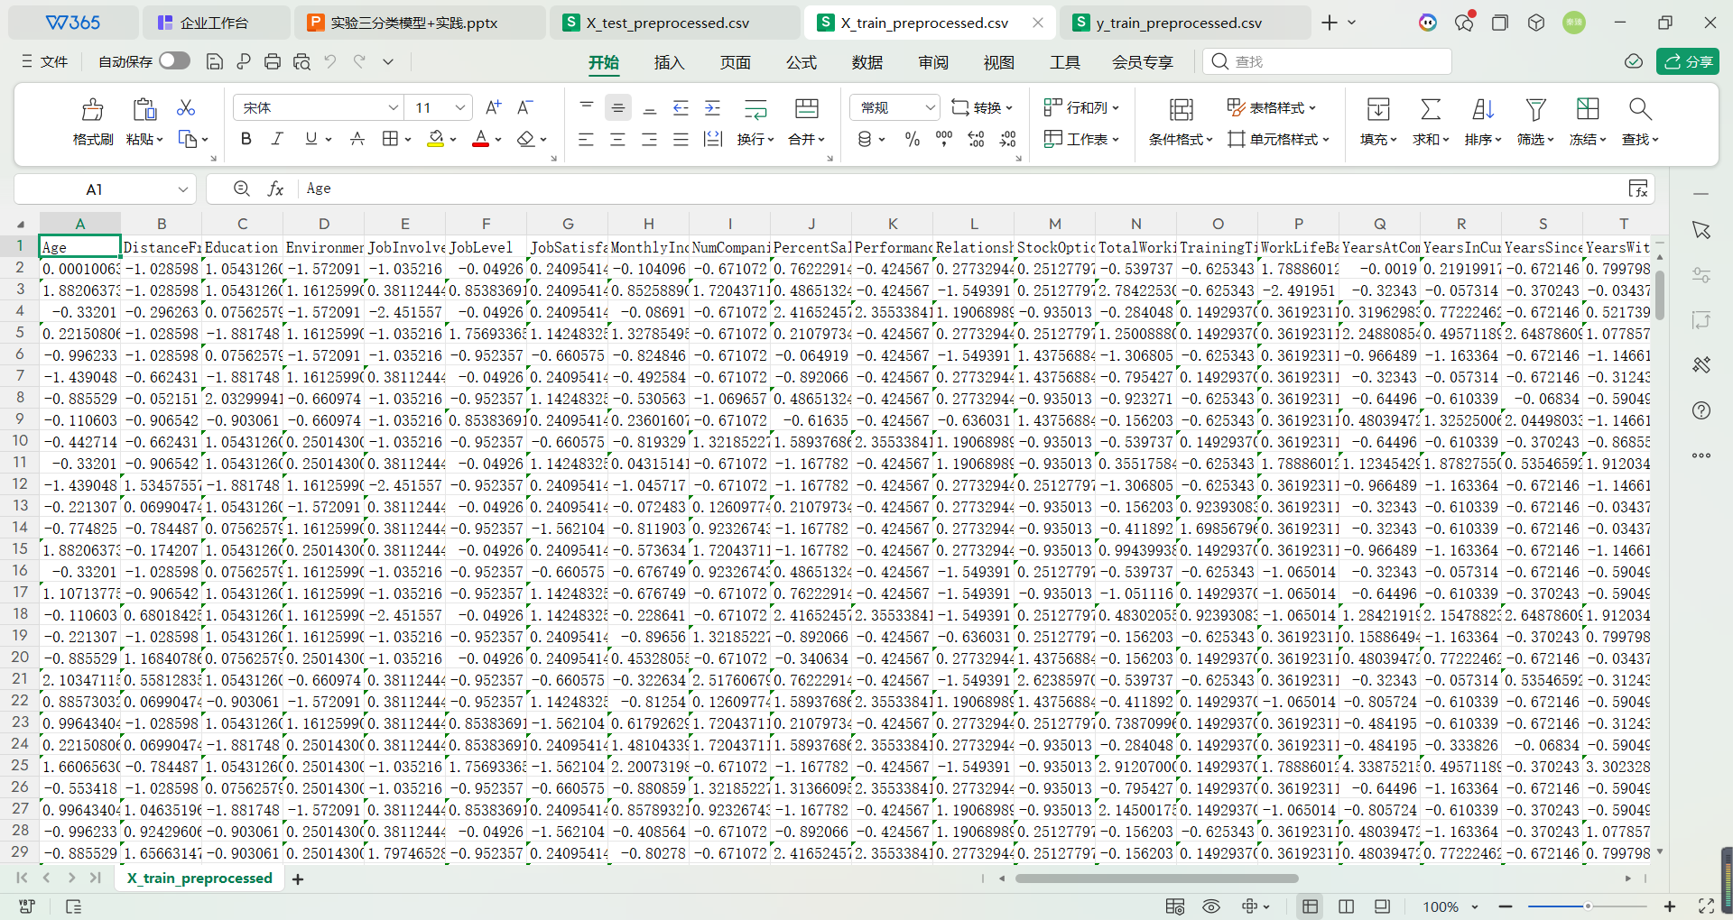



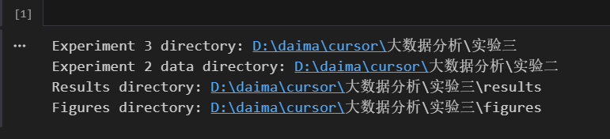Experimental Results:

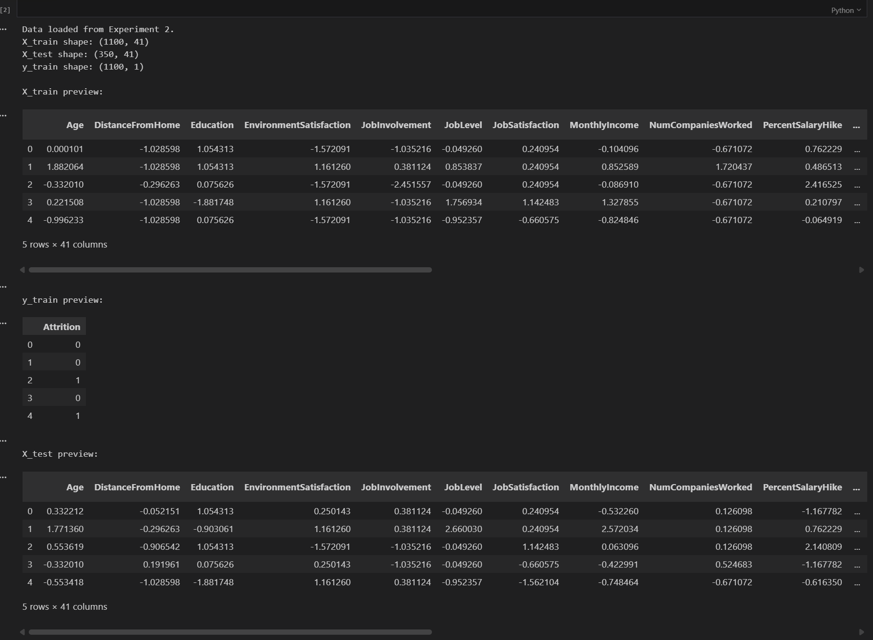

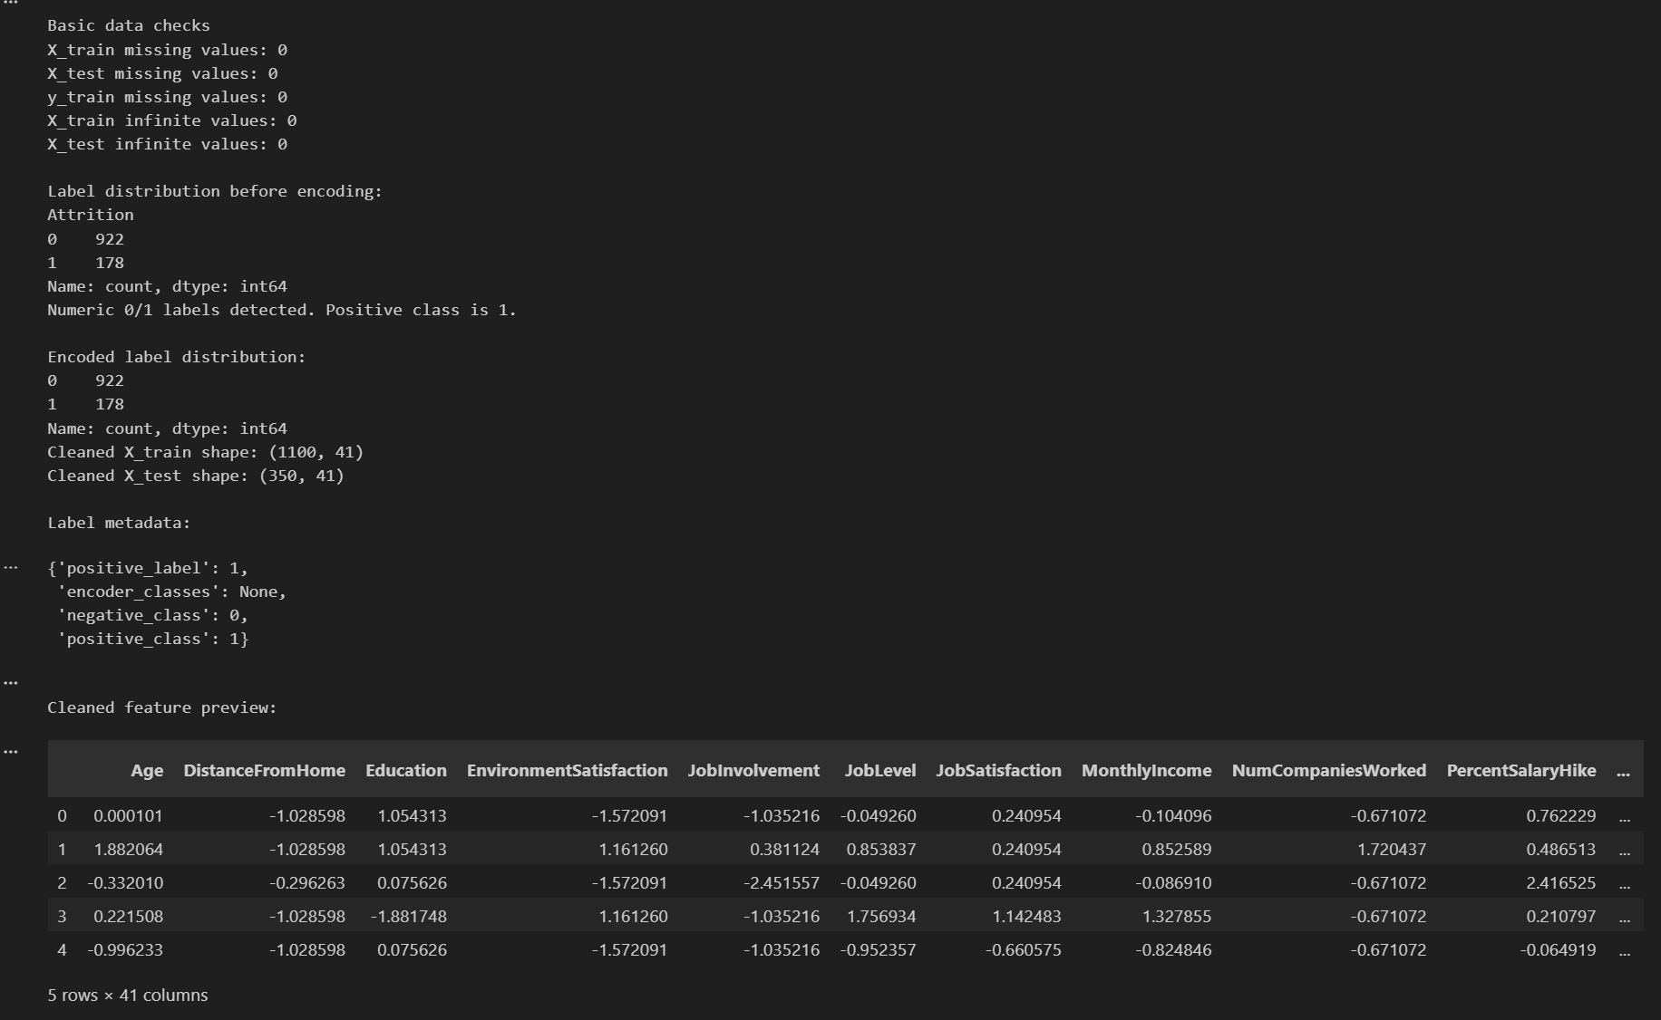

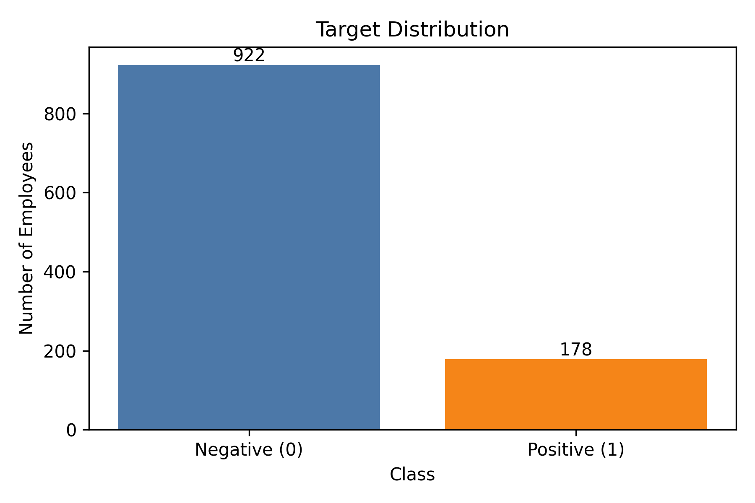

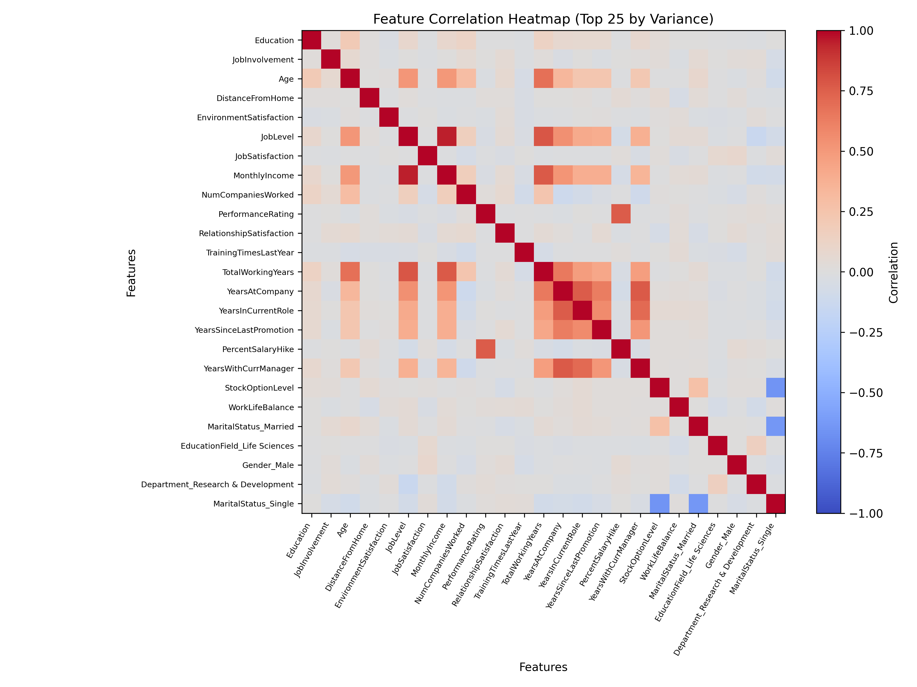

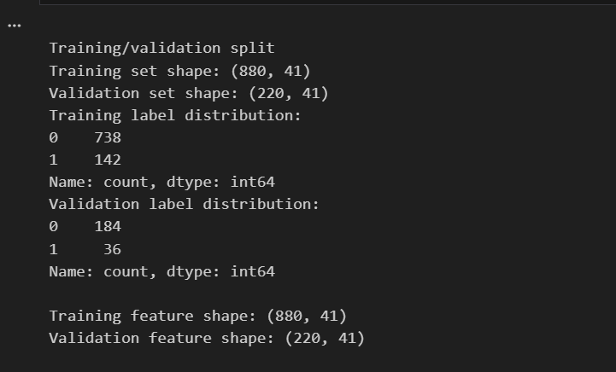

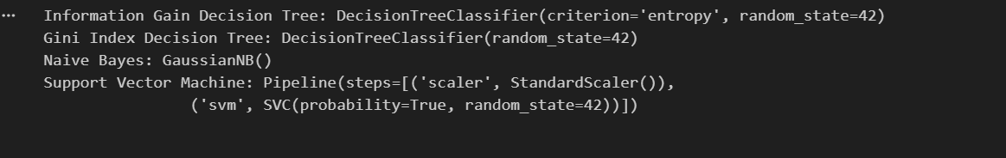

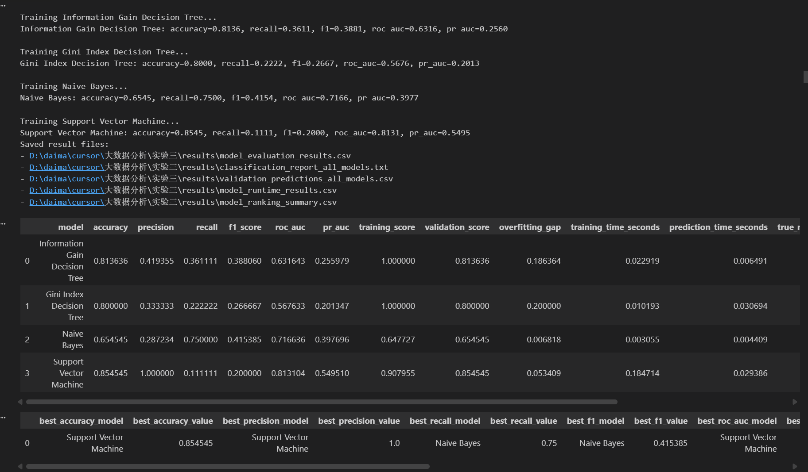

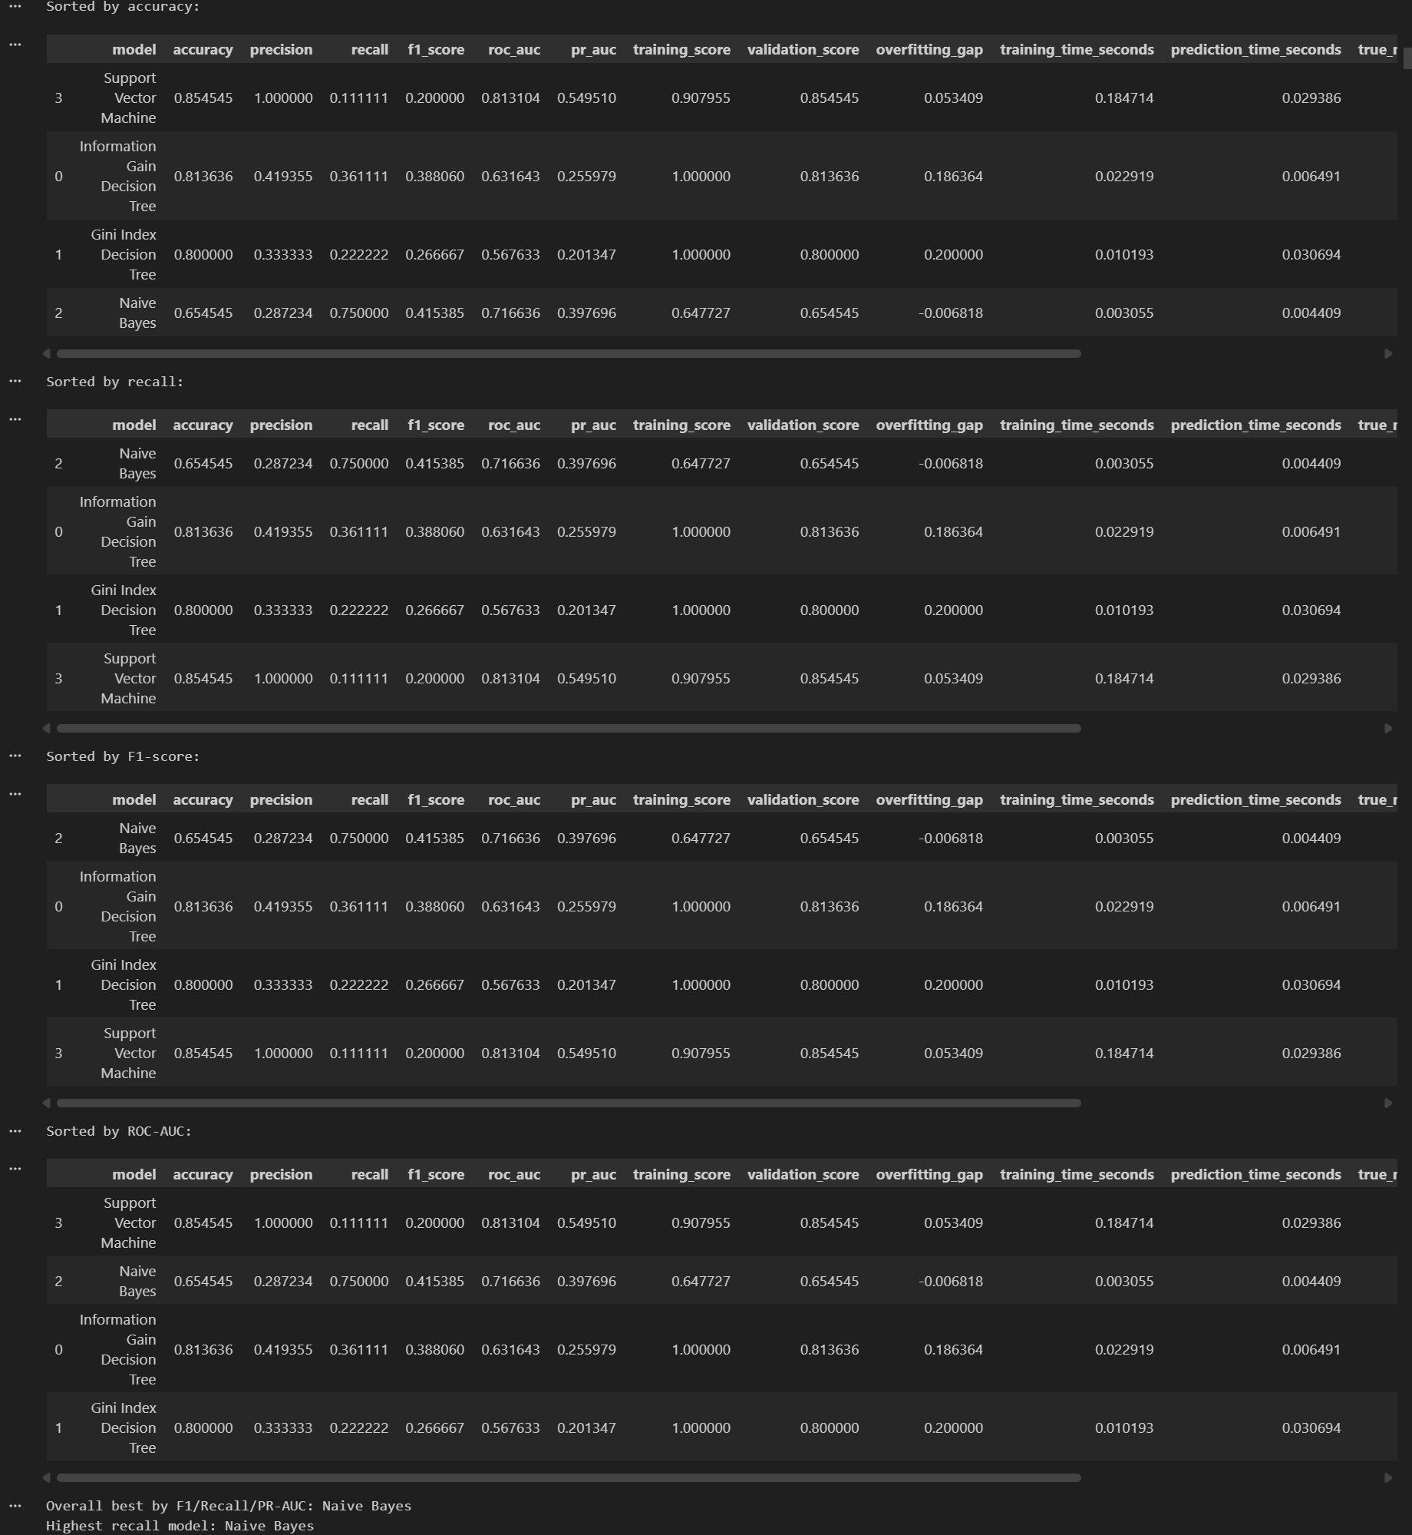

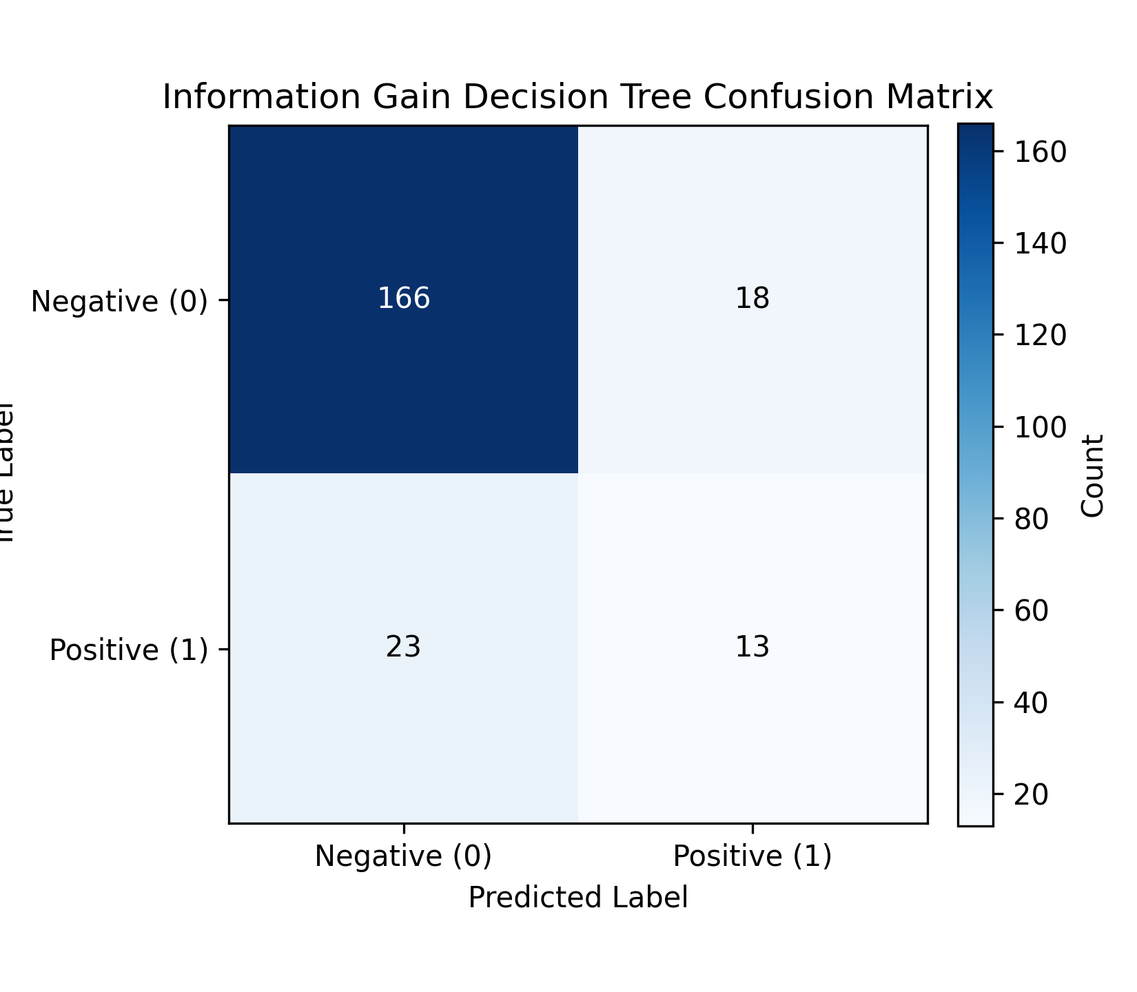

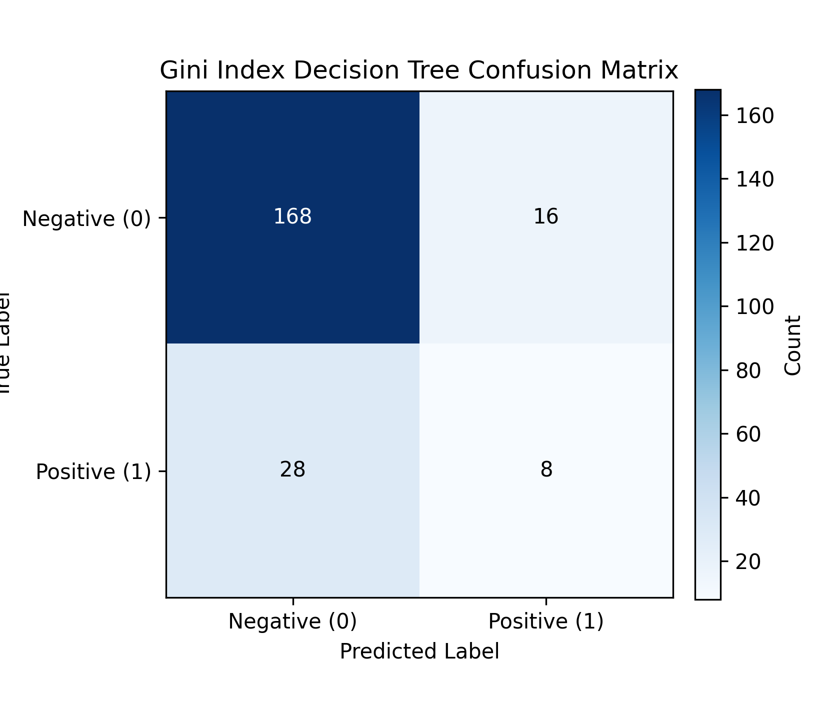

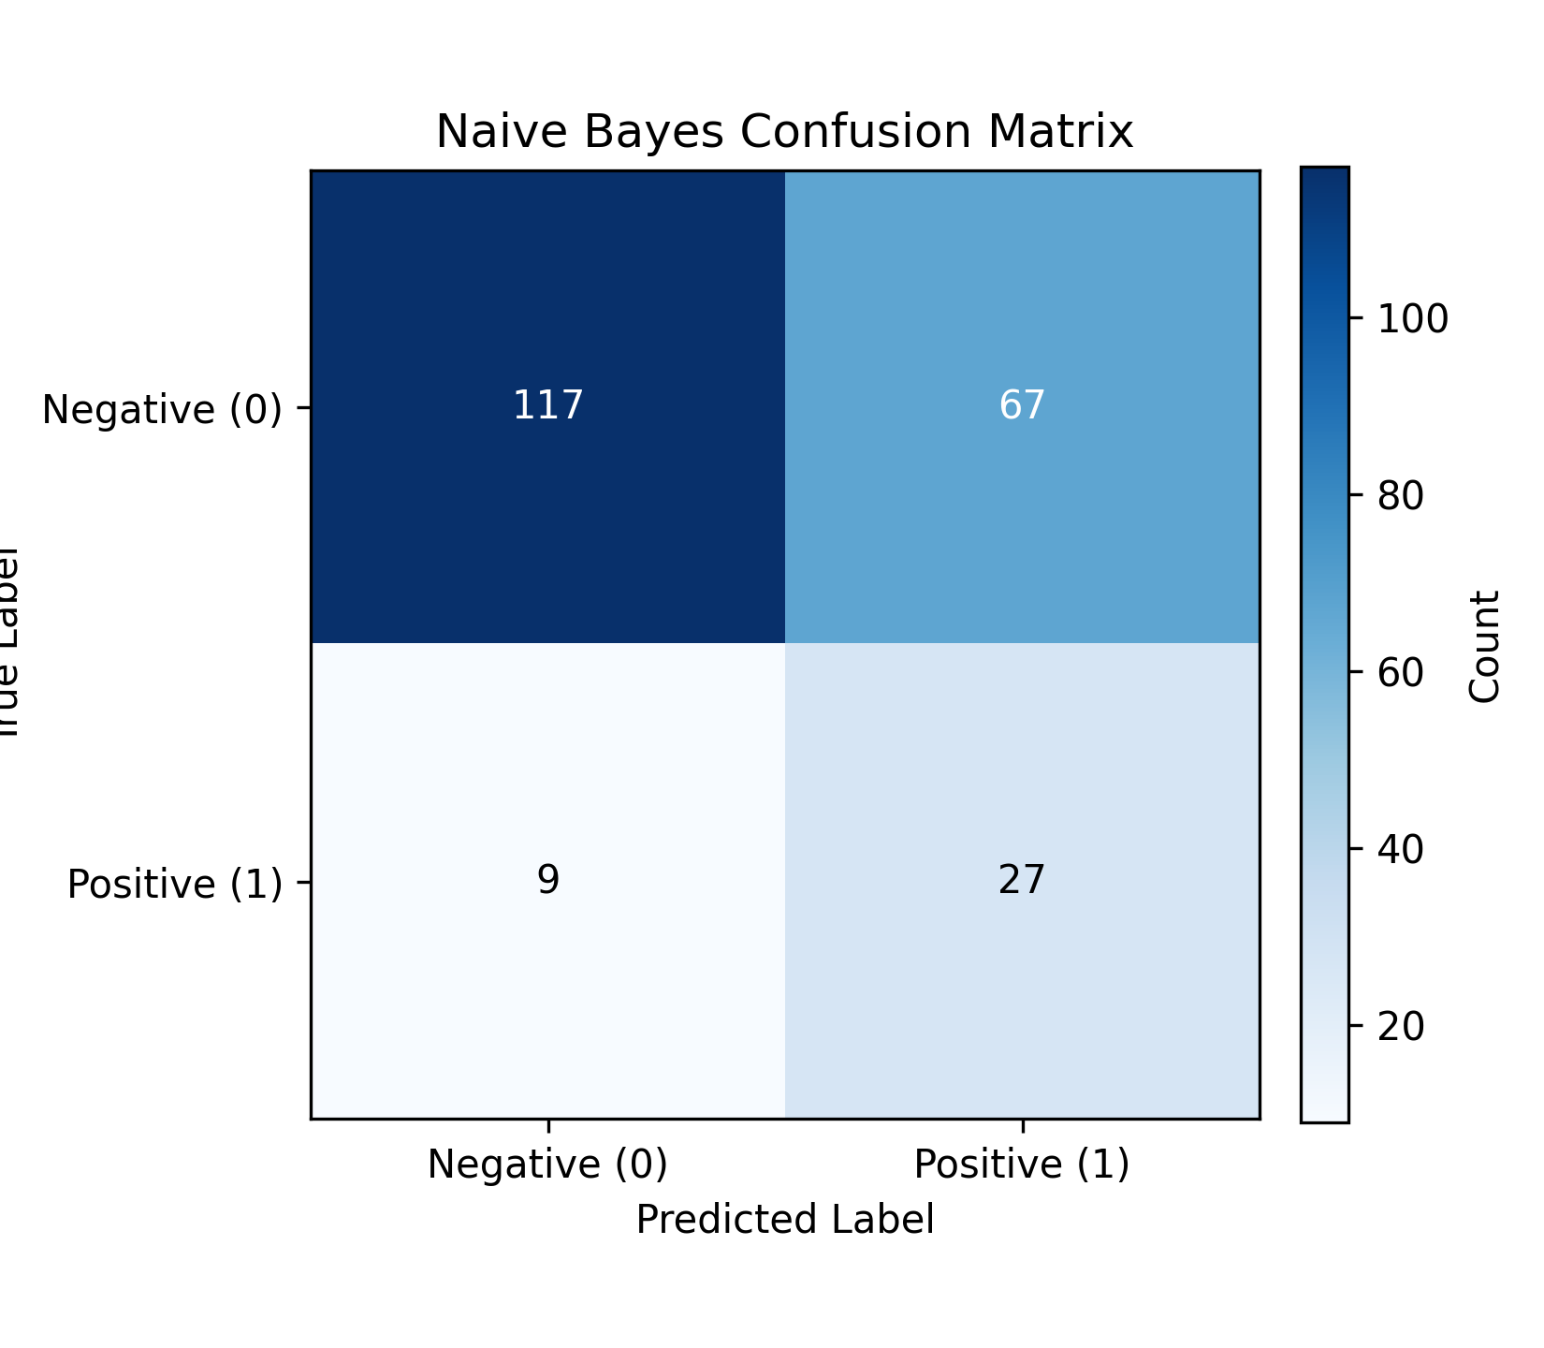

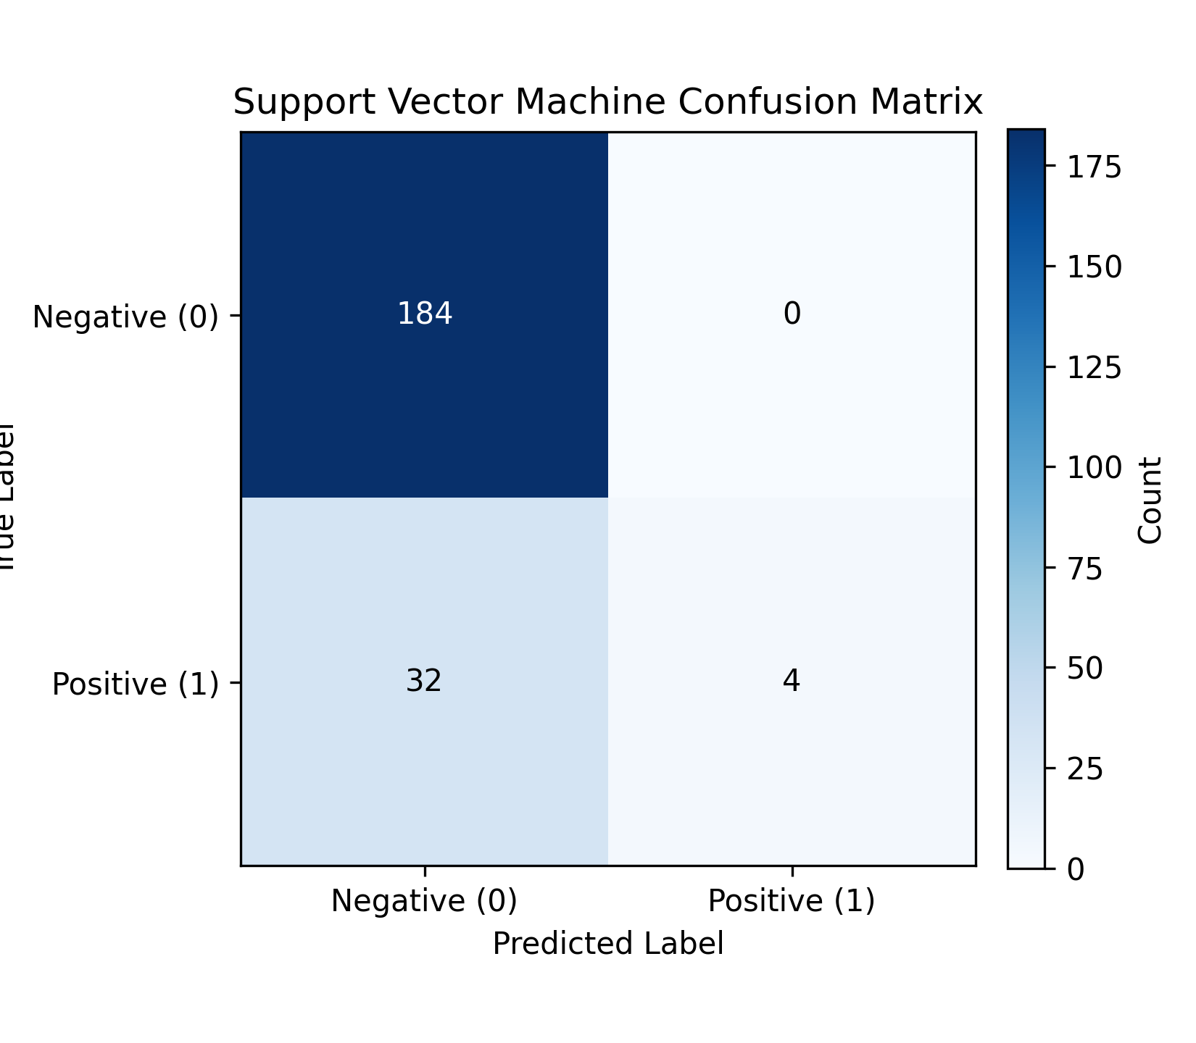

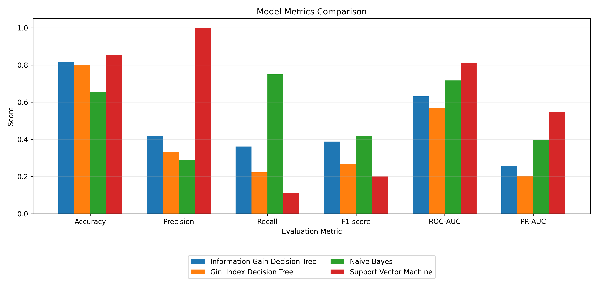

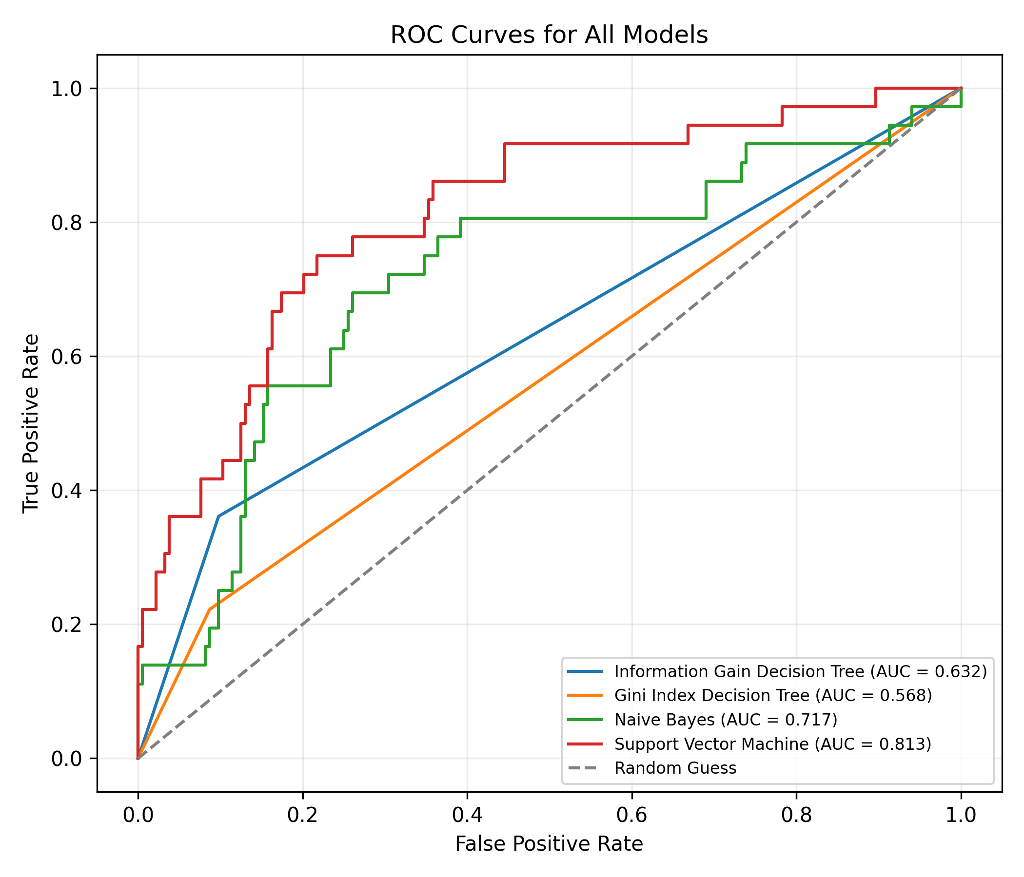

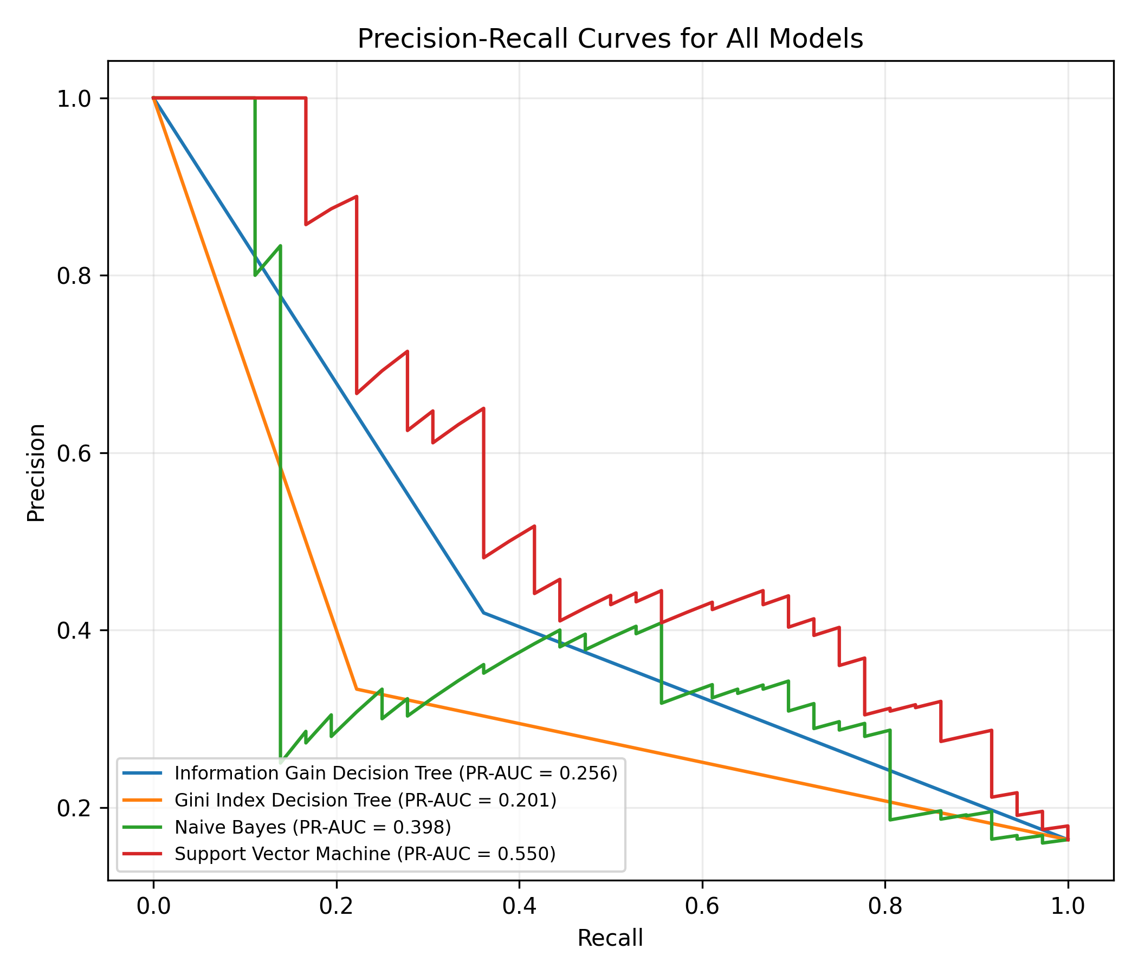

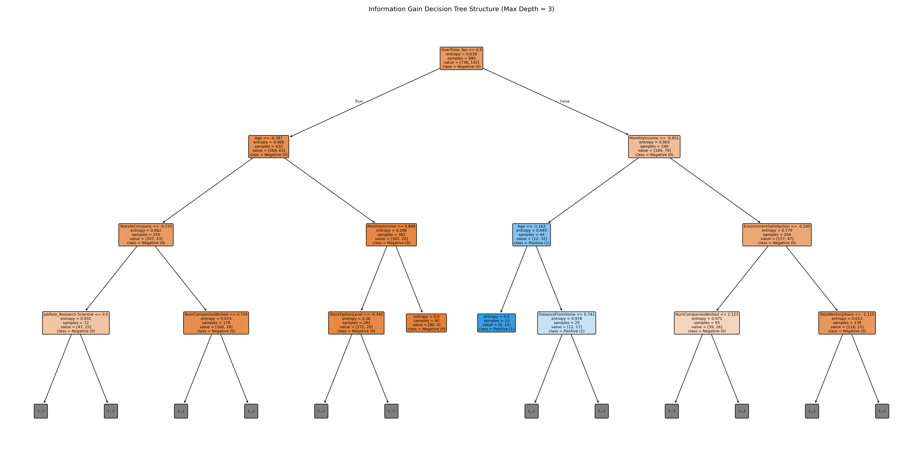

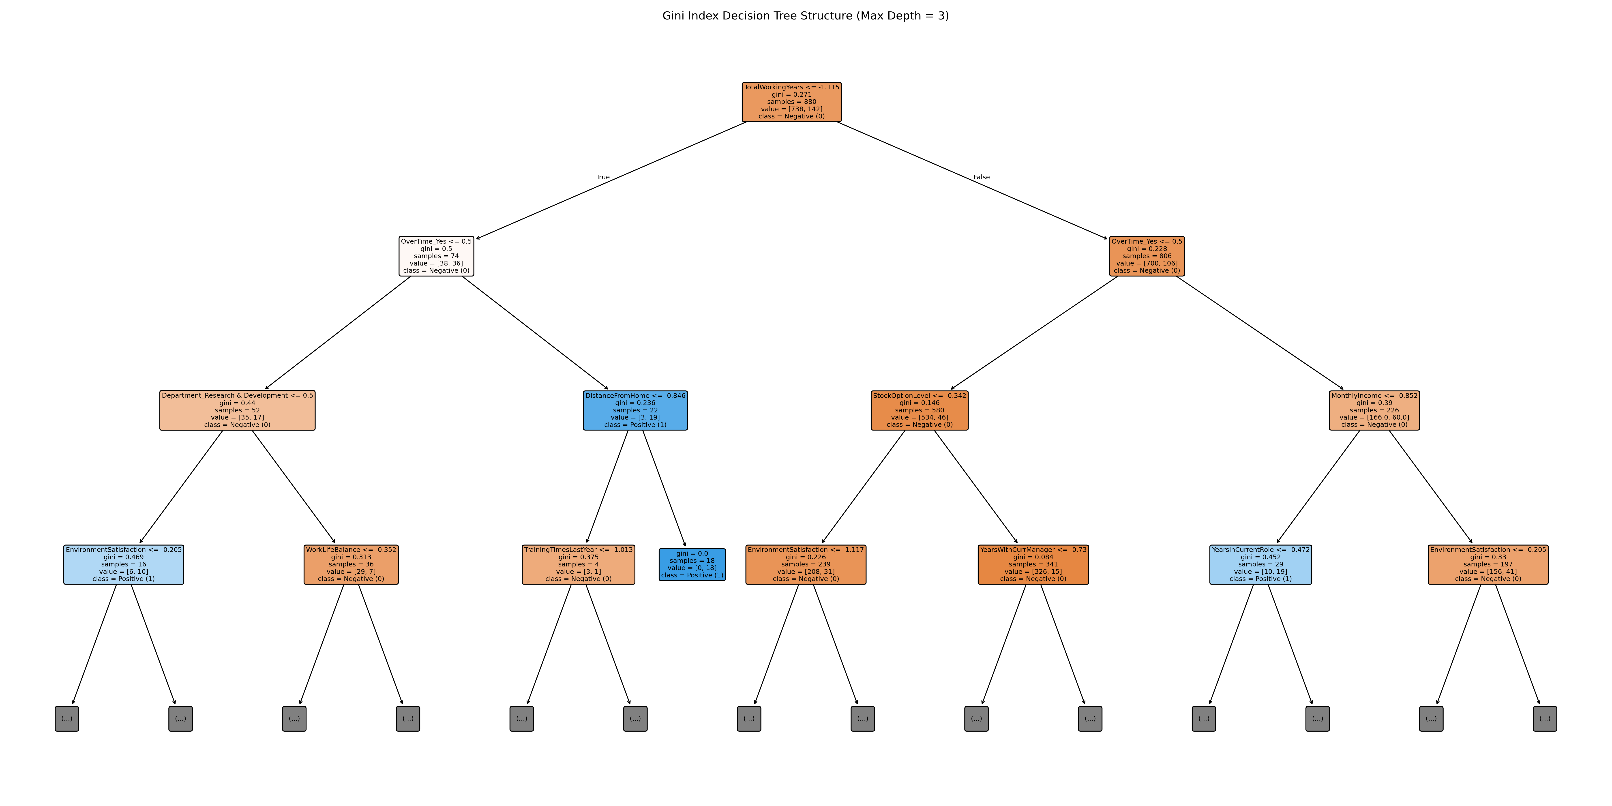

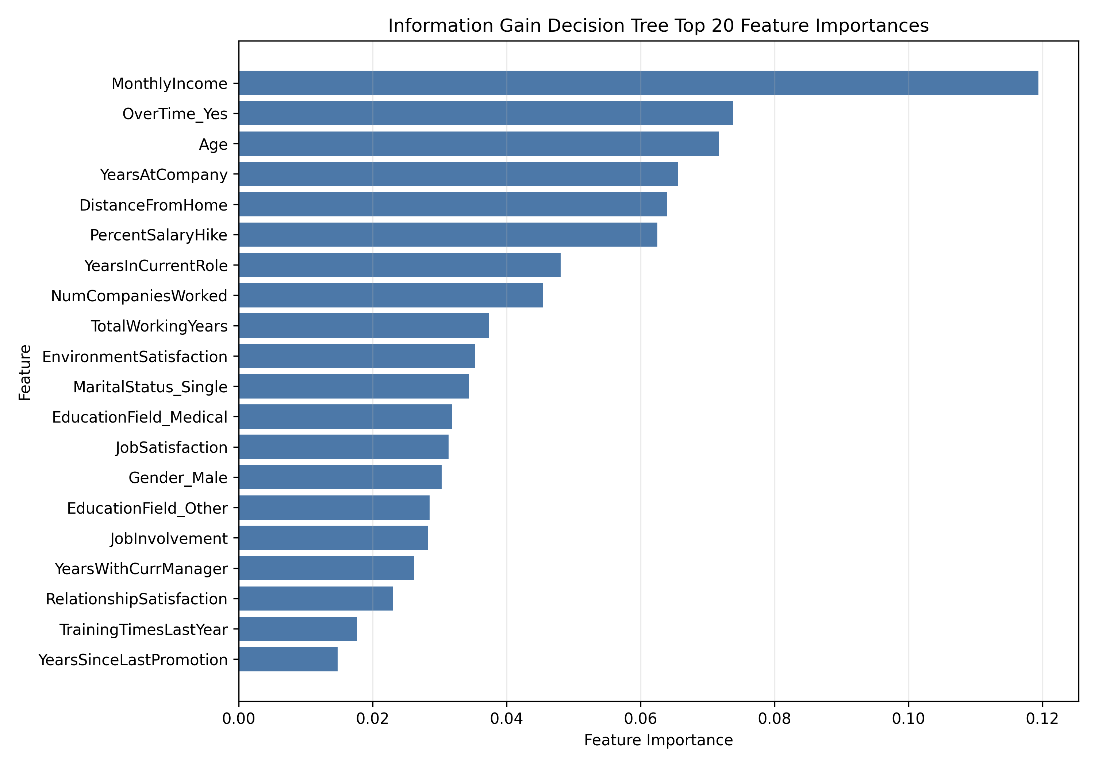

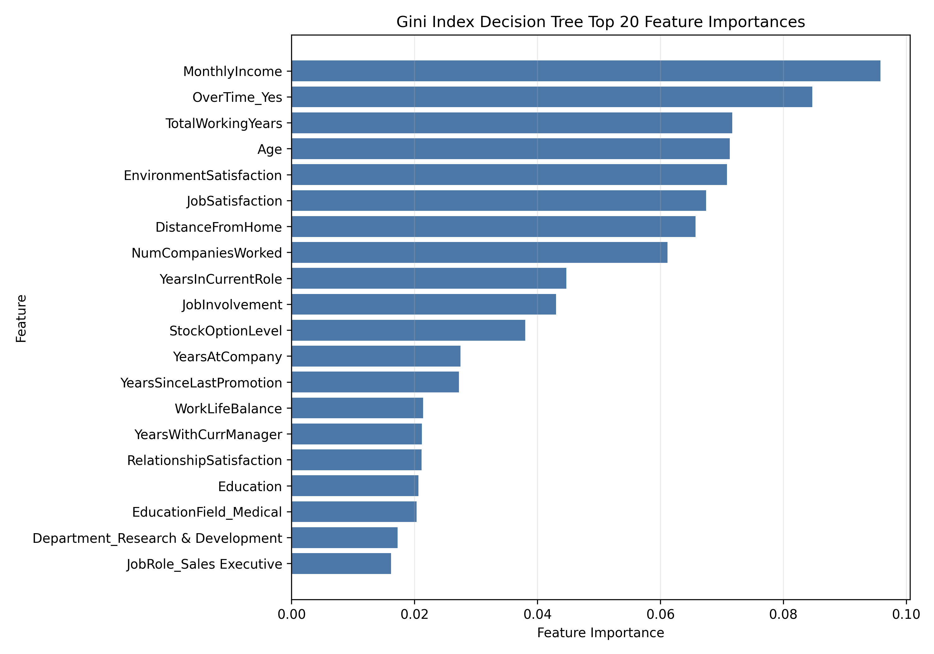

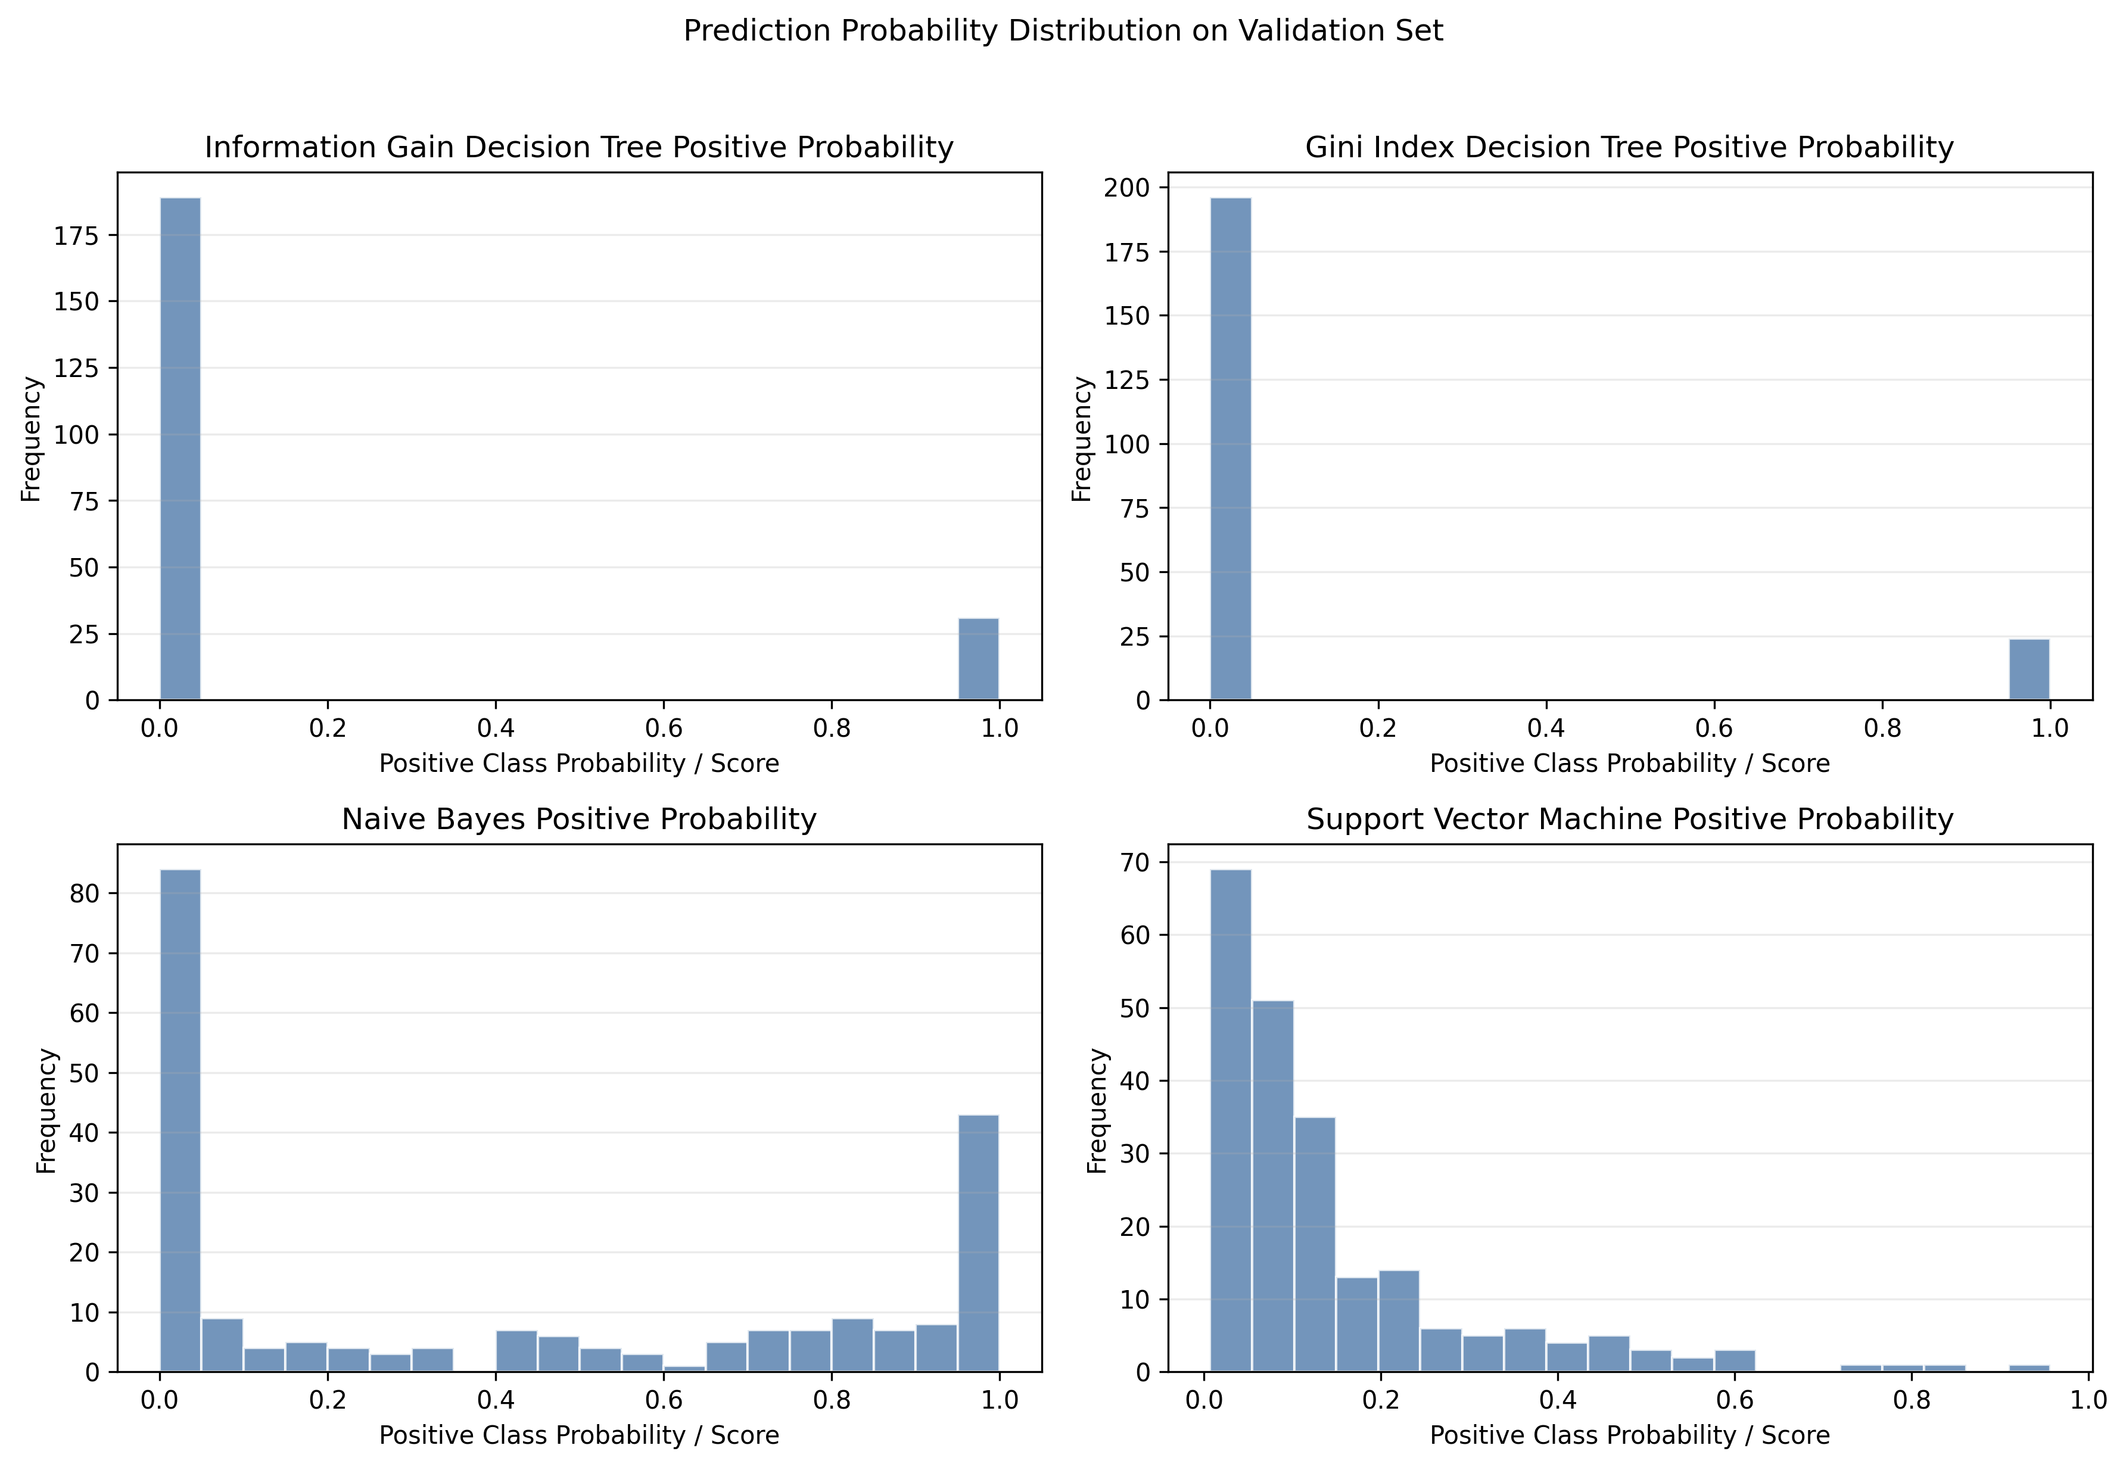

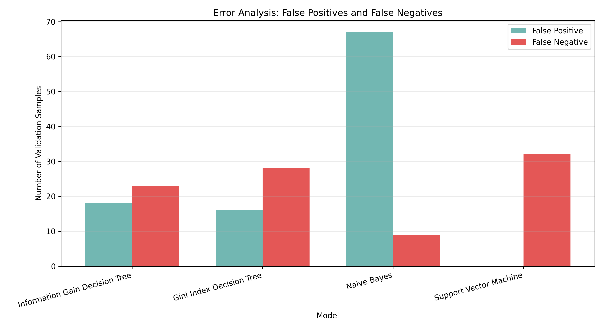

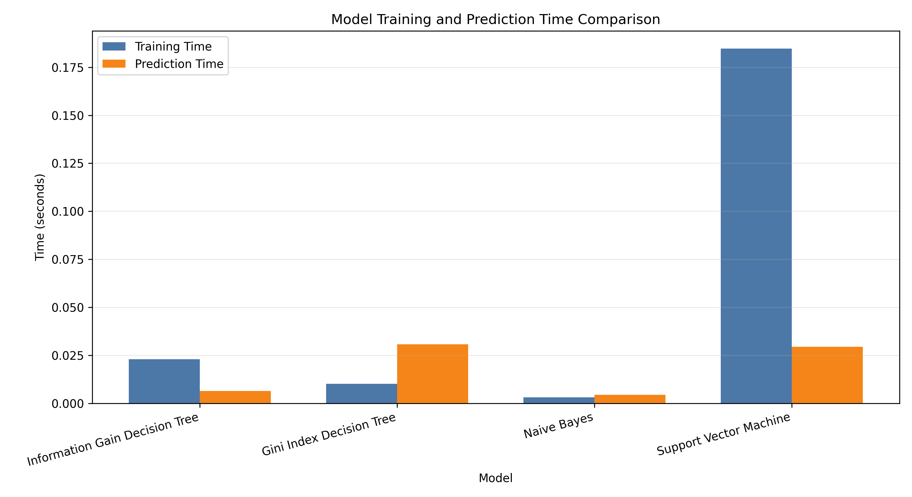

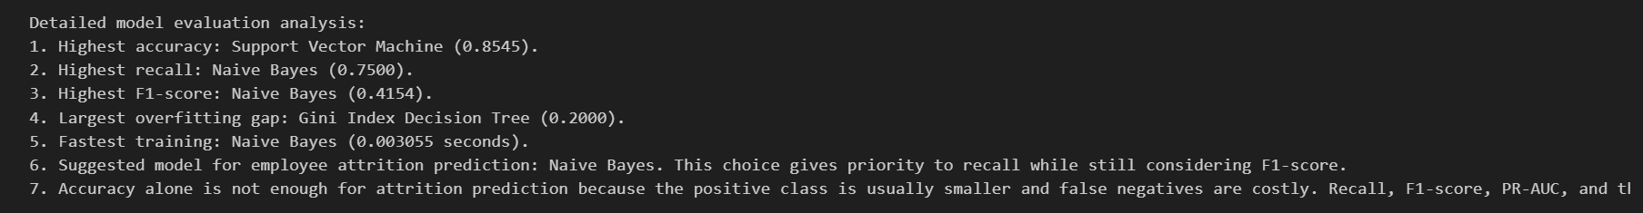

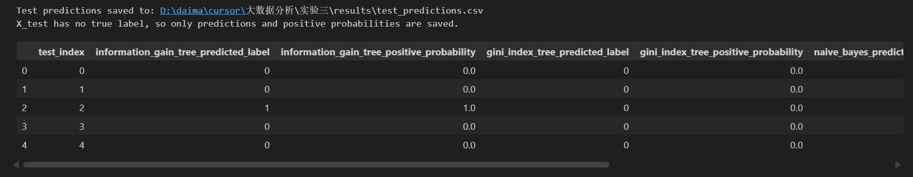

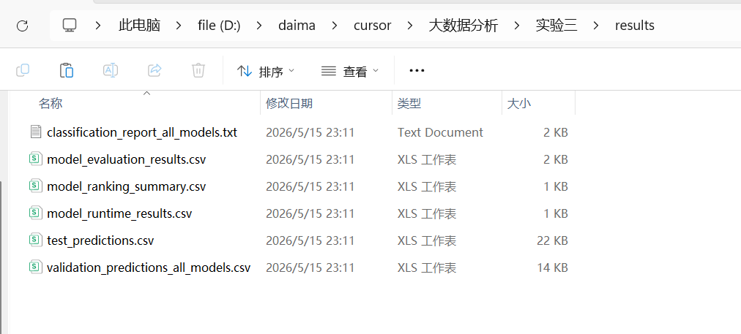

classification_report_all_models.txt
=== Information Gain Decision Tree ===
Confusion matrix labels: [0, 1]
[[166 18]
[ 23 13]]

precision recall f1-score support

Negative (0) 0.88 0.90 0.89 184
Positive (1) 0.42 0.36 0.39 36

accuracy 0.81 220
macro avg 0.65 0.63 0.64 220
weighted avg 0.80 0.81 0.81 220

=== Gini Index Decision Tree ===
Confusion matrix labels: [0, 1]
[[168 16]
[ 28 8]]

precision recall f1-score support

Negative (0) 0.86 0.91 0.88 184
Positive (1) 0.33 0.22 0.27 36

accuracy 0.80 220
macro avg 0.60 0.57 0.58 220
weighted avg 0.77 0.80 0.78 220

=== Naive Bayes ===
Confusion matrix labels: [0, 1]
[[117 67]
[ 9 27]]

precision recall f1-score support

Negative (0) 0.93 0.64 0.75 184
Positive (1) 0.29 0.75 0.42 36

accuracy 0.65 220
macro avg 0.61 0.69 0.59 220
weighted avg 0.82 0.65 0.70 220

=== Support Vector Machine ===
Confusion matrix labels: [0, 1]
[[184 0]
[ 32 4]]

precision recall f1-score support

Negative (0) 0.85 1.00 0.92 184
Positive (1) 1.00 0.11 0.20 36

accuracy 0.85 220
macro avg 0.93 0.56 0.56 220
weighted avg 0.88 0.85 0.80 220

model_evaluation_results.csv

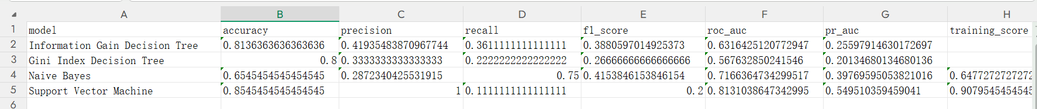

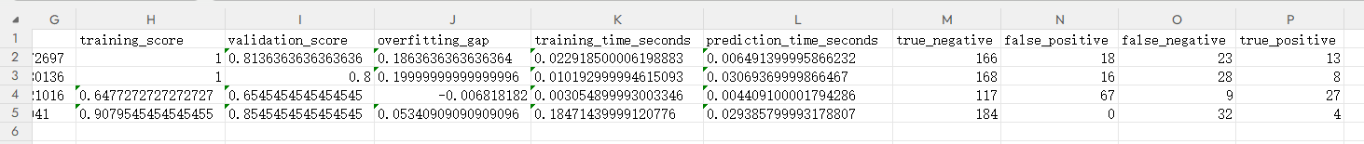

model_ranking_summary.csv

model_runtime_results.csv
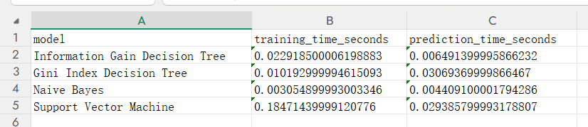

test_predictions.csv
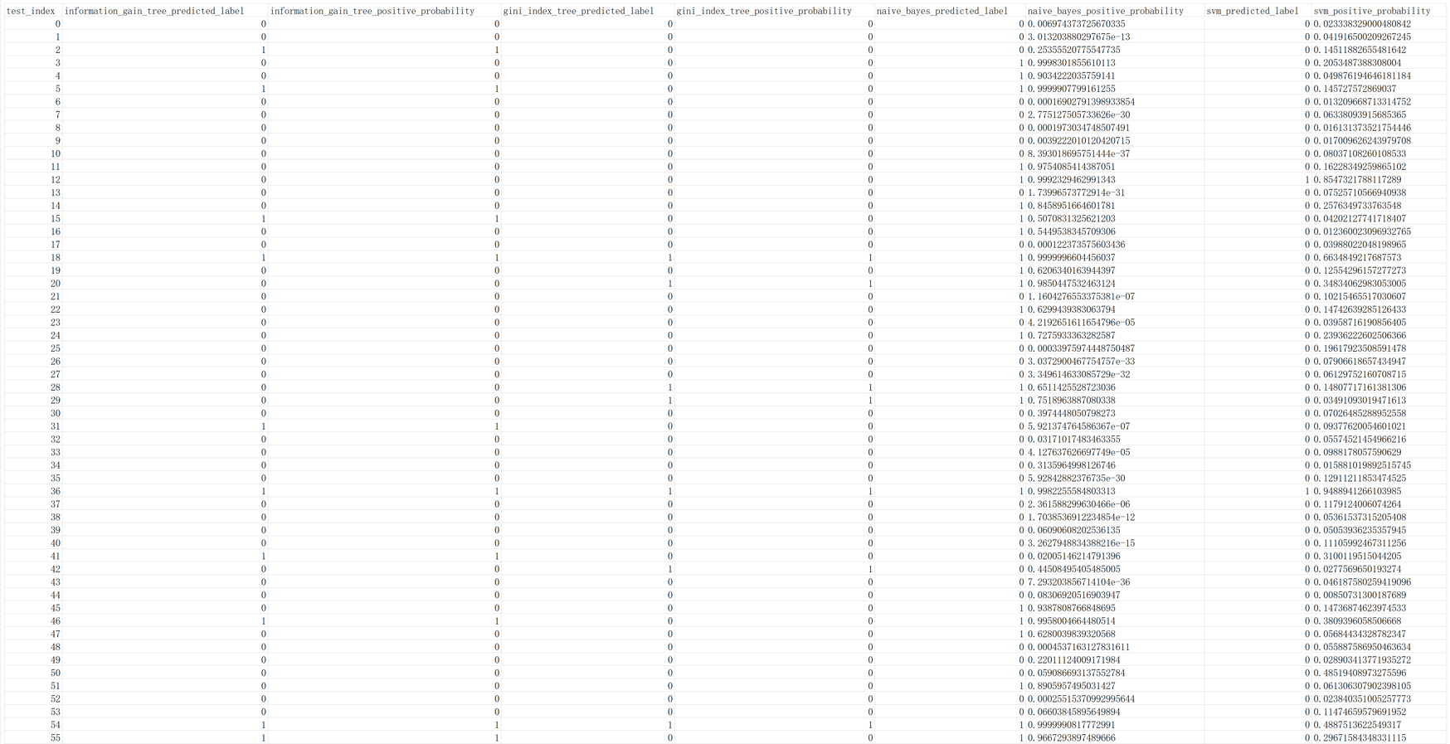

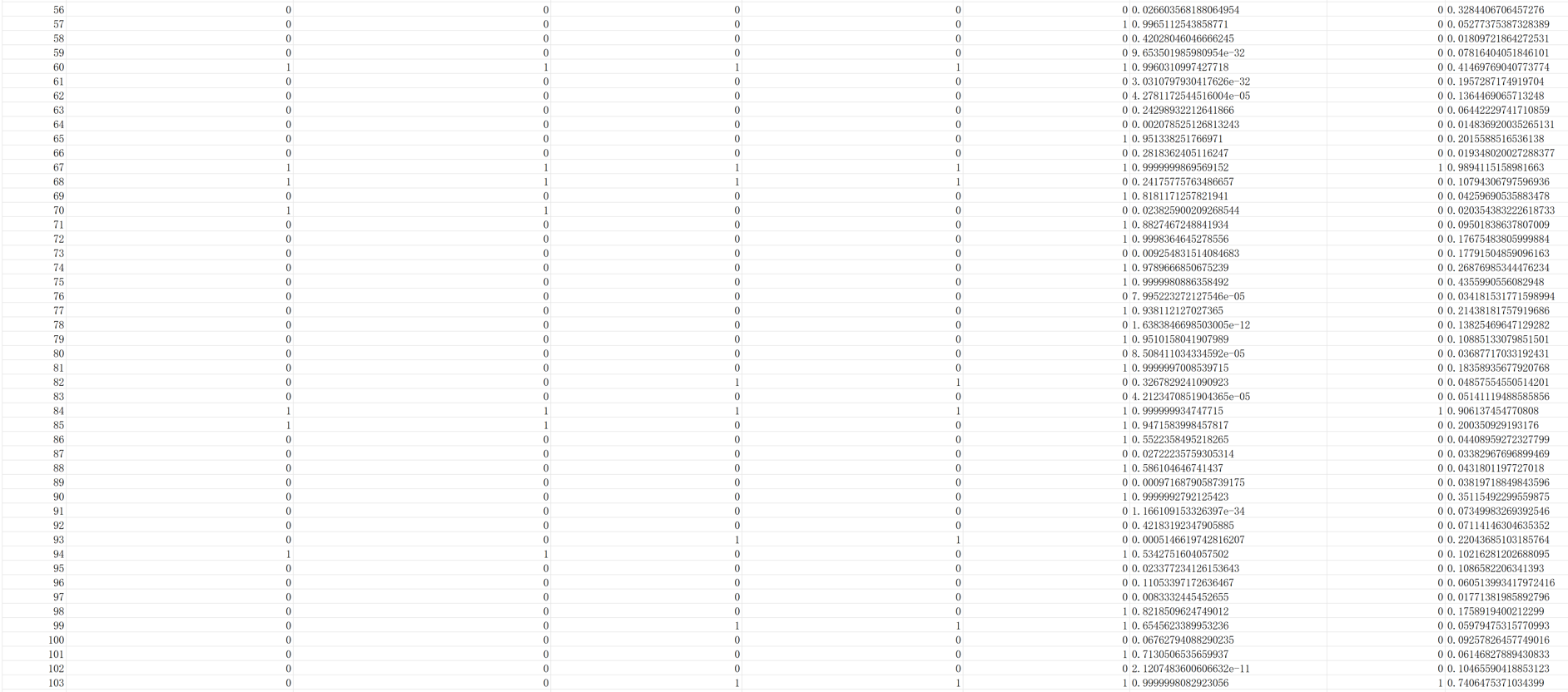

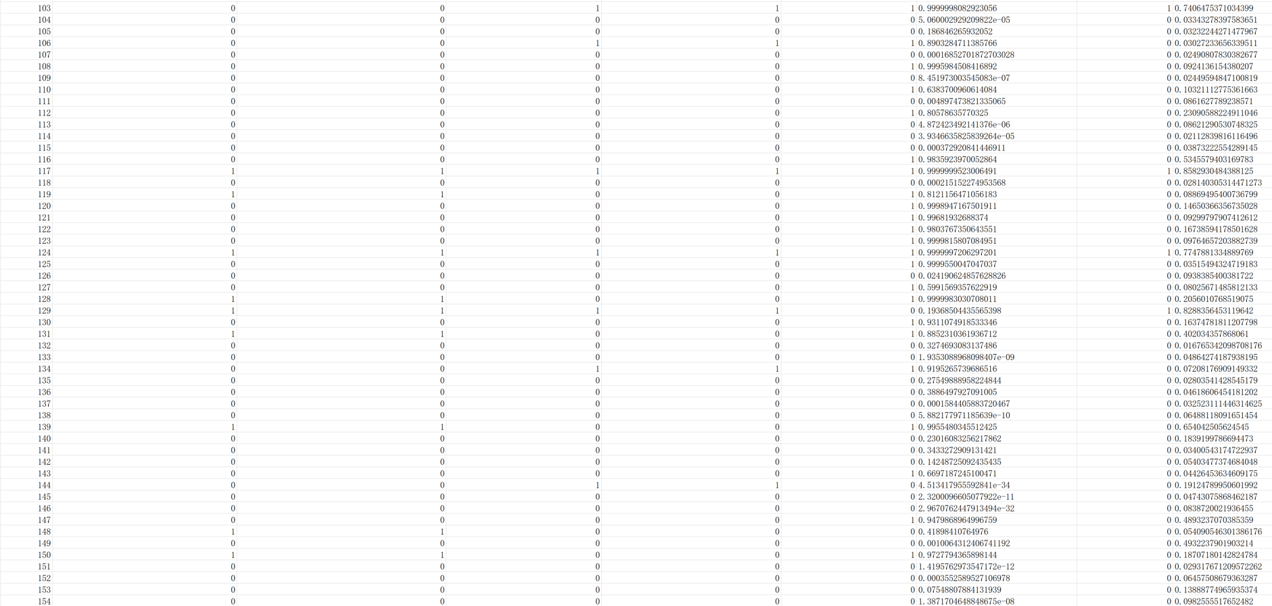

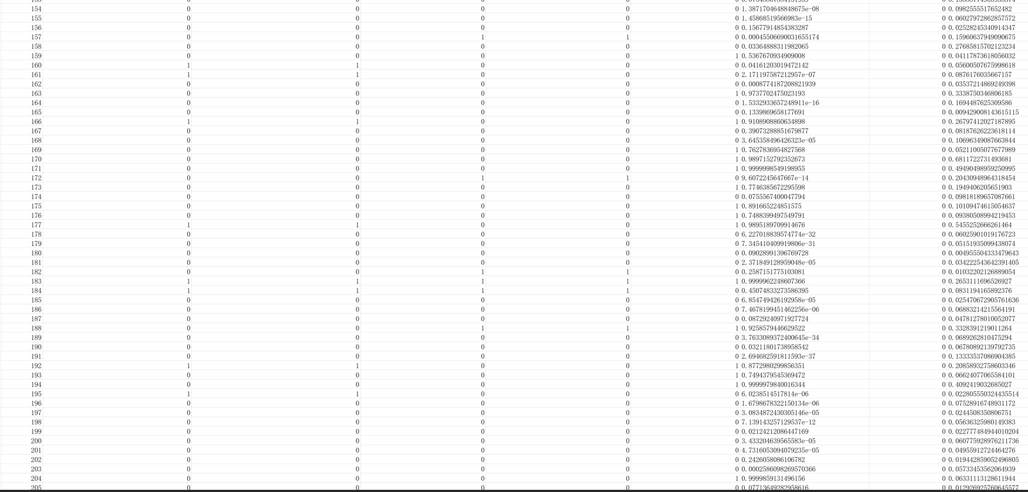

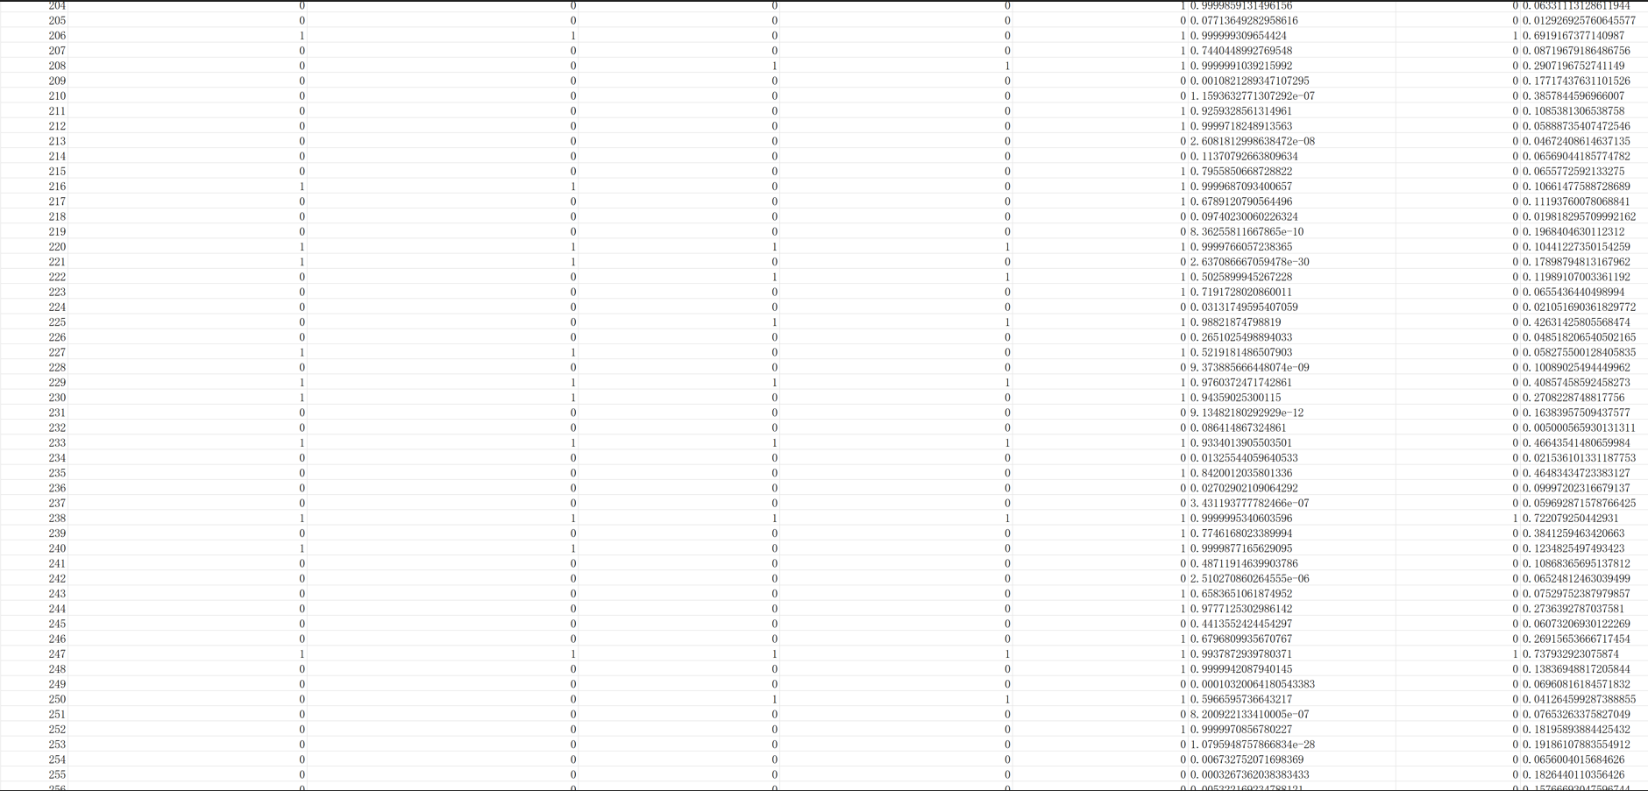

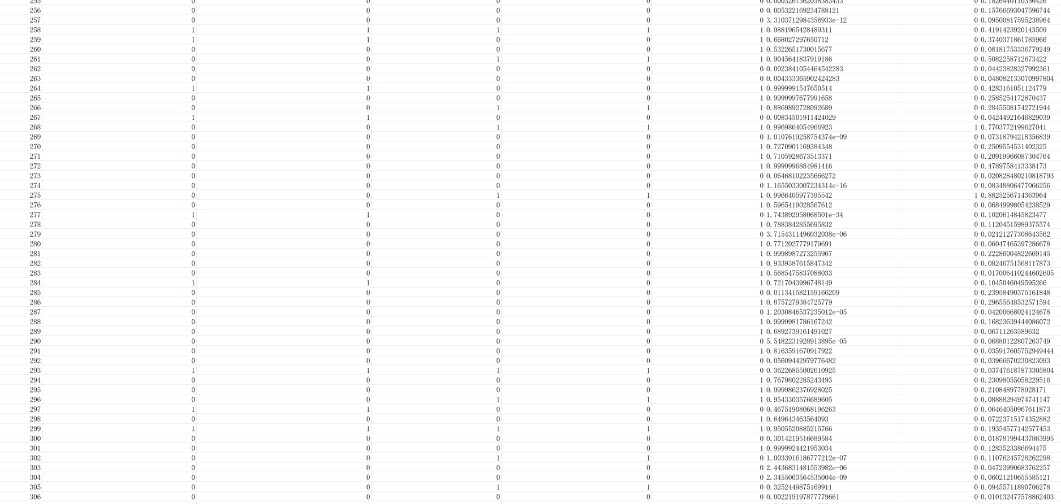

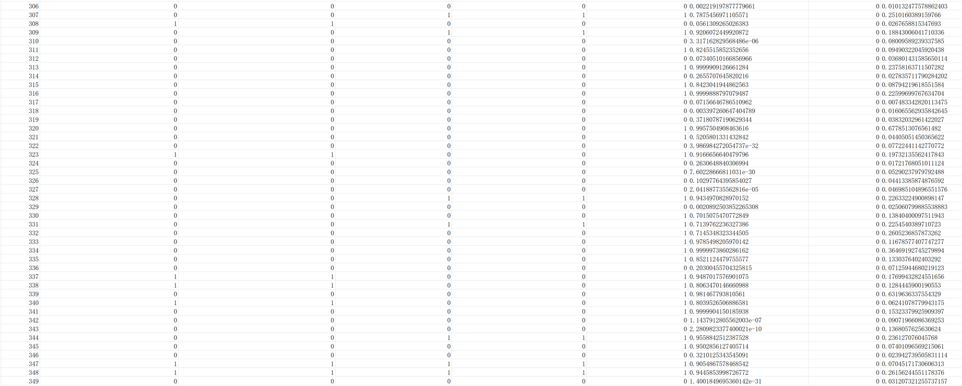

validation_predictions_all_models.csv

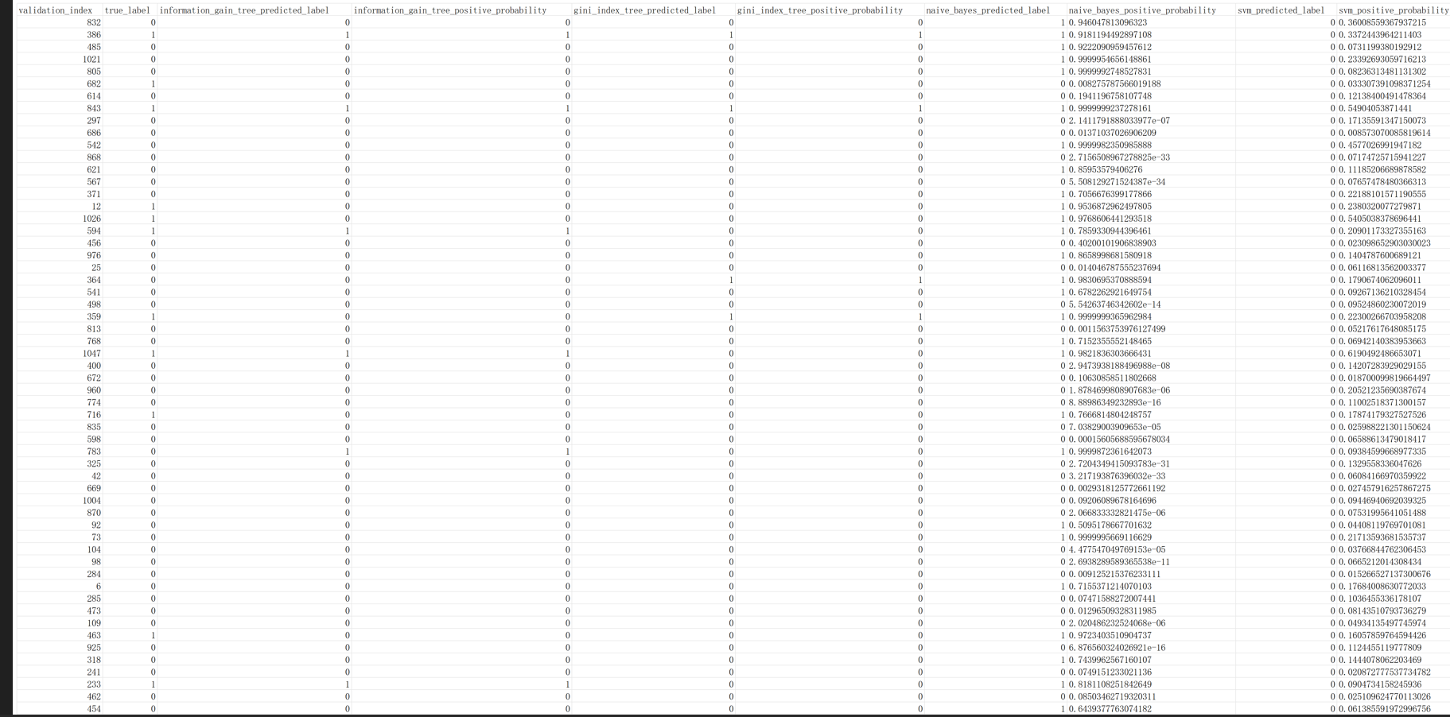

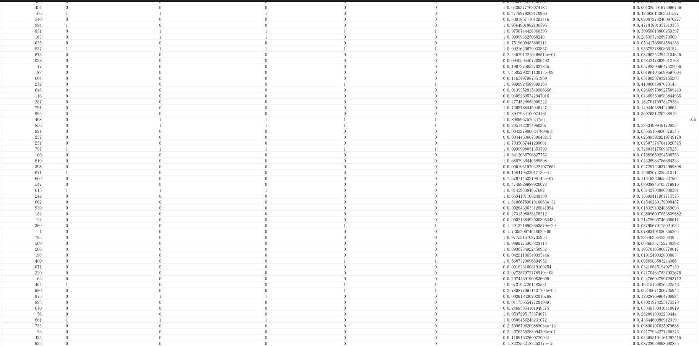

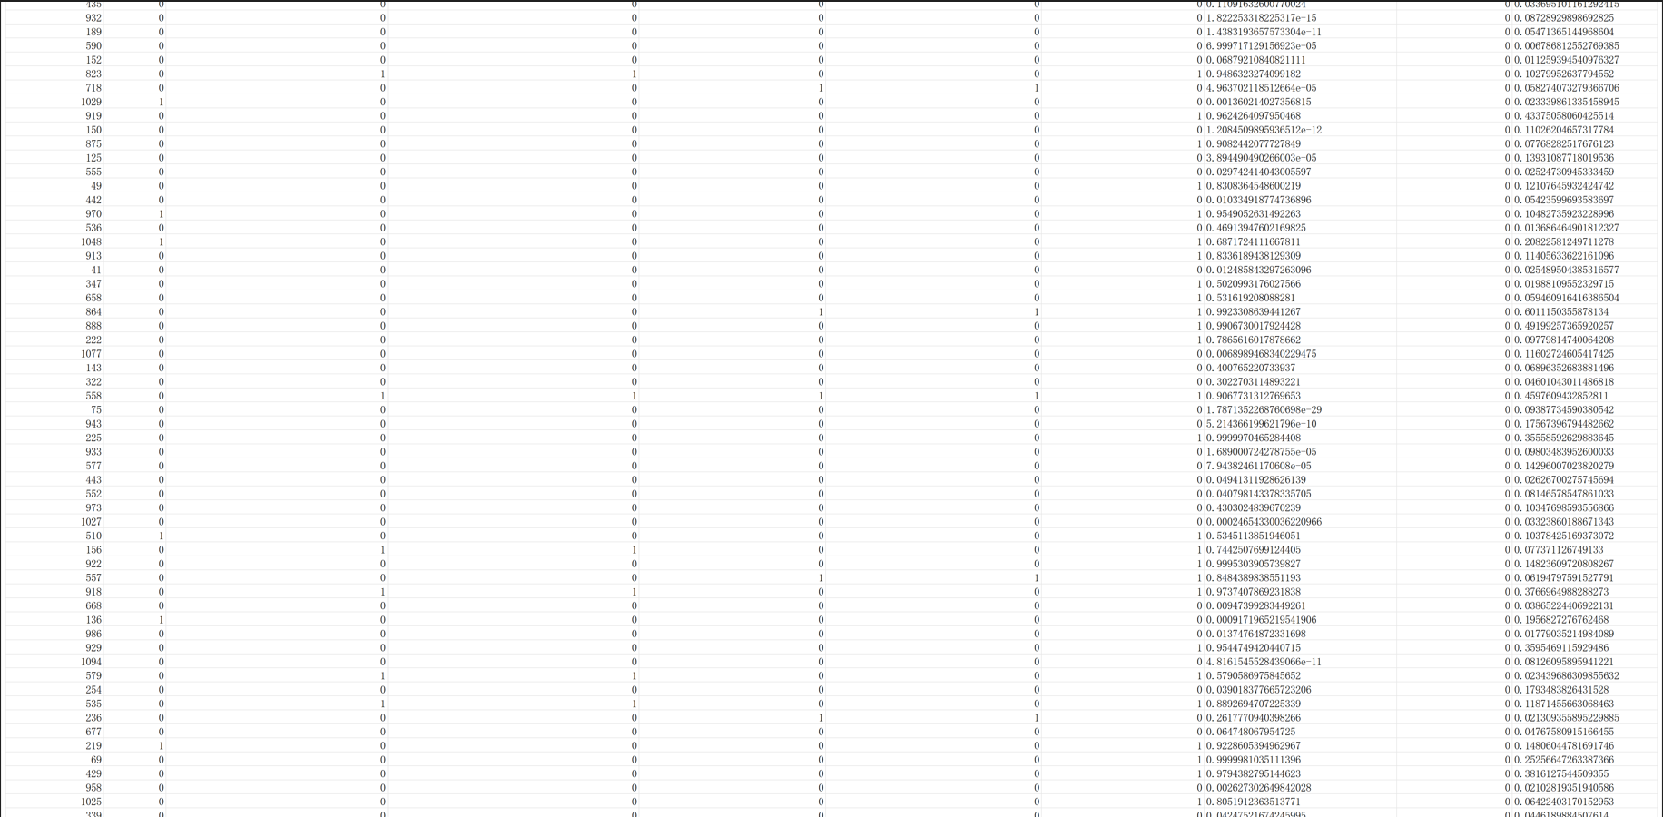

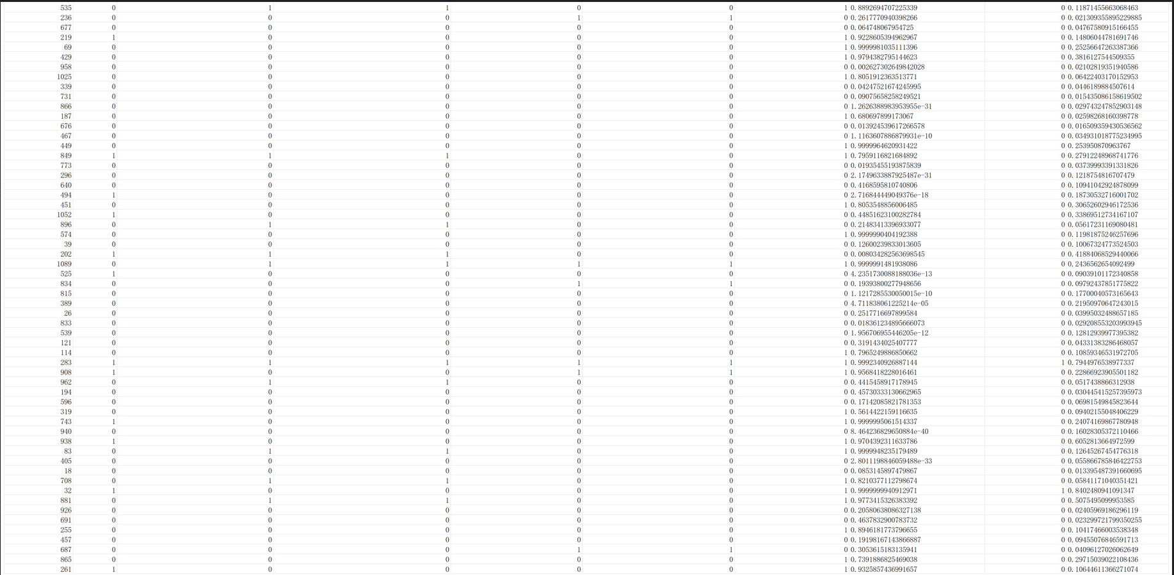

From the validation results, the four models showed different performance characteristics. The Support Vector Machine achieved the highest overall accuracy and strong ROC-AUC, so it had good overall discrimination ability. However, its recall for the positive class was very low, which means that it missed many true employee attrition cases. Therefore, although SVM performed well in some metrics, I cannot simply say that it is the best model for this task.
Compared with SVM, Naive Bayes had lower overall accuracy, but it achieved the highest recall and F1-score for the positive class. This means that Naive Bayes was better at finding employees who may leave. For an employee attrition prediction task, this is very important because a false negative means that the model fails to identify an employee who is actually likely to leave. In a real HR situation, missing these employees may be more serious than giving some extra false alarms.

The two decision tree models also showed useful differences. The Information Gain Decision Tree performed better than the Gini Index Decision Tree on most positive-class metrics, including precision, recall, and F1-score. However, both decision tree models had a large gap between their training performance and validation performance, which suggests possible overfitting. This shows that decision trees are easy to understand and interpret, but they may learn too many details from the training data if they are not controlled.

Overall, the result shows that accuracy alone is not enough for this classification problem. Since employee attrition is an imbalanced task, I need to consider recall, F1-score, PR-AUC, the confusion matrix, and the number of false negatives together. Based on the validation results, SVM had the strongest overall ranking ability, while Naive Bayes was more suitable for detecting positive attrition cases. Therefore, the final model choice should depend on the real purpose of the task: if the goal is overall discrimination, SVM is useful; if the goal is to find more employees who may leave, Naive Bayes is more practical.

5. Reflections on the Experiment
This experiment made me feel that the previous preprocessing work was really connected with the later modeling work. In Experiment 1 and Experiment 2, I mainly focused on cleaning the raw employee data, encoding categorical variables, scaling numeric features, and making the training and test feature columns consistent. At that time, some of these steps looked like preparation work only. But in Experiment 3, those preprocessed files became the direct input of the classification models. This made me understand that a data analysis project is not made of separate parts. Data preprocessing, model training, validation evaluation, result analysis, and final prediction are all connected.

At the beginning, I thought this experiment would mainly be about training four models and comparing their scores. However, after checking the data files carefully, I found that the first important problem was actually how to evaluate the models correctly. The test data only contained features, and there was no real test label file. Because of this, I could not use the test set to calculate accuracy, precision, recall, F1-score, or other evaluation metrics. This made me more careful about the difference between a validation set and a test set. A file named “test” does not always mean it can be used for evaluation. If there is no ground-truth label, it can only be used for final prediction.

One thing I noticed from Teacher Li Jie’s class is that she often spent a lot of time on the mathematical reasoning and derivation process behind the models. I may not remember every detail of the derivation perfectly, but this way of teaching made me realize that machine learning models are not just sklearn function names. Behind each model, there is a reason why it can classify samples. This helped me slow down when writing the code. Instead of only thinking about whether the program could run, I also tried to think about what the model was actually doing and why the evaluation result looked like that.

For example, the two decision tree models became more meaningful to me after connecting them with the mathematical ideas from class. Before this experiment, I might only treat entropy and gini as two different parameter values in sklearn. But after learning more about the idea behind decision tree splitting, I understood that they are two different ways to measure whether a split makes the data cleaner or more mixed. In my code, the Information Gain Decision Tree used the entropy criterion, while the Gini Index Decision Tree used the gini criterion. This made the comparison between the two trees more than just a code difference. It was also a comparison between two different splitting ideas.

The Naive Bayes part also left a strong impression on me. I remember that in class we had a manual calculation example with features like Outlook, Temperature, Humidity, and Wind. The test sample was something like sunny, cool, high humidity, and strong wind, and then we needed to judge whether the class should be Yes or No. This kind of hand calculation was useful because it forced me to follow the reasoning step by step. It was not just clicking a button or calling a model. I had to think about prior information, feature conditions, and how the final class decision was made.

This also helped me understand GaussianNB() better. In the Python code, Naive Bayes only looks like one simple line, so it is easy to forget what happens behind it. But after doing the manual example in class, I understood that the model is still using probability information from the training data to make a classification decision. I appreciated this part of the class because it connected the PPT theory, manual reasoning, and Python implementation together. Without this kind of example, I might only know how to call the function, but not really understand why the model can give a result.

For Support Vector Machine, I also had a similar feeling. Before this experiment, I mainly remembered SVM as a strong classifier. But after learning the mathematical reasoning behind it, I understood that SVM is related to finding a better decision boundary between classes. It is not simply drawing any line or curve. It tries to separate the classes in a more reasonable way. In this experiment, I used an RBF kernel, so the SVM model could handle nonlinear patterns better than a simple linear boundary. This helped me understand why SVM showed strong overall discrimination ability in the results.

The model comparison also changed how I looked at evaluation metrics. Before this experiment, I still had a habit of looking at accuracy first, because it is the easiest number to understand. But the employee attrition dataset is not balanced. Most employees belong to the non-attrition class, and only a smaller part belongs to the attrition class. Because of this, a model can still get high accuracy even if it misses many employees who actually leave. This made me understand that accuracy alone is not enough for this task.

In my results, Support Vector Machine had high accuracy and strong ROC-AUC, but its recall for the positive class was very low. This means it was very careful when predicting attrition, but it missed many real attrition cases. From a practical HR perspective, this is a serious problem. If an employee is really likely to leave but the model does not detect it, the company may lose the chance to take action earlier. So I cannot simply say that SVM is the best model only because some of its scores are high.

On the other hand, Naive Bayes did not have the highest accuracy, but it had the highest recall and F1-score in this experiment. This made me think more carefully about the goal of the task. If the purpose is to find more employees who may leave, then recall is very important. A false positive may only cause extra attention, but a false negative means the model completely misses a possible attrition case. So this experiment helped me understand that the best model depends on the real purpose of the task, not just one number in the result table.

The two decision tree models also taught me something about overfitting. Both decision trees had very high training scores, but their validation scores were lower. This showed that the trees may have learned too many details from the training data. Decision trees are easy to understand because they can show splitting rules and feature importance, but they can also become too complex. This made me realize that a model can be interpretable but still not generalize well. Interpretability is useful, but it does not automatically mean the model is the best.

Another important lesson was the meaning of false positives and false negatives. Before this experiment, I knew these words from textbooks, but the confusion matrices made them much more concrete. For example, SVM had almost no false positives, so its precision was very high. However, it had many false negatives, so its recall was low. Naive Bayes found more positive cases, but it also produced more false positives. After seeing these numbers, I understood the evaluation metrics much better. They were no longer just definitions. They became a way to understand the real behavior of each model.

The figures also helped me a lot when interpreting the results. The model metrics comparison figure gave me a quick overview of the four models. The confusion matrices showed the actual prediction mistakes. The ROC curves and PR curves helped me compare models beyond a single threshold. The FP/FN error analysis was especially useful because it directly showed which models missed more positive cases. These visual results made the experiment easier to explain than only using tables.

From the coding side, this experiment made me more aware of reproducibility. I saved the evaluation results into the results folder and saved all figures into the figures folder. I also kept the Python script and notebook consistent, so the experiment could be checked in different ways. Compared with the previous experiments, I felt that my workflow became more organized. The final result was not only a piece of code, but a complete set of data input, model training, validation evaluation, result files, figures, and test predictions.

Overall, this experiment helped me connect course theory, mathematical reasoning, manual calculation, and Python implementation together. I learned that sklearn can make model training very convenient, but convenience does not mean I can ignore the logic behind the model. Teacher Li Jie’s teaching style, especially the emphasis on reasoning and derivation, helped me understand that classification models should not be treated as black boxes. For me, the biggest gain from this experiment is that I learned to think about a model from both sides: what the algorithm is trying to do and what the evaluation result really means.

In conclusion, Experiment 3 made the whole project feel more complete. The earlier experiments prepared the data, and this experiment used the prepared data to train and compare classification models. Through this process, I learned that a meaningful machine learning experiment should not only run successfully. It should also use the data correctly, choose a fair validation method, compare suitable metrics, and explain the results carefully. This is the most important lesson I gained from this classification model practice.

Grade:

Reviewed by: --------

Date: --------

