Hubei University

Academic Year 2025 -- 2026
Semester 2

Student Laboratory Report Book

Institute： Manchester United College
Student Name： Qin Tian
Class： 2402
Student ID： 202431123002054
Course Course： Big Data Analysis
Instructor： Li Jie

Student Laboratory Rules

1. Students must conduct experiments at the scheduled time and may not be absent or late without cause.
2. Before each experiment, students must preview the assigned experiment and prepare a preview report as required.
3. Before each experiment, students must submit the previous experiment report and the preview report for the current experiment. The experiment may begin only after the instructor has checked and approved them.
4. After reaching their assigned lab station, students must check the instruments they use against the equipment list for any missing or damaged items. Any problems must be reported to the instructor promptly. Using another group's instruments without authorization is strictly forbidden.
5. During the experiment, students must maintain a rigorous scientific attitude and strictly follow instrument operating procedures and precautions.
6. After the experiment, students must submit their data to the instructor for inspection. Once approved, they should restore and organize the instruments and equipment before leaving the lab.
7. Keep the laboratory quiet and tidy. Loud talking, littering, and eating are prohibited.
8. If an accident or damage to instruments or equipment is caused by violating operating procedures or conducting experiments without permission, it must be reported promptly. A damage list must be completed, and compensation shall be made according to the college's relevant regulations.

Experiment Title:
Lab3-Experiment 4 Clustering Model Practice

Laboratory: Innovation & Entrepreneurship 7001 Date: 2026.5.29

Problem Description
This experiment is Experiment 4: Clustering Model Practice in the continuous project of Big Data Analysis and Application. Different from Experiment 3, this experiment is not a supervised classification task. The main purpose of this experiment is to practise unsupervised clustering on the given wine dataset. Although the original wine.data file is a classification dataset and its first column contains the class label, the requirement of this experiment is to remove the label before clustering. Therefore, the model should not learn from the known class. Instead, it should discover possible groups only from the chemical features of the wine samples.

The main task of this experiment is to build clustering models for the wine data and compare their clustering results. In the dataset, the first column is class, while the remaining columns are 13 chemical features, such as Alcohol, Malic acid, Ash, Magnesium, Flavanoids, Color intensity, Hue, and Proline. According to the requirement of this experiment, the class column can only be saved as optional reference information, but it must not be used in model training, parameter selection, or the main evaluation process. The real input of the clustering models is only the feature matrix after dropping the class column.

According to Teacher Li Jie’s PPT and class explanation, this experiment should cover three important types of clustering methods: Partition-based Clustering, Density-Based Clustering, and Hierarchical Clustering. In my implementation, KMeans is used as the partition-based clustering model, DBSCAN is used as the density-based clustering model, and AgglomerativeClustering is used as the hierarchical clustering model. These three models represent different ideas of grouping data. KMeans divides samples into a fixed number of clusters according to distance. DBSCAN tries to find dense regions and can mark some samples as noise. AgglomerativeClustering builds clusters step by step by merging similar samples. By comparing these models, I can better understand that clustering is not only about producing labels, but also about understanding different assumptions behind different clustering methods.

One important problem in this experiment is the difference between classification and clustering. In a classification task, the target label is used during training, and the model learns how to predict the known class. However, in a clustering task, the model should work without using the known label. This means that even though the wine dataset originally has class labels, these labels should be removed before clustering. At first, this point looked like a small data-processing detail, but after thinking about it more carefully, I found that it is actually the key point of the whole experiment. If the class label is accidentally included in the feature matrix, the experiment will no longer be a real clustering experiment.

Another important problem is how to evaluate the clustering results correctly. Since this experiment is a clustering task, I should not use classification metrics as the main evaluation criteria. Metrics such as accuracy, precision, recall, F1-score, ROC-AUC, PR-AUC, confusion matrix, and classification report are suitable for supervised classification tasks, but they are not suitable as the main metrics for this clustering experiment. Instead, the main evaluation metrics should be Silhouette Coefficient, Calinski-Harabasz Index, and Davies-Bouldin Index. These metrics evaluate the compactness and separation of clusters without depending on the original class labels.

In this experiment, the original class label is only used after clustering as an optional external comparison. For example, metrics such as ARI, NMI, homogeneity, completeness, v-measure, and the class-cluster crosstab can help me observe whether the clustering result is similar to the original wine classes. However, these results are only optional references. They cannot be treated as the main evaluation of the clustering models, because the core requirement of the experiment is to complete an unsupervised clustering process after removing the classification label.

At first, this experiment looked easier than the previous classification experiment, because there was no target variable to predict and no train-test split for supervised evaluation. However, after preparing the code and checking the result files, I realized that the real difficulty was not simply running KMeans, DBSCAN, or AgglomerativeClustering. The more important difficulty was keeping the experimental logic correct. I needed to make sure that the class label was removed, that the feature matrix only contained the 13 wine chemical features, and that the evaluation metrics matched the nature of clustering. This also made me understand more clearly why Teacher Li Jie emphasized the logic behind the model instead of only asking us to run sklearn code.

Teacher Li Jie’s class has benefited me a lot in this part. Her explanation helped me notice that a machine learning experiment is not only about whether the code can run successfully. It is also about whether the model, the data, and the evaluation method match the real task. For this experiment, if I used classification metrics as the main result, or if I kept the original label in the feature matrix, the code might still run, but the experiment would be wrong in principle. This reminder made me more careful when designing the workflow and writing the report.

So the main problem in this experiment is how to complete a correct and complete clustering workflow on the wine dataset. More specifically, I need to remove the original class label, standardize the 13 chemical features, build and compare KMeans, DBSCAN, and AgglomerativeClustering models, evaluate the clustering results with proper internal clustering metrics, and use result tables and figures to explain the final cluster structures. In my understanding, this experiment is not only a practice of clustering algorithms, but also a practice of distinguishing supervised learning from unsupervised learning and choosing evaluation methods according to the real task type.

2. Basic Approach
My basic idea in this experiment was to complete the clustering task step by step instead of directly applying one clustering algorithm to the data. Since this experiment is Clustering Model Practice, the first thing I needed to do was to make sure that the workflow was really an unsupervised learning workflow. The wine dataset originally contains a class label in the first column, but this label should not be used in clustering. Therefore, before building any model, I first loaded the wine.data file, set clear column names for all variables, saved the first column only as y_true_optional, and then removed the class column from the feature matrix.

After this step, the actual input data for clustering only contained the 13 chemical features of wine. These features included Alcohol, Malic acid, Ash, Alcalinity of ash, Magnesium, Total phenols, Flavanoids, Nonflavanoid phenols, Proanthocyanins, Color intensity, Hue, OD280/OD315 of diluted wines, and Proline. I also checked the basic information of the dataset, including the data shape, missing values, duplicate rows, data types, and feature descriptive statistics. This inspection step was important because clustering models are sensitive to the quality and scale of input features. If I skipped this step, I might not notice whether the input data contained abnormal values or whether some features had much larger ranges than others.

Next, I standardized the feature matrix with StandardScaler. This step was necessary because most clustering methods in this experiment are based on distance or similarity. In the wine dataset, different chemical features have very different value ranges. For example, some features have small decimal values, while Proline has much larger numerical values. If I used the raw data directly, features with larger scales might dominate the distance calculation, and the clustering result would become biased. After standardization, all 13 features were placed on a comparable scale, which made the later clustering models more reasonable.

I also used PCA to reduce the standardized features to two dimensions for visualization. PCA was not used as the main training feature space. It was mainly used to draw clear scatter plots so that I could observe the cluster structure more intuitively. This helped me compare different clustering results visually, especially for KMeans, AgglomerativeClustering, and DBSCAN. However, I understood that a two-dimensional PCA plot is only a visualization tool. The main model training and metric evaluation were still based on the standardized 13-dimensional feature space.

For the first model type, I used KMeans as the Partition-based Clustering method. In this part, I tested different numbers of clusters from k = 2 to k = 10. For each value of k, I recorded inertia, Silhouette Coefficient, Calinski-Harabasz Index, Davies-Bouldin Index, training time, and cluster size information. I also drew the elbow curve, silhouette curve, Calinski-Harabasz curve, and Davies-Bouldin curve to help choose a reasonable number of clusters. Since the original wine dataset is known to have three wine types, but the class label could not be used in clustering, I treated KMeans with k = 3 as an important model for explanation, while still comparing it with the best KMeans setting selected by internal clustering metrics.

For the second model type, I used DBSCAN as the Density-Based Clustering method. Different from KMeans, DBSCAN does not require the number of clusters to be given directly. Instead, it depends mainly on eps and min_samples. Therefore, I performed a parameter search over several eps values and min_samples values. For each parameter setting, I recorded the number of valid clusters, the number of noise samples, the noise ratio, and the three internal clustering metrics. I also drew the k-distance curve, DBSCAN silhouette heatmap, noise ratio heatmap, and cluster count heatmap. This part helped me understand that DBSCAN can find dense regions and mark uncertain samples as noise, but it is also very sensitive to parameter selection.

For the third model type, I used AgglomerativeClustering as the Hierarchical Clustering method. I tested several linkage methods, including ward, complete, average, and single, and for each linkage method I tested cluster numbers from 2 to 10. For each setting, I calculated Silhouette Coefficient, Calinski-Harabasz Index, and Davies-Bouldin Index. I also generated comparison figures for the different linkage methods and drew a dendrogram to show the hierarchical merging process. This model was useful because it gave me another way to understand clustering: instead of directly assigning samples into fixed groups, it builds a tree-like structure by gradually merging similar samples.

After building the three types of clustering models, I compared them using only proper internal clustering metrics. The main evaluation metrics were Silhouette Coefficient, Calinski-Harabasz Index, and Davies-Bouldin Index. A higher Silhouette value usually means that samples are closer to their own cluster and farther from other clusters. A higher Calinski-Harabasz value usually means better cluster separation. A lower Davies-Bouldin value usually means better clustering quality. These metrics are suitable for this experiment because they do not require the original class label.

At the same time, I paid special attention not to use classification metrics as the main evaluation criteria. Metrics such as accuracy, precision, recall, F1-score, ROC-AUC, PR-AUC, confusion matrix, and classification report were used in the previous classification experiment, but they are not suitable as the main evaluation metrics for this clustering experiment. This was one of the most important differences between Experiment 3 and Experiment 4. In Experiment 3, the target label was used for supervised learning and validation evaluation. In this experiment, the class label had to be removed before clustering, so the evaluation method also had to change.

Although the original wine class label was removed from the clustering process, I still kept it as optional external comparison after the models had already produced clustering results. This means that metrics such as ARI, NMI, homogeneity, completeness, v-measure, and the class-cluster crosstab were only used as additional reference information. They helped me observe whether the discovered clusters were similar to the original wine classes, but they were not used for training, parameter selection, or main model evaluation. I think this design made the experiment more complete while still following the requirement that the classification labels should be removed before clustering.

After the model comparison, I saved the numerical results into the results folder. The result files included basic data information, feature descriptive statistics, KMeans selection results, AgglomerativeClustering grid results, DBSCAN grid search results, final model comparison, model ranking summary, cluster profile summary, final cluster assignments, and optional external label comparison files. I also made sure that final_cluster_assignments.csv did not contain the original class label. It only stored the sample id and cluster labels produced by different clustering models. This was important because the final clustering output should not mix the true class label into the main result file.

At the same time, I generated figures in the figures folder. These figures included feature boxplots before and after scaling, feature correlation heatmap, PCA visualization, KMeans elbow and metric curves, AgglomerativeClustering comparison plots, the hierarchical dendrogram, DBSCAN parameter heatmaps, final model metrics comparison, cluster size comparison, and cluster profile heatmap. These visual results made the experiment easier to explain. For example, the KMeans elbow curve and silhouette curve helped me discuss the choice of cluster number, the DBSCAN heatmaps helped me explain the sensitivity of density-based clustering, and the cluster profile heatmap helped me describe the characteristics of different clusters.

Finally, I used the final clustering results to analyze the cluster profiles. For the main interpretation model, I focused more on KMeans with k = 3, because it assigns every sample to a cluster and gives a clear three-cluster structure. Although DBSCAN achieved strong internal metric values under one parameter setting, it also produced a relatively high noise ratio, so it was more suitable as a density-based comparison model rather than the main model for explaining all wine samples. This comparison helped me understand that the model with the best metric value is not always the easiest or most stable model to interpret in a report.

Overall, my approach was to keep the experiment correct, complete, and reproducible. I first removed the original class label, then standardized the 13 wine chemical features, built three types of clustering models, evaluated them with internal clustering metrics, saved enough result files and figures, and finally used cluster profiles to explain the result. Compared with the previous classification experiment, this experiment made me more careful about the relationship between the task type, the input data, and the evaluation metrics. For me, the most important idea in this approach was not just to run clustering algorithms, but to make sure that the whole workflow really matched the meaning of clustering.

3. Source Code
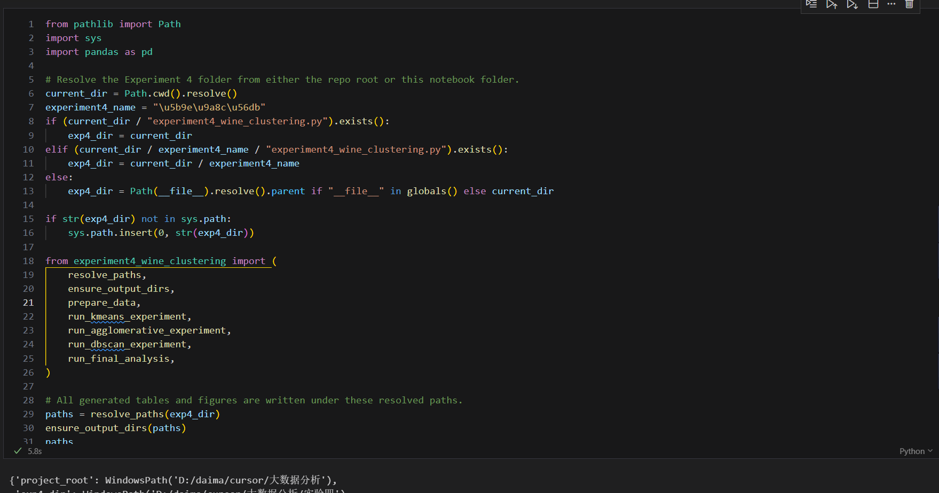

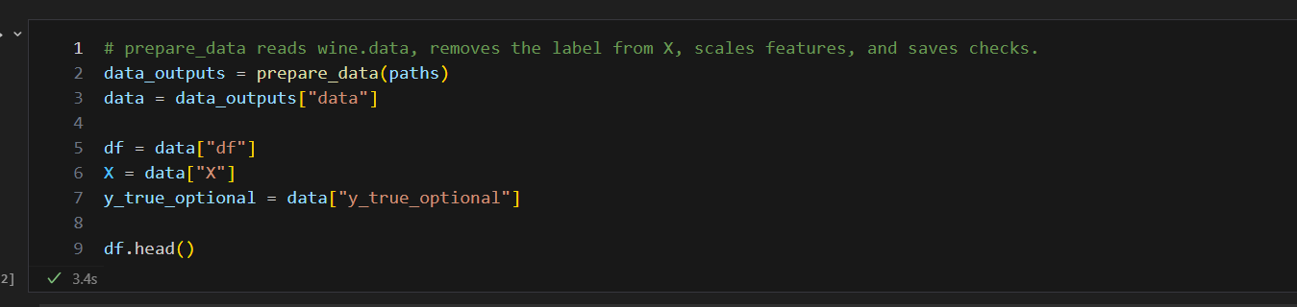

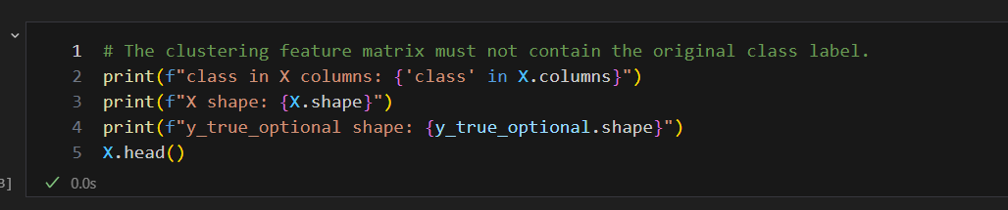

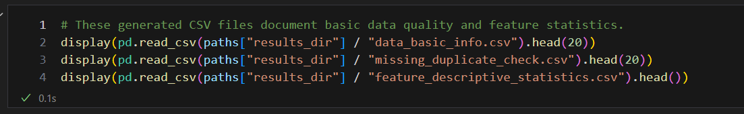

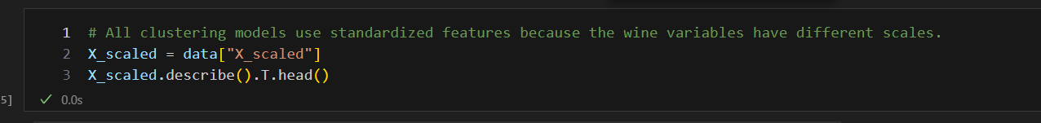

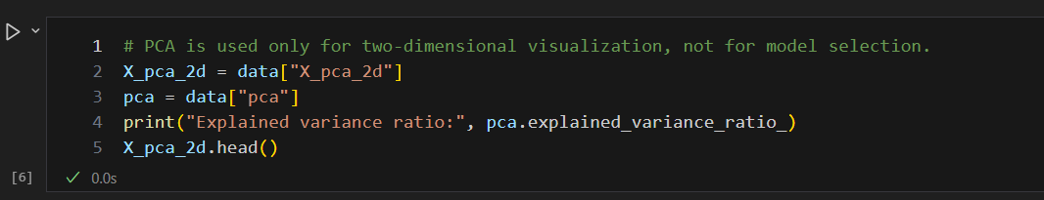

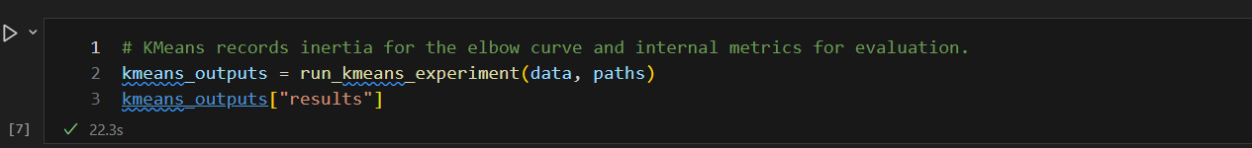

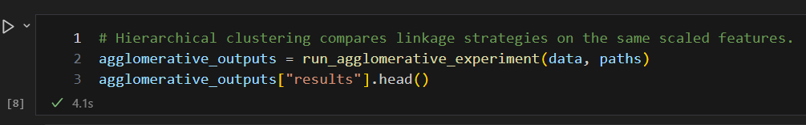

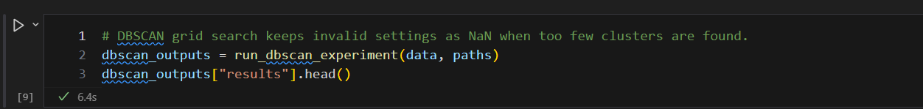

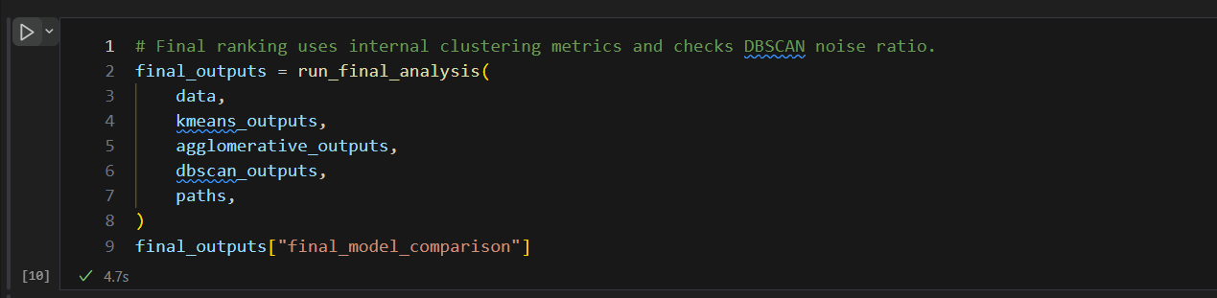

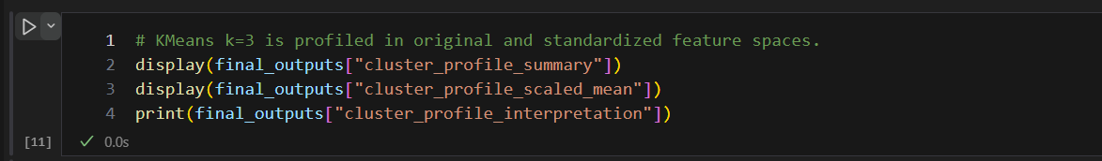

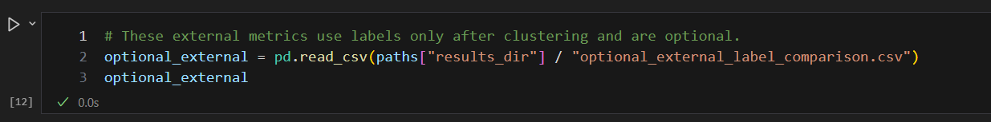

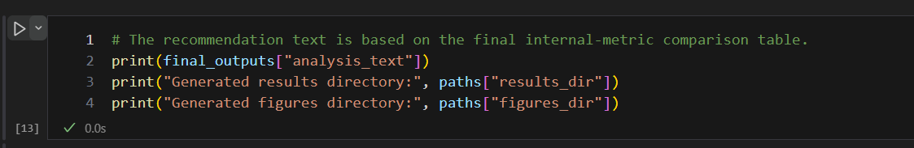

from __future__ import annotations

import shutil
import time
import warnings
import zipfile
from pathlib import Path
from typing import Any

import matplotlib.pyplot as plt
import numpy as np
import pandas as pd
from sklearn.cluster import AgglomerativeClustering, DBSCAN, KMeans
from sklearn.decomposition import PCA
from sklearn.metrics import (
adjusted_rand_score,
calinski_harabasz_score,
completeness_score,
davies_bouldin_score,
homogeneity_score,
normalized_mutual_info_score,
silhouette_score,
v_measure_score,
)
from sklearn.neighbors import NearestNeighbors
from sklearn.preprocessing import StandardScaler

RANDOM_STATE = 42
FIGURE_DPI = 300

# Keep the dataset schema explicit so the label column can be separated safely.
WINE_COLUMNS = [
"class",
"Alcohol",
"Malic acid",
"Ash",
"Alcalinity of ash",
"Magnesium",
"Total phenols",
"Flavanoids",
"Nonflavanoid phenols",
"Proanthocyanins",
"Color intensity",
"Hue",
"OD280/OD315 of diluted wines",
"Proline",
]
FEATURE_COLUMNS = WINE_COLUMNS[1:]

# Centralize search ranges and output names to keep the script/report aligned.
KMEANS_K_VALUES = list(range(2, 11))
AGGLOMERATIVE_LINKAGES = ["ward", "complete", "average", "single"]
DBSCAN_EPS_VALUES = np.round(np.arange(0.3, 5.01, 0.1), 2)
DBSCAN_MIN_SAMPLES_VALUES = [3, 4, 5, 6, 8, 10]
DBSCAN_REASONABLE_NOISE_RATIO = 0.40

REQUIRED_RESULT_FILES = [
"data_basic_info.csv",
"feature_descriptive_statistics.csv",
"missing_duplicate_check.csv",
"kmeans_k_selection_results.csv",
"agglomerative_grid_results.csv",
"dbscan_grid_search_results.csv",
"final_model_comparison.csv",
"model_ranking_summary.csv",
"cluster_profile_summary.csv",
"cluster_profile_scaled_mean.csv",
"cluster_profile_interpretation.txt",
"final_cluster_assignments.csv",
"optional_external_label_comparison.csv",
"optional_kmeans_class_crosstab.csv",
"optional_agglomerative_class_crosstab.csv",
"optional_dbscan_class_crosstab.csv",
]

REQUIRED_FIGURE_FILES = [
"01_feature_boxplots_before_scaling.png",
"02_feature_boxplots_after_scaling.png",
"03_feature_correlation_heatmap.png",
"04_pca_original_labels_optional.png",
"05_kmeans_elbow_curve.png",
"06_kmeans_silhouette_by_k.png",
"07_kmeans_ch_by_k.png",
"08_kmeans_db_by_k.png",
"09_pca_kmeans_k3_clusters.png",
"10_pca_best_kmeans_clusters.png",
"11_agglomerative_silhouette_comparison.png",
"12_agglomerative_ch_comparison.png",
"13_agglomerative_db_comparison.png",
"14_agglomerative_dendrogram.png",
"15_pca_agglomerative_ward_k3_clusters.png",
"16_dbscan_k_distance_curve.png",
"17_dbscan_silhouette_heatmap.png",
"18_dbscan_noise_ratio_heatmap.png",
"19_dbscan_cluster_count_heatmap.png",
"20_pca_best_dbscan_clusters.png",
"21_final_model_metrics_comparison.png",
"22_cluster_size_comparison.png",
"23_cluster_profile_heatmap.png",
"24_optional_external_metric_comparison.png",
]

def resolve_paths(exp4_dir: str | Path | None = None) -> dict[str, Path]:
"""Resolve paths so the script works from the repo root or Experiment 4."""
if exp4_dir is None:
exp4_dir = Path(__file__).resolve().parent
else:
exp4_dir = Path(exp4_dir).resolve()
# Allow callers to pass either the repository root or the Experiment 4 folder.
if exp4_dir.name != "实验四" and (exp4_dir / "实验四").exists():
exp4_dir = exp4_dir / "实验四"

project_root = exp4_dir.parent
data_dir = exp4_dir / "data"
return {
"project_root": project_root,
"exp4_dir": exp4_dir,
"data_dir": data_dir,
"results_dir": exp4_dir / "results",
"figures_dir": exp4_dir / "figures",
"wine_data": data_dir / "wine.data",
"wine_names": data_dir / "wine.names",
"wine_index": data_dir / "Index",
}

def ensure_output_dirs(paths: dict[str, Path]) -> None:
paths["data_dir"].mkdir(parents=True, exist_ok=True)
paths["results_dir"].mkdir(parents=True, exist_ok=True)
paths["figures_dir"].mkdir(parents=True, exist_ok=True)

def extract_wine_zip_if_needed(paths: dict[str, Path]) -> Path | None:
"""Extract wine.data, wine.names, and Index from wine.zip when needed."""
if paths["wine_data"].exists():
return None

# The assignment forbids downloading data, so only local wine.zip files are used.
zip_candidates = [
paths["data_dir"] / "wine.zip",
paths["exp4_dir"] / "wine.zip",
paths["project_root"] / "wine.zip",
]
allowed_names = {"wine.data", "wine.names", "Index"}

for zip_path in zip_candidates:
if not zip_path.exists():
continue

with zipfile.ZipFile(zip_path) as archive:
for member in archive.infolist():
member_name = Path(member.filename).name
if member.is_dir() or member_name not in allowed_names:
continue
target_path = paths["data_dir"] / member_name
with archive.open(member) as source, target_path.open("wb") as target:
shutil.copyfileobj(source, target)

if paths["wine_data"].exists():
return zip_path

return None

def check_wine_data(paths: dict[str, Path]) -> None:
extract_wine_zip_if_needed(paths)
if not paths["wine_data"].exists():
raise FileNotFoundError(
"wine.data was not found. Please put the file at "
f"{paths['wine_data']}.\n"
"If you have wine.zip, place it in the repository root, "
"Experiment 4 directory, or Experiment 4/data, then run again."
)

def load_wine_data(paths: dict[str, Path]) -> tuple[pd.DataFrame, pd.DataFrame, pd.Series]:
"""Load wine.data and remove the class label from the clustering features."""
check_wine_data(paths)

df = pd.read_csv(paths["wine_data"], header=None)
if df.shape[1] != len(WINE_COLUMNS):
raise ValueError(
f"Expected {len(WINE_COLUMNS)} columns in wine.data, got {df.shape[1]}."
)

df.columns = WINE_COLUMNS
df = df.apply(pd.to_numeric, errors="coerce")

# The original class label is saved only for optional post-clustering comparison.
y_true_optional = df["class"].copy()
# All clustering models must use only the 13 chemical features.
X = df.drop(columns=["class"]).copy()

if "class" in X.columns:
raise RuntimeError("The class label was not removed from X.")

return df, X, y_true_optional

def standardize_and_project(
X: pd.DataFrame,
) -> tuple[StandardScaler, pd.DataFrame, pd.DataFrame, PCA]:
"""Standardize feature matrix and build a two-dimensional PCA view."""
scaler = StandardScaler()
X_scaled_array = scaler.fit_transform(X)
X_scaled = pd.DataFrame(X_scaled_array, columns=X.columns, index=X.index)

# PCA is a visualization aid only; it is not used for model selection.
pca = PCA(n_components=2, random_state=RANDOM_STATE)
X_pca_2d = pca.fit_transform(X_scaled)
X_pca_2d = pd.DataFrame(X_pca_2d, columns=["PC1", "PC2"], index=X.index)

return scaler, X_scaled, X_pca_2d, pca

def save_data_check_outputs(
df: pd.DataFrame,
X: pd.DataFrame,
y_true_optional: pd.Series,
X_scaled: pd.DataFrame,
paths: dict[str, Path],
) -> list[Path]:
"""Save shape, missing value, duplicate, dtype, and feature statistics."""
# Class distribution is recorded as optional context, not as a training signal.
class_distribution = y_true_optional.value_counts().sort_index()

info_rows = [
{"item": "dataset_file", "value": str(paths["wine_data"])},
{"item": "n_samples", "value": len(df)},
{"item": "n_original_columns", "value": df.shape[1]},
{"item": "n_features_used_for_clustering", "value": X.shape[1]},
{"item": "removed_label_column", "value": "class"},
{
"item": "feature_columns_used_for_clustering",
"value": "; ".join(X.columns),
},
{
"item": "optional_original_class_distribution_note",
"value": (
"Original class labels are optional information only and are not "
"used for clustering training, parameter selection, or main evaluation."
),
},
]
for label, count in class_distribution.items():
info_rows.append(
{
"item": f"optional_original_class_{int(label)}_count",
"value": int(count),
}
)
for column, dtype in df.dtypes.items():
info_rows.append({"item": f"dtype_{column}", "value": str(dtype)})

data_basic_info = pd.DataFrame(info_rows)
data_basic_info_path = paths["results_dir"] / "data_basic_info.csv"
data_basic_info.to_csv(data_basic_info_path, index=False)

missing_rows = [
{"item": "total_missing_values_in_original_data", "value": int(df.isna().sum().sum())},
{"item": "total_missing_values_in_X", "value": int(X.isna().sum().sum())},
{"item": "duplicate_rows_in_original_data", "value": int(df.duplicated().sum())},
{"item": "duplicate_rows_in_X", "value": int(X.duplicated().sum())},
]
for column in df.columns:
missing_rows.append(
{"item": f"missing_values_{column}", "value": int(df[column].isna().sum())}
)
missing_duplicate_check = pd.DataFrame(missing_rows)
missing_duplicate_path = paths["results_dir"] / "missing_duplicate_check.csv"
missing_duplicate_check.to_csv(missing_duplicate_path, index=False)

before_stats = X.describe().T.reset_index().rename(columns={"index": "feature"})
before_stats.insert(0, "data_version", "before_scaling")
after_stats = X_scaled.describe().T.reset_index().rename(columns={"index": "feature"})
after_stats.insert(0, "data_version", "after_scaling")
descriptive_statistics = pd.concat([before_stats, after_stats], ignore_index=True)
descriptive_statistics_path = paths["results_dir"] / "feature_descriptive_statistics.csv"
descriptive_statistics.to_csv(descriptive_statistics_path, index=False)

return [
data_basic_info_path,
descriptive_statistics_path,
missing_duplicate_path,
]

def save_figure(fig: plt.Figure, output_path: Path) -> Path:
fig.tight_layout()
fig.savefig(output_path, dpi=FIGURE_DPI, bbox_inches="tight")
plt.close(fig)
return output_path

def plot_feature_boxplots(
frame: pd.DataFrame,
title: str,
ylabel: str,
output_path: Path,
) -> Path:
fig, ax = plt.subplots(figsize=(11, 6))
boxplot_kwargs = {"patch_artist": True, "showfliers": False}
try:
# Matplotlib 3.9 renamed labels to tick_labels; keep a fallback for older versions.
box = ax.boxplot(
frame.to_numpy(),
tick_labels=frame.columns,
**boxplot_kwargs,
)
except TypeError:
box = ax.boxplot(
frame.to_numpy(),
labels=frame.columns,
**boxplot_kwargs,
)
for patch in box["boxes"]:
patch.set_facecolor("#7AA6C2")
patch.set_alpha(0.75)
ax.set_title(title)
ax.set_ylabel(ylabel)
ax.tick_params(axis="x", labelrotation=70, labelsize=8)
ax.grid(axis="y", alpha=0.25)
return save_figure(fig, output_path)

def plot_feature_correlation_heatmap(X: pd.DataFrame, paths: dict[str, Path]) -> Path:
correlation = X.corr(numeric_only=True)

fig, ax = plt.subplots(figsize=(9, 7.5))
image = ax.imshow(correlation, cmap="coolwarm", vmin=-1, vmax=1)
ax.set_title("Feature Correlation Heatmap")
ax.set_xticks(np.arange(len(correlation.columns)))
ax.set_yticks(np.arange(len(correlation.index)))
ax.set_xticklabels(correlation.columns, rotation=70, ha="right", fontsize=7)
ax.set_yticklabels(correlation.index, fontsize=7)
cbar = fig.colorbar(image, ax=ax, shrink=0.85)
cbar.set_label("Correlation")

return save_figure(
fig,
paths["figures_dir"] / "03_feature_correlation_heatmap.png",
)

def plot_pca_labels(
X_pca_2d: pd.DataFrame,
labels: np.ndarray | pd.Series,
title: str,
output_path: Path,
xlabel: str = "Principal Component 1",
ylabel: str = "Principal Component 2",
) -> Path:
fig, ax = plt.subplots(figsize=(7.5, 5.8))
label_series = pd.Series(labels, index=X_pca_2d.index, name="label")
unique_labels = sorted(label_series.dropna().unique())
cmap = plt.get_cmap("tab10")

for index, label in enumerate(unique_labels):
mask = label_series == label
# Noise is shown only for DBSCAN; all other labels are cluster IDs.
display_label = "Noise" if int(label) == -1 else f"Cluster {int(label)}"
if "original" in output_path.name:
display_label = f"Class {int(label)}"
color = "#808080" if int(label) == -1 else cmap(index % 10)
ax.scatter(
X_pca_2d.loc[mask, "PC1"],
X_pca_2d.loc[mask, "PC2"],
s=38,
alpha=0.82,
label=display_label,
color=color,
edgecolors="white",
linewidths=0.35,
)

ax.set_title(title)
ax.set_xlabel(xlabel)
ax.set_ylabel(ylabel)
ax.grid(alpha=0.2)
ax.legend(loc="best", fontsize=8, frameon=True)
return save_figure(fig, output_path)

def plot_data_overview_figures(
X: pd.DataFrame,
X_scaled: pd.DataFrame,
X_pca_2d: pd.DataFrame,
y_true_optional: pd.Series,
paths: dict[str, Path],
) -> list[Path]:
figure_paths = [
plot_feature_boxplots(
X,
"Feature Boxplots Before Scaling",
"Original Feature Value",
paths["figures_dir"] / "01_feature_boxplots_before_scaling.png",
),
plot_feature_boxplots(
X_scaled,
"Feature Boxplots After Standard Scaling",
"Standardized Feature Value",
paths["figures_dir"] / "02_feature_boxplots_after_scaling.png",
),
plot_feature_correlation_heatmap(X, paths),
plot_pca_labels(
X_pca_2d,
y_true_optional,
"PCA Projection Colored by Original Labels (Optional)",
paths["figures_dir"] / "04_pca_original_labels_optional.png",
),
]
return figure_paths

def prepare_data(paths: dict[str, Path]) -> dict[str, Any]:
"""Read data, remove class labels, standardize features, and save checks."""
ensure_output_dirs(paths)
df, X, y_true_optional = load_wine_data(paths)
# From this point on, model inputs are based on X only, never on df["class"].
scaler, X_scaled, X_pca_2d, pca = standardize_and_project(X)

result_paths = save_data_check_outputs(df, X, y_true_optional, X_scaled, paths)
figure_paths = plot_data_overview_figures(
X,
X_scaled,
X_pca_2d,
y_true_optional,
paths,
)

return {
"data": {
"df": df,
"X": X,
"y_true_optional": y_true_optional,
"scaler": scaler,
"X_scaled": X_scaled,
"X_pca_2d": X_pca_2d,
"pca": pca,
},
"result_paths": result_paths,
"figure_paths": figure_paths,
}

def format_cluster_size_summary(labels: np.ndarray) -> str:
counts = pd.Series(labels).value_counts().sort_index()
return "; ".join(f"{int(cluster)}:{int(count)}" for cluster, count in counts.items())

def count_clusters_excluding_noise(labels: np.ndarray) -> int:
return len([label for label in np.unique(labels) if int(label) != -1])

def compute_internal_metrics(
X_scaled_array: np.ndarray,
labels: np.ndarray,
exclude_noise: bool = False,
) -> dict[str, float]:
"""Compute internal clustering metrics; optionally ignore DBSCAN noise."""
labels = np.asarray(labels)
if exclude_noise:
# DBSCAN metrics are computed on non-noise samples when valid clusters exist.
mask = labels != -1
X_eval = X_scaled_array[mask]
labels_eval = labels[mask]
else:
X_eval = X_scaled_array
labels_eval = labels

unique_labels = np.unique(labels_eval)
if len(unique_labels) < 2 or len(unique_labels) >= len(labels_eval):
# Internal metrics are undefined for fewer than two usable clusters.
return {
"silhouette_score": np.nan,
"calinski_harabasz_score": np.nan,
"davies_bouldin_score": np.nan,
}

return {
"silhouette_score": float(silhouette_score(X_eval, labels_eval)),
"calinski_harabasz_score": float(calinski_harabasz_score(X_eval, labels_eval)),
"davies_bouldin_score": float(davies_bouldin_score(X_eval, labels_eval)),
}

def select_best_by_internal_metrics(
results_df: pd.DataFrame,
extra_sort_columns: list[str] | None = None,
) -> pd.Series:
# Tie-breaking follows the report rule: Silhouette high, CH high, DB low.
sort_columns = [
"silhouette_score",
"calinski_harabasz_score",
"davies_bouldin_score",
]
ascending = [False, False, True]
if extra_sort_columns:
sort_columns.extend(extra_sort_columns)
ascending.extend([True] * len(extra_sort_columns))

valid_df = results_df.dropna(subset=["silhouette_score"]).copy()
if valid_df.empty:
raise ValueError("No valid clustering result is available for model selection.")

return valid_df.sort_values(sort_columns, ascending=ascending).iloc[0]

def plot_single_metric_by_k(
results_df: pd.DataFrame,
metric: str,
title: str,
ylabel: str,
output_path: Path,
) -> Path:
fig, ax = plt.subplots(figsize=(7.5, 5))
ax.plot(
results_df["n_clusters"],
results_df[metric],
marker="o",
linewidth=2,
color="#4C78A8",
)
ax.set_title(title)
ax.set_xlabel("Number of Clusters (k)")
ax.set_ylabel(ylabel)
ax.set_xticks(results_df["n_clusters"])
ax.grid(alpha=0.25)
return save_figure(fig, output_path)

def run_kmeans_experiment(data: dict[str, Any], paths: dict[str, Path]) -> dict[str, Any]:
X_scaled_array = data["X_scaled"].to_numpy()
labels_by_k: dict[int, np.ndarray] = {}
records = []

# KMeans is evaluated across k values; inertia is kept only for the elbow curve.
for k in KMEANS_K_VALUES:
model = KMeans(n_clusters=k, n_init=50, random_state=RANDOM_STATE)
start_time = time.perf_counter()
labels = model.fit_predict(X_scaled_array)
elapsed = time.perf_counter() - start_time

labels_by_k[k] = labels
metrics = compute_internal_metrics(X_scaled_array, labels)
records.append(
{
"model": "KMeans",
"n_clusters": k,
"inertia": float(model.inertia_),
**metrics,
"training_time_seconds": elapsed,
"cluster_size_summary": format_cluster_size_summary(labels),
}
)

results_df = pd.DataFrame(records)
result_path = paths["results_dir"] / "kmeans_k_selection_results.csv"
results_df.to_csv(result_path, index=False)

best_row = select_best_by_internal_metrics(results_df)
best_k = int(best_row["n_clusters"])

# Both the assignment-required k=3 result and the best-by-silhouette result are kept.
figure_paths = [
plot_single_metric_by_k(
results_df,
"inertia",
"KMeans Elbow Curve",
"Inertia",
paths["figures_dir"] / "05_kmeans_elbow_curve.png",
),
plot_single_metric_by_k(
results_df,
"silhouette_score",
"KMeans Silhouette Score by k",
"Silhouette Coefficient",
paths["figures_dir"] / "06_kmeans_silhouette_by_k.png",
),
plot_single_metric_by_k(
results_df,
"calinski_harabasz_score",
"KMeans Calinski-Harabasz Index by k",
"Calinski-Harabasz Index",
paths["figures_dir"] / "07_kmeans_ch_by_k.png",
),
plot_single_metric_by_k(
results_df,
"davies_bouldin_score",
"KMeans Davies-Bouldin Index by k",
"Davies-Bouldin Index",
paths["figures_dir"] / "08_kmeans_db_by_k.png",
),
plot_pca_labels(
data["X_pca_2d"],
labels_by_k[3],
"PCA Projection of KMeans Clusters (k=3)",
paths["figures_dir"] / "09_pca_kmeans_k3_clusters.png",
),
plot_pca_labels(
data["X_pca_2d"],
labels_by_k[best_k],
f"PCA Projection of Best KMeans Clusters (k={best_k})",
paths["figures_dir"] / "10_pca_best_kmeans_clusters.png",
),
]

return {
"results": results_df,
"labels_by_k": labels_by_k,
"best_k": best_k,
"best_row": best_row,
"k3_labels": labels_by_k[3],
"best_labels": labels_by_k[best_k],
"result_paths": [result_path],
"figure_paths": figure_paths,
}

def plot_agglomerative_metric_comparison(
results_df: pd.DataFrame,
metric: str,
title: str,
ylabel: str,
output_path: Path,
) -> Path:
fig, ax = plt.subplots(figsize=(8, 5.5))
for linkage in AGGLOMERATIVE_LINKAGES:
subset = results_df[results_df["linkage"] == linkage]
ax.plot(
subset["n_clusters"],
subset[metric],
marker="o",
linewidth=2,
label=linkage,
)
ax.set_title(title)
ax.set_xlabel("Number of Clusters (k)")
ax.set_ylabel(ylabel)
ax.set_xticks(KMEANS_K_VALUES)
ax.grid(alpha=0.25)
ax.legend(title="Linkage")
return save_figure(fig, output_path)

def plot_agglomerative_dendrogram(data: dict[str, Any], paths: dict[str, Path]) -> Path:
from scipy.cluster.hierarchy import dendrogram, linkage

linked = linkage(data["X_scaled"].to_numpy(), method="ward")

fig, ax = plt.subplots(figsize=(10, 5.5))
dendrogram(
linked,
truncate_mode="level",
p=5,
no_labels=True,
color_threshold=None,
ax=ax,
)
ax.set_title("Agglomerative Clustering Dendrogram (Ward Linkage)")
ax.set_xlabel("Samples")
ax.set_ylabel("Distance")
ax.grid(axis="y", alpha=0.2)
return save_figure(fig, paths["figures_dir"] / "14_agglomerative_dendrogram.png")

def run_agglomerative_experiment(
data: dict[str, Any],
paths: dict[str, Path],
) -> dict[str, Any]:
X_scaled_array = data["X_scaled"].to_numpy()
labels_by_setting: dict[tuple[str, int], np.ndarray] = {}
records = []

# Linkage methods are compared on the same scaled feature matrix for fairness.
for linkage in AGGLOMERATIVE_LINKAGES:
for k in KMEANS_K_VALUES:
model = AgglomerativeClustering(n_clusters=k, linkage=linkage)
start_time = time.perf_counter()
labels = model.fit_predict(X_scaled_array)
elapsed = time.perf_counter() - start_time

labels_by_setting[(linkage, k)] = labels
metrics = compute_internal_metrics(X_scaled_array, labels)
records.append(
{
"model": "AgglomerativeClustering",
"linkage": linkage,
"n_clusters": k,
**metrics,
"training_time_seconds": elapsed,
"cluster_size_summary": format_cluster_size_summary(labels),
}
)

results_df = pd.DataFrame(records)
result_path = paths["results_dir"] / "agglomerative_grid_results.csv"
results_df.to_csv(result_path, index=False)

best_row = select_best_by_internal_metrics(results_df)
best_linkage = str(best_row["linkage"])
best_k = int(best_row["n_clusters"])

# Ward k=3 is retained as the required final hierarchical baseline.
figure_paths = [
plot_agglomerative_metric_comparison(
results_df,
"silhouette_score",
"Agglomerative Silhouette Score Comparison",
"Silhouette Coefficient",
paths["figures_dir"] / "11_agglomerative_silhouette_comparison.png",
),
plot_agglomerative_metric_comparison(
results_df,
"calinski_harabasz_score",
"Agglomerative Calinski-Harabasz Index Comparison",
"Calinski-Harabasz Index",
paths["figures_dir"] / "12_agglomerative_ch_comparison.png",
),
plot_agglomerative_metric_comparison(
results_df,
"davies_bouldin_score",
"Agglomerative Davies-Bouldin Index Comparison",
"Davies-Bouldin Index",
paths["figures_dir"] / "13_agglomerative_db_comparison.png",
),
plot_agglomerative_dendrogram(data, paths),
plot_pca_labels(
data["X_pca_2d"],
labels_by_setting[("ward", 3)],
"PCA Projection of Agglomerative Clusters (Ward, k=3)",
paths["figures_dir"] / "15_pca_agglomerative_ward_k3_clusters.png",
),
]

return {
"results": results_df,
"labels_by_setting": labels_by_setting,
"best_linkage": best_linkage,
"best_k": best_k,
"best_row": best_row,
"ward_k3_labels": labels_by_setting[("ward", 3)],
"best_labels": labels_by_setting[(best_linkage, best_k)],
"result_paths": [result_path],
"figure_paths": figure_paths,
}

def plot_dbscan_k_distance_curve(data: dict[str, Any], paths: dict[str, Path]) -> Path:
neighbors = NearestNeighbors(n_neighbors=5)
neighbors.fit(data["X_scaled"].to_numpy())
distances, _ = neighbors.kneighbors(data["X_scaled"].to_numpy())
# Sorted kth-neighbor distances help explain a reasonable eps range.
kth_distances = np.sort(distances[:, -1])

fig, ax = plt.subplots(figsize=(7.5, 5))
ax.plot(np.arange(1, len(kth_distances) + 1), kth_distances, color="#4C78A8")
ax.set_title("DBSCAN k-Distance Curve (5th Nearest Neighbor)")
ax.set_xlabel("Samples Sorted by Distance")
ax.set_ylabel("5th Nearest Neighbor Distance")
ax.grid(alpha=0.25)
return save_figure(fig, paths["figures_dir"] / "16_dbscan_k_distance_curve.png")

def plot_dbscan_heatmap(
results_df: pd.DataFrame,
value_column: str,
title: str,
colorbar_label: str,
output_path: Path,
cmap_name: str = "viridis",
) -> Path:
# Pivot the grid search result into eps x min_samples matrices for reporting.
pivot = results_df.pivot(
index="min_samples",
columns="eps",
values=value_column,
).sort_index()
matrix = pivot.to_numpy(dtype=float)

fig, ax = plt.subplots(figsize=(10, 4.8))
cmap = plt.get_cmap(cmap_name).copy()
cmap.set_bad("#EFEFEF")
image = ax.imshow(matrix, aspect="auto", cmap=cmap, origin="lower")

x_positions = np.arange(len(pivot.columns))
shown_x_positions = x_positions[::5]
if x_positions[-1] not in shown_x_positions:
shown_x_positions = np.append(shown_x_positions, x_positions[-1])
ax.set_xticks(shown_x_positions)
ax.set_xticklabels([f"{pivot.columns[i]:.1f}" for i in shown_x_positions])
ax.set_yticks(np.arange(len(pivot.index)))
ax.set_yticklabels([str(value) for value in pivot.index])
ax.set_title(title)
ax.set_xlabel("eps")
ax.set_ylabel("min_samples")
cbar = fig.colorbar(image, ax=ax, shrink=0.9)
cbar.set_label(colorbar_label)
return save_figure(fig, output_path)

def select_best_dbscan(results_df: pd.DataFrame) -> pd.Series:
valid_df = results_df.dropna(subset=["silhouette_score"]).copy()
# Avoid recommending a DBSCAN setting that labels too many samples as noise.
reasonable_df = valid_df[
valid_df["noise_ratio"] <= DBSCAN_REASONABLE_NOISE_RATIO
].copy()
selection_df = reasonable_df if not reasonable_df.empty else valid_df

if selection_df.empty:
return results_df.sort_values(
["cluster_count_excluding_noise", "noise_ratio"],
ascending=[False, True],
).iloc[0]

return selection_df.sort_values(
[
"silhouette_score",
"calinski_harabasz_score",
"davies_bouldin_score",
"noise_ratio",
],
ascending=[False, False, True, True],
).iloc[0]

def run_dbscan_experiment(data: dict[str, Any], paths: dict[str, Path]) -> dict[str, Any]:
X_scaled_array = data["X_scaled"].to_numpy()
labels_by_setting: dict[tuple[float, int], np.ndarray] = {}
records = []

# DBSCAN is sensitive to eps/min_samples, so the full grid is retained.
for eps in DBSCAN_EPS_VALUES:
for min_samples in DBSCAN_MIN_SAMPLES_VALUES:
model = DBSCAN(eps=float(eps), min_samples=int(min_samples))
start_time = time.perf_counter()
labels = model.fit_predict(X_scaled_array)
elapsed = time.perf_counter() - start_time

cluster_count = count_clusters_excluding_noise(labels)
noise_count = int(np.sum(labels == -1))
noise_ratio = noise_count / len(labels)

if cluster_count < 2:
# Metrics are intentionally NaN when there are not enough valid clusters.
metrics = {
"silhouette_score": np.nan,
"calinski_harabasz_score": np.nan,
"davies_bouldin_score": np.nan,
}
else:
metrics = compute_internal_metrics(
X_scaled_array,
labels,
exclude_noise=True,
)

labels_by_setting[(float(eps), int(min_samples))] = labels
records.append(
{
"model": "DBSCAN",
"eps": float(eps),
"min_samples": int(min_samples),
"cluster_count_excluding_noise": cluster_count,
"noise_count": noise_count,
"noise_ratio": noise_ratio,
**metrics,
"training_time_seconds": elapsed,
}
)

results_df = pd.DataFrame(records)
result_path = paths["results_dir"] / "dbscan_grid_search_results.csv"
results_df.to_csv(result_path, index=False)

best_row = select_best_dbscan(results_df)
best_eps = float(best_row["eps"])
best_min_samples = int(best_row["min_samples"])

figure_paths = [
plot_dbscan_k_distance_curve(data, paths),
plot_dbscan_heatmap(
results_df,
"silhouette_score",
"DBSCAN Silhouette Score Heatmap",
"Silhouette Coefficient",
paths["figures_dir"] / "17_dbscan_silhouette_heatmap.png",
),
plot_dbscan_heatmap(
results_df,
"noise_ratio",
"DBSCAN Noise Ratio Heatmap",
"Noise Ratio",
paths["figures_dir"] / "18_dbscan_noise_ratio_heatmap.png",
cmap_name="magma",
),
plot_dbscan_heatmap(
results_df,
"cluster_count_excluding_noise",
"DBSCAN Cluster Count Heatmap",
"Cluster Count Excluding Noise",
paths["figures_dir"] / "19_dbscan_cluster_count_heatmap.png",
cmap_name="plasma",
),
plot_pca_labels(
data["X_pca_2d"],
labels_by_setting[(best_eps, best_min_samples)],
f"PCA Projection of Best DBSCAN Clusters (eps={best_eps:.2f}, min_samples={best_min_samples})",
paths["figures_dir"] / "20_pca_best_dbscan_clusters.png",
),
]

return {
"results": results_df,
"labels_by_setting": labels_by_setting,
"best_eps": best_eps,
"best_min_samples": best_min_samples,
"best_row": best_row,
"best_labels": labels_by_setting[(best_eps, best_min_samples)],
"result_paths": [result_path],
"figure_paths": figure_paths,
}

def make_final_model_comparison(
kmeans_outputs: dict[str, Any],
agglomerative_outputs: dict[str, Any],
dbscan_outputs: dict[str, Any],
) -> pd.DataFrame:
# The final table contains required fixed settings plus internally selected models.
kmeans_results = kmeans_outputs["results"]
agglomerative_results = agglomerative_outputs["results"]
dbscan_best = dbscan_outputs["best_row"]

kmeans_k3 = kmeans_results[kmeans_results["n_clusters"] == 3].iloc[0]
best_kmeans = kmeans_outputs["best_row"]
agglomerative_ward_k3 = agglomerative_results[
(agglomerative_results["linkage"] == "ward")
& (agglomerative_results["n_clusters"] == 3)
].iloc[0]
best_agglomerative = agglomerative_outputs["best_row"]

rows = [
{
"model": "KMeans",
"setting": "k=3",
"n_clusters": int(kmeans_k3["n_clusters"]),
"noise_ratio": 0.0,
"silhouette_score": kmeans_k3["silhouette_score"],
"calinski_harabasz_score": kmeans_k3["calinski_harabasz_score"],
"davies_bouldin_score": kmeans_k3["davies_bouldin_score"],
"training_time_seconds": kmeans_k3["training_time_seconds"],
"notes": "Fixed k=3 retained for cluster interpretation.",
},
{
"model": "KMeans",
"setting": f"best by silhouette, k={int(best_kmeans['n_clusters'])}",
"n_clusters": int(best_kmeans["n_clusters"]),
"noise_ratio": 0.0,
"silhouette_score": best_kmeans["silhouette_score"],
"calinski_harabasz_score": best_kmeans["calinski_harabasz_score"],
"davies_bouldin_score": best_kmeans["davies_bouldin_score"],
"training_time_seconds": best_kmeans["training_time_seconds"],
"notes": "Selected by internal clustering metrics only.",
},
{
"model": "AgglomerativeClustering",
"setting": "linkage=ward, k=3",
"n_clusters": int(agglomerative_ward_k3["n_clusters"]),
"noise_ratio": 0.0,
"silhouette_score": agglomerative_ward_k3["silhouette_score"],
"calinski_harabasz_score": agglomerative_ward_k3[
"calinski_harabasz_score"
],
"davies_bouldin_score": agglomerative_ward_k3["davies_bouldin_score"],
"training_time_seconds": agglomerative_ward_k3["training_time_seconds"],
"notes": "Ward linkage with k=3 retained as a hierarchical baseline.",
},
{
"model": "AgglomerativeClustering",
"setting": (
"best by silhouette, "
f"linkage={best_agglomerative['linkage']}, "
f"k={int(best_agglomerative['n_clusters'])}"
),
"n_clusters": int(best_agglomerative["n_clusters"]),
"noise_ratio": 0.0,
"silhouette_score": best_agglomerative["silhouette_score"],
"calinski_harabasz_score": best_agglomerative[
"calinski_harabasz_score"
],
"davies_bouldin_score": best_agglomerative["davies_bouldin_score"],
"training_time_seconds": best_agglomerative["training_time_seconds"],
"notes": "Selected by internal clustering metrics only.",
},
{
"model": "DBSCAN",
"setting": (
f"eps={float(dbscan_best['eps']):.2f}, "
f"min_samples={int(dbscan_best['min_samples'])}"
),
"n_clusters": int(dbscan_best["cluster_count_excluding_noise"]),
"noise_ratio": float(dbscan_best["noise_ratio"]),
"silhouette_score": dbscan_best["silhouette_score"],
"calinski_harabasz_score": dbscan_best["calinski_harabasz_score"],
"davies_bouldin_score": dbscan_best["davies_bouldin_score"],
"training_time_seconds": dbscan_best["training_time_seconds"],
"notes": (
"Best valid DBSCAN setting; noise ratio is considered because "
"DBSCAN is sensitive to eps and min_samples."
),
},
]
final_df = pd.DataFrame(rows)
return sort_final_models(final_df)

def sort_final_models(final_df: pd.DataFrame) -> pd.DataFrame:
working_df = final_df.copy()
# High-noise DBSCAN settings are not preferred even when one metric looks strong.
dbscan_high_noise = (
(working_df["model"] == "DBSCAN")
& (working_df["noise_ratio"] > DBSCAN_REASONABLE_NOISE_RATIO)
)
working_df["_recommendation_candidate"] = ~dbscan_high_noise
working_df["_silhouette_sort"] = working_df["silhouette_score"].fillna(-np.inf)
working_df["_ch_sort"] = working_df["calinski_harabasz_score"].fillna(-np.inf)
working_df["_db_sort"] = working_df["davies_bouldin_score"].fillna(np.inf)

sorted_df = working_df.sort_values(
[
"_recommendation_candidate",
"_silhouette_sort",
"_ch_sort",
"_db_sort",
"noise_ratio",
],
ascending=[False, False, False, True, True],
)
return sorted_df[final_df.columns].reset_index(drop=True)

def make_model_ranking_summary(final_df: pd.DataFrame) -> pd.DataFrame:
ranking_df = final_df.copy()
ranking_df.insert(0, "rank", np.arange(1, len(ranking_df) + 1))
ranking_df["recommendation_candidate"] = ~(
(ranking_df["model"] == "DBSCAN")
& (ranking_df["noise_ratio"] > DBSCAN_REASONABLE_NOISE_RATIO)
)
ranking_df["ranking_rule"] = (
"Prefer higher Silhouette, then higher Calinski-Harabasz, then lower "
"Davies-Bouldin. DBSCAN settings with high noise ratio are not preferred."
)
ranking_df["recommended"] = ranking_df["rank"] == 1
return ranking_df

def save_final_cluster_assignments(
kmeans_outputs: dict[str, Any],
agglomerative_outputs: dict[str, Any],
dbscan_outputs: dict[str, Any],
paths: dict[str, Path],
) -> Path:
n_samples = len(kmeans_outputs["k3_labels"])
# Do not include the original class label in this main clustering output.
assignments = pd.DataFrame(
{
"sample_id": np.arange(1, n_samples + 1),
"kmeans_k3_cluster": kmeans_outputs["k3_labels"],
"best_kmeans_cluster": kmeans_outputs["best_labels"],
"agglomerative_ward_k3_cluster": agglomerative_outputs["ward_k3_labels"],
"best_agglomerative_cluster": agglomerative_outputs["best_labels"],
"best_dbscan_cluster": dbscan_outputs["best_labels"],
}
)
output_path = paths["results_dir"] / "final_cluster_assignments.csv"
assignments.to_csv(output_path, index=False)
return output_path

def save_cluster_profiles(
data: dict[str, Any],
kmeans_outputs: dict[str, Any],
paths: dict[str, Path],
) -> dict[str, Any]:
# KMeans k=3 is used for interpretable cluster profiles in both feature spaces.
labels = kmeans_outputs["k3_labels"]
X = data["X"]
X_scaled = data["X_scaled"]

profile_frame = X.copy()
profile_frame["cluster"] = labels
sample_counts = profile_frame.groupby("cluster").size().rename("sample_count")
original_means = profile_frame.groupby("cluster")[X.columns].mean()
profile_summary = pd.concat([sample_counts, original_means], axis=1).reset_index()

profile_summary_path = paths["results_dir"] / "cluster_profile_summary.csv"
profile_summary.to_csv(profile_summary_path, index=False)

scaled_profile_frame = X_scaled.copy()
scaled_profile_frame["cluster"] = labels
scaled_means = scaled_profile_frame.groupby("cluster")[X.columns].mean().reset_index()
scaled_mean_path = paths["results_dir"] / "cluster_profile_scaled_mean.csv"
scaled_means.to_csv(scaled_mean_path, index=False)

interpretation_text = build_cluster_profile_interpretation(
profile_summary,
scaled_means,
)
interpretation_path = paths["results_dir"] / "cluster_profile_interpretation.txt"
interpretation_path.write_text(interpretation_text, encoding="utf-8")

heatmap_path = plot_cluster_profile_heatmap(
scaled_means,
paths["figures_dir"] / "23_cluster_profile_heatmap.png",
)

return {
"profile_summary": profile_summary,
"scaled_means": scaled_means,
"interpretation_text": interpretation_text,
"result_paths": [
profile_summary_path,
scaled_mean_path,
interpretation_path,
],
"figure_paths": [heatmap_path],
}

def build_cluster_profile_interpretation(
profile_summary: pd.DataFrame,
scaled_means: pd.DataFrame,
) -> str:
lines = [
"Cluster profile interpretation based on KMeans k=3.",
"The values are interpreted from standardized feature means; positive values are above the overall average and negative values are below the overall average.",
]
scaled_indexed = scaled_means.set_index("cluster")
profile_indexed = profile_summary.set_index("cluster")

# The top positive and negative standardized means give a compact description.
for cluster_id, row in scaled_indexed.iterrows():
feature_values = row.drop(labels=[], errors="ignore").astype(float)
high_features = feature_values.sort_values(ascending=False).head(3)
low_features = feature_values.sort_values(ascending=True).head(3)
sample_count = int(profile_indexed.loc[cluster_id, "sample_count"])
high_text = ", ".join(
f"{feature} ({value:+.2f})" for feature, value in high_features.items()
)
low_text = ", ".join(
f"{feature} ({value:+.2f})" for feature, value in low_features.items()
)
lines.append(
f"Cluster {int(cluster_id)} contains {sample_count} samples. "
f"It is relatively high in {high_text}, and relatively low in {low_text}."
)

return "\n".join(lines)

def plot_cluster_profile_heatmap(scaled_means: pd.DataFrame, output_path: Path) -> Path:
heatmap_data = scaled_means.set_index("cluster")
values = heatmap_data.to_numpy(dtype=float)
max_abs = max(1.0, float(np.nanmax(np.abs(values))))

fig, ax = plt.subplots(figsize=(11, 4.6))
image = ax.imshow(values, aspect="auto", cmap="coolwarm", vmin=-max_abs, vmax=max_abs)
ax.set_title("KMeans k=3 Cluster Profile Heatmap")
ax.set_xlabel("Feature")
ax.set_ylabel("Cluster")
ax.set_xticks(np.arange(len(heatmap_data.columns)))
ax.set_xticklabels(heatmap_data.columns, rotation=70, ha="right", fontsize=8)
ax.set_yticks(np.arange(len(heatmap_data.index)))
ax.set_yticklabels([f"Cluster {int(value)}" for value in heatmap_data.index])
cbar = fig.colorbar(image, ax=ax, shrink=0.9)
cbar.set_label("Standardized Mean")
return save_figure(fig, output_path)

def save_optional_external_label_comparison(
data: dict[str, Any],
kmeans_outputs: dict[str, Any],
agglomerative_outputs: dict[str, Any],
dbscan_outputs: dict[str, Any],
paths: dict[str, Path],
) -> list[Path]:
"""Use original labels only after clustering as optional external comparison."""
# This section is deliberately separate from training, selection, and main metrics.
y_true_optional = data["y_true_optional"].to_numpy()
label_sets = {
"KMeans k=3": kmeans_outputs["k3_labels"],
"Best KMeans": kmeans_outputs["best_labels"],
"Agglomerative ward k=3": agglomerative_outputs["ward_k3_labels"],
"Best Agglomerative": agglomerative_outputs["best_labels"],
"Best DBSCAN": dbscan_outputs["best_labels"],
}

rows = []
for model_name, labels in label_sets.items():
rows.append(
{
"model": model_name,
"adjusted_rand_index_optional": adjusted_rand_score(
y_true_optional,
labels,
),
"normalized_mutual_info_optional": normalized_mutual_info_score(
y_true_optional,
labels,
),
"homogeneity_optional": homogeneity_score(y_true_optional, labels),
"completeness_optional": completeness_score(y_true_optional, labels),
"v_measure_optional": v_measure_score(y_true_optional, labels),
"note": (
"Optional external comparison only; original labels were not "
"used in clustering training, parameter selection, or main evaluation."
),
}
)

comparison_df = pd.DataFrame(rows)
comparison_path = paths["results_dir"] / "optional_external_label_comparison.csv"
comparison_df.to_csv(comparison_path, index=False)

optional_paths = [comparison_path]
crosstab_specs = [
(
"optional_kmeans_class_crosstab.csv",
kmeans_outputs["k3_labels"],
),
(
"optional_agglomerative_class_crosstab.csv",
agglomerative_outputs["ward_k3_labels"],
),
(
"optional_dbscan_class_crosstab.csv",
dbscan_outputs["best_labels"],
),
]
for file_name, labels in crosstab_specs:
crosstab = pd.crosstab(
pd.Series(labels, name="cluster"),
pd.Series(y_true_optional, name="class"),
)
crosstab_path = paths["results_dir"] / file_name
crosstab.to_csv(crosstab_path)
optional_paths.append(crosstab_path)

return optional_paths

def plot_optional_external_metric_comparison(
optional_comparison: pd.DataFrame,
output_path: Path,
) -> Path:
metric_columns = [
"adjusted_rand_index_optional",
"normalized_mutual_info_optional",
"homogeneity_optional",
"completeness_optional",
"v_measure_optional",
]
display_metrics = ["ARI", "NMI", "Homogeneity", "Completeness", "V-measure"]
model_labels = optional_comparison["model"].tolist()
x_positions = np.arange(len(model_labels))
bar_width = 0.15

fig, ax = plt.subplots(figsize=(10, 5.5))
for metric_index, metric in enumerate(metric_columns):
offset = (metric_index - 2) * bar_width
ax.bar(
x_positions + offset,
optional_comparison[metric],
width=bar_width,
label=display_metrics[metric_index],
)

ax.set_title("Optional External Label Comparison Metrics")
ax.set_xlabel("Model")
ax.set_ylabel("Score")
ax.set_xticks(x_positions)
ax.set_xticklabels(model_labels, rotation=25, ha="right")
ax.set_ylim(0, 1.05)
ax.grid(axis="y", alpha=0.25)
ax.legend(ncol=3, fontsize=8)
return save_figure(fig, output_path)

def plot_final_model_metrics_comparison(
final_df: pd.DataFrame,
output_path: Path,
) -> Path:
model_labels = [
f"{row.model}\n{row.setting}" for row in final_df.itertuples(index=False)
]
x_positions = np.arange(len(model_labels))

fig, axes = plt.subplots(3, 1, figsize=(10, 9), sharex=True)
metric_specs = [
("silhouette_score", "Silhouette Coefficient", "Higher is better"),
("calinski_harabasz_score", "Calinski-Harabasz Index", "Higher is better"),
("davies_bouldin_score", "Davies-Bouldin Index", "Lower is better"),
]
colors = ["#4C78A8", "#59A14F", "#F58518"]

# Plot the three internal metrics separately because their scales are different.
for ax, (metric, ylabel, subtitle), color in zip(axes, metric_specs, colors):
ax.bar(x_positions, final_df[metric], color=color, alpha=0.85)
ax.set_ylabel(ylabel)
ax.set_title(subtitle, fontsize=10)
ax.grid(axis="y", alpha=0.25)

axes[0].set_title("Final Model Internal Metrics Comparison", fontsize=13)
axes[-1].set_xticks(x_positions)
axes[-1].set_xticklabels(model_labels, rotation=20, ha="right", fontsize=8)
return save_figure(fig, output_path)

def plot_cluster_size_comparison(
labels_map: dict[str, np.ndarray],
output_path: Path,
) -> Path:
# Stacked horizontal bars make cluster balance and DBSCAN noise easy to compare.
all_cluster_labels = sorted(
{int(label) for labels in labels_map.values() for label in np.unique(labels)}
)
colors = plt.get_cmap("tab20")(np.linspace(0, 1, max(1, len(all_cluster_labels))))
color_map = {
cluster_label: colors[index]
for index, cluster_label in enumerate(all_cluster_labels)
}

fig, ax = plt.subplots(figsize=(10, 5.4))
y_positions = np.arange(len(labels_map))
for y_position, (model_name, labels) in zip(y_positions, labels_map.items()):
counts = pd.Series(labels).value_counts().sort_index()
left = 0
for cluster_label in all_cluster_labels:
count = int(counts.get(cluster_label, 0))
if count == 0:
continue
legend_label = "Noise" if cluster_label == -1 else f"Cluster {cluster_label}"
ax.barh(
y_position,
count,
left=left,
color=color_map[cluster_label],
label=legend_label,
)
left += count

handles, labels = ax.get_legend_handles_labels()
unique_legend = dict(zip(labels, handles))
ax.set_title("Cluster Size Comparison")
ax.set_xlabel("Sample Count")
ax.set_yticks(y_positions)
ax.set_yticklabels(list(labels_map.keys()))
ax.grid(axis="x", alpha=0.25)
ax.legend(
unique_legend.values(),
unique_legend.keys(),
bbox_to_anchor=(1.01, 1),
loc="upper left",
fontsize=8,
)
return save_figure(fig, output_path)

def build_short_analysis_text(final_df: pd.DataFrame) -> str:
recommended = final_df.iloc[0]
dbscan_row = final_df[final_df["model"] == "DBSCAN"]
dbscan_note = ""
if not dbscan_row.empty:
dbscan_noise_ratio = float(dbscan_row.iloc[0]["noise_ratio"])
dbscan_note = (
f" The selected DBSCAN setting has a noise ratio of {dbscan_noise_ratio:.2%}, "
"so DBSCAN sensitivity to eps and min_samples should be discussed."
)

return (
f"Recommended model: {recommended['model']} ({recommended['setting']}). "
f"It has Silhouette={recommended['silhouette_score']:.4f}, "
f"Calinski-Harabasz={recommended['calinski_harabasz_score']:.4f}, "
f"and Davies-Bouldin={recommended['davies_bouldin_score']:.4f}. "
"The recommendation is based only on internal clustering metrics; original "
"class labels are used only for optional external comparison."
f"{dbscan_note}"
)

def run_final_analysis(
data: dict[str, Any],
kmeans_outputs: dict[str, Any],
agglomerative_outputs: dict[str, Any],
dbscan_outputs: dict[str, Any],
paths: dict[str, Path],
) -> dict[str, Any]:
# Collect the final tables, cluster assignments, profiles, and optional label checks.
final_df = make_final_model_comparison(
kmeans_outputs,
agglomerative_outputs,
dbscan_outputs,
)
final_model_path = paths["results_dir"] / "final_model_comparison.csv"
final_df.to_csv(final_model_path, index=False)

ranking_df = make_model_ranking_summary(final_df)
ranking_path = paths["results_dir"] / "model_ranking_summary.csv"
ranking_df.to_csv(ranking_path, index=False)

assignments_path = save_final_cluster_assignments(
kmeans_outputs,
agglomerative_outputs,
dbscan_outputs,
paths,
)

profile_outputs = save_cluster_profiles(data, kmeans_outputs, paths)
optional_paths = save_optional_external_label_comparison(
data,
kmeans_outputs,
agglomerative_outputs,
dbscan_outputs,
paths,
)
optional_comparison = pd.read_csv(
paths["results_dir"] / "optional_external_label_comparison.csv"
)

labels_map = {
"KMeans k=3": kmeans_outputs["k3_labels"],
"Best KMeans": kmeans_outputs["best_labels"],
"Agglomerative ward k=3": agglomerative_outputs["ward_k3_labels"],
"Best Agglomerative": agglomerative_outputs["best_labels"],
"Best DBSCAN": dbscan_outputs["best_labels"],
}
figure_paths = [
plot_final_model_metrics_comparison(
final_df,
paths["figures_dir"] / "21_final_model_metrics_comparison.png",
),
plot_cluster_size_comparison(
labels_map,
paths["figures_dir"] / "22_cluster_size_comparison.png",
),
]
figure_paths.extend(profile_outputs["figure_paths"])
figure_paths.append(
plot_optional_external_metric_comparison(
optional_comparison,
paths["figures_dir"] / "24_optional_external_metric_comparison.png",
)
)

result_paths = [
final_model_path,
ranking_path,
assignments_path,
*profile_outputs["result_paths"],
*optional_paths,
]
analysis_text = build_short_analysis_text(final_df)

return {
"final_model_comparison": final_df,
"model_ranking_summary": ranking_df,
"cluster_profile_summary": profile_outputs["profile_summary"],
"cluster_profile_scaled_mean": profile_outputs["scaled_means"],
"cluster_profile_interpretation": profile_outputs["interpretation_text"],
"analysis_text": analysis_text,
"result_paths": result_paths,
"figure_paths": figure_paths,
}

def run_experiment(exp4_dir: str | Path | None = None) -> dict[str, Any]:
warnings.filterwarnings("ignore", category=UserWarning)
plt.rcParams["font.family"] = "DejaVu Sans"
plt.rcParams["axes.unicode_minus"] = False

paths = resolve_paths(exp4_dir)
ensure_output_dirs(paths)

print("Experiment 4: Wine Clustering Model Practice")
print(f"Experiment 4 directory: {paths['exp4_dir']}")
print(f"Data directory: {paths['data_dir']}")
print("Original class labels will be removed before clustering.")

# The workflow mirrors the report: data checks, model grids, comparison, profiles.
data_outputs = prepare_data(paths)
data = data_outputs["data"]
kmeans_outputs = run_kmeans_experiment(data, paths)
agglomerative_outputs = run_agglomerative_experiment(data, paths)
dbscan_outputs = run_dbscan_experiment(data, paths)
final_outputs = run_final_analysis(
data,
kmeans_outputs,
agglomerative_outputs,
dbscan_outputs,
paths,
)

result_paths = [
*data_outputs["result_paths"],
*kmeans_outputs["result_paths"],
*agglomerative_outputs["result_paths"],
*dbscan_outputs["result_paths"],
*final_outputs["result_paths"],
]
figure_paths = [
*data_outputs["figure_paths"],
*kmeans_outputs["figure_paths"],
*agglomerative_outputs["figure_paths"],
*dbscan_outputs["figure_paths"],
*final_outputs["figure_paths"],
]

recommended = final_outputs["final_model_comparison"].iloc[0]
print("\nGenerated results files:")
for file_name in REQUIRED_RESULT_FILES:
print(f"- {file_name}")
print("\nGenerated figures files:")
for file_name in REQUIRED_FIGURE_FILES:
print(f"- {file_name}")
print(
"\nRecommended model: "
f"{recommended['model']} ({recommended['setting']})"
)
print("\nShort analysis text:")
print(final_outputs["analysis_text"])

print("\nExperiment 4 completed successfully.")
print(f"Results directory: {paths['results_dir']}")
print(f"Figures directory: {paths['figures_dir']}")

return {
"paths": paths,
"data": data,
"kmeans": kmeans_outputs,
"agglomerative": agglomerative_outputs,
"dbscan": dbscan_outputs,
"final": final_outputs,
"result_paths": result_paths,
"figure_paths": figure_paths,
}

def main() -> None:
run_experiment()

if __name__ == "__main__":
main()

4. Experimental Data and Results

Experimental Data:
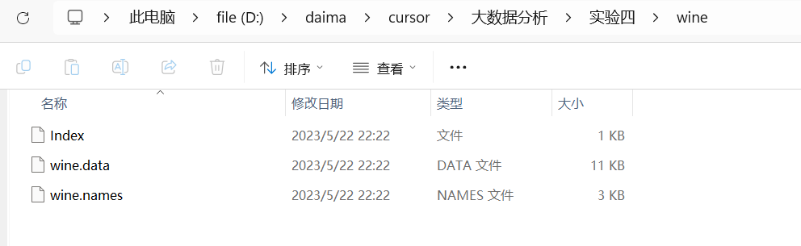

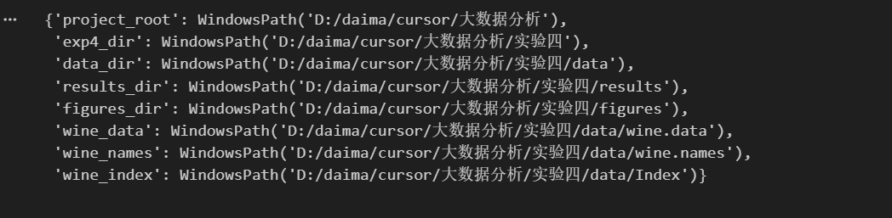

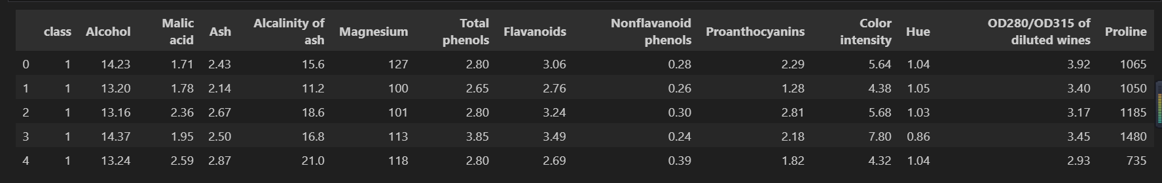

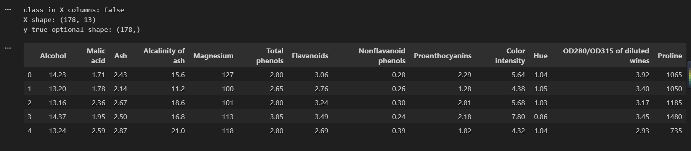

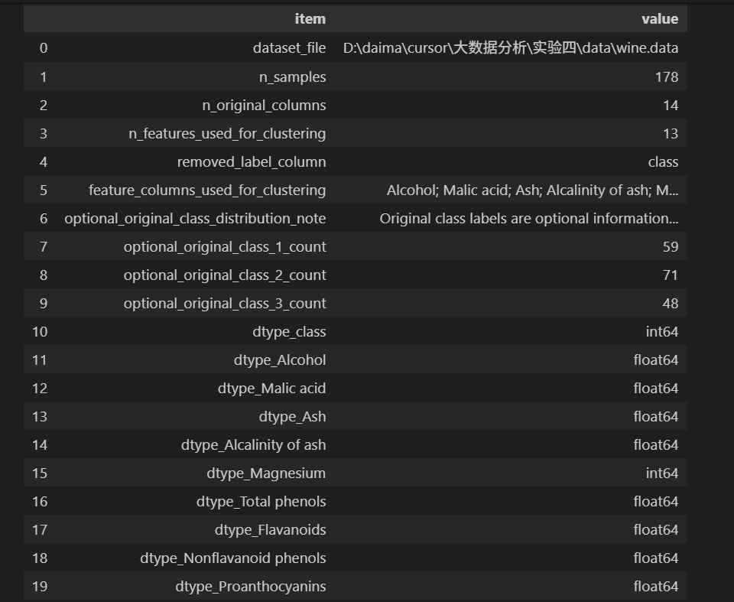

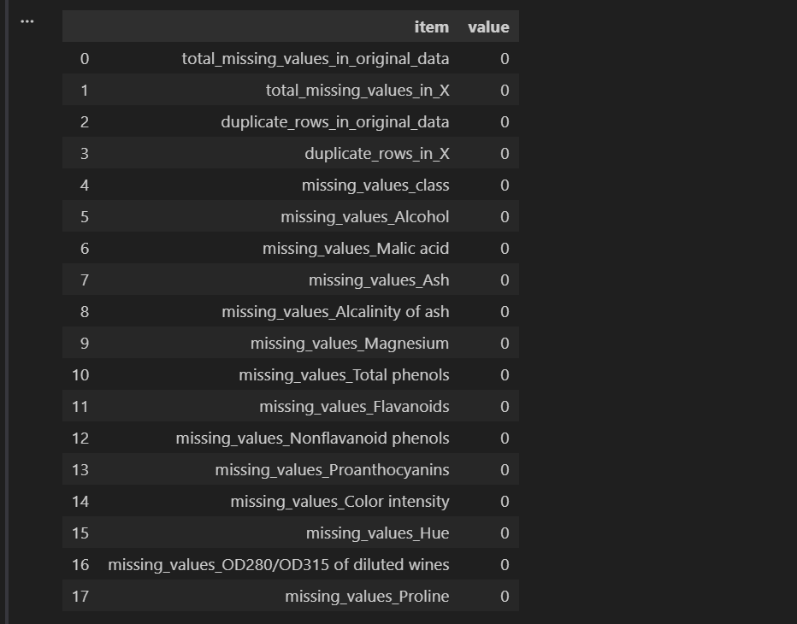

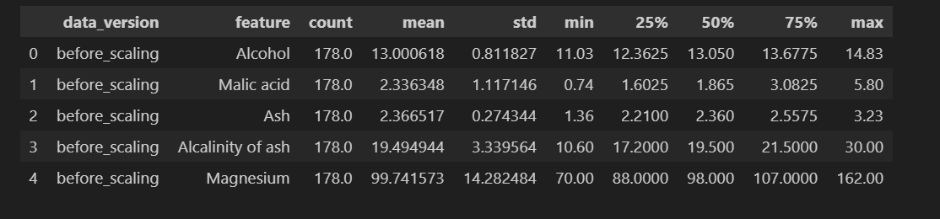

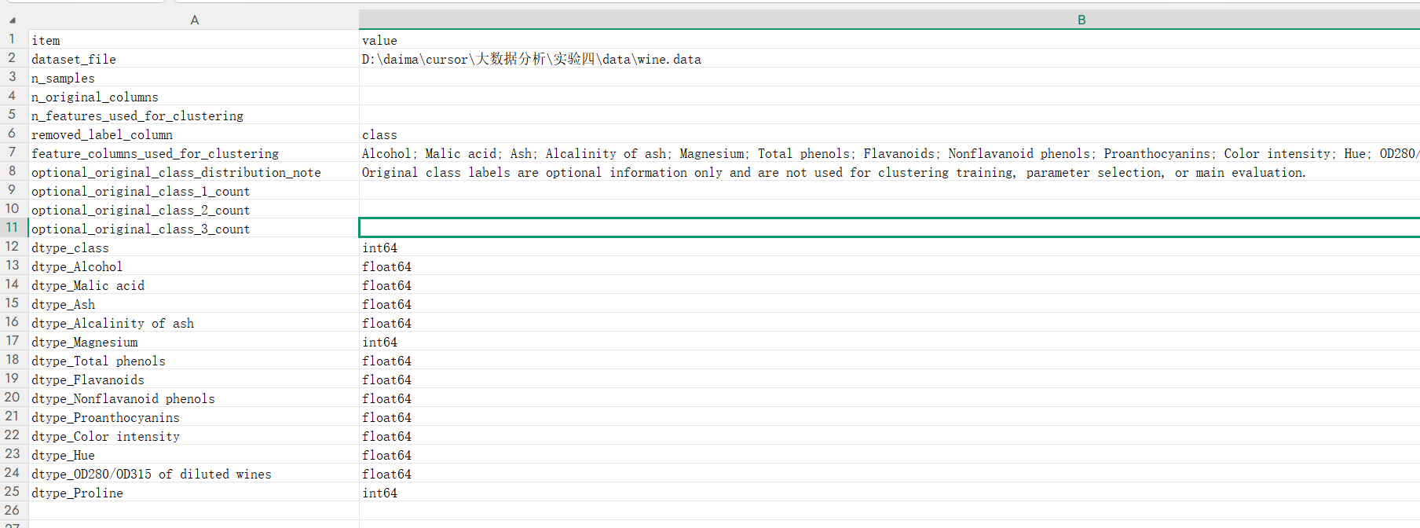

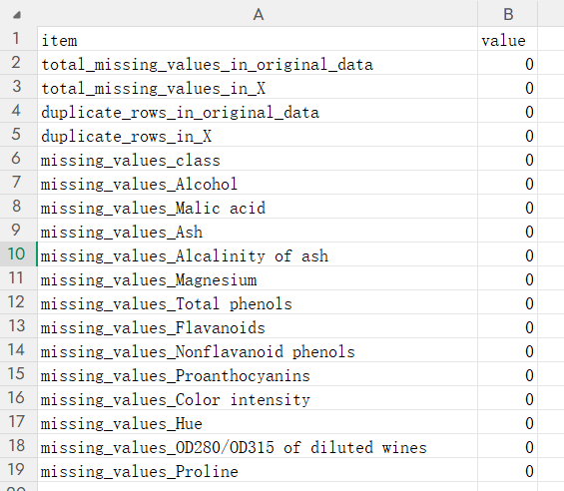

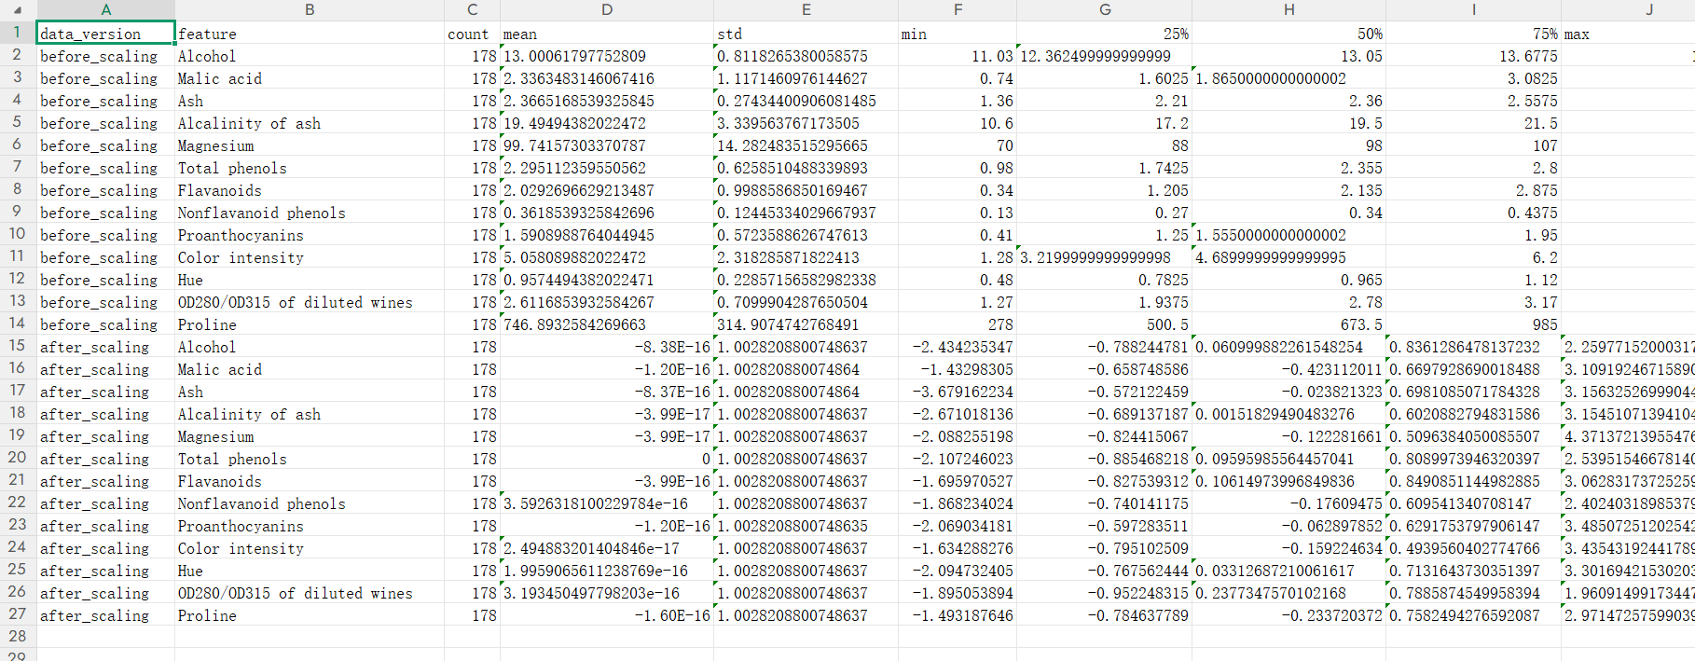

Experimental Results:
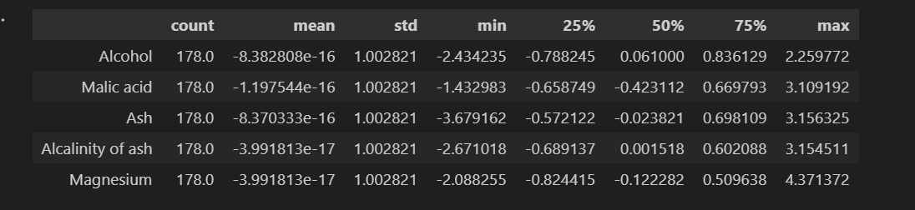

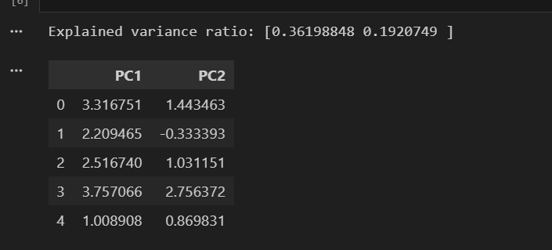

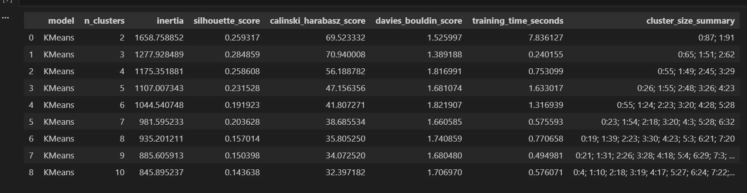

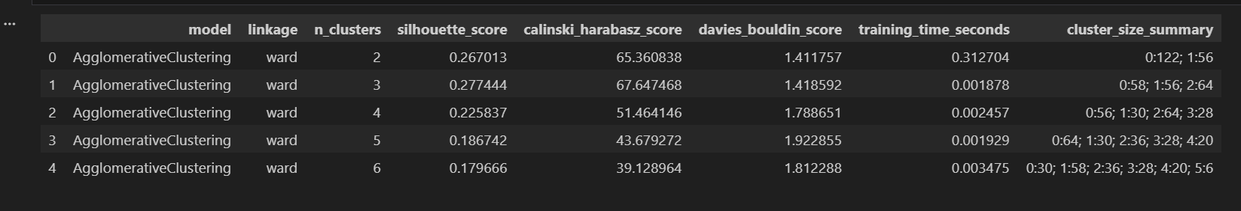

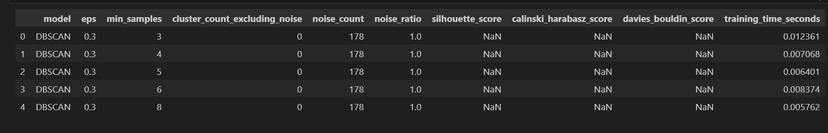

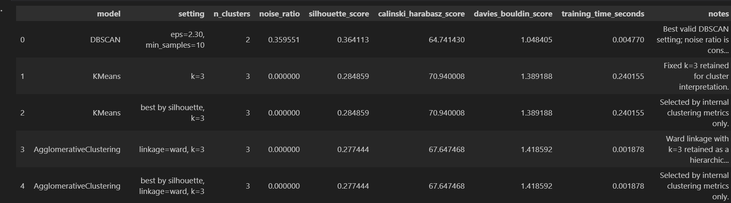

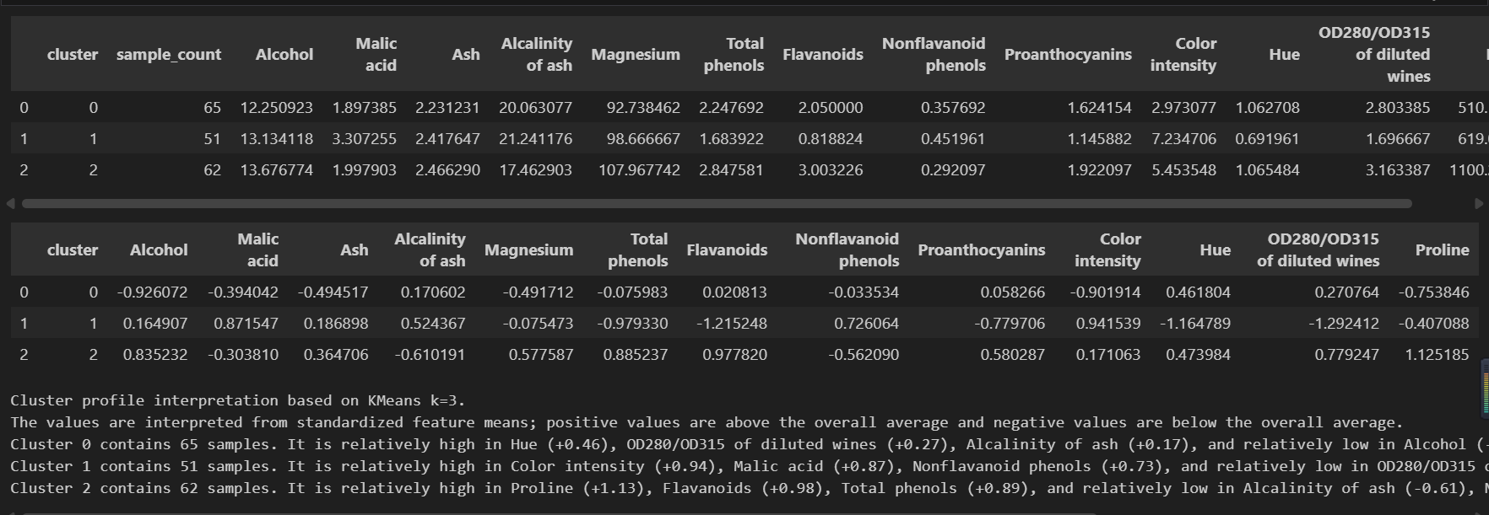

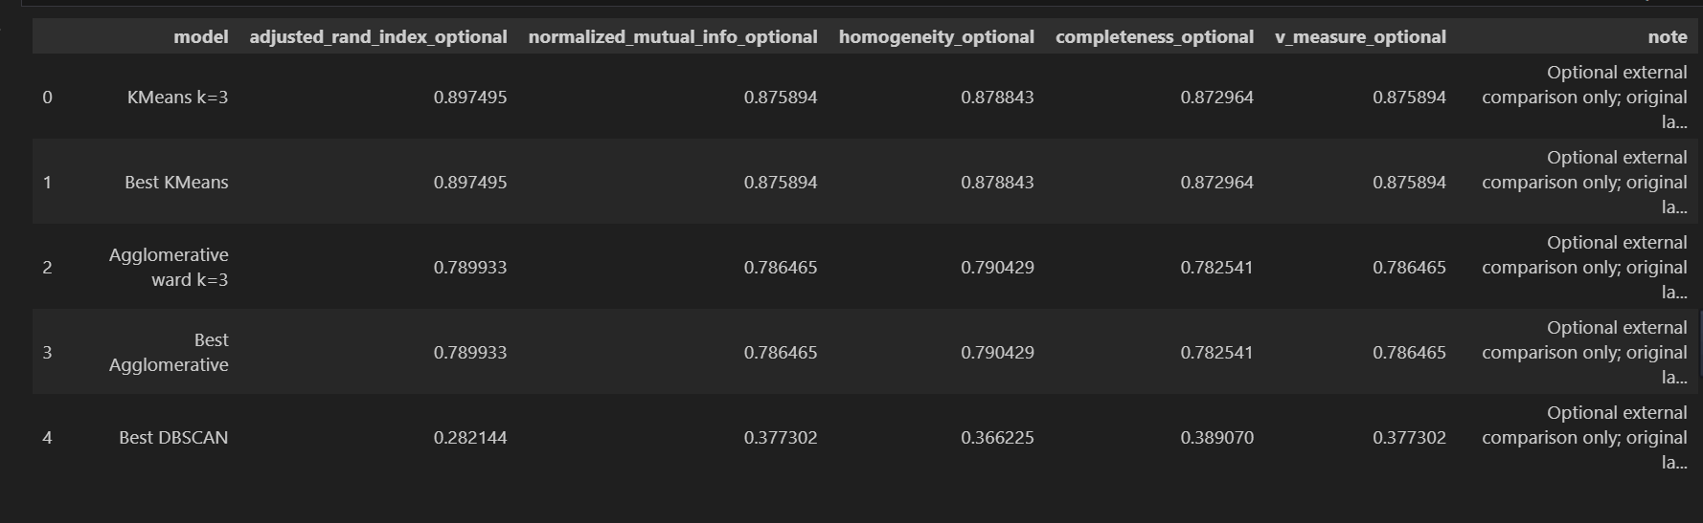

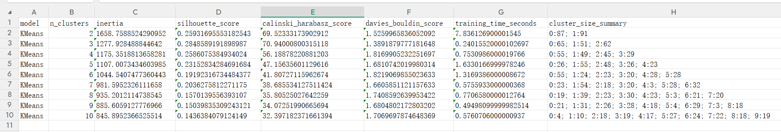

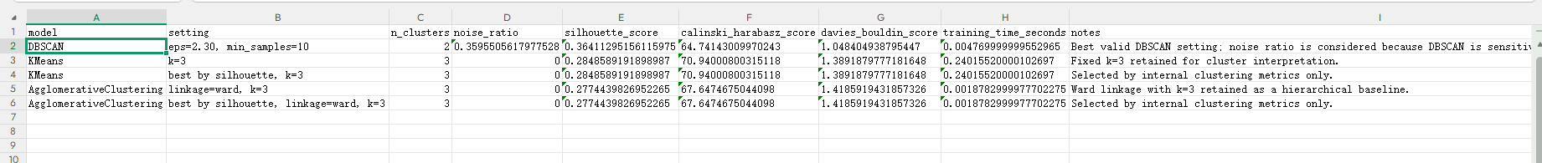

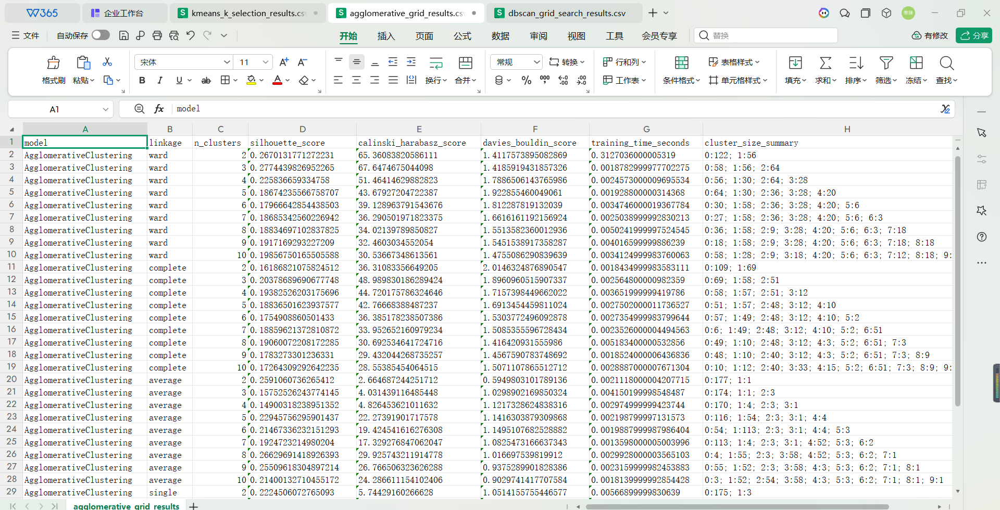

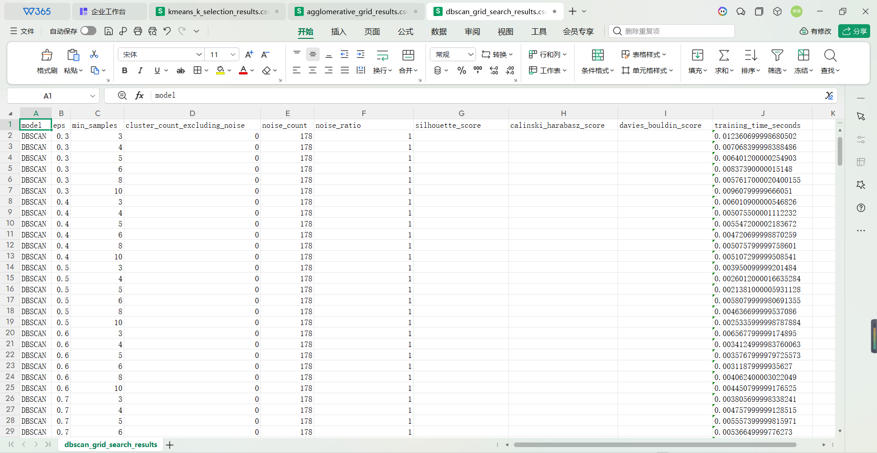

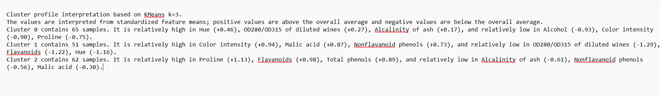

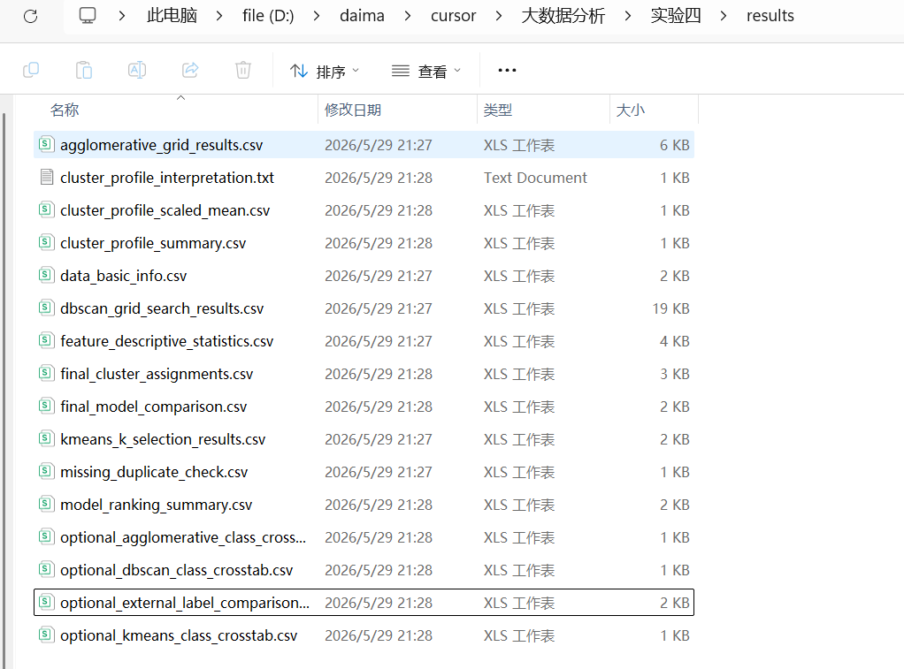

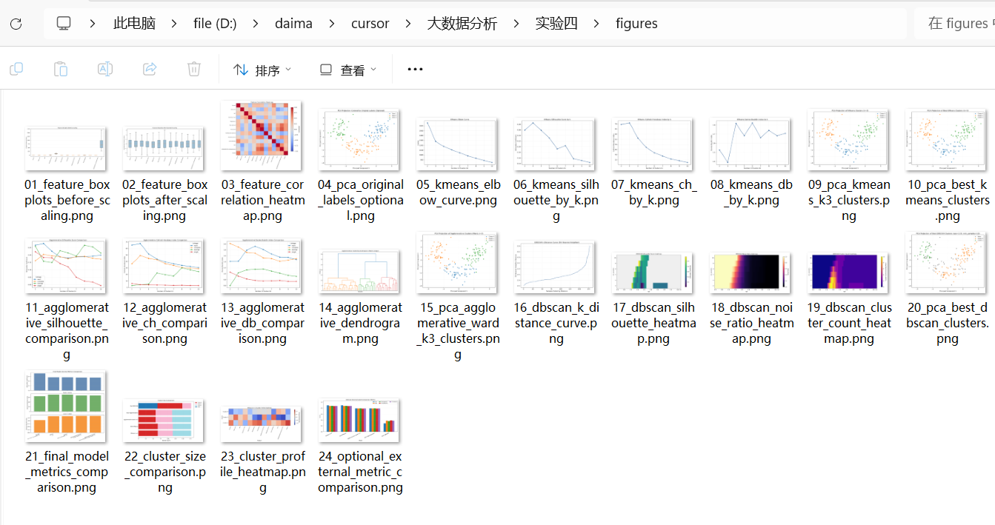

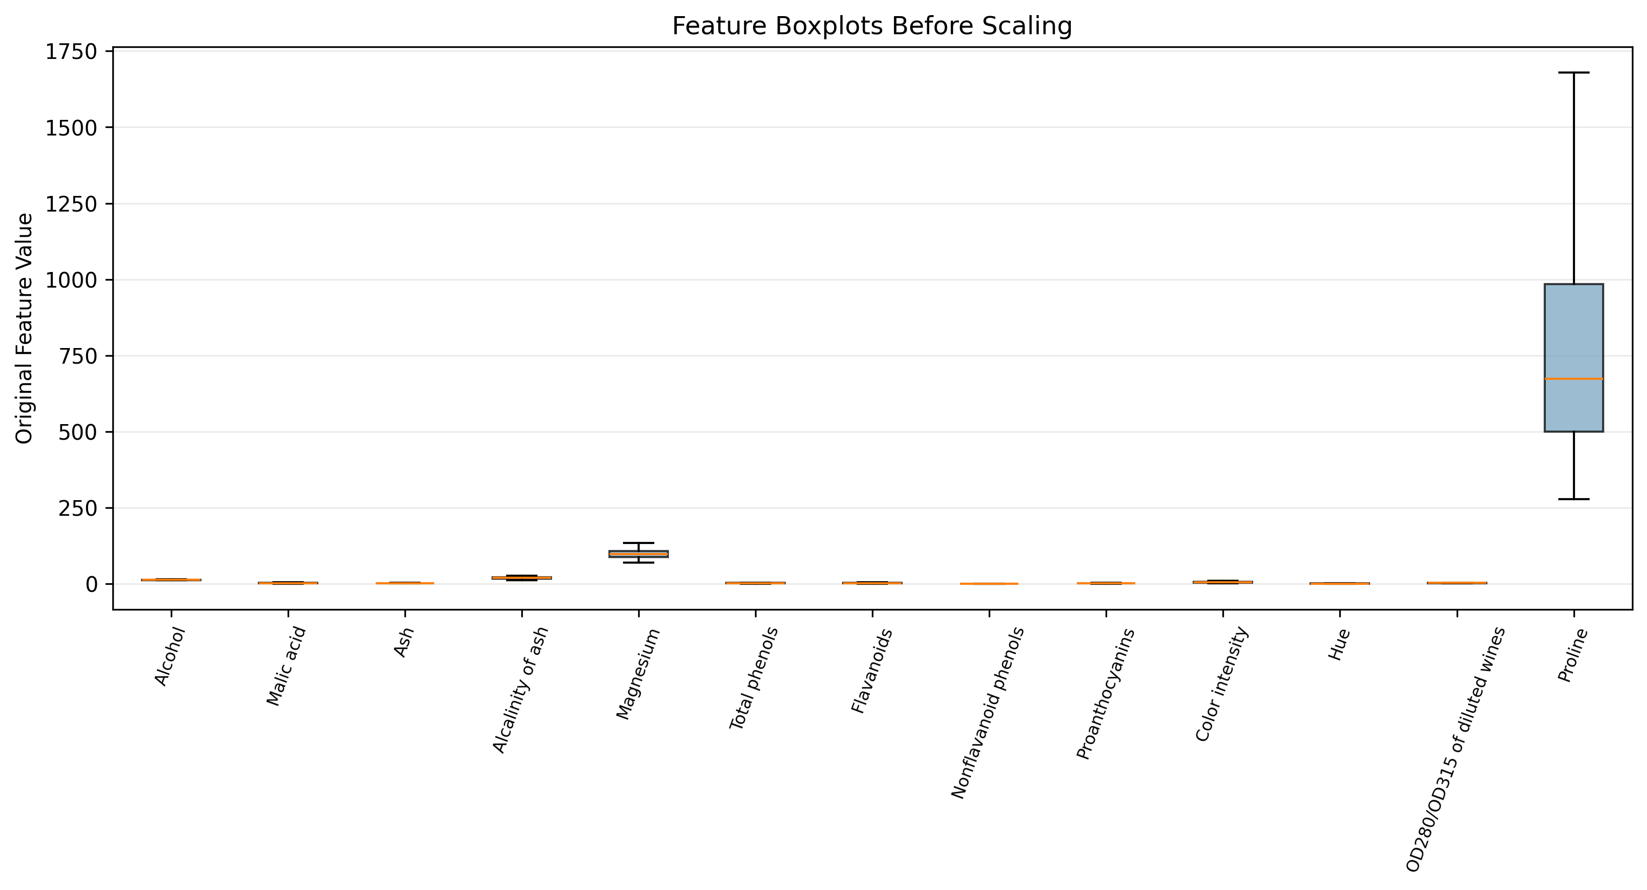

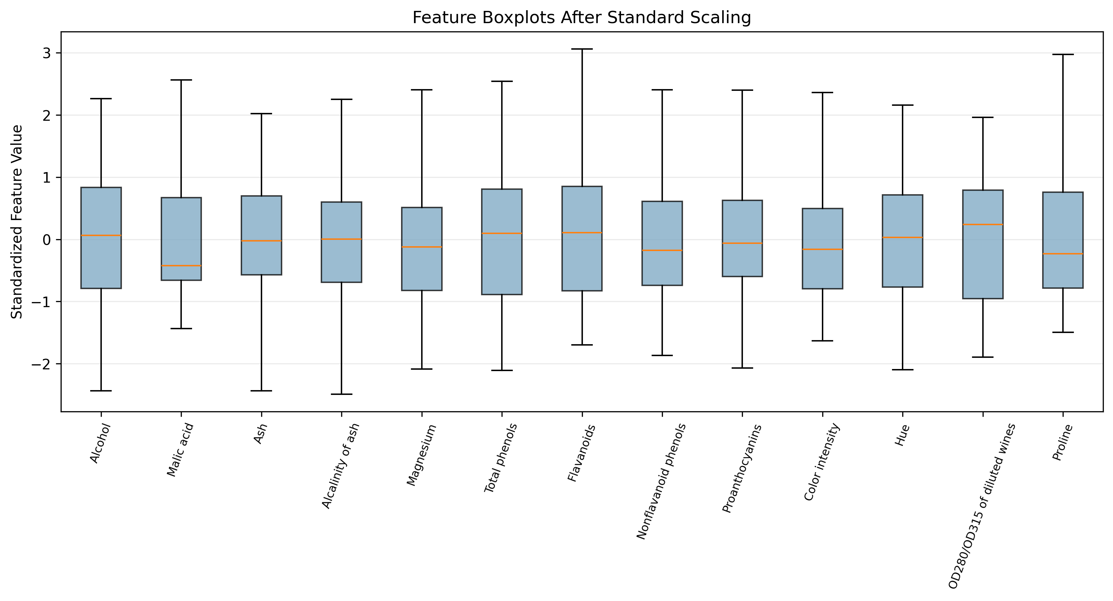

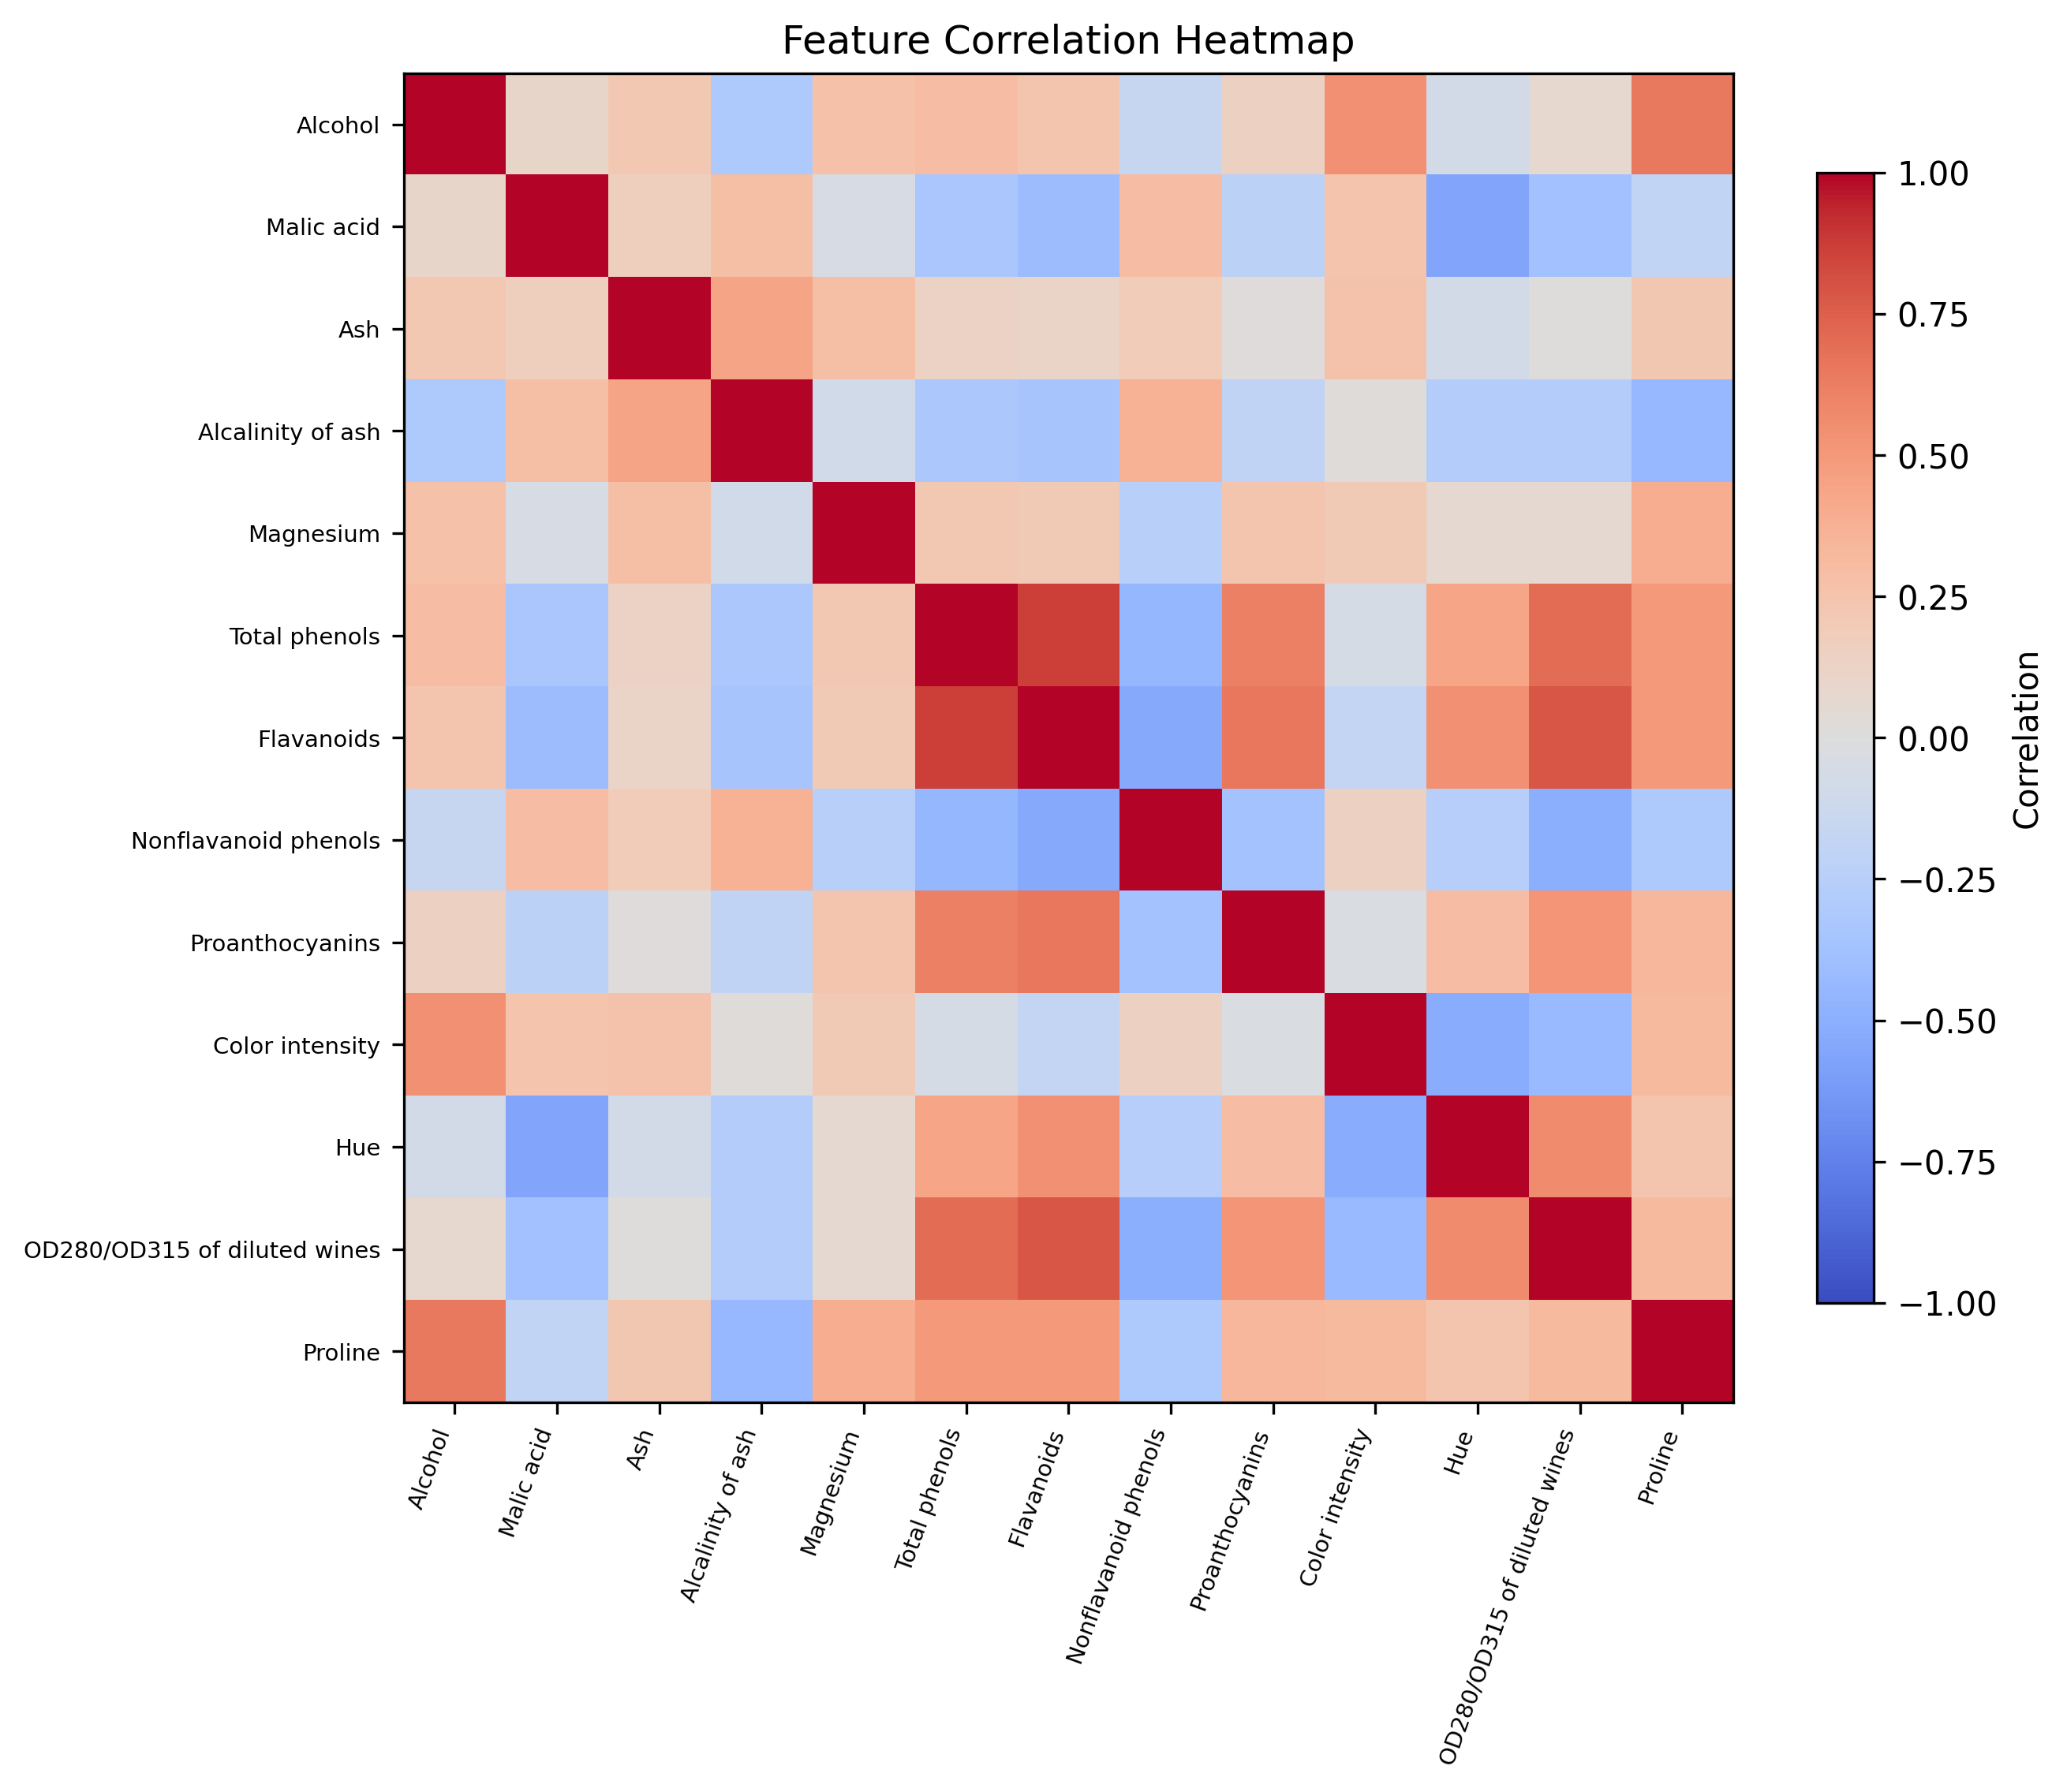

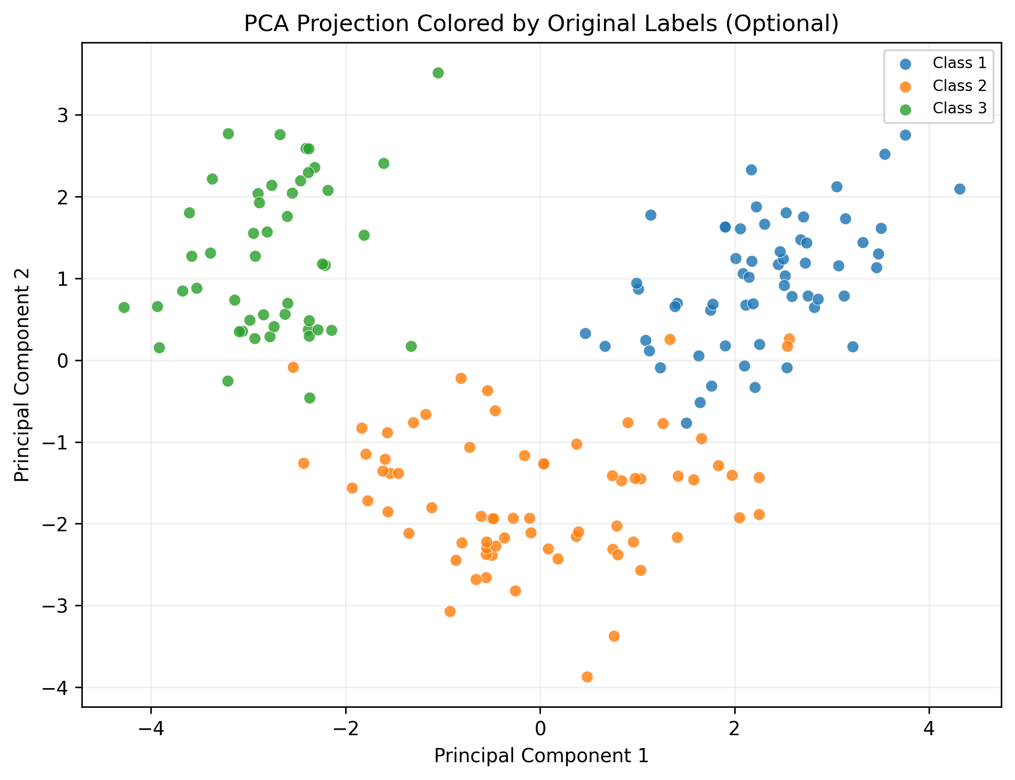
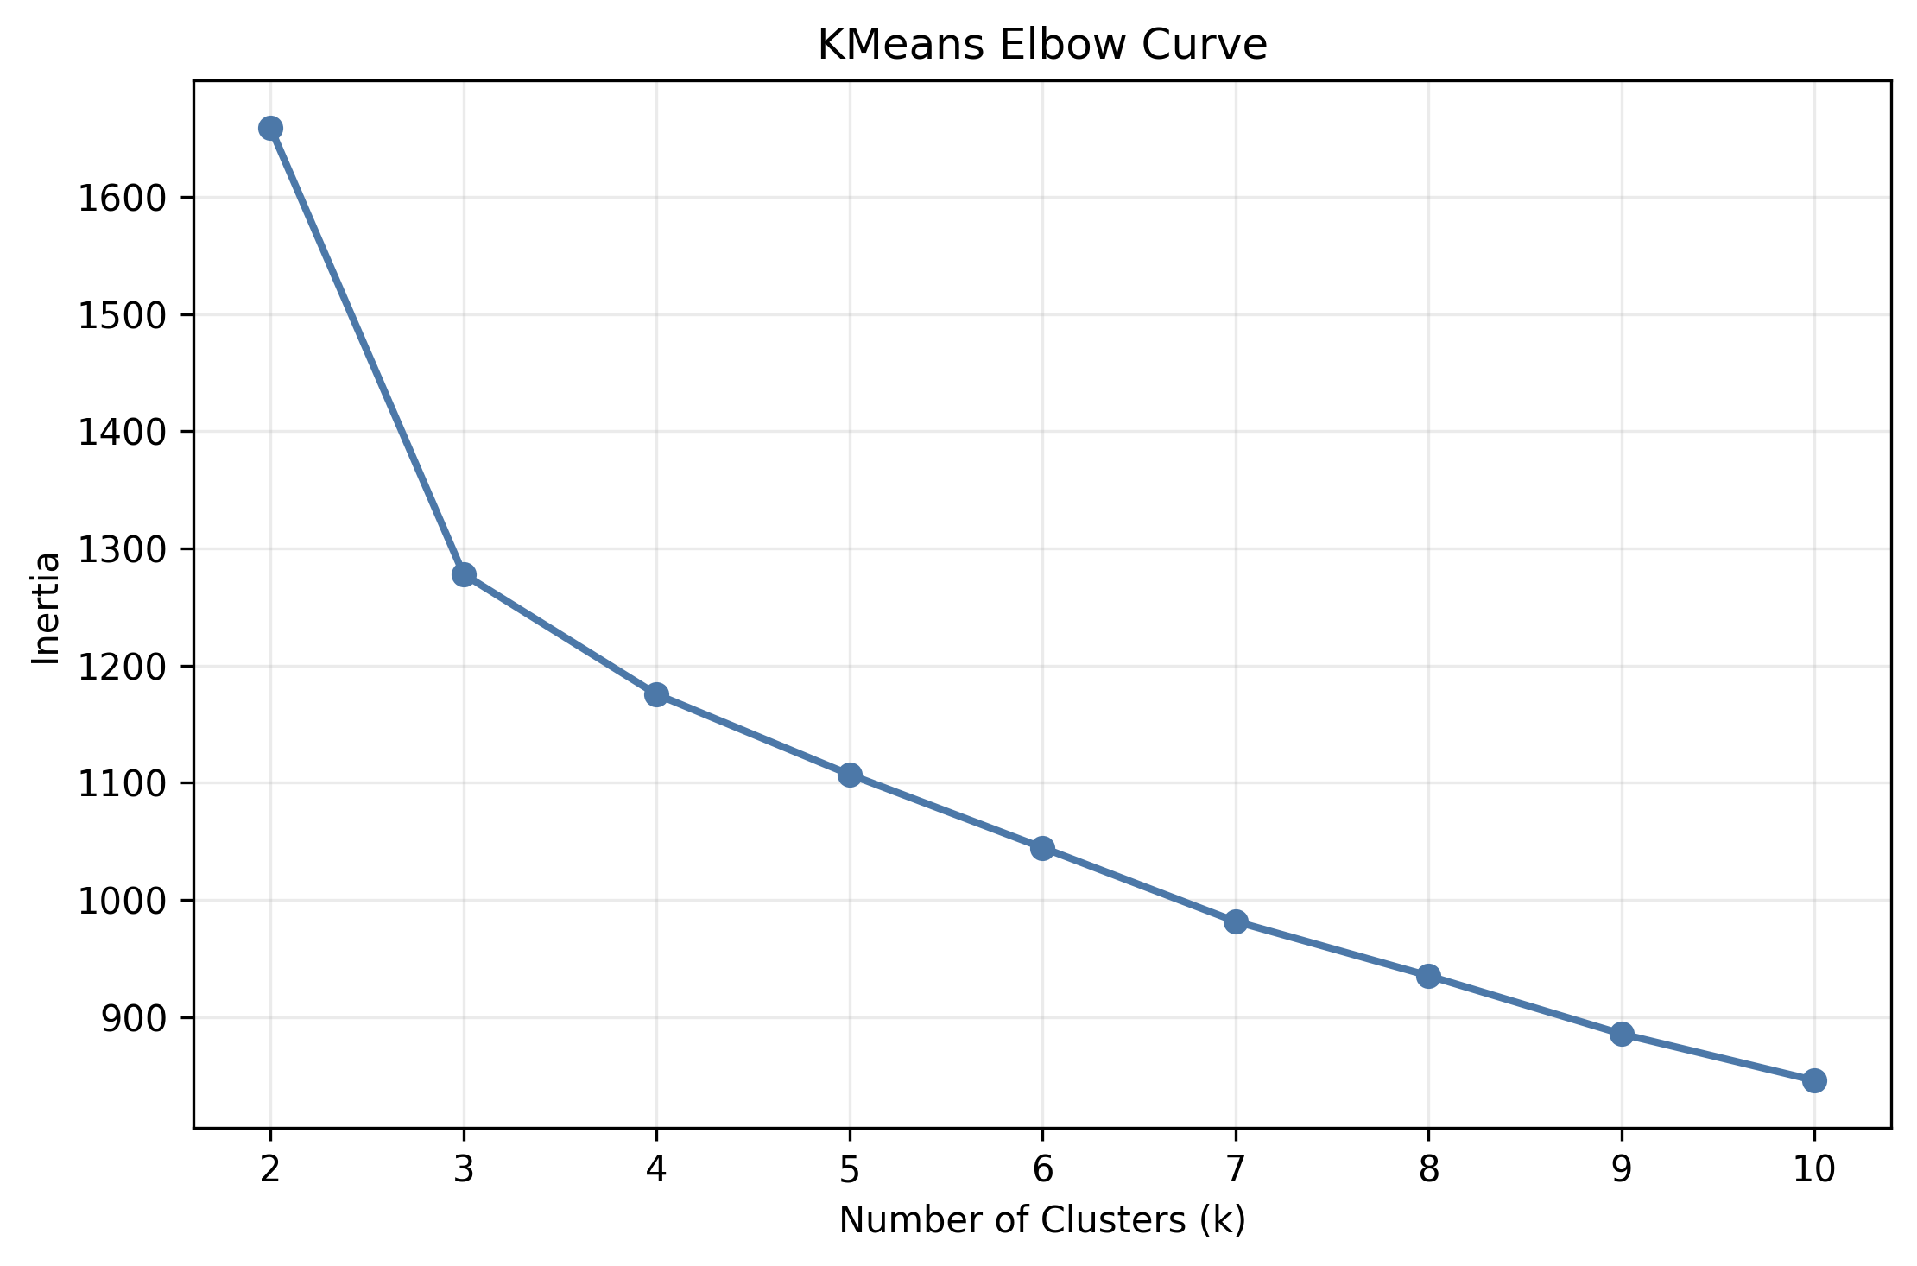

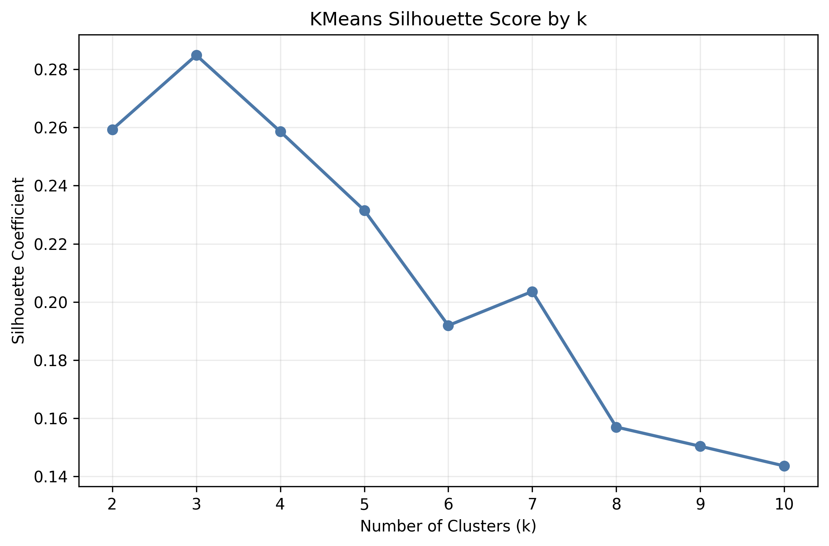

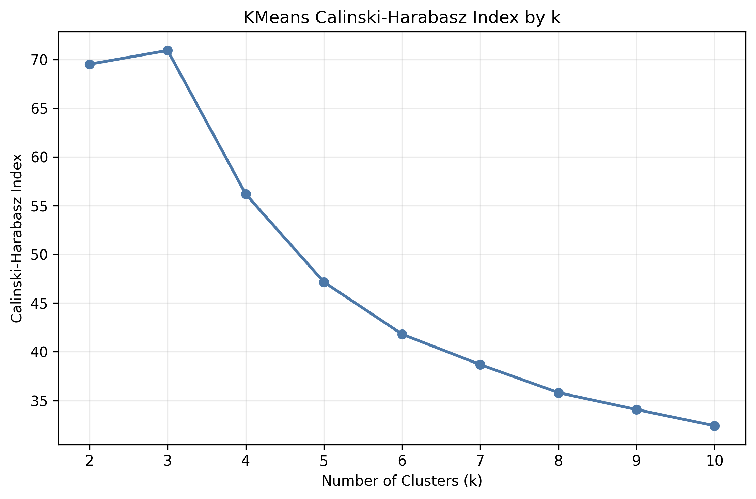

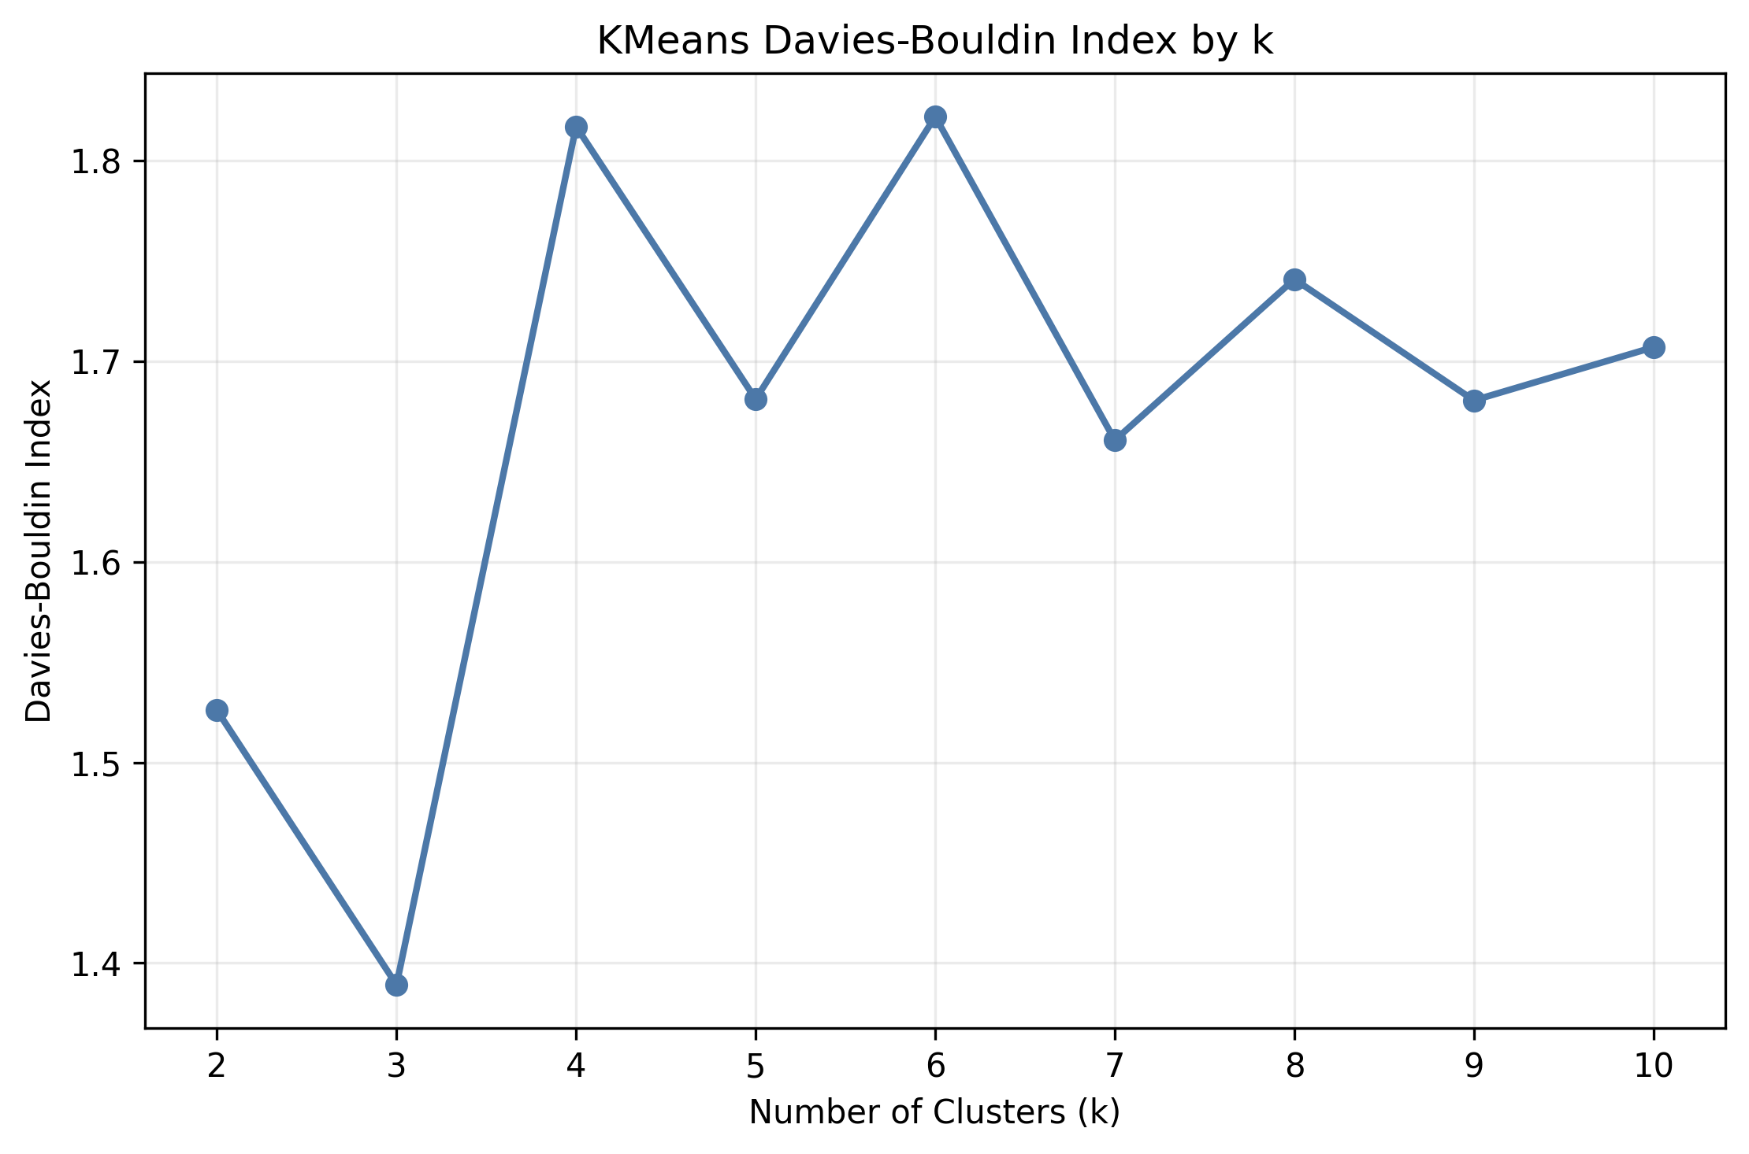

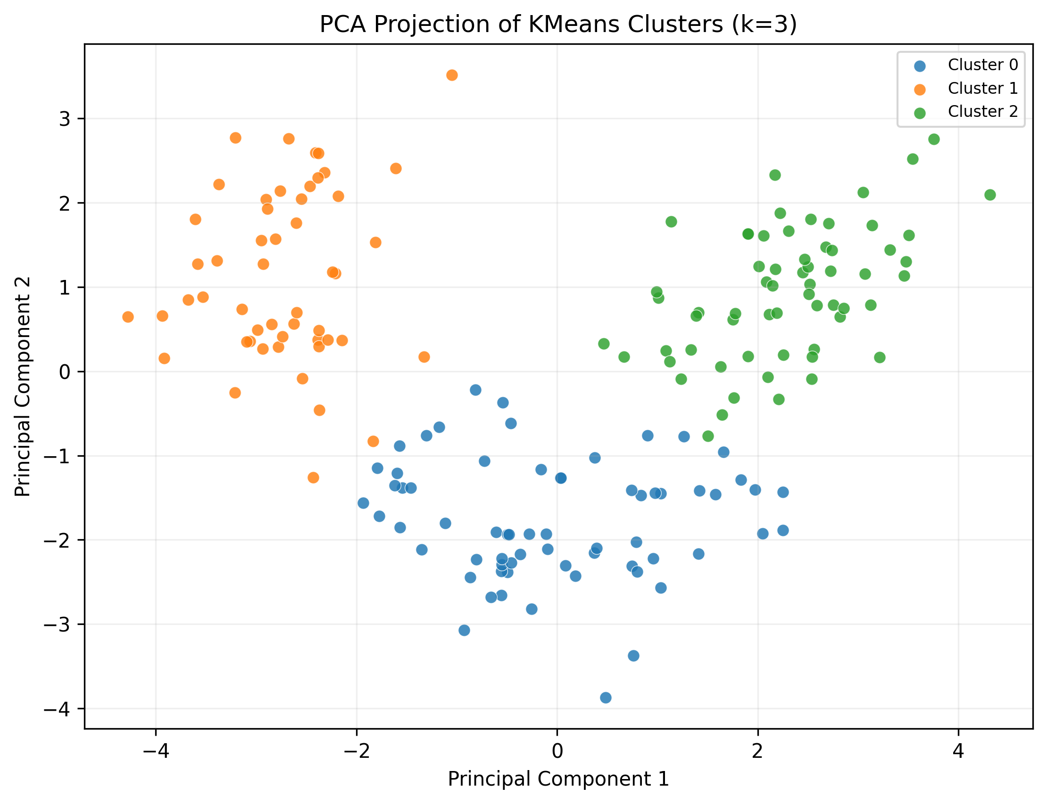

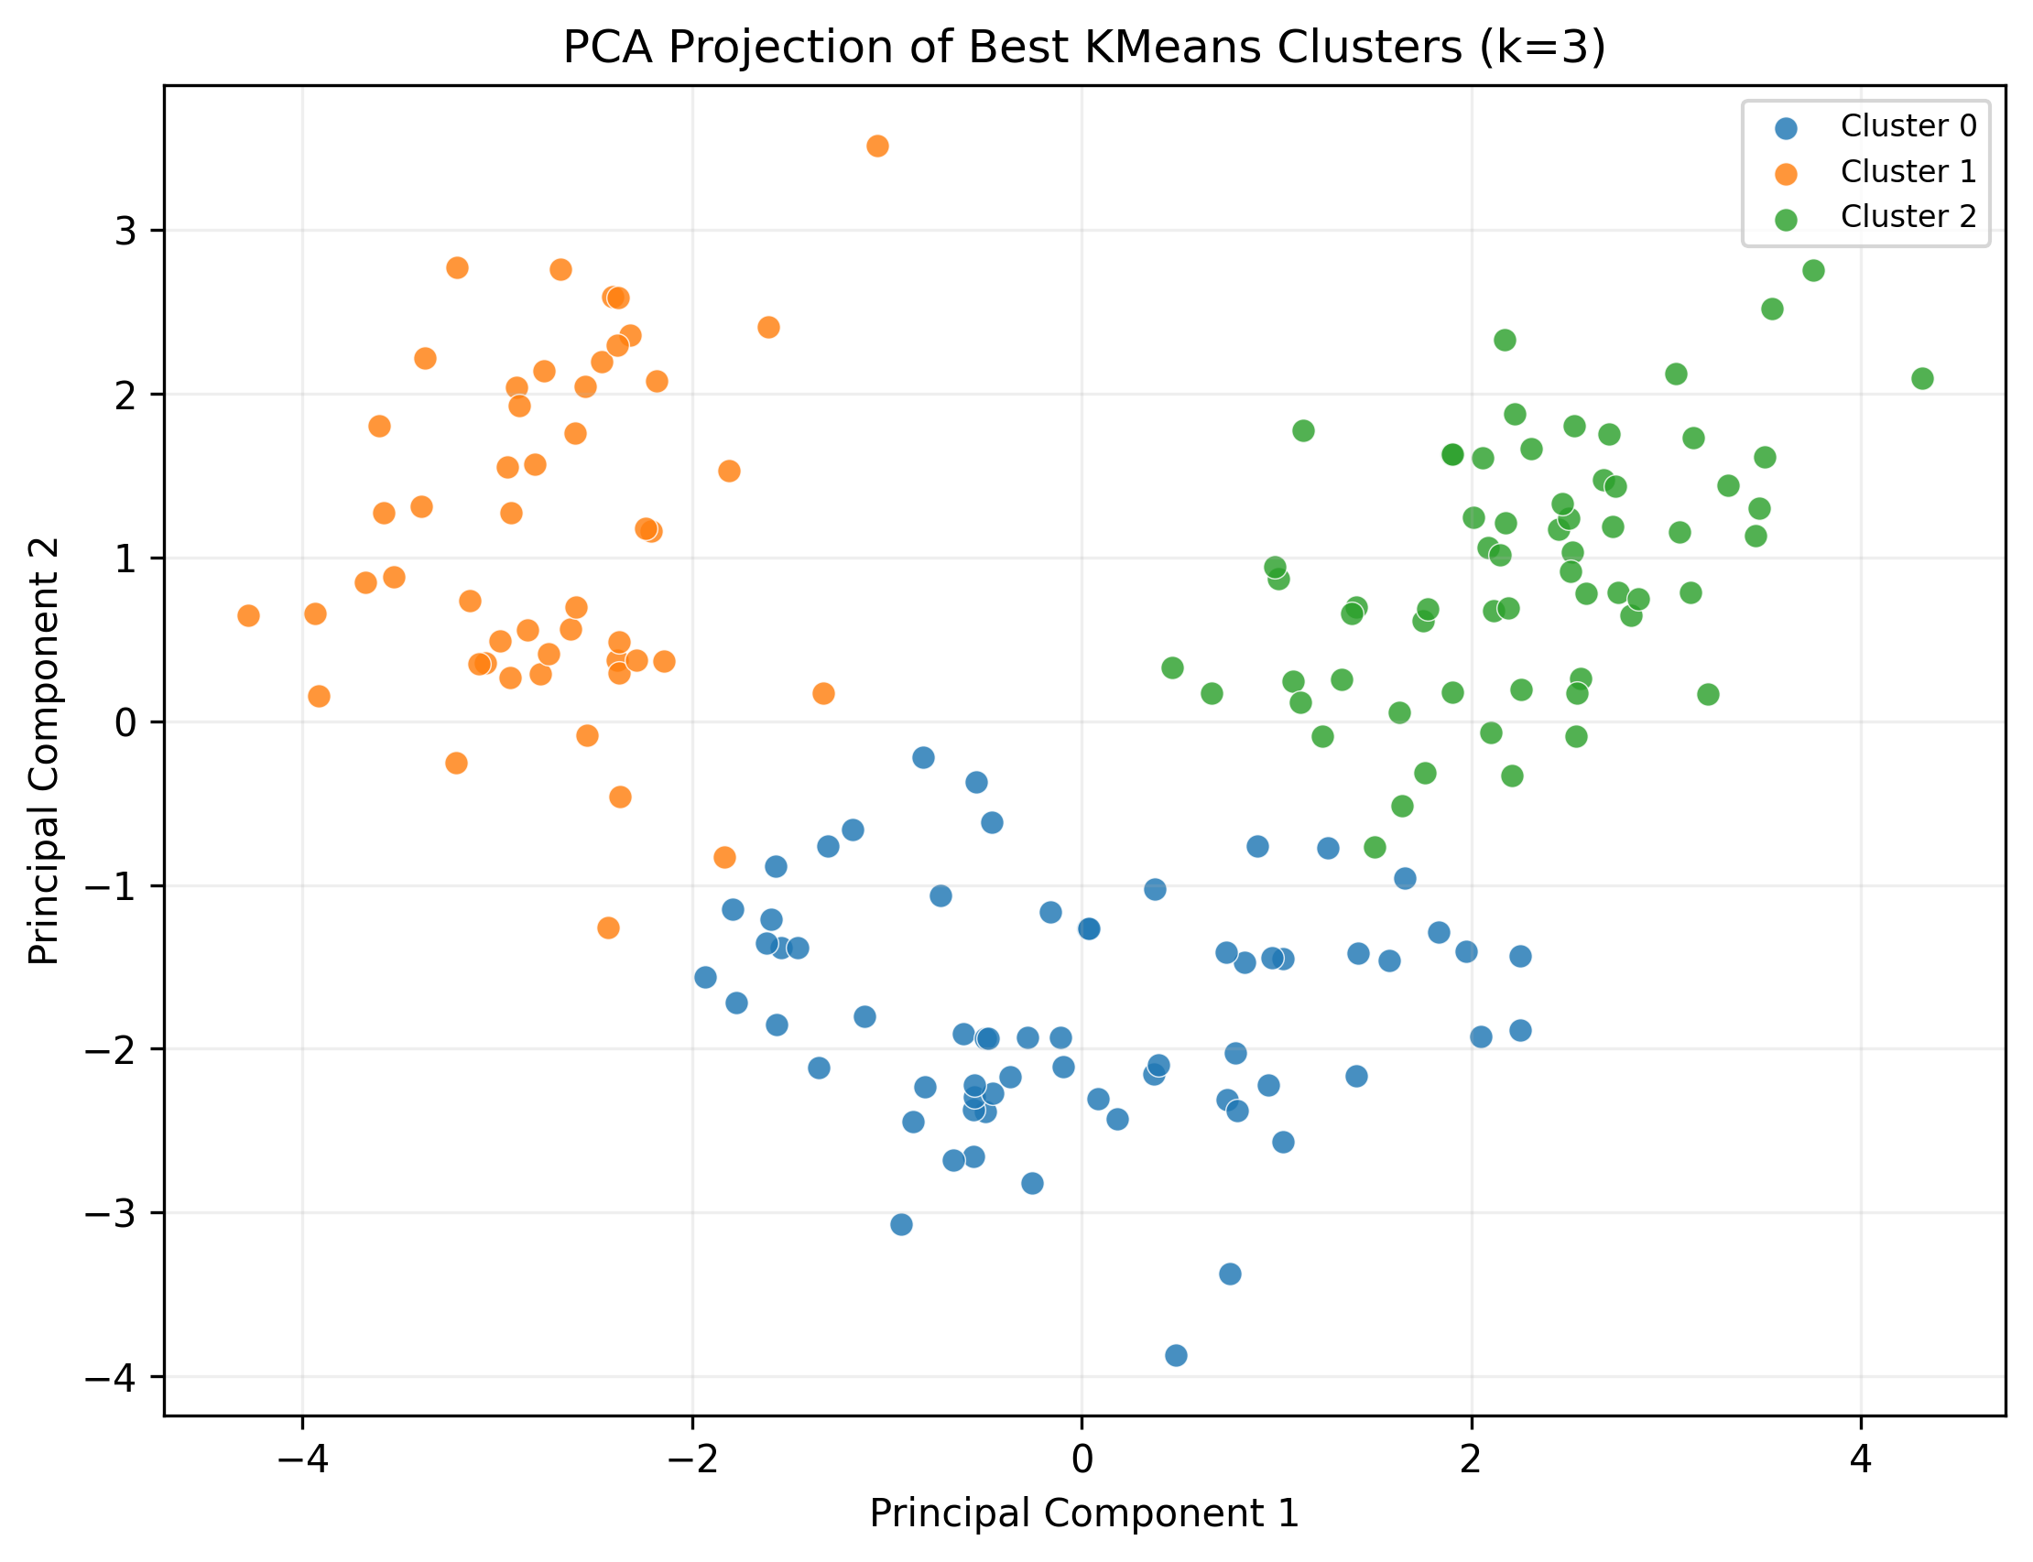

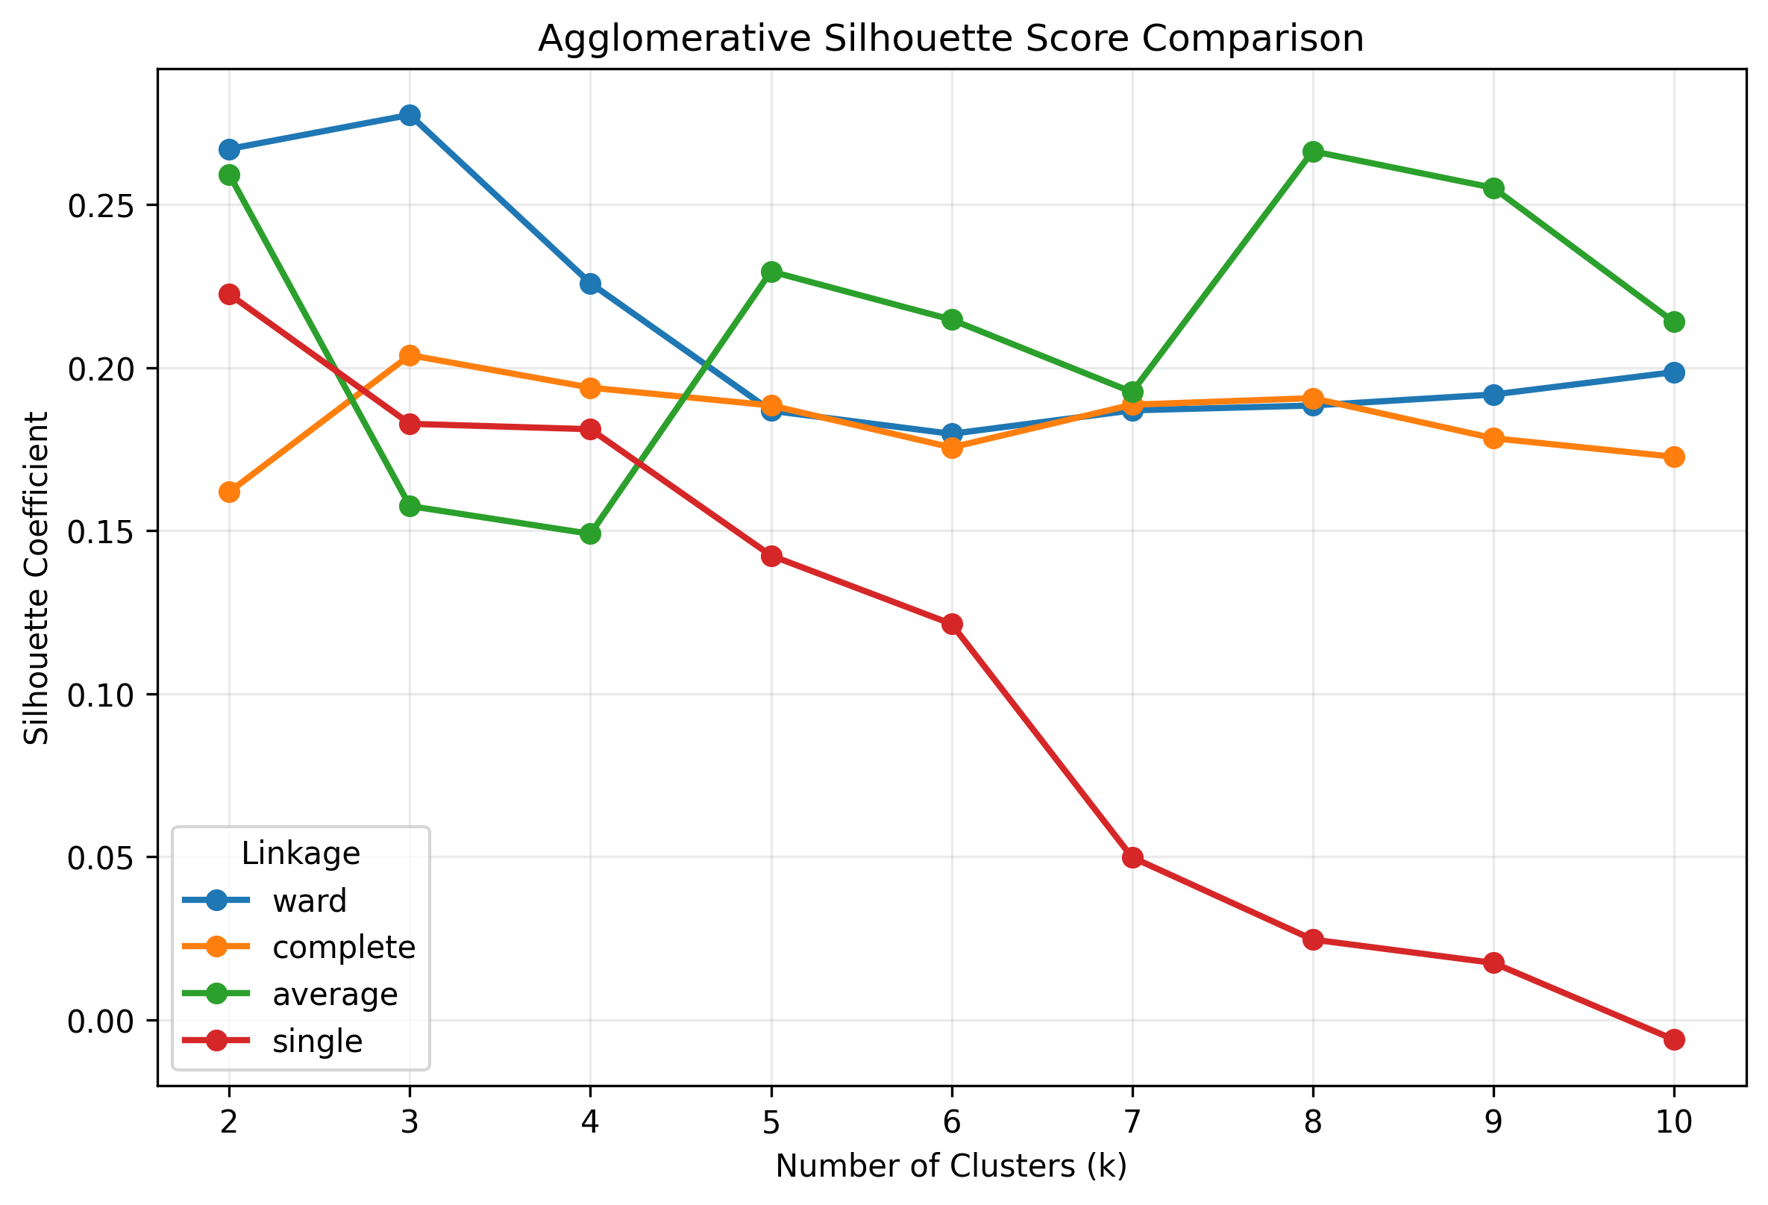

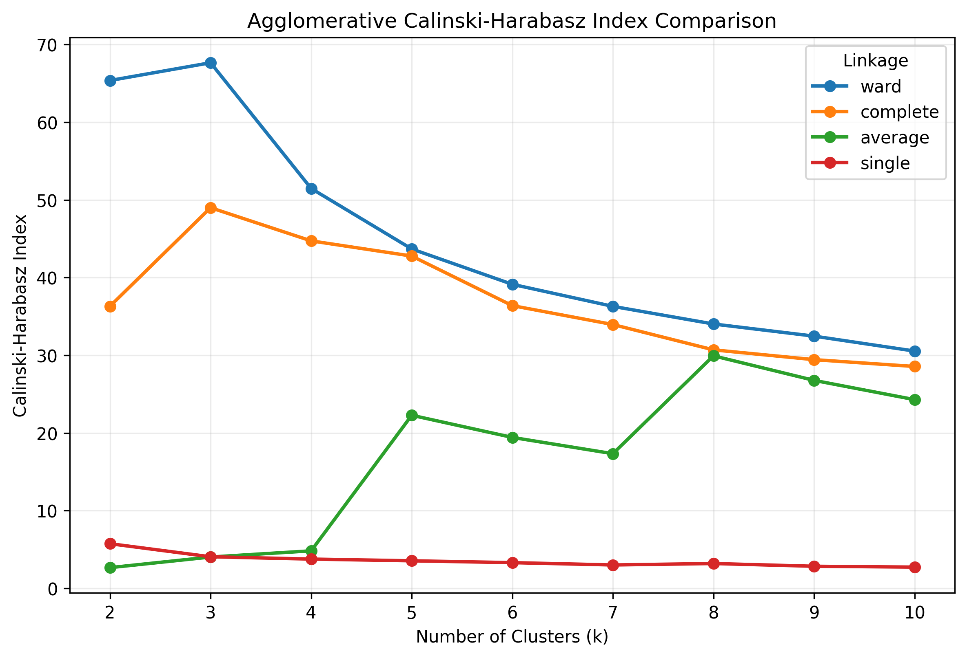

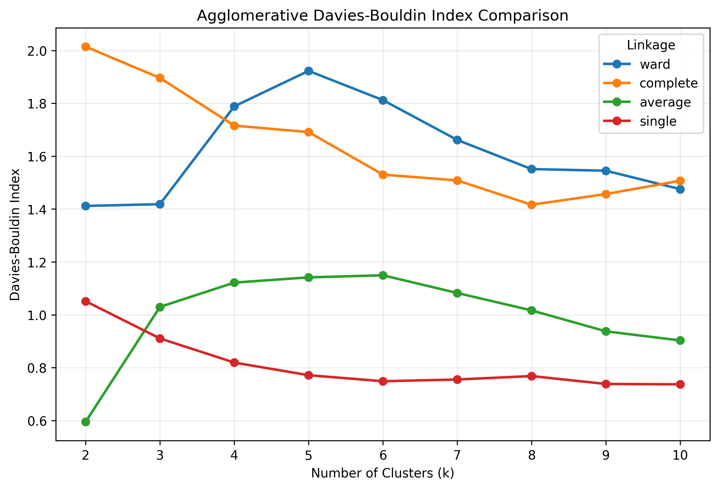

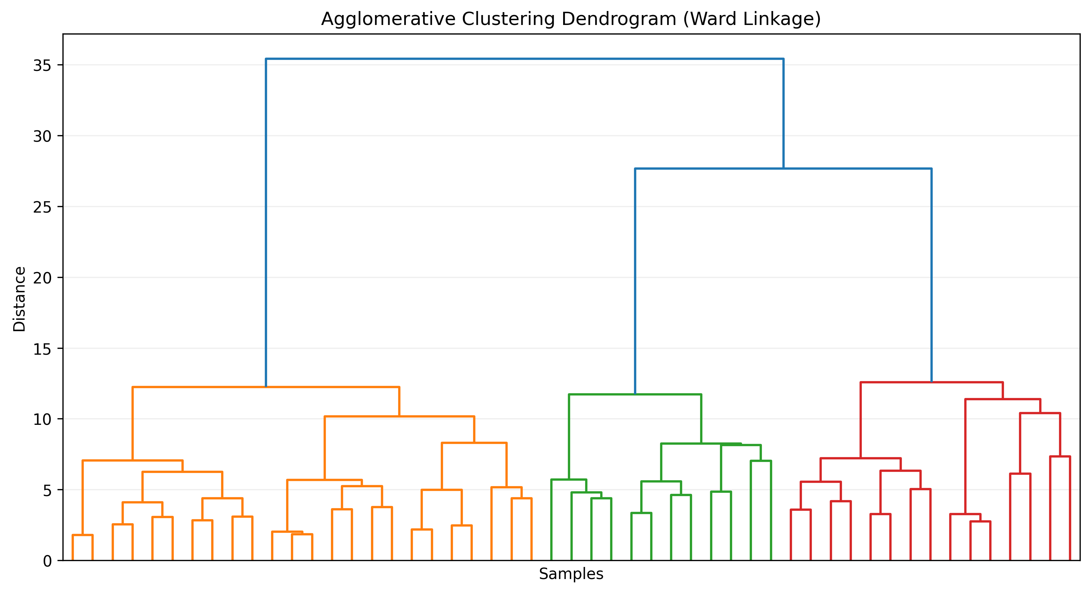

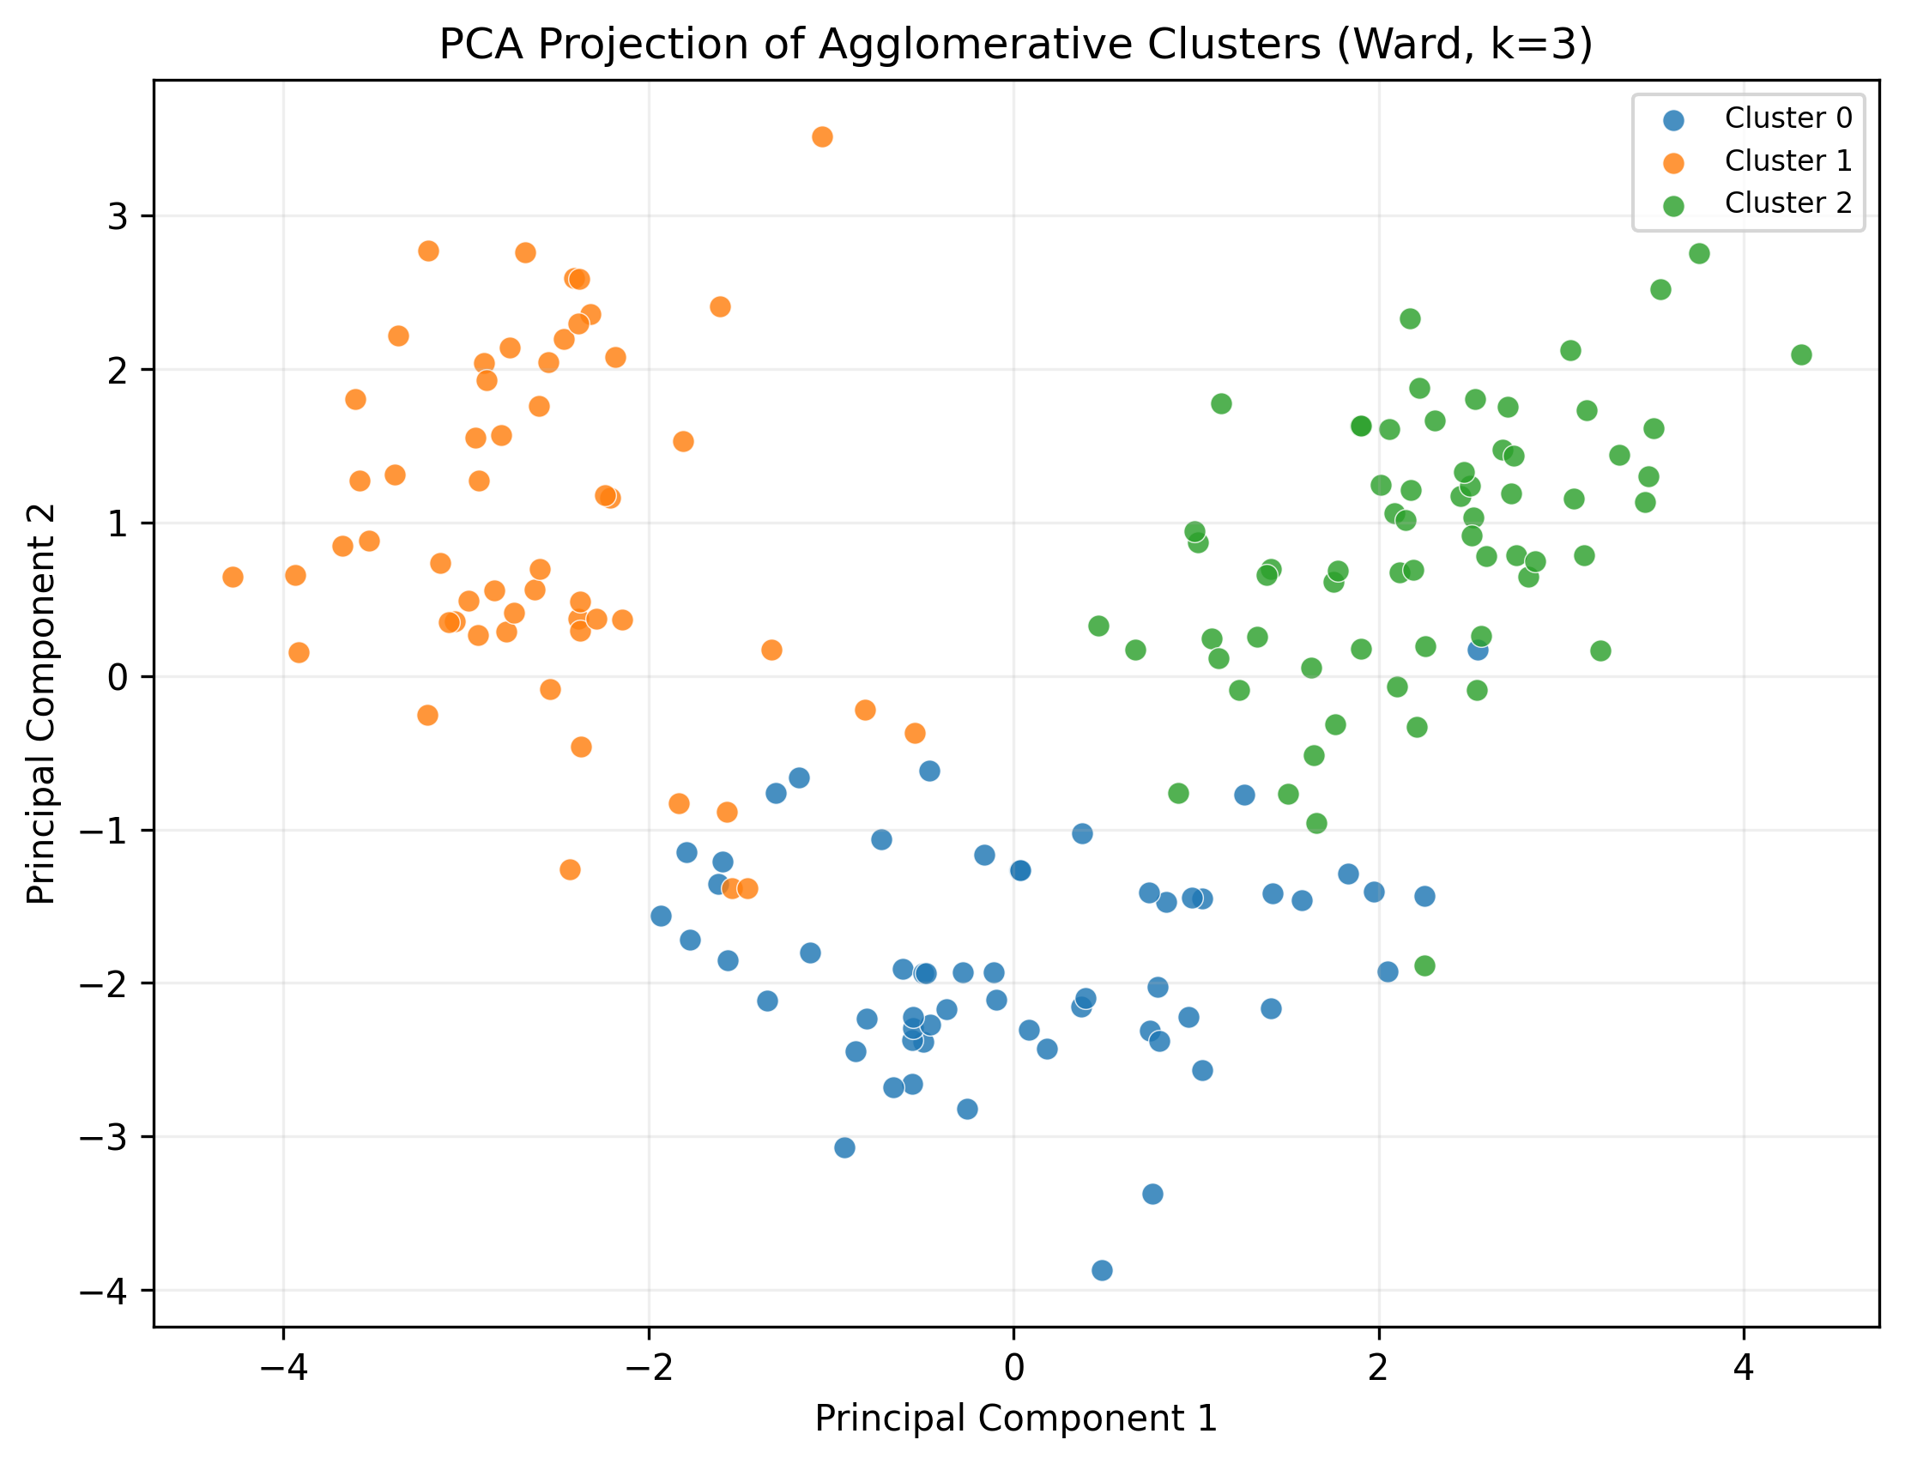

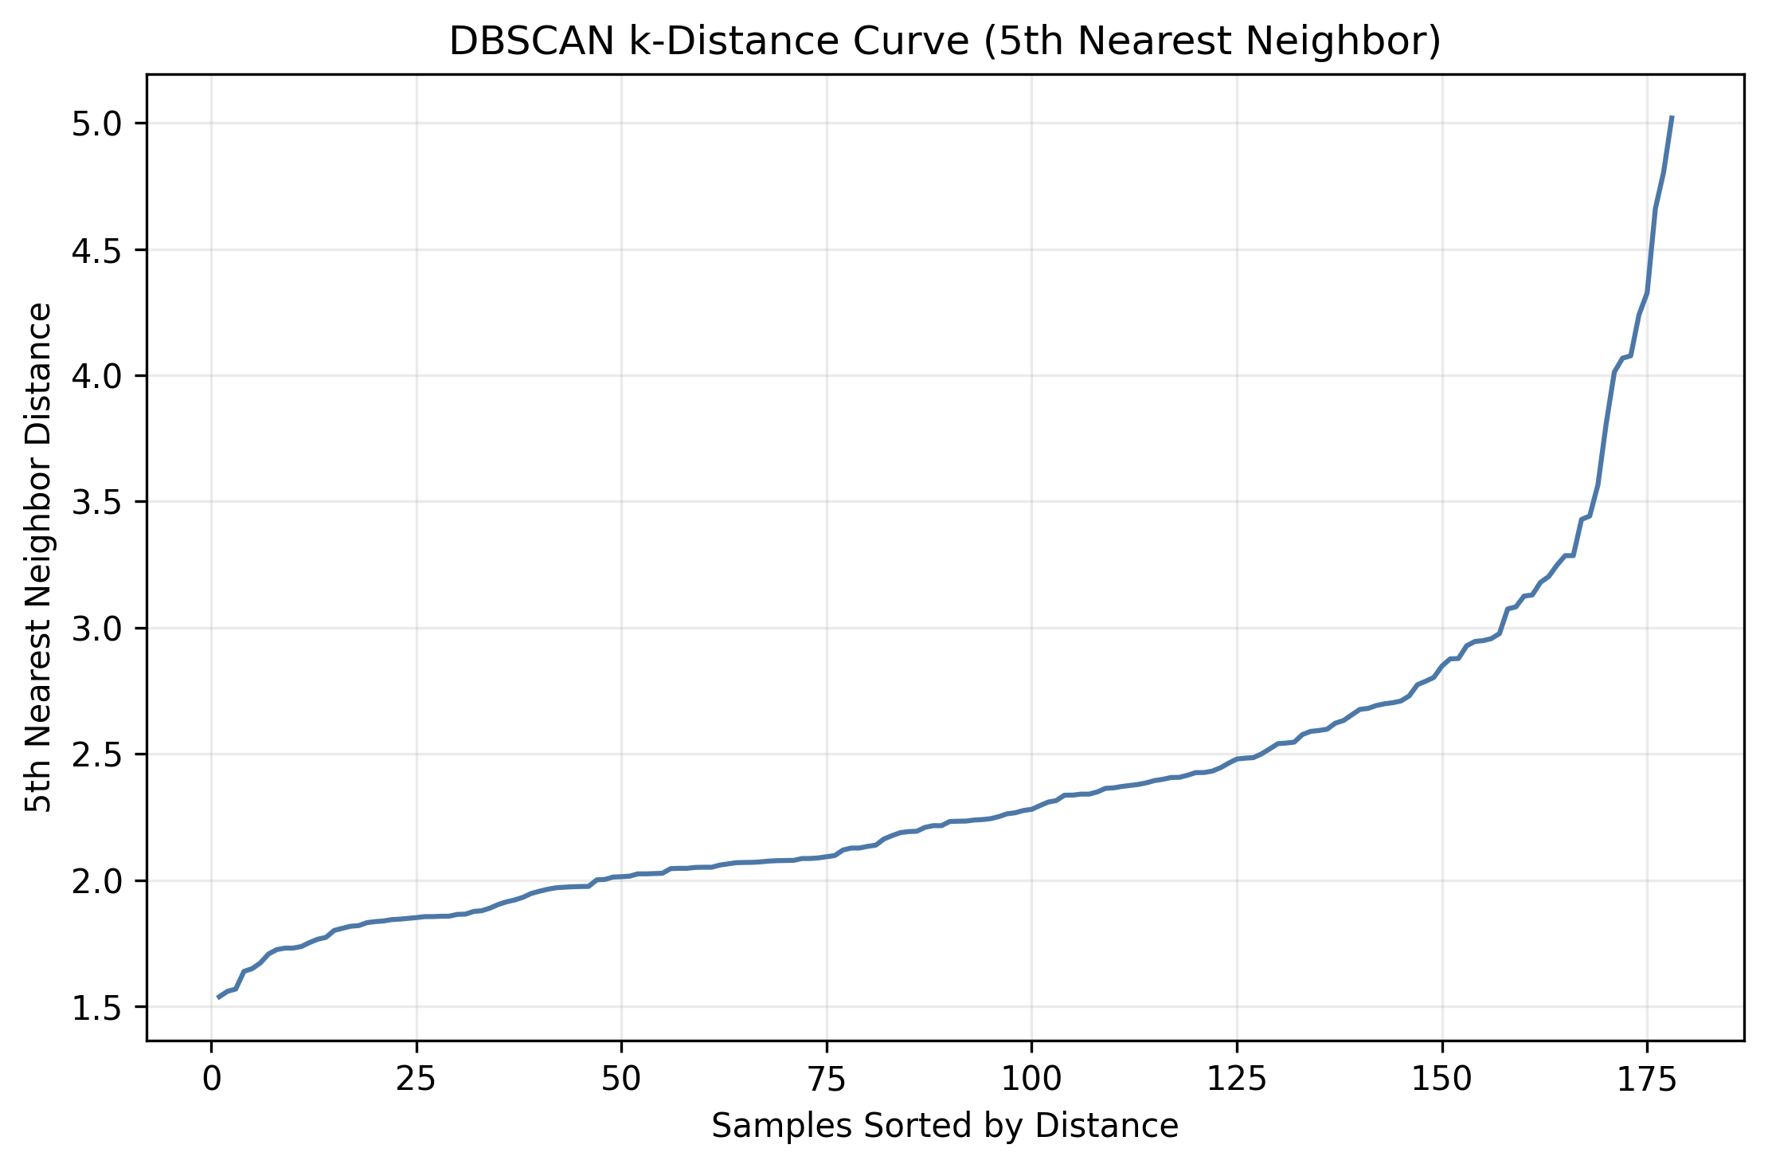

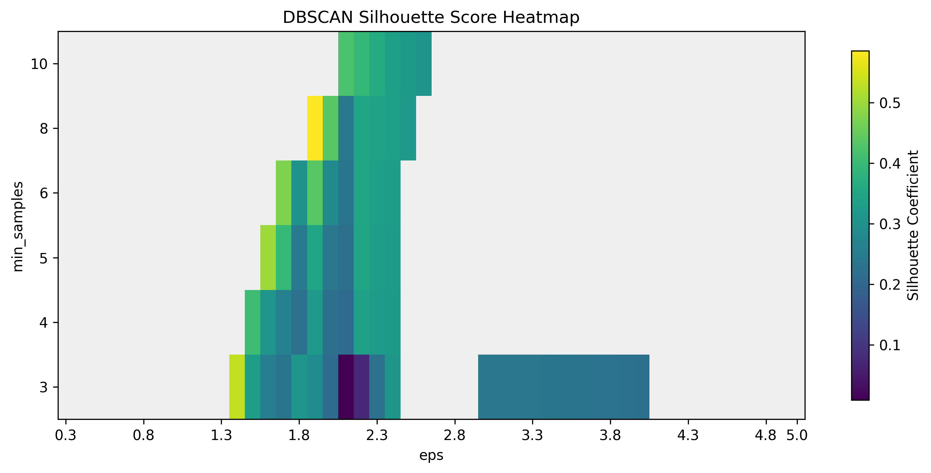

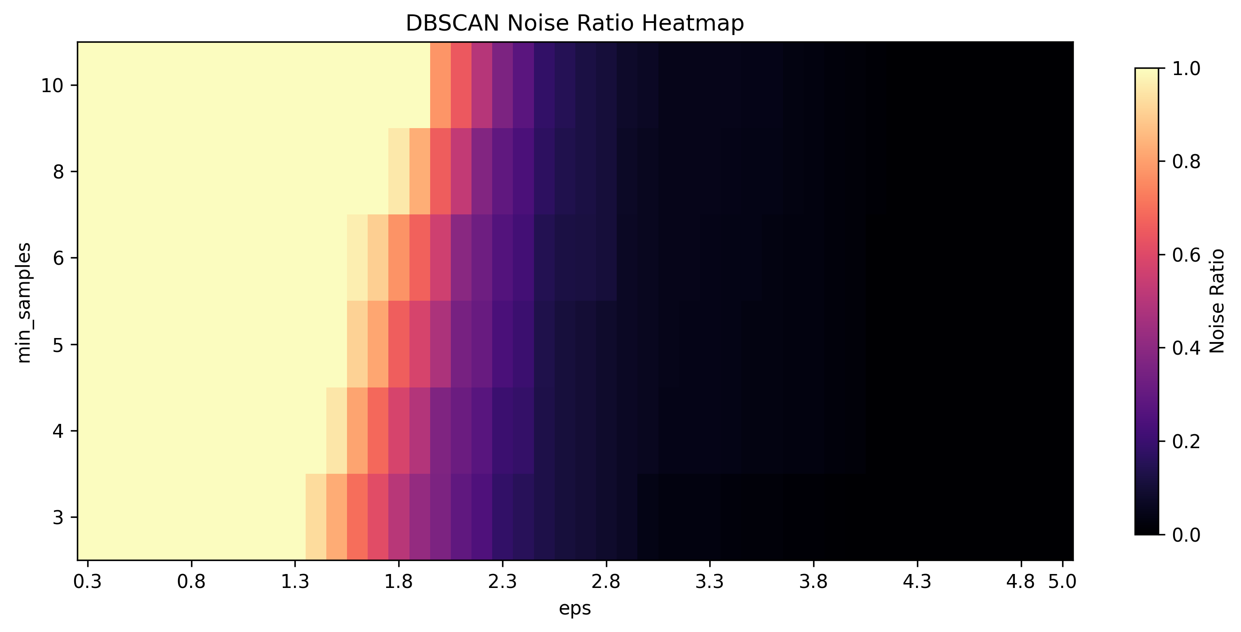

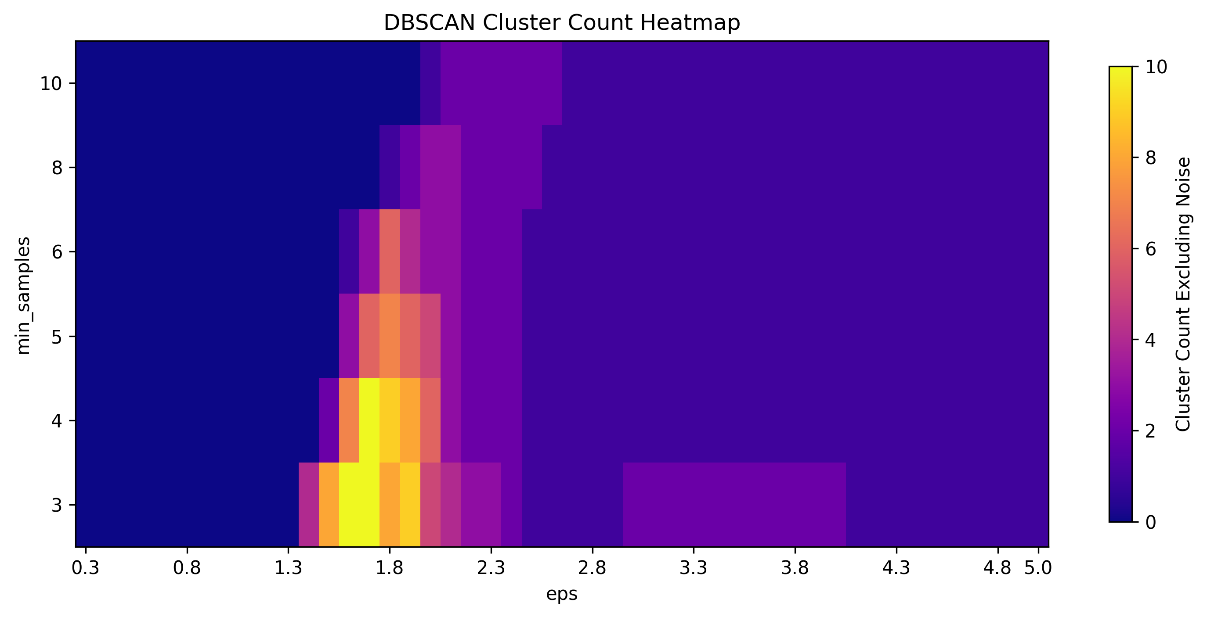

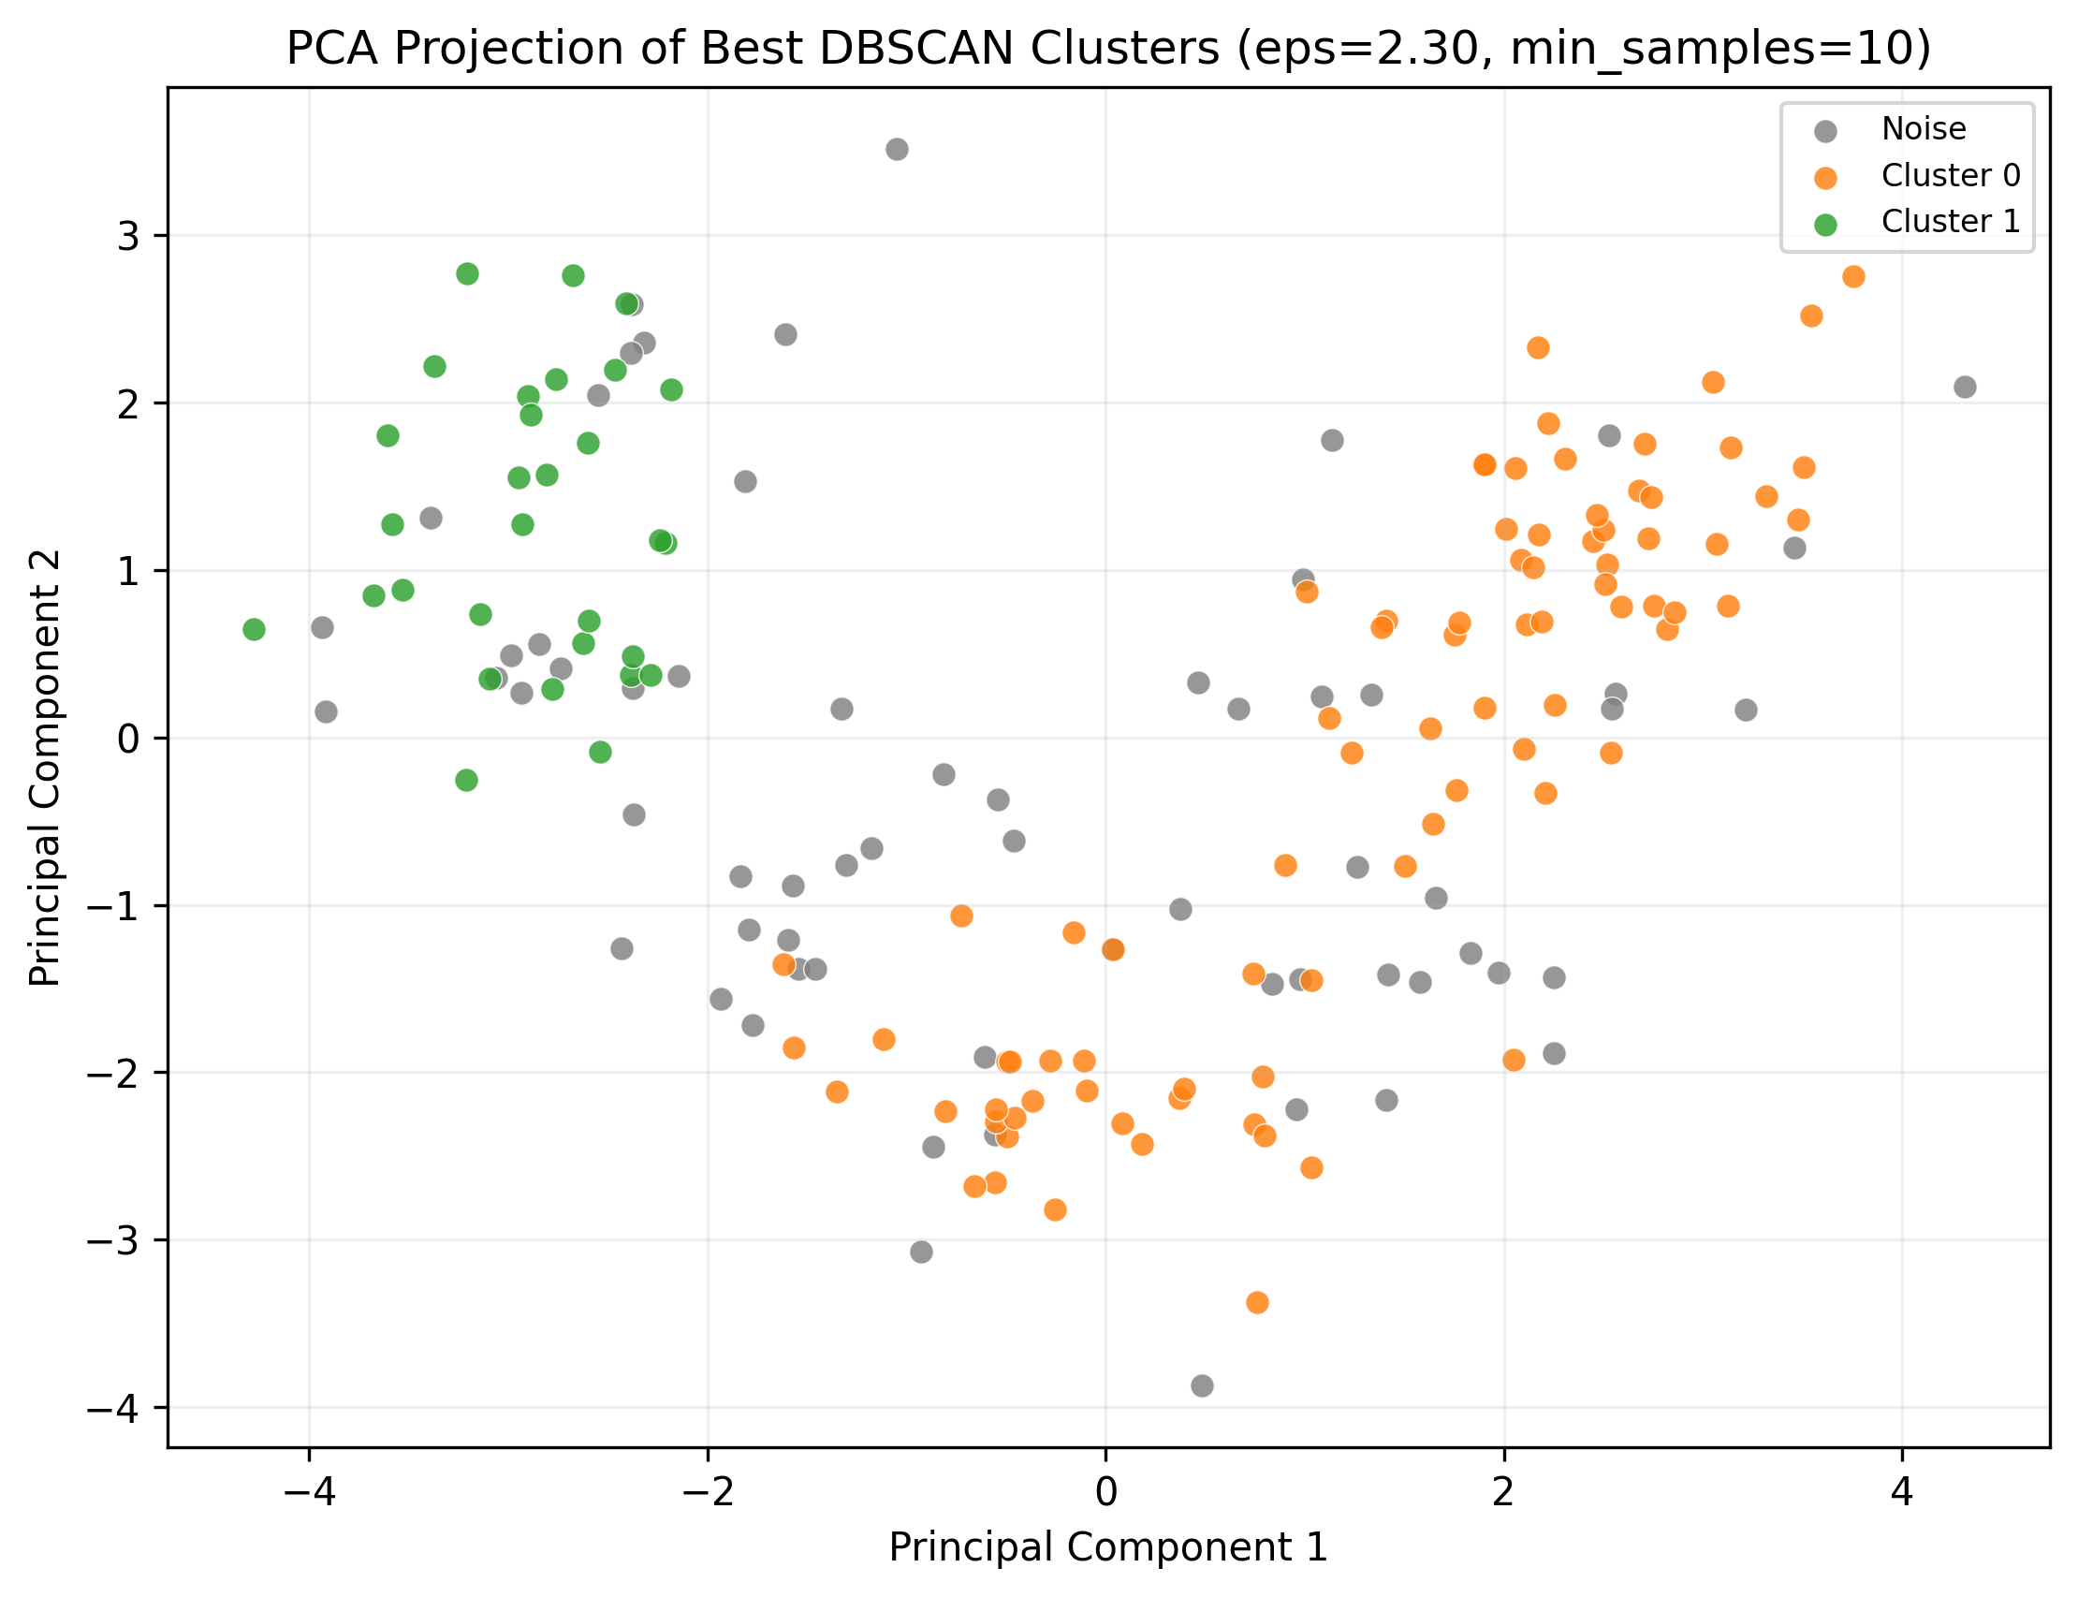

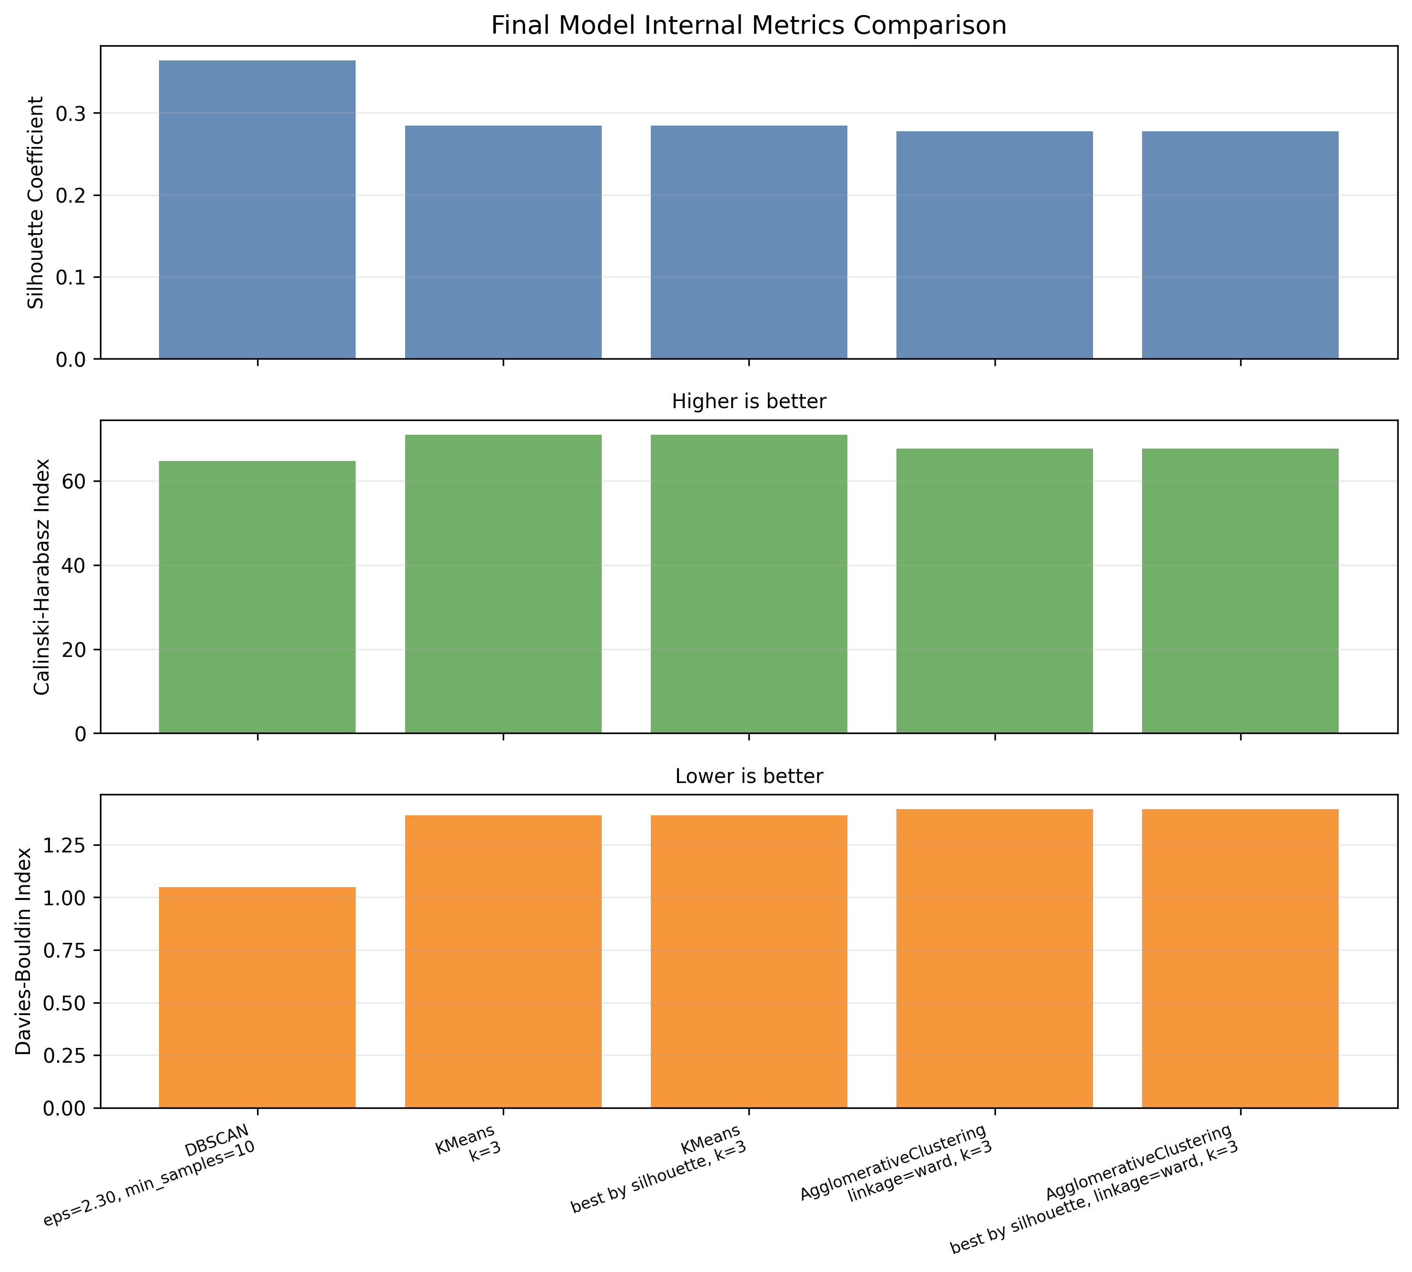

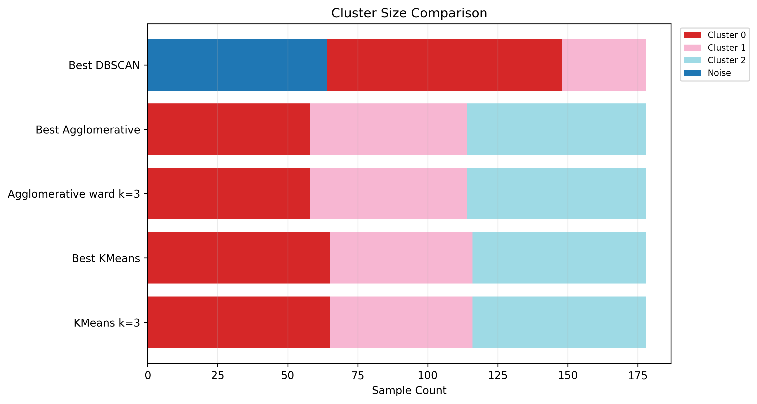

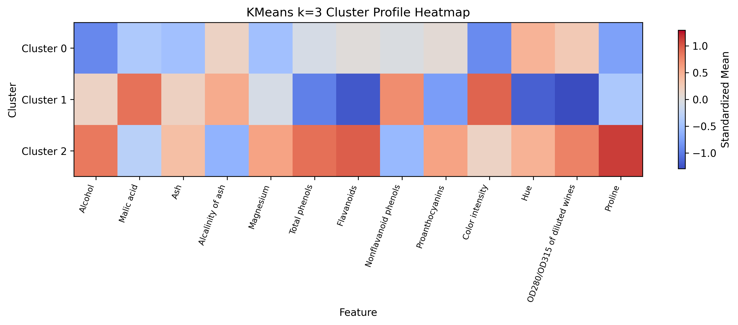

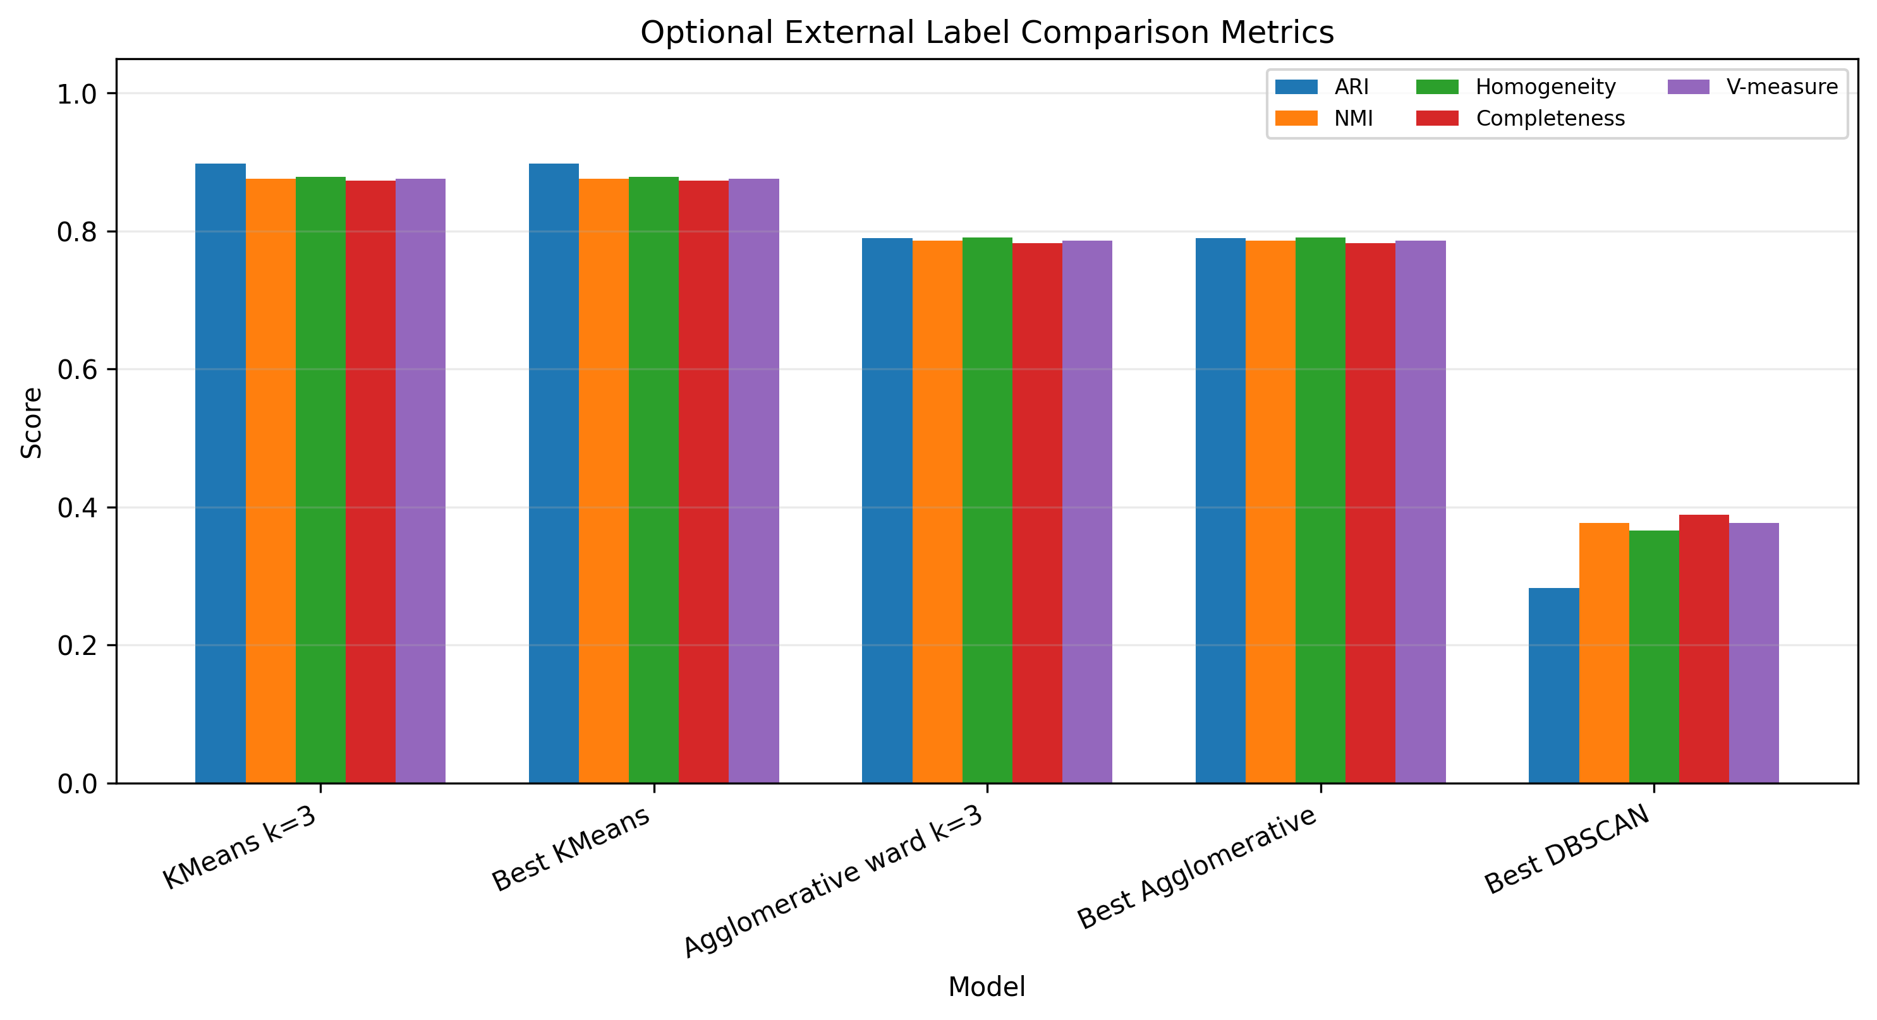
From the experimental results, the three clustering methods showed different characteristics on the wine dataset. Before clustering, the original class label was removed, and only the 13 wine chemical features were used as the input features. The dataset contained 178 samples and 13 features for clustering, so the experiment followed the requirement of using the wine data as an unsupervised clustering task instead of a classification task. The original class labels were only kept as optional reference information and were not used in model training, parameter selection, or main evaluation.

For KMeans, the result of k = 3 was the most suitable one for the main explanation. When k = 3, the model produced three clusters with sample sizes 65, 51, and 62. Its Silhouette Coefficient was 0.2849, the Calinski-Harabasz Index was 70.9400, and the Davies-Bouldin Index was 1.3892. Compared with other k values, k = 3 gave a clear and stable three-cluster structure, and every sample was assigned to one cluster. This made KMeans k = 3 easier to interpret in the report.

For AgglomerativeClustering, the final hierarchical model used ward linkage with k = 3. Its Silhouette Coefficient was 0.2774, the Calinski-Harabasz Index was 67.6475, and the Davies-Bouldin Index was 1.4186. These values were close to the KMeans k = 3 result, but slightly weaker in the main internal metrics. However, the hierarchical clustering result was still useful because it provided another way to understand the grouping process, especially with the dendrogram figure.

For DBSCAN, the best valid setting was eps = 2.30 and min_samples = 10. This setting produced 2 valid clusters and reached the highest internal metric performance among the final compared models, with Silhouette Coefficient = 0.3641, Calinski-Harabasz Index = 64.7414, and Davies-Bouldin Index = 1.0484. However, its noise ratio was about 35.96%, which means that many samples were treated as noise instead of being assigned to normal clusters. Therefore, although DBSCAN had strong internal metric values, it was less convenient for explaining all wine samples clearly.

The cluster profile analysis also supported the use of KMeans k = 3 as the main interpretation model. Cluster 0 was relatively high in Hue and OD280/OD315 of diluted wines, but relatively low in Alcohol, Color intensity, and Proline. Cluster 1 was relatively high in Color intensity, Malic acid, and Nonflavanoid phenols, but relatively low in OD280/OD315 of diluted wines, Flavanoids, and Hue. Cluster 2 was relatively high in Proline, Flavanoids, and Total phenols, but relatively low in Alcalinity of ash, Nonflavanoid phenols, and Malic acid. These feature differences made the cluster labels more meaningful, because they connected the abstract clustering results with real wine chemical characteristics.

Overall, the result shows that DBSCAN achieved the best internal metric scores under the selected parameter setting, but its high noise ratio made it less suitable as the main explanation model. KMeans k = 3 was more stable and easier to interpret because it produced three clear clusters and assigned every sample to a cluster. AgglomerativeClustering gave a similar three-cluster result and helped explain the hierarchical grouping process. Therefore, in this report, I treat DBSCAN as the best model from the internal metric perspective, but I use KMeans k = 3 as the main model for cluster interpretation. This conclusion also matches the nature of this experiment: the task is clustering, so the main evaluation is based on Silhouette Coefficient, Calinski-Harabasz Index, and Davies-Bouldin Index, not classification metrics such as accuracy, precision, recall, or F1-score.

5. Reflections on the Experiment
This experiment gave me a clearer understanding of the difference between classification and clustering. In the previous experiment, I mainly worked on supervised classification models, so I was used to thinking about a target label, training accuracy, validation accuracy, precision, recall, F1-score, ROC-AUC, and confusion matrices. However, in this experiment, the task was different. It was a clustering experiment, not a classification experiment. This difference seems simple in words, but when I actually wrote the code and prepared the report, I found that it affected almost every part of the workflow.

The first important lesson I learned was about the wine dataset itself. The file wine.data originally contains a class label in the first column, because the dataset was first designed as a classification dataset. At first, it was easy to think that this label might be useful, because it already tells us the original wine type. But Teacher Li Jie reminded us that for clustering, if the dataset has labels, the label should be removed directly before modeling. This point helped me understand the basic rule of unsupervised learning more clearly. In a clustering task, the model should discover groups from the feature patterns, not from the known answer.

Because of this, I paid special attention to the line of logic that saved the original label only as y_true_optional and then removed it from the feature matrix. The real clustering input was only the 13 wine chemical features, such as Alcohol, Malic acid, Ash, Magnesium, Flavanoids, Color intensity, Hue, and Proline. This step was very important because if I accidentally kept the class column in X, the clustering result might look good, but the experiment would be wrong in principle. The model would no longer be discovering hidden structure. It would be indirectly using the answer.

The second important lesson was about evaluation metrics. In the previous classification experiment, metrics such as accuracy, precision, recall, F1-score, ROC-AUC, PR-AUC, confusion matrix, and classification report were very useful. But this time, I learned that these classification metrics should not be written as the main evaluation metrics for a clustering experiment. This is one of the points Teacher Li Jie emphasized, and I think it is very important. A metric is not good just because it is familiar. It must match the type of task. Since clustering does not use the original class label during training, the main evaluation should not depend on classification-style prediction correctness.

Therefore, in this experiment, I used Silhouette Coefficient, Calinski-Harabasz Index, and Davies-Bouldin Index as the main clustering evaluation metrics. These metrics helped me evaluate whether the clusters were compact and well separated. This made me realize that clustering evaluation is more indirect than classification evaluation. In classification, I can compare predicted labels with true labels. But in clustering, I need to judge the structure of the data itself. This made the experiment more difficult than I first expected, because there was no single “correct answer” that could simply decide the best model.

Another thing I learned was the importance of standardization. Before running the clustering models, I used StandardScaler on the 13 wine features. This step was necessary because the features had very different value ranges. For example, Proline has a much larger numerical scale than many other chemical features. If I used the raw data directly, the distance calculation might be dominated by large-scale features, and the clustering result could become biased. Through this step, I understood more clearly that preprocessing is not only needed in classification. It is also very important in clustering, especially for distance-based methods.

The three clustering methods also gave me different impressions. KMeans was the easiest model to understand and explain. It belongs to Partition-based Clustering, and it divides samples into a fixed number of clusters. In my experiment, KMeans with k = 3 gave a clear and stable result, and it assigned every sample to a cluster. Because the wine dataset naturally has a three-class background, KMeans k = 3 was very suitable for the main interpretation, although the original class label was not used during training. This helped me understand that prior knowledge can guide explanation, but it should not be used as input for unsupervised modeling.

DBSCAN gave me a different feeling. It belongs to Density-Based Clustering, and it can find dense regions while marking some samples as noise. In my result, the best DBSCAN setting had strong internal metric values, but the noise ratio was about 35.96%. This means that a relatively large part of the wine samples were treated as noise instead of being assigned to normal clusters. At first, I wanted to simply choose the model with the best metric value. But after checking the noise ratio, I realized that the highest metric score does not always mean the model is the most suitable for explanation. DBSCAN was useful as a density-based comparison model, but for writing a clear report and explaining all samples, KMeans k = 3 was more stable and easier to understand.

AgglomerativeClustering helped me understand Hierarchical Clustering better. Different from KMeans, it does not directly start from fixed cluster centers. Instead, it builds clusters step by step by merging similar samples. The dendrogram figure made this process more visual. I could see that hierarchical clustering is not only about the final cluster labels, but also about the merging process behind them. This made me feel that different clustering models are not just different sklearn function names. They represent different assumptions about how data points should be grouped.

Teacher Li Jie’s class helped me a lot in this experiment. What impressed me most was that she did not only ask us to run code. She also emphasized the meaning behind the model and the correct experimental logic. For this experiment, the most important logic was that wine is a labeled dataset, but clustering must remove the label first. Another important logic was that classification metrics should not be mixed into the main evaluation of clustering. These two reminders helped me avoid writing the report in the wrong direction. I felt that I benefited a lot from her course, because it trained me to think about whether the experiment design is correct, not only whether the program can run.

This experiment also made me more careful about the role of optional external comparison. Since the original wine dataset has class labels, I could still compare the final cluster results with the original labels after clustering. Metrics such as ARI, NMI, homogeneity, completeness, v-measure, and the class-cluster crosstab were useful for checking whether the discovered clusters were similar to the original classes. However, I learned that these results should only be treated as optional references. They cannot be used as the main evaluation or as the basis for training and parameter selection. This distinction helped me understand how to use labels carefully in a clustering experiment without breaking the unsupervised setting.

The figures also helped me understand the results more clearly. The KMeans elbow curve and silhouette curve helped me observe how the number of clusters influenced the result. The PCA cluster scatter plots made the clustering structure easier to see. The DBSCAN heatmaps showed that DBSCAN was sensitive to eps and min_samples. The dendrogram helped me understand the hierarchical merging process. The final model metrics comparison and cluster profile heatmap made the final analysis easier to explain. Through these figures, I felt that visualization is especially important in clustering, because clustering results are not as straightforward as classification accuracy.

From the coding side, this experiment also improved my sense of reproducibility. I saved the numerical outputs into the results folder and saved the figures into the figures folder. I also made sure that final_cluster_assignments.csv did not contain the original class label, because the main clustering output should only include sample ids and cluster assignments. The original labels were only saved in optional comparison files. This file organization made the experiment cleaner and easier to check. It also helped me understand that a good experiment should not only produce a result, but also keep the result traceable and explainable.

Compared with the previous classification experiment, this experiment made me think more about the relationship between data, model, and evaluation. In classification, the target label defines the learning goal directly. In clustering, the goal is less direct, so I need to be more careful when interpreting the result. A cluster label like 0, 1, or 2 does not have an original meaning by itself. I need to look at the feature profiles of each cluster to understand what makes one cluster different from another. This made the cluster profile analysis very useful, because it connected the abstract cluster numbers back to real wine chemical features.

Overall, this experiment helped me understand that clustering is not just “classification without labels.” It has its own logic, its own evaluation methods, and its own difficulties. The two points I will remember most are: first, when doing clustering on a labeled dataset like wine, the class label must be removed before modeling; second, classification metrics such as accuracy, precision, recall, F1-score, ROC-AUC, confusion matrix, and classification report should not be used as the main evaluation metrics for clustering. These two points may look small, but they decide whether the whole experiment is correct.

In conclusion, Experiment 4 made me more familiar with Partition-based Clustering, Density-Based Clustering, and Hierarchical Clustering. It also helped me understand the practical differences between KMeans, DBSCAN, and AgglomerativeClustering. More importantly, it taught me that a meaningful machine learning experiment should match the model, data, and metrics correctly. For me, the biggest gain from this experiment was not only learning how to run three clustering algorithms, but also learning how to keep the experimental logic clear. This is why I think Teacher Li Jie’s course was very helpful: it made me pay attention to the reasoning behind the workflow, and it helped me build a more careful attitude toward data analysis and machine learning experiments.

Grade:

Reviewed by: --------

Date: --------

