* * * * * * * * * * * 学 号： 姓 名： * * * * * * * * * * * * * * * * * * * * * * * * * * * * * * * * * * * * * * * * * * * * 学 院： 专业年级： * * * * * * * * * * * * * * * * * * * * * * * * * * * * * * * * * * * * * * * * * * * * * * * * * * * * * * * * * *
The paper of course exam

Name： | Big Data Analysis and Applications
Content： | Course Report （Class assignments、thesis、report ）
Institution： |  | Teacher： | Li Jie
Grade and major：

Teacher’s comments | Total score | Grading teacher

…………………………………………………………………………………………………

Digital Lifestyle Analysis: High-Risk Screening, Digital Dependence Prediction, and Lifestyle Profile Clustering

1. Analysis Goals and Tasks
This report follows the workflow required by the course: define the analysis goal, introduce the dataset, clean and transform the data, conduct statistical visualization, train and evaluate machine learning models, and finally interpret the results. The main purpose is not to claim that every model is perfect. The purpose is to make each step explainable and supported by data evidence.

1.1 Background
Digital lifestyle data combine device use, notifications, social media time, sleep, study, and activity records. These variables provide a practical setting for studying whether behavior patterns are associated with High Risk labels, digital dependence scores, and exploratory lifestyle profiles.

1.2 Key Questions
Can High Risk samples be screened from behavior and lifestyle variables?
Can digital_dependence_score be predicted more reliably than productivity_score?
Can continuous behavior features be summarized into readable lifestyle profiles?

1.3 Analysis Tasks
The report uses three machine learning tasks: classification for high_risk_flag, regression for digital_dependence_score and productivity_score, and clustering for lifestyle profiling. The same preprocessing pipeline is used to keep the analysis coherent across tasks.

2. Dataset and Task Support

2.1 Dataset Source
The selected dataset is the 2025 Digital Lifestyle Benchmark Dataset. It contains 3,500 rows and 24 original fields in CSV format. The dataset is a benchmark or educational dataset, so the results should be interpreted as course-level analysis rather than real individual assessment.

2.2 Raw Data Preview
Table1 is used to confirm that the report starts from the raw CSV rather than from a pre-summarized result table.
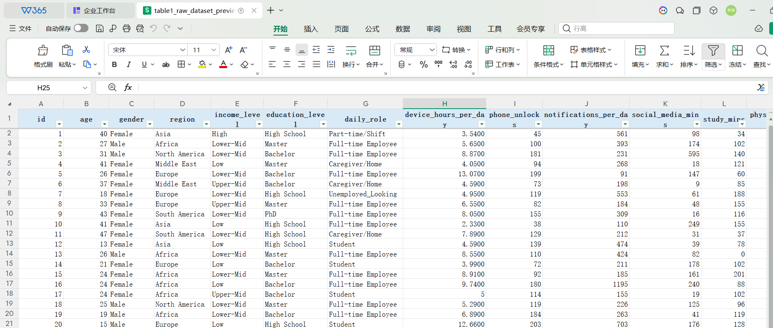
Table1 Raw Dataset Preview
The key point is that this is an individual-level raw table, not a pre-summarized result table. Table1 confirms that each row combines digital behavior fields, lifestyle fields, and outcome-style variables in the same record. This structure matters because it allows one coherent workflow to support High Risk classification, digital-dependence regression, productivity weak-prediction checking, and lifestyle clustering.

2.3 Field Structure
Table2 lists every original field with its type and role, which makes the later leakage-control decision traceable.
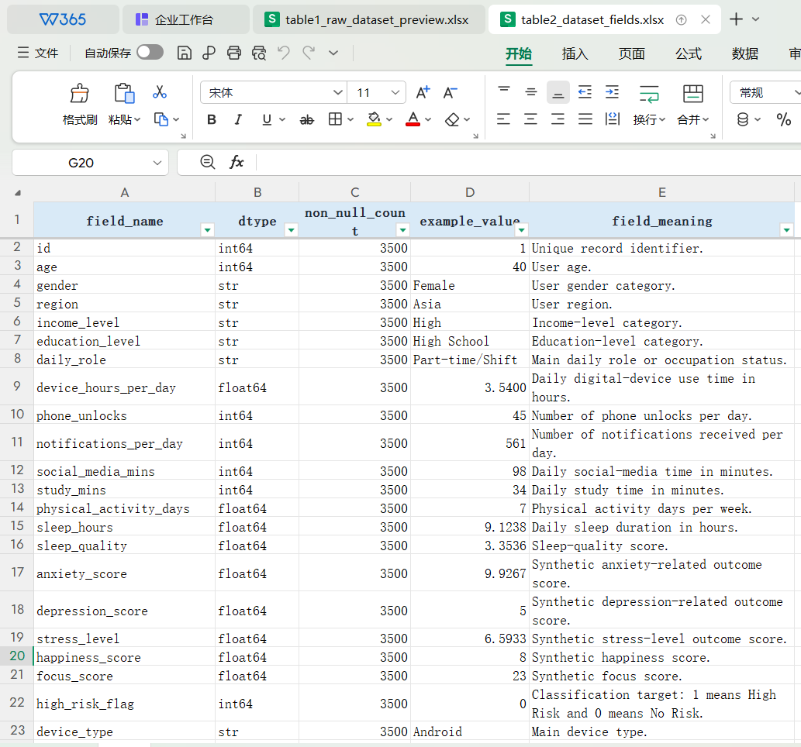
Table2 Dataset Fields
The key point is that target-like fields must be separated from ordinary inputs before modeling. Table2 clarifies the role of every original field. high_risk_flag, digital_dependence_score, and productivity_score define or describe outcomes, so they should not be blindly mixed into every task. This role separation supports leakage control and keeps later model evaluation credible.

2.4 Task Support
The dataset naturally supports at least two machine learning task types and in this report supports three. high_risk_flag is the classification target, digital_dependence_score is the main regression target, productivity_score is used as a weak-prediction check, and behavior/lifestyle variables are used for clustering.

3. Data Cleaning and Feature Engineering

3.1 Data Loading
The loading step verifies the input file shape and column structure. The raw dataset contains exactly 3,500 records and 24 fields, matching the dataset requirement and the later task design.

3.2 Missing and Duplicate Check
Table3 checks every field before any modeling step.
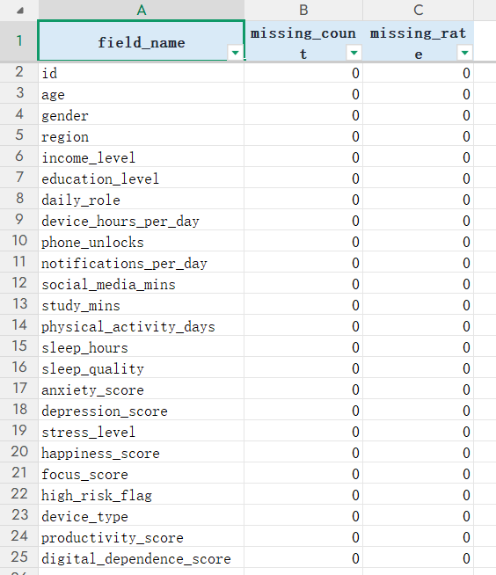
Table3 Missing Value Check
The key point is that the dataset can be kept complete without imputation. Table3 confirms that all 24 original fields contain zero missing values. Therefore, the later model results are not affected by assumptions about how missing values should be filled, and the feature-engineering step remains traceable.
Table4 tests whether repeated rows or duplicated identifiers should be removed.
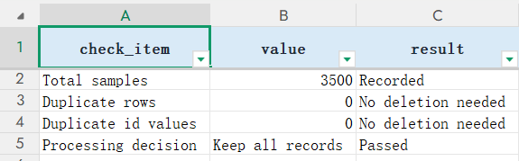
Table4 Duplicate Check
The key point is that the evaluation is not inflated by repeated records. Table4 reports 0 duplicate rows and 0 duplicate id values, so all 3,500 samples can be kept. This supports the reliability of the train/test split because duplicated samples would otherwise make the test result look more stable than it really is.

3.3 Range and Rationality Check
Table5 summarizes the minimum, maximum, and mean values of key numerical fields.
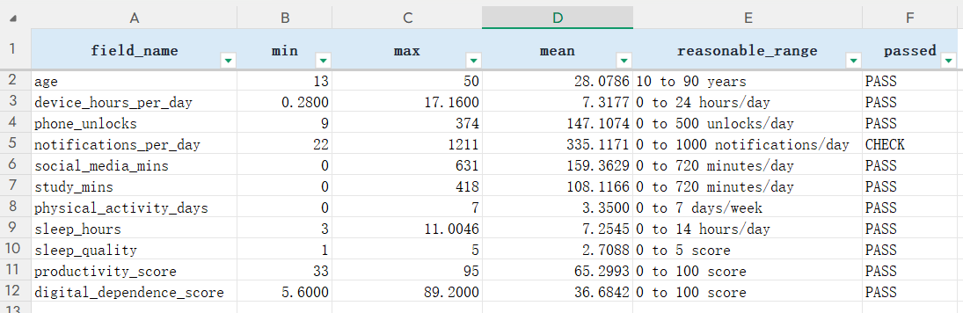
Table5 Range and Rationality Check
The key point is that wide behavioral variation exists, but it is still interpretable. Table5 shows that device_hours_per_day ranges from 0.28 to 17.16, notifications_per_day ranges from 22 to 1,211, and sleep_hours ranges from 3.00 to 11.00. These ranges do not require record deletion; instead, they explain why scale-sensitive methods later need standardization.

3.4 Feature Engineering
Table6 records the engineered behavior-intensity variables.
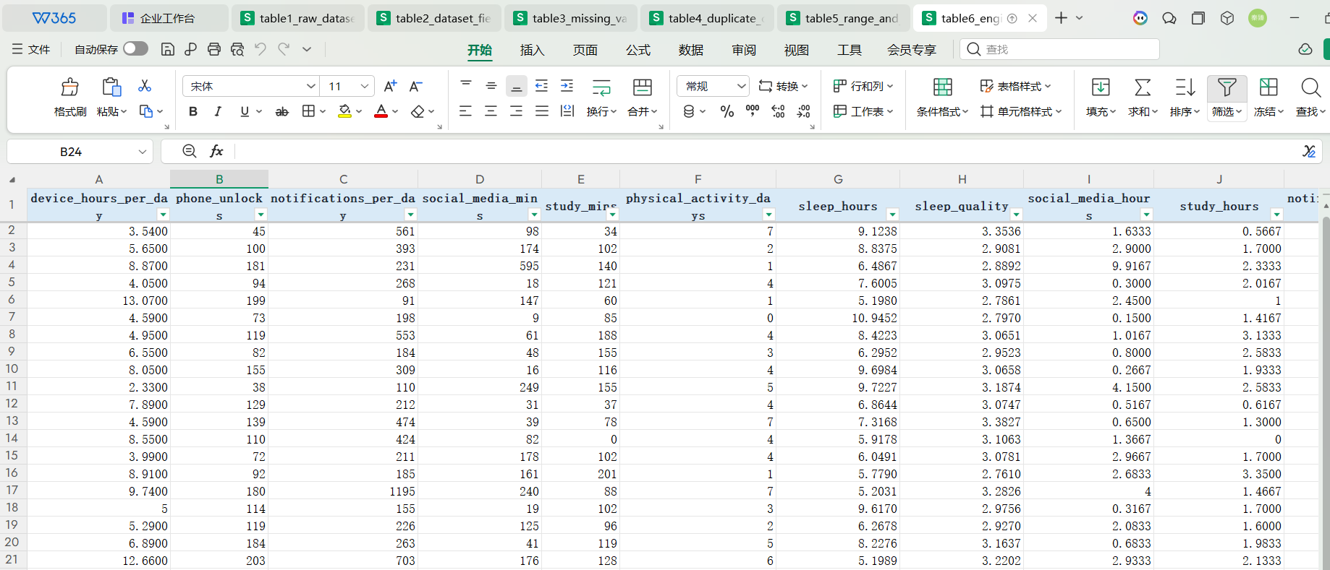
Table6 Engineered Features Preview
The key point is that feature engineering turns raw counts into behavior-intensity evidence. Table6 shows that notifications_per_device_hour, unlocks_per_device_hour, device_to_sleep_ratio, and social_to_study_ratio describe digital load more directly than raw counts alone. activity_sleep_interaction is consistently defined as physical_activity_days multiplied by sleep_hours, so it links activity and sleep without introducing outcome variables.

3.5 Feature Selection and Leakage Control
Table7 explains which columns are excluded before modeling.
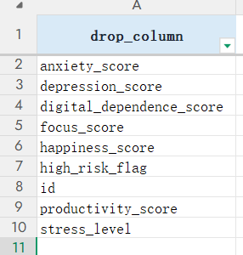
Table7 Feature Selection and Leakage Control
The key point is that leakage control is the credibility boundary of this report. For High Risk classification, Table7 excludes id, high_risk_flag, digital_dependence_score, productivity_score, anxiety_score, depression_score, stress_level, happiness_score, and focus_score from the inputs. This forces the classifier to rely on behavior and lifestyle evidence rather than direct outcome-style information. Regression and clustering also use task-specific feature sets, so the tasks remain comparable but not leaked.

3.6 PCA and GMM Extension
Table8 provides the numerical evidence for the PCA extension.
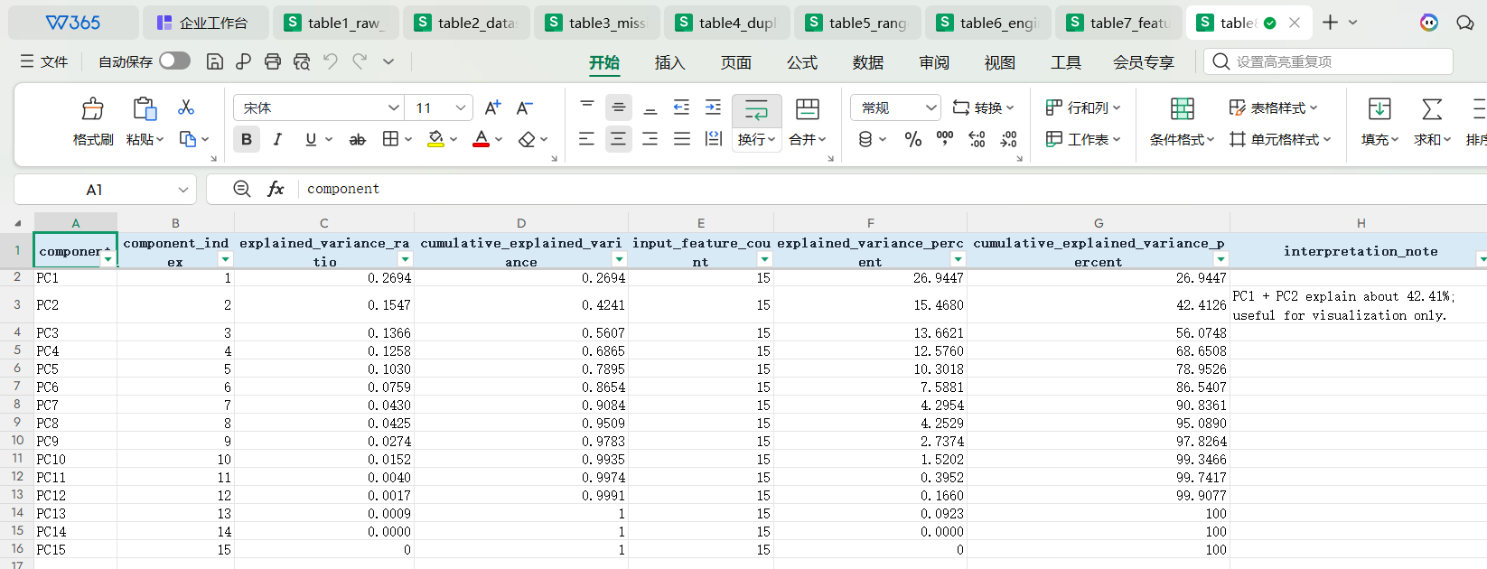
Table8 PCA Explained Variance
The key point is that PCA is useful evidence but not a replacement for the full feature space. Table8 shows that PC1 and PC2 explain 42.41% of the total variance. Since 57.59% remains outside the first two components and 6 components are needed to exceed 80%, the report uses PCA only as auxiliary structure evidence and does not overstate a two-dimensional projection.

4. Statistics and Visualization

4.1 Descriptive Statistics
Table9 gives the mathematical summary before visual analysis.
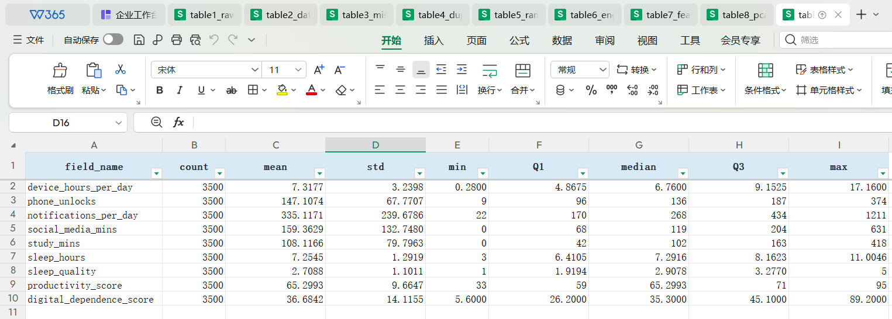
Table9 Descriptive Statistical Summary
The key point is that scale differences shape the later modeling choices. Table9 confirms that notifications_per_day and social_media_mins vary much more widely than bounded variables such as sleep_quality. This explains why StandardScaler is needed for PCA, KMeans, GaussianMixture, and linear models, while tree-based models are less sensitive to raw feature scale.

4.2 Target Distribution
Fig1 is used to check the class structure before model training.
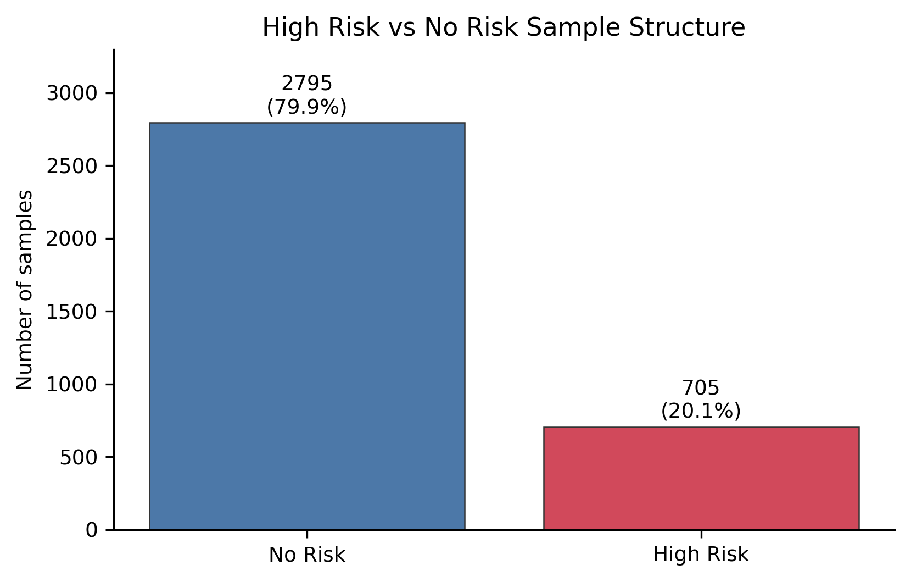
Fig1 High Risk vs No Risk Sample Structure
My main conclusion is that Accuracy alone is not a suitable classification focus here. Fig1 shows a clear class-imbalance problem: No Risk samples account for 2,795 records (79.86%), while High Risk samples account for 705 records (20.14%). A model could mainly predict No Risk and still look acceptable on Accuracy, so the later classification analysis must emphasize Recall, F1, PR-AUC, and the confusion matrix.

4.3 Numeric Feature Distribution
Fig2 summarizes the main numerical variables before modeling.
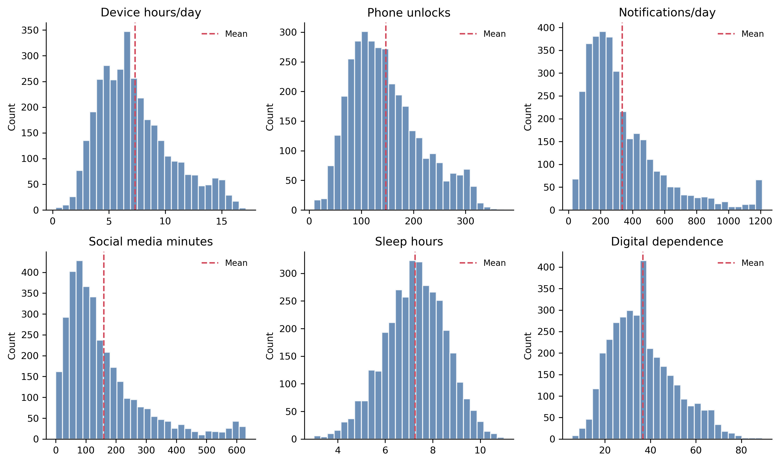
Fig2 Core Digital Lifestyle Feature Distributions
My interpretation is that digital load appears not only in averages but also in heavy-use tails. Fig2 shows that notifications_per_day has a long right tail up to 1,211 and phone_unlocks reaches 374, while sleep_hours stays in a much narrower range from about 3 to 11 hours. This supports scaling for PCA, KMeans, GaussianMixture, and linear models, while tree-based models can still split directly on raw thresholds.

4.4 Correlation Structure
Fig3 checks the correlation structure among behavior variables, lifestyle variables, and outcomes.
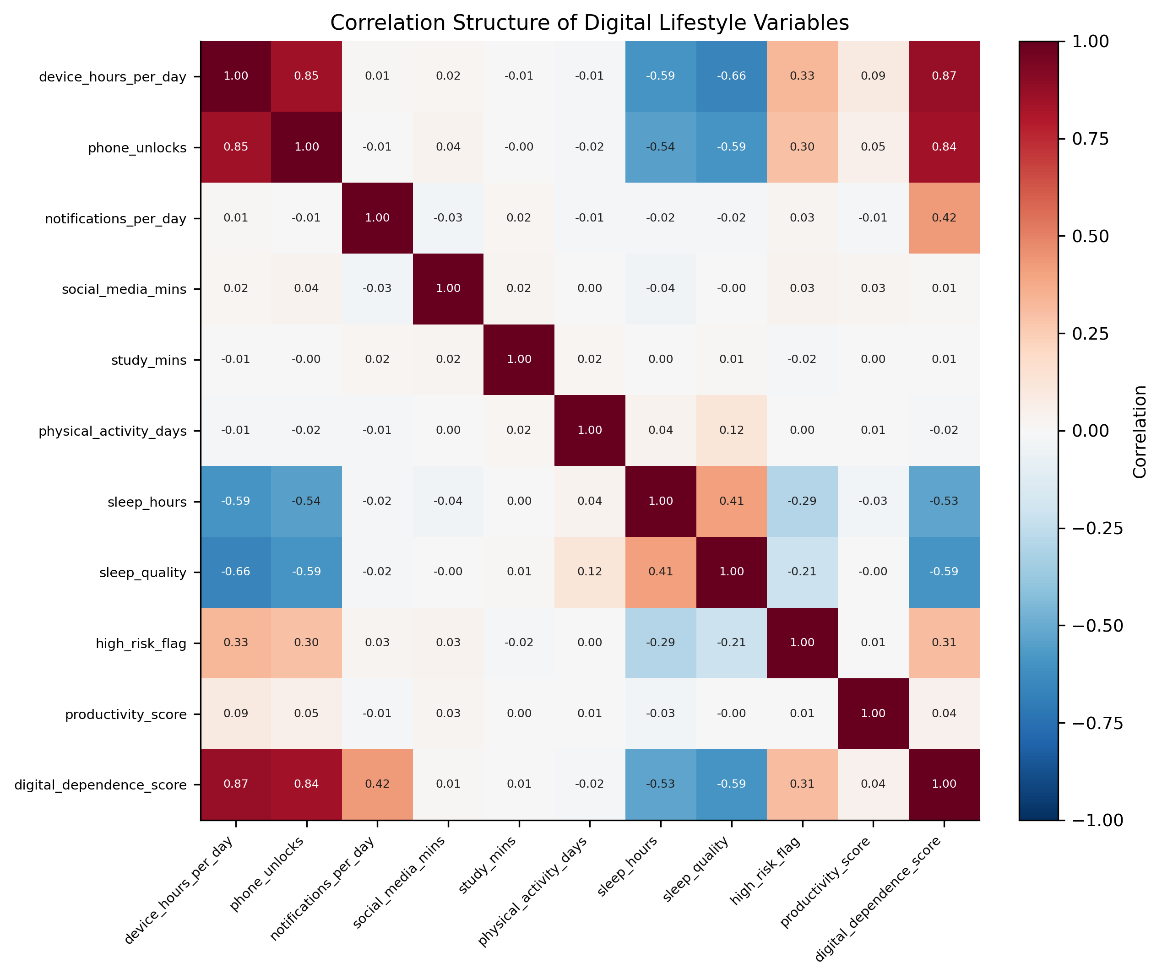
Fig3 Correlation Structure of Digital Lifestyle Variables
My main conclusion is that digital dependence is much more represented by the current features than productivity is. Fig3 shows that digital_dependence_score has a strong positive relationship with device_hours_per_day (r=0.87) and a clear negative relationship with sleep_quality (r=-0.59). In contrast, productivity_score has a much weaker relationship with device_hours_per_day (r=0.09). This explains why digital dependence is later predicted well while productivity remains weak, but the heatmap is correlation evidence only and does not support causal claims.

4.5 High Risk and No Risk Group Difference
Fig4 compares the High Risk and No Risk groups using the variables with direct behavioral meaning.
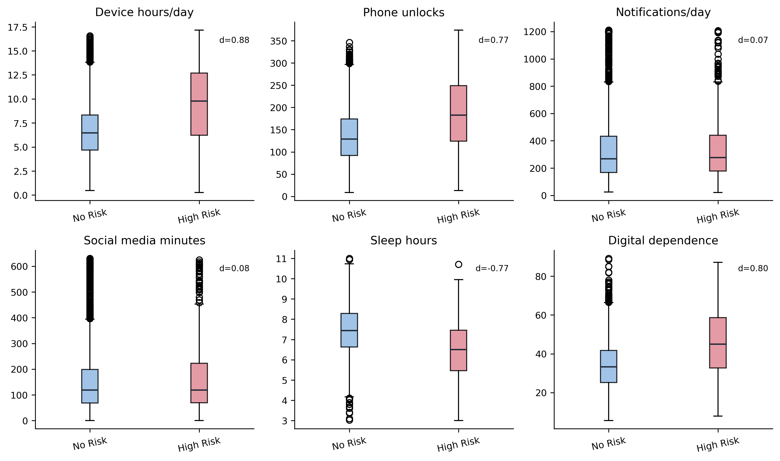
Fig4 Behavioral Difference Between High Risk and No Risk Groups
My conclusion is that High Risk is more closely associated with sustained device use and sleep-balance patterns than with notification volume alone. Fig4 uses digital_dependence_score only as an EDA descriptor, not as an input to the High Risk classifier. High Risk samples have a higher median device_hours_per_day (9.78 vs 6.48), a higher median digital_dependence_score (45.00 vs 33.40), and lower sleep_hours. device_hours_per_day has the largest standardized difference (Cohen's d=0.88), followed by digital_dependence_score (d=0.80) and sleep_hours (d=-0.77), while notifications_per_day has only a small difference (d=0.07). Because even the strongest variables overlap, no single rule can separate the classes, which supports the later multi-feature classifier and recall-oriented threshold tuning.

5. Model Training and Evaluation

5.1 Experimental Setup
All supervised experiments use train/test separation, random_state=42, cross-validation or grid-search evidence, and final testing on the held-out test set. Classification focuses on Recall, F1, PR-AUC, ROC-AUC, Balanced Accuracy, and the confusion matrix. Regression focuses on R2, MSE, RMSE, and MAE. Clustering uses inertia, Silhouette, Calinski-Harabasz, Davies-Bouldin, and profile interpretability.

5.2 High Risk Classification
Fig5 compares the three candidate classifiers before threshold adjustment.
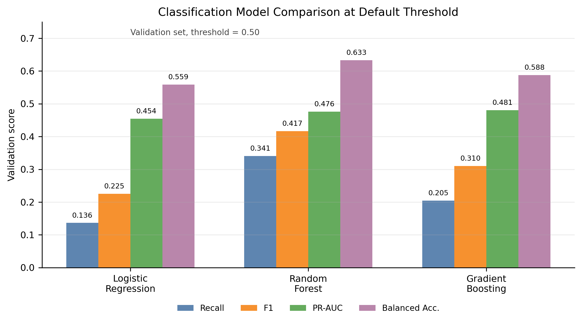
Fig5 Classification Model Comparison at the Default Threshold
My view is that model selection is not a simple winner-takes-all metric comparison. Fig5 compares candidate classifiers at the default 0.50 threshold before screening adjustment. Random Forest has the strongest default-threshold screening metrics, with Recall=0.3409, F1=0.4167, and Balanced Accuracy=0.6333, while Gradient Boosting has only a small advantage in PR-AUC=0.4805 and ROC-AUC=0.7233. The report keeps Gradient Boosting because its probability-ranking performance can be combined with threshold tuning to serve the High Risk screening objective.
Fig6 explains why the final classifier does not use the default threshold of 0.50.
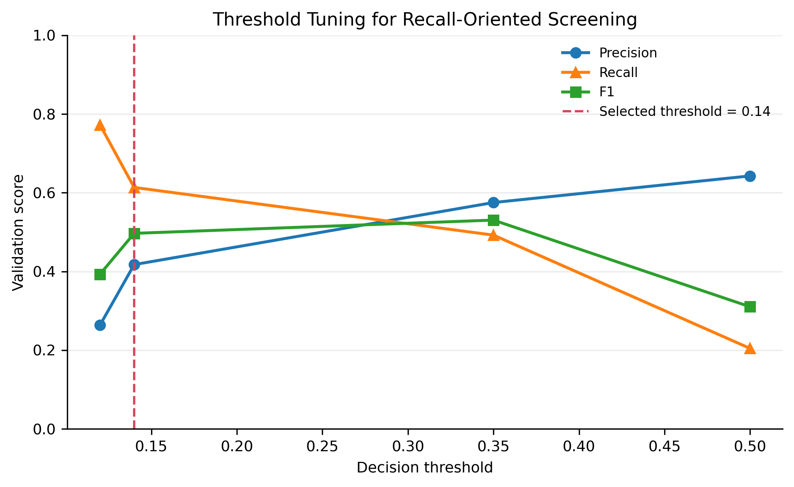
Fig6 Threshold Tuning for Recall-Oriented Screening
The clear decision is that threshold=0.14 is chosen for screening, not for maximizing overall correctness. Fig6 shows that as the decision threshold increases, precision rises but recall drops sharply. The middle threshold gives stronger validation F1, while threshold=0.14 preserves recall for screening. On the independent test set, this policy reaches Precision=0.4593, Recall=0.6420, F1=0.5355, PR-AUC=0.5084, ROC-AUC=0.7531, and Balanced Accuracy=0.7259.
Fig7 provides the final test-set confusion matrix for Gradient Boosting at threshold 0.14.
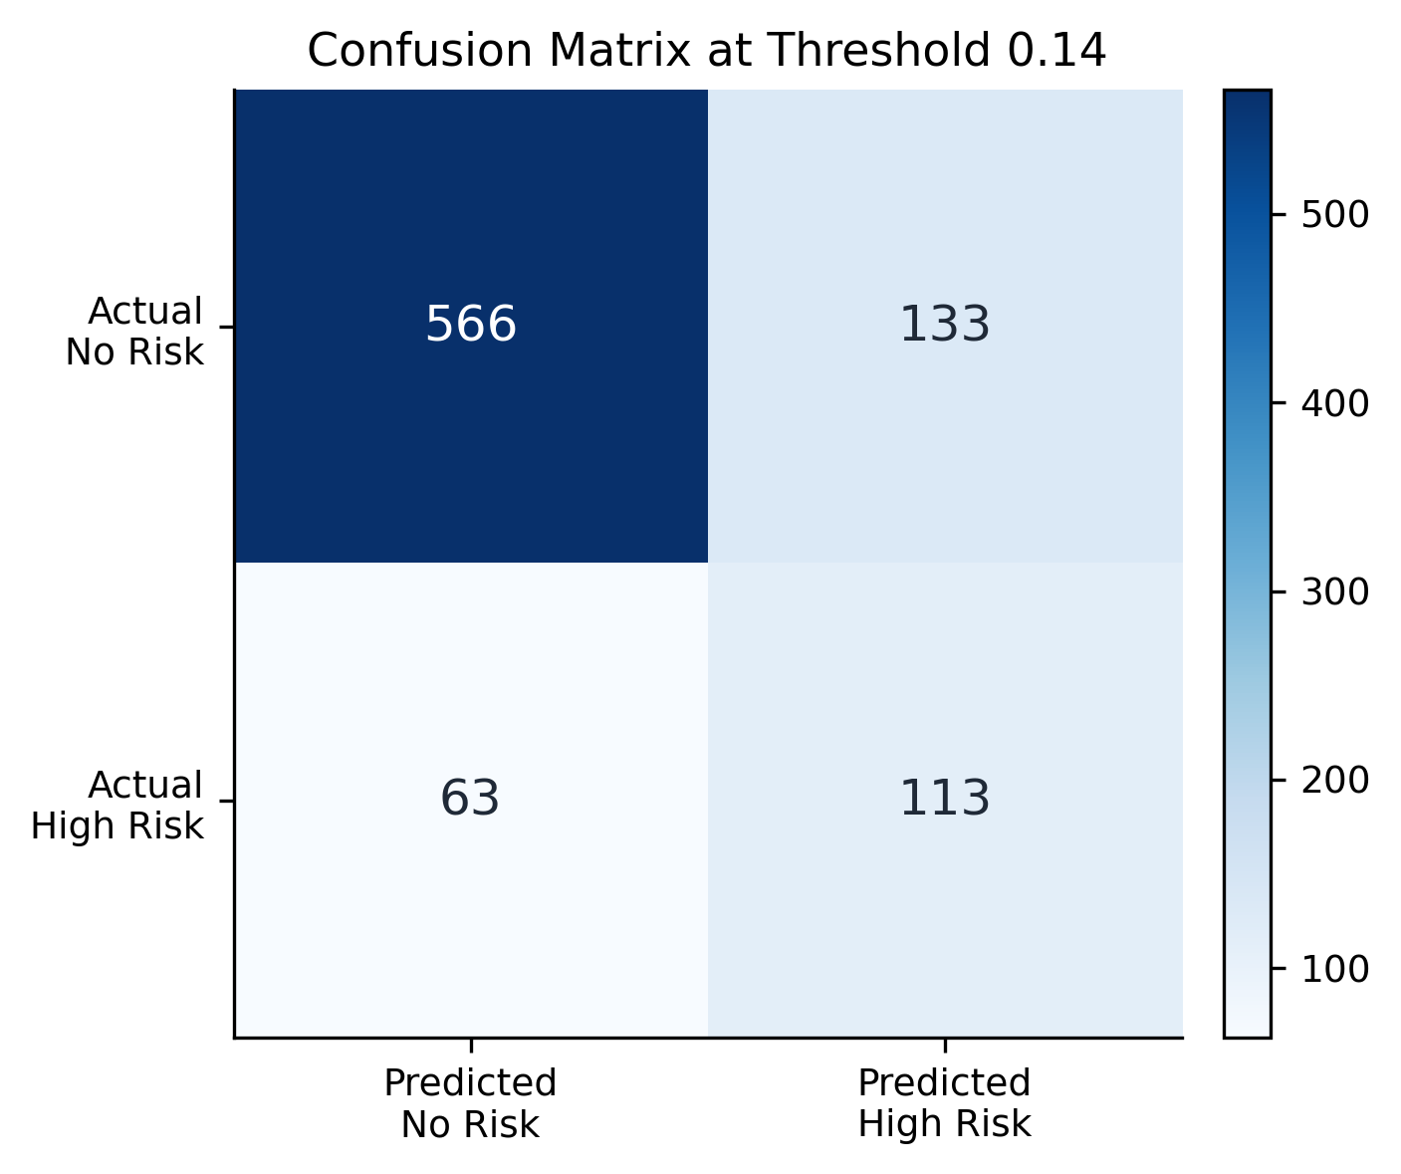
Fig7 Confusion Matrix of the Final High Risk Classifier
My conclusion is that the final classifier should be used as a screening reference, not as a final individual judgment. Fig7 gives the concrete cost of threshold=0.14: TN=566, FP=133, FN=63, and TP=113. The classifier correctly identifies 113 High Risk samples but still misses 63, and the 133 false alarms show the price paid for higher recall.
Fig8 evaluates the High Risk ranking ability across thresholds.
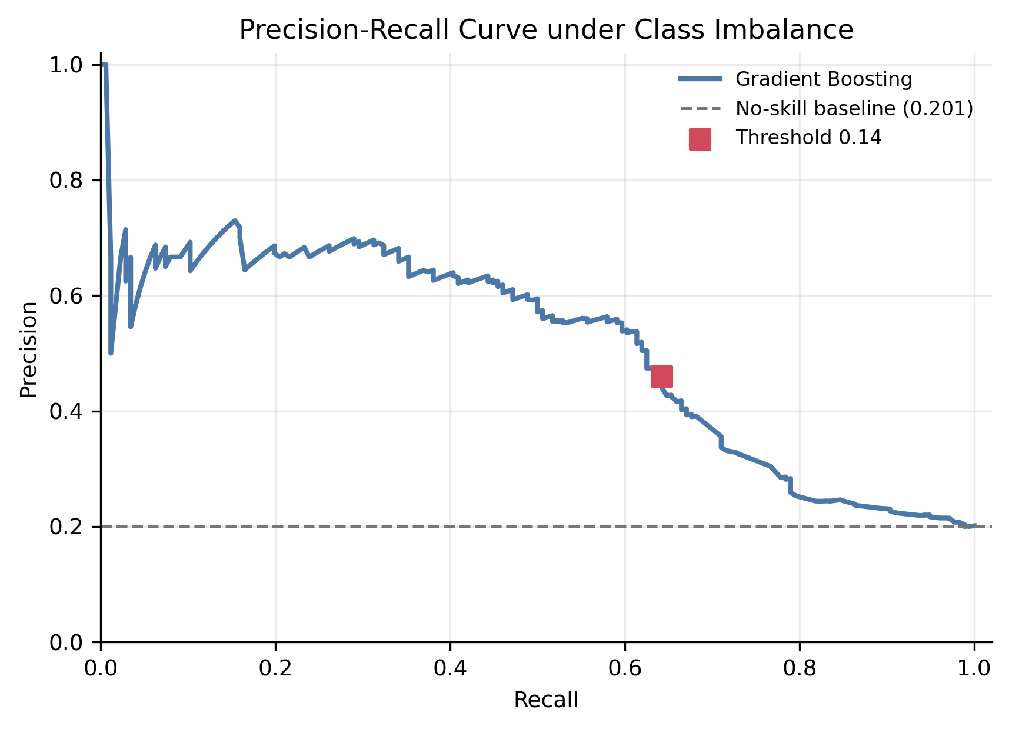
Fig8 Precision-Recall Curve under Class Imbalance
The PR curve shows useful ranking ability, but not a high-precision screening system. Fig8 uses the test-set High Risk proportion, about 20.11%, as the no-skill baseline. PR-AUC=0.5084 is clearly above this baseline, so the model ranks High Risk samples better than random ordering. However, it is still not enough to rely on one score, which is why the report combines PR-AUC with the confusion matrix and threshold analysis.

5.3 Digital Dependence and Productivity Regression
Fig9 checks whether the final digital_dependence_score predictions align with the observed scores.
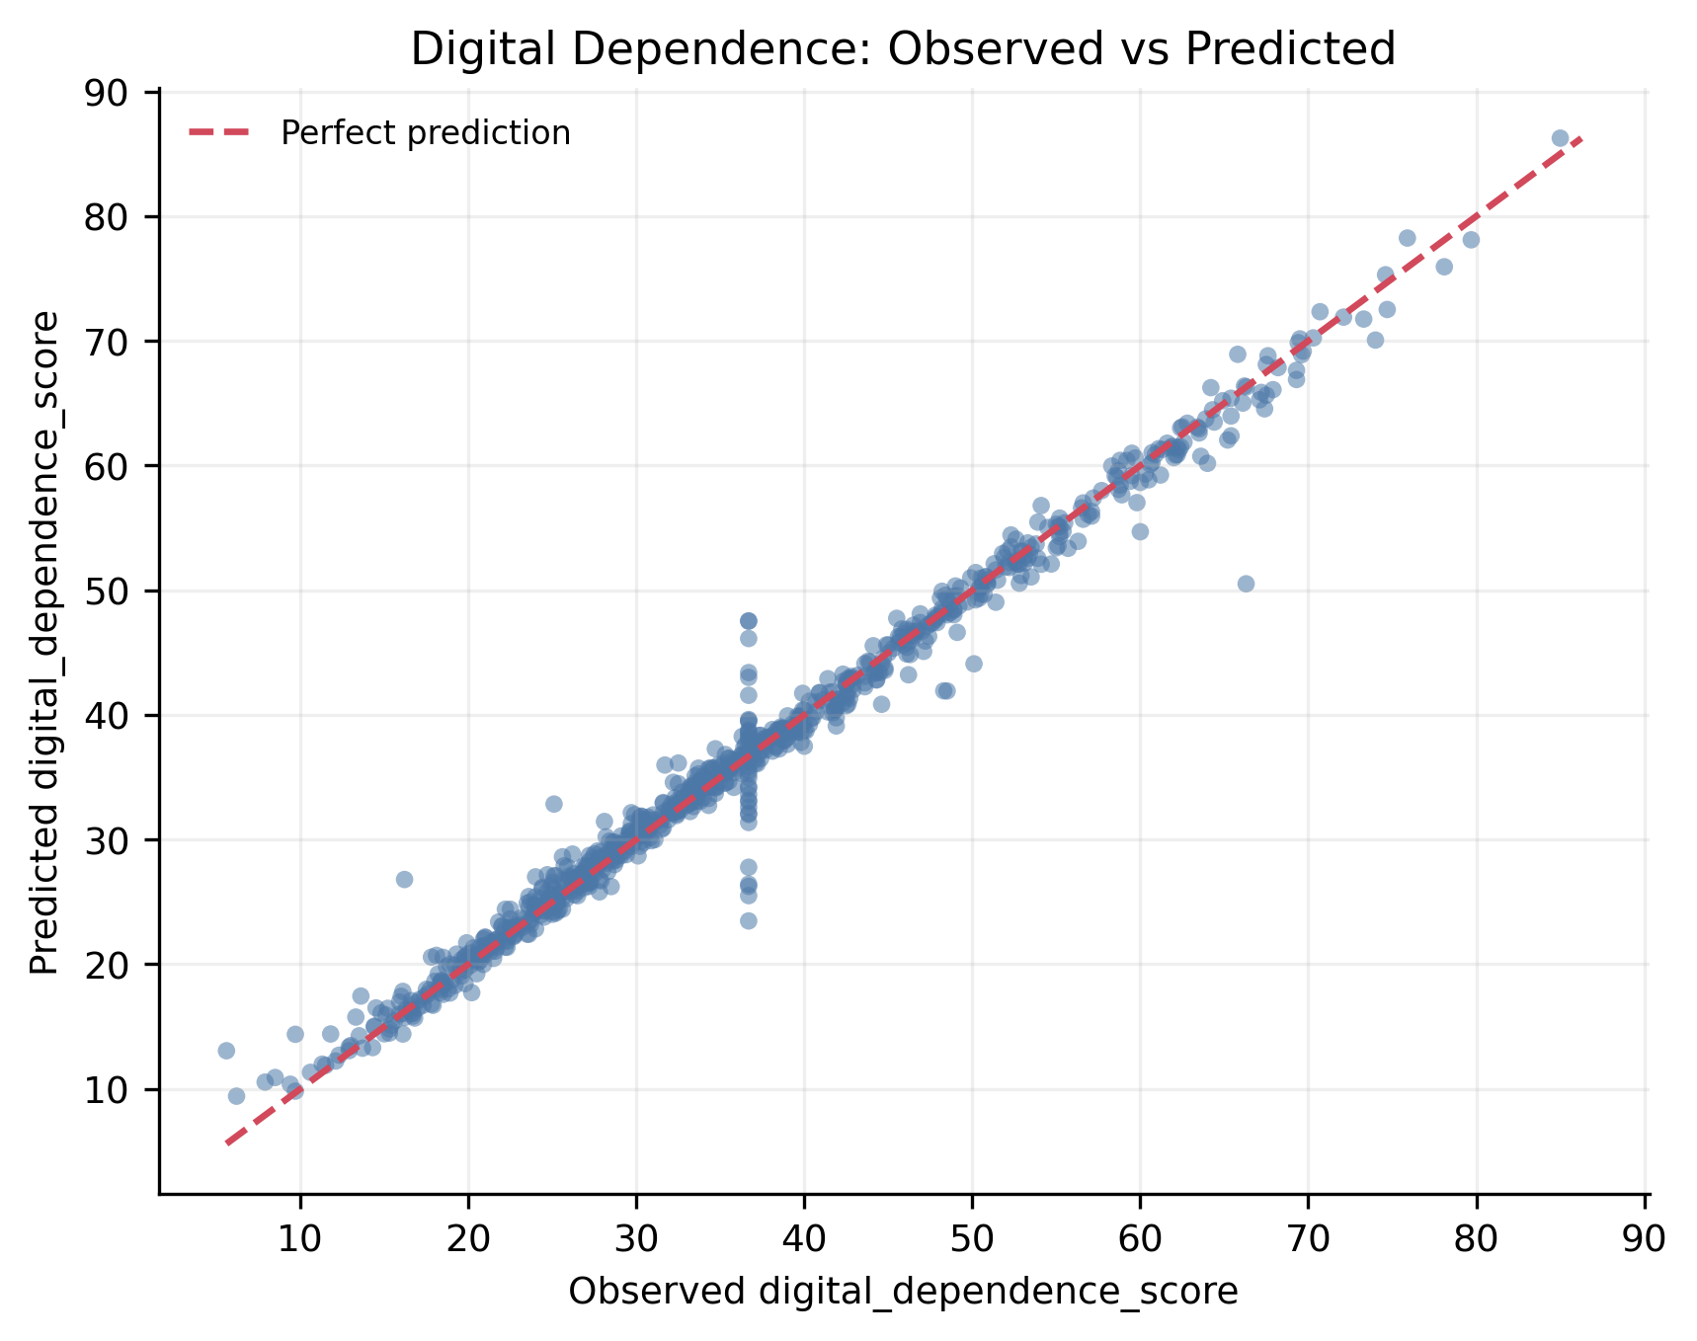
Fig9 Digital Dependence Observed vs Predicted Scores
The main regression viewpoint is that digital_dependence_score is strongly represented inside this benchmark dataset. Fig9 shows most predicted points close to the 45-degree reference line, and Gradient Boosting reaches R2=0.9839, MSE=3.1471, and MAE=0.9982. The point cloud does not show a strong systematic curve away from the diagonal, so device-use, sleep, and lifestyle variables contain strong in-dataset predictive information. This is still prediction within the dataset, not causal evidence about real users.
Fig10 keeps the productivity_score experiment as a negative-result check.
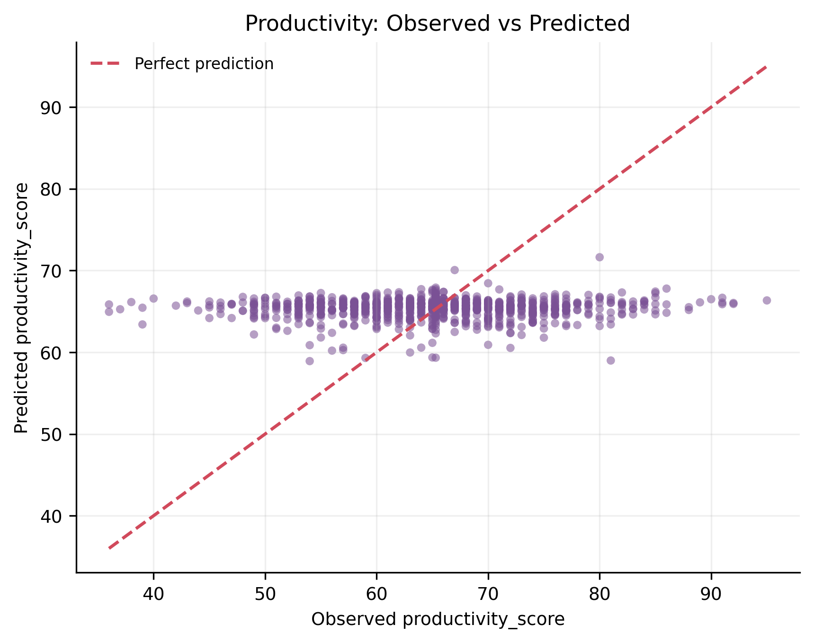
Fig10 Productivity Weak Prediction Observed vs Predicted Scores
The important result is the negative result: productivity_score is not explained by the same feature set. Fig10 shows that observed productivity_score spans about 59.0 points, while predicted values cover only about 12.7 points and concentrate near the average. This regression-to-the-mean pattern matches R2=-0.0041, meaning the model does not outperform a simple mean baseline. This matters because it proves that the same digital-lifestyle features cannot explain every outcome equally well.
Fig11 summarizes the R2 contrast between the two regression targets.
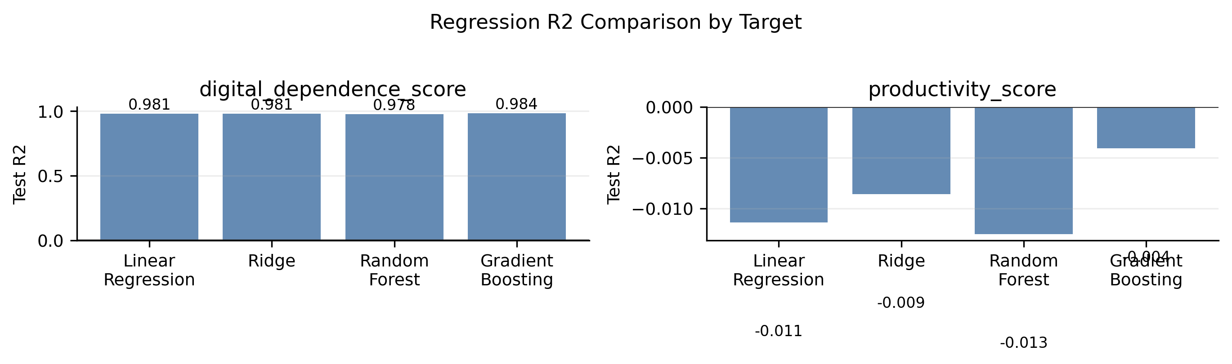
Fig11 Regression R2 Comparison by Target
My conclusion is that the dataset is much more suitable for digital-dependence prediction than productivity prediction. Fig11 compares the two regression targets using R2 only, so MSE and MAE are not mixed with a different scale on the same axis. All models predict digital_dependence_score well, with Gradient Boosting reaching R2=0.9839, while productivity_score R2 values are close to or below zero. This makes the regression section more honest because it includes both a strong result and a weak result.

5.4 Digital Lifestyle Clustering
Fig12 combines inertia and silhouette evidence to explain the clustering choice.
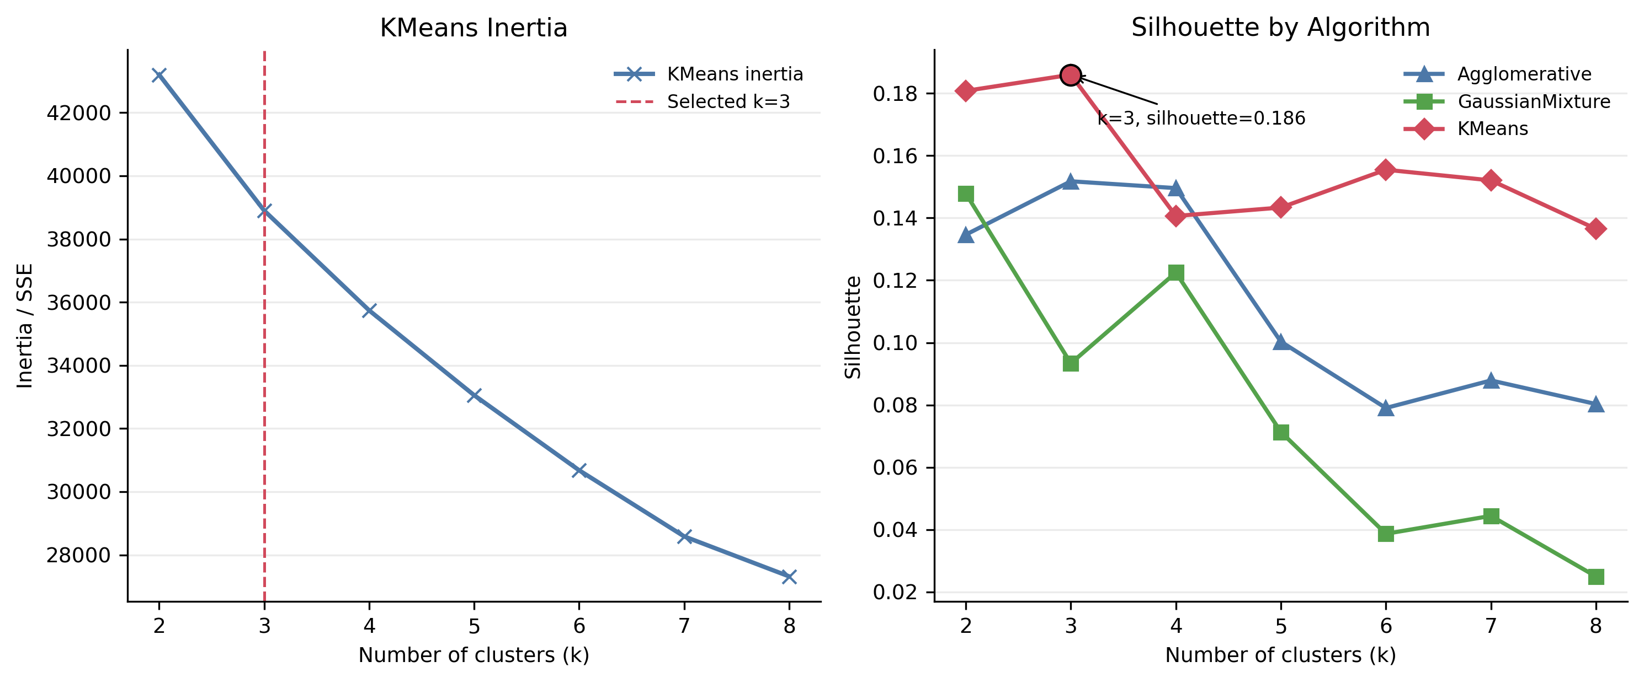
Fig12 K Selection by Inertia and Silhouette
My clustering viewpoint is cautious: k=3 is readable, but the evidence is weak. Fig12 shows that the KMeans inertia curve decreases smoothly and does not form a sharp elbow. The silhouette comparison shows that KMeans reaches its highest tested silhouette at k=3 with Silhouette=0.1860, while AgglomerativeClustering and GaussianMixture do not provide a clearly stronger alternative. Because 0.1860 is low, k=3 should not be interpreted as proof of strict natural groups.
Fig13 summarizes the final KMeans k=3 lifestyle profiles.
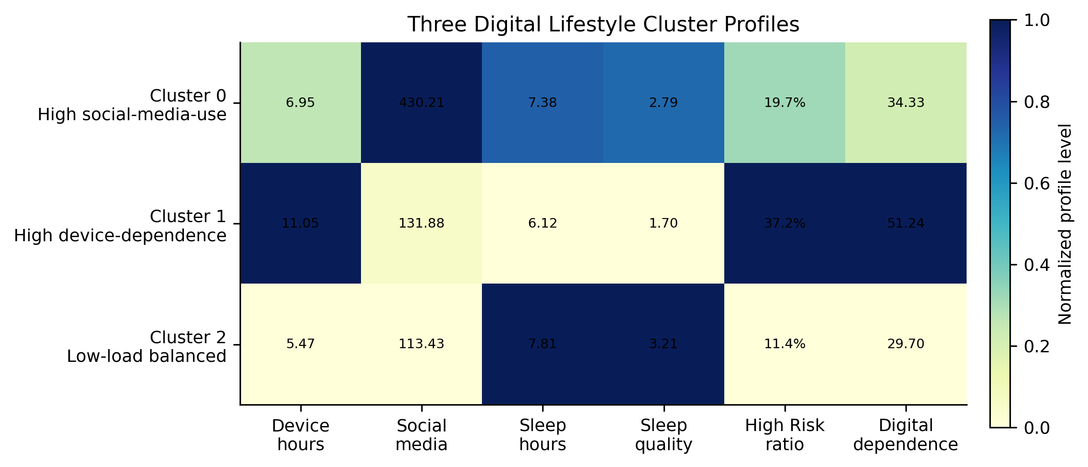
Fig13 Three Digital Lifestyle Cluster Profiles
The cluster names are useful as lifestyle summaries, not as hard population labels. Fig13 uses high_risk_flag and digital_dependence_score only as post-clustering descriptors, not clustering inputs. Cluster 0 has very high social_media_mins (430.2) but moderate device_hours_per_day (6.95), Cluster 1 has the highest device_hours_per_day (11.05), lowest sleep_quality (1.70), highest High Risk ratio (37.2%), and highest digital_dependence_score (51.24), and Cluster 2 has the lowest device_hours_per_day (5.47) and lowest High Risk ratio (11.4%). The low silhouette score means these profiles are gradual lifestyle summaries rather than sharply separated groups.
Fig14 provides the PCA evidence used to discuss dimensionality reduction.
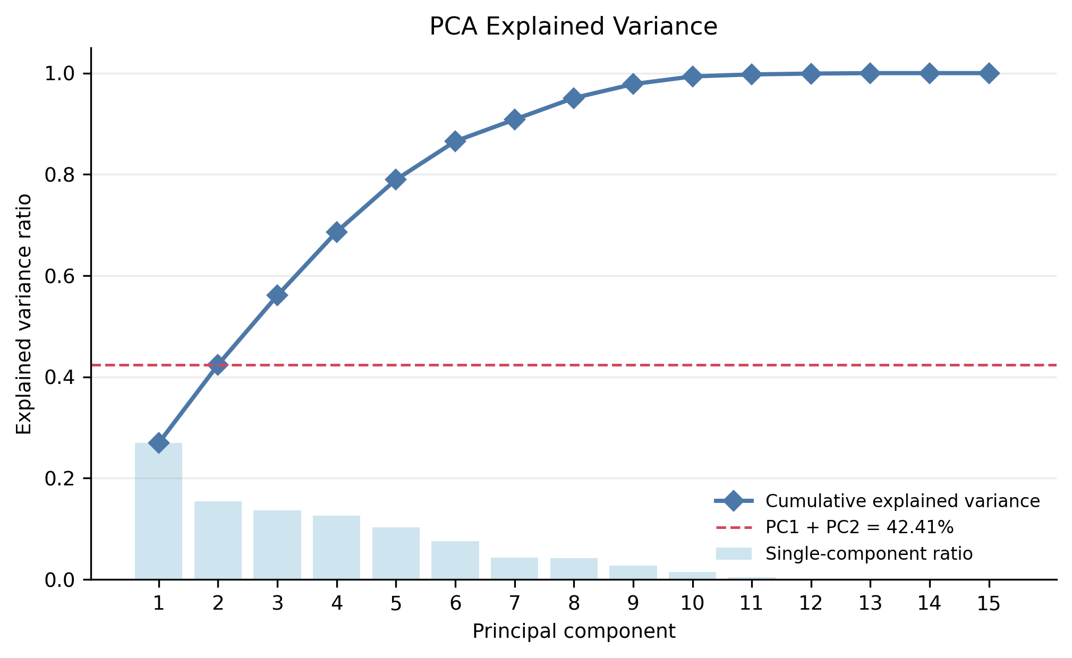
Fig14 PCA Explained Variance for Dimensionality Reduction
The PCA result prevents overclaiming from a two-dimensional view. Fig14 shows that the first two principal components explain 42.41% of the total variance, so 57.59% remains outside the two-dimensional view. The cumulative curve reaches 80% only after 6 components. Therefore, PCA can help readers understand part of the structure, but it should not replace the original feature space for classification, regression, or clustering evaluation.

5.5 Integrated Result Analysis
The integrated conclusion is that the report follows a traceable chain from data evidence to model choice. EDA first shows class imbalance, scale differences, correlation differences, and group overlap. Based on this evidence, classification is designed as recall-oriented screening rather than perfect separation. Regression then shows that digital_dependence_score is strongly represented by the current behavior features, while productivity_score remains outside the explanatory power of the same feature set. Finally, clustering gives readable lifestyle profiles, but the low silhouette value prevents the report from claiming strict population segmentation. Therefore, the value of the modeling chapter is not perfect performance; it is an evidence-based chain from data to model choice and honest interpretation.

6. Findings and Reflection

6.1 Main Findings
The main finding is that the dataset supports a complete workflow, but the strength of evidence differs across tasks. High Risk can be screened as a reference because the final threshold identifies 64.20% of true High Risk samples, but 133 false positives and 63 false negatives show that the model cannot be used as a final personal judgment. digital_dependence_score is strongly predicted in this benchmark dataset, with R2=0.9839, MSE=3.1471, and MAE=0.9982, which suggests that device-use and sleep-related features strongly represent this score. In contrast, productivity_score remains a weak-prediction target with R2=-0.0041, showing that the current features do not explain every outcome equally. KMeans k=3 gives readable lifestyle profiles, but Silhouette=0.1860 means they should be treated as exploratory summaries rather than strict groups.

6.2 Limitations
The limitations should be read together with the results, because they define what the report can and cannot claim. First, the dataset is a benchmark or educational dataset, so the very high R2 for digital_dependence_score may partly reflect the data-generation structure. Second, the classification recall is not 100%, which means some High Risk samples are still missed even after threshold adjustment. Third, productivity_score is not explained well, suggesting that productivity may depend on motivation, task context, learning environment, and self-control variables that are not fully captured here. Fourth, the clustering silhouette score is low, so the lifestyle profiles are useful for exploration but not for strict segmentation. External validation with real digital lifestyle data would be needed before making stronger practical claims.

6.3 Personal Reflection
The biggest lesson is that figures and tables should prove a point, not decorate the report. A useful chart should answer a question and support the next analytical step. In this report, class imbalance explains why Accuracy is not enough, the threshold curve explains why recall and false alarms must be balanced, the weak productivity result shows the boundary of the feature set, and the low clustering silhouette prevents overclaiming. Through this process, I learned that a complete data-analysis report should be traceable from raw data to cleaning, feature engineering, visualization, model evaluation, and honest reflection.

Appendix A Complete Runnable Code

A.1 Environment and Dependencies
The experiment was completed with a CPU-based Python environment. The main dependencies are pandas, NumPy, scikit-learn, Matplotlib, openpyxl, python-docx, and joblib. The environment can be installed with: pip install -r requirements.txt.

A.2 Complete Code
The complete runnable code is copied from appendix_A_complete_code.py.
﻿"""Complete runnable code source for Appendix A.

Run from the project directory:
python appendix_A_complete_code.py

Or run from the repository root:
python <project_dir>/appendix_A_complete_code.py

This file rebuilds the final report evidence files without changing the
validated core CSV metrics. It loads the raw dataset, checks data quality,
creates engineered features, documents leakage control, regenerates the final
figures, exports screenshot Excel tables, and summarizes the validated results.
"""

from __future__ import annotations

import runpy
from pathlib import Path

import pandas as pd

PROJECT_ROOT = Path(__file__).resolve().parent
RAW_DATA_PATH = PROJECT_ROOT / "data" / "raw" / "digital_lifestyle_benchmark_2025.csv"
PROCESSED_DATA_PATH = PROJECT_ROOT / "data" / "processed" / "digital_lifestyle_benchmark_2025_processed.csv"
RESULTS_DIR = PROJECT_ROOT / "results"
FIGURE_DIR = PROJECT_ROOT / "figures" / "final_report"
SCREENSHOT_TABLE_DIR = PROJECT_ROOT / "screenshot_tables"
RANDOM_STATE = 42

def load_raw_data() -> pd.DataFrame:
df = pd.read_csv(RAW_DATA_PATH)
print("Raw dataset shape:", df.shape)
print("Raw columns:", df.columns.tolist())
print(df.head())
return df

def check_missing_duplicates_and_ranges(df: pd.DataFrame) -> None:
key_numeric = [
"age",
"device_hours_per_day",
"phone_unlocks",
"notifications_per_day",
"social_media_mins",
"study_mins",
"sleep_hours",
"sleep_quality",
"productivity_score",
"digital_dependence_score",
]
print("\nMissing values:")
print(df.isna().sum())
print("\nDuplicate rows:", df.duplicated().sum())
print("Duplicate id:", df["id"].duplicated().sum())
print("\nRange summary:")
print(df[key_numeric].agg(["min", "max", "mean"]).T)

def add_engineered_features(df: pd.DataFrame) -> pd.DataFrame:
engineered = df.copy()
eps = 1e-6
engineered["social_media_hours"] = engineered["social_media_mins"] / 60
engineered["study_hours"] = engineered["study_mins"] / 60
engineered["notifications_per_device_hour"] = (
engineered["notifications_per_day"] / engineered["device_hours_per_day"].clip(lower=eps)
)
engineered["unlocks_per_device_hour"] = (
engineered["phone_unlocks"] / engineered["device_hours_per_day"].clip(lower=eps)
)
engineered["device_to_sleep_ratio"] = (
engineered["device_hours_per_day"] / engineered["sleep_hours"].clip(lower=eps)
)
engineered["activity_sleep_interaction"] = (
engineered["physical_activity_days"] * engineered["sleep_hours"]
)
engineered["social_to_study_ratio"] = engineered["social_media_mins"] / (
engineered["study_mins"] + 1
)
engineered.to_csv(PROCESSED_DATA_PATH, index=False)
print("\nProcessed dataset saved:", PROCESSED_DATA_PATH)
return engineered

def define_feature_sets(engineered: pd.DataFrame) -> dict[str, list[str]]:
outcome_cols = [
"anxiety_score",
"depression_score",
"stress_level",
"happiness_score",
"focus_score",
"high_risk_flag",
"productivity_score",
"digital_dependence_score",
]
classification_drop = [
"id",
"high_risk_flag",
"anxiety_score",
"depression_score",
"stress_level",
"happiness_score",
"focus_score",
"productivity_score",
"digital_dependence_score",
]

def regression_drop_for(target: str) -> list[str]:
drop_cols = {"id", target}
drop_cols.update(outcome_cols)
if target == "digital_dependence_score":
drop_cols.add("productivity_score")
if target == "productivity_score":
drop_cols.add("digital_dependence_score")
return sorted(drop_cols)

digital_dependence_drop = regression_drop_for("digital_dependence_score")
productivity_drop = regression_drop_for("productivity_score")
clustering_features = [
"device_hours_per_day",
"phone_unlocks",
"notifications_per_day",
"social_media_mins",
"study_mins",
"physical_activity_days",
"sleep_hours",
"sleep_quality",
"social_media_hours",
"study_hours",
"notifications_per_device_hour",
"unlocks_per_device_hour",
"device_to_sleep_ratio",
"activity_sleep_interaction",
"social_to_study_ratio",
]
classification_features = [c for c in engineered.columns if c not in classification_drop]
digital_dependence_features = [c for c in engineered.columns if c not in digital_dependence_drop]
productivity_features = [c for c in engineered.columns if c not in productivity_drop]
print("\nClassification drop columns:", classification_drop)
print("Classification feature count:", len(classification_features))
print("Digital dependence regression feature count:", len(digital_dependence_features))
print("Productivity regression feature count:", len(productivity_features))
print("Clustering features:", clustering_features)
return {
"classification_drop": classification_drop,
"classification_features": classification_features,
"digital_dependence_drop": digital_dependence_drop,
"digital_dependence_features": digital_dependence_features,
"productivity_drop": productivity_drop,
"productivity_features": productivity_features,
"clustering_features": clustering_features,
}

def summarize_validated_results() -> None:
classification = pd.read_csv(RESULTS_DIR / "classification_tuned_metrics.csv")
regression_dd = pd.read_csv(RESULTS_DIR / "regression_digital_dependence_metrics.csv")
regression_prod = pd.read_csv(RESULTS_DIR / "regression_productivity_metrics.csv")
clustering = pd.read_csv(RESULTS_DIR / "clustering_kmeans_scores.csv")

final_cls = classification[
(classification["dataset"] == "test")
& (classification["model"] == "gradient_boosting")
& (classification["threshold"].round(2) == 0.14)
].iloc[0]
final_dd = regression_dd[regression_dd["model"] == "gradient_boosting"].iloc[0]
final_prod = regression_prod[regression_prod["model"] == "gradient_boosting"].iloc[0]
final_cluster = clustering[clustering["k"] == 3].iloc[0]

summary = pd.DataFrame(
[
{
"task": "classification_high_risk",
"main_result": "Gradient Boosting threshold=0.14",
"metric_1": f"Recall={final_cls['recall']:.4f}",
"metric_2": f"F1={final_cls['f1']:.4f}",
"metric_3": f"PR-AUC={final_cls['pr_auc']:.4f}",
},
{
"task": "regression_digital_dependence",
"main_result": "Gradient Boosting",
"metric_1": f"R2={final_dd['r2']:.4f}",
"metric_2": f"MSE={final_dd['mse']:.4f}",
"metric_3": f"MAE={final_dd['mae']:.4f}",
},
{
"task": "regression_productivity",
"main_result": "weak prediction / negative result",
"metric_1": f"R2={final_prod['r2']:.4f}",
"metric_2": "",
"metric_3": "",
},
{
"task": "clustering_lifestyle_profiles",
"main_result": "KMeans k=3",
"metric_1": f"Silhouette={final_cluster['silhouette']:.4f}",
"metric_2": "",
"metric_3": "",
},
]
)
output = RESULTS_DIR / "final_workflow_report_summary.csv"
summary.to_csv(output, index=False)
print("\nValidated result summary saved:", output)

def regenerate_figures_and_screenshot_tables() -> None:
FIGURE_DIR.mkdir(parents=True, exist_ok=True)
SCREENSHOT_TABLE_DIR.mkdir(parents=True, exist_ok=True)
runpy.run_path(str(PROJECT_ROOT / "scripts" / "generate_final_report_figures.py"), run_name="__main__")
runpy.run_path(str(PROJECT_ROOT / "scripts" / "export_screenshot_tables.py"), run_name="__main__")

def main() -> None:
print("Random state:", RANDOM_STATE)
df = load_raw_data()
check_missing_duplicates_and_ranges(df)
engineered = add_engineered_features(df)
define_feature_sets(engineered)
summarize_validated_results()
regenerate_figures_and_screenshot_tables()
print("\nComplete workflow evidence generation finished.")

if __name__ == "__main__":
main()

