* * * * * * * * * * * 学 号： 姓 名： * * * * * * * * * * * * * * * * * * * * * * * * * * * * * * * * * * * * * * * * * * * * 学 院： 专业年级： * * * * * * * * * * * * * * * * * * * * * * * * * * * * * * * * * * * * * * * * * * * * * * * * * * * * * * * * * *
The paper of course exam

Name： | Big Data Analysis and Applications
Content： | Course Report （Class assignments、thesis、report ）
Institution： |  | Teacher： | Li Jie
Grade and major：

Teacher’s comments | Total score | Grading teacher

…………………………………………………………………………………………………

Digital Lifestyle Analysis: High-Risk Screening, Digital Dependence Prediction, and Lifestyle Profile Clustering

1. Analysis Goals and Tasks
This report follows the workflow required by the course: define the analysis goal, introduce the dataset, clean and transform the data, conduct statistical visualization, train and evaluate machine learning models, and finally interpret the results. The main purpose is not to claim that every model is perfect. The purpose is to make each step explainable and supported by data evidence.

1.1 Background
Digital lifestyle data combine device use, notifications, social media time, sleep, study, and activity records. These variables provide a practical setting for studying whether behavior patterns are associated with High Risk labels, digital dependence scores, and exploratory lifestyle profiles.

1.2 Key Questions
Overall research question: Under an increasingly digital lifestyle, which daily behaviors should be treated as priority warning signs of digital dependence, and how can these signals guide personal self-management and public digital-wellbeing support?

Three specific questions are used to answer it:
- Which behavior patterns most clearly distinguish High Risk and No Risk samples? (Classification)
- Can these patterns support High Risk screening and predict digital dependence more reliably than productivity? (Regression)
- Can lifestyle profiles translate these findings into different support strategies? (Clustering)

1.3 Analysis Tasks
The report answers the overall question in three connected steps. EDA first identifies the strongest warning patterns. Classification and regression then test whether these patterns can support early screening and dependence estimation. Clustering finally turns the patterns into different lifestyle profiles for targeted guidance. The logic therefore moves from finding warning signals, to testing their predictive value, and then to designing practical responses.

2. Dataset and Task Support

2.1 Dataset Source
The dataset is the 2025 Digital Lifestyle Benchmark Dataset, published by Tarek Masryo on Kaggle and available through Hugging Face. It contains 3,500 fully synthetic records and 24 fields in CSV format.

2.2 Raw Data Preview
Table1 is used to confirm that the report starts from the raw CSV rather than from a pre-summarized result table.
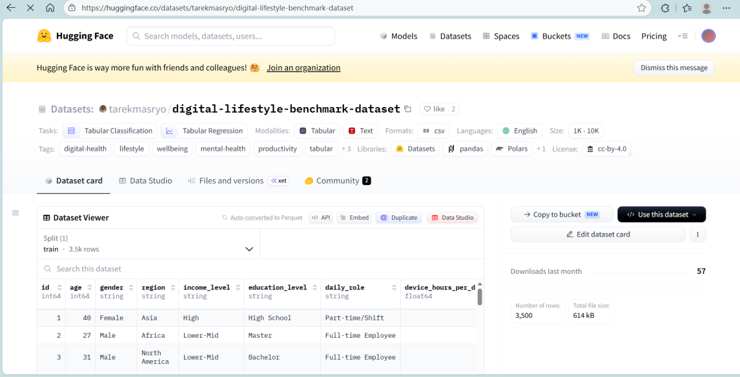
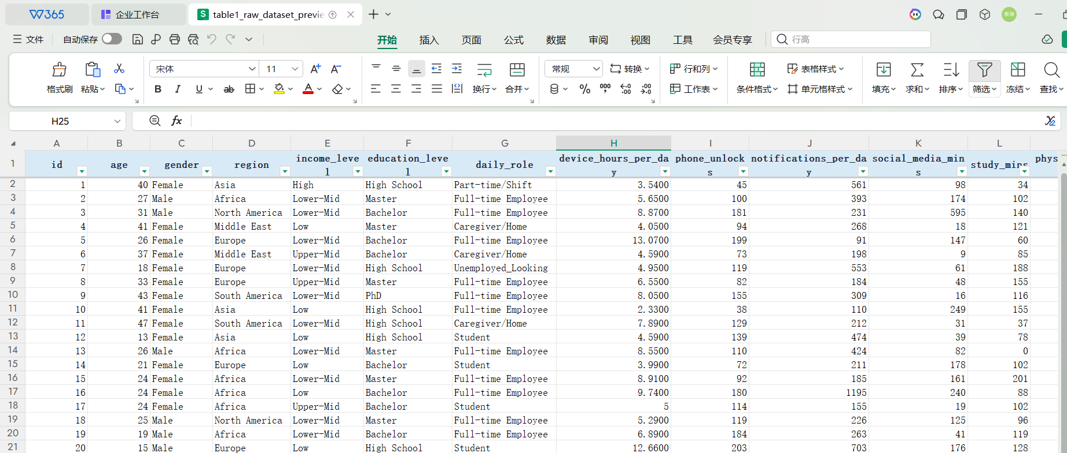
Table1 Raw Dataset Preview
The raw data already fits the report design. In Table1, each record contains digital behavior, lifestyle information, and outcome-style fields in one row. This means the dataset is not only used for one model. It can support High Risk screening, score prediction, and lifestyle clustering in the same workflow.

2.3 Field Structure
Table2 lists every original field with its type and role, which makes the later leakage-control decision traceable.
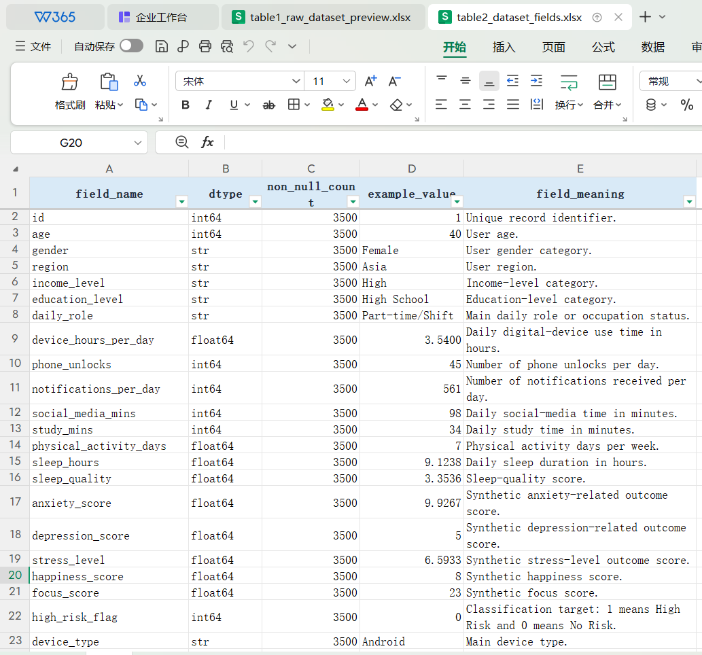
Table2 Dataset Fields
The field roles need to be separated before modeling. Table2 marks high_risk_flag as the classification target, while digital_dependence_score and productivity_score are outcome-style scores. If these fields are used carelessly as inputs, the model may learn the answer too directly. Therefore, this table supports the later leakage-control step.

2.4 Task Support
high_risk_flag is the classification target, digital_dependence_score is the main regression target, productivity_score is used as a weak-prediction check, and behavior/lifestyle variables are used for clustering.

3. Data Cleaning and Feature Engineering

3.1 Data Loading
The loading step verifies the input file shape and column structure. The raw dataset contains exactly 3,500 records and 24 fields, matching the dataset requirement and the later task design.

3.2 Missing and Duplicate Check
Table3 checks every field before any modeling step.
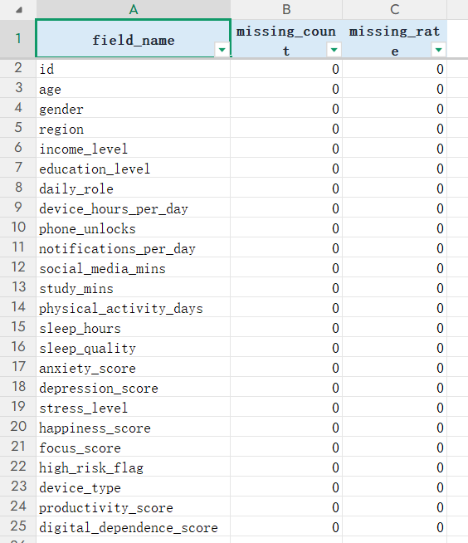
Table3 Missing Value Check
The missing-value check makes the preprocessing simpler. Table3 reports 0 missing values in all 24 fields, so no imputation is needed. This keeps all 3,500 records in the analysis and avoids adding artificial filling rules before modeling.

Table4 tests whether repeated rows or duplicated identifiers should be removed.
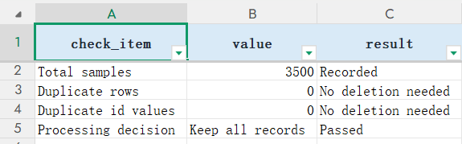
Table4 Duplicate Check
The dataset also passes the duplicate check. Table4 reports 0 duplicate rows and 0 duplicate id values. Therefore, no sample is removed at this step. This makes the later train/test result more reliable because repeated records are not inflating the evaluation.

3.3 Range and Rationality Check
Table5 summarizes the minimum, maximum, and mean values of key numerical fields.

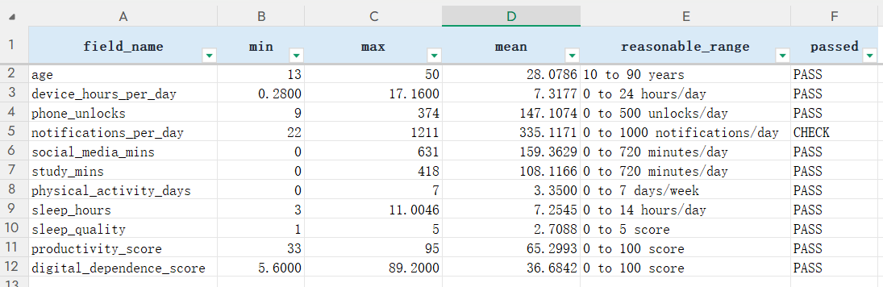
Table5 Range and Rationality Check
The range check suggests that the wide values are still usable. In Table5, device_hours_per_day ranges from 0.28 to 17.16, and notifications_per_day reaches 1,211. These values show large behavior differences, but they are still meaningful in a digital-lifestyle dataset. So the report keeps the records and handles scale differences later.

3.4 Feature Engineering
Table6 records the engineered behavior-intensity variables.
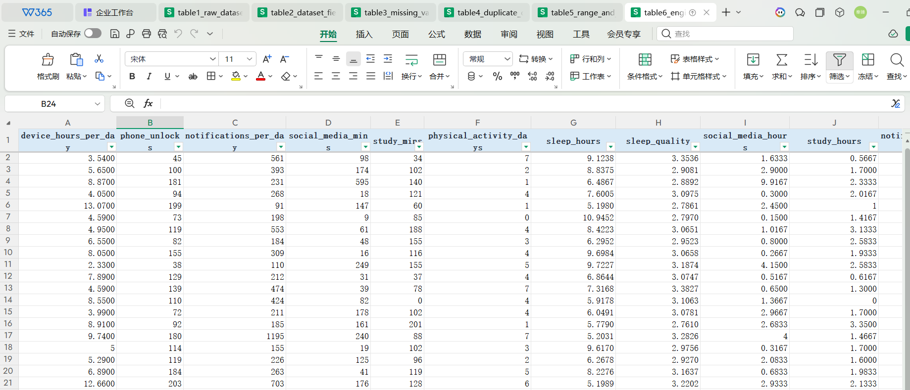
Table6 Engineered Features Preview
Feature engineering makes the behavior variables easier to interpret. Table6 changes raw minutes and counts into intensity features such as notifications_per_device_hour and device_to_sleep_ratio.

3.5 Feature Selection and Leakage Control
Table7 explains which columns are excluded before modeling.
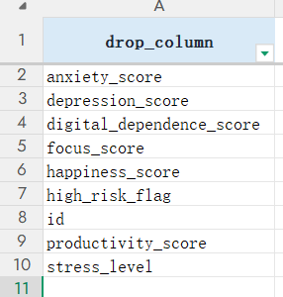
Table7 Feature Selection and Leakage Control
Leakage control protects the credibility of the models. Table7 removes target-like fields such as high_risk_flag, digital_dependence_score, productivity_score, anxiety_score, depression_score, stress_level, happiness_score, and focus_score from the High Risk classifier inputs. This means the classifier must rely on behavior and lifestyle evidence, not direct outcome information.

3.6 PCA and GMM Extension
Table8 provides the numerical evidence for the PCA extension.
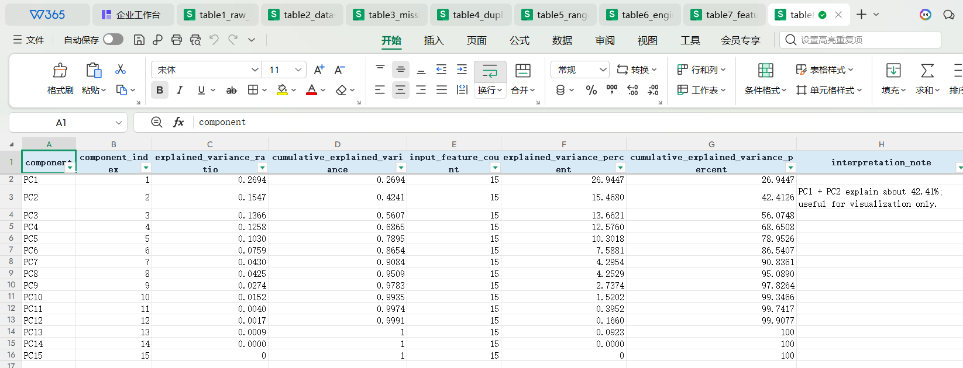
Table8 PCA Explained Variance
PCA is useful, but it cannot replace the full feature space. Table8 shows that the first two components explain 42.41% of the variance. More than half of the information is still outside the two-dimensional view. Therefore, PCA is used only for structure understanding, not as the main input for classification or regression.

4. Statistics and Visualization

4.1 Descriptive Statistics
Table9 gives the mathematical summary before visual analysis.
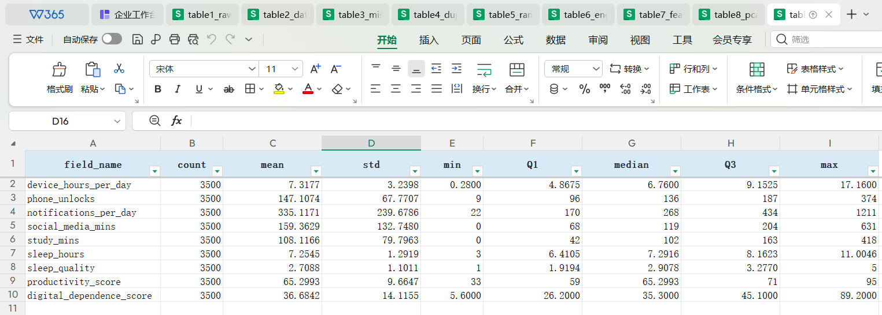
Table9 Descriptive Statistical Summary
The descriptive statistics explain why scaling is needed later. In Table9, notifications_per_day and social_media_mins have much wider ranges than bounded variables such as sleep_quality. This makes scaling necessary for PCA and clustering, while tree-based models can still work with raw feature values.

4.2 Target Distribution
Fig1 is used to check the class structure before model training.

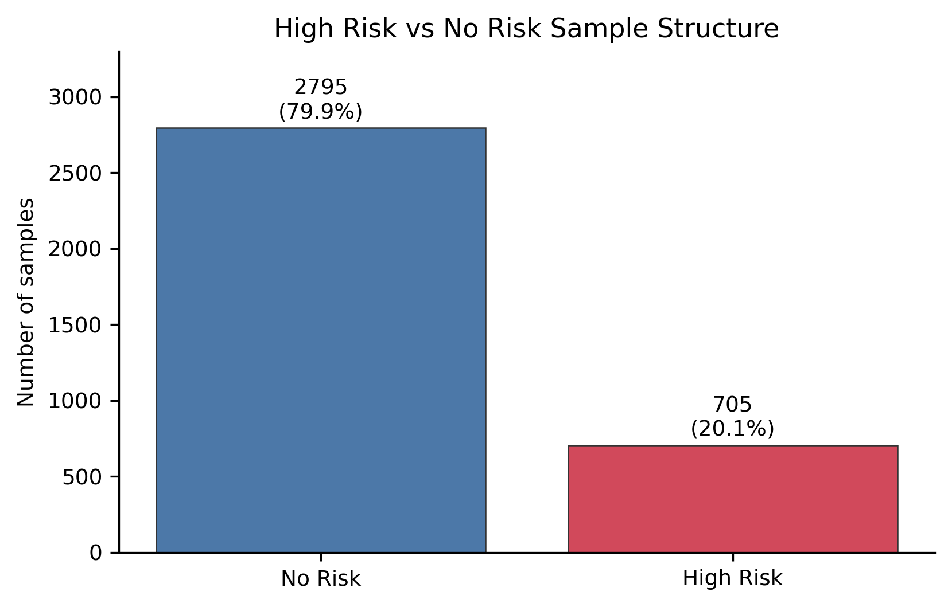
Fig1 High Risk vs No Risk Sample Structure
The first modeling issue is class imbalance. As shown in Fig1, No Risk takes up 79.86% of the samples, while High Risk takes only 20.14%. If the report only used Accuracy, the model might look good by predicting mostly No Risk. Therefore, the classification section focuses on Recall, F1, PR-AUC, and the confusion matrix, because these metrics show whether High Risk samples are actually found.

4.3 Numeric Feature Distribution
Fig2 summarizes the main numerical variables before modeling.
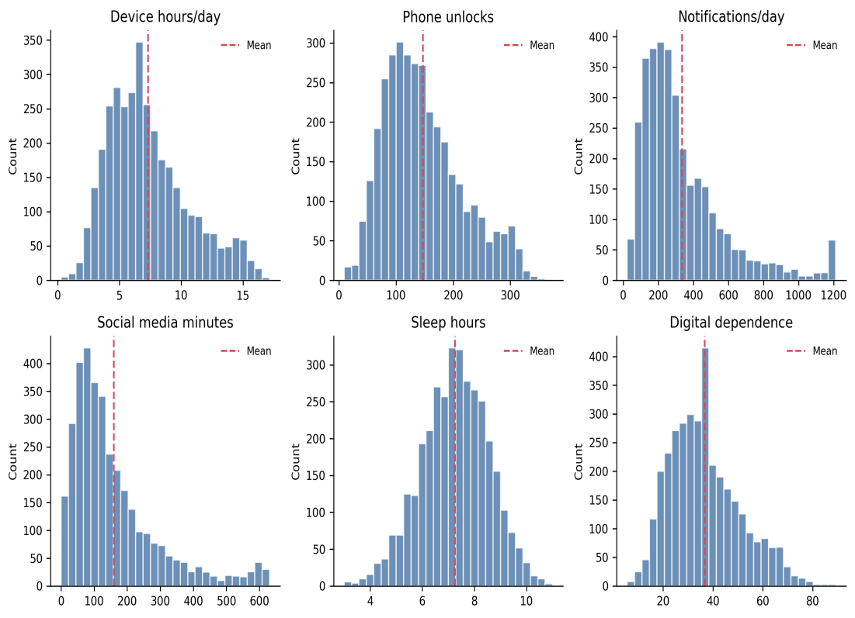
Fig2 Core Digital Lifestyle Feature Distributions
The main issue in Fig2 is the difference in feature scale. Notifications_per_day reaches 1,211, while sleep_hours remains between about 3 and 11 hours. In distance-based methods, variables with larger ranges would have too much influence if the raw values were used directly. Therefore, the data are standardized before PCA and clustering, while tree models are less affected because they split variables separately.

4.4 Correlation Structure
Fig3 checks the correlation structure among behavior variables, lifestyle variables, and outcomes.
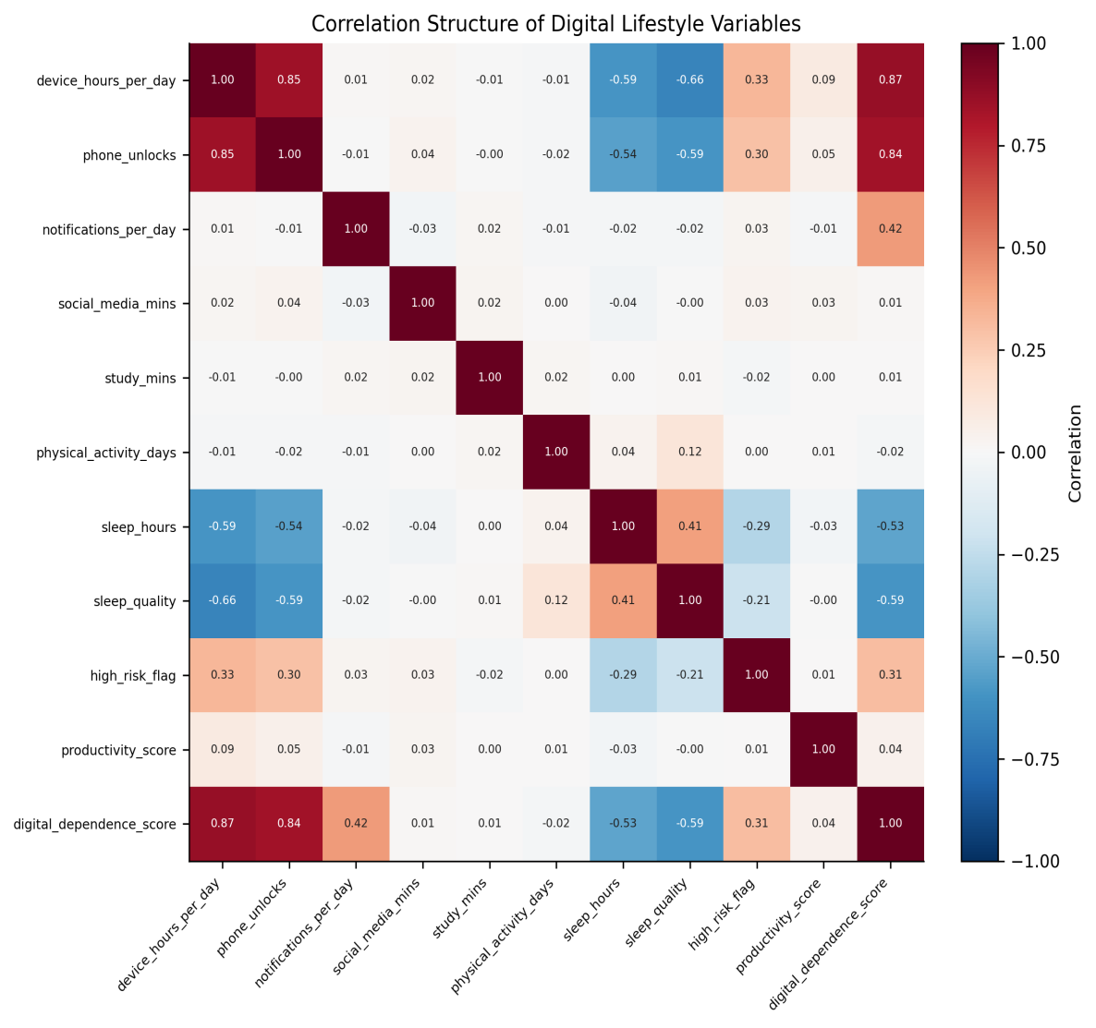
Fig3 Correlation Structure of Digital Lifestyle Variables
Fig3 explains why the two regression targets produce very different results. digital_dependence_score has a strong positive relationship with device_hours_per_day, with r=0.87, and a negative relationship with sleep_quality, with r=-0.59. In contrast, productivity_score has only a weak relationship with device_hours_per_day, with r=0.09. This pattern suggests that the current features contain strong predictive information for digital dependence, but little information for productivity. The heatmap only gives correlation evidence, so the report needs a more detailed analysis later.

4.5 High Risk and No Risk Group Difference
Fig4 compares the High Risk and No Risk groups using the variables with direct behavioral meaning.
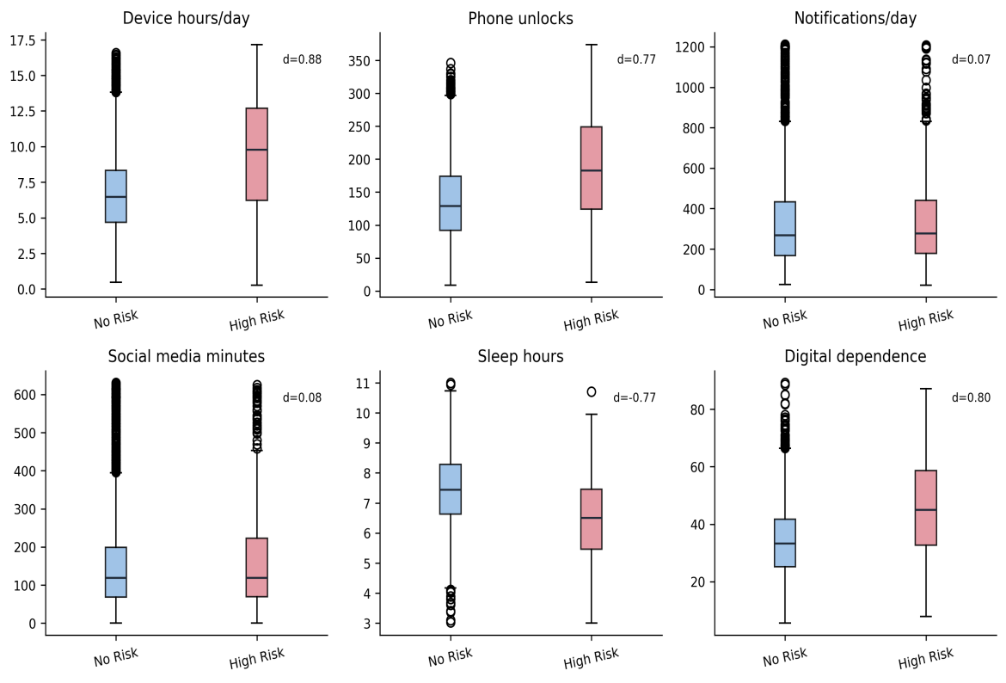
Fig4 Behavioral Difference Between High Risk and No Risk Groups
High Risk is more connected with long device use and weaker sleep balance than with notification amount. In Fig4, the High Risk group has higher device_hours_per_day and higher digital_dependence_score, while sleep_hours is lower. The strongest group difference is device_hours_per_day, but notifications_per_day is weak. Since the two groups still overlap, one single variable cannot separate High Risk from No Risk. This is why the later classifier needs multiple features and threshold tuning.

5. Model Training and Evaluation

5.1 Experimental Setup
All supervised experiments use train/test separation, random_state=42, cross-validation or grid-search evidence, and final testing on the held-out test set. Classification focuses on Recall, F1, PR-AUC, ROC-AUC, Balanced Accuracy, and the confusion matrix. Regression focuses on R2, MSE, RMSE, and MAE. Clustering uses inertia, Silhouette, Calinski-Harabasz, Davies-Bouldin, and profile interpretability.
Because High Risk represents only 20.14% of the data, PR-AUC is used to compare how well the models retrieve and rank the minority class(our high risk is minority so we used highest PR-AUC) across different thresholds. Recall and F1 are then used to choose the final screening threshold.

5.2 High Risk Classification
Fig5 compares the three candidate classifiers before threshold adjustment.
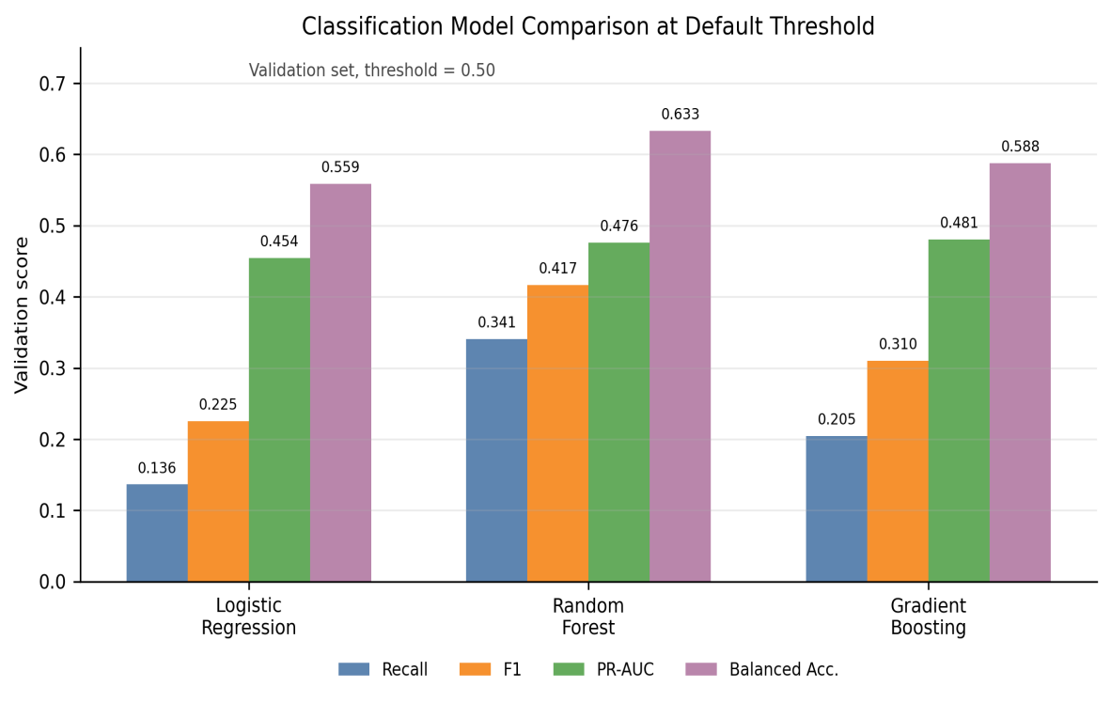
Fig5 Classification Model Comparison at the Default Threshold
The model comparison in Fig5 shows that model choice is not decided by one score. High Risk represents only 20.14% of the samples, so overall Accuracy can look acceptable even when many High Risk cases are missed. PR-AUC is the area under the Precision–Recall curve. Precision asks how many warned samples are truly High Risk, while Recall asks how many real High Risk samples are found. A higher PR-AUC therefore means that the model can place more rare High Risk cases near the top of the risk ranking while controlling false alarms across different thresholds.
At threshold=0.50, Random Forest has better Recall, F1, and Balanced Accuracy. However, Gradient Boosting has the highest validation PR-AUC at 0.4805, compared with 0.4759 for Random Forest and 0.4543 for Logistic Regression. Its advantage over Random Forest is only 0.0046. Therefore, Gradient Boosting is selected as the slightly better High Risk ranking model, while threshold=0.14 is chosen separately in Fig6 to increase Recall.

Fig6 explains why the final classifier does not use the default threshold of 0.50.
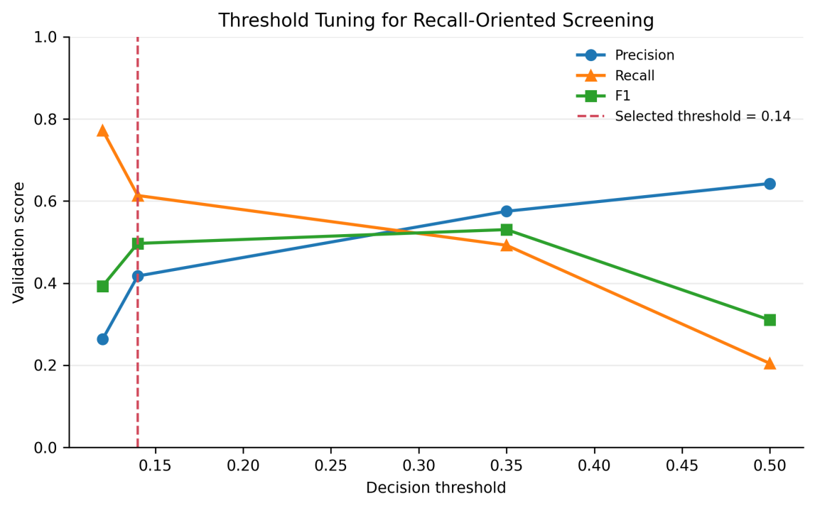
Fig6 Threshold Tuning for Recall-Oriented Screening
The final threshold is chosen for screening rather than for maximum overall accuracy. As Fig6 shows, precision rises as the threshold increases, while recall falls quickly. Because the task aims to miss fewer High Risk samples, threshold=0.14 is used. On the test set, Recall reaches 0.6420, although the lower threshold also creates more false alarms. This is a deliberate screening trade-off.

Fig7 provides the final test-set confusion matrix for Gradient Boosting at threshold 0.14.
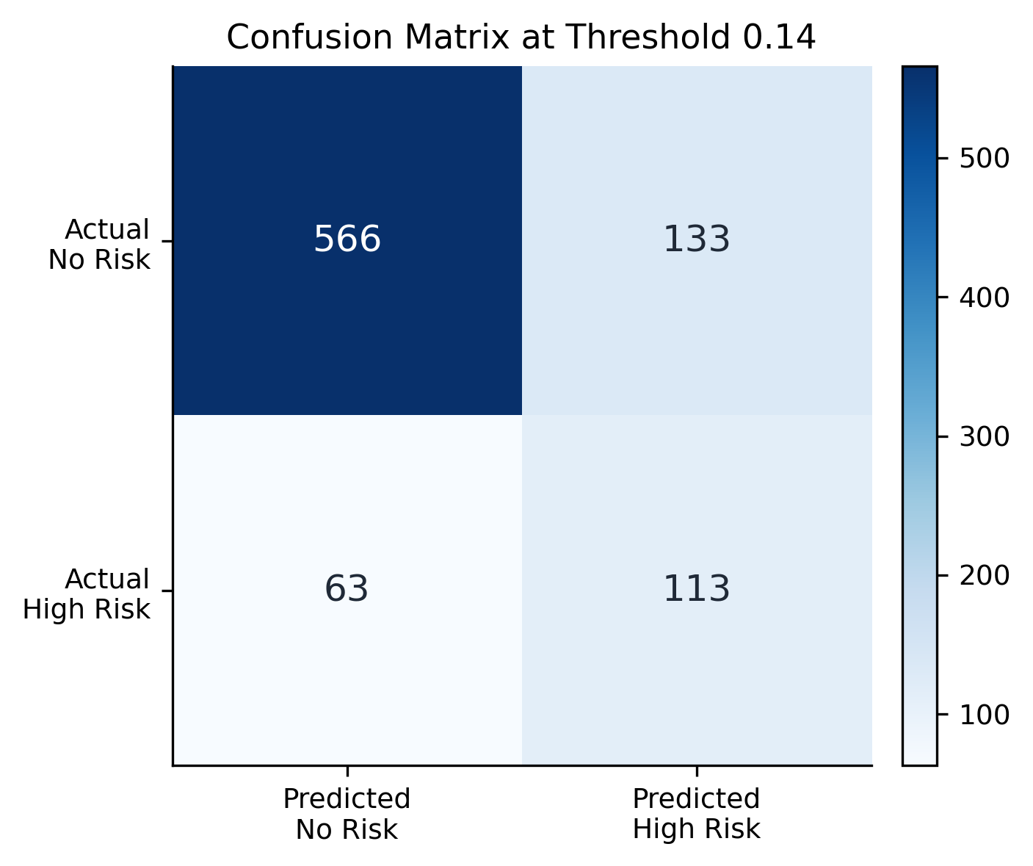
Fig7 Confusion Matrix of the Final High Risk Classifier
The confusion matrix makes the screening cost clear. In Fig7, the model finds 113 true High Risk samples, but it still misses 63. It also creates 133 false alarms. This trade-off is expected because the threshold was lowered to find more High Risk cases. So the final classifier should be used as a screening reference, not as a final personal judgment.

Fig8 evaluates the High Risk ranking ability across thresholds.
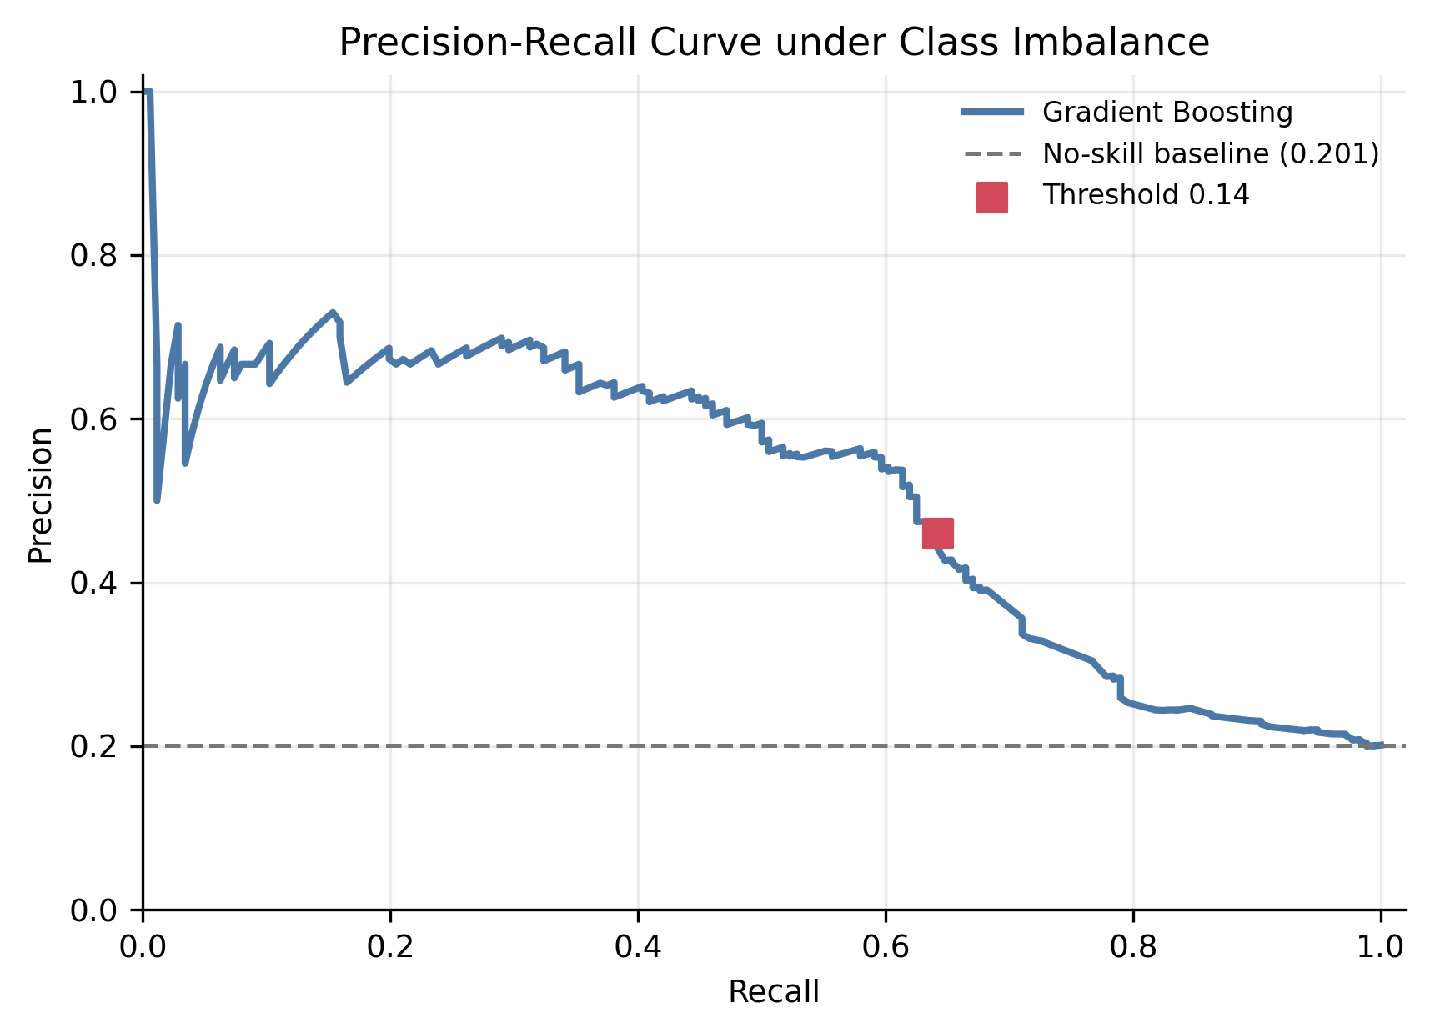
Fig8 Precision-Recall Curve under Class Imbalance
The PR curve shows that the classifier has ranking value, but it is not perfect. In Fig8, PR-AUC is clearly higher than the no-skill baseline, so the model is better than random ranking. However, the curve also shows that high recall and high precision are hard to get at the same time. This supports the same conclusion as Fig6 and Fig7: the model is useful for early screening, but it still needs human or follow-up judgment.

from sklearn.model_selection import StratifiedKFold, GridSearchCV, train_test_split
from sklearn.ensemble import GradientBoostingClassifier
from sklearn.metrics import precision_recall_fscore_support
from sklearn.compose import ColumnTransformer
from sklearn.pipeline import Pipeline
from sklearn.preprocessing import OneHotEncoder, StandardScaler

X = engineered.drop(columns=classification_drop)
y = engineered["high_risk_flag"]
num_cols = X.select_dtypes(include="number").columns.tolist()
cat_cols = X.select_dtypes(exclude="number").columns.tolist()

X_train, X_test, y_train, y_test = train_test_split(
X, y, test_size=0.25, stratify=y, random_state=42
)

preprocess = ColumnTransformer([
("num", StandardScaler(), num_cols),
("cat", OneHotEncoder(handle_unknown="ignore"), cat_cols),
])
pipe = Pipeline([
("preprocess", preprocess),
("model", GradientBoostingClassifier(random_state=42)),
])
cv = StratifiedKFold(n_splits=5, shuffle=True, random_state=42)
grid = GridSearchCV(
pipe,
{"model__learning_rate": [0.03, 0.05, 0.1], "model__max_depth": [2, 3]},
scoring="average_precision",
cv=cv,
)
grid.fit(X_train, y_train)
proba = grid.predict_proba(X_test)[:, 1]
pred = (proba >= 0.14).astype(int)
print(precision_recall_fscore_support(y_test, pred, average="binary"))

Code explanation: The pipeline uses a stratified split to preserve the High Risk ratio and GridSearchCV with average precision to tune Gradient Boosting. The final probability scores are converted into screening labels with threshold=0.14.

5.3 Digital Dependence and Productivity Regression
Fig9 checks whether the final digital_dependence_score predictions align with the observed scores.

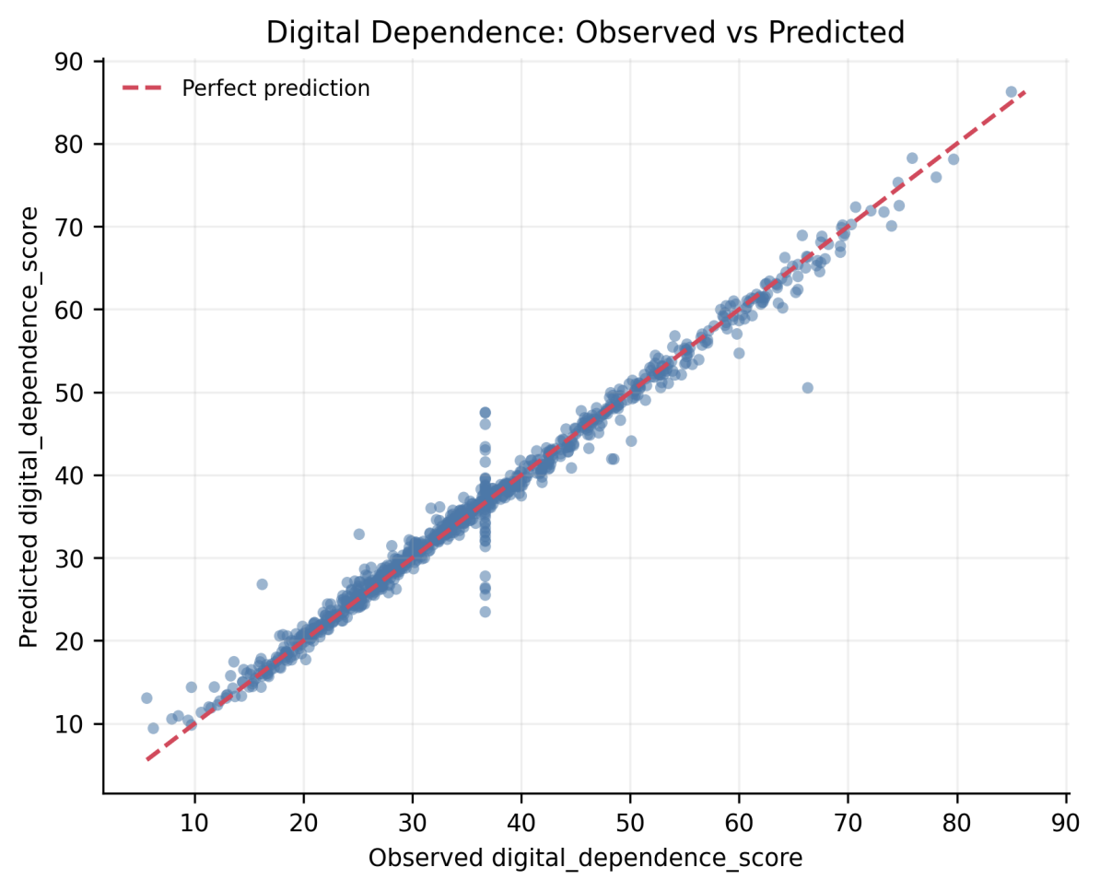
Fig9 Digital Dependence Observed vs Predicted Scores
The digital-dependence prediction is the best result in the report. In Fig9, most points stay close to the diagonal line, and the final R² reaches 0.9839. This means the current behavior and lifestyle variables describe digital_dependence_score very well inside this benchmark dataset. The conclusion is about prediction, not causality.

Fig10 keeps the productivity_score experiment as a negative-result check.
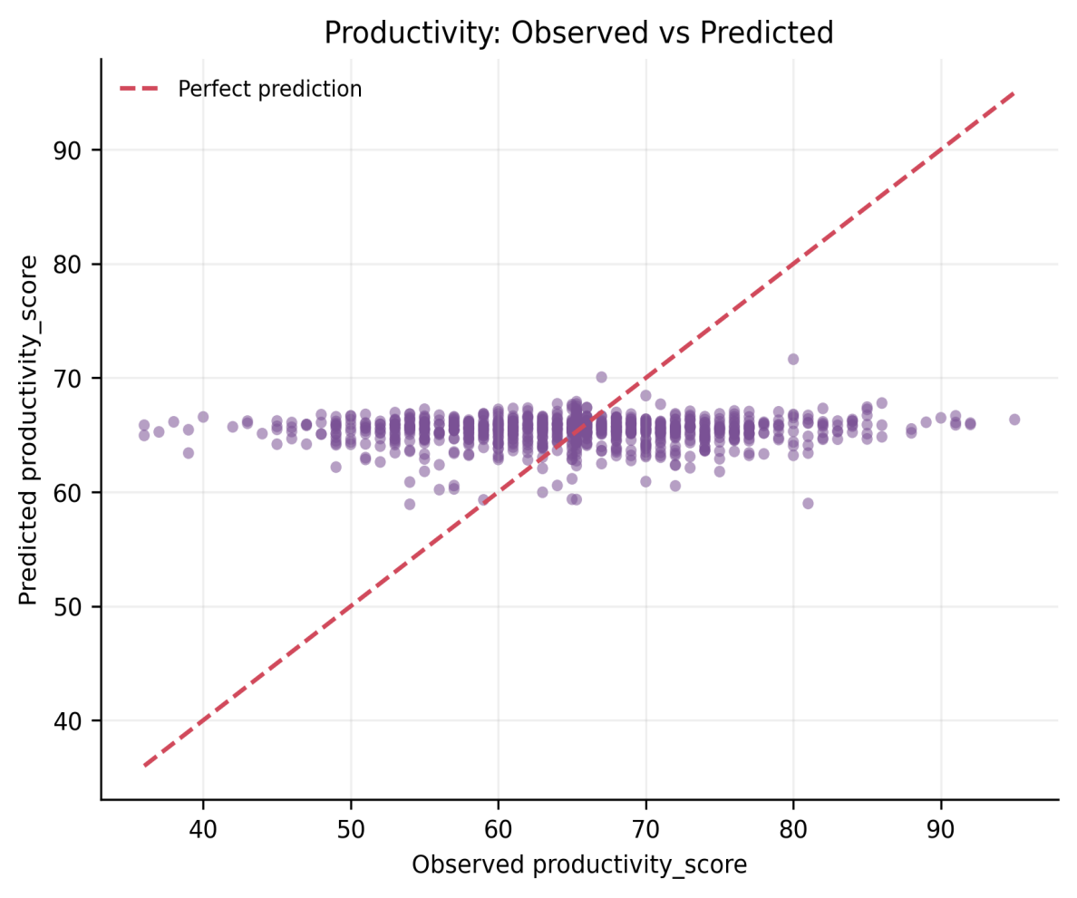
Fig10 Productivity Weak Prediction Observed vs Predicted Scores
The productivity result is weak, and this weakness is meaningful. In Fig10, the predicted values stay near the average instead of following the full spread of actual productivity_score. This means the model cannot tell high-productivity and low-productivity samples apart well. With R² below zero, the current features are not enough for productivity prediction. This negative result shows the boundary of the dataset.

Fig11 summarizes the R2 contrast between the two regression targets.
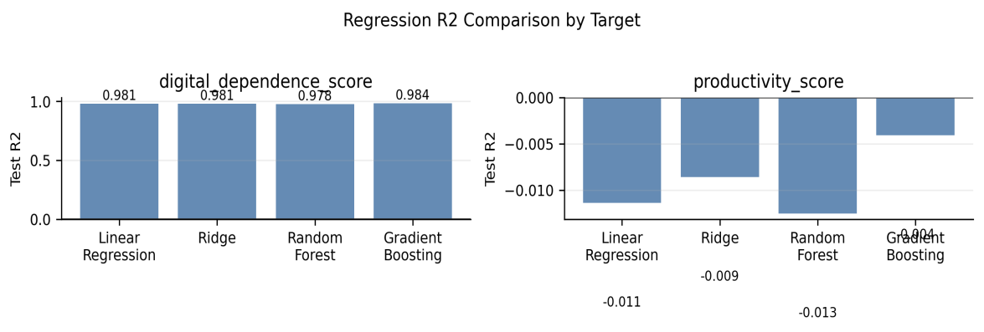
Fig11 Regression R2 Comparison by Target
The contrast in Fig11 makes the regression finding clearer. The same feature set works very well for digital_dependence_score, but it fails for productivity_score. This is important because it prevents overclaiming. The report can say that digital behavior strongly represents digital dependence, but it cannot say that the same behavior explains productivity.

import numpy as np
from sklearn.metrics import mean_absolute_error, mean_squared_error, r2_score

def regression_metrics(y_true, y_pred):
mse = mean_squared_error(y_true, y_pred)
return {
"r2": r2_score(y_true, y_pred),
"mse": mse,
"rmse": np.sqrt(mse),
"mae": mean_absolute_error(y_true, y_pred),
}

dd_pred = pd.read_csv(PROJECT_ROOT / "results" / "regression_digital_dependence_predictions.csv")
prod_pred = pd.read_csv(PROJECT_ROOT / "results" / "regression_productivity_predictions.csv")

print(regression_metrics(dd_pred["actual"], dd_pred["predicted"]))
print(regression_metrics(prod_pred["actual"], prod_pred["predicted"]))

Code explanation: The same function calculates R², MSE, RMSE, and MAE for both targets, so the strong digital-dependence result and weak productivity result are compared under the same evaluation rule.

5.4 Digital Lifestyle Clustering
Fig12 combines inertia and silhouette evidence to explain the clustering choice.

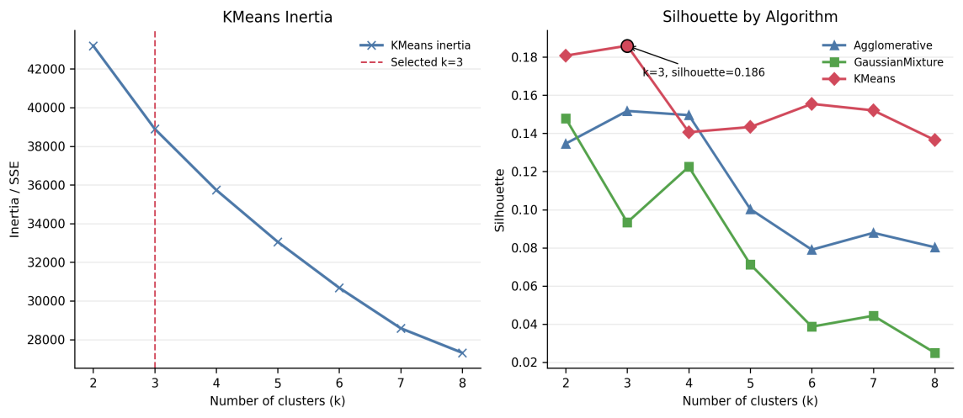
Fig12 K Selection by Inertia and Silhouette
The clustering result should be read carefully. In Fig12, the inertia curve does not show a sharp elbow, and the best KMeans silhouette at k=3 is only 0.1860. This means the clusters are not strongly separated. Therefore, k=3 is used because it gives readable profiles, not because the data naturally form three clear groups.

Fig13 summarizes the final KMeans k=3 lifestyle profiles.
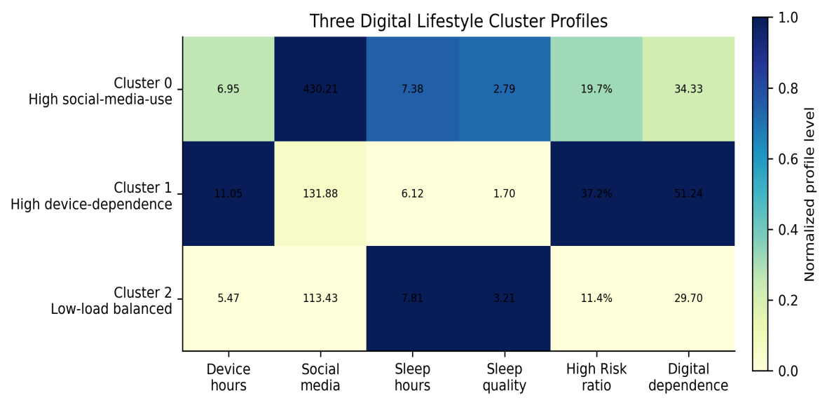
Fig13 Three Digital Lifestyle Cluster Profiles
The three clusters have different behavior focuses. In Fig13, Cluster 0 has the highest social_media_mins (430.2) but only moderate device_hours_per_day (6.95), so it is mainly a High social-media-use profile. Cluster 1 has the highest device_hours_per_day (11.05), the lowest sleep_quality (1.70), and the highest High Risk ratio (37.2%), so it is the strongest High device-dependence profile. Cluster 2 has the lowest device_hours_per_day (5.47) and the lowest High Risk ratio (11.4%), so it is the Low-load balanced profile. However, Silhouette=0.1860 means these are gradual lifestyle patterns.

Fig14 provides the PCA evidence used to discuss dimensionality reduction.
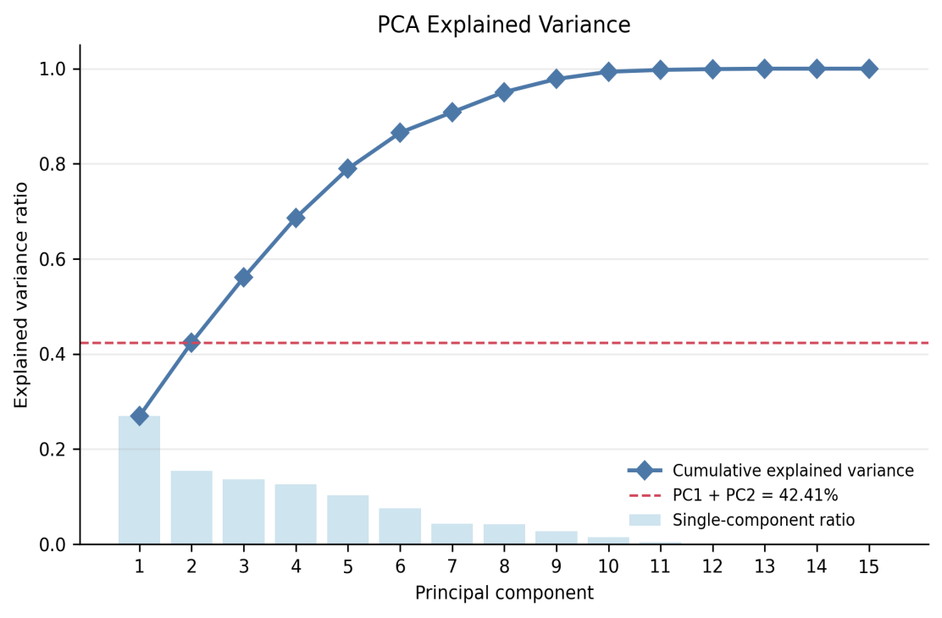
Fig14 PCA Explained Variance for Dimensionality Reduction
PCA helps with understanding, but it also shows its own limit. In Fig14, the first two principal components explain 42.41% of the variance, so a large part of the information is still hidden outside the two-dimensional view. This means PCA can support visual explanation, but it should not replace the original feature space. The final models should still be evaluated with their own metrics.

from sklearn.cluster import KMeans
from sklearn.cluster import AgglomerativeClustering
from sklearn.mixture import GaussianMixture
from sklearn.metrics import silhouette_score
from sklearn.preprocessing import StandardScaler

X_cluster = engineered[clustering_features]
X_scaled = StandardScaler().fit_transform(X_cluster)

scores = []
for k in range(2, 9):
km = KMeans(n_clusters=k, random_state=42, n_init=10)
km_labels = km.fit_predict(X_scaled)
agg = AgglomerativeClustering(n_clusters=k)
agg_labels = agg.fit_predict(X_scaled)
gmm = GaussianMixture(n_components=k, random_state=42)
gmm_labels = gmm.fit_predict(X_scaled)
scores.extend([
{"algorithm": "KMeans", "k": k, "silhouette": silhouette_score(X_scaled, km_labels)},
{"algorithm": "Agglomerative", "k": k, "silhouette": silhouette_score(X_scaled, agg_labels)},
{"algorithm": "GaussianMixture", "k": k, "silhouette": silhouette_score(X_scaled, gmm_labels)},
])

print(pd.DataFrame(scores))

Code explanation: The clustering features are standardized first, and KMeans, AgglomerativeClustering, and GaussianMixture are compared for k=2–8. The silhouette results support using KMeans k=3 only as an exploratory profile solution.

5.5 Integrated Result Analysis
The overall analysis leads to one clear conclusion: prolonged device use and weak sleep balance are the first behavior patterns that should be monitored when assessing digital dependence, while notification volume is not a reliable warning sign.

The Gradient Boosting classification model turns behavior and lifestyle variables into a High Risk screening score. With threshold=0.14, Recall reaches 0.6420, so the model can prioritize possible High Risk cases for follow-up, but it cannot make final personal decisions.

The Gradient Boosting regression model predicts digital_dependence_score well, with R²=0.9839 and MAE=0.9982. However, the same features fail to predict productivity_score, with R²=-0.0041, showing that the dataset is useful for dependence-related analysis rather than general performance judgment.

The KMeans Clustering model with k=3 further organizes the samples into three readable lifestyle profiles, although Silhouette=0.1860 means that these profiles are not strict natural groups.

Therefore, the three models form one practical process: the Gradient Boosting classifier identifies people who may need further attention, the Gradient Boosting regression model provides a reference estimate of digital dependence, and the KMeans Clustering profiles support different guidance—social-media time management for Cluster 0, device-use and sleep-balance support for Cluster 1, and balanced-habit maintenance for Cluster 2. This process turns the model results into targeted follow-up and lifestyle guidance.

6. Findings and Reflection

6.1 Main Findings
The main finding is that the three models support different but connected uses.

The Gradient Boosting classifier at threshold=0.14 identifies 64.20% of true High Risk samples, including 113 true positives, but it also produces 133 false positives. Therefore, it is more suitable for prioritizing follow-up than for making final personal judgments.

The Gradient Boosting regression model predicts digital_dependence_score accurately, with R²=0.9839 and MAE=0.9982, while productivity_score remains unpredictable, with R²=-0.0041.

KMeans with k=3 produces three broad lifestyle profiles, although Silhouette=0.1860 shows that their boundaries are weak.

These results lead to practical guidance at three levels.

At the individual level, people should pay more attention to prolonged device use, long social-media sessions, and weak sleep balance.

At the school or community level, voluntary screening can be used to decide who should receive a follow-up questionnaire: Cluster 0 can receive social-media time-management guidance, Cluster 1 can receive stronger device-use and sleep-balance support, and Cluster 2 can focus on maintaining balanced habits.

At the public level, education and health authorities can strengthen digital-wellbeing and sleep-health education, while platforms and device providers can offer clearer screen-time summaries and nighttime reminders.

The practical value of this project is not only analyze the data, but also to use data to decide who may need support, what behavior should be monitored, and which type of guidance may be more suitable.

6.2 Limitations
The limitations show what the report should not overclaim.
First, the dataset is a benchmark educational dataset, so the very high digital-dependence result may partly come from the dataset structure that means its man-made.
Second, the classifier still misses 63 High Risk samples and produces 133 false alarms, even after lowering the threshold.
Third, productivity_score may depend on factors not included here, such as motivation, task context, or learning environment.
Fourth, the clustering boundary is weak because of the the low silhouette score.
Therefore, these results are useful for course-level analysis, but stronger real-world claims would need external validation.

6.3 Personal Reflection
Big Data Analysis and Applications has helped me build a complete understanding of data analysis. Professor’s careful requirements and feedback on analysis logic, visualization, model comparison, and conclusion writing encouraged me to explain not only what the numerical results are, but also why they matter and where the evidence.

The course has also provided a useful foundation for my future study of machine learning and deep learning, especially in data preprocessing, feature engineering, model evaluation, and responsible interpretation. I now understand that only score alone is not enough. The metric must match the problem, weak results should not be hidden, and practical conclusions must remain.

Organizing the project on GitHub was my own extension of the reproducibility idea. It made the data, code, figures, and final results easier to review and manage. I believe the knowledge and analytical habits developed through Big Data Analysis and Applications will continue to help me in later courses, competitions, ccf-c paper writing, research, and practical data-analysis projects.

Appendix A Complete Runnable Code

A.1 Environment and Dependencies
The experiment was completed with a CPU-based Python environment. The main dependencies are pandas, NumPy, scikit-learn, Matplotlib, openpyxl, python-docx, and joblib. The environment can be installed with: pip install -r requirements.txt.
To support reproducibility, the complete project—including preprocessing scripts, model results, figures, and final report files—is available in the GitHub repository:
https://github.com/hansu650/Big-Data-Homework/tree/main

A.2 Complete Code

"""Complete runnable code source for Appendix A.

Run from the project directory:
python appendix_A_complete_code.py

Or run from the repository root:
python <project_dir>/appendix_A_complete_code.py

This file rebuilds the final report evidence files without changing the
validated core CSV metrics. It loads the raw dataset, checks data quality,
creates engineered features, documents leakage control, regenerates the final
figures, exports screenshot Excel tables, and summarizes the validated results.
"""

from __future__ import annotations

import runpy
from pathlib import Path

import pandas as pd

PROJECT_ROOT = Path(__file__).resolve().parent
RAW_DATA_PATH = PROJECT_ROOT / "data" / "raw" / "digital_lifestyle_benchmark_2025.csv"
PROCESSED_DATA_PATH = PROJECT_ROOT / "data" / "processed" / "digital_lifestyle_benchmark_2025_processed.csv"
RESULTS_DIR = PROJECT_ROOT / "results"
FIGURE_DIR = PROJECT_ROOT / "figures" / "final_report"
SCREENSHOT_TABLE_DIR = PROJECT_ROOT / "screenshot_tables"
RANDOM_STATE = 42

def load_raw_data() -> pd.DataFrame:
df = pd.read_csv(RAW_DATA_PATH)
print("Raw dataset shape:", df.shape)
print("Raw columns:", df.columns.tolist())
print(df.head())
return df

def check_missing_duplicates_and_ranges(df: pd.DataFrame) -> None:
key_numeric = [
"age",
"device_hours_per_day",
"phone_unlocks",
"notifications_per_day",
"social_media_mins",
"study_mins",
"sleep_hours",
"sleep_quality",
"productivity_score",
"digital_dependence_score",
]
print("\nMissing values:")
print(df.isna().sum())
print("\nDuplicate rows:", df.duplicated().sum())
print("Duplicate id:", df["id"].duplicated().sum())
print("\nRange summary:")
print(df[key_numeric].agg(["min", "max", "mean"]).T)

def add_engineered_features(df: pd.DataFrame) -> pd.DataFrame:
engineered = df.copy()
eps = 1e-6
engineered["social_media_hours"] = engineered["social_media_mins"] / 60
engineered["study_hours"] = engineered["study_mins"] / 60
engineered["notifications_per_device_hour"] = (
engineered["notifications_per_day"] / engineered["device_hours_per_day"].clip(lower=eps)
)
engineered["unlocks_per_device_hour"] = (
engineered["phone_unlocks"] / engineered["device_hours_per_day"].clip(lower=eps)
)
engineered["device_to_sleep_ratio"] = (
engineered["device_hours_per_day"] / engineered["sleep_hours"].clip(lower=eps)
)
engineered["activity_sleep_interaction"] = (
engineered["physical_activity_days"] * engineered["sleep_hours"]
)
engineered["social_to_study_ratio"] = engineered["social_media_mins"] / (
engineered["study_mins"] + 1
)
engineered.to_csv(PROCESSED_DATA_PATH, index=False)
print("\nProcessed dataset saved:", PROCESSED_DATA_PATH)
return engineered

def define_feature_sets(engineered: pd.DataFrame) -> dict[str, list[str]]:
outcome_cols = [
"anxiety_score",
"depression_score",
"stress_level",
"happiness_score",
"focus_score",
"high_risk_flag",
"productivity_score",
"digital_dependence_score",
]
classification_drop = [
"id",
"high_risk_flag",
"anxiety_score",
"depression_score",
"stress_level",
"happiness_score",
"focus_score",
"productivity_score",
"digital_dependence_score",
]

def regression_drop_for(target: str) -> list[str]:
drop_cols = {"id", target}
drop_cols.update(outcome_cols)
if target == "digital_dependence_score":
drop_cols.add("productivity_score")
if target == "productivity_score":
drop_cols.add("digital_dependence_score")
return sorted(drop_cols)

digital_dependence_drop = regression_drop_for("digital_dependence_score")
productivity_drop = regression_drop_for("productivity_score")
clustering_features = [
"device_hours_per_day",
"phone_unlocks",
"notifications_per_day",
"social_media_mins",
"study_mins",
"physical_activity_days",
"sleep_hours",
"sleep_quality",
"social_media_hours",
"study_hours",
"notifications_per_device_hour",
"unlocks_per_device_hour",
"device_to_sleep_ratio",
"activity_sleep_interaction",
"social_to_study_ratio",
]
classification_features = [c for c in engineered.columns if c not in classification_drop]
digital_dependence_features = [c for c in engineered.columns if c not in digital_dependence_drop]
productivity_features = [c for c in engineered.columns if c not in productivity_drop]
print("\nClassification drop columns:", classification_drop)
print("Classification feature count:", len(classification_features))
print("Digital dependence regression feature count:", len(digital_dependence_features))
print("Productivity regression feature count:", len(productivity_features))
print("Clustering features:", clustering_features)
return {
"classification_drop": classification_drop,
"classification_features": classification_features,
"digital_dependence_drop": digital_dependence_drop,
"digital_dependence_features": digital_dependence_features,
"productivity_drop": productivity_drop,
"productivity_features": productivity_features,
"clustering_features": clustering_features,
}

def summarize_validated_results() -> None:
classification = pd.read_csv(RESULTS_DIR / "classification_tuned_metrics.csv")
regression_dd = pd.read_csv(RESULTS_DIR / "regression_digital_dependence_metrics.csv")
regression_prod = pd.read_csv(RESULTS_DIR / "regression_productivity_metrics.csv")
clustering = pd.read_csv(RESULTS_DIR / "clustering_kmeans_scores.csv")

final_cls = classification[
(classification["dataset"] == "test")
& (classification["model"] == "gradient_boosting")
& (classification["threshold"].round(2) == 0.14)
].iloc[0]
final_dd = regression_dd[regression_dd["model"] == "gradient_boosting"].iloc[0]
final_prod = regression_prod[regression_prod["model"] == "gradient_boosting"].iloc[0]
final_cluster = clustering[clustering["k"] == 3].iloc[0]

summary = pd.DataFrame(
[
{
"task": "classification_high_risk",
"main_result": "Gradient Boosting threshold=0.14",
"metric_1": f"Recall={final_cls['recall']:.4f}",
"metric_2": f"F1={final_cls['f1']:.4f}",
"metric_3": f"PR-AUC={final_cls['pr_auc']:.4f}",
},
{
"task": "regression_digital_dependence",
"main_result": "Gradient Boosting",
"metric_1": f"R2={final_dd['r2']:.4f}",
"metric_2": f"MSE={final_dd['mse']:.4f}",
"metric_3": f"MAE={final_dd['mae']:.4f}",
},
{
"task": "regression_productivity",
"main_result": "weak prediction / negative result",
"metric_1": f"R2={final_prod['r2']:.4f}",
"metric_2": "",
"metric_3": "",
},
{
"task": "clustering_lifestyle_profiles",
"main_result": "KMeans k=3",
"metric_1": f"Silhouette={final_cluster['silhouette']:.4f}",
"metric_2": "",
"metric_3": "",
},
]
)
output = RESULTS_DIR / "final_workflow_report_summary.csv"
summary.to_csv(output, index=False)
print("\nValidated result summary saved:", output)

def regenerate_figures_and_screenshot_tables() -> None:
FIGURE_DIR.mkdir(parents=True, exist_ok=True)
SCREENSHOT_TABLE_DIR.mkdir(parents=True, exist_ok=True)
runpy.run_path(str(PROJECT_ROOT / "scripts" / "generate_final_report_figures.py"), run_name="__main__")
runpy.run_path(str(PROJECT_ROOT / "scripts" / "export_screenshot_tables.py"), run_name="__main__")

def main() -> None:
print("Random state:", RANDOM_STATE)
df = load_raw_data()
check_missing_duplicates_and_ranges(df)
engineered = add_engineered_features(df)
define_feature_sets(engineered)
summarize_validated_results()
regenerate_figures_and_screenshot_tables()
print("\nComplete workflow evidence generation finished.")

if __name__ == "__main__":
main()

