CS4296 Cloud Computing (Spring 2026) — Final Report
Project: Benchmarking WordPress Deployment Performance with Docker (Local Profiles)
Group ID: Group 234 Member(s): Zhang Wangbo Student ID(s): 58522136

Abstract (≤250 words)
[WRITE THIS YOURSELF] Abstract summary of goal, method, and key findings (≤250 words).

1. Introduction
[WRITE THIS YOURSELF] Background: WordPress, cloud instance selection, and containerized deployment.
[WRITE THIS YOURSELF] Project objective and what is benchmarked.
[WRITE THIS YOURSELF] Contributions / what you found (high-level).

2. Methodology

2.1 System setup
Stack: Nginx (reverse proxy) → WordPress (PHP-FPM) → MySQL, deployed via Docker Compose on Windows + Docker Desktop.
Because AWS login was unavailable, we emulate three EC2-like profiles by applying Docker CPU/memory limits: general / compute / memory.
Host machine specs: OS=Microsoft Windows 11 Professional (version 10.0.26200, build 26200); CPU=11th Gen Intel(R) Core(TM) i7-11370H @ 3.30GHz (cores=4, logical=8); RAM=15.8 GB.

2.2 Workloads and metrics
Load generator: ApacheBench (ab) running inside WSL Ubuntu.
Scenarios: S1 (c=10, 180s), S2 (c=50, 300s), S3 (c=100, 300s), each repeated 3 times.
Endpoints: / and /?p=1
Metrics: requests/sec, time per request (mean), failed requests; plus docker stats sampling.

3. Results
Table 1. Aggregated results by profile and scenario (from artifact outputs).
profile | scenario | rps_mean | rps_std | tpr_mean | tpr_std | failed_sum
compute | S1 | nan | nan | nan | nan | 0.000
compute | S2 | nan | nan | nan | nan | 0.000
compute | S3 | nan | nan | nan | nan | 0.000
general | S1 | 36.983 | 25.790 | 453.496 | 315.528 | 0.000
memory | S1 | nan | nan | nan | nan | 0.000
memory | S2 | nan | nan | nan | nan | 0.000
memory | S3 | nan | nan | nan | nan | 0.000

3.1 Throughput
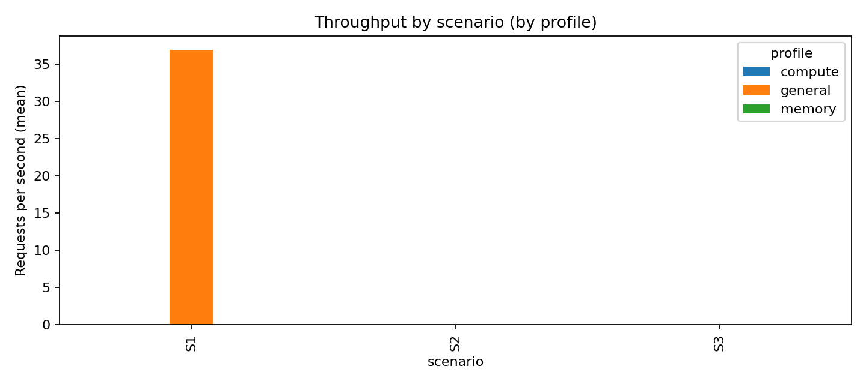
Figure 1. Throughput (requests/sec mean) by scenario, grouped by profile.
[WRITE THIS YOURSELF] Explain throughput trends and why profiles differ.

3.2 Latency
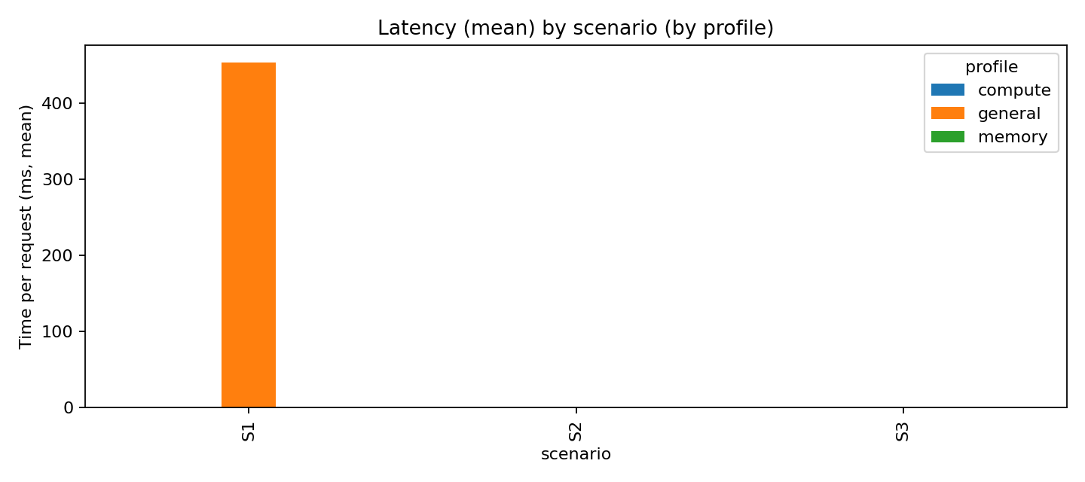
Figure 2. Latency (time per request mean, ms) by scenario, grouped by profile.
[WRITE THIS YOURSELF] Explain latency trends and any bottlenecks observed.

4. Discussion: Validity and limitations
This artifact uses local container resource limits to emulate instance-type differences. It does not capture cloud networking variability, EBS behavior, or CPU microarchitecture differences across real EC2 families.
[WRITE THIS YOURSELF] Write 3–6 bullet points on limitations and how they might affect conclusions.

5. Conclusion and future work
[WRITE THIS YOURSELF] Conclude in 3–4 sentences. Mention future work (e.g., caching, CDN, real cloud runs).

References
- [1] WordPress Docker image documentation, Docker Hub.
- [2] MySQL Docker image documentation, Docker Hub.
- [3] Nginx Docker image documentation, Docker Hub.
- [4] Apache HTTP Server Project, ApacheBench (ab) documentation.
- [5] Docker Desktop documentation, Docker Inc.
- [6] Windows Subsystem for Linux (WSL) documentation, Microsoft.

Artifact Appendix (reproducibility)
Repository: https://github.com/hansz109/cs4296-project-
Prerequisites: Docker Desktop, WSL Ubuntu, Python 3.11+
Reproduce (high level):
- 1) Start stack: .\scripts\up_profile.ps1 -Profile general
- 2) Seed content: .\scripts\seed_wp.ps1
- 3) Install ab in WSL: .\scripts\install_ab_wsl.ps1
- 4) Run benchmarks: .\scripts\run_bench_wsl.ps1 -Profile <general|compute|memory> -Scenario <S1|S2|S3> -Repeat 3
- 5) Analyze: python scripts\analyze_results.py --results_dir experiments\results --out_dir experiments\summary
Expected outputs:
- - experiments\results\<RUN_ID>\ab_*.txt, meta.txt, docker_stats.csv
- - experiments\summary\ab_summary_by_profile_scenario.csv
- - experiments\summary\throughput_by_profile_scenario.png
- - experiments\summary\latency_by_profile_scenario.png

